Activity 2 “Computer History – Compiler vs. Interpreter”

- "Machine instructions" refer to the low-level instructions that are directly executed by a computer's central processing unit (CPU). Each instruction corresponds to a specific operation that the CPU can perform, such as arithmetic operations, data movement, or control flow.

It is technically possible for programmers to write software directly in machine instructions.

It is highly impractical and error prone. Machine instructions are represented in binary or hexadecimal, making them difficult for humans to read and write. Additionally, different computer architectures have different instruction sets, so machine code written for one architecture may not work on another.

The programming languages that are very close to machine instructions are often referred to as "low-level languages" or "assembly languages." Assembly languages use mnemonic codes to represent machine instructions, making it somewhat more human-readable than raw machine code. However, they still require a deep understanding of the underlying hardware architecture.

- Compiler:
A compiler is a program that translates the entire source code of a high-level programming language into machine code or an intermediate code in a single batch.
The compilation process produces an executable file, which can be run independently of the original source code. Compilation is done before the program is executed, and the resulting machine code is typically saved to disk. Compilation often involves multiple stages, including lexical analysis, syntax analysis, optimization, and code generation.

Interpreter:
An interpreter is a program that translates and executes the source code line by line, without producing a separate executable file. The interpreter reads the source code, interprets each statement, and performs the corresponding actions directly. Interpretation happens at runtime, and the original source code remains required for the program to run. Interpreters are generally slower than compiled programs because they need to analyze and execute code on-the-fly.
- i. Opening visual studio, need to click on the project to create a new project, select the empty project template, click on next and name the project. After naming the project, select the path from the default and click on “Create”.
ii. From top bar menu, click on the Project > Add a new file, select “Code”, then select “C++ File (.cpp). Enter a name with extension “.c” as I want to run the program in C language. Finally click the button “Add”.
iii. Then I need to enter the source code. First, I need to include the library standard input and output header file which is “#include <stdio.h>”.
iv. Second, calling the main function which is “int main (void)” and a curly brace. After that the real program will start.
v. Inside the main function, I need to type the statement “printf” and I need to write everything in the braces and double quote (“ ”) which I want to show as an output to the user.
vi. And if I want to show more than one line in the output, for every ending of a line, I need to add “\n”. That means the starting of a new line.

vii. As I have started the main function with int (integer) I need to return an integer to the main function, by adding the statement “return 0;” (showed in the step vi). After that need to close the main function by the closing curly braces.
viii. After finishing writing the code, for building the project, first go to "Build" in the menu and select "Build Solution" to compile the code.
ix. For running the program, go to "Debug" in the menu and select "Start Without Debugging" to run the program. Then it will show the output.

- Answer: I have copied/pasted the answers document in that program source code.
- Answer: Here is the screenshot-
- 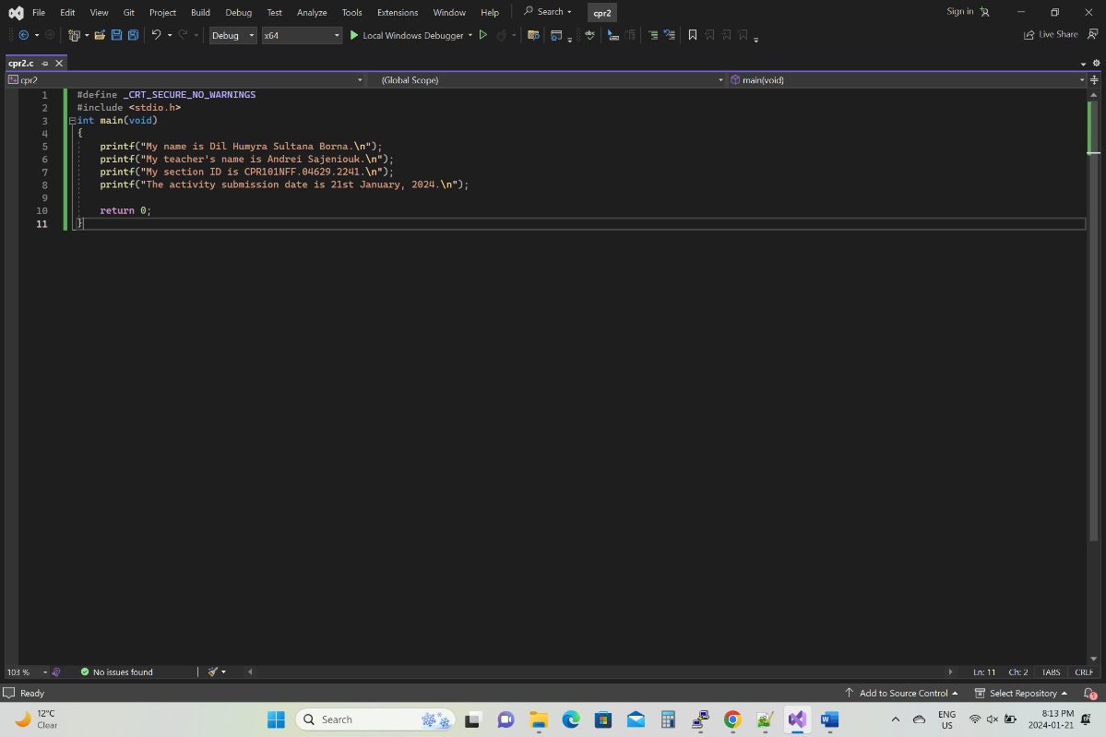

- Answer: Here is the screenshot-
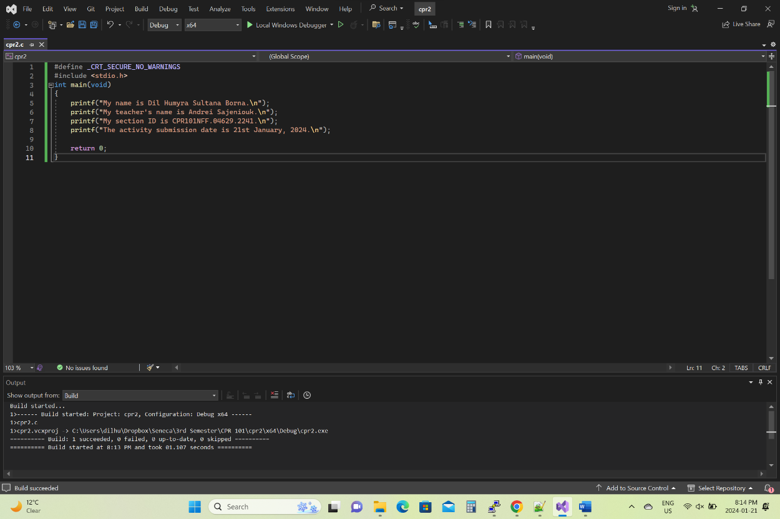
7 Answer: Here is the screenshot-

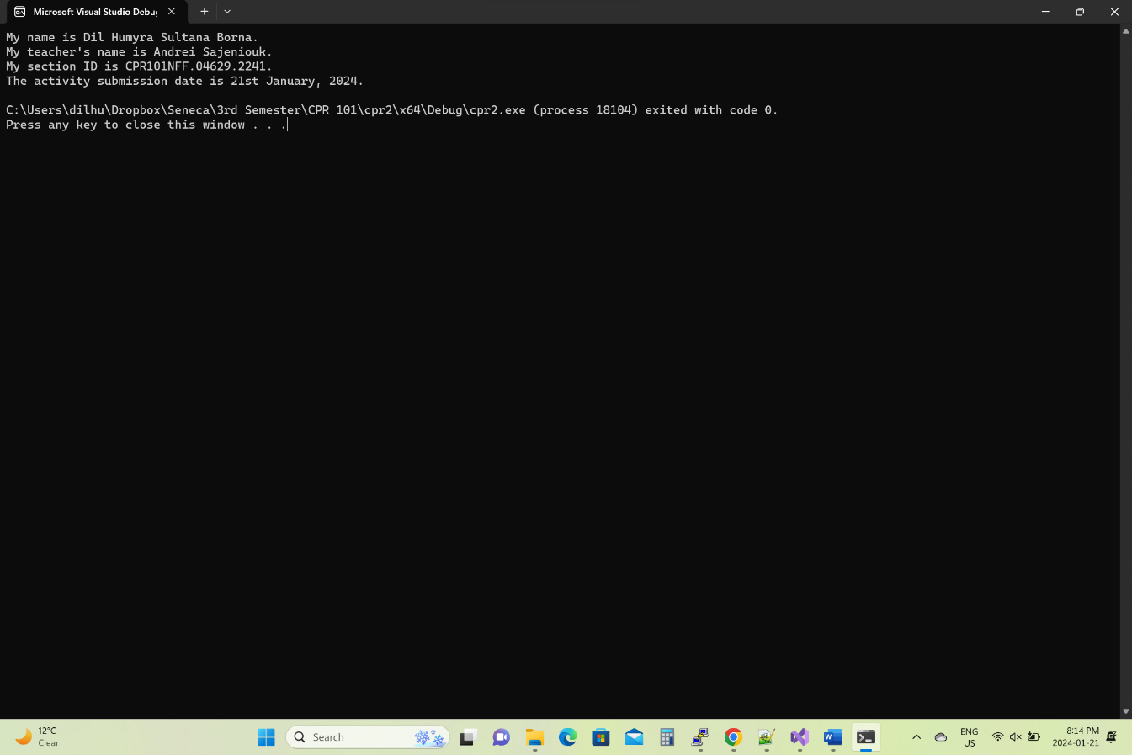

8 Answer: After downloading and setting up MS Visual studio code-
- I have created a file on notepad with the extension .html.
- Opened the file on Visual studio code.
- Started the code with <!DOCTYPE html>
- In the head part I have added the title
- In the body part, I have started the body with <body> and typed the part that I want to type in document.write(" ");
- For the next line I have typed document.write("<br>");.
- Ended the body by entering </body> and ended the script by entering </html>
- Then for running the program in a web browser I have clicked twice in the file.
9. Answer: I have copied/pasted the answer document the JavaScript program source code.
10. Answer: Here are the screen shots-
