Name: Dil Humyra Sultana Borna
ID: 139166227

“Hello Networking” Activity 7 Instructions
======================================
Answer 1: Created a new project after starting MS Visual Studio.
Answer 2: Have made 3 choices: language - C++, platform – Windows, type – Desktop.
Answer 3: Named the project “Activity6”.
Answer 4: Checked the tool windows- Solution Explorer and Resource View.
Answer 5: Have pressed (CTRL+F5), everything is working, Opened through the main menu the about dialog.
Answer 6: Here is the screenshot of the main application-
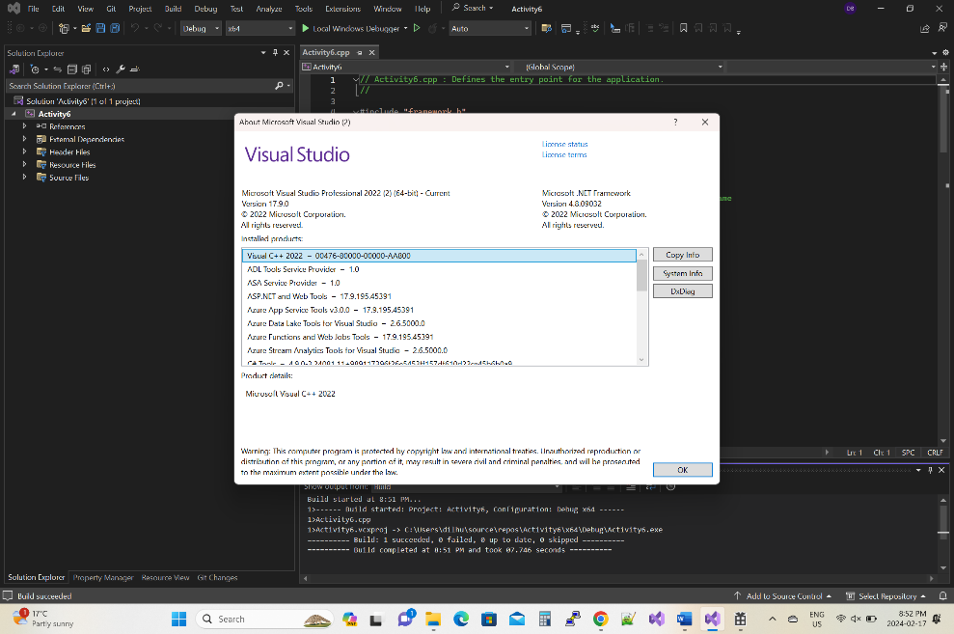
Answer 7: Added directives below the existing #include directives.
Answer 8: Added a new menu command under File menu- Start Networking.
Answer 9: Here is the second screen shot-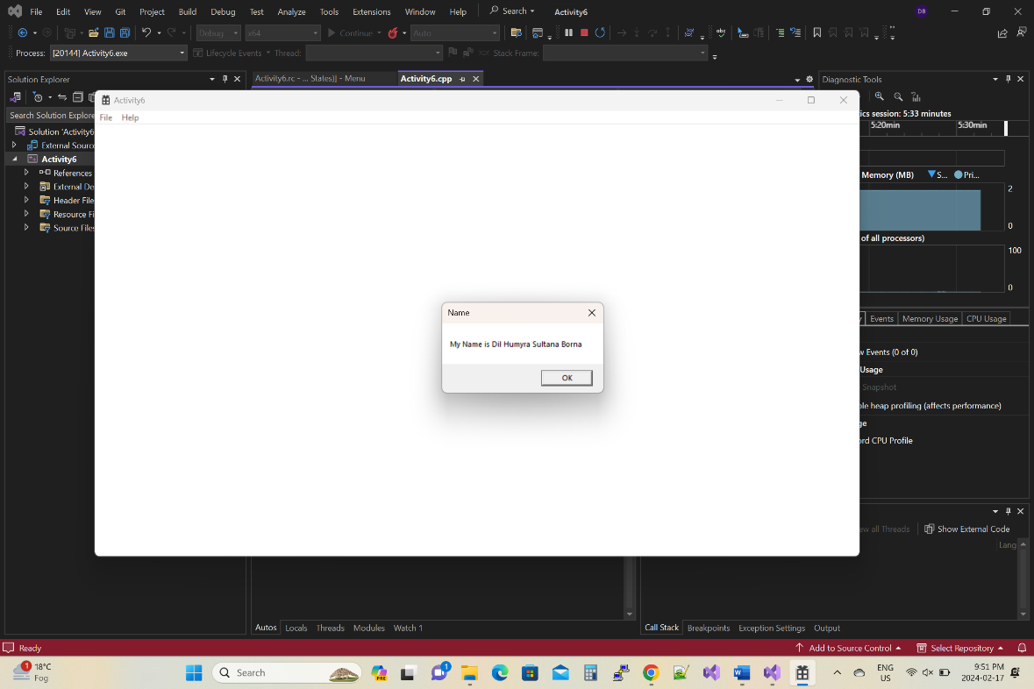

Answer 10: Declared the variables and called the windows API function.
Answer 11: Networking DLL is loaded successfully and printed the success message.
Answer 12: Here is the screenshot-
