Name: Dil Humyra Sultana Borna
ID: 139166227

Activity 5 Google Cloud Apps
=================================

Part 1 - Google Docs:
==================
Answer 1: Accessing different Google APPS from y computer process-
Using Google Apps Launcher:
- Opening Google Chrome in my computer.
- Ensuring that I am signed in to my Google account. If not, need to click on the profile picture in the top right and sign in.
- In the top right corner, there is "Google Apps" or "Google Workspace" launcher. It is represented by a grid of squares or dots, clicking on it.
- A menu will appear with various Google Apps and services. Finally need to click on the app that I want to access.

Here is the screenshot-
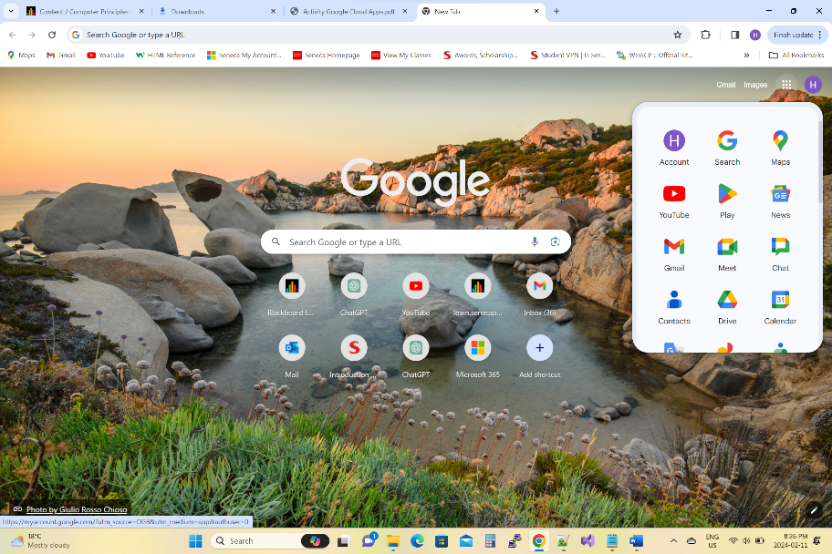

Answer 2: I have installed “Google Doc” and started a new document on my phone. Here is the screenshot-
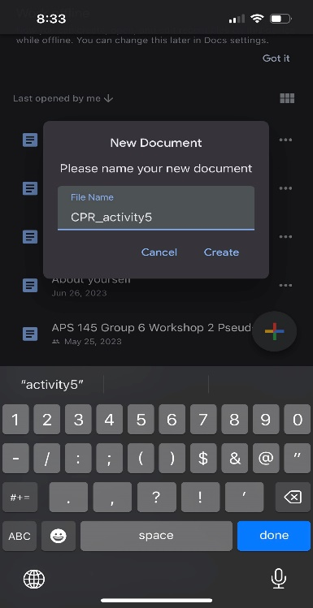

Answer 3: My place of Birth is Dhaka, Bangladesh. My cultural background is Bangladeshi culture. I have completed my High School and now I am studying CPA (Computer Programming Analysis) in Seneca College.
I have duplicated these 3 sentences in a new “Google Docs” document using my Google Chrome browser.

Answer 4: Here is the shared link to the essay in the cloud-
https://docs.google.com/document/d/10neKp6sW7CRTonneL_e0_3Jp7VQP5U1ChbIEAlnMPgs/edit

Part 2 - Google Sheets:
=====================
Answer 5: I have installed “Google Sheets” app on my phone and started a new spreadsheet. Here is the screenshot-
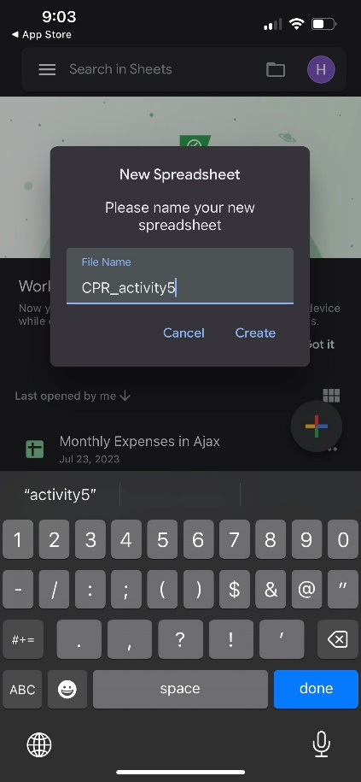

Answer 6: Creating a Spreadsheet using Google Chrome on my computer that calculates the average mar for my first 4 activities-
- Opening Google Chrome and go to Google Sheets.
- Create a new spreadsheet.
- In the first column (Column A), entering the activity names.
- In the next columns, entering the marks for each activity.
- In a cell where the average mark will appear, entering the following formula: “=average(Beginning Column Number:Ending Column Number)”.
This formula calculates the average of the marks for the activities.

Answer 7: Here is the shared link of Sheet app where it shows the average activity mark and the average quizzes mark-
https://docs.google.com/spreadsheets/d/1hO0-Gac14G9clzP4IHS9PlmDxNKf9dei_q34ddkghGM/edit#gid=0

Part 3 – Google Slides:
====================
Answer 8: The first type of loop in C is the "for" loop. Here's a short example:
#include <stdio.h>
int main()
{
// Example of a for loop to print numbers from 1 to 5
for (int i = 1; i <= 5; i++) {
printf("%d\n", i);
}
return 0;
}
In this example, the for loop is used to iterate over the values of the variable i from 1 to 5.

Answer 9: The second type of loop in C is the "while" loop, and the third type is the "do-while" loop. Here are short examples for both:

Example of a "while" loop:
#include <stdio.h>
int main()
{
// Example of a while loop to print numbers from 1 to 5
int i = 1;
while (i <= 5) {
printf("%d\n", i);
i++;
}
return 0;
}
In this example, the "while" loop continues to execute as long as the condition i <= 5 is true. The loop variable i is incremented within the loop.

Example of a "do-while" loop:
#include <stdio.h>
int main()
{
// Example of a do-while loop to print numbers from 1 to 5
int i = 1;
do {
printf("%d\n", i);
i++;
} while (i <= 5);
return 0;
}
In this example, the "do-while" loop guarantees that the loop body will be executed at least once, as the condition is checked at the end of the loop. The loop will continue to execute as long as the condition i <= 5 is true, and the loop variable i is incremented within the loop.

Answer 10: Here is the link to Google Slides presentation with 3 slides-
https://docs.google.com/presentation/d/1uL-LjesWNtuUygDMUbGRkseXMOKTzSNFgHbr2FDNRMU/edit#slide=id.g2b82ce457e9_0_299

