Assignment – 3
===============
Qa. Generally, what are syslog and rsyslog? Specifically, name three features of syslog/rsyslog and compare them to your embedded debug logging. Will there be any overlap of information?
Answer: Syslog is a standard protocol and tool in Unix/Linux systems for collecting, storing, and forwarding log messages from various system components and applications. It provides a centralized way to manage logs from multiple sources.
Rsyslog is an enhanced version of syslog, offering improved performance, additional features, and greater flexibility. It supports various input/output modules, advanced filtering, and network log forwarding.
Three features of syslog/rsyslog:
- Centralized logging: Collects logs from multiple sources and stores them in a central location (e.g., /var/log/syslog).
- Log filtering and prioritization: Allows filtering based on facility and severity (e.g., error, warning, info).
- Network forwarding: Can forward log messages over the network using UDP or TCP to remote servers.
Comparison to embedded debug logging:
- Both provide severity filtering and centralized collection of logs.
- Syslog/rsyslog handle system and application logs at an OS-wide level, while embedded logging is tailored for a specific product’s internal debugging messages.
- Overlap: Both may contain severity, timestamp, message, and source information. However, embedded logging also includes precise code location details (__FILE__, __func__, __LINE__), which are not typically present in syslog.

Qb. Name five features of syslog-ng.
Answer: Here are the five features:
- Multiple transport protocols: Supports TCP, UDP, TLS, and Unix domain sockets, including encrypted connections.
- Advanced filtering and rewriting: Flexible rules to handle, modify, and route messages.
- Structured logging: Supports formats such as JSON and XML for modern analysis tools.
- Wide variety of sources: Can collect logs from files, databases, remote systems, and more.
- Parsing and enrichment: Can parse, normalize, and enhance logs with macros and templates.

Qc. Name five ways syslog-ng is an improvement over syslog/rsyslog.
Answer: Here are five ways -
- Better reliability: Supports TCP and TLS for guaranteed delivery and encryption.
- Structured logging: Can output logs in structured formats (e.g., JSON) for better automation and analytics.
- More advanced filtering: Offers more powerful filtering and message transformation options.
- Modular architecture: Plugin support for numerous input/output destinations.
- Scalability: Handles high-volume logging efficiently using multi-threading.

Qd. Consider a Log Server that must manage embedded logs for a massive number of processes on a massive number of machines. Name three ways the server could manage the connections to each process.
Answer: Managing connections for massive-scale log servers, three ways -
- Use asynchronous/non-blocking I/O to handle large numbers of simultaneous connections without blocking threads.
- Employ thread pools or worker threads to distribute log processing load efficiently.
- Use connection multiplexing/event-driven frameworks (e.g., epoll, select) to monitor many sockets at once.

Qe. Consider a Log Server that must manage embedded logs for a massive number of processes on a massive number of machines. With such a large amount of data in the logs, name three ways a user could extract useful information from them (be general).
Answer: Managing connections for massive-scale log servers, three ways.
- Filtering: Narrow down logs by severity, timestamp, process ID, or keywords.
- Aggregation: Summarize logs into metrics or counts (e.g., error frequency per hour).
- Search and indexing: Store logs in indexed databases (e.g., Elasticsearch) for fast searching.

Qf. Explain how gdb could be used on a Linux machine to attach to a process and get thread information. Is this also useful in debugging?
Answer: Using gdb to attach to a process and get thread info; usefulness in debugging.
- Run gdb -p <pid> to attach to a running process by its process ID.
- Use info threads to list all threads and their statuses.
- Switch between threads using thread <thread-number>.
- Inspect call stacks, variables, and set breakpoints per thread.
Usefulness: This is very helpful for debugging live processes, especially when diagnosing deadlocks, race conditions, or crashes in multi-threaded applications. It provides a real-time view of what each thread is doing.

SCREENSHOTS:
Here I have added the screenshots of the program –
First, I have compiled the server and client files by entering the command Makefile.server and make. And then run the command ./Logerserver to start the server. This is what I got -
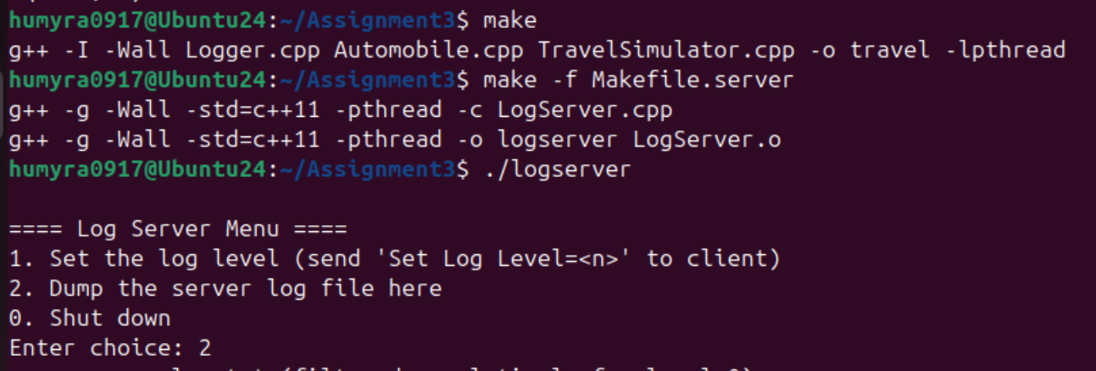

I have opened another terminal and start the client by running the command ./travel. And entered the choice 2 in the 1st terminal to display the log file. It displayed all the messages of warning, error and debug. Here are the screenshots –

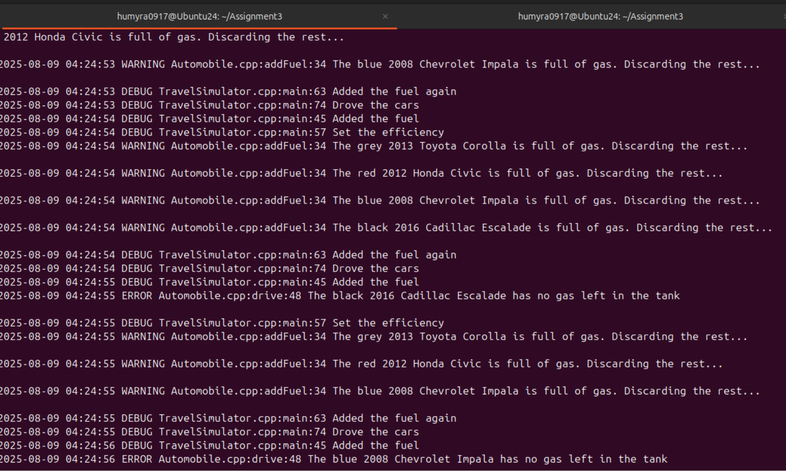

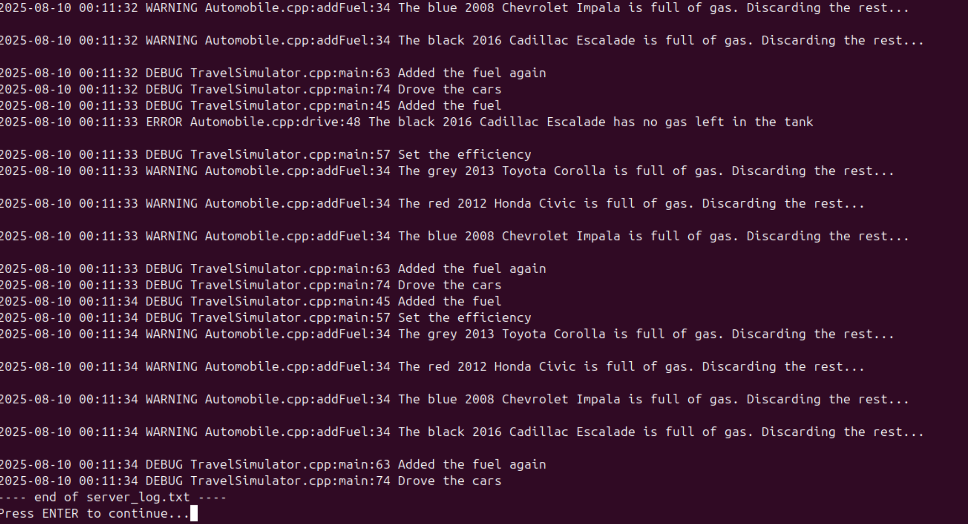

Then I press Enter to continue to check if other menu options are working. First, I have entered 1 from the main menu and then select 0 and it displayed all the Debugging messages only. Here is the screenshot –
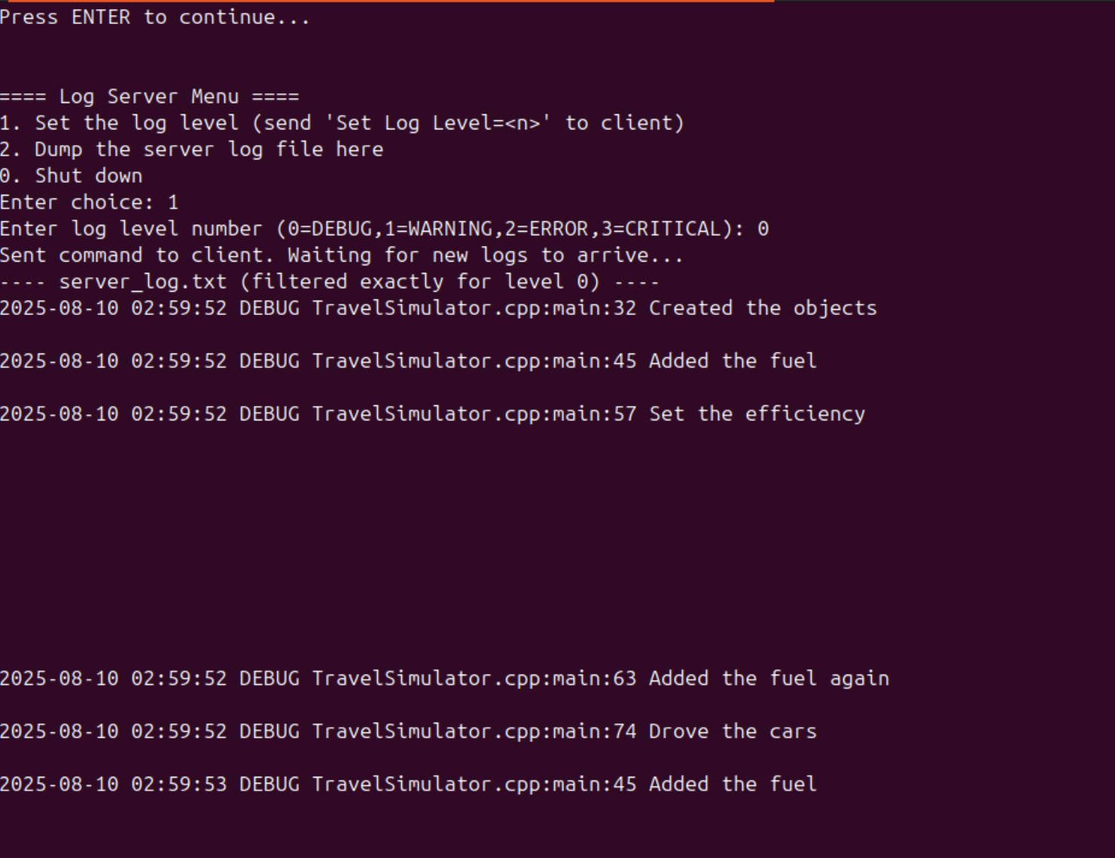

Then I have entered 1 to display all the Warning messages only. Here is the screenshot
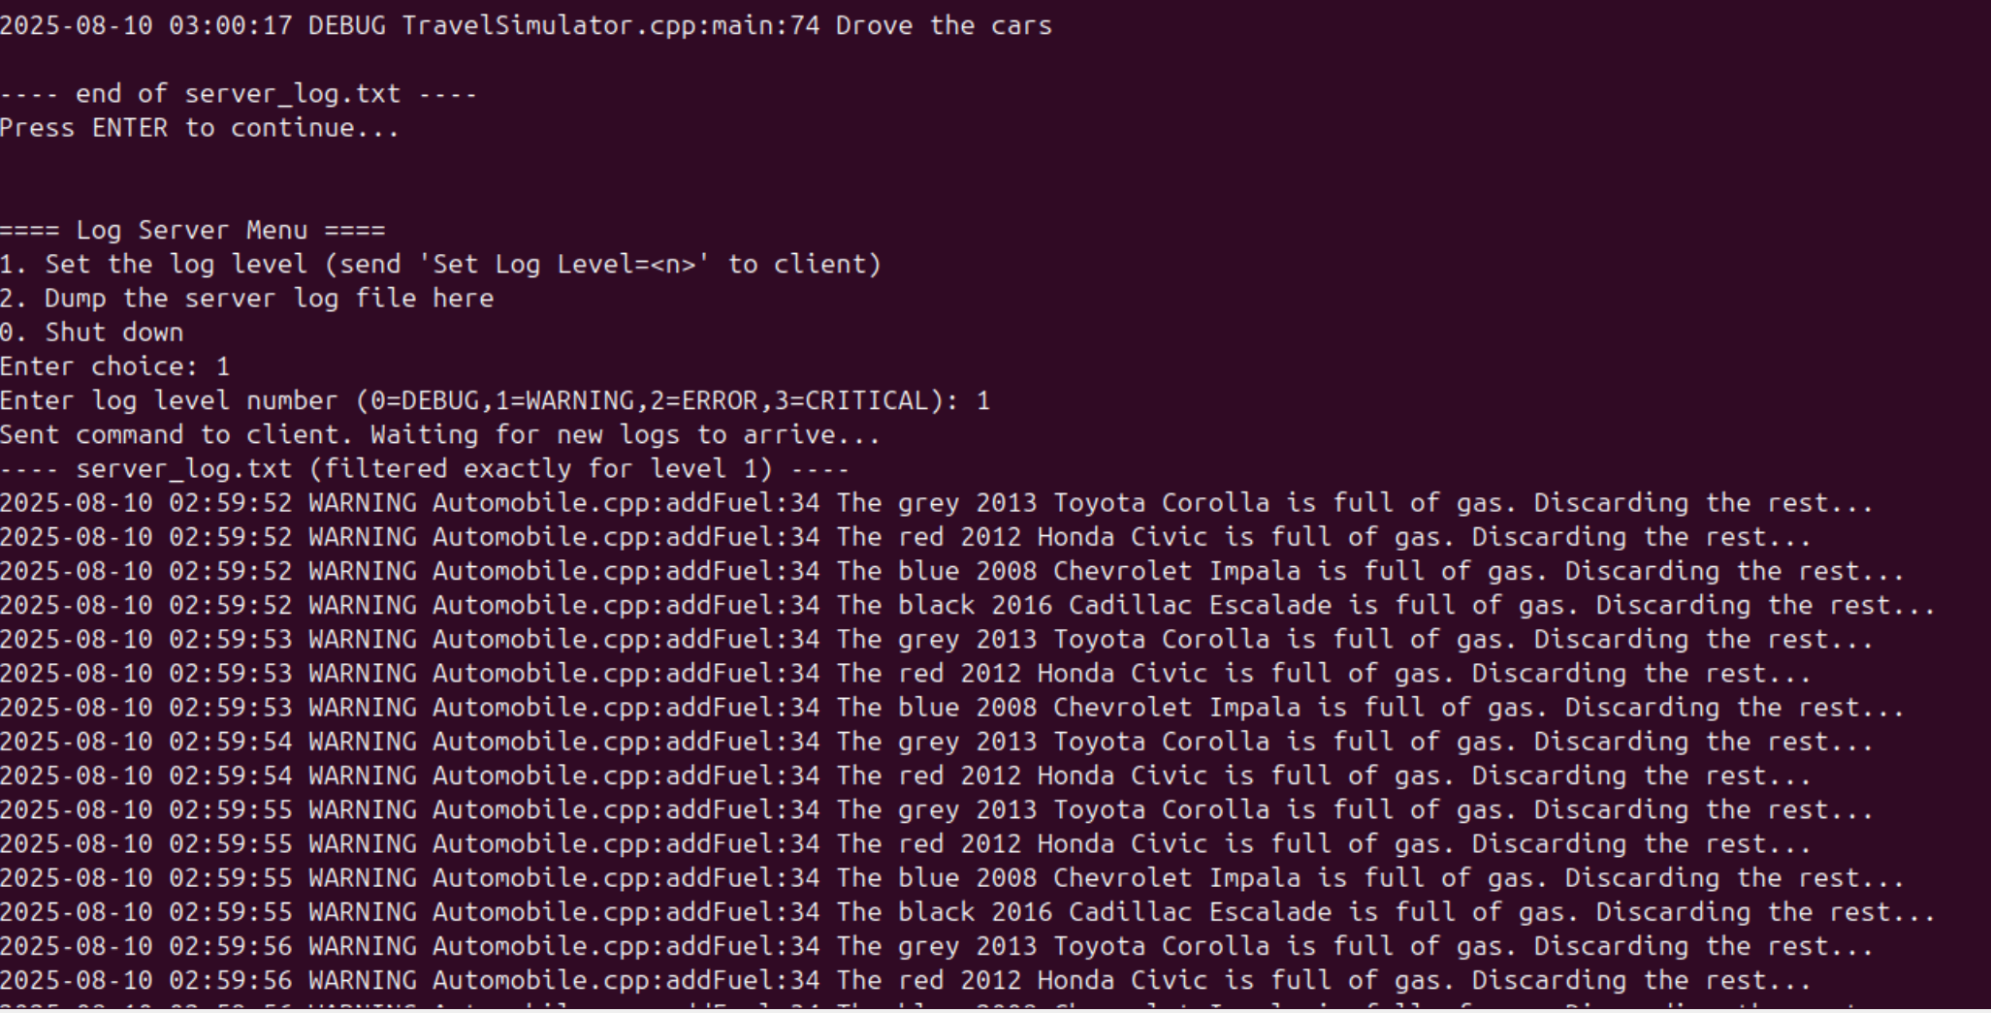

Then I have entered 2 to check all the Error messages only, here is the screenshot -
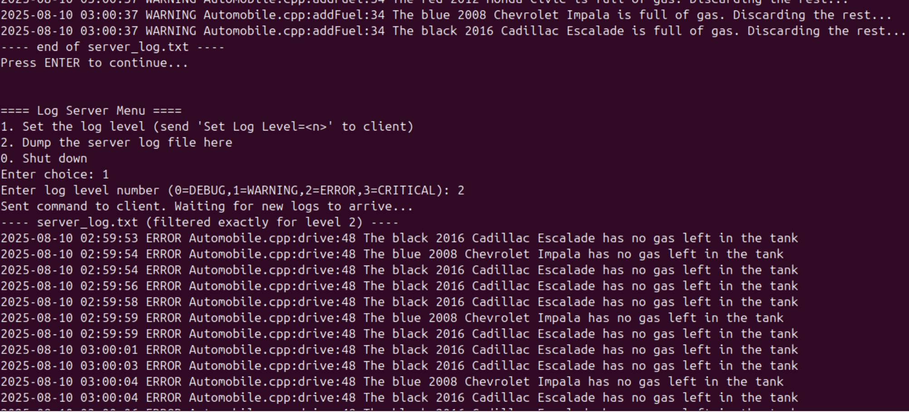

Next, I have entered 3 to check if there were any Critical messages. But there weren’t any, so nothing showed up on the screen. Finally, I have entered 0 from the main menu for exit from the program. Here is the screenshot –
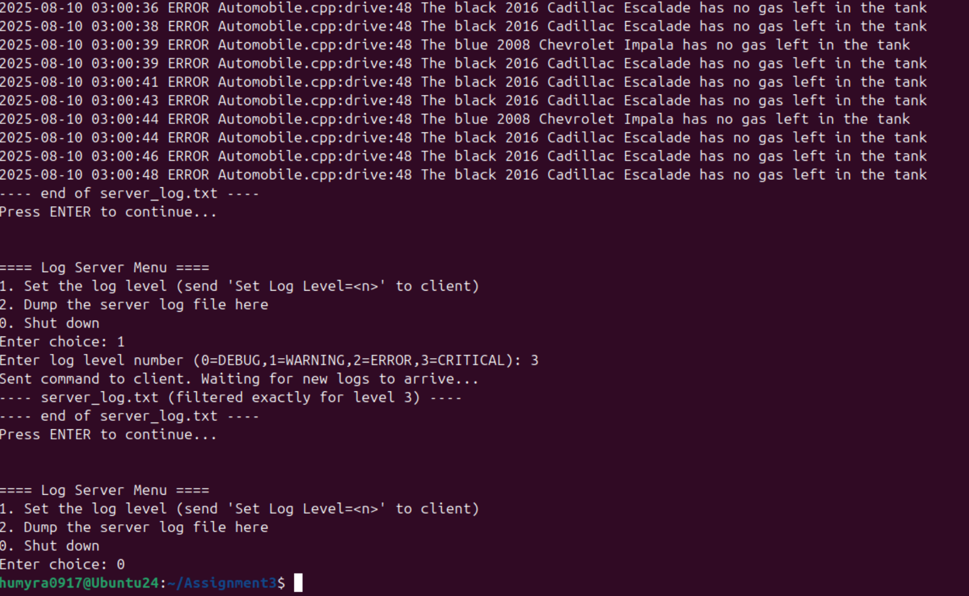

And in the client terminal it displayed the options I was selecting, here is the screenshot -
