Lab – 4
==============

- Introduction
This assignment is about working with the Linux Framebuffer.
A framebuffer is like a digital canvas where the system draws what you see on the screen.
The goal is to:
- Read screen information from the Linux framebuffer.
- Display that information (like resolution, pixel depth, etc.) in the terminal.
- Log errors to a file called Screen.log if anything goes wrong.

- What Did I Need to Do?
- Write a C++ program (Lab4.cpp) that:
  - Connects to the Linux framebuffer (/dev/fb0).
  - Uses ioctl (input/output control) commands to get screen information:
    - Fixed Screen Info: Info that doesn’t change (like screen ID, visual type).
    - Variable Screen Info: Info that can change (like resolution, color depth).
  - Handle errors properly and log them into Screen.log.
- Create a Makefile to compile the C++ code easily with the make command.
- Run the program to see the screen information.

- Wrote the C++ Code (Lab4.cpp)
In the code, we did the following:
- Included necessary libraries for file handling, error logging, and ioctl operations.
- Opened a log file to capture errors:
int log_fd = open("Screen.log", O_WRONLY | O_CREAT | O_APPEND, 0644);
dup2(log_fd, STDERR_FILENO); // Redirect errors to Screen.log
- Opened the framebuffer device (/dev/fb0):
int fb_fd = open("/dev/fb0", O_RDONLY | O_NONBLOCK);

The framebuffer device (/dev/fb0) is used to directly access and control the display screen’s pixel data, allowing programs to read or modify what is shown on the screen without using higher-level graphics libraries.
- Created a simple menu to choose between:
  - Option 1: Show Fixed Screen Info
  - Option 2: Show Variable Screen Info
  - Option 0: Exit
- Used ioctl system calls to get screen information:
  - For Fixed Info:
ioctl(fb_fd, FBIOGET_FSCREENINFO, &fix_info);
  - For Variable Info:
ioctl(fb_fd, FBIOGET_VSCREENINFO, &var_info);
- Displayed the information in the terminal using cout.
- Closed the framebuffer and exited the program.

- Create the Makefile
The Makefile helped us compile the program without writing long commands.

- Run the Program
make
sudo ./Lab4
When we selected:
- 1 (Fixed Info): It showed info like screen ID, visual type, etc.
- 2 (Variable Info): It showed info like screen resolution and bits per pixel.
- 0 (exit): It exits from the program.
Here I have added the screenshot –
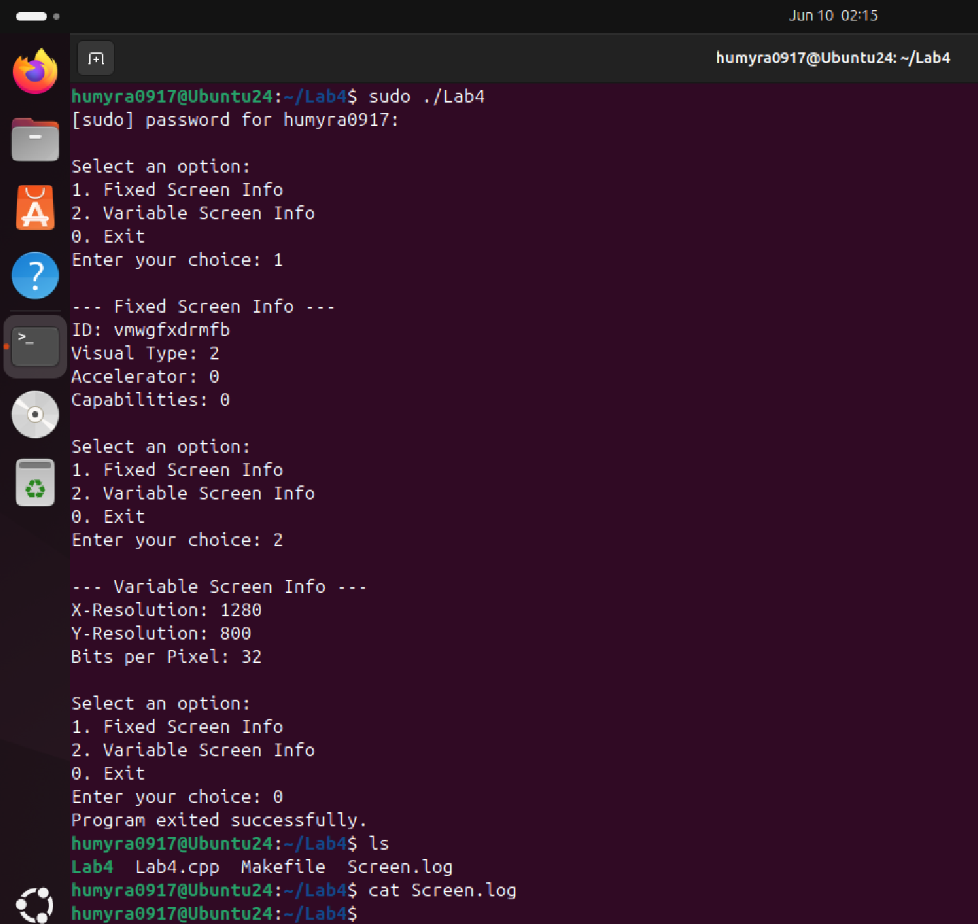

- Error Handling
- If there were any errors, they were logged into the Screen.log file.
- I used dup2() to redirect errors to that file.
I have run the command ./Lab4 to check the errors. Here is the acreenshot –
