/*********************************************************************************
* UNX511-Lab1
* I declare that this lab is my own work in accordance with Seneca Academic Policy.
* No part of this assignment has been copied manually or electronically from any other source
* (including web sites) or distributed to other students.
* * Name: Dil Humyra Sultana Borna Student ID: 139166227 Date: 18/05/2025 * * ********************************************************************************/
Answer 1: Scanning /proc for High Memory Usage Processes
To complete this task, I wrote a C program that scans all the directories in /proc. It checks which directories are named with digits (indicating they are process IDs). For each process, it opens the /proc/[PID]/status file and looks for two fields: Name: (process name) and VmRSS: (resident memory in kilobytes). If the resident memory (VmRSS) is greater than 10,000 kB, the program prints the process ID, name, and memory usage.
After logging into the matrix, I have created a directory and then created a file for the source code and then run it. Here are commands of the whole procedure –

Cd ~ (home directory)
mkdir Lab1 (creating a directory)
cd Lab1 (going to the Lab1 directory)
touch memcheck.c (creating the source code file)
touch Makefile
touch process_monitor.h
vi memcheck (building sourcecode)
vi Makefile
vi process_monitor
(I (Insert)
Esc
:wq (write, quite))
make (Compiled the code)
./memcheck (run the code).
Here is the screenshot of the output –
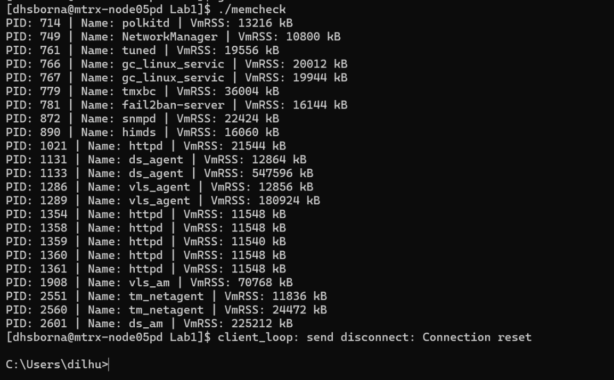

Answer 2: As we are using the cluster for Matrix, I have tried several times to login to the same node as the program node. Finally, I have opened a second command line for the same node and run the command “top”. Both outputs report process memory usage, but in different formats.
- ./memcheck output reports: PID, Name, and VmRSS (resident memory in kB).
- top output reports: PID, %CPU, %MEM, VIRT, RES, SHR, TIME+, and more.
We can compare by PID and RES (or VmRSS), both represent resident memory (actual physical memory used). Here is a side-by-side comparison of the processes with matching PIDs in both outputs:
PID | Process Name | VmRSS (kB)  (memcheck) | RES (kB)  (top) | Difference  (VmRSS - RES) | Notes
782 | fail2ban-server | 17916 | 18180 | -264 | Minor difference, possibly due to runtime fluctuation.
878 | snmpd | 21832 | 21832 | 0 | Perfect match.
1113 | ds_agent | 507816 | 463692 | 44124 | memcheck shows higher memory usage, could be peak usage or measurement timing difference.
2513 | ds_am | 223696 | 224116 | -420 | Very close; within fluctuation margin.

Here I have added the screenshot –
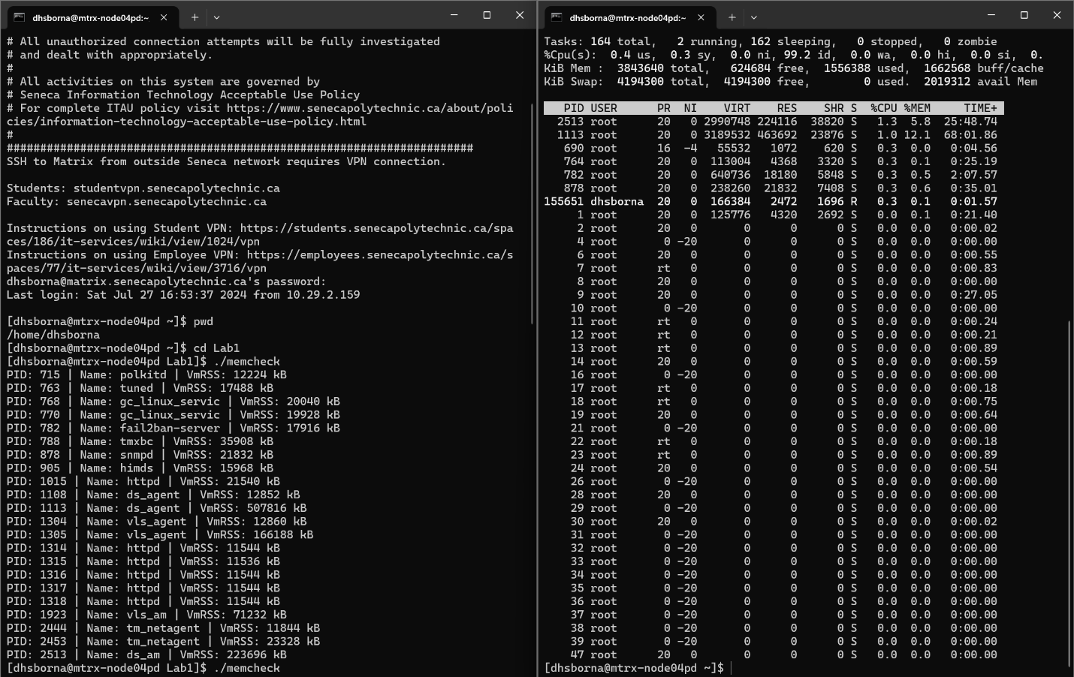
VmRSS from memcheck refers to the Resident Set Size (physical memory used). RES from top also refers to the Resident Memory, but it's measured live and can change rapidly.
- Minor differences (a few KBs) are normal due to:
- Real-time memory allocation/deallocation
- Tool-specific rounding or sampling delay
- Large differences (like with PID 1113) may suggest:
- Background memory optimization
- Swapped pages not visible in top
- memcheck possibly catching usage during a peak
All matching PIDs show mostly consistent memory usage between memcheck and top. snmpd (PID 878) is perfectly matched. fail2ban-server, ds_am, and ds_agent are close, with acceptable variation.
Answer 3: Here is the definition of the Virtual memory and Resident memory –
Virtual memory: Virtual memory is the total address space assigned to a process, including memory in use and memory that is allocated but not currently active in RAM. It may include code, shared libraries, and mapped files, and is represented by VmSize: in /proc/[pid]/status.
Resident Memory: Resident memory is the portion of memory that a process is actively using in physical RAM. It excludes memory that has been swapped out and shows how much memory is currently occupying system RAM. It is shown as VmRSS: in /proc/[pid]/status.
Difference Between Virtual Memory and Resident Memory
Virtual memory refers to the total memory a process is allowed to use, including physical RAM and swap space on the disk. It includes all parts of the process’s address space — such as the program’s code, data, stack, heap, and any shared libraries it uses. However, this memory is not necessarily loaded into physical RAM. It represents the allocated memory space, not the actual memory in use. This value is shown under the field VmSize: in the /proc/[pid]/status file.
Resident memory, on the other hand, represents the portion of a process’s memory that is loaded into physical RAM at a given moment. It excludes swapped-out memory and only reflects what is truly occupying system RAM. This is the memory that directly impacts RAM usage on the system. It is displayed in the VmRSS: field in the /proc/[pid]/status file and gives a more accurate picture of the real memory demand of a process.
Answer 4: Below are descriptions of three processes returned by the custom memcheck.c program:
1. fail2ban-server (PID 782)
What it does: fail2ban is a log-parsing security tool used on Linux servers to prevent brute-force attacks. It monitors log files (e.g., /var/log/auth.log) and automatically updates firewall rules to block suspicious IPs that fail authentication repeatedly (like SSH login attempts). The fail2ban-server process runs as a Python daemon and continuously checks logs based on configured filters and actions.
Why it's important: It improves server security by reducing attack vectors from bots or hackers trying to guess passwords. Used commonly on public-facing servers like web servers or SSH-enabled systems.
2. snmpd (PID 878)
What it does: This is the Simple Network Management Protocol (SNMP) Daemon. It provides network management information to administrators or monitoring systems (like Nagios, Zabbix, or Cacti). It listens on port 161 and reports system stats (CPU, memory, disk, network) in a standardized format.
Why it's important: Used in enterprise environments to monitor system health and performance. Helps with automated alerts, usage reporting, and troubleshooting. Can be configured to allow secure, read-only access to specific metrics.
3. ds_agent (PID 1113)
What it does: ds_agent is a process related to Trend Micro Deep Security Agent. It's a security module that provides anti-malware, integrity monitoring, intrusion prevention, and firewall protection for servers. It communicates with a Deep Security Manager for real-time threat intelligence and policy updates.
Why it's important: Commonly found in enterprise cloud or data center environments where security compliance is critical. Helps ensure servers are protected from known and emerging threats.

