Assignment – 2:
===============
1. Answer:
General Architecture: Describe it as a client-server model or a centralized intelligence model. The networkMonitor acts as the central control/server, and multiple intfMonitor processes act as distributed clients or agents.
Network Monitor's Role: State that it's responsible for user interaction (getting interface names), launching intfMonitor children using fork() and exec(), setting up the central Unix domain socket server, managing connections to multiple intfMonitors using select(), and orchestrating their actions (e.g., telling them to monitor, or to set a link up/down). It also handles graceful shutdown.
Interface Monitor's Role: State that each intfMonitor is a dedicated process for a single network interface. It connects to the networkMonitor's socket, continuously polls (reads) detailed statistics from the /sys filesystem for its assigned interface, prints these statistics, reports specific events (like link down) to the networkMonitor, and performs actions (like setting a link up) when instructed. It also handles its own graceful shutdown.
2. Answer: Yes, it could. I would avoid fork() and exec(). Instead of separate processes, I would have multiple threads within a single process.
  - The main thread could handle user input and the select() loop (or similar event loop).
  - For each interface, I would create a new thread. This thread would contain the logic currently in intfMonitor.cpp's main loop (reading /sys files, printing, etc.).
  - Communication between these threads (e.g., if a monitoring thread detects "Link Down" and needs the central logic to tell another thread to "Set Link Up") would happen via inter-thread communication mechanisms like mutexes, condition variables, message queues, or shared data structures, rather than sockets. The ioctl calls would still need sudo if the main process is not run with sudo.
3. Answer: This is significantly more challenging, and likely NOT efficient or advisable in a single process.
  - Polling Frequency (1ms): Polling 128 interfaces every 1ms means you need to complete all reads, processing, and output within that 1ms window for each interface. That's a very tight deadline for potentially I/O-bound operations (reading from /sys files).
  - Context Switching (Threads): While threads are lighter than processes, 128 active threads constantly waking up, reading files, and printing could lead to significant context switching overhead within a single process. The kernel might spend more time managing threads than doing useful work.
  - Shared Resources & Locking: If they are all in one process, they will share more resources (memory, file descriptors). This could lead to more contention and require more careful locking (mutexes) around shared data, which introduces complexity and potential performance bottlenecks.
  - I/O Bottlenecks: Reading from 128 distinct files in /sys every millisecond might overwhelm the disk I/O subsystem or the kernel's ability to serve these requests rapidly from a single process context.
  - Scalability & Robustness: If one thread crashes due to an error, it could bring down the entire single process, affecting all 128 monitors. With separate processes, an intfMonitor crashing only affects that one interface.
While technically possible to implement with threads, it would be highly inefficient and complex to manage the real-time demands and potential I/O bottlenecks. The current multi-process model (or even a hybrid with a few threads per process) would likely be more robust and scalable for such high-performance, high-volume monitoring due to better isolation and kernel-level scheduling benefits.
4. Software Defined Network (SDN): SDN is an architectural approach to networking that separates the network's control plane (decision-making) from its data plane (packet forwarding). This allows network administrators to manage network services through high-level software applications without direct interaction with individual network devices. It makes networks more agile, flexible, and programmable.
Layers:
  - Applications Layer (Northbound API): This is where network applications, services, and business logic reside. It communicates with the control layer using northbound APIs (Application Programming Interfaces). Examples include network orchestration tools, cloud management platforms, security applications, and traffic engineering tools that can request and define network behavior.
  - Control Layer (SDN Controller): This is the "brain" of the SDN. It receives requests from the applications layer, interprets them, and translates them into forwarding instructions for the data plane. It maintains a centralized view of the network topology and state. Controllers communicate with the forwarding layer using southbound APIs (e.g., OpenFlow). It essentially makes all the routing and policy decisions.
  - Forwarding Layer (Data Plane / Network Devices): This layer consists of the actual network hardware (switches, routers) that forward data packets based on instructions received from the control layer. These devices are "dumb" in that they don't make their own routing decisions; they simply execute the rules pushed down by the controller. They perform the high-speed packet processing and forwarding.

Screenshots: Here I have added the screenshot of the main program and all the testing –
Here I have checked the local machine IP Address by entering the command ip a
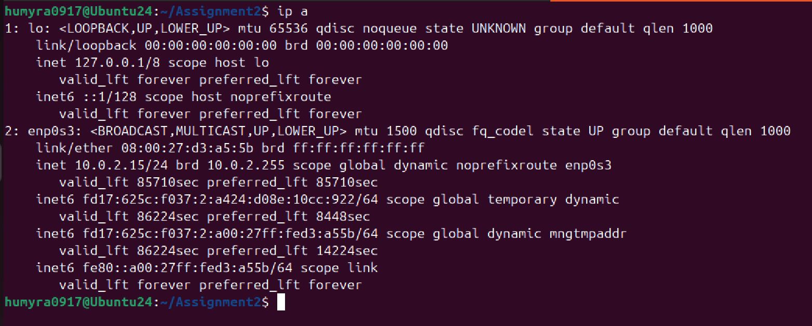

After running the command $ sudo ./networkMonitor,
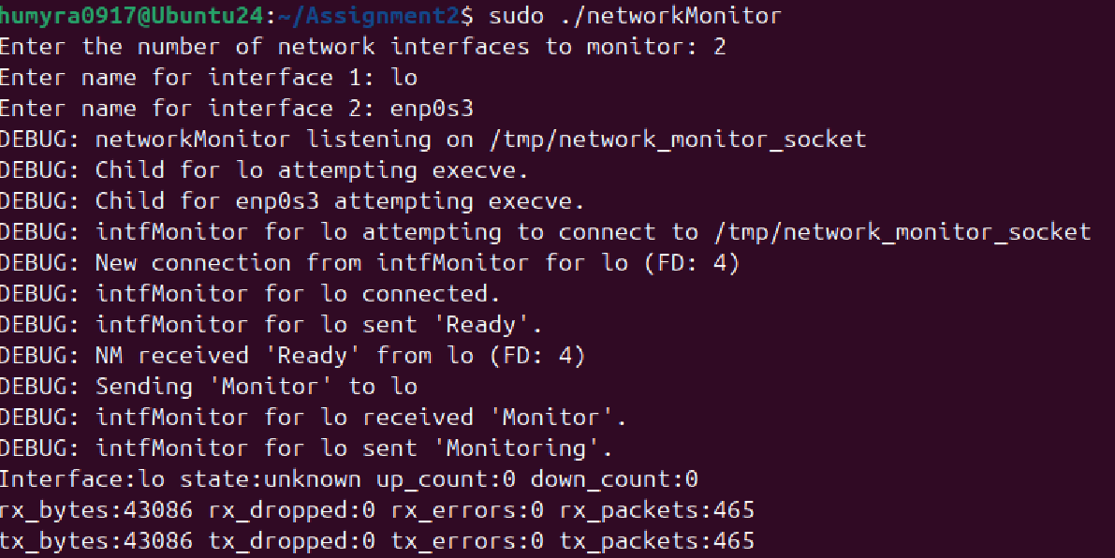

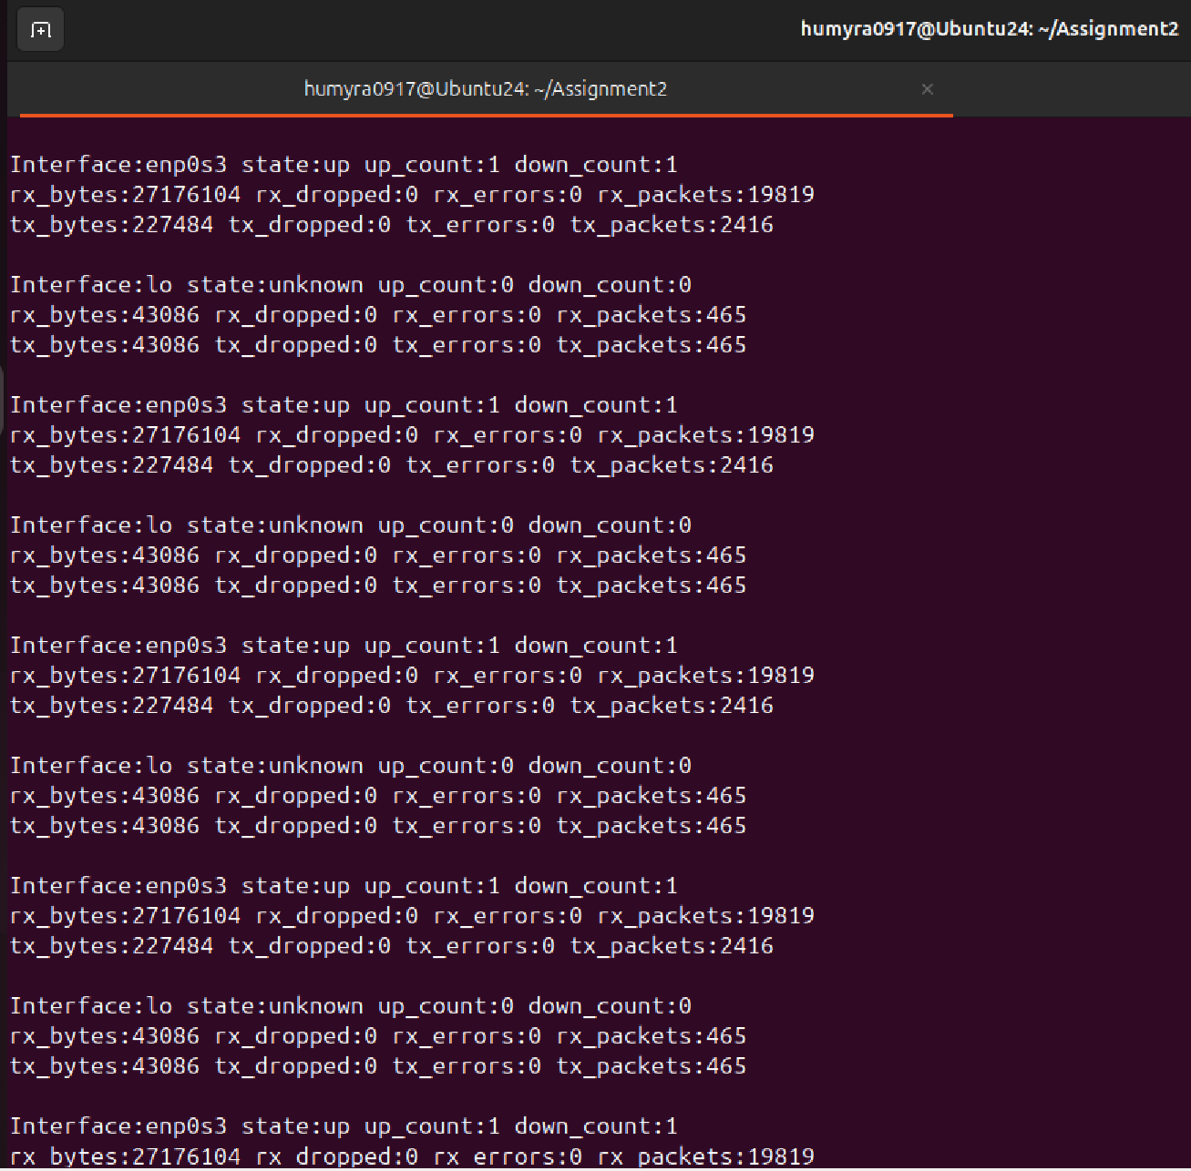

Here it shows the /sys/class/net/enp0s3 -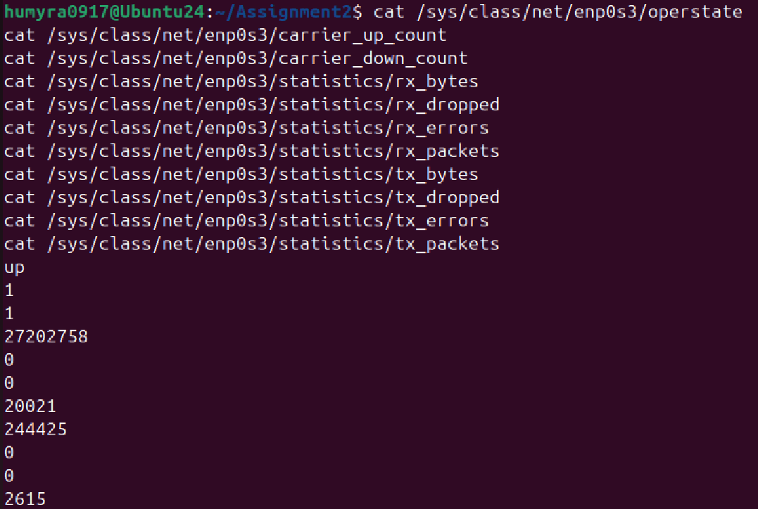
Here its showing the /sys/class/net/lo -
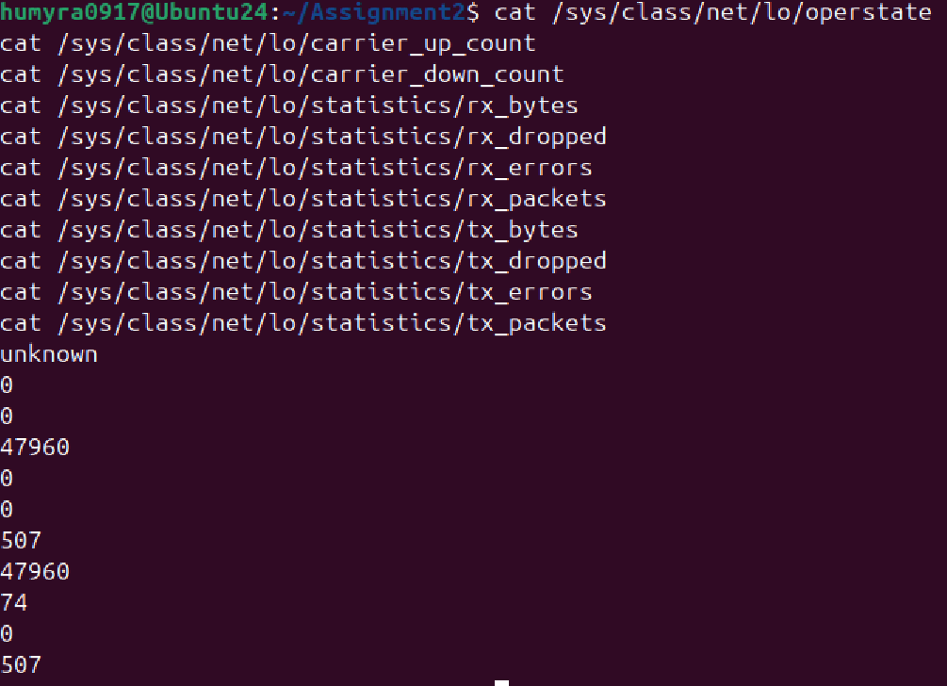

This is what I got after entering the command $ ifconfig.
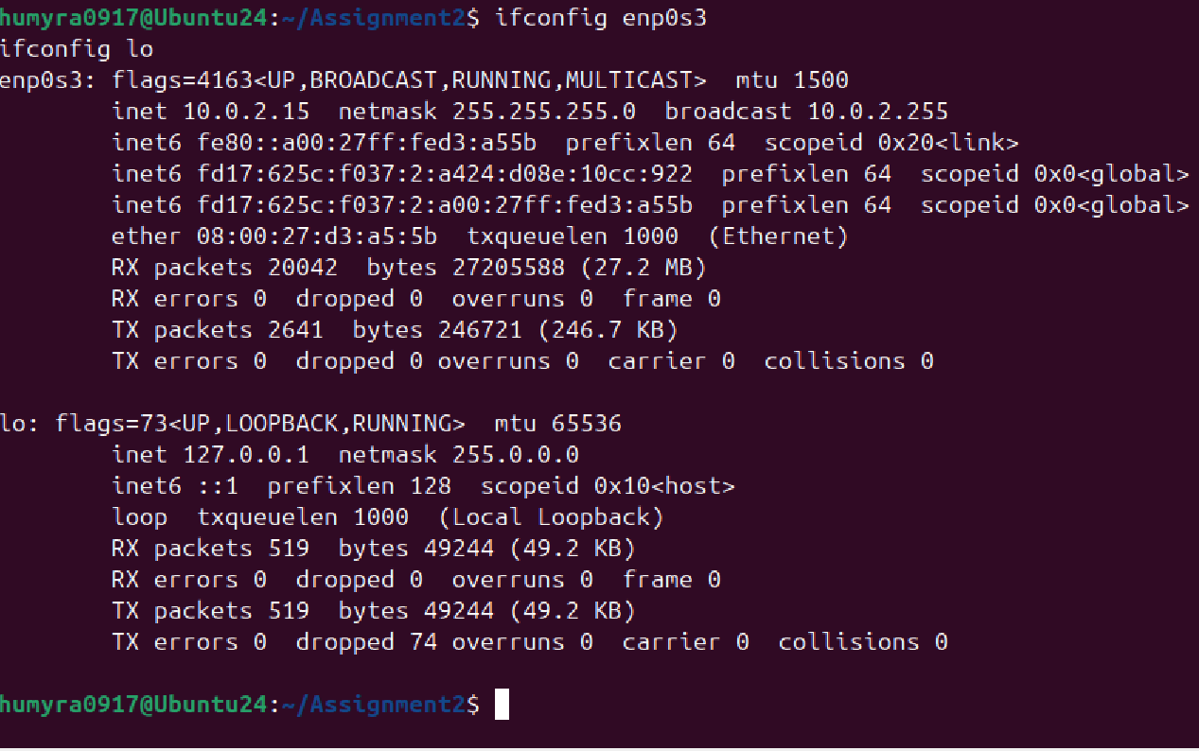

This is what I got in terminal 1 after running the command ifconfig in terminal 2 -
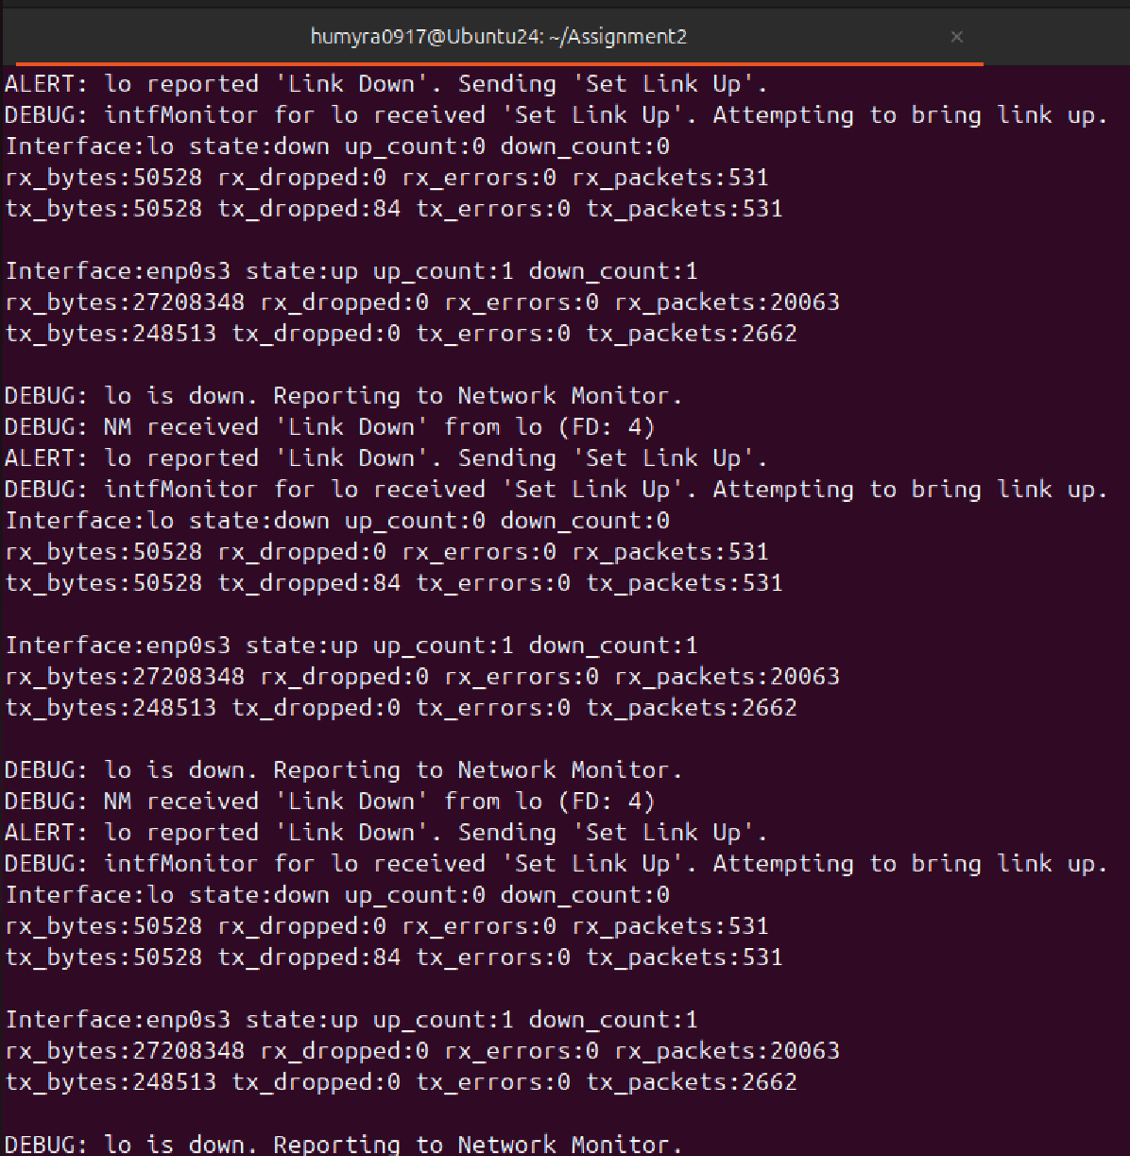
Finally got this after entering the command $ sudo ip link set lo down
