/******************************************************************************
***
* UNX511-Lab5
* I declare that this lab is my own work in accordance with Seneca Academic Policy.
* No part of this assignment has been copied manually or electronically from any other source
* (including web sites) or distributed to other students.
*
* Name: Dil Humyra Sultana Borna Student ID: 139166227 Date: 18/06/2025
*
*
******************************************************************************
**/
• Please submit the Source code (zip all .c, .h, and makeFiles)
• Please answer the following two declarations:
o D1) On a scale from 1 to 5, How much did you use generative AI to complete this
assignment?
▪ where:
▪ 1 means you did not use generative AI at all
▪ 2 means you used it very minimally
▪ 3 means you used it moderately
▪ 4 means you used it significantly
▪ 5 means you relied on it almost entirely
▪ Your answer : 1
I have not used any AI at all.
o D2) On a scale from 1 to 5, How confident are you in your understanding of the
generative AI support you utilized in this assignment, and in your ability to explain it if
questioned?
▪ where:
▪ 1 means "Not confident at all – I do not understand the generative AI support I
used and cannot explain it."
UNX511: Lab5 Professor: Shahdad
▪ 2 means "Slightly confident – I understand a little, but I have many
uncertainties."
▪ 3 means "Moderately confident – I understand the majority of the support,
though some parts are unclear."
▪ 4 means "Very confident – I understand most of the AI support well and can
explain it with minor gaps."
▪ 5 means "Extremely confident – I fully understand the generative AI support I
used and can clearly explain or justify it if asked."
▪ Your answer : I have not used any AI at all.

Lab 5b - Process Communication Using Signals
In this lab I have implemented inter-process communication using UNIX signals in a Linux environment. The parent process communicates with child processes to synchronize startup and shutdown using SIGUSR1 and SIGUSR2, while handling additional signals like SIGINT and SIGTSTP.
I have completed the files sysmonExec.cpp and intfMonitor.cpp. Then I have uploaded those files along with the Makefile. After that I have compiled the program by running the command make.
This has created two executables, can see it by using the command ls:
- sysmonExec (the parent)
- intfMonitor (the child)
Here I have added the screenshot –

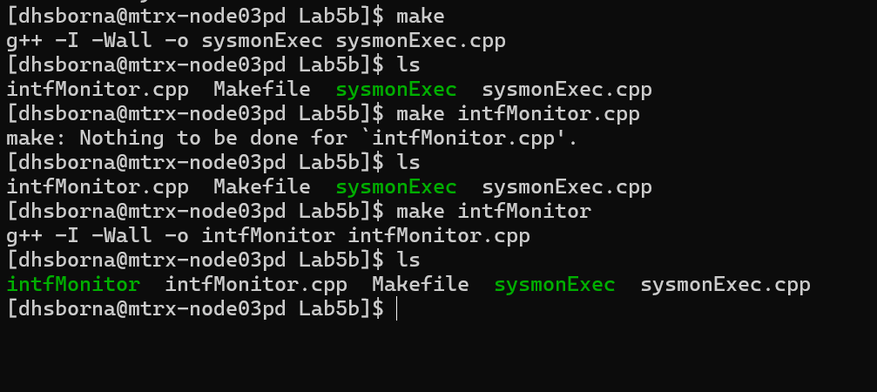

Then I have run the program by running the command ./sysmonExec. And This is what happened –
- sysmonExec (the parent) will fork two child processes.
- Each child will run:
  - ./intfMonitor lo
  - ./intfMonitor ens33
- The children will wait until the parent sends SIGUSR1.
- After 10 seconds, the parent sends SIGUSR1 to both children.
- Children will start printing: intfMonitor: starting up
- They will log network stats into Network.log.
- After 30 seconds, the parent sends SIGUSR2.
- Children will stop printing and exit with: intfMonitor: shutting down.
- The parent will wait for both and print their termination status.
Here I have added the screenshot –

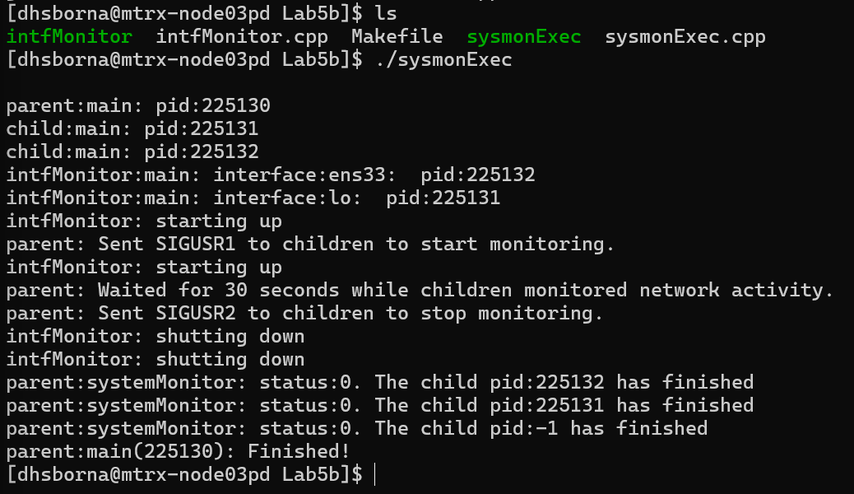

After this there a new file will be created, Network.log. The children will write there and to check the content I have run the command cat Network.log. Log file contents showing stats for lo and ens33. Here I have added the screenshot -
