- /********************************************************************************** *
- I declare that this lab is my own work in accordance with Seneca Academic Policy. * No part of this assignment has been copied manually or electronically from any other source* (including web sites) or distributed to other students.* *
- Name: Dil Humyra Sultana Borna Student ID: 139166227 Date: 09.07.25
- **********************************************************************************/
- Please submit the Source code (zip all .c, .h, and makeFiles)
- Please answer the following two declarations:
- D1) On a scale from 1 to 5, How much did you use generative AI to complete this assignment?
- where:
- 1 means you did not use generative AI at all
- 2 means you used it very minimally
- 3 means you used it moderately
- 4 means you used it significantly
- 5 means you relied on it almost entirely
- Your answer : 1
- D2) On a scale from 1 to 5, How confident are you in your understanding of the generative AI support you utilized in this assignment, and in your ability to explain it if questioned?
- where:
- 1 means "Not confident at all – I do not understand the generative AI support I used and cannot explain it."
- 2 means "Slightly confident – I understand a little, but I have many uncertainties."
- 3 means "Moderately confident – I understand the majority of the support, though some parts are unclear."
- 4 means "Very confident – I understand most of the AI support well and can explain it with minor gaps."
- 5 means "Extremely confident – I fully understand the generative AI support I used and can clearly explain or justify it if asked."
- Your answer : I did not use AI.

Part 1: Conceptual Questions Answered
Here I have added the screenshot of the part 1 –
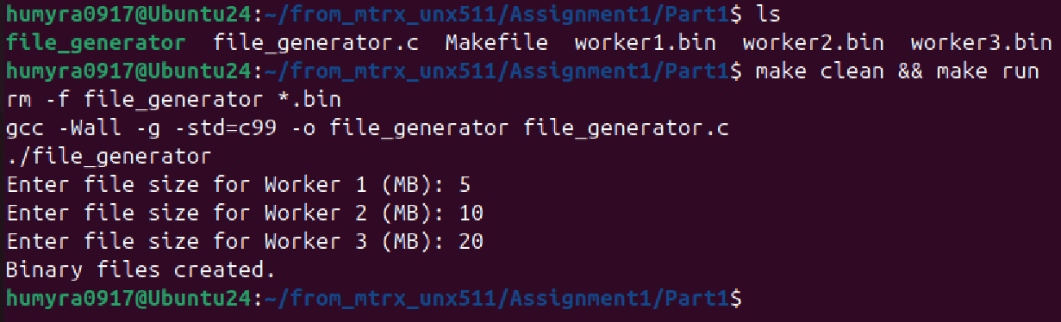

- Why do we use O_CREAT | O_TRUNC in open()?
Answer:
  - O_CREAT: Creates the file if it doesn’t exist.
  - O_TRUNC: Truncates the file (empties it) if it already exists.
- What happens if write() fails inside the loop?
Answer:
  - It will return -1, and perror() will show the error (e.g., disk full).
  - The code exits with an error message.
- Why do we use memset() before writing to the file?
Answer:
  - To fill the buffer with known dummy data ('X') before writing.
  - This ensures that the file isn't filled with garbage values.
Part 2: Conceptual Questions Answered
Here I have added the screenshot of the part 2 –
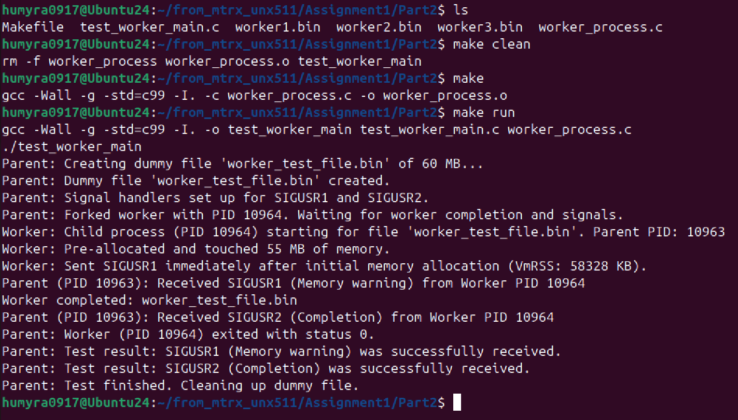

1. Why do we check /proc/self/status for memory usage?
Answer: It provides real-time info about the current process's memory, CPU, threads, etc.
VmRSS: is the Resident Set Size, meaning actual physical memory used by the process.
- What happens if kill(parent_pid, SIGUSR1) fails?
Answer:
- kill() returns -1, and errno is set.
- It fails if:
  - parent_pid is incorrect or no longer exists.
  - The parent process does not have permission to receive signals.
- We can check it like:
if (kill(parent_pid, SIGUSR1) == -1) {
perror("Failed to send SIGUSR1");
}

- How does read() behave in blocking vs non-blocking mode?
Answer:
Mode | Behavior
Blocking (default) | read() waits until data is available.
Non-blocking | read() returns immediately, even if no data is available. You must check if bytes_read == -1 and errno == EAGAIN or EWOULDBLOCK.
We can make a file descriptor non-blocking with:
int flags = fcntl(fd, F_GETFL);
fcntl(fd, F_SETFL, flags | O_NONBLOCK);

Part 3: Conceptual Questions Answered
Here I have added the screenshot of the part 3 –
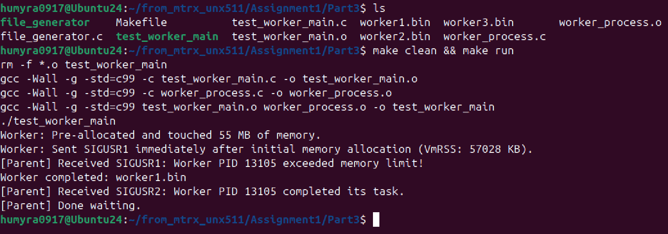

- What happens if two workers send SIGUSR1 at the same time?
Answer: Signals are not queued by default (except with sigqueue or real-time signals). If two signals of the same type are sent before the handler runs, only one may be delivered. However, if you use sigaction with SA_SIGINFO, you get the sender PID and can track signals better. Only one SIGUSR1 may be received if they come nearly simultaneously — this is a classic race condition.
- Why is signal(SIGUSR1, handler) (or sigaction(...)) needed in main()?
Answer: Without setting a signal handler, any process uses the default handler (which may do nothing or terminate the program). To catch the signal and run the custom logic (logging memory usage, etc.), we must register the handler using signal() or sigaction(). It's essential to install the signal handler in main() to make the parent aware of the workers' messages.

Part 4: Conceptual Questions Answered
Here I have added the screenshot of the part 4 –
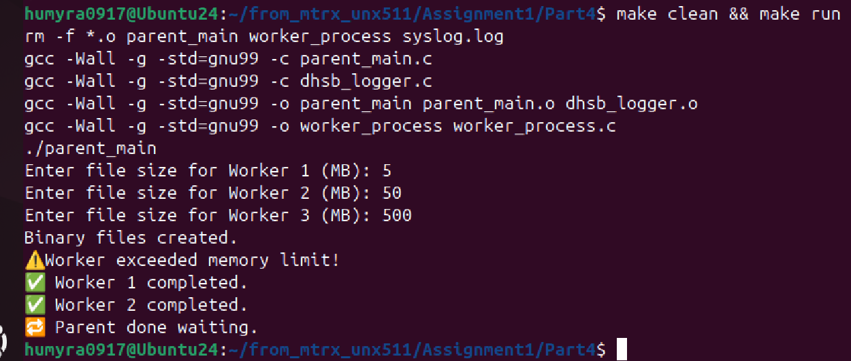

- What is F_WRLCK, and why do we use it?
Answer: F_WRLCK is a write lock in fcntl() locking system. It prevents other processes from reading/writing while the lock is active. Ensures only one writer at a time accesses the file.
- How does file locking prevent data corruption?
Answer: Without locks, multiple processes might write to the file at the same time, causing overlapping or broken log lines. Locking ensures one writer holds exclusive access, completing its write before others proceed maintaining log file integrity.

