/******************************************************************************
***
* UNX511-Lab3
* I declare that this lab is my own work in accordance with Seneca Academic Policy.
* No part of this assignment has been copied manually or electronically from any other source
* (including web sites) or distributed to other students.
*
* Name: Dil Humyra Sultana Borna Student ID: 139166227 Date: 01/06/2025
*
*
******************************************************************************
**/
- In this lab I have used I/O control (ioctl) and sockets to get information from a network
interface. I have used ioctl's to retrieve an interface's MAC address, IP address, netmask, and broadcast address. First, I have completed the etherCtrl.cpp file and the I have created a Makefile. After running the command make, I have entered the command ifconfig to check the Network Interface of my Machine type. Here is the screenshot -

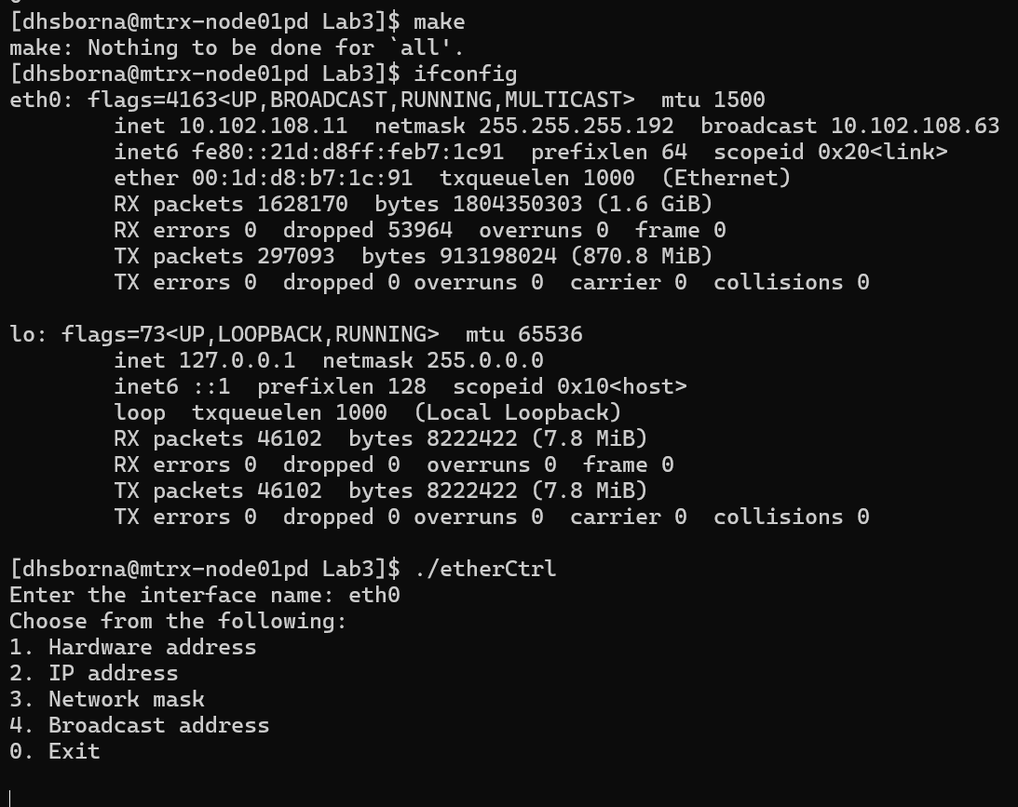

Here it is showing all the information. Then I have run the code by entering the command ./etherCtrl. After that I have entered the interface name eth0. Then it showed all the options. Here I have selected each option, and it showed the value which matched with the existing network interface. Here I have added all the screenshots –

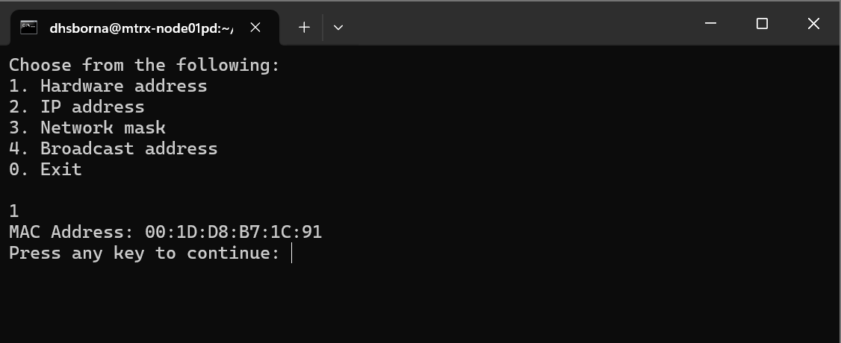
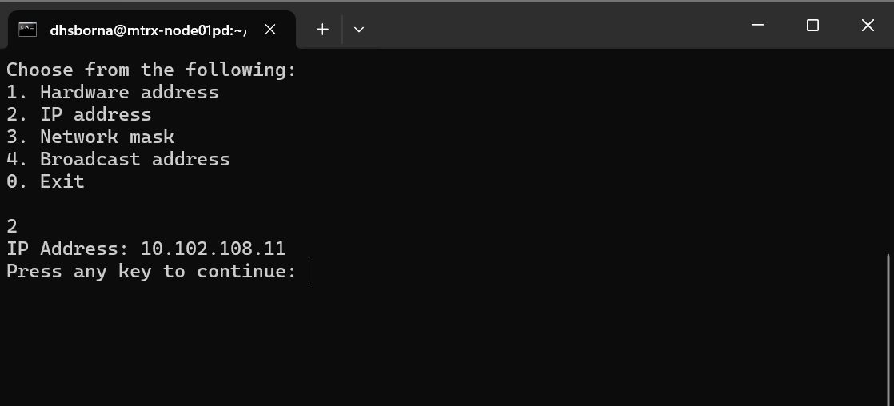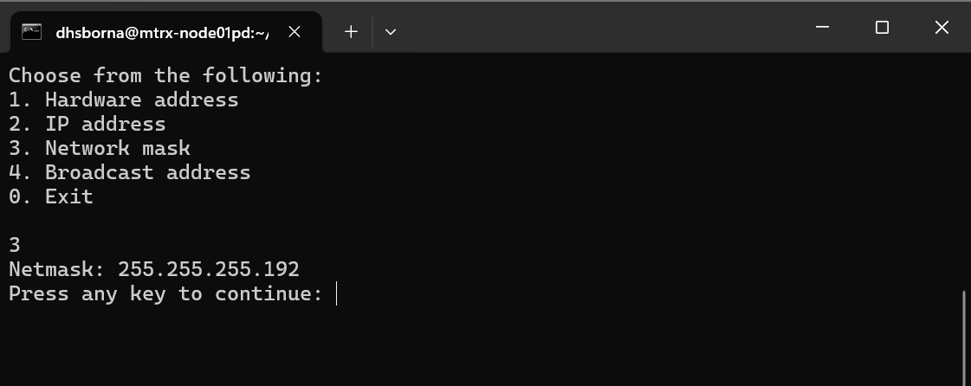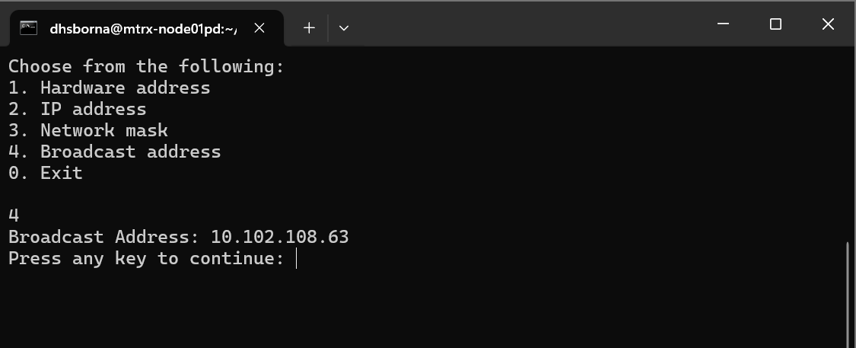

- Here I have tested the program with the loopback interface by entering the command lo. I have compared the results of my program with those given by ifconfig. They are same. Here I have attached the screenshots –

