Lab – 8
=========
/******************************************************************************
* UNX511-Lab8
* I declare that this lab is my own work in accordance with Seneca Academic Policy.
* No part of this assignment has been copied manually or electronically from any other source
* (including web sites) or distributed to other students.
*
* Name: Dil Humyra Sultana Borna Student ID: 139166227 Date: 28/07/2025
*
*
*****************************************************************************/
• Please answer the following two declarations:
o D1) On a scale from 1 to 5, How much did you use generative AI to complete this
assignment?
▪ where:
▪ 1 means you did not use generative AI at all
▪ 2 means you used it very minimally
▪ 3 means you used it moderately
▪ 4 means you used it significantly
▪ 5 means you relied on it almost entirely
▪ Your answer : 1
o D2) On a scale from 1 to 5, How confident are you in your understanding of the
generative AI support you utilized in this assignment, and in your ability to explain it if
questioned?
▪ where:
▪ 1 means "Not confident at all – I do not understand the generative AI support I
used and cannot explain it."
▪ 2 means "Slightly confident – I understand a little, but I have many
uncertainties."
▪ 3 means "Moderately confident – I understand the majority of the support,
though some parts are unclear."
▪ 4 means "Very confident – I understand most of the AI support well and can
explain it with minor gaps."
UNX511: Lab8 Professor: Shahdad
▪ 5 means "Extremely confident – I fully understand the generative AI support I
used and can clearly explain or justify it if asked."
▪ Your answer : I have not used AI

- Between sockets, pipes, fifos, and messages, which is your favorite and why?
Answer: I like using message queues.
The main reason I enjoy utilizing message queues is that they facilitate communication between many programs. Message queues allow the sender to simply add a message to the queue without waiting for the recipient to be ready. In situations like our lab, when numerous clients are interacting with a single server, this is useful. Additionally, the software is easier to create and comprehend because each message is sent as a complete unit rather than being divided into smaller ones.

- Which is your least favorite and why?
Answer: Pipes are my least favorite because they aren't helpful when two different applications need to communicate. Like a parent and child procedure, they function best when one program initiates the other. Additionally, since pipes only allow data to flow in one direction, creating two pipes is necessary to enable two-way communication, which adds to the effort. Pipes are less adaptable and more difficult to use in more complicated scenarios than message queues or sockets.

- For the scenario presented in this lab, is there a need for a server? Why?
Answer: Yes. Because it regulates the communication flow between the three clients, the server is crucial to this lab. The clients submit messages to the server rather than directly communicating with one another. After verifying who the message is intended for, the server forwards it to the appropriate client. Everything is easier to handle as a result. The program would get more complex if each client had to manage communicating with the others in the absence of the server.

Here I have added the screenshots –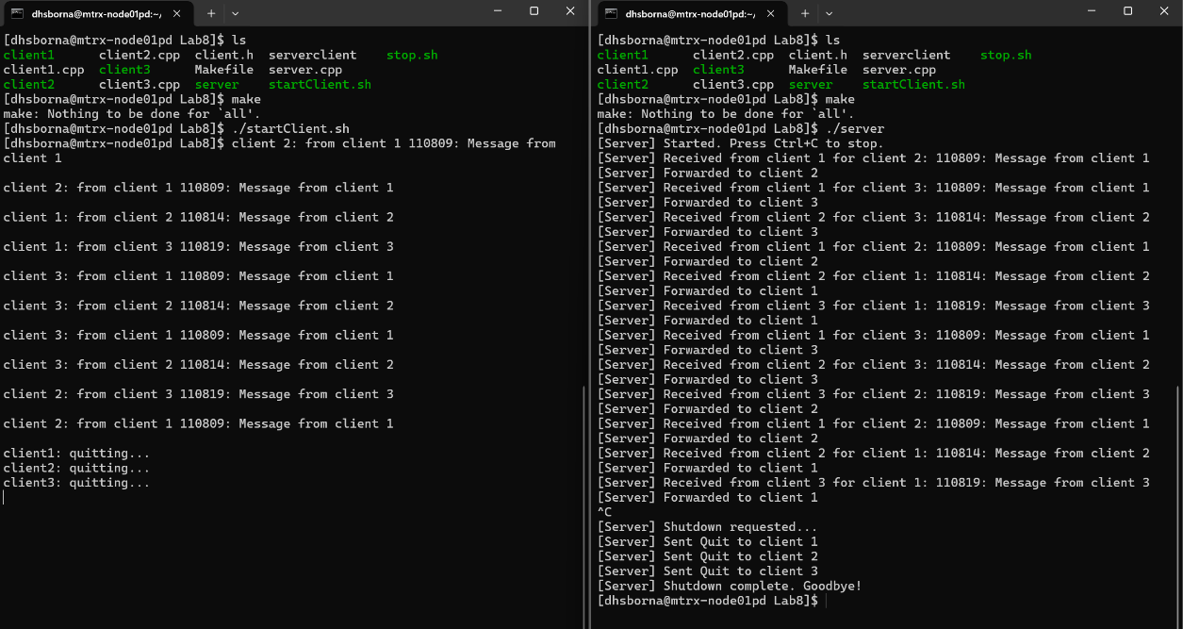
This is for client 1 –
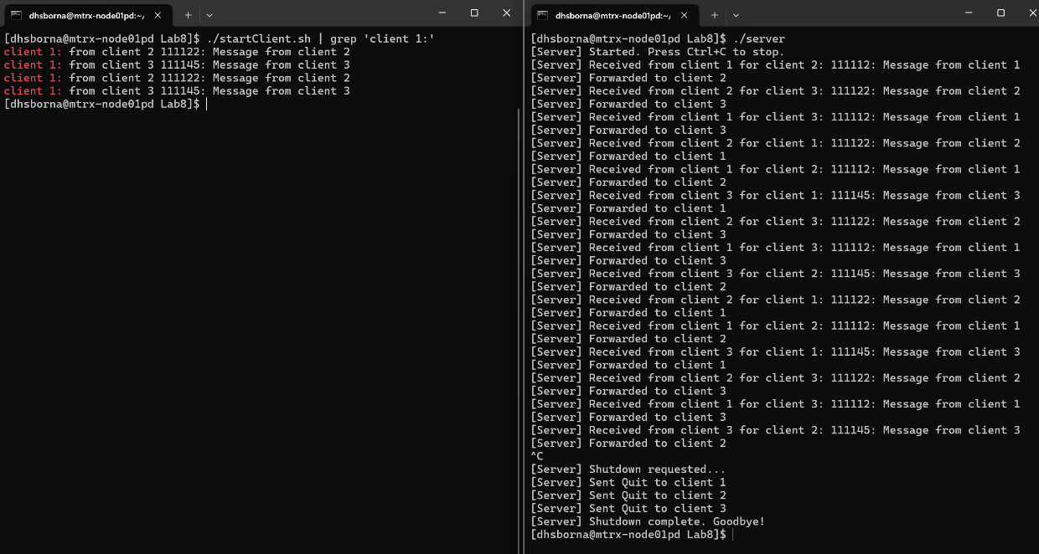

This is for client 2 –
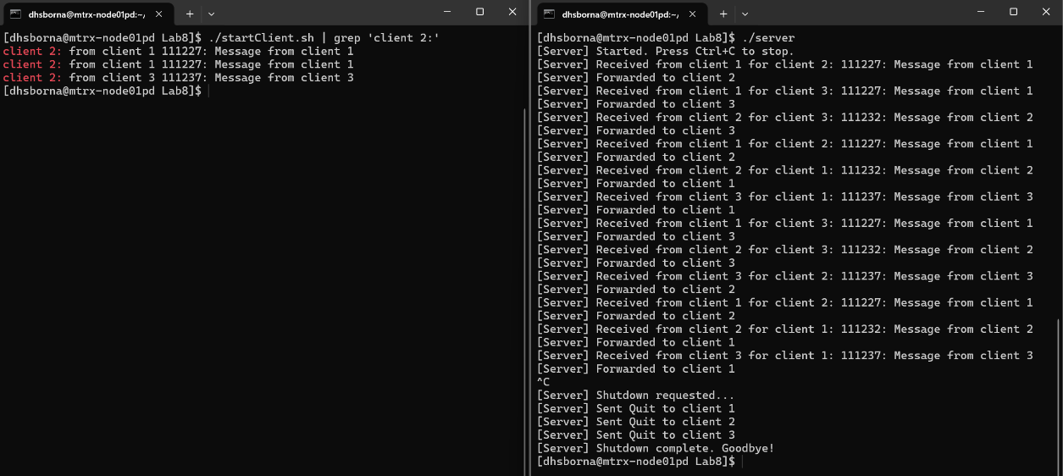
This is for client 3 –