/********************************************************************************* * UNX511-Lab2 * I declare that this lab is my own work in accordance with Seneca Academic Policy. * No part of this assignment has been copied manually or electronically from any other source * (including web sites) or distributed to other students.
* *
Name: Dil Humyra Sultana Borna Student ID: 139166227 Date: 25/05/2025
* *
********************************************************************************/

• Please answer the following two declarations:
D1) On a scale from 1 to 5, How much did you use generative AI to complete this assignment? ▪ where:
▪ Your answer: I would rate 2 (means you used it very minimally). For the Part A, I couldn’t successfully compile the code and it is not working for me. To find out the error I took help from Gemini but unfortunately it wasn’t also able to help me to resolve the issue.
D2) On a scale from 1 to 5, How confident are you in your understanding of the generative AI support you utilized in this assignment, and in your ability to explain it if questioned?
▪ where:
▪ Your answer: I would rate 3 (means "Moderately confident – I understand the majority of the support, though some parts are unclear."), I took help and tried to follow the instruction but the solution that Gemini gave was not clear and it didn’t solve my problem.

Part A: I have downloaded the libPidUtil.a and its header file pidUtil.h. I have created the Makefile and Lab2-Dil.cpp. Checked the libPidUtil.a file by using the command $ nm libPidUtil.a | grep ' T '. But for some reason I can not compile the code successfully. Getting a long error saying that the .a file version is not matching with my machine version, and I need to edit the libPidUtil.a file. Here is the screenshot -
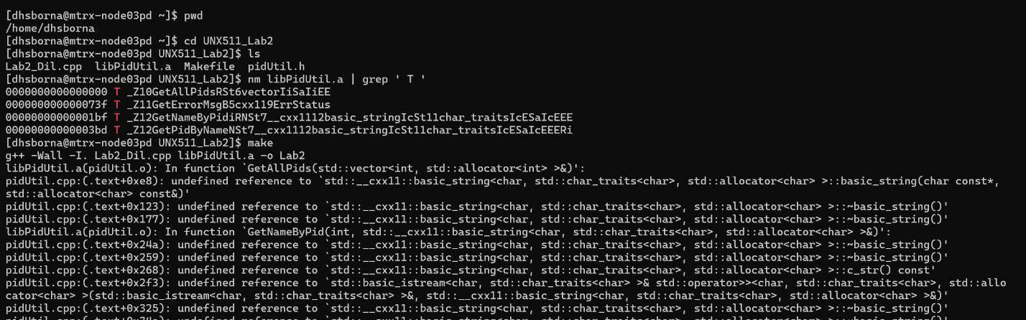

Part B: Makefile explanation
CC=g++ # Set the C++ compiler to g++
CFLAGS=-I # Set compiler include path flag (incomplete, typically -I. for current directory)
CFLAGS+=-Wall # Add compiler flag to enable all common warnings
CFLAGS+=-c # Add compiler flag to compile only (no linking, output .o file)
AR=ar # Set the archive tool to 'ar' for creating static libraries

pidUtil: pidUtil.cpp # Target 'pidUtil' depends on pidUtil.cpp
$(CC) $(CFLAGS) pidUtil.cpp -o pidUtil.o # Compile pidUtil.cpp into object file pidUtil.o

lib: pidUtil.o # Target 'lib' depends on pidUtil.o
$(AR) rcs libPidUtil.a pidUtil.o # Archive pidUtil.o into libPidUtil.a (static library)

clean: # Target 'clean' for cleaning build files
rm -f *.o *.a # Forcefully remove all .o and .a files in the current directory

install: # Target 'install' to copy output to parent directory
cp libPidUtil.a ../. # Copy libPidUtil.a to the parent directory
cp pidUtil.h ../. # Copy pidUtil.h to the parent directory
all: pidUtil lib # Default target 'all' builds both pidUtil.o and libPidUtil.a

