Lab – 9
=========
/******************************************************************************
* UNX511-Lab9
* I declare that this lab is my own work in accordance with Seneca Academic Policy.
* No part of this assignment has been copied manually or electronically from any other source
* (including web sites) or distributed to other students.
*
* Name: Dil Humyra Sultana Borna Student ID: 139166227 Date: 02/08/2025
*
*
*****************************************************************************/
• Please answer the following two declarations:
o D1) On a scale from 1 to 5, How much did you use generative AI to complete this
assignment?
▪ where:
▪ 1 means you did not use generative AI at all
▪ 2 means you used it very minimally
▪ 3 means you used it moderately
▪ 4 means you used it significantly
▪ 5 means you relied on it almost entirely
▪ Your answer : 1
o D2) On a scale from 1 to 5, How confident are you in your understanding of the
generative AI support you utilized in this assignment, and in your ability to explain it if
questioned?
▪ where:
▪ 1 means "Not confident at all – I do not understand the generative AI support I
used and cannot explain it."
▪ 2 means "Slightly confident – I understand a little, but I have many
uncertainties."
▪ 3 means "Moderately confident – I understand the majority of the support,
though some parts are unclear."
▪ 4 means "Very confident – I understand most of the AI support well and can
explain it with minor gaps."
▪ 5 means "Extremely confident – I fully understand the generative AI support I
used and can clearly explain or justify it if asked."
▪ Your answer : I have not used any generative AI.

Answer 1: Here is the difference between synchronous and asynchronous communication -
Synchronous communication means that actions happen one after another, in a blocking or coordinated manner. When one part of a program performs a task (e.g., reading from a socket), it must wait until that task completes before continuing.
Example: read() blocks the main thread until data arrives.
Asynchronous communication means tasks can happen independently and in parallel. The program doesn’t wait for a task to complete. Instead, other operations continue, often using threads or callbacks.
Example: A background thread reads data from the socket and puts it into a queue, while the main thread continues doing other things.
In this lab, we use asynchronous communication. Each client sends data, and the server receives it in a separate thread using non-blocking sockets. This allows all clients to work independently at the same time without waiting.

Answer 2: I prefer reading from sockets in a receive thread. It allows the server to handle multiple clients concurrently without blocking the main thread. The main thread can focus on managing connections and processing messages (e.g., writing output or pushing to clients), while each thread handles its own input. Using threads for reads provides asynchronous behavior, avoiding the need for select() or poll() when managing multiple sockets. If everything (read and write) were in main(), the server would have to manage all sockets using select() or poll(), making the code more complex and less scalable.

Screenshots of the program –
I have uploaded all the files and worked on the server.cpp file. After compiling by running the command make, it has created client1, client2, client3 & server file. Here is the screenshot -
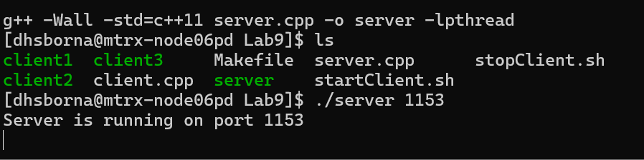

Then I have run the command ./server 1153 to start the server in one termial and on another termoinal started the client by running the command ./startClient.sh 1153
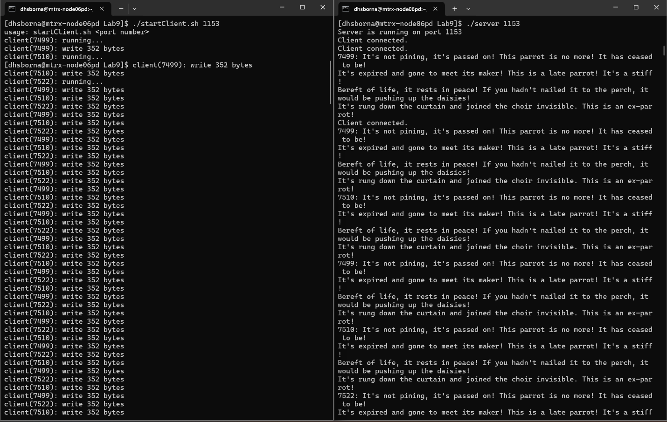
To stop the server, I have clicked on the ctrl+c and after that it has stopped -
