/******************************************************************************
***
* UNX511-Lab5
* I declare that this lab is my own work in accordance with Seneca Academic Policy.
* No part of this assignment has been copied manually or electronically from any other source
* (including web sites) or distributed to other students.
*
* Name: Dil Humyra Sultana Borna Student ID: 139166227 Date: 15/06/2025
*
*
******************************************************************************
**/
• Please answer the following two declarations:
o D1) On a scale from 1 to 5, How much did you use generative AI to complete this
assignment?
▪ where:
▪ 1 means you did not use generative AI at all
▪ 2 means you used it very minimally
▪ 3 means you used it moderately
▪ 4 means you used it significantly
▪ 5 means you relied on it almost entirely
▪ Your answer : 1
o D2) On a scale from 1 to 5, How confident are you in your understanding of the
generative AI support you utilized in this assignment, and in your ability to explain it if
questioned?
▪ where:
▪ 1 means "Not confident at all – I do not understand the generative AI support I
used and cannot explain it."
▪ 2 means "Slightly confident – I understand a little, but I have many
uncertainties."
▪ 3 means "Moderately confident – I understand the majority of the support,
though some parts are unclear."
▪ 4 means "Very confident – I understand most of the AI support well and can
explain it with minor gaps."
▪ 5 means "Extremely confident – I fully understand the generative AI support I
used and can clearly explain or justify it if asked."
▪ Your answer : I have not used AI

Lab-5
========
The objective of this lab was to complete a partially implemented Linux kernel device driver by adding support for the read() and ioctl() system calls. The device simulates a hardware buffer that is updated every second by a kernel thread. The read() function was implemented to allow a user-space application to access the contents of this buffer. Additionally, two I/O control commands—HARDWARE_DEVICE_HALT and HARDWARE_DEVICE_RESUME—were implemented through the ioctl() function. These commands pause and resume the buffer updates, respectively. A user-space test program (userHardware.cpp) was provided to verify the functionality by reading from the buffer before and after halting/resuming the thread. The kernel module was compiled, loaded, and tested successfully, confirming that the required features were implemented correctly.

Fist I have created a folder Lab5 and in that folder I have created 2 more folders kernel and user. In the kernel I have copy paste the files that was provided and, I have completed the hardwareDevice.c file. After that I have run the command chmod 777 *.sh to change the permission or access. Then I have run the command ./build.sh. As regular users can’t read system logs like /var/log/syslog. To read the log, I have run the command sudo tail -f /var/log/syslog. Here I have added the screenshot of he output -

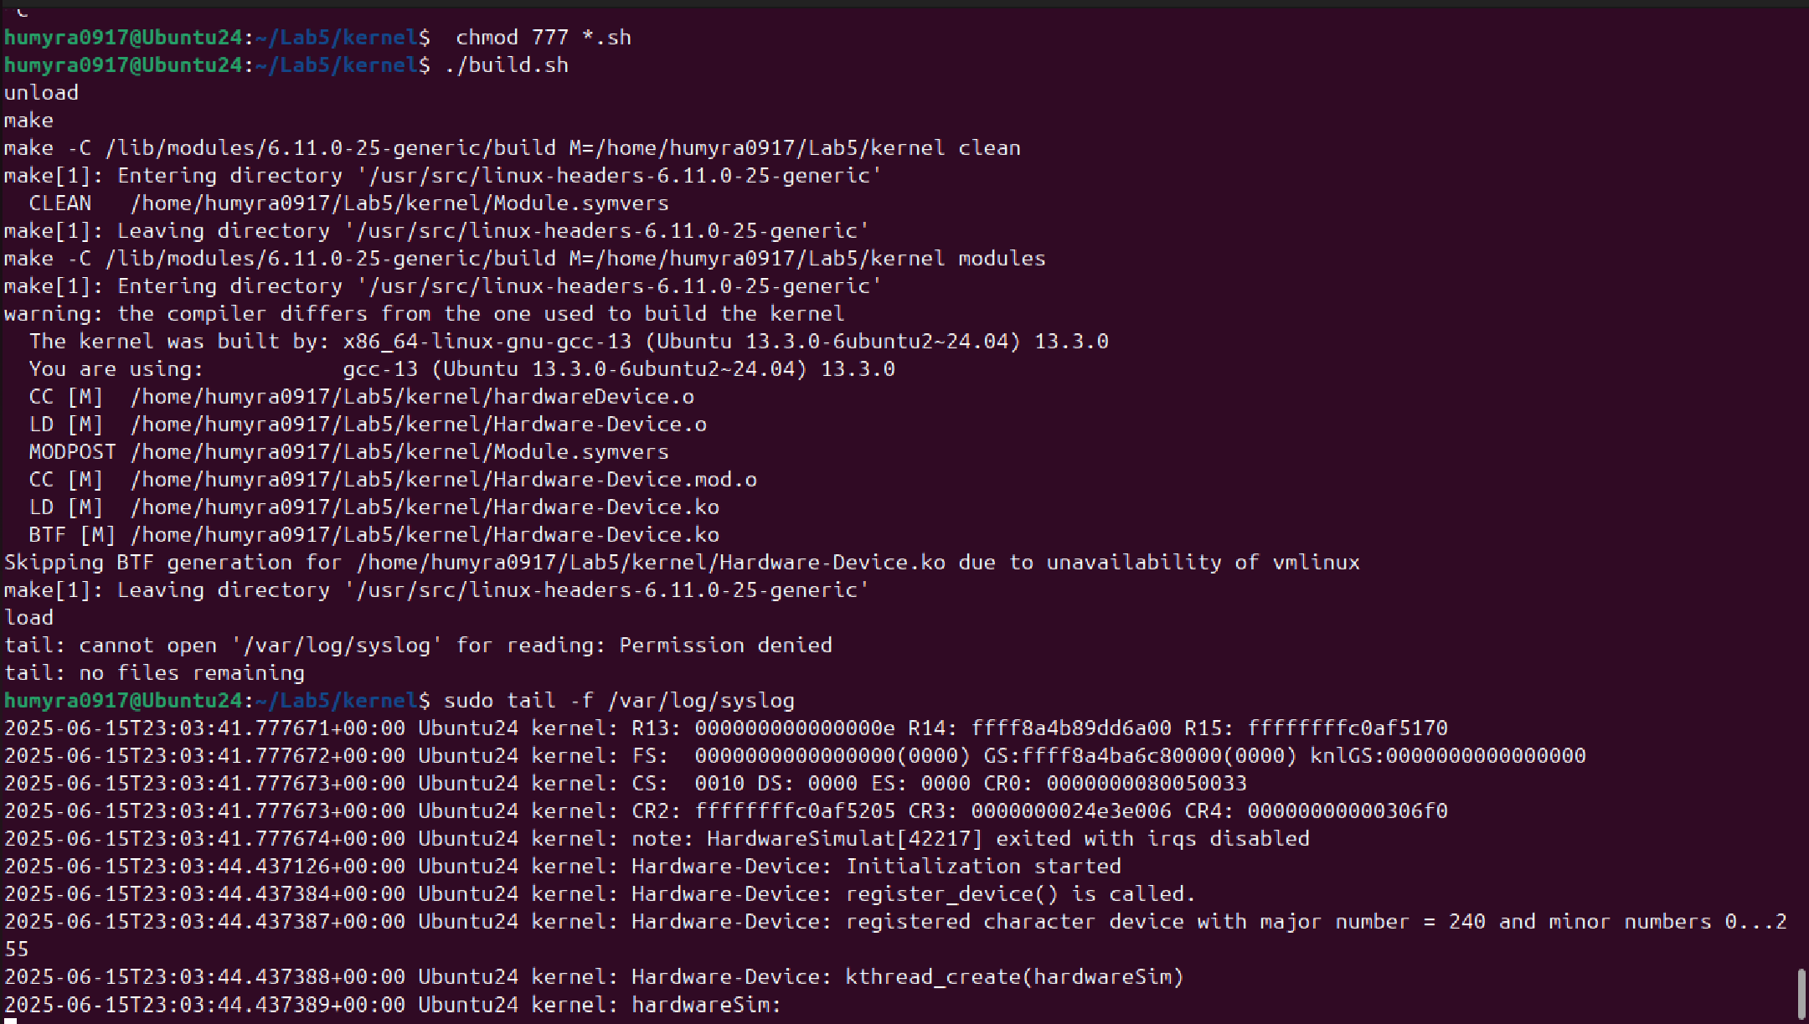

After finishing this to test my implementation, I have copy paste the provided Makefile and userHardware.cpp in the user folder. From inside the user/ folder, I have Compiled and run userHardware.cpp by using the command – make, ./userHardware.
Here I have added the screenshot of the output –
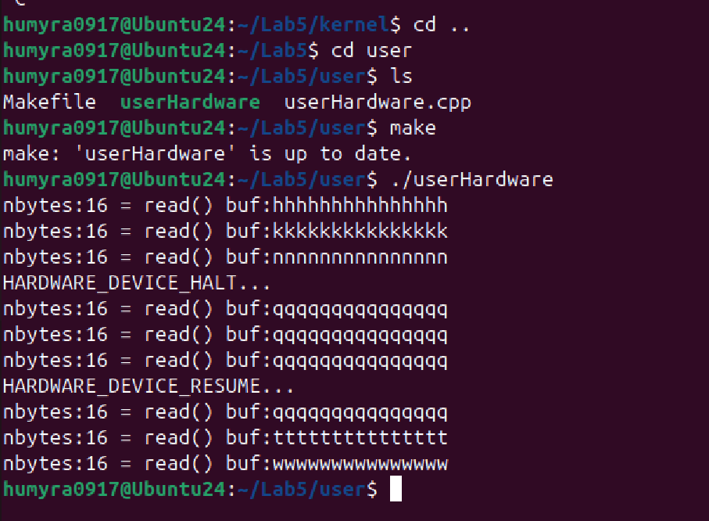
Before HALT
nbytes:16 = read() buf:ttttttttttttttt
nbytes:16 = read() buf:wwwwwwwwwwwwwww
nbytes:16 = read() buf:zzzzzzzzzzzzzzz
This shows the kernel buffer is updating every second as expected.
After HALT
HARDWARE_DEVICE_HALT...
nbytes:16 = read() buf:ccccccccccccccc
nbytes:16 = read() buf:ccccccccccccccc
nbytes:16 = read() buf:ccccccccccccccc
After calling ioctl(HALT), the buffer stops updating it's stuck on ccc.... This is the expected behavior.
After RESUME
HARDWARE_DEVICE_RESUME...
nbytes:16 = read() buf:ccccccccccccccc
nbytes:16 = read() buf:fffffffffffffff
nbytes:16 = read() buf:iiiiiiiiiiiiiii
RESUME restarts the kernel thread, and the buffer continues to update alphabetically.

