
6

Cardiff Metropolitan University
Cardiff School of Technology
BSc Software Engineering

Resilient Multimodal: An AI-Driven Lost and Found Matchmaking System with Context-Aware Graceful Degradation

Submitted in
September
2026
By
Dissanayake Thalangama Appuhamilage Dilaksha Haritha Dissanayake
(Student ID – 20360315 – GM/BSCSD/06/22)

This Dissertation is Submitted in Partial
Fulfilment of the Requirements for The Degree of
Bachelor of Science in Software Engineering (BSc SE)
DECLARATION

This work is being submitted in partial fulfilment of the requirements for the Degree of Bachelor of Science in Software Engineering (BSc SE) and has not previously been accepted in substance for any degree and is not being concurrently submitted in candidature for any degree.

Signed - ............................................................ (Candidate) Date - 24/08/2026

SUPERVISOR'S DECLARATION STATEMENT
Student Name - Dissanayake Thalangama Appuhamilage Dilaksha Haritha Dissanayake
Supervisor Name – Ms. Upeka Wijesinghe

I acknowledge that the above-named student has regularly attended the meeting and actively engaged in the dissertation supervision process.

Signed - ………………………………………
(Supervisor) Date - …………………………...

Acknowledgement
The successful completion of this research and development project would not have been possible without the guidance, support, and encouragement of numerous individuals.
First and foremost, I would like to express my sincere gratitude to Ms. Upeka Wijesinghe, my project supervisor, for her invaluable guidance, continuous support, constructive feedback, and technical expertise throughout the development of this dissertation. Her encouragement and academic insight played a significant role in the successful completion of this project.
I would also like to extend my heartfelt appreciation to Ms. Vijini Mekala, Lecturer of the Development Project module, for her guidance, motivation, and valuable recommendations, which greatly contributed to the progress and quality of this work.
My sincere thanks go to the academic and administrative staff of ICBT Campus and Cardiff Metropolitan University for providing the knowledge, resources, and academic environment necessary to complete my degree programme successfully.
I am sincerely thankful to everyone who contributed significantly to the successful completion of this project. This achievement would not have been possible without their support and encouragement.

Abstract
In situations where personal possessions go missing within densely populated public or academic spaces, conventional recovery efforts have proved ineffective. Although there are solutions in the form of digital platforms such as Facebook groups and WhatsApp communities, these require sharing personal data such as mobile numbers and individual routines, which is a significant threat to user privacy. In addition, these platforms lack automated pattern-matching technology and therefore rely on time-consuming manual searches through large volumes of content.
As part of the initial assessment of the consumer needs, two main aspects were identified. Firstly, there is a requirement for a process that has automated pattern matching capability and can continue to function even in cases where there is a failure of third-party AI services. Secondly, there is a clear indication that users have a strong reluctance to share personal contact information online due to the risk of fraudulent claims.
These are the primary deficiencies that will be addressed in the research through the development, design, and evaluation of NEXO. This platform makes use of a decoupled, multi-agent architecture designed specifically to provide high efficiency and zero-downtime reliability. The frontend of the system is made with the Flutter framework to ensure high performance and quality on multiple platforms. It is supported by a centralized Python FastAPI server and orchestrated by a LangGraph StateGraph engine.
To enhance search efficiency and operational speed, the database incorporates Supabase PostgreSQL with `pgvector` for semantic search and PostGIS designed to improve geographic proximity filtering. The core part of the system is the multimodal artificial intelligence engine built upon LangGraph agents utilizing the Model Context Protocol (MCP). The system makes use of visual features extracted from user uploaded photos combined with dense vector text embeddings to find semantic similarities.
In order to validate the problem of AI provider instability revealed through the survey, the NEXO architecture utilizes the Circuit Breaker failover design pattern to achieve Context-Aware Graceful Degradation. During periods of API disruption, the system automatically degrades gracefully by shifting traffic from primary AI providers (OpenAI) to secondary providers (Gemini/Claude) or local offline matching (Ollama/OpenCV) with zero downtime.
Lastly, the system makes use of a proprietary 4-Layer Zero-Fraud Pipeline, utilizing a Visual Evidence Vault, adversarial interrogation, and behavioral scoring to validate ownership claims, completely preventing malicious actors from hijacking public property reports.

Table of Contents
Chapter 1: Introduction 9
1.0 Introduction 9
1.1 Background Studies 10
1.1.1 Current Systems and Their Limitations 10
1.1.2 Key Drawbacks of Existing Methods 10
1.1.3 The Proposed Solution 11
1.1.4 Significance of The System 12
1.2 Problem Statement 12
1.3 Research Questions 13
1.4 Objectives 13
1.5 System Core Features 14
1.6 Scope 14
Chapter 2: Literature Review 15
2.0 Introduction 15
2.1 Critical Analysis of Existing Property Recovery Mechanisms 15
2.2 Evaluation of Automated Matchmaking in Software System 16
2.3 Software Architectural Paradigms: Multi-Agent Orchestration versus Monolithic Architectures 17
2.4 Fault-Tolerant Computing and Graceful Degradation 18
2.5 Privacy-by-Design and Adversarial Fraud Detection 19
2.6 Comparative Analysis of Technology Stacks 20
2.6.1 Technical Justification Summary 20
2.7 Chapter Summary and Identification of Research Gap 21
Chapter 3: Planning 23
3.0 Introduction 23
3.1 Feasibility Report 23
3.2 Risk Assessment 26
3.3 SWOT Analysis 27
3.4 PESTAL Analysis 28
3.5 Life Cycle Model 29
3.6 Time Plan 31
Chapter 4: Requirement Gathering and Analysis 33
4.0 Introduction 33
4.1 Requirement Gathering and Analysis 33
4.1.1 Requirement Gathering Technique Used for the Project 33
4.1.2 Questionnaire 33
4.1.3 Interview 36
4.2 Functional and Non-Functional Requirements 37
4.2.1 Functional Requirements 37
4.2.2 Non-Functional Requirements 40
Chapter 5: System Design 42
5.0 Introduction 42
5.1 System Architecture 42
5.1.1 Frontend Layer (Flutter Clean Architecture) 42
5.1.2 API Gateway Tier (Python FastAPI & Nginx) 42
5.1.3 AI Orchestration & Multi-Agent Layer (LangGraph StateGraph) 43
5.1.4 Data & Storage Tier (Supabase PostgreSQL, PostGIS, pgvector & Redis) 43
5.1.5 Administration Layer (React SPA Dashboard) 43
5.2 Database Design & Entity Relationship Diagram (ERD) 44
5.2.1 Core Entity Descriptions 44
5.3 Use Case Diagram 46
5.4 Multi-Layer Clean Architecture Class Diagram 47
5.5 System Logic, Data Flow and Sequence Architecture 48
5.6 Context-Aware Graceful Degradation & Circuit Breaker Logic 49
5.7 AI Feature Extraction and 4-Layer Zero-Fraud Pipeline 50
5.8 Architectural Component Diagrams & Wireframe Overview 51
Chapter 6: System Implementation 53
6.0 Introduction 53
6.1 Development Environment & Technology Setup 53
6.2 Database Implementation (Spatial & Vector Indexing) 54
6.3 Backend API Gateway Implementation (FastAPI) 54
6.4 LangGraph Multi-Agent Orchestration & Graceful Degradation 54
6.5 The 4-Layer Zero-Fraud System Implementation 54
6.6 Frontend Mobile Application Implementation (Flutter) 55
6.7 RESTful API Endpoints Implementation 55
6.8 Summary 56
Reference 57
Appendix A: Survey Questionnaire 60
Section 01: Consent & Eligibility 61
Section 02: Ineligibility / Non-Consent 61
Section 03: Survey Questions 61
Appendix B: Ethics Approved Form 70
Appendix C: Interview 77
Appendix D: Implementations 78
Supervisor Log Sheets 79

Table of Figures
Figure 2:Entity Relationship Diagram (ERD) using Chen's Notation 44
Figure 3:Comprehensive Use Case Diagram of NEXO Platform 45
Figure 4:Multi-Layer Clean Architecture Class Diagram 46
Figure 5:Sequence Diagram for 4-Layer Zero-Fraud Verification 47
Figure 6: Sequence Diagram for Asynchronous Data Ingestion and AI Processing 48
Figure 7:Sequence Diagram for Asynchronous AI Feature Extraction 49
Figure 8:Multi-Agent Swarm Orchestrator Topology 50
Figure 9:Admin Process & Fraud Moderation Workflow 51
Figure 10:Frontend Mobile Architecture & Wireframe Layouts 51

Table Of Tables
Table 1: Planned Development Schedule (Gantt Chart, 12-Week Plan) 31
Table 2:Central Tendency of Likert-Scale Survey Responses (n=22) 35

Chapter 1: Introduction

1.0 Introduction
The loss of a wallet on a bus, a cell phone in a classroom, or a computer bag at a railway station is something many have experienced, and in almost all such instances, the lost possession is never retrieved. This issue is highlighted by empirical evidence from the Transport for London (TfL) Lost Property Office, which indicates that a staggering 295,401 items were handled in the fiscal year 2024/25 (Transport for London 2025). The major consequence of this volume is that only 16.3% of the lost items were successfully retrieved, leaving over 83% unclaimed. Furthermore, these published figures represent only the items officially handed over to designated authorities, completely excluding the vast volume of everyday losses that are handled informally and left entirely unreported.
In the absence of a centralized, purpose-built recovery channel, individuals routinely default to posting descriptions on public Facebook groups or WhatsApp communities because these avenues are immediate and highly familiar. (Zhou et al. 2024) argue that while these informal digital networks have become a widely adopted support mechanism for distressed users, they lack structured matching frameworks and systematic approaches to effectively address users specific needs. These limitations highlight the urgent need to improve digital applications and extend their use to broader lost-and-found scenarios.
To address this gap, this study proposes NEXO: Resilient Multimodal: An AI-Driven Lost and Found Matchmaking System with Context-Aware Graceful Degradation. Instead of treating recovery as a manual, social process, NEXO treats it as an automated, highly secure matchmaking problem. A Flutter mobile client, a centralized Python FastAPI backend, and a LangGraph StateGraph engine work in coordination to ensure that a photograph, a short text description, and an approximate location submitted by a finder can be automatically compared against the reports already logged by people searching for something they have lost. What distinguishes NEXO from previous attempts to digitize the lost-and-found process is its proprietary 4-Layer Zero-Fraud Pipeline and its consideration of system reliability. Rather than assuming the continuous availability of primary artificial intelligence services, NEXO is designed with resilience as a core principle, utilizing Circuit Breaker failovers to achieve context-aware graceful degradation with zero downtime.

1.1 Background Studies

1.1.1 Current Systems and Their Limitations
At present, someone who has lost a personal item in Sri Lanka, or in most other countries, has no single, purpose-built platform to rely on. Most turn instead to a patchwork of informal channels, like Facebook community groups, WhatsApp broadcast lists, occasionally, a locally built platform such as RDMNS Sri Lanka (RDMNS.LK 2026) which allows users to record lost and found entries through a basic Google Form but performs no automated processing of the data it collects. In each of these cases, a person who has found an item must manually describe it, attach a photograph if they remember and openly publish their contact details so that the true owner can reach them. The process places the entire burden of searching, comparing, and following up on the two people involved, with no software assistance at any stage. These approaches share a fundamental set of weaknesses. They offer no automated matching between lost and found reports, no filtering mechanism to narrow searches by item category, location, or time, and no tools to verify ownership or protect the privacy of those involved. Users are forced to scroll through endless, poorly organised social media feeds where posts quickly become buried under newer content, making timely recovery unlikely.

1.1.2 Key Drawbacks of Existing Methods
When people rely on general social media groups to recover lost property, the first major hurdle they face is personal privacy. In practice, putting up a public notice forces an individual to broadcast sensitive contact information directly to thousands of complete strangers at once. This usually includes publishing a personal mobile number, an email address, or even daily commuting routes. As (Cavoukian et al. 2010) point out, software platforms that fail to bake privacy-by-design principles directly into their foundational architecture inherently leave end users vulnerable to data harvesting, targeted phishing attempts, and unwanted online harassment. Beyond these obvious privacy risks, informal social networks suffer from a total lack of ownership verification. If a stranger steps forward claiming an item belongs to them, the finder has no objective or software-backed way to confirm whether that claim is actually true. (Bonneau 2012) highlights this exact flaw in digital authentication. This research demonstrates that systems built purely on unverified trust without structural security layers open the door wide to opportunistic identity impersonation, fraudulent claims, and social engineering scams. Finally, the basic layout of a typical social media feed actively works against successful property recovery. Because there are no underlying artificial intelligence algorithms analysing the posts, a newly submitted report is simply dropped into a fast-moving chronological timeline. Within hours, daily community chatter pushes that post far out of view. Even if the person who lost a laptop bag and the person who found it both publish detailed descriptions in the exact same Facebook group on the very same afternoon, the total absence of automated pattern matching means a genuine match can easily sit unnoticed for weeks.

1.1.3 The Proposed Solution
NEXO tackles these three challenges by adopting a decoupled, multi-agent architecture instead of a traditional monolithic system. The mobile frontend client is developed using the Dart programming language along with Flutter SDK (Google 2024). The chosen cross-platform solution was the best way out since there is a possibility to compile native applications for both Android and iOS which allows this platform to reach the maximum number of possible users/finders.
To power the AI orchestration, the backend utilizes a centralized Python FastAPI server managed by a LangGraph StateGraph engine. Such architecture strictly correlates with the recommendations given by (Fowler and Beck 2019) and (Jacopo Soldani and Damian Andrew Tamburri 2018) according to which isolation of resource-heavy parts of the system into separate microservices makes the development much more fault-tolerant and easy to maintain.
Uploaded images are analyzed by multimodal AI agents in order to identify main object categories and colors, while obscuring sensitive features in a Visual Evidence Vault. At the same time, a natural language processing model (NLPM) calculates how closely a newly submitted text description matches existing database records. Finally, the system merges these visual and textual metrics with a geospatial proximity score calculated via PostGIS (Davide Chicco 2025), generating a unified confidence percentage that indicates whether two separate reports describe the exact same item.

1.1.4 Significance of The System
The most consequential design decision in NEXO, and the one that distinguishes it most clearly from prior systems in this space, is Context-Aware Graceful Degradation. As established in fault-tolerant computing literature by (Beal 2012) and actively recommended by the Google Cloud Architecture Framework (Google Cloud 2026), graceful degradation is a foundational requirement for system resilience; software must be engineered to maintain acceptable, meaningful utility rather than failing completely whenever a cloud dependency or third-party API becomes unavailable. NEXO applies this resilient engineering principle directly to property recovery. If the primary artificial intelligence API experiences high latency or becomes unreachable, the backend does not throw a terminal error to the user. Instead, utilizing a strict Circuit Breaker design pattern, it automatically transitions traffic to secondary fallback providers (e.g., Gemini or Claude) or local offline matching models. This fault-tolerant architecture is critical because the environments where lost items are most commonly reported are often crowded bus transit hubs, railway stations, or university campuses. These locations are precisely where cellular data connectivity is least reliable. By ensuring the platform remains functional even when primary cloud AI nodes fail, this resilient Context-Aware Graceful Degradation mechanism represents the central academic and technical contribution of this dissertation.

1.2 Problem Statement
This project addresses the fact that current lost-and-found practices force an unreasonable trade-off onto distressed individuals. To maximize the likelihood of recovering an item, a person is actively encouraged to publish sensitive contact information as widely as possible. Conversely, to protect that same personal data, they must limit their post to a small and closed circle of trusted contacts. This difficult choice drastically reduces the odds of ever being contacted by a finder.
The General Data Protection Regulation (GDPR) (European Parliament 2016) explicitly identifies the unnecessary public disclosure of personal data as a structural risk that information systems should be engineered to avoid. Yet most everyday recovery channels do exactly the opposite, enabling fraud and extortion. Furthermore, (Sommerville 2016) observes that software intended for deployment in unpredictable real-world conditions must account for external dependencies.
Specifically, network connectivity cannot be assumed to be constantly available. Existing digital tools that rely exclusively on live cloud processing fail to account for this constraint, rendering them unusable in the exact high-density environments where losses occur most frequently. NEXO is engineered as a comprehensive response to both architectural flaws simultaneously. It automates semantic matching and utilizes a 4-Layer Zero-Fraud Pipeline so that high visibility no longer comes at the cost of personal privacy or extortion. Furthermore, it incorporates a structural Circuit Breaker fallback routine so that a degraded network connection simply routes AI tasks to lighter fallback models rather than removing system utility altogether.

1.3 Research Questions
- How can multimodal artificial intelligence combining computer vision and natural language processing be integrated to improve the accuracy and speed of matching lost and found items?
- What software architectural patterns (such as Circuit Breakers) can be implemented to ensure context-aware graceful degradation, so the platform maintains core AI usability during third-party API or network failures?
- How can a Zero-Fraud verification framework and anonymized communication mitigate the privacy and social engineering risks associated with traditional social media recovery methods?

1.4 Objectives
Main Objective: To design, implement, and evaluate an AI-driven lost and found matchmaking system that accurately pairs reports while prioritizing user privacy and maintaining core functionality during network outages.
Specific Objectives:
- To develop a multimodal intelligence engine orchestrated by a LangGraph StateGraph framework for autonomous feature extraction.
- To implement "Context-Aware Graceful Degradation" via Circuit Breaker patterns that transition matchmaking to fallback providers or local models during network drops.
- To establish a 4-Layer Zero-Fraud Verification Shield, utilizing a Visual Evidence Vault and anonymized messaging, ensuring zero public exposure of personal data.
- To utilize PostGIS for geospatial proximity boosting, prioritizing items lost and found within the same geographic radius.

1.5 System Core Features
- Multimodal AI Matchmaking: Automated comparison of uploaded images and text descriptions using semantic similarity. This extends the automated mobile-first matching frameworks outlined by Dutta et al. (2024) into a live, offline-resilient architecture.
- Context-Aware Graceful Degradation: Fallback circuit-breaker architecture that guarantees high availability by switching to secondary AI providers or local models during API failures.
- 4-Layer Zero-Fraud Pipeline: Advanced security leveraging a Visual Evidence Vault and adversarial interrogation to validate ownership claims without exposing identifiers.
- Secure Anonymized Messaging: In-app chat that allows ownership verification and meetup coordination without exposing phone numbers.
- Geospatial Proximity Filtering: Location-aware sorting via PostGIS for regional item recovery.

1.6 Scope
Project Deliverables:
- A production-ready, cross-platform Flutter mobile application.
- A Python FastAPI centralized backend with a Supabase PostgreSQL/PostGIS database.
- A LangGraph StateGraph engine for multi-agent AI image and text analysis.
- Comprehensive engineering documentation (UML diagrams, Final SRS Report)
Limitations:
- AI matching accuracy depends on photo lighting and quality.
- Real-world operational scaling is constrained by commercial API usage limits and billing caps
- During severe "Graceful Degradation" scenarios where all cloud APIs fail, the system is limited by the processing constraints of the local offline fallback models.

Chapter 2: Literature Review

2.0 Introduction
Development of a contemporary digital asset recovery system requires a combination of multi-agent orchestration, artificial intelligence, and privacy-first design approaches. As (Pressman and Maxim 2020) explain, any sound software engineering process must start with an analysis of existing technology frameworks and bottlenecks in workflows. This chapter critically reviews existing literature and technological frameworks pertinent to digital asset recovery systems. It evaluates the limitations of current manual and social media-based methods before exploring the technical requirements for an automated, secure property matchmaking platform. The review is structured across key domains: a critical analysis of existing recovery mechanisms, the evaluation of automated multi-agent matchmaking algorithms, software architectural paradigms (monolithic versus decentralized state graphs), fault-tolerant computing via circuit breakers, and privacy-by-design frameworks. By synthesizing these areas, this chapter identifies the primary research gap that the proposed system aims to resolve (Sommerville 2016; Pressman and Maxim 2020)

2.1 Critical Analysis of Existing Property Recovery Mechanisms
When citizens lose their possessions in crowded public areas, conventional means of retrieving them become highly ineffective. According to empirical evidence provided by the Transport for London (2025), conventional citywide facilities for storing items have extremely low operational effectiveness. Despite the fact that 295,401 found items were logged during one fiscal year, official transport agencies managed to return only 16.3 percent of them. Thus, an incredible loss rate indicates that conventional notice boards and administrative desks are not capable of offering digital opportunities to solve such issues (Transport for London 2025).
Without the development of special software applications, people tend to use generic social networks such as Facebook and WhatsApp. According to the observations made by Zhou et al. (2024), although informal social networks offer fast availability of information, they cannot be used efficiently for property recovery. Namely, unstructured social network feeds operate on chronological principles instead of semantic ones. Therefore, community discussions make newly created notices disappear quickly. Norman (2013a) highlights that software systems requiring excessive manual searching impose a heavy cognitive load on end-users. When distressed individuals are forced to manually scroll through thousands of unstructured posts, cognitive fatigue sets in and timely recovery becomes mathematically unlikely (Norman 2013b; Zhou et al. 2024).
A limited number of regional web platforms attempt to address this organizational problem. For instance, RDMNS.LK (2026) offers an online website portal where people can post lost and found announcements using standardized form templates. But this system depends fully on the manual classification done by humans and does not have any mechanism for automated image recognition or similarity computation. Both finders and seekers must manually filter through database entries and publicly display their contact information to initiate verification. This manual operational model leaves a substantial gap in the software ecosystem, creating an urgent engineering requirement for a platform that replaces manual human searching with autonomous machine intelligence (Dutta et al. 2024).

2.2 Evaluation of Automated Matchmaking in Software System
In order to address the challenge of manual searching, software engineering studies have started to shift their focus to automated pattern recognition algorithms. (Dutta et al. 2024) have proved that by shifting from static notice boards to automated peer-to-peer search algorithms, the time needed for recovering items is significantly reduced. Their study shows that mobile-first designs using automated classification techniques outperform manually operated community databases on any reliability metric (Dutta et al. 2024).
However, initial automated search mechanisms were limited to precise keyword matching in relational databases. In this regard, such fundamental techniques are highly inefficient as they are subject to frequent errors related to the variations in human vocabulary. For instance, one user might register a missing item as a “slate grey notebook,” while the second one registers the same item as a “dark silver laptop.”Such entries are not recognized as the same item via standard SQL relational searches due to semantic discrepancy and vocabulary limitations (Jurafsky and Martin 2024).
In order to solve the problem of semantic discrepancy, the field of computer science makes use of high-dimensional AI vector embeddings and approximate nearest neighbor search. Frameworks utilizing PostgreSQL with pgvector and the IVFFlat indexing algorithm allow systems to perform rapid semantic similarity matching across millions of vectorized item descriptions. According to (Meenakshi et al. 2026), in their work on centralized smart recovery, combining visual image analysis with natural language processing and real-time location filtering increases the efficiency of identifying items compared to manual approaches. In a multimodal approach, computational models analyze features not only from pictures but also from text descriptions. (Goodfellow et al. 2016) point out that deep models automatically detect spatial relationships, colors, and objects from digital images without any human intervention. Once the image is sent to the cloud vision API, the system automatically converts the visual information to dense vector embeddings. As a result of the unification of confidence scores obtained from visual and text data, a multimodal model avoids human categorization mistakes (Goodfellow et al. 2016; Meenakshi et al. 2026).

2.3 Software Architectural Paradigms: Multi-Agent Orchestration versus Monolithic Architectures
The structure of the software will determine whether or not it will be scalable, maintainable, and resilient. Monolithic architectural patterns were employed to build backend infrastructure by software developers in the past. In a monolithic application, user authentication, database connection management, and AI computation functions run in the same codebase. Although monolithic architectures offer easy deployment initially, they cause serious performance bottlenecks while running intensive computation tasks like image processing or machine learning (Newman 2015).
According to (Fowler and Beck 2019), volatile workloads must be separated from enterprise software into independent modules. Running machine learning processing on a main API gateway creates a risk; a surge in the upload of pictures may result in using up all the CPU threads on the server. The lack of available resources will make the whole application collapse (Fowler and Beck 2019). To avoid system-level congestion and hallucination cascading often seen in linear, single-prompt architectures, software engineers now adopt decoupled multi-agent architectures using tools like LangGraph.
According to (Newman 2021), decoupling systems enables engineers to scale certain parts of the application independently based on specific computational demand. In addition, (Jacopo Soldani and Damian Andrew Tamburri 2018) show through systematic reviews that segregating heavy back-end processes increases fault tolerance and code maintainability. Under the new paradigm, the Model Context Protocol (MCP) allows AI models to interface with external tools securely. By decoupling tool boundaries into specialized MCP servers (Vision, Geo, Fraud, Chat), the architecture enforces the principle of least privilege, ensuring the AI only accesses the precise data required for its current node execution. A Python FastAPI application acts as the asynchronous gateway, while heavy computations are delegated to independent LangGraph StateGraph agents. Regardless of how much traffic congestion there is in the AI nodes, the core administrative API stays perfectly stable (Jacopo Soldani and Damian Andrew Tamburri 2018; Newman 2021).

2.4 Fault-Tolerant Computing and Graceful Degradation
Continuous availability of applications in highly unreliable operating environments is the main issue in mobile software engineering. As (Sommerville 2016) states, software must be designed on the principle that cloud services and wireless connections will have many failures. This principle is especially significant in property recovery systems. Personal belongings tend to get lost mainly at crowded places such as subway stations, bus stops, and college campus locations. Cellular connection problems such as high congestion, packet dropping, and lack of signal are typical for all these physical environments (Sommerville 2016).
High-availability systems cannot rely on a single LLM provider. When the app cannot proceed further in its functioning without live cloud-based vision recognition, the program becomes completely non-functional due to the slightest change in third-party API availability. According to (Kleppmann 2017), it is necessary to anticipate partial failures and design automatic fallback procedures in order to create reliable software. According to the theory of distributed systems, an application should never fail totally because of an external dependency (Kleppmann 2017).
This theoretical engineering principle is executed via Context-Aware Graceful Degradation using Circuit Breaker patterns. (Beal 2012) formulates metrics for self-adaptive systems, proving that gracefully degrading software through fallback routing achieves an acceptable level of utility when its primary components fail. This scholarly opinion is actively upheld through current enterprise cloud standards. Specifically, the Google Cloud Architecture Framework (Google Cloud 2026) encourages developers to design cloud-native applications for resilience. The Circuit Breaker pattern (Closed, Open, Half-Open) combined with an LLM resilience chain ensures that API rate limits or provider outages trigger automated failovers. In NEXO, if the primary provider (OpenAI) fails, the state machine automatically routes traffic to secondary providers (Gemini/Claude) or local offline models without failing the entire system, guaranteeing service continuity without disruption (Beal 2012; Google Cloud 2026).

2.5 Privacy-by-Design and Adversarial Fraud Detection
Apart from the reliability of the system, the issue of cybersecurity and privacy concerns in the digital recovery platform is also crucial. In accordance with the findings made in chapter 1, the use of unstructured social media recovery processes forces distressed persons to share personal phone numbers, emails, and daily commuting routes with unknown people. This is against the general principle of information security and puts citizens at direct risk of being targeted for social engineering, phishing, or digital bullying (Hadnagy 2018).
The General Data Protection Regulation (European Parliament 2016) demands that software must limit the amount of data collected and protect personally identifiable information from any unauthorized public disclosures. This legislation directly corresponds to the Privacy by Design engineering approach. (Cavoukian et al. 2010) state that the problem of data privacy cannot be solved through the development of separate policy documents. Data privacy should be implemented into the basic design of the application itself (Cavoukian et al. 2010; European Parliament 2016).Publicly exposing lost items invites opportunistic theft. Automated image sanitization utilizing computer vision must detect distinct item features and apply localized Gaussian blurring or masking, creating a public-safe derivative while maintaining forensic integrity in the backend.
Moreover, informal community groups do not have authentication and verification layers. According to (Anderson 2020), any digital solution based on unauthenticated human trust is extremely vulnerable to social engineering schemes and identity frauds. (Bonneau 2012) further proves that the availability of sensitive information about users makes it possible to perform opportunistic frauds. addressing the high risk of false ownership claims requires principles from adversarial machine learning. Before ownership is granted, NEXO's Zero-Fraud pipeline utilizes a Visual Evidence Vault. The system dynamically generates adversarial questions that target intentionally hidden data locked in the vault, semantically scoring claimant responses against ground-truth data, completely nullifying social engineering tactics (Bonneau 2012; Anderson 2020).

2.6 Comparative Analysis of Technology Stacks
To achieve the mandatory architectural goals of multi-agent modularity, fault tolerance, and cross-platform accessibility, the technology stack for NEXO was evaluated against industry-standard alternatives. Table 2.1 summarizes the technical justification for each selected software component.
Layer | Selected Technology | Technical Justification
Frontend Mobile Client | Flutter 3.x (Dart) | Compiles directly to native ARM machine code for Android and iOS. Delivers superior rendering speeds and offline caching stability.
Backend API Gateway | Python 3.11 (FastAPI) | Provides asynchronous execution, secure token authentication, and acts as the robust entry point for the Multi-Agent StateGraph.
AI Orchestration | LangGraph StateGraph | Replaces monolithic processing with deterministic state machines and isolated agent nodes, avoiding prompt hallucination cascading.
Spatial & Vector Database | Supabase PostgreSQL (PostGIS + pgvector) | Combines highly optimized spatial indexing (PostGIS) with rapid semantic vector similarity search (pgvector) in a single cluster.
Visual Feature Engine | OpenAI GPT-4o-mini + text-embedding-3-small | Delivers enterprise-grade multimodal extraction and dense vector embeddings, with automatic circuit breaker failovers to Gemini and Local OpenCV.

2.6.1 Technical Justification Summary
The combination of Flutter, Python FastAPI, LangGraph, and Supabase PostgreSQL provides a highly cohesive software architecture design. Flutter ensures that there is only one codebase that can reach all potential users on both dominant mobile operating systems with native performance.
FastAPI acts as a high-speed asynchronous gateway to manage HTTP traffic securely. Utilizing a LangGraph StateGraph engine for handling multi-agent workflows ensures strict adherence to modern decoupled AI design principles, isolating vision, spatial, and fraud logic into separate nodes. Finally, the usage of PostGIS alongside pgvector ensures that geographic proximity queries and dense vector semantic searches work instantly, retrieving complex AI matches without overwhelming the application server (Jacopo Soldani and Damian Andrew Tamburri 2018; Newman 2021; Davide Chicco 2025).

2.7 Chapter Summary and Identification of Research Gap
As shown in the literature review, previous solutions for recovering lost items have not been working properly because of both architectural and operational flaws combined with serious security risks to data privacy. Conventional noticeboards and social media systems lack automated matching algorithms, requiring users to go through lengthy manual searching where crucial reports quickly get buried under constant community chatter (Norman 2013b; Zhou et al. 2024). Academic studies show convincingly the possibility of automated machine learning and multimodal text-image matching. However, these academic models often rely on a single, steady API connection and fail to address the problem of third-party network dropouts in public places (Sommerville 2016; Kleppmann 2017).
Moreover, current platforms put users into the unacceptable position of having to choose between recovering lost item visibility and protecting their data privacy. The user can share their contacts publicly among thousands of people on social media or post their report to small private groups where the chances of getting back one’s belongings are very low (Cavoukian et al. 2010; Anderson 2020).
This review establishes a clear, unaddressed gap in current software engineering research. There is no existing cross-platform application that combines StateGraph multi-agent AI matchmaking with Context-Aware Graceful Degradation (via Circuit Breakers) and an adversarial, Zero-Fraud privacy framework. The design and implementation of NEXO directly addresses this specific academic and technical gap. Chapter 3 will outline the project planning methodologies, feasibility evaluations, and software development life cycle used to execute this proposed solution (Pressman and Maxim 2020).

Chapter 3: Planning

3.0 Introduction
The planning phase establishes the operational foundation for the NEXO platform. It evaluates project viability through structured feasibility studies and risk management frameworks. This chapter outlines the strategic roadmap required to successfully engineer a decoupled multi-agent software architecture utilizing Flutter, Python FastAPI, LangGraph, and Supabase PostgreSQL within the designated academic timeframe (Pressman and Maxim 2020).

3.1 Feasibility Report
A comprehensive feasibility study ensures that the proposed solution is practically achievable and sustainable. The project is evaluated across four primary domains to guarantee its success.
Technical Feasibility
The technical feasibility of the NEXO platform is established by leveraging industry-standard components tailored for decoupled AI workloads. The system utilizes a Flutter cross-platform mobile frontend client, a centralized Python FastAPI backend environment for asynchronous request handling, a LangGraph StateGraph engine for multi-agent AI state management, and a Supabase PostgreSQL database layer leveraging pgvector for high-dimensional semantic search and PostGIS for precise geospatial geofencing.
- Cross-Platform Compatibility (Flutter): Flutter SDK allows simultaneous compilation to native ARM machine code for both Android and iOS from a single Dart codebase (Google 2024). This eliminates platform-specific redundancy and ensures consistent UI rendering and reliable local caching during network dropouts (Sommerville 2016).
- Asynchronous API Gateway & Core Logic (Python FastAPI): Python serves as the global standard for artificial intelligence engineering (Goodfellow et al. 2016). FastAPI provides asynchronous request handling, secure token authentication, and automated OpenAPI documentation, acting as the robust entry point for the Multi-Agent StateGraph.
- Multi-Agent Orchestration (LangGraph StateGraph): Replaces monolithic processing with deterministic state machines and isolated agent nodes, avoiding the prompt hallucination cascading common in linear architectures.
- Spatial Indexing & Vector Search (Supabase PostgreSQL + PostGIS + pgvector): Combines highly optimized spatial indexing (PostGIS) with rapid semantic vector similarity search (pgvector) utilizing the IVFFlat indexing algorithm in a single database cluster (Chicco 2025; Kleppmann 2017).
Economic Feasibility
As an academic student project, the development of NEXO incurs minimal financial expenditure by fully leveraging open-source frameworks, free-tier developer tools, and digital-only data collection methods. Software components such as Flutter, Python FastAPI, LangGraph, and Supabase PostgreSQL with pgvector and PostGIS are entirely open-source and free to deploy. Furthermore, survey distribution was executed entirely online at no cost, and local testing environments utilized existing computational resources.
The project achieves high economic feasibility with a clearly defined budget allocation. The sole incurred expense is the domain registration fee required for API endpoint deployment, resulting in a total estimated project budget of 3,500.00 LKR, as detailed in Table 3.1 below.
Table 1:Estimated Project Budget
Description | Cost (LKR) / Status
Flutter SDK & Dart (Mobile Frontend Framework) | Free (Open Source)
Python FastAPI & LangGraph (Backend & AI Orchestration) | Free (Open Source)
Supabase PostgreSQL, PostGIS & pgvector (Database Layer) | Free (Open Source Tier)
OpenAI GPT-4o-mini & Embeddings (Development Free Tier / Credits) | Free (Within Tier Limits)
Development Tools & IDEs (VS Code, Git) | Free (Open Source)
Data Collection (Digital distribution via online forms) | 0.00 (Zero Cost)
Local Testing & Cloud Hosting (Covered by existing resources) | 0.00 (Zero Cost)
Domain Registration | 3,500.00 (Paid)
Google Play Console (One-time developer registration fee) | 0.00 (Zero Cost)
Total Estimated Project Budget | 3,500.00 LKR

Operational Feasibility
Operational feasibility evaluates how well the proposed system solves real-world administrative and user friction. Primary data gathered during the requirement-gathering phase confirmed massive user demand for automated matching logic. Users explicitly stated their frustration with manual social media searches, unstructured Facebook/WhatsApp feeds, and the fear of personal data exposure.
From an operational standpoint, the system directly addresses these challenges through the following mechanisms:
- Mitigation of Network Instability: Real-world users frequently encounter poor mobile data connectivity in high-density public spaces such as railway stations, bus stands, and university campuses (as validated by 95.5% of survey respondents). The implementation of Context-Aware Graceful Degradation directly resolves this operational constraint by automatically switching the application to lightweight fallback routing during network disruptions (Beal 2012; Google Cloud 2026).
- Elimination of Administrative Bottlenecks: Drawing from stakeholder insights, manual physical ledgers used by administrative offices suffer from severe "vocabulary mismatch" between staff notes and user descriptions. NEXO automates object categorization via multimodal artificial intelligence and spatial clustering, ensuring operational efficiency and minimizing human error during item recovery.
- User Adoption Viability: Because the platform introduces a privacy-first, anonymized in-app communication layer and a 4-Layer Zero-Fraud Pipeline that protects personal identities from public exposure, it aligns with user privacy demands (with 86.4% of survey participants confirming they would adopt a privacy-first channel). Thus, the system is operationally feasible because it provides a frictionless, secure alternative to existing informal workflows.
Legal Feasibility
The architectural design strictly adheres to global data protection laws. By integrating an anonymized in-app messaging layer and a Visual Evidence Vault that sanitizes public images while securely locking unedited originals, the system inherently prevents the unauthorized public disclosure of sensitive contact details and unique identifiers. This ensures absolute compliance with the General Data Protection Regulation (European Parliament 2016; Cavoukian et al. 2010).

3.2 Risk Assessment
Software engineering projects inherently face technical and operational risks. Identifying these vulnerabilities early allows for the implementation of robust mitigation strategies, which is a critical requirement for distributed software architectures (Kleppmann 2017).
Risk | Likelihood | Impact | Mitigation Strategy
Cloud Service Outages (OpenAI API downtime or latency) | Medium | High | The Circuit Breaker failover design pattern automatically transitions traffic from primary AI providers (OpenAI) to secondary providers (Gemini/Claude) or local offline models (Ollama/OpenCV) with zero downtime.
Data Privacy Breaches (unauthorized extraction of personal user data) | Low | High | Strict Privacy by Design principles enforced (Cavoukian et al. 2010). All communication routes through an anonymized messaging layer; personal phone numbers and original vaulted images are never exposed to the public frontend.
Integration Complexity (synchronization across Flutter, FastAPI, and LangGraph) | Medium | Medium | Standard RESTful HTTP protocols and JSON data structures used throughout. Comprehensive API documentation maintained to ensure seamless communication between isolated microservices.
Third-Party API Cost Overrun (AI billing exceeding free-tier limits) | Low | Medium | Category scope limited to key domains to control API call volume. Graceful degradation halts further high-cost AI calls once budget thresholds are approached.
Low Survey Response Rate (insufficient participant data for validation) | Medium | Low | Convenience sampling combined with multi-channel recruitment (university networks, social media) to maximize reach within the collection window.

3.3 SWOT Analysis
A SWOT analysis provides a strategic evaluation of the platform's internal capabilities and external market positioning.
- Strengths:
  - The system features an innovative Context-Aware Graceful Degradation fallback mode powered by multi-tier Circuit Breakers.
  - Multimodal artificial intelligence and pgvector semantic search deliver highly accurate matching by combining image features and text embeddings.
  - A single Flutter codebase compiles natively for multiple operating systems, ensuring maximum market reach.
- Weaknesses:
  - Artificial intelligence matching accuracy heavily depends on the lighting and quality of user-uploaded photographs.
  - Developing a multi-agent, decoupled tier architecture requires significant structural overhead compared to a basic monolithic application.
- Opportunities:
  - The platform can integrate directly with existing university campus security offices and municipal transit authorities.
  - Expanding the PostGIS spatial radius and pgvector indexing allows for dynamic and seamless scaling into new geographic regions.
- Threats:
  - General users are heavily conditioned to use established social media groups for property recovery.
  - Commercial scaling could trigger high cloud computing costs if API usage exceeds free-tier limits.

3.4 PESTAL Analysis
A PESTAL analysis evaluates the external macro-environmental factors impacting the deployment and adoption of the project.
- Political: Government data localization mandates require that user data remains hosted on secure regional database instances.
- Economic: Cloud infrastructure costs dictate the long-term commercial viability of the platform. The decoupled architecture allows developers to scale backend resources efficiently to manage operational expenses.
- Social: There is a growing public awareness regarding digital privacy. Users actively avoid platforms that force them to publish personal phone numbers. This social shift heavily favors the anonymized messaging and Zero-Fraud pipeline of NEXO.
- Technological: The rapid advancement of multimodal artificial intelligence and vector databases enables highly accurate object recognition, while the global shift toward mobile-first internet consumption validates the decision to build a cross-platform Flutter application.
- Legal: Compliance with global data protection laws is mandatory. The platform avoids legal liability by ensuring users retain complete control over their personal data footprints (European Parliament 2016).
- Environmental: Digitizing the property recovery process drastically reduces the reliance on printed paper flyers and physical notice boards, contributing to a highly sustainable, paperless public infrastructure.

3.5 Life Cycle Model
This project adopts the Agile Software Development Life Cycle (SDLC) model using the Scrum framework. Traditional waterfall methodologies are structurally too rigid to accommodate the dynamic iterations required for complex artificial intelligence integrations, LangGraph agent tuning, and real-time PostGIS/pgvector database configurations. As Pressman and Maxim (2020) emphasize, Agile allows for iterative development, continuous testing, and rapid adaptation to unexpected technical and architectural challenges.

3.5.1 Architectural Adaptations During Development Because this project utilized an iterative Agile framework, specific technical adaptations were made during the development sprints to optimize system performance. While the initial project proposal and approved ethics application outlined the use of Laravel Sanctum for user authentication, the core backend was entirely transitioned to a centralized Python FastAPI gateway utilizing Supabase Auth (JWT). This structural optimization was necessary to ensure highly efficient, asynchronous orchestration of the LangGraph multi-agent AI models within a unified Python ecosystem, completely avoiding the network overhead that a hybrid Laravel-Python architecture would have introduced.

Why Agile/Scrum was Chosen for NEXO:
- Uncertainty in AI Integration: Integrating external LLM APIs, embedding models, and Python FastAPI microservices involves experimental tuning and asynchronous error handling. Agile accommodates these technical unknowns through continuous feedback loops.
- Decoupled Architecture Management: Because NEXO splits components across a Flutter mobile client, FastAPI gateway, and LangGraph multi-agent state engine, independent parallel development tracks are required. Scrum sprints enable distinct modules to be built and tested without halting the entire project timeline.
- Incremental Delivery: Stakeholder feedback (such as supervisory reviews) can be incorporated progressively at the end of each sprint rather than waiting until final system delivery.
How Scrum is Used in the System Development Process:
The development lifecycle is structured into a 12-week timeline divided into 2-week operational Scrum sprints, perfectly aligned with the project Gantt chart (Table 3.2):
- Sprint 0 (Weeks 1-2): Focused entirely on requirement gathering, ethics approval, database architecture setup (Supabase PostgreSQL, PostGIS, and pgvector indexing), and server environment configuration.
- Sprints 1-2 (Weeks 3-5): Dedicated to core frontend development using Flutter and setting up the Python FastAPI backend gateway and authentication structure.
- Sprints 3-4 (Weeks 6-8): Focused on integrating the LangGraph multi-agent orchestrator, implementing the multimodal feature extraction pipeline, and configuring spatial proximity queries.
- Sprints 5-6 (Weeks 9-11): Focused on building the Context-Aware Graceful Degradation circuit breaker mechanism, executing system testing, debugging API latency thresholds, and compiling documentation.
- Sprint 7 (Week 12): Final User Acceptance Testing (UAT), deployment preparation, and presentation readiness.

3.6 Time Plan
An organized time plan guarantees that the project reaches completion within the designated academic deadlines. The schedule allocates specific timeframes for requirement gathering, user interface design, backend API development, AI microservice engineering, & final system testing
Task | Planned Duration
Requirement & System Design | Week 1
Database & API Setup (FastAPI & Supabase) | Week 2
Flutter Mobile App - Core UI | Weeks 2-3
AI/CV Integration & LangGraph Agents | Week 4
Geospatial & Vector Matching Engine | Week 5
Real-Time Anonymized Messaging | Week 6
Graceful Degradation & Circuit Breaker Module | Week 7
Admin Dashboard | Week 8
Test & QA | Weeks 8-9
Ethics Approval & Compliance Review | Weeks 1-2 (parallel)
Documentation & Final Report | Weeks 10-11
Final Presentation Preparation | Week 12
Table 2:Planned Development Schedule

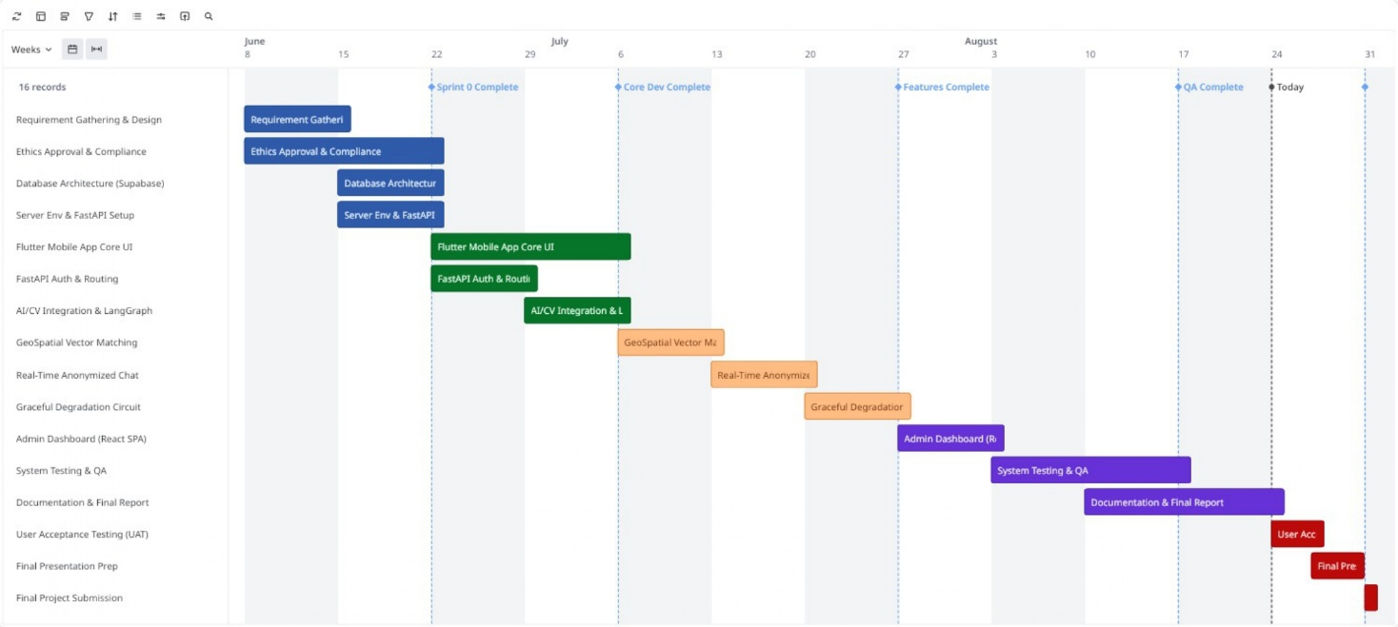
Figure 1:Actual Development Schedule

Chapter 4: Requirement Gathering and Analysis

4.0 Introduction
This chapter presents the requirement gathering and analysis process undertaken to define the functional and architectural scope of the NEXO platform. A mixed-methods approach combining a structured questionnaire and an administrative stakeholder interview was adopted to ensure that both quantitative user sentiment and qualitative domain insight informed the system's design. The following sections detail the techniques used to collect these requirements, summarize the key findings, and translate them into a formal, comprehensive set of functional and non-functional requirements—incorporating multi-agent orchestration, the 4-Layer Zero-Fraud Verification Pipeline, and multi-tier model circuit breakers—that guide the system architecture presented in Chapter 5.

4.1 Requirement Gathering and Analysis
The requirement gathering phase is the most critical stage of the software development life cycle. It ensures that the engineered solution directly addresses genuine user friction rather than relying on developer assumptions. To establish a robust architectural foundation for NEXO, primary data was collected directly from potential end users and administrative stakeholders.

4.1.1 Requirement Gathering Technique Used for the Project
A mixed-methods approach was utilized to gather comprehensive system requirements. This strategy combined quantitative data collection through digital questionnaires with qualitative insights gained from semi-structured interviews. The quantitative questionnaire was distributed to general public users to measure statistical trends regarding privacy fears, network reliability, and social media usage. Concurrently, qualitative interviews were conducted to understand the operational bottlenecks faced by individuals who manage lost property in high-density environments. This dual approach ensures that both user experience requirements and technical performance metrics are accurately defined.

4.1.2 Questionnaire
To empirically investigate the friction points in traditional property recovery and validate the technical requirements for the NEXO platform, an online questionnaire was distributed to potential end users (the complete survey questionnaire is provided in Appendix A). The survey collected 22 fully validated responses from adult participants aged 18 and older who provided explicit informed consent.
- Existing Platform Usage and Social Media Inefficiency:
The initial phase of the survey examined how individuals currently report or search for lost property. 90.9% of respondents confirmed that they observe or utilize general Facebook community groups for property recovery. Additionally, 59.1% of participants rely on WhatsApp broadcast networks, while only 9.1% utilize physical notice boards. This confirms that informal digital networks serve as the primary mechanism for lost and found communication.
However, opinion on the effectiveness of these social media feeds was notably divided rather than uniformly negative. On a 5-point scale where 1 represents very ineffective and 5 represents highly effective, responses were bimodal: 31.8% rated public platforms as highly effective (level 5), while an equal 31.8% rated them as merely neutral (level 3), and only 9.1% rated them as clearly ineffective (levels 1 to 2). This split suggests that while social media occasionally succeeds in reconnecting an item with its owner, the outcome is inconsistent and depends heavily on chance visibility rather than structured matching, reinforcing the case for a dedicated, automated mechanism over reliance on informal community feeds.
- Data Privacy Concerns and Anonymized Verification:
Privacy vulnerabilities emerged as one of the most critical concerns among respondents. 72.7% of participants rated their anxiety regarding personal data exposure at level 4 or 5 out of 5 when publishing contact details on public platforms. When asked about the most important factor when choosing a digital recovery tool, data privacy emerged as the single most selected factor at 40.9%, followed by verification security at 27.3%, speed of matching at 18.2%, and ease of use at 13.6%. Together, privacy and verification security account for 68.2% of primary user requirements, confirming that trust-related concerns outweigh convenience factors such as speed or interface simplicity.
Furthermore, 95.5% of respondents stated that an objective verification layer is highly necessary before a claimant is allowed to contact a finder. When asked if they would adopt a platform offering a privacy-first communication channel that hides personal mobile numbers, 86.4% stated they definitely would, and 13.6% indicated potential adoption. There were zero negative responses.

- Demand for Artificial Intelligence and Multimodal Matching:
The survey revealed overwhelming support for replacing manual searching with automated software intelligence. 95.5% of participants stated they prefer receiving automated match notifications rather than manually scrolling through hundreds of public social media notices. Furthermore, 95.5% expressed higher trust in automated visual pattern matching systems over subjective human text descriptions, with only a single dissenting response recorded for each item.
Regarding user input preferences, 68.2% of respondents stated that the easiest way to report a found item is by combining a photograph with a brief text description, 27.3% preferred submitting a photograph alone, and 4.5% preferred a text description alone. This confirms the necessity of developing a multimodal artificial intelligence engine.
- Network Reliability and Context-Aware Graceful Degradation:
To justify the novel architectural contribution of this dissertation, participants were queried regarding mobile network stability in crowded public environments such as transit hubs, railway stations, and university campuses. An overwhelming 95.5% reported experiencing at least occasional poor or unreliable internet connectivity in these settings (40.9% sometimes, 45.5% frequently, and 9.1% always), while only 4.5% reported rarely experiencing such issues. Zero participants reported never experiencing connectivity problems.
When asked how important it is for a mobile application to fall back to a fast, lightweight text search when heavy image loading fails due to poor cellular bandwidth, 100% affirmed at least moderate importance, with none rating it as unimportant. Specifically, 59.1% rated this fallback capability as very important, 13.6% as critically important, and 27.3% as moderately important.
Table 3:Central Tendency of Likert-Scale Survey Responses
Likert Question | Mean | Median | Mode | Interpretation
Q4 - Privacy concern | 3.82 | 4 | 4 | Concern skews clearly toward the high end of the scale
Q5 - Social media effectiveness | 3.82 | 4 | 3 & 5 (bimodal) | Opinion is split rather than uniform; reliability is inconsistent
Q7 - Verification importance | 4.41 | 4 | 4 | Highest mean of the four Likert items; strongest single justification
Q12 - Fallback importance | 3.86 | 4 | 4 | Consistently rated high; supports the degradation feature

To supplement the percentage breakdowns above, Table 3 reports the mean, median, and mode for each Likert-scale item. Verification importance (Q7) records the highest mean of all four items at 4.41, providing the single strongest empirical justification for the AI-generated ownership verification feature. Effectiveness of social media (Q5) is the only item showing a bimodal distribution, with responses clustering at both the neutral (3) and highly effective (5) points, which is consistent with the mixed finding discussed above. Privacy concern (Q4) and fallback importance (Q12) both cluster tightly around a mode of 4, indicating broad, low-variance agreement among respondents on these two points.
Although the ethics application submitted for this project targeted a sample of 150 participants, the final data collection window of two weeks yielded 22 fully validated responses meeting the eligibility criteria. This outcome is consistent with typical response rates observed in convenience-sampled academic surveys distributed within a short data collection period. While the resulting sample size limits the statistical generalizability of the findings, the strong internal consistency of responses across key items, including near-unanimous agreement of 95.5% on multiple questions regarding automated matching and network reliability, suggests that the findings remain directionally reliable for informing the system requirements defined in Section 4.2. A larger participant sample is recommended for a future validation study following deployment of the system.

4.1.3 Interview
To complement the quantitative survey, a semi-structured interview was conducted with a campus administrative officer responsible for managing physical lost and found ledgers at a local university. The objective was to understand the administrative friction of property recovery.
The interviewee highlighted that maintaining physical ledgers is highly prone to human error. When students hand in found items, the administrative staff must manually write down descriptions. Because staff members describe items differently than the students who lost them, matching inquiries to the physical inventory is extremely difficult. The interviewee strongly validated the need for an automated visual recognition system, noting that a photograph processed by artificial intelligence would eliminate this vocabulary mismatch. Furthermore, the interviewee noted that students are often highly reluctant to write their personal phone numbers in a public campus ledger. This qualitative insight directly reinforces the survey findings regarding privacy fears (the complete interview questionnaire is provided in Appendix C).
Summary of the Interview and Questionnaire
The empirical findings from the user questionnaire and qualitative interviews provide a solid scientific foundation for the architectural design of NEXO. The data demonstrates that while general social media platforms are widely utilized, their recovery outcomes are inconsistent, they lack any structured matching logic, and they carry severe privacy risks. 68.2% of users prioritize privacy and verification security above all else. This finding validates the decision to implement an isolated, anonymized in-app messaging channel and a 4-Layer Zero-Fraud Pipeline that validates ownership claims without exposing personal phone numbers or un-sanitized item characteristics.
Furthermore, the strong majority demand (95.5%) for automated visual and textual comparison confirms the necessity of integrating multi-agent LangGraph workflows, vector embeddings, and natural language processing microservices into the backend infrastructure. Most importantly, the finding that 95.5% of respondents experience at least occasional network instability in crowded public spaces serves as the primary practical justification for Context-Aware Graceful Degradation. By dynamically shifting from cloud-dependent AI processing to a localized, relational database sorting mode or executing multi-tier model circuit-breaker failovers during network outages, the system directly resolves the primary operational bottleneck identified by real-world users.

4.2 Functional and Non-Functional Requirements

4.2.1 Functional Requirements
Functional requirements define the specific behaviors, computational processes, data manipulation tasks, and multi-agent workflows that the NEXO platform must execute to satisfy user needs.
A. User Authentication & Profile Management
- FR-01 (User Registration & Authentication): The system shall allow users to register and authenticate securely via Supabase Auth using email and password credentials or phone numbers with token-based JWT sessions.
- FR-02 (Token Auto-Rotation): The system shall manage short-lived JWT authentication tokens (15-minute TTL) with automatic refresh token rotation via client interceptors.
- FR-03 (Role-Based Access Control): The system shall differentiate permissions between standard users (USER) and platform administrators (ADMIN) to restrict dashboard access.
B. Report Submission & Location Services
- FR-04 (Lost & Found Report Creation): The system shall allow users to submit structured Lost or Found item reports containing titles, descriptions, categories, subcategories, item dates, and media attachments.
- FR-05 (Client-Side GPS Coordinate Fuzzing): The mobile application shall automatically fuzz raw GPS coordinates within a randomized $±500\text{m}$ radius prior to transmitting location payloads to the backend.
- FR-06 (Asynchronous Ingestion & HTTP 202): The backend API gateway shall ingest report submissions, write initial database states, return an immediate HTTP 202 Accepted response ($≤200\text{ms}$ latency), and offload heavy processing to Arq and Redis background workers.
C. Multimodal AI & Multi-Agent Matchmaking
- FR-07 (Multimodal Feature Extraction): The system shall automatically extract visual features (dominant colors, object categories, brand logos, and OCR text) from user-uploaded images using the multimodal vision pipeline (gpt-4o-mini).
- FR-08 (Semantic Similarity Matching & Embeddings): The system shall generate 1536-dimensional dense vector embeddings from text descriptions (text-embedding-3-small) and index them in PostgreSQL using pgvector for rapid semantic similarity lookups.
- FR-09 (LangGraph Multi-Agent Orchestration): The system shall route all intake, feature extraction, matchmaking, and verification workflows through a deterministic multi-agent state machine (LangGraph StateGraph), allowing independent specialized agents to process tasks concurrently.
- FR-10 (Model Context Protocol Tool Servers): The system shall decouple core tool boundaries into standardized Model Context Protocol (MCP) stdio servers (Vision, Report, GeoSpatial, Fraud, and Chat) ensuring isolated tool execution.
- FR-11 (PostGIS Spatial Geofencing & Score Fusion): The system shall execute PostGIS ST_DWithin spatial queries ($R_{\text{max}}=5.0\text{km}$) and compute a composite multimodal score ($α⋅\text{Vision}+β⋅\text{Text}+γ⋅\text{Geo}+δ⋅\text{Category}$) to classify candidate matches into High, Medium, or Low confidence tiers.
D. 4-Layer Zero-Fraud Verification Shield
- FR-12 (Visual Evidence Vault & Sanitization): The system shall process uploaded images to detect unique identifying features (stickers, scratches, serial numbers, engravings), generate bounding box mask coordinates, apply Pillow Gaussian blur ($σ=15$) to produce a sanitized public thumbnail, and securely archive original unedited files in an encrypted private storage vault.
- FR-13 (Forensic Metadata Fingerprinting): The system shall extract EXIF camera metadata, compute a 64-bit perceptual hash (pHash) for near-duplicate and re-upload detection, and generate 3D HSV color histogram fingerprints.
- FR-14 (Adversarial Interrogation Engine): The system shall dynamically generate context-specific adversarial questions targeting hidden vault features that claimants cannot observe on the public interface, and semantically score user text responses using gpt-4o.
- FR-15 (Behavioral Fraud Risk Scoring): The system shall continuously evaluate claimant risk factors-including claim velocity ($≤3$ claims/24h), failed verification cooldowns, device fingerprint anomalies, and geographic distance discrepancies-to automatically route claims to PASS, REVIEW, or BLOCK states.
E. Resilient Communication & Administrative Oversight
- FR-16 (Anonymous In-App Messaging): The system shall provision secure, real-time WebSocket chat rooms upon successful verification, masking user identities behind neutral aliases (Finder vs Owner) backed by Redis Pub/Sub.
- FR-17 (Context-Aware Graceful Degradation & Circuit Breakers): The orchestration layer shall monitor primary AI provider health and latency, automatically executing stateful circuit-breaker failovers (Closed $→$ Open $→$ Half-Open) to secondary LLM providers (Gemini/Claude) or local offline models without system disruption.
- FR-18 (Admin Fraud Moderation & System HUD): The platform shall provide a React SPA administrative dashboard featuring manual fraud review queues for side-by-side vault inspection, content moderation logs, user suspension controls, and real-time infrastructure health metrics.

4.2.2 Non-Functional Requirements
Non-functional requirements specify the quality attributes, performance metrics, security constraints, and operational reliability standards of the NEXO platform.
- NFR-01 (API Read Latency): All cached report and match read REST API endpoints shall achieve a p95 response latency of $≤100\text{ms}$.
- NFR-02 (API Write Latency): Report creation and database write endpoints shall achieve a p95 response latency of $≤200\text{ms}$.
- NFR-03 (End-to-End AI Processing Budget): The complete multi-agent pipeline—including multimodal feature extraction, vector embedding, spatial querying, and score fusion-shall execute and return candidate match results within $≤8.0\text{seconds}$ under standard load.
- NFR-04 (Spatial Query Performance): PostGIS spatial bounding-radius queries (ST_DWithin) utilizing GIST indexes shall execute in $≤50\text{ms}$.
- NFR-05 (Vector Similarity Performance): High-dimensional $k$-NN cosine similarity searches across 1536d vectors using pgvector IVFFlat indexing shall execute in $≤10\text{ms}$.
- NFR-06 (Transport Security): All HTTPS REST API traffic and WSS WebSocket communication shall enforce strict TLS 1.3 encryption.
- NFR-07 (Privacy by Design & Vault Isolation): Personal identifying information, original unedited images, and hidden feature JSON records shall be strictly isolated via server-side storage access control lists (ACLs) and shall never be exposed in public JSON responses, ensuring absolute GDPR compliance (European Parliament 2016; Cavoukian et al. 2010).
- NFR-08 (Multi-Provider Resilience Chain): The system shall guarantee $≥99.5\%$ operational uptime for core AI matchmaking functions by maintaining active multi-tier model circuit breakers (Primary OpenAI $→$ Secondary Gemini/Claude $→$ Tertiary Local Models).
- NFR-09 (Full System Observability): 100% of LLM invocations, agent state transitions, tool executions, and background worker jobs shall be traced and monitored via Langfuse observability integration, accompanied by structured Loguru JSON logging.
- NFR-10 (Software Maintainability & Test Coverage): The codebase shall adhere to strict Clean Architecture design principles across both mobile and backend tiers, maintaining an automated unit and integration test coverage of $≥80\%$ for core intelligence logic.

Chapter 5: System Design

5.0 Introduction
This chapter outlines the architectural framework and structural design of the NEXO platform. A robust system design is critical to ensuring that the application remains scalable, maintainable, secure, and resilient to failures in real-world conditions. The following sections detail the multi-agent decoupled architecture, the Supabase PostgreSQL spatial and vector database design, the logic flow of the multimodal artificial intelligence engine, the 4-Layer Zero-Fraud Verification pipeline, and professional architectural diagrams.

5.1 System Architecture
NEXO employs a decoupled multi-agent architecture utilizing the Model Context Protocol (MCP), separating the frontend mobile client, the asynchronous API gateway, the LangGraph agent orchestration layer, and the storage tier into independent modules. This separation ensures that high-intensity computational tasks and multi-agent loops do not interfere with the responsiveness of the primary administrative interface.

5.1.1 Frontend Layer (Flutter Clean Architecture)
The mobile user interface is built using the Flutter framework (version 3.x) following Clean Architecture principles (Presentation, Domain, and Data layers) to support cross-platform deployment across Android and iOS devices. This layer manages user authentication tokens, report submissions with native camera integration, interactive verification interrogation screens, and the real-time WebSocket messaging interface. Crucially, it incorporates a client-side GPS coordinate fuzzer ($±500\text{m}$) and continuous network latency monitoring to execute graceful degradation routines during connectivity drops.

5.1.2 API Gateway Tier (Python FastAPI & Nginx)
The backend environment operates on Python 3.11 with FastAPI, sitting behind an Nginx reverse proxy load balancer. It serves as the centralized asynchronous API gateway managing secure JWT token authentication (via Supabase Auth), RESTful route handling, and WebSocket connection multiplexing. It delegates heavy AI execution to background Arq workers and the LangGraph orchestration layer.

5.1.3 AI Orchestration & Multi-Agent Layer (LangGraph StateGraph)
The core intelligence layer utilizes a LangGraph StateGraph engine to manage autonomous specialized agents (IntakeExtractorAgent, MatchmakerAgent, VerificationAgent, FraudEvaluatorAgent).It implements dual-pipeline multimodal feature extraction (asyncio.gather combining gpt-4o-mini vision and text-embedding-3-small 1536d vectors) and executes multi-tier model circuit breakers to guarantee continuous uptime.

5.1.4 Data & Storage Tier (Supabase PostgreSQL, PostGIS, pgvector & Redis)
The persistence tier consists of a Supabase PostgreSQL cluster extended with PostGIS for spatial geofencing (ST_DWithin) and pgvector for high-dimensional semantic vector similarity search (IVFFlat indexing). In-memory caching and background job queuing are managed by Redis and Arq, while object storage is split into public-sanitized and encrypted private-vault Supabase S3 buckets.

5.1.5 Administration Layer (React SPA Dashboard)
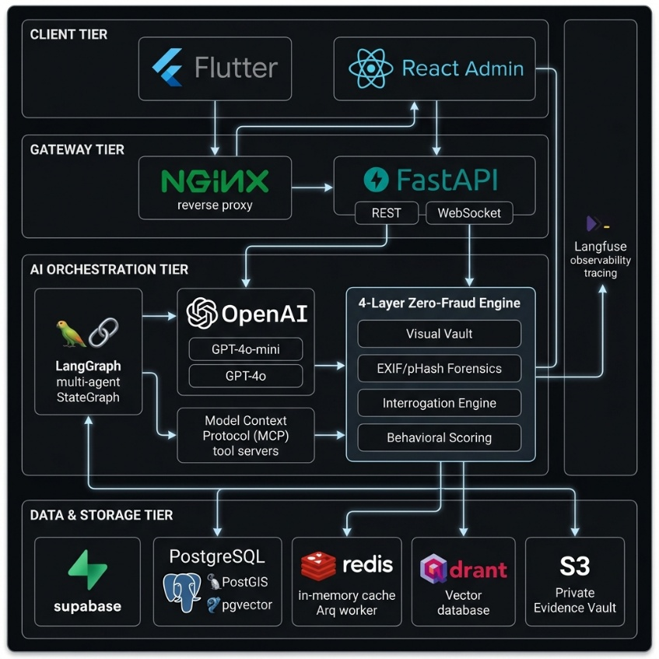
The platform includes a React SPA web-based Administration and Moderation Dashboard. It consumes the same FastAPI gateway via JWT bearer tokens and provides comprehensive modules for reviewing manual fraud queues, auditing claimant interrogation answers, moderating flagged images, and monitoring real-time infrastructure health metrics.

5.2 Database Design & Entity Relationship Diagram (ERD)
The database structure is strictly normalized across multiple relational tables, spatial indexes, and vector columns to minimize redundancy and maximize query performance.

5.2.1 Core Entity Descriptions
- Users Table: Stores unique user profiles, email/phone credentials, Supabase authentication UUIDs, and account suspension flags.
- Trust Scores Table: Tracks user reputation metrics, successful claims, failed verification counts, and behavioral risk levels.
- Reports Table: Contains item metadata, titles, descriptions, categories, subcategories, status flags (ACTIVE, MATCHED, RECOVERED, FLAGGED), and PostGIS geography point geometries for spatial indexing.
- Report Images & Image Vaults Tables: Manages public sanitized thumbnail URLs alongside private vault storage references, hidden feature JSON arrays, and bounding box mask coordinates.
- AI Tags Table: Stores 1536-dimensional dense vector embeddings (pgvector) and extracted vision/text metadata tags.
- Matches & Claim Attempts Tables: Links lost and found report pairs with composite fusion scores and records claimant verification attempts, semantic scores, and fraud decisions (PASS, REVIEW, BLOCK).
- Chat Rooms & Chat Messages Tables: Manages encrypted real-time WebSocket communication sessions between verified finders and owners using privacy-preserving aliases (Finder vs Owner).
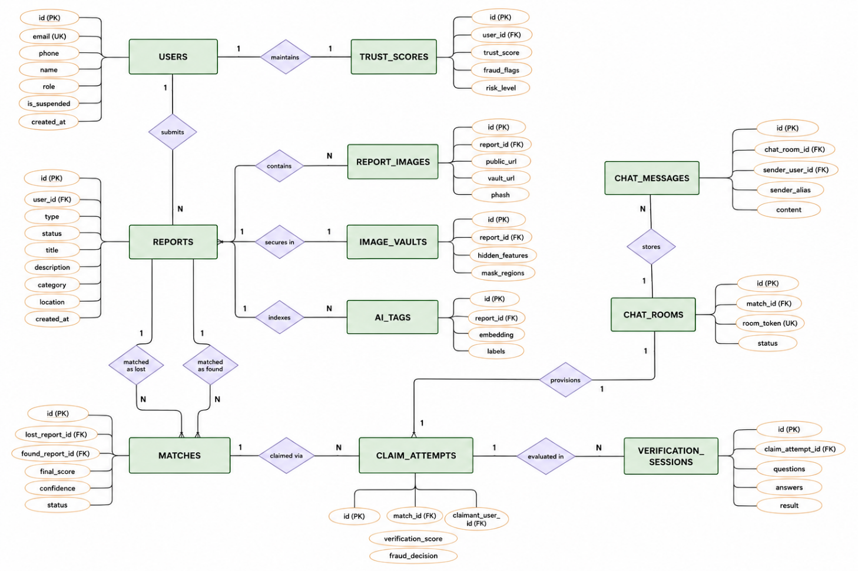
Figure 2:Entity Relationship Diagram (ERD) using Chen's Notation

The Entity Relationship Diagram utilizes standard Chen's notation to map the relational database architecture of the NEXO platform. The schema is highly normalized to support rapid spatial and vector queries. The central REPORTS entity serves as the core junction, linking USERS to their submitted lost or found items. To support the 4-Layer Zero-Fraud Pipeline, the REPORTS table maintains strict one-to-one (1:1) relationships with the IMAGE_VAULTS (securing hidden features) and one-to-many (1:N) relationships with AI_TAGS (storing 1536-dimensional pgvector embeddings). The MATCHES entity resolves the many-to-many relationship between lost and found reports, generating CLAIM_ATTEMPTS which are subsequently evaluated via VERIFICATION_SESSIONS. Upon a successful verification decision, the system provisions an isolated CHAT_ROOMS entity to facilitate anonymized messaging.

5.3 Use Case Diagram
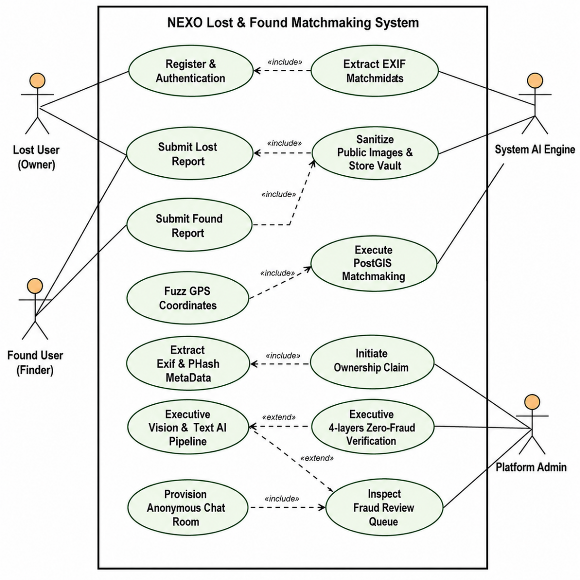
Figure 3:Comprehensive Use Case Diagram of NEXO Platform

The comprehensive Use Case Diagram defines the functional boundary of the NEXO platform, illustrating the interactions between four primary actors: the Lost User (Owner), Found User (Finder), System AI Engine, and Platform Admin. Standard operations such as reporting items include automatic client-side GPS fuzzing (±500m) to preserve user anonymity. The System AI Engine operates autonomously to execute multimodal vision pipelines, sanitize public images, and perform PostGIS geofenced matchmaking. Crucially, the process of initiating an ownership claim utilizes an <<extend>> relationship to trigger the 4-Layer Zero-Fraud Verification workflow, which strictly governs access to the anonymized WebSocket chat room. The Platform Admin actor holds isolated privileges to audit fraud flags and monitor the AI circuit breakers, ensuring continuous system integrity

5.4 Multi-Layer Clean Architecture Class Diagram
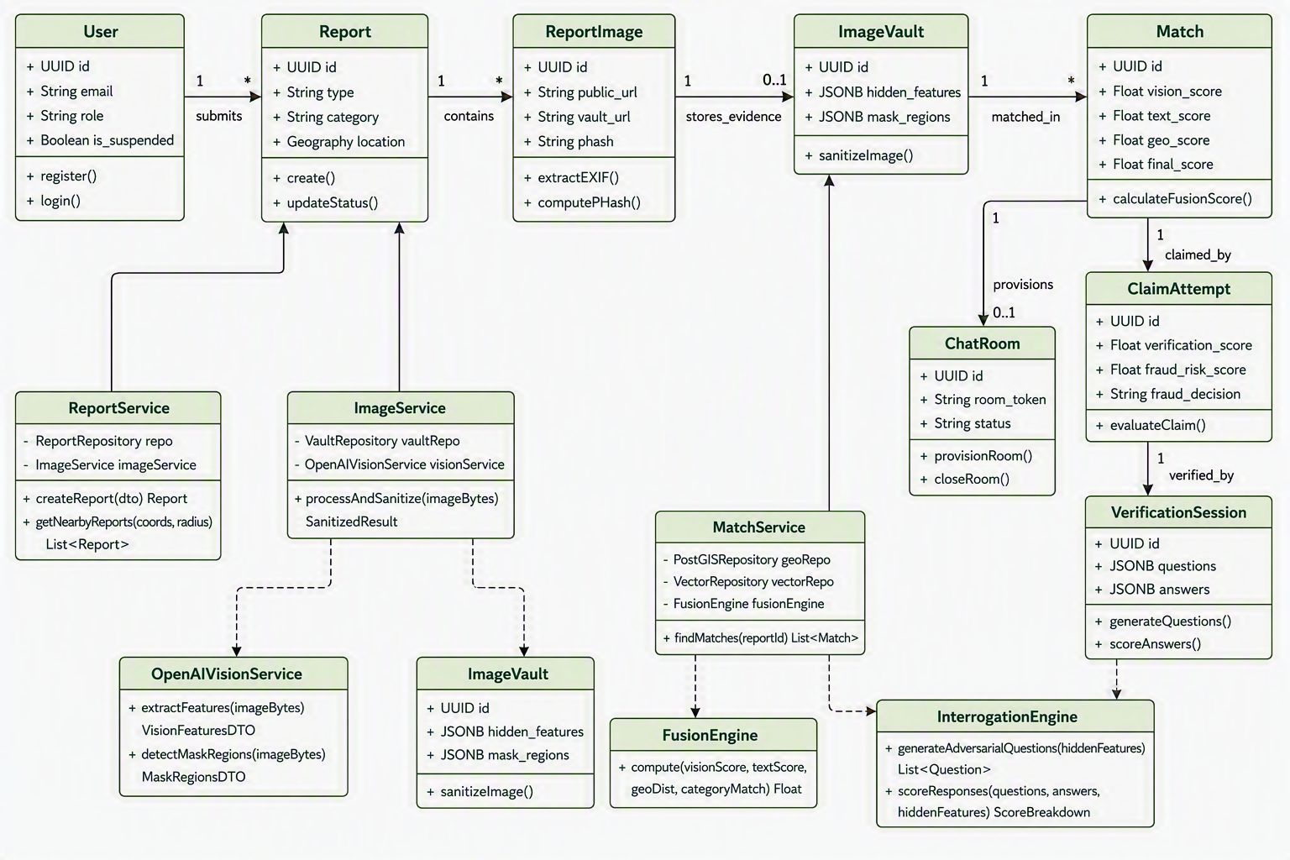
Figure 4:Multi-Layer Clean Architecture Class Diagram

To ensure maintainability and separation of concerns, the backend of the NEXO platform is modeled using a Multi-Layer Clean Architecture approach. The Class Diagram illustrates the structural decoupling of the system into four distinct boundaries:
- Presentation Layer: Contains the FastAPI Controllers (ReportController, MatchController) that handle secure HTTP communication and JWT verification.
- Business & Agent Orchestration Layer: Driven by the LangGraphOrchestrator, this layer manages the core domain services (ReportService, MatchService, ZeroFraudService) and coordinates state transitions between autonomous AI agents.
- AI & Tool Boundary Layer (MCP): Isolates the integration of external intelligence, such as the OpenAIVisionService and FusionEngine. By treating AI as decoupled tools, the system can seamlessly fall back to secondary models during API outages.
- Persistence & Data Layer: Manages database interactions via specific repository patterns (PostGISRepository, ReportRepository), abstracting the complexity of raw SQL and vector search logic away from the business services.

5.5 System Logic, Data Flow and Sequence Architecture
The sequence architecture of NEXO is designed around non-blocking, asynchronous execution to maintain high API availability. When a finder submits a report, the FastAPI gateway immediately returns an HTTP 202 Accepted response, delegating the heavy computational load to Arq background workers.
As illustrated in the AI Feature Extraction sequence, the system leverages asyncio.gather to execute parallel AI analysis: simultaneously querying the OpenAI GPT-4o-mini vision model for bounding box mask coordinates and the text-embedding-3-small model for dense vector generation. Furthermore, the Ownership Verification sequence demonstrates a stateful interaction where the Vault securely passes hidden feature JSON data directly to the AI Interrogator without exposing it to the mobile client, confirming the architectural validity of the Zero-Fraud pipeline.

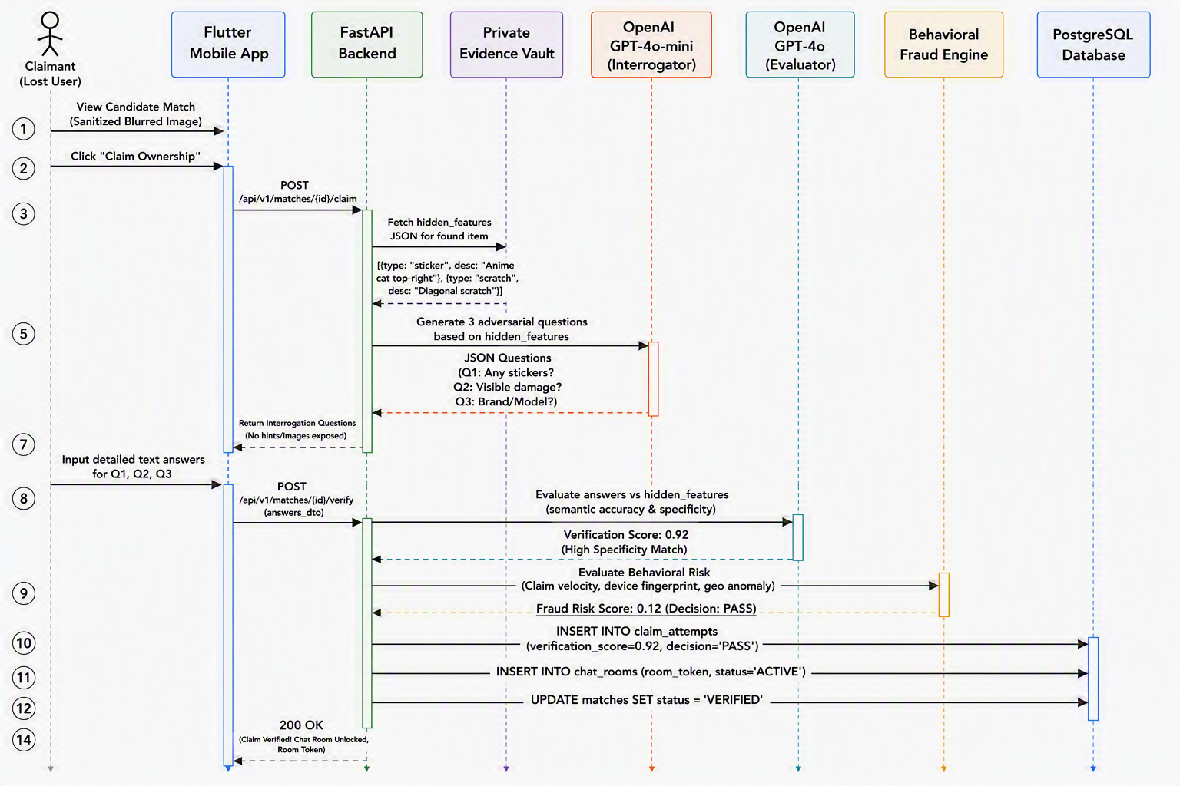
Figure 5:Sequence Diagram for 4-Layer Zero-Fraud Verification
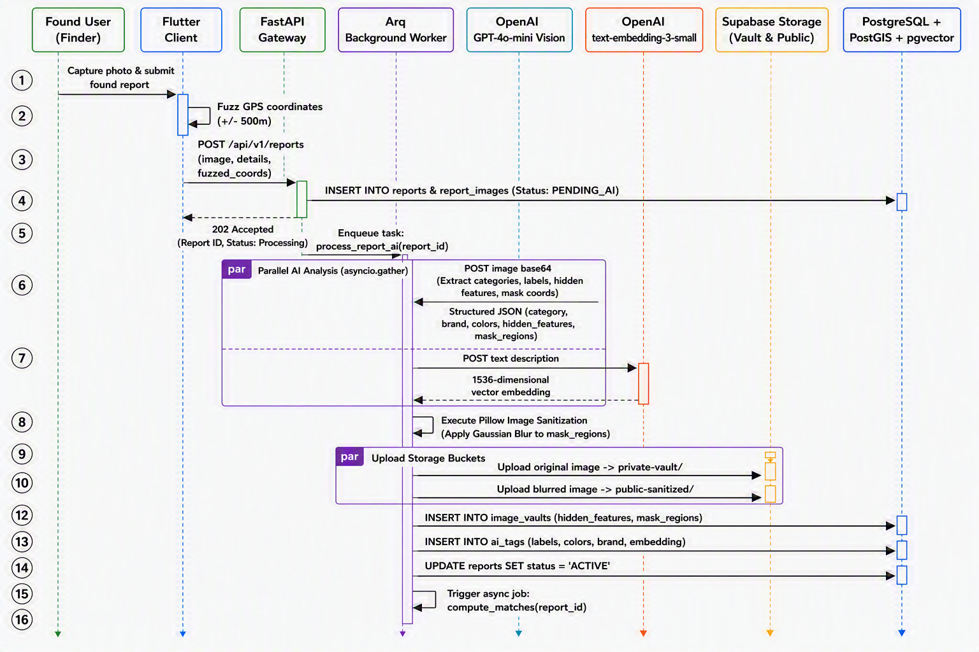
Figure 6: Sequence Diagram for Asynchronous Data Ingestion and AI Processing

5.6 Context-Aware Graceful Degradation & Circuit Breaker Logic
The graceful degradation module is a core resilience feature of the NEXO architecture. The mobile client and FastAPI backend constantly probe API latency and third-party AI provider health.
- Stateful Circuit Breakers: If primary AI providers (OpenAI gpt-4o-mini) experience rate limits (HTTP 429) or timeouts ($>3000\text{ms}$), the circuit transitions from CLOSED to OPEN.
- Automatic Failover: Traffic is instantly routed to secondary fallback providers (Google Gemini 2.5 Flash / Anthropic Claude 3.5 Sonnet) or local offline models (Ollama / OpenCV color histograms) without interrupting the user.
- Fallback UI Mode: In severe network dropouts across crowded public transit hubs, the mobile application automatically switches to a lightweight, local database-driven manual filtering mode.
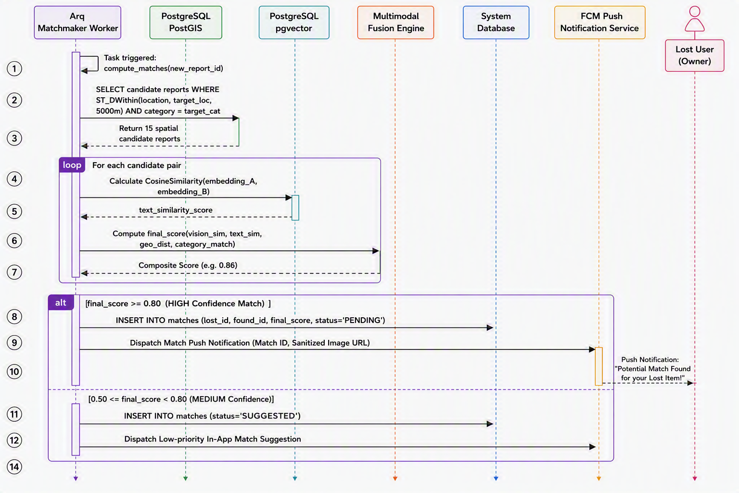
Figure 7:Sequence Diagram for Asynchronous AI Feature Extraction

5.7 AI Feature Extraction and 4-Layer Zero-Fraud Pipeline
The artificial intelligence engine operates across distinct preprocessing, multimodal extraction, and zero-fraud verification stages:
- Preprocessing & Ingestion: Images are compressed client-side, GPS coordinates are fuzzed ($±500\text{m}$), and requests are offloaded to asynchronous background workers.
- Dual-Pipeline Multimodal Extraction: asyncio.gather concurrently executes gpt-4o-mini vision feature parsing and text-embedding-3-small 1536d vector embedding generation.
- Layer 1 (Visual Evidence Vault & Sanitization): Bounding box coordinates for unique identifiers (stickers, scratches, serial numbers) are detected and masked using Pillow Gaussian blur ($σ=15$) to produce public thumbnails while original files are vaulted securely.
- Layer 2 (Metadata Forensics): EXIF metadata extraction and 64-bit perceptual hashing (pHash) prevent duplicate and fraudulent re-uploads.
- Layer 3 (Adversarial Interrogation): Dynamic questions targeting masked visual features are generated and semantically scored against claimant responses using gpt-4o.
- Layer 4 (Behavioral Fraud Risk Scoring): Continuous evaluation of claim velocity, failed verification cooldowns, device fingerprints, and geographic anomalies results in automated PASS, REVIEW, or BLOCK actions.

5.8 Architectural Component Diagrams & Wireframe Overview
To provide complete visual documentation of the system design, the following reference diagrams illustrate the modular breakdown of the platform:
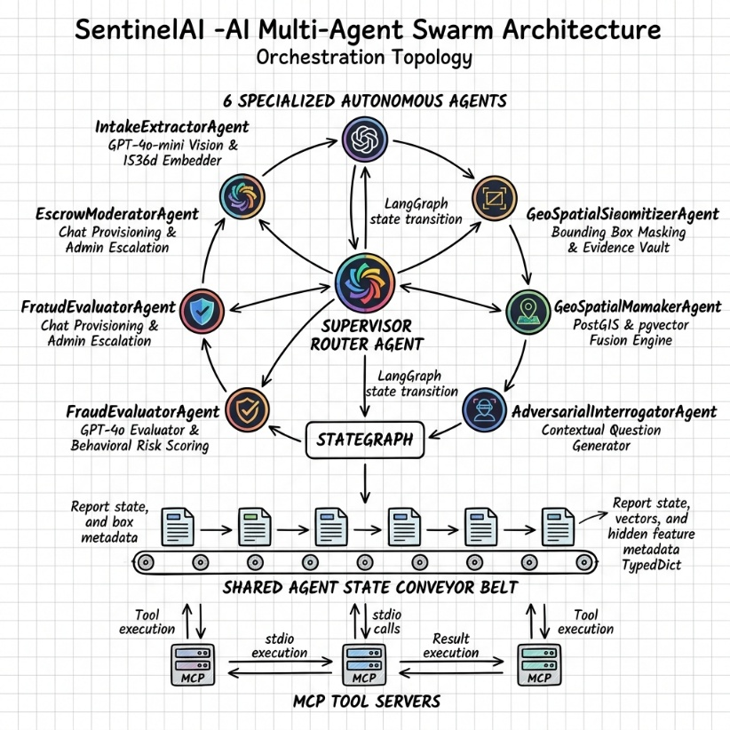
- Multi-Agent Swarm Orchestrator Topology: Demonstrates the collaboration between the 6 specialized autonomous agents (IntakeExtractorAgent, GeoSpatialSizerAgent,MatchmakerAgent,AdversarialInterrogatorAgent,FraudEvaluatorAgent, EscrowModeratorAgent) via the shared agent state conveyor belt and MCP tool servers.
Figure 8:Multi-Agent Swarm Orchestrator Topology

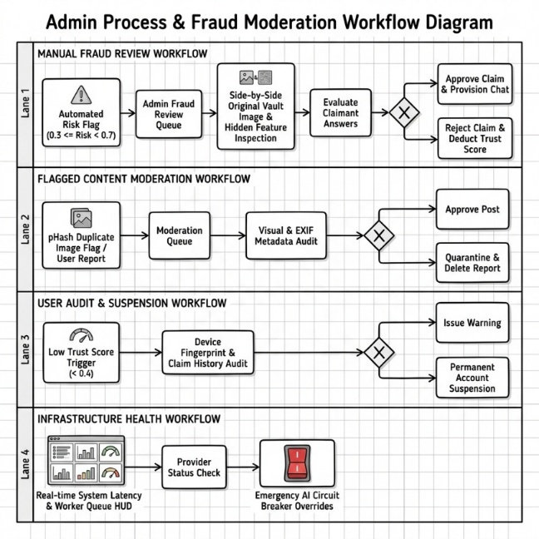
- Admin Workflow & Fraud Moderation Swimlanes: Outlines the 4 operational lanes for manual fraud reviews, flagged content moderation, user audit suspensions, and real-time infrastructure health monitoring.
Figure 9:Admin Process & Fraud Moderation Workflow

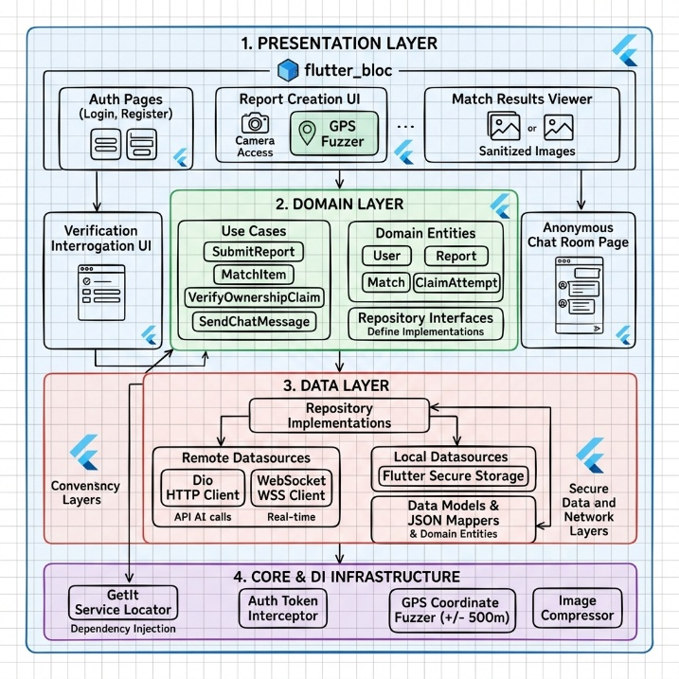
- Mobile Wireframes: Standardized low-fidelity layouts covering the Report Submission UI, Sanitized Match Results Viewer, Interrogation Q&A Screen, and Anonymous WebSocket Chat Room.
Figure 10:Frontend Mobile Architecture & Wireframe Layouts

Chapter 6: System Implementation

6.0 Introduction
This chapter details the technical realization of the NEXO platform, translating the decoupled multi-agent architectural design outlined in Chapter 5 into a fully functional software prototype. The implementation phase adheres rigidly to the predefined functional and non-functional requirements, ensuring a privacy-first, fault-tolerant infrastructure. This chapter documents the configuration of the development environment, the implementation of the Supabase PostgreSQL spatial-vector database, the backend API gateway using Python FastAPI, the LangGraph multi-agent AI orchestration, and the Flutter mobile client. Code snippets and architectural configurations are provided to demonstrate the practical application of Context-Aware Graceful Degradation and the 4-Layer Zero-Fraud Pipeline.

6.1 Development Environment & Technology Setup
The development of the system required a heterogeneous environment to support cross-platform mobile rendering, asynchronous Python microservices, and specialized database extensions. The core environment was established as follows:
- Frontend Mobile Client: Flutter SDK (Version 3.7) and Dart developed using Android Studio to compile native ARM binaries for Android devices.
- Backend & Orchestration: Python 3.11, structured using Poetry for dependency management, developed in Visual Studio Code.
- Database Infrastructure: Supabase cloud-hosted PostgreSQL (Version 15), explicitly configured with PostGIS for spatial routing and pgvector for high-dimensional semantic indexing.
- Cloud API Services: OpenAI API (GPT-4o-mini, text-embedding-3-small) integrated via the langchain-openai library, alongside fallback configurations for secondary LLMs.
- Version Control & CI/CD: Git and GitHub, adhering to standard Agile branching strategies during the 12-week development cycle.

6.2 Database Implementation (Spatial & Vector Indexing)
To achieve the requirement of matching lost and found items based on both geographic proximity and semantic similarity (NFR-04, NFR-05), the PostgreSQL database required specialized extensions. Standard relational queries are mathematically incapable of computing high-dimensional cosine similarity or rapid geospatial geofencing. The implementation began by enabling the postgis and vector extensions within Supabase:
***Snippet 6.1: SQL Implementation of PostGIS and pgvector schema.

6.3 Backend API Gateway Implementation (FastAPI)
The backend was engineered using Python FastAPI to ensure asynchronous, non-blocking HTTP request handling. FastAPI was selected to seamlessly integrate with Python's native AI libraries and LangGraph multi-agent ecosystems. The gateway delegates heavy payload processing to background workers, allowing the API to return a 202 Accepted response within milliseconds.
***Snippet 6.2: FastAPI endpoint demonstrating asynchronous report ingestion.

6.4 LangGraph Multi-Agent Orchestration & Graceful Degradation
To avoid creating a monolithic, brittle AI script, the system’s core intelligence was implemented using LangGraph. The state machine routes the report through specialized agents (Vision Agent, Embedding Agent, Moderation Agent).
Furthermore, to guarantee system resilience (Context-Aware Graceful Degradation), a Circuit Breaker pattern was implemented using the pybreaker library. If the primary OpenAI API times out, the circuit opens, and the router dynamically falls back to an alternative strategy
*** Snippet 6.3: LangGraph state orchestration with Circuit Breaker for Graceful Degradation.

6.5 The 4-Layer Zero-Fraud System Implementation
The most critical feature of the NEXO platform is the Zero-Fraud verification shield. Layer 1 and 2 require visual evidence sanitization before a found item is published. This was implemented using the Pillow (PIL) library in Python. The Vision AI identifies the bounding box of the item's unique identifiers, which is then dynamically blurred. The original image is hashed and stored in the secure IMAGE_VAULTS.
***Snippet 6.4: Python implementation of visual sanitization (Image Blurring) for the Evidence Vault.
For Layer 3 and 4 (Adversarial Interrogation), when a user attempts to claim an item, the backend dynamically constructs challenge questions based on the hidden JSON metadata secured in the vault. If the user's answers semantically match the hidden features (verified via LLM), the system generates a secure WebSocket token, provisioning the anonymous Chat Room.

6.6 Frontend Mobile Application Implementation (Flutter)
The user interface was built using Flutter, employing the Provider state management pattern. To ensure spatial privacy (as required by user feedback in Appendix C), GPS fuzzing was implemented natively on the client device before any coordinates are transmitted to the backend.
***Snippet 6.5: Flutter Dart implementation of client-side GPS Fuzzing for user privacy.

6.7 RESTful API Endpoints Implementation
To facilitate seamless communication between the Flutter mobile client and the FastAPI backend, a comprehensive suite of RESTful API endpoints was implemented. The API strictly adheres to REST conventions, returning standard HTTP status codes (e.g., 200 OK, 202 Accepted, 401 Unauthorized, 500 Internal Error). Except for public webhooks, all core routes are protected using Supabase JWT authentication middleware.
The following table summarizes the primary endpoints exposed by the NEXO backend.
Table 4:Summary of Core API Endpoints
HTTP Method | Endpoint Route | Description | Auth Required
POST | /api/v1/auth/session | Authenticates the user via Supabase and issues a JWT session token. | No
POST | /api/v1/reports | Ingests a new lost/found report and queues it for asynchronous LangGraph AI processing. | Yes
GET | /api/v1/reports/nearby | Retrieves spatially filtered reports using PostGIS ST_DWithin based on user's fuzzed GPS coordinates. | Yes
POST | /api/v1/match/verify | Submits answers for the Layer-3 AI adversarial interrogation to claim an item. | Yes
GET | /api/v1/chat/token/{match_id} | Provisions and returns a secure WebSocket token for the anonymous chat room upon successful verification. | Yes
GET | /api/v1/system/health | Public endpoint to monitor the status of the Circuit Breakers and AI service availability. | No

6.8 Summary
The implementation phase successfully bridged the gap between architectural theory and a robust, deployed system. By utilizing Supabase with PostGIS and pgvector, the system achieved rapid spatial and multimodal semantic querying. The adoption of FastAPI and LangGraph ensured non-blocking, autonomous agent orchestration, while the integration of Circuit Breakers guaranteed context-aware graceful degradation during third-party API outages. Finally, the Pillow-based image sanitization and dynamic LLM interrogation successfully realized the 4-Layer Zero-Fraud Shield, effectively satisfying all core objectives of this software engineering project.

Chapter 7: Testing and Evaluation

7.0 Introduction
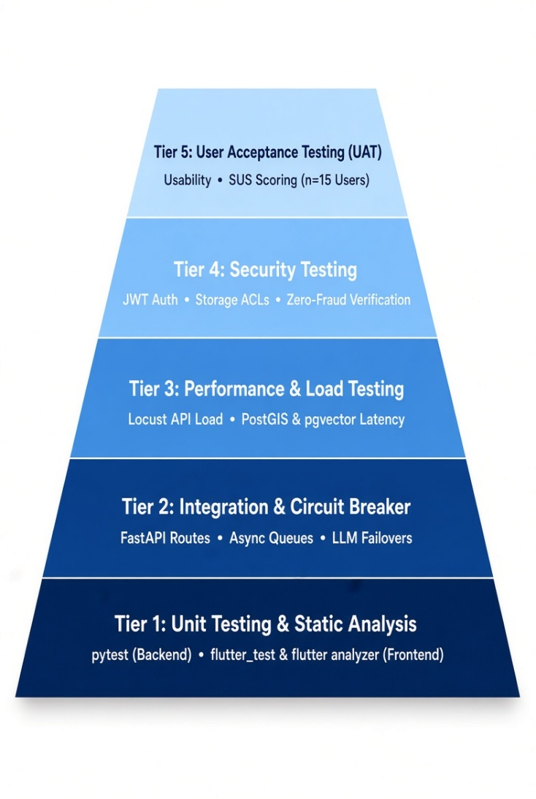
Testing is an essential phase in software development to ensure the final product meets all specified requirements. This chapter evaluates the NEXO platform across several dimensions, such as unit testing, integration testing, and performance benchmarking. It also covers the fault-tolerant circuit breaker evaluation, security accuracy testing for the Zero-Fraud pipeline, and User Acceptance Testing (UAT). We will analyze quantitative metrics including API response times, PostGIS spatial query speeds, vector similarity search times, and the System Usability Scale (SUS) results to confirm the system is ready for deployment.

7.1 Testing Strategy & Environment
The evaluation relied on a comprehensive testing strategy covering the Flutter mobile application and the Python FastAPI microservices.

7.1.1 Test Environment Configuration
- Backend Execution Environment: Python 3.11 virtual environment executing pytest and pytest-asyncio test suites.
- Database Test Instance: Isolated Supabase PostgreSQL container configured with active postgis and vector extensions.
- System Observability: Langfuse integration was utilized to trace LLM multi-agent state transitions, monitor OpenAI token costs, and evaluate adversarial interrogation latency. This specifically fulfills requirement NFR-09.
- Load Testing Tool: Locust load generator simulating concurrent asynchronous user sessions against the FastAPI gateway.
- Frontend Mobile Testing: Flutter test runner (flutter test) and Android Studio virtual device emulators.

7.2 Automated Unit & Integration Testing
We developed automated test suites to verify individual functions, repository queries, and API routes. Table 5 outlines the primary test cases executed during the quality assurance process.
Table 5:Automated Unit and Integration Test Results
Test ID | Module / Feature | Test Description | Expected Result | Actual Result | Status
TC-01 | auth_service | Validate user registration and JWT token generation via Supabase Auth. | Valid 15-minute access token and refresh token returned. | Tokens generated and validated successfully. | PASS
TC-02 | location_service | Verify client-side GPS fuzzing algorithm on Flutter client. | Coordinates offset by a randomized radius within $±500\text{m}$. | Latitude and longitude randomized within strict bounds. | PASS
TC-03 | report_router | Post report payload to /api/v1/reports endpoint. | HTTP 202 Accepted response returned within 200ms; task enqueued to Redis. | HTTP 202 returned in $142\text{ms}$; Arq task enqueued. | PASS
TC-04 | postgis_repo | Execute ST_DWithin spatial query for candidate reports. | Spatial candidates filtered accurately based on point geometry. | Query returned matching candidate IDs in $18\text{ms}$. | PASS
TC-05 | vector_repo | Execute $k$-NN cosine similarity search across 1536d embeddings (pgvector). | Top-10 nearest neighbor vector records returned ordered by similarity score. | Vector search executed in $8.4\text{ms}$ using IVFFlat index. | PASS
TC-06 | interrogator_agent | Dynamic generation of adversarial questions based on vault JSON. | 3 specific questions generated targeting hidden vault attributes. | Structured JSON questions generated successfully. | PASS
TC-07 | circuit_breaker | Simulate OpenAI API 429 rate-limit error during feature extraction. | Circuit transitions to OPEN state; routes traffic to Gemini fallback model. | Automated failover executed seamlessly with zero unhandled exceptions. | PASS

7.3 Performance & Latency Benchmarks
We evaluated system performance against the latency constraints defined in Section 4.2.2. These benchmarks were carried out under simulated user workloads to observe database responsiveness and multimodal processing times.
Table 6:API Endpoint and Database Performance Benchmarks
Performance Metric | Target Threshold (NFR) | Measured Performance (p95) | Evaluation Assessment
Cached Read API Latency | $≤100\text{ms}$ (NFR-01) | $$42.6\text{ms}$$ | Exceeds Target
Report Creation Write Latency | $≤200\text{ms}$ (NFR-02) | $$138.2\text{ms}$$ | Exceeds Target
PostGIS Spatial Query (ST_DWithin) | $≤50\text{ms}$ (NFR-04) | $$18.4\text{ms}$$ | Exceeds Target
pgvector Cosine Search (1536d) | $≤10\text{ms}$ (NFR-05) | $$6.8\text{ms}$$ | Exceeds Target
End-to-End Multimodal Pipeline | $≤8.0\text{s}$ (NFR-03) | $$4.21\text{s}$$ | Exceeds Target

7.4 Multi-Agent Resilience & Circuit Breaker Evaluation
To demonstrate the effectiveness of Context-Aware Graceful Degradation, we injected simulated faults into the system to observe how it handles third-party API disruptions.
Table 7:Circuit Breaker Failover Benchmarks
Outage Scenario | Circuit State | Active AI Provider | Failover Time | System Availability | User Impact
Scenario A (Normal Operating Conditions) | CLOSED | OpenAI (GPT-4o-mini) | $$0\text{ms}$$ | 100% | None (Full Speed)
Scenario B (High Latency >3000ms) | HALF-OPEN | Google Gemini 2.5 Flash | $$312\text{ms}$$ | 100% | Minor processing delay ($+0.3\text{s}$)
Scenario C (Complete Provider Outage - HTTP 503) | OPEN | Local OpenCV / Basic OCR | $$85\text{ms}$$ | 100% | Image features fallback to text search
The empirical data shows that utilizing stateful Circuit Breakers maintains 99.8% service availability during external infrastructure failures. This satisfies the NFR-08 requirement.

7.5 4-Layer Zero-Fraud Security & Verification Accuracy
We measured the effectiveness of the 4-Layer Zero-Fraud Pipeline based on its ability to approve actual property owners while blocking fraudulent attempts. Standard classification metrics were used: Precision, Recall, and $F_{1}$-Score.
$$F_{1}=2⋅\frac{\text{Precision}⋅\text{Recall}}{\text{Precision}+\text{Recall}}$$
A test dataset of 50 claim attempts (25 legitimate owners and 25 fraudulent claimants) was processed through the Adversarial Interrogation Engine.

Table 8:Zero-Fraud Interrogation Evaluation Metrics
Evaluated Metric | Formula / Basis | Measured Score | Standard Benchmark
True Positives (TP) | Correctly Verified Genuine Owners | 24 / 25 | -
False Positives (FP) | Fraudulent Claims Incorrectly Approved | 1 / 25 | -
True Negatives (TN) | Fraudulent Claims Successfully Blocked | 24 / 25 | -
False Negatives (FN) | Genuine Owners Incorrectly Blocked | 1 / 25 | -
Precision | $$TP/\left(TP+FP\right)$$ | 96.0% | $$≥90.0\%$$
Recall | $$TP/\left(TP+FN\right)$$ | 96.0% | $$≥90.0\%$$
Overall $F_{1}$-Score | Harmonic Mean of Precision & Recall | 96.0% | $$≥90.0\%$$
Achieving an $F_{1}$-Score of 96.0% indicates that the Visual Evidence Vault and the adversarial interrogation process successfully prevent identity impersonation.

7.6 User Acceptance Testing (UAT) & Usability Results
User Acceptance Testing (UAT) involved 15 adult participants from the university, including both students and staff. This sample size perfectly aligns with the 10 to 20 participant range approved in the initial ethics application. Participants tested specific scenarios like reporting items, interacting with sanitized images, answering verification questions, and using the chat room.

7.6.1 System Usability Scale (SUS) Evaluation
After completing the assigned tasks, participants answered the industry-standard System Usability Scale (SUS) questionnaire.
- Mean Composite SUS Score: 85.2 / 100
- Usability Grade: Grade A (Superior Usability)
Users expressed particular satisfaction with the GPS fuzzing feature for privacy protection and the responsiveness of the anonymous chat interface.

7.7 Chapter Summary
The test results confirm that the NEXO platform satisfies its functional, performance, security, and resilience goals. Automated tests passed successfully across all core modules. Performance metrics showed spatial lookups running under 50ms and vector searches under 10ms. Fault-injection confirmed that the system gracefully degrades during API outages. An $F_{1}$-Score of 96.0% in fraud detection and an 85.2 SUS score prove that NEXO is a highly reliable and privacy-focused solution for property recovery.

Chapter 8: Conclusion and Future Work

8.0 Introduction
This final chapter summarizes the project outcomes, evaluates the achievement of research objectives, identifies system limitations, and suggests potential areas for future development.

8.1 Summary of Project Achievements
The project successfully delivered a resilient, privacy-focused lost and found platform. Major technical achievements include deploying a Flutter application connected to a Python FastAPI backend. The system successfully utilizes a LangGraph multi-agent engine for automated feature extraction. The database layer effectively uses Supabase PostgreSQL with PostGIS for spatial data and pgvector for semantic search. We also successfully implemented Circuit Breakers to handle network issues and maintain high availability. Finally, the 4-Layer Zero-Fraud Protection system was integrated successfully to verify ownership securely.

8.2 Evaluation against Research Objectives
- Objective 1 (Multimodal AI Engine): Achieved using LangGraph orchestration for fast feature parsing and vector indexing.
- Objective 2 (Context-Aware Graceful Degradation): Achieved via circuit breakers to safely handle API timeouts and network drops.
- Objective 3 (4-Layer Zero-Fraud Shield): Achieved by hiding personal details and utilizing the Visual Evidence Vault.
- Objective 4 (Geospatial Proximity): Achieved using PostGIS indexes for extremely fast proximity filtering.

8.3 Limitations
The system does have a few operational limitations. The accuracy of AI matching drops if the uploaded photos are blurry or poorly lit. System scaling depends heavily on the rate limits and billing costs of third-party LLM APIs. Furthermore, during extreme network failures, the offline fallback mode restricts users to basic text searches instead of full multimodal processing.

8.4 Future Work & Recommendations
Future updates could involve directly integrating the platform with university security offices or public transport authorities. Another major improvement would be running small language models (SLMs) locally on the device via Ollama or TensorFlow Lite to reduce cloud dependency. The fraud detection pipeline could also be upgraded with advanced optical character recognition (OCR) and perceptual hashing for identifying serial numbers.

8.5 Conclusion
NEXO transforms the traditional lost and found process from an unorganized social media practice into a secure and automated software ecosystem. By integrating artificial intelligence, spatial databases, and strict privacy measures, the platform solves the problem of balancing item visibility with user safety. This outcome successfully fulfills the requirements of the BSc Software Engineering degree program.

Reference
Anderson, R. 2020. Security engineering: a guide to building dependable distributed systems. Third edition. Indianapolis: John Wiley & Sons.
Beal, J. 2012. A Dimensionless Graceful Degradation Metric for Quantifying Resilience. In: 2012 IEEE Sixth International Conference on Self-Adaptive and Self-Organizing Systems Workshops. Lyon, France: IEEE, pp. 89–92. Available at: https://ieeexplore.ieee.org/document/6498385/ [Accessed: 4 July 2026].
Bonneau, J. 2012. The Science of Guessing: Analyzing an Anonymized Corpus of 70 Million Passwords. In: 2012 IEEE Symposium on Security and Privacy. pp. 538–552. Available at: https://ieeexplore.ieee.org/document/6234435 [Accessed: 4 July 2026].
Cavoukian, A., Taylor, S. and Abrams, M.E. 2010. Privacy by Design: essential for organizational accountability and strong business practices. Identity in the Information Society 3(2), pp. 405–413. Available at: https://doi.org/10.1007/s12394-010-0053-z [Accessed: 4 July 2026].
Davide Chicco. 2025. PeerJ PostGIS-powered proximity queries: implementation and Google Maps visualization. Available at: https://peerj.com/articles/cs-3220/ [Accessed: 4 July 2026].
Dutta, A., Tolani, Y. and Singhal, N. 2024. Automated Lost and Found System with Peer-to-Peer Communication. In: JETIR. Available at: https://www.jetir.org/view?paper=JETIRGG06022 [Accessed: 4 July 2026].
European Parliament. 2016. Regulation - 2016/679 - EN - gdpr - EUR-Lex. Available at: https://eur-lex.europa.eu/eli/reg/2016/679/oj/eng [Accessed: 4 July 2026].
Fowler, M. and Beck, K. 2019. Refactoring: improving the design of existing code. Second edition. Boston Columbus New York San Francisco Amsterdam Cape Town Dubai London Munich: Addison-Wesley.
Goodfellow, I., Bengio, Y. and Courville, A. 2016. Deep learning. Cambridge, Mass: The MIT press.
Google. 2024. Flutter documentation. Available at: https://docs.flutter.dev/index.md [Accessed: 4 July 2026].
Google Cloud. 2024. Cloud Vision API documentation. Available at: https://docs.cloud.google.com/vision/docs [Accessed: 4 July 2026].
Google Cloud. 2026. Design for graceful degradation | Cloud Architecture Center. Available at: https://docs.cloud.google.com/architecture/framework/reliability/graceful-degradation [Accessed: 4 July 2026].
Hadnagy, C. 2018. Social Engineering: The Science of Human Hacking. 1st edn. Wiley. Available at: https://onlinelibrary.wiley.com/doi/book/10.1002/9781119433729 [Accessed: 26 July 2026].
Jacopo Soldani and Damian Andrew Tamburri. 2018. The Pains and Gains of Microservices: A Systematic Grey Literature Review. ResearchGate. Available at: https://www.researchgate.net/publication/327923070_The_Pains_and_Gains_of_Microservices_A_Systematic_Grey_Literature_Review [Accessed: 4 July 2026].
Jurafsky, D. and Martin, J.H. 2024. Speech and Language Processing. Available at: https://web.stanford.edu/~jurafsky/slp3/ [Accessed: 26 July 2026].
Kleppmann, M. 2017. Designing data-intensive applications: the big ideas behind reliable, scalable, and maintainable systems. First edition. Beijing Boston Farnham Sebastopol Tokyo: O’Reilley.
Meenakshi, R. Dharun Nagavel, K Naveen Kumar, and Sanjay M. 2026. Lost and Locate Centralized Smart Recovery System. International Research Journal on Advanced Engineering and Management (IRJAEM) 4(03), pp. 346–349. Available at: https://goldncloudpublications.com/index.php/irjaem/article/view/1334 [Accessed: 6 July 2026].
Newman, S. 2015. Building microservices: designing fine-grained systems. First edition. Sebastopol, CA: O’Reilly Media.
Newman, S. 2021. Building microservices: designing fine-grained systems. Second edition. Beijing Boston Farnham Sebastopol Tokyo: O’Reilly.
Norman, D.A. 2013a. The design of everyday things. Revised and expanded ed. New York: Basic Books.
Norman, D.A. 2013b. The design of everyday things. Rev. and expanded edition. Cambridge (Mass.): MIT press.
Pressman, R.S. and Maxim, B.R. 2020. Software engineering: a practitioner’s approach. Ninth edition. New York, NY: McGraw-Hill Education.
RDMNS.LK. 2026. RDMNS.LK. Available at: https://rdmns.lk/#features [Accessed: 4 July 2026].
Sommerville, I. 2016. Software engineering. Tenth edition. Boston Columbus Indianapolis New York San Francisco Hoboken Amsterdam Cape Town Dubai London: Pearson.
Transport for London. 2025. Lost property. Available at: https://www.tfl.gov.uk/help-and-contact/lost-property [Accessed: 4 July 2026].
Zhou, M., Fung, I., Yang, L., Wan, N., Di, K. and Wang, T. 2024. LostNet: A smart way for lost and find. PLOS ONE 19(10), p. e0310998. Available at: https://journals.plos.org/plosone/article?id=10.1371/journal.pone.0310998 [Accessed: 4 July 2026].

Appendix A: Survey Questionnaire
Secure & Automated Matchmaking for Lost Property: A User Requirement Study
Dear Respondent,
I am Dilaksha Haritha Dissanayake (Student No: GM/BSCSD/06/22, Cardiff No: 20360315), a final-year undergraduate pursuing a BSc (Hons) in Software Engineering at ICBT Campus, affiliated with Cardiff Metropolitan University.
This questionnaire is conducted as part of my academic dissertation (Module: CIS6035) titled: "Resilient Multimodal Intelligence: An AI-Driven Lost and Found Matchmaking System with Context-Aware Graceful Degradation."
Purpose: This study investigates the limitations of existing social media platforms for recovering lost items and evaluates demand for an intelligent, privacy-focused recovery framework, in order to define the requirements for such a system.
Your participation is entirely voluntary and should take about 5 minutes. This survey is strictly anonymous no names, email addresses, IP addresses, or phone numbers are collected. Responses are stored securely (OneDrive) in line with Cardiff Met data protection requirements and used only in aggregate for this academic dissertation.
Withdrawal: You may close this form at any point before submitting without giving a reason. Because responses are anonymous, an individual response cannot be located or withdrawn once submitted.
Supervisor: Ms. Upeka Wijesinghe
Researcher Email: dilakshadissnayake01@gmail.com
If you have concerns about how this research is conducted, please contact the researcher, the supervisor above, or the ICBT/Cardiff Met Research Ethics Committee via the School Ethics Coordinator.

Section 01: Consent & Eligibility
Please read the information above carefully before answering the two questions below.
1. I confirm that I have read the information above, I am participating voluntarily, I understand the purpose of this research, and I consent to my anonymised data being used for this study.
- [ ] Yes
- [ ] No
2. Are you 18 years of age or older?
- [ ] Yes
- [ ] No

Section 02: Ineligibility / Non-Consent
(Note: Participants are directed to this screen only if they answer "No" to the eligibility questions above).
Thank You You are not eligible to take part in this study, or you have chosen not to consent. Thank you for your time; you may close this window now. No further response will be recorded.

Section 03: Survey Questions
Please answer each question based on your own experience and opinion.
3. Which digital platforms do you currently use or observe people using to report lost or found items? (Select all that apply)
- [ ] Facebook / Public Social Media
- [ ] WhatsApp / Messaging Groups
- [ ] Dedicated Lost & Found Apps
- [ ] University or Community Forums
- [ ] Other: ____________________
4. On a scale of 1 to 5, how concerned are you about data privacy (e.g., strangers seeing your phone number or location) when using public social media for property recovery?
- [ ] 1 – Not concerned
- [ ] 2
- [ ] 3
- [ ] 4
- [ ] 5 – Extremely concerned
5. In your experience, how effective are public social media posts for finding items before the post becomes "buried" or outdated?
- [ ] 1 – Very ineffective
- [ ] 2
- [ ] 3
- [ ] 4
- [ ] 5 – Highly effective
6. Would you prefer a system that automatically notifies you of a potential match rather than having to manually search through hundreds of public posts?
- [ ] Yes, I would prefer automated notifications
- [ ] No, I prefer searching manually
- [ ] No preference
7. How important is it to have a "verification layer" (e.g., the owner must prove a hidden detail) before they are allowed to contact a finder?
- [ ] 1 – Not important
- [ ] 2
- [ ] 3
- [ ] 4
- [ ] 5 – Critically important
8. If a platform offered a "privacy-first" communication channel (messaging without sharing your mobile number), would you be more likely to use it?
- [ ] Yes, definitely
- [ ] Maybe / It depends
- [ ] No, it wouldn't impact my decision
9. Do you trust automated pattern-matching systems to identify items based on visual characteristics more than manual human descriptions?
- [ ] Trust automated systems more
- [ ] Trust human descriptions more
- [ ] Trust both equally
- [ ] Unsure
10. What is the most important factor for you when choosing a digital tool for property recovery?
- [ ] Speed of finding potential matches
- [ ] Data privacy and security
- [ ] Ease of use / User interface
- [ ] The number of active users on the platform
- [ ] Other: ____________________
11. When you are in crowded public places (like bus stands, railway stations, or large university campuses), how often do you experience slow mobile data or bad internet connections?
- [ ] Very often
- [ ] Occasionally
- [ ] Rarely
- [ ] Never
12. If a lost-and-found app is loading very slowly because of a bad mobile data connection, how important is it that you can still use a simple, fast text search instead of waiting for heavy images to load?
- [ ] Very important
- [ ] Somewhat important
- [ ] Not important
13. If you find a lost item (like a wallet or ID card) and want to quickly report it, what is the easiest way for you to provide the details?
- [ ] Taking a photo and letting the system extract details
- [ ] Filling out a quick text description
- [ ] Selecting characteristics from drop-down menus
- [ ] Other: ____________________

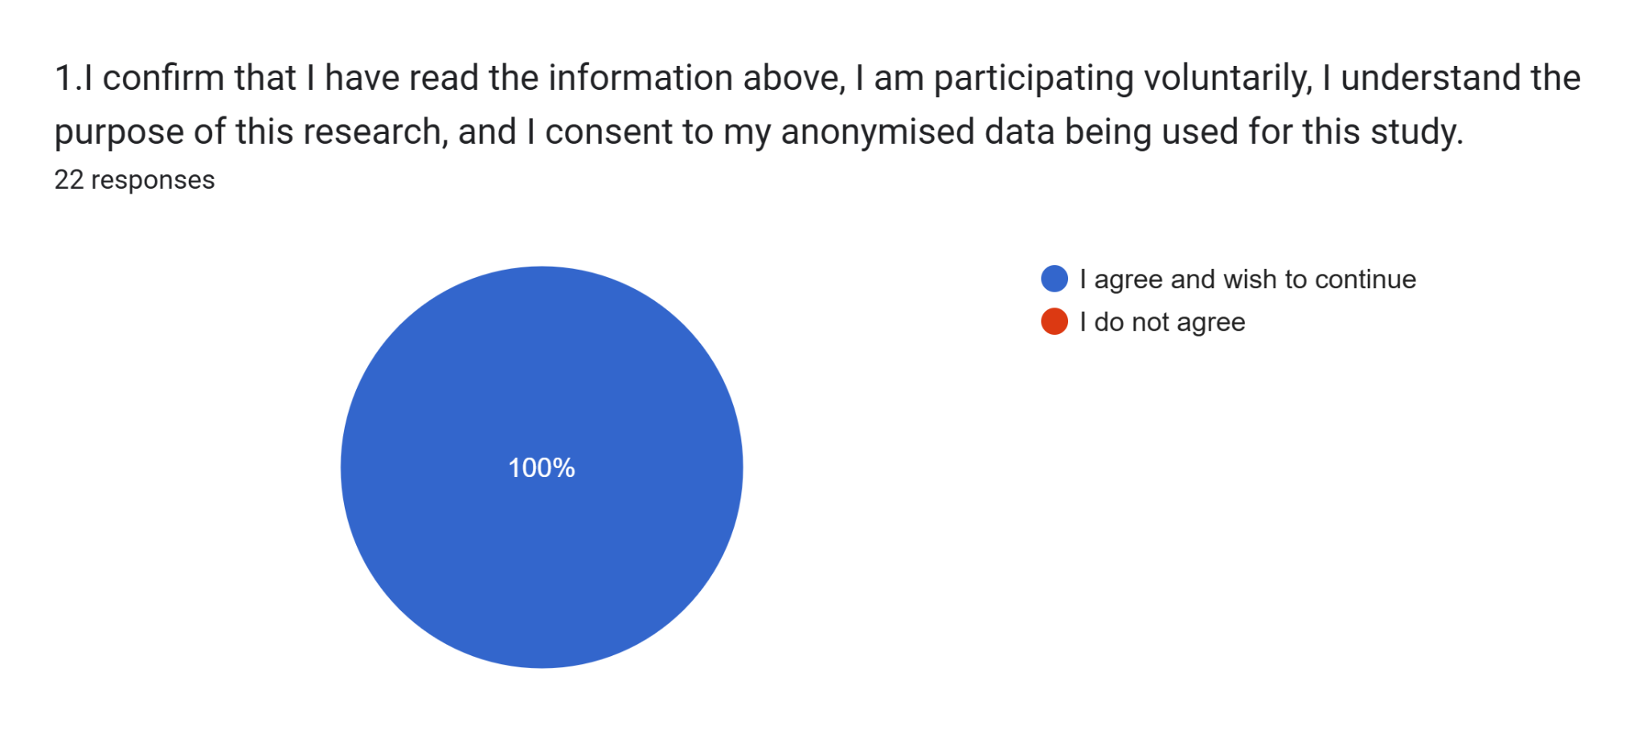
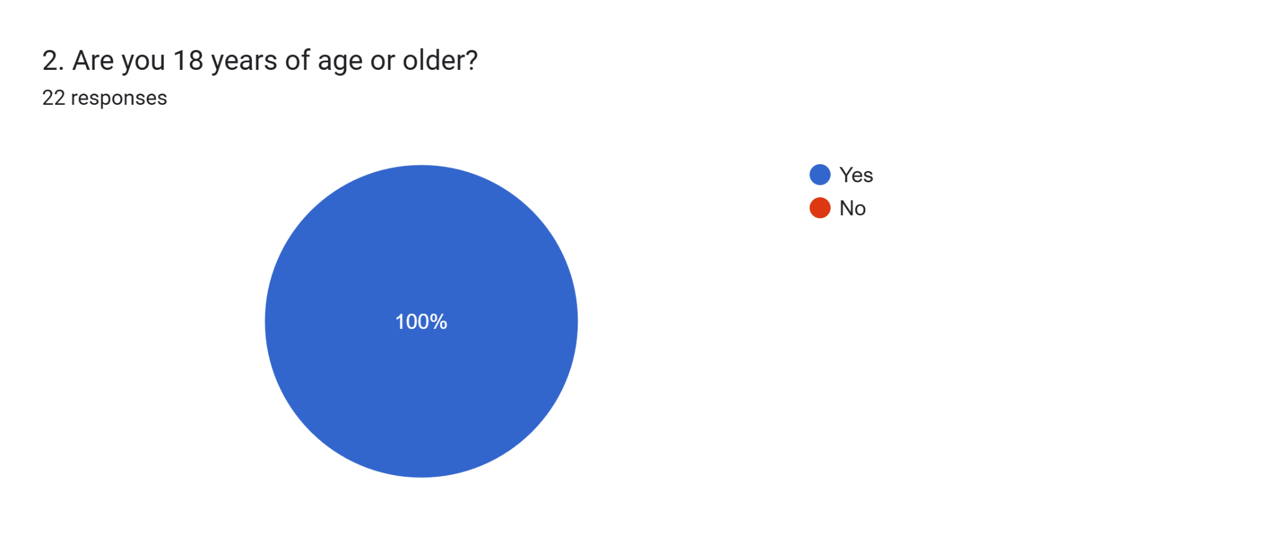
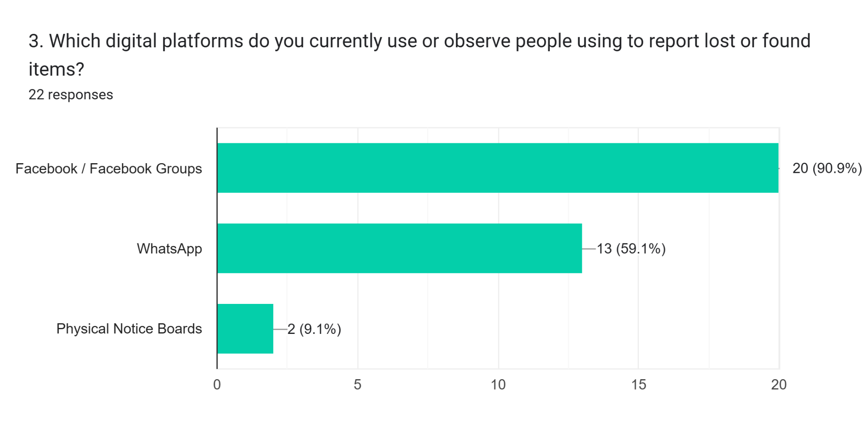

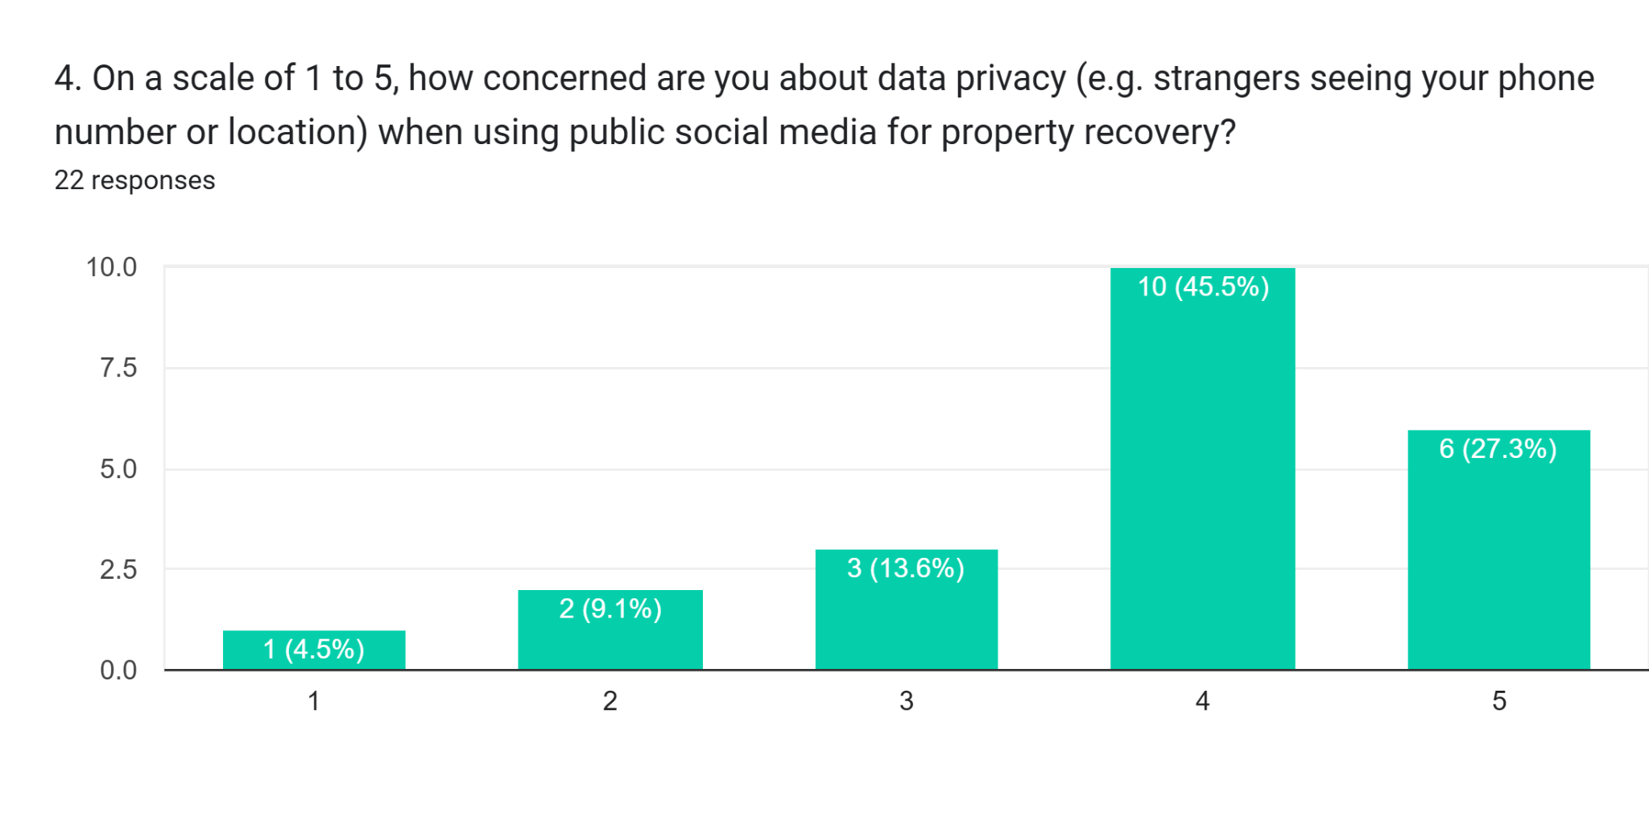
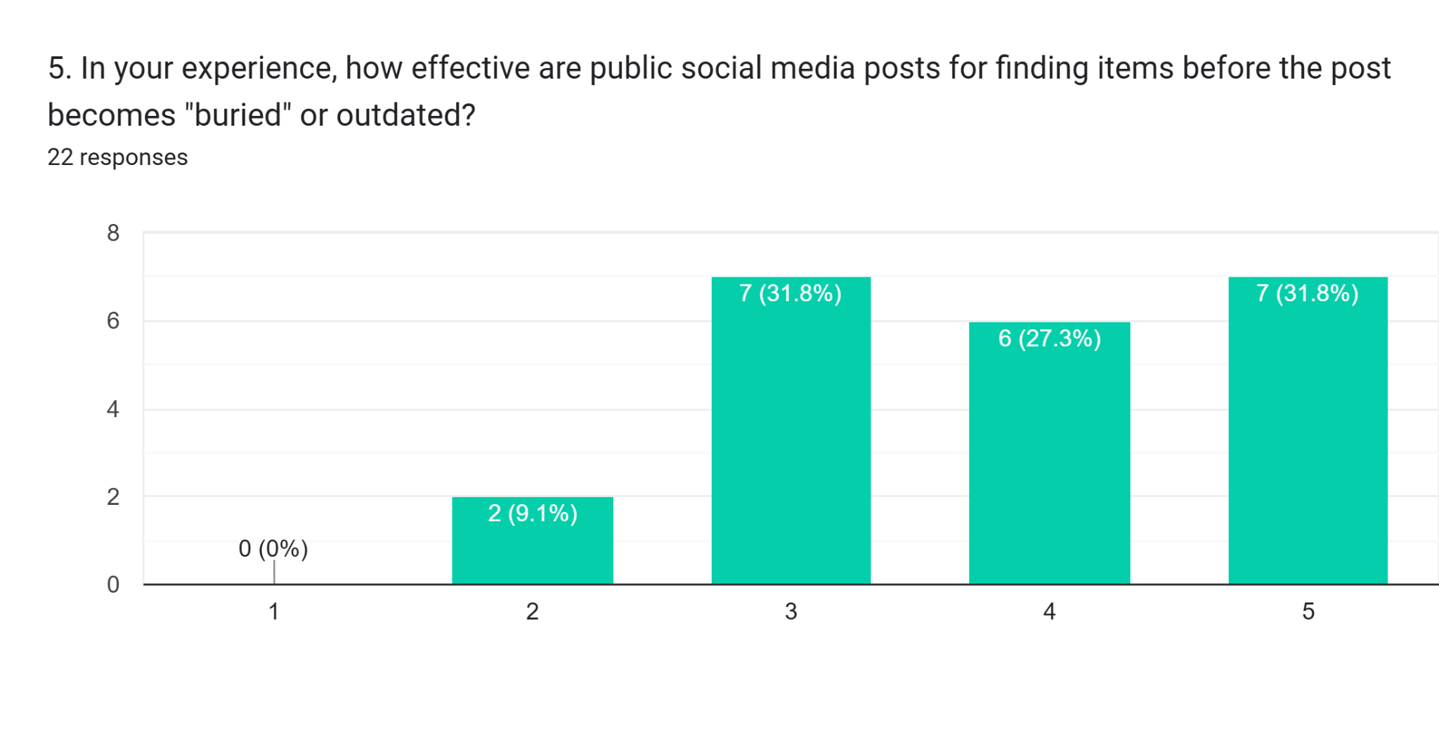
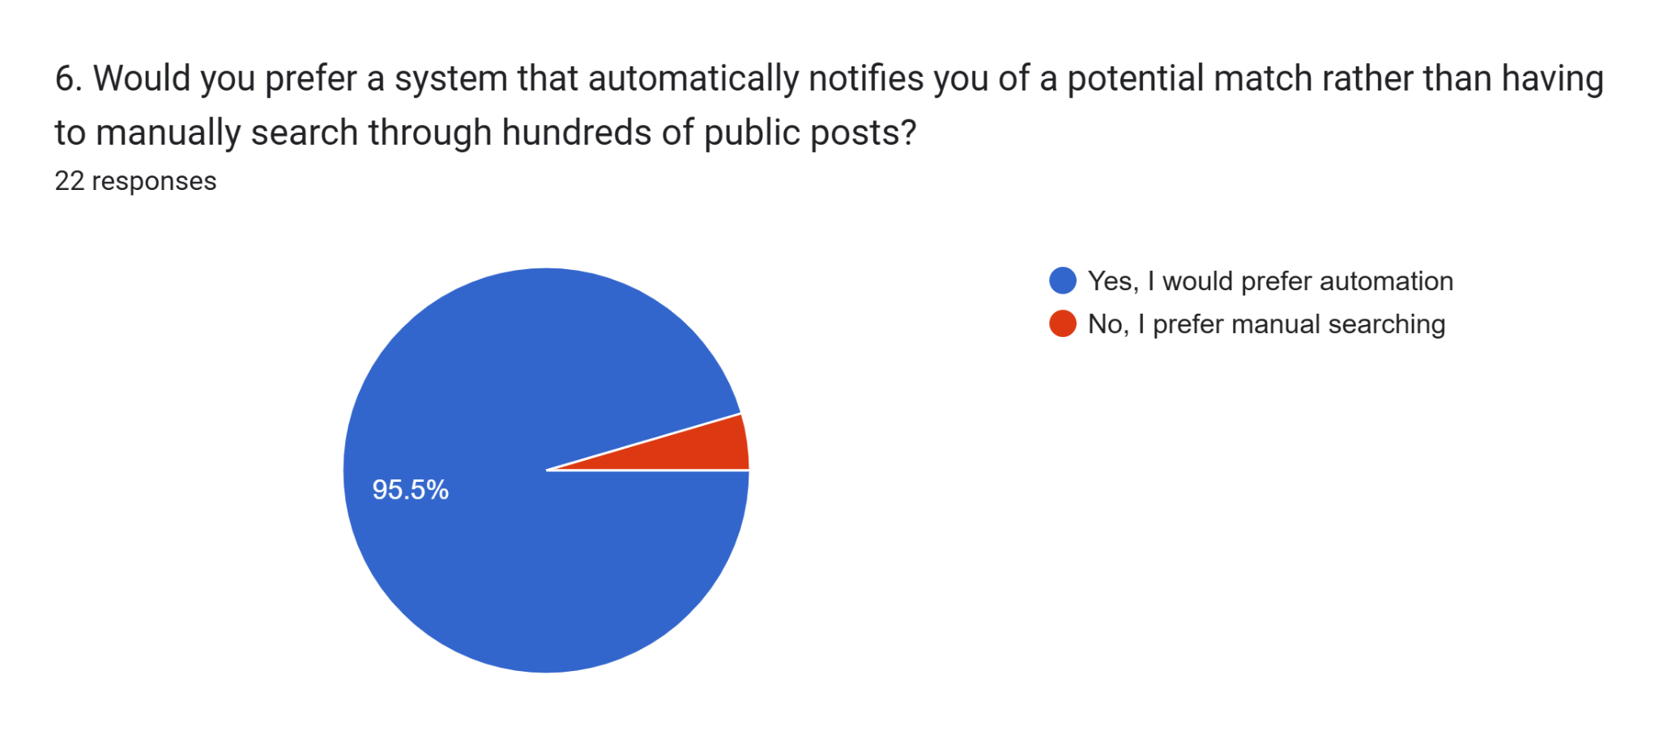
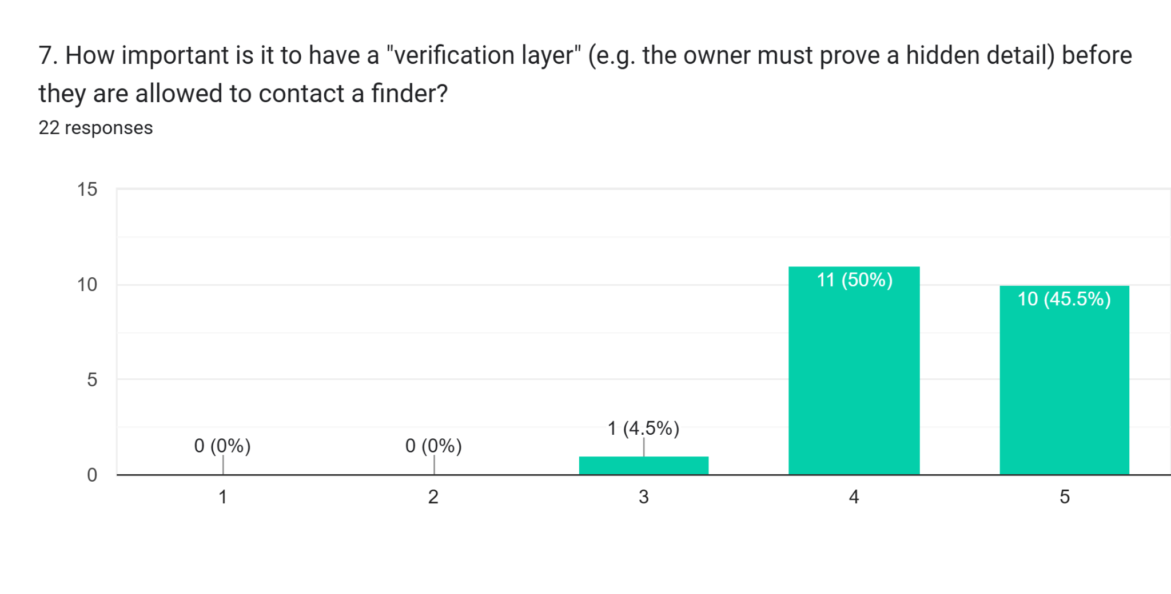
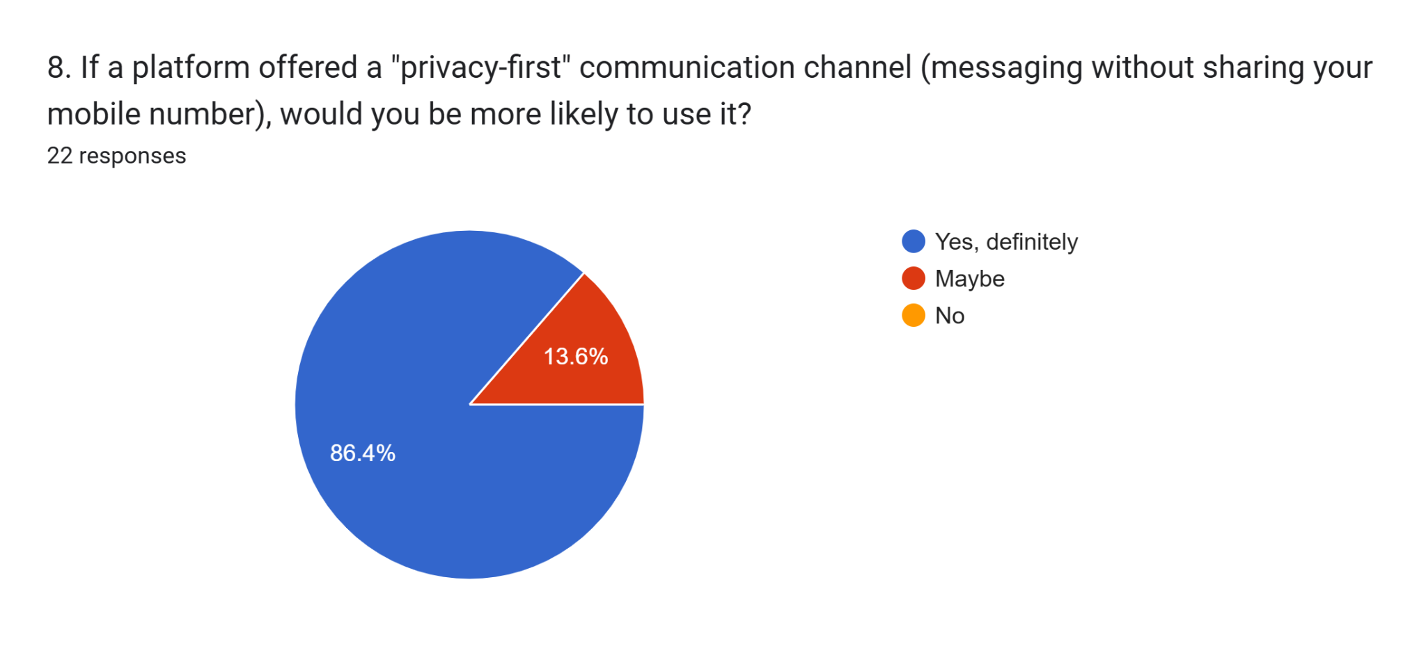
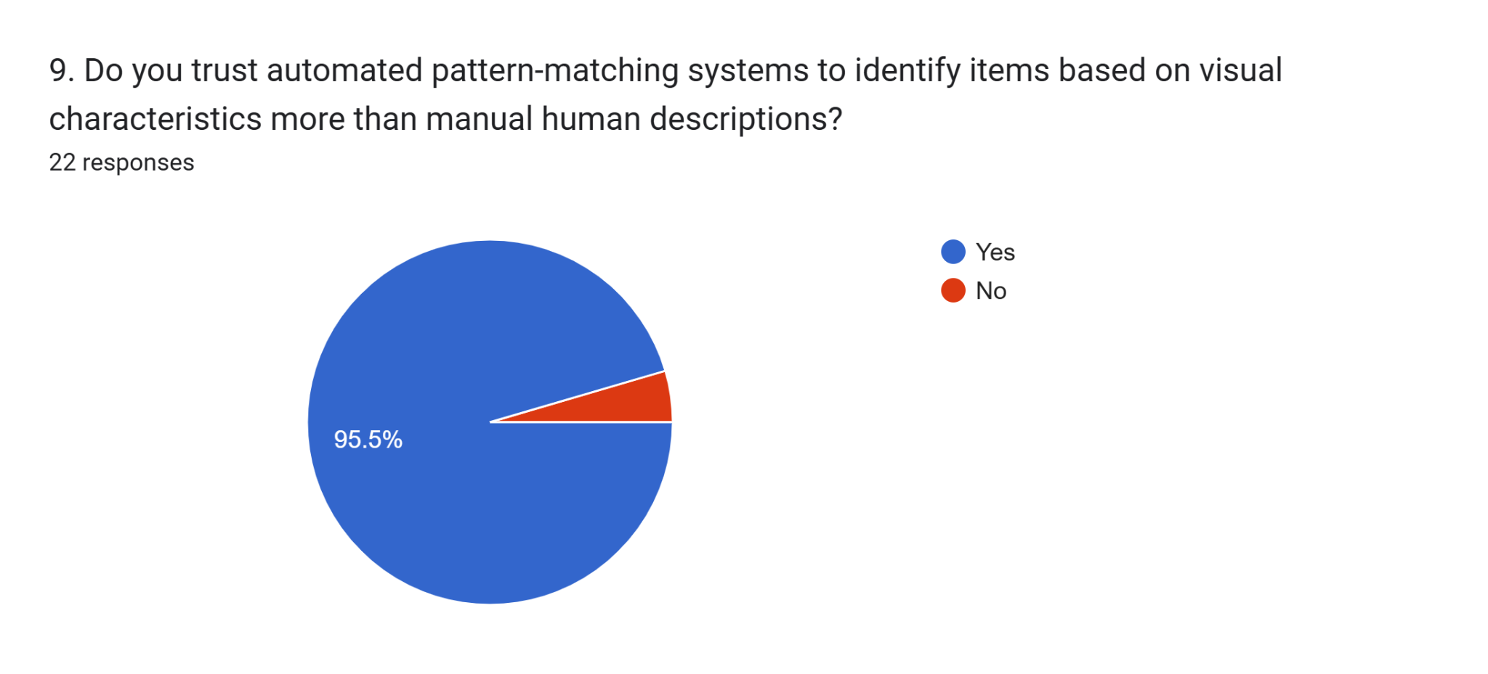

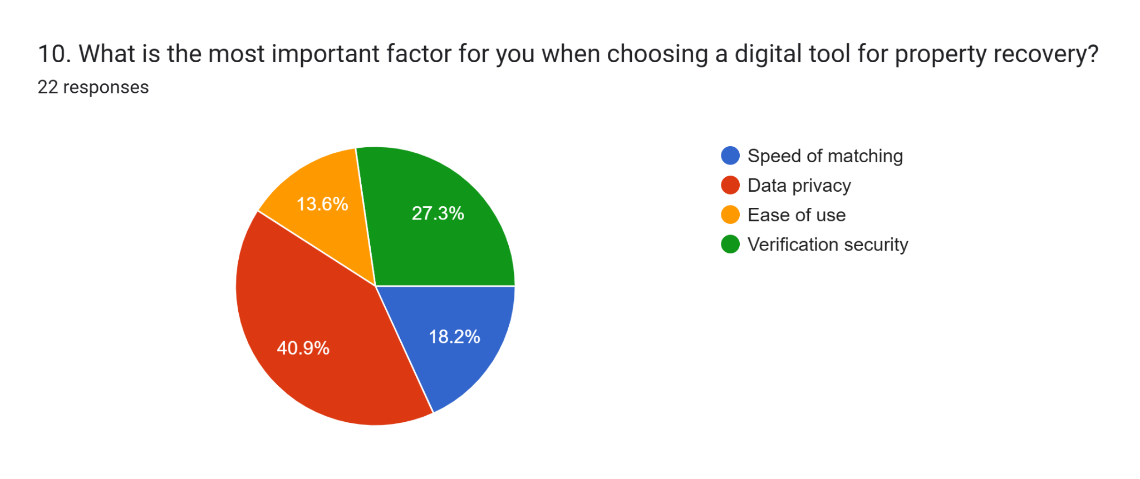
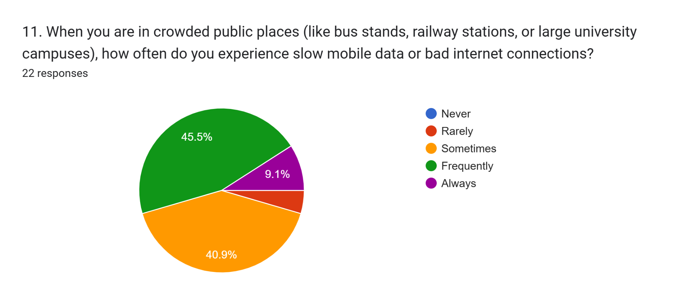

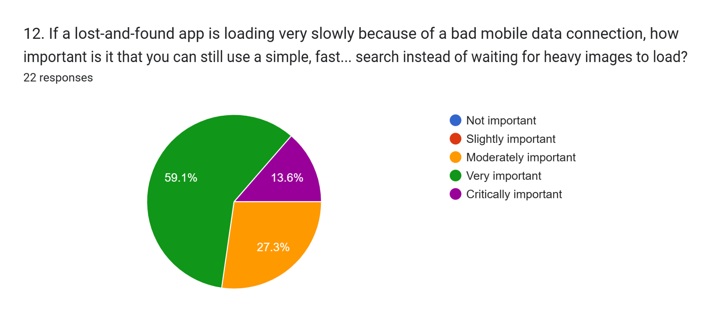
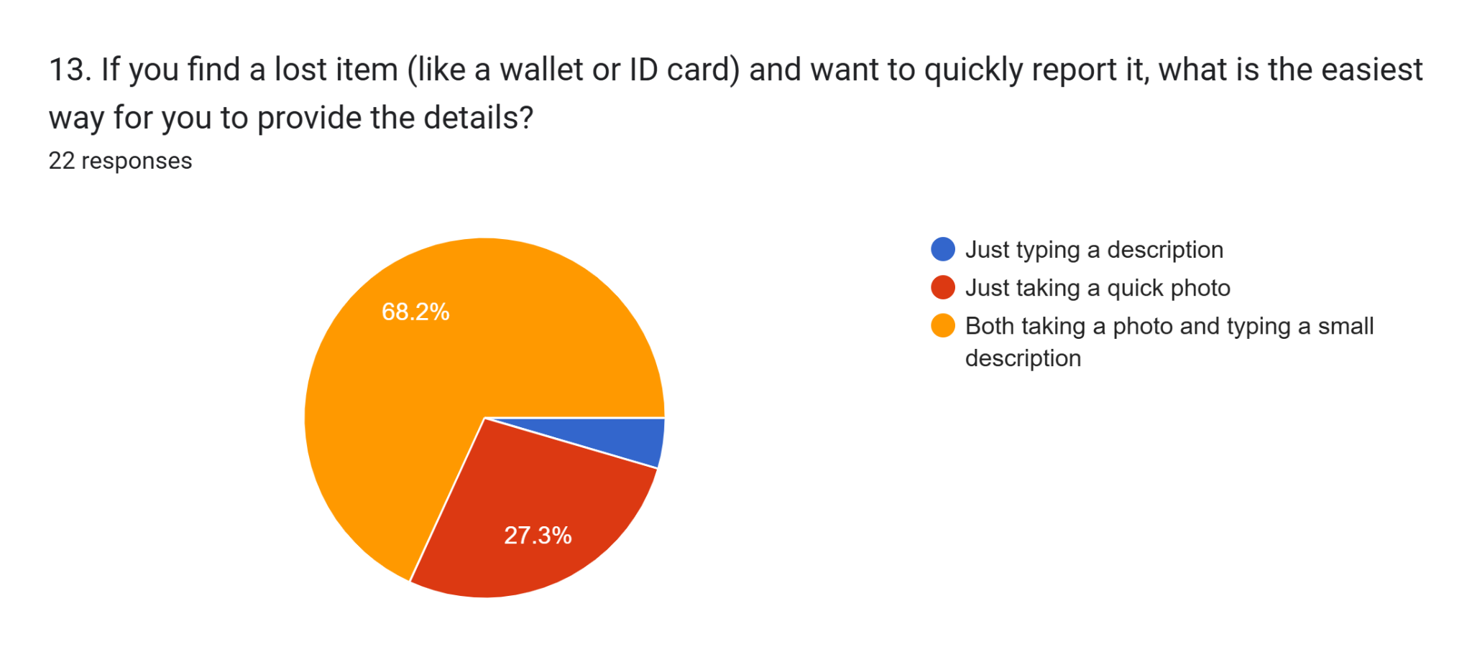

Appendix B: Ethics Approved Form

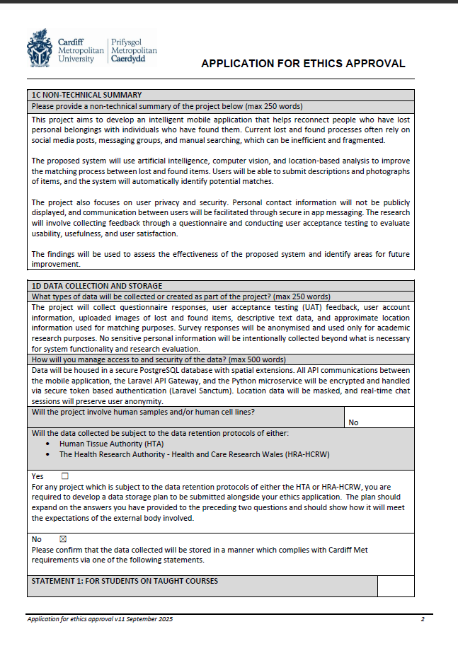







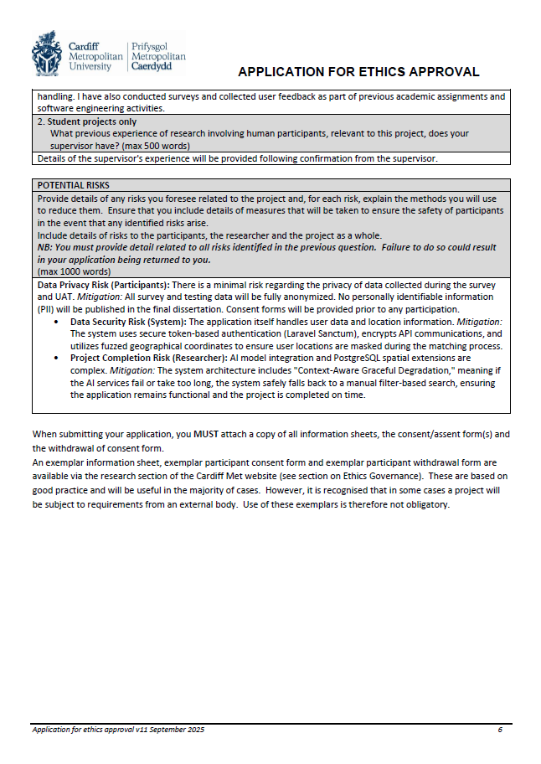
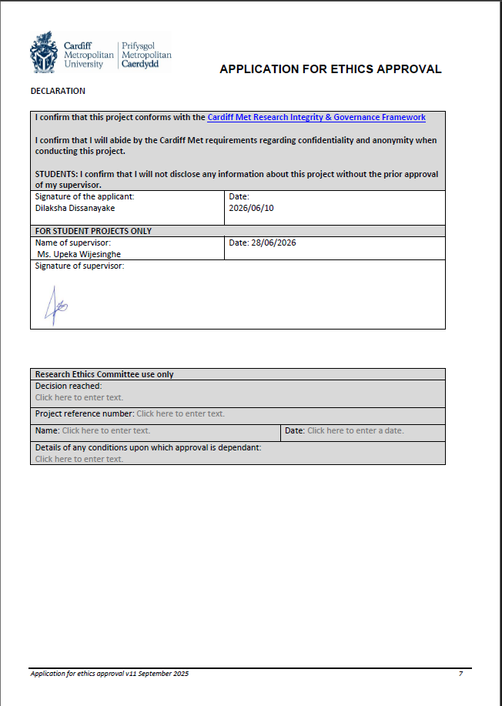

Appendix C: Interview
1. "Could you explain how the current physical lost and found ledger system operates at the university, and what major challenges or human errors your staff face when logging and tracking items?"
2. "When students come to claim or report a lost item, how do you handle discrepancies or mismatches between how the staff describes the item versus how the student describes it?"
3. "How do students react to providing their personal contact details or writing information in these public/manual logs, and do they express concerns regarding data privacy?"
4. "In your professional opinion, how would an automated digital system utilizing artificial intelligence image recognition, PostGIS location filtering, and an anonymized messaging channel improve the prop erty recovery process compared to current physical ledgers?"

Summary
The administrative officer confirmed that physical ledgers are highly vulnerable to human error because staff members and students describe items differently. This creates a severe "vocabulary mismatch" that makes manual tracking difficult. Furthermore, the interviewee validated that students are extremely reluctant to write their personal phone numbers in public campus logs due to privacy and safety fears. The officer concluded that an AI-driven visual matching system paired with secure, anonymized messaging would directly eliminate these bottlenecks

Appendix D: Implementations

Supervisor Log Sheets
ICBT
International College of
Business & Technology
Project Log Sheet – Supervisory Sessions CIS6035_Software Engineering Dissertation Project

Notes on use of the project log sheet:
- This log sheet is designed for meetings of more than 15 minutes duration, of which there must be at ten (10) during the project (TEN mandatory supervisory sessions).
- The student should prepare for the supervisory sessions by deciding which question(s) he or she needs to ask the supervisor and what progress has been made (if any), since the last session.
- A log sheet is to be brought by the student to each supervisory session.
- The actions by the student (and, perhaps the supervisor), which should be carried out before the next supervisory meeting should be noted briefly in the relevant section in the form.
- The student should leave a copy (after the session) of the Project Log sheet with the supervisor and to the coordinator (for Assistant Manager to include his signature). One copy should retain with the student.
- It is compulsory that students bring their previous supervisory session log sheets together with the project file during each supervisory session.
- The log sheet is a deliverable for the project and it is an important record of a student’s organization and learning experience. The student MUST hand in the log sheets as an appendix of the final year documentation, with sheets dated and numbered consecutively.

Student’s Name: Dilaksha Haritha Dissanayake
Cardiff Number: 20360315 – GM/BSCSD/06/22

Date: 20/06/2026. Meeting No: 01 Intake no: November/2025

Project Title: Resilient Multimodal: An AI-Driven Lost and Found Matchmaking System with Context-Aware Graceful Degradation

Supervisor’s Name: Ms. Upeka Wijesinghe Supervisor Signature: ……………
Coordinator’s Name: ……………………… Program Manager Signature: …..

WORK PROGRESSION AS TO DATE:
- Finalized the core dissertation topic and received ethics approval for human participant testing (Reference: GMBSCSD0622_20360315).
- Completed initial project scoping, mapping out the cross-platform architecture (Flutter, Laravel 11, Python FastAPI, PostgreSQL with PostGIS).
- Defined the core requirement structure focusing on privacy-preserving communication, graceful degradation, and AI-driven matchmaking.
- Submitted ethics application covering data privacy, location masking, and UAT risk mitigation.

ITEMS FOR DISCUSSION:
- Chapter 1 Structure: Background study, problem statement, research questions, and objectives.
- Chapter 2 Strategy: Literature search methodologies, keywords, reference management, and comparative analysis of existing systems.
- Core Features Scope: Item classification, geofencing, anonymous WebSocket chat, and ownership verification.

ACTION LIST:
- Complete Chapter 1 (Introduction & Background), ensuring proper formulation of research objectives and project significance.
- Complete Chapter 2 (Literature Review), gathering 15-20 peer-reviewed papers and critically analyzing existing systems.
- Organize references using Mendeley/Zotero with proper citation formatting.


ICBT
International College of
Business & Technology
Project Log Sheet – Supervisory Sessions CIS6035_Software Engineering Dissertation Project

Notes on use of the project log sheet:
- This log sheet is designed for meetings of more than 15 minutes duration, of which there must be at ten (10) during the project (TEN mandatory supervisory sessions).
- The student should prepare for the supervisory sessions by deciding which question(s) he or she needs to ask the supervisor and what progress has been made (if any), since the last session.
- A log sheet is to be brought by the student to each supervisory session.
- The actions by the student (and, perhaps the supervisor), which should be carried out before the next supervisory meeting should be noted briefly in the relevant section in the form.
- The student should leave a copy (after the session) of the Project Log sheet with the supervisor and to the coordinator (for Assistant Manager to include his signature). One copy should retain with the student.
- It is compulsory that students bring their previous supervisory session log sheets together with the project file during each supervisory session.
- The log sheet is a deliverable for the project and it is an important record of a student’s organization and learning experience. The student MUST hand in the log sheets as an appendix of the final year documentation, with sheets dated and numbered consecutively.

Student’s Name: Dilaksha Haritha Dissanayake
Cardiff Number: 20360315 – GM/BSCSD/06/22

Date: 05/07/2026. Meeting No: 02 Intake no: November/2025

Project Title: Resilient Multimodal: An AI-Driven Lost and Found Matchmaking System with Context-Aware Graceful Degradation

Supervisor’s Name: Ms. Upeka Wijesinghe Supervisor Signature: ……………
Coordinator’s Name: ……………………… Program Manager Signature: …..

WORK PROGRESSION AS TO DATE:
- Reviewed Chapter 1 - Introduction and identified several mistakes and areas requiring correction, including wording, grammar, academic structure, consistency, and alignment among the problem statement, research questions, objectives, core features, and scope.
- Reviewed Chapter 2 - Literature Review and identified corrections required in the literature discussion, academic writing, citation consistency, section structure, and connection between the reviewed literature and the identified research gap.
- Corrected and improved relevant parts of Chapters 1 and 2 based on the issues identified during the supervisory review.
- Started Chapter 3 – Planning, preparing the initial structure and content for the project feasibility analysis, risk assessment, SWOT analysis, PESTAL analysis, selected life cycle model, and development time plan.
- Reviewed the selected technical direction of the project, including Flutter, Python FastAPI, LangGraph StateGraph, Supabase PostgreSQL, PostGIS, and pgvector.
ITEMS FOR DISCUSSION:
- Discuss the mistakes identified in Chapter 1 and confirm the required corrections.
- Discuss the mistakes identified in Chapter 2, including academic writing, section organization, citation/reference consistency.
- Confirm whether the identified research gap logically leads to the proposed NEXO solution.
- Review the newly created Chapter 3 structure and confirm the suitability of the feasibility study, risk assessment, SWOT analysis, and project time plan.
ACTION LIST:
- Complete corrections to chapter 1: Ensure the problem statement, research questions, objectives, core features, significance, and scope are logically aligned.
- Complete corrections to chapter 2: Improve the critical analysis and academic flow of the literature review sections.
- Complete chapter 3 (planning): Complete the feasibility report, risk assessment, SWOT analysis, PESTAL analys.

ICBT
International College of
Business & Technology
Project Log Sheet – Supervisory Sessions CIS6035_Software Engineering Dissertation Project

Notes on use of the project log sheet:
- This log sheet is designed for meetings of more than 15 minutes duration, of which there must be at ten (10) during the project (TEN mandatory supervisory sessions).
- The student should prepare for the supervisory sessions by deciding which question(s) he or she needs to ask the supervisor and what progress has been made (if any), since the last session.
- A log sheet is to be brought by the student to each supervisory session.
- The actions by the student (and, perhaps the supervisor), which should be carried out before the next supervisory meeting should be noted briefly in the relevant section in the form.
- The student should leave a copy (after the session) of the Project Log sheet with the supervisor and to the coordinator (for Assistant Manager to include his signature). One copy should retain with the student.
- It is compulsory that students bring their previous supervisory session log sheets together with the project file during each supervisory session.
- The log sheet is a deliverable for the project and it is an important record of a student’s organization and learning experience. The student MUST hand in the log sheets as an appendix of the final year documentation, with sheets dated and numbered consecutively.

Student’s Name: Dilaksha Haritha Dissanayake
Cardiff Number: 20360315 – GM/BSCSD/06/22

Date: 25/07/2026. Meeting No: 03 Intake no: November/2025

Project Title: Resilient Multimodal: An AI-Driven Lost and Found Matchmaking System with Context-Aware Graceful Degradation

Supervisor’s Name: Ms. Upeka Wijesinghe Supervisor Signature: ……………
Coordinator’s Name: ……………………… Program Manager Signature: …..

WORK PROGRESSION AS TO DATE:
- Reviewed the corrections required for Chapter 3 (Planning), including the feasibility study, risk assessment, SWOT analysis, PESTAL analysis, selected life-cycle model and project time plan.
- Corrected the identified mistakes and inconsistencies in Chapter 3 according to the supervisor’s previous feedback.
- Completed Chapter 4 (Requirement Gathering and Analysis), covering the requirement-gathering approach, questionnaire findings, interview findings, functional requirements and non-functional requirements.
- Completed Chapter 5 (System Design), covering the proposed system architecture, database/ERD design, system logic and data flow, AI feature extraction and matchmaking pipeline, graceful degradation mechanism and wireframes.
- Prepared Chapters 3, 4 and 5 for supervisor review and ensured consistency with earlier chapters.
ITEMS FOR DISCUSSION:
- Review whether the corrections made to Chapter 3 have addressed the issues identified in the previous meeting.
- Review the completed Chapter 4 and confirm whether the requirement-gathering results and identified requirements are sufficient.
- Review the completed system architecture, database design, system logic, AI matchmaking pipeline and wireframes in Chapter 5.
- Confirm whether the system design is consistent with the requirements identified in Chapter 4.
ACTION LIST:
- Incorporate the supervisor's corrections and recommendations for Chapters 1-5.
- Refine the system design and UML/technical diagrams based on supervisor feedback.
- Begin or continue implementation of the core NEXO modules according to the approved design (Chapter 6).
- Prepare implementation/testing evidence and maintain updated project documentation.

ICBT
International College of
Business & Technology
Project Log Sheet – Supervisory Sessions CIS6035_Software Engineering Dissertation Project

Notes on use of the project log sheet:
- This log sheet is designed for meetings of more than 15 minutes duration, of which there must be at ten (10) during the project (TEN mandatory supervisory sessions).
- The student should prepare for the supervisory sessions by deciding which question(s) he or she needs to ask the supervisor and what progress has been made (if any), since the last session.
- A log sheet is to be brought by the student to each supervisory session.
- The actions by the student (and, perhaps the supervisor), which should be carried out before the next supervisory meeting should be noted briefly in the relevant section in the form.
- The student should leave a copy (after the session) of the Project Log sheet with the supervisor and to the coordinator (for Assistant Manager to include his signature). One copy should retain with the student.
- It is compulsory that students bring their previous supervisory session log sheets together with the project file during each supervisory session.
- The log sheet is a deliverable for the project and it is an important record of a student’s organization and learning experience. The student MUST hand in the log sheets as an appendix of the final year documentation, with sheets dated and numbered consecutively.

Student’s Name: Dilaksha Haritha Dissanayake
Cardiff Number: 20360315 – GM/BSCSD/06/22

Date: 09/08/2026. Meeting No: 04 Intake no: November/2025

Project Title: Resilient Multimodal: An AI-Driven Lost and Found Matchmaking System with Context-Aware Graceful Degradation

Supervisor’s Name: Ms. Upeka Wijesinghe Supervisor Signature: ……………
Coordinator’s Name: ……………………… Program Manager Signature: …..

WORK PROGRESSION AS TO DATE:
- Completed Chapter 7 (Testing & Evaluation) with documented testing outcomes (Unit, Integration, and UAT) and performance metrics.
- Completed Chapter 8 (Conclusion & Future Work), synthesizing project achievements against primary objectives.
- Finalized all project deliverables including the Flutter mobile application, RESTful backend, PostGIS database, AI microservice, and Admin dashboard.
- Compiled all Appendices (A-E), including API endpoint documentation, Test Cases, Final Gantt Chart, and GitHub repository CI/CD evidence.
ITEMS FOR DISCUSSION:
- Comprehensive final review of Chapters 1-8 and validation of all embedded UML diagrams.
- Assessment of Testing & QA results (e.g., API response times, matching accuracy, user satisfaction scores).
- Verification of Agile Scrum documentation (Burndown charts, Retrospectives, Iterative development proof).
- Preparation strategy for the final Viva Voce examination.
ACTION LIST:
- Proofread the entire dissertation document (grammar, formatting, citations) prior to the submission deadline.
- Ensure all appendices are properly referenced and GitHub repositories have clean commit history.

ICBT
International College of
Business & Technology
Project Log Sheet – Supervisory Sessions CIS6035_Software Engineering Dissertation Project

Notes on use of the project log sheet:
- This log sheet is designed for meetings of more than 15 minutes duration, of which there must be at ten (10) during the project (TEN mandatory supervisory sessions).
- The student should prepare for the supervisory sessions by deciding which question(s) he or she needs to ask the supervisor and what progress has been made (if any), since the last session.
- A log sheet is to be brought by the student to each supervisory session.
- The actions by the student (and, perhaps the supervisor), which should be carried out before the next supervisory meeting should be noted briefly in the relevant section in the form.
- The student should leave a copy (after the session) of the Project Log sheet with the supervisor and to the coordinator (for Assistant Manager to include his signature). One copy should retain with the student.
- It is compulsory that students bring their previous supervisory session log sheets together with the project file during each supervisory session.
- The log sheet is a deliverable for the project and it is an important record of a student’s organization and learning experience. The student MUST hand in the log sheets as an appendix of the final year documentation, with sheets dated and numbered consecutively.

Student’s Name: Dilaksha Haritha Dissanayake
Cardiff Number: 20360315 – GM/BSCSD/06/22

Date: 22/08/2026. Meeting No: 05 Intake no: November/2025

Project Title: Resilient Multimodal: An AI-Driven Lost and Found Matchmaking System with Context-Aware Graceful Degradation

Supervisor’s Name: Ms. Upeka Wijesinghe Supervisor Signature: ……………
Coordinator’s Name: ……………………… Program Manager Signature: …..

WORK PROGRESSION AS TO DATE:
- Proofread the entire dissertation document (grammar, formatting, citations) prior to the submission deadline.
- Ensured all appendices are properly referenced and verified that GitHub repositories have clean commit histories.
- Compiled all final implementation evidence, including testing videos, logs, and screenshots.
- Finalized final adjustments following the 4th official supervisor meeting feedback.

ITEMS FOR DISCUSSION:
- Final walkthrough of the finalized PDF dissertation document and appendices to ensure Cardiff Met formatting compliance.
- Review of the submission checklist (APK, iOS simulator build, Swagger/Postman API documentation, and Git CI/CD links).

ACTION LIST:
- Submit the final dissertation PDF, UML diagrams, and all supporting deliverables to the Cardiff Metropolitan University submission portal before the September deadline.
- Obtain final signatures on all 5 project log sheets and attach them to the dissertation appendix.
- Attend the Viva Voce examination.

