Results:

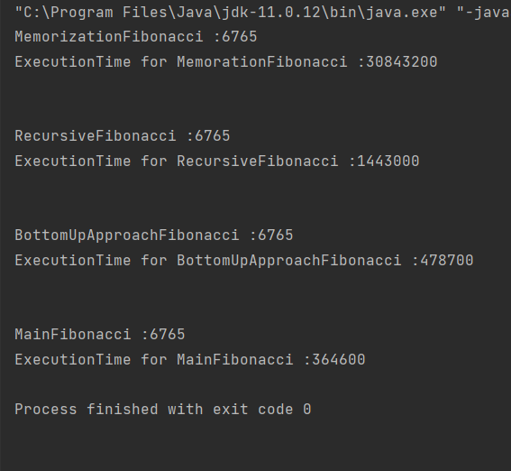

Disadvantages of Dynamic Programming

Dynamic programming has concepts that are more difficult to understand than other mathematical programming techniques.

Another major disadvantage of dynamic programming is the size issue.

The efficiency of an effective computational algorithm makes dynamic programming more conceptual than practical in making real dynamic decisions.

Dynamic programming may not be practical for very large problems.