THE UNIVERSITY OF WESTERN AUSTRALIA
PROJECT SPECIFICATION AND PLANS
GeoQueryBench Annotation Platform
CITS5206 Spatial Data Analytics | Group 7 Submission
GROUP MEMBERS
Chaitanya Neerukattu
Dilani Gunathilaka Mapitigamage
Sarwesh Kattel
Thomas Ouyang
Ziyue Xu
ASSESSMENT
Project Spec and Plans (Group Submission)
Due: 18 August 2026, 11:59 pm AWST
Final group submission

PROJECT SPECIFICATION AND PLANS

GeoQueryBench Annotation Platform
A web-based workspace for validating geospatial benchmark questions, gold answers and LLM-generated code
Project detail | Information
Unit | CITS5206 Spatial Data Analytics
Team | Group 7
Submission | Project Spec and Plans (Group Submission)
Due | 18 August 2026, 11:59 pm AWST
Status | Final group submission

Project decision: Build a practical annotation web application that lets reviewers inspect benchmark questions, gold code/results and LLM-generated outputs together, record structured judgements, and export traceable annotations for research-quality evaluation.

Executive Summary
GeoQueryBench is a benchmark-in-progress for evaluating whether large language models can generate correct SQL, Python, GeoPandas and visualisation code for real Western Australian mineral-exploration data. The client needs a reliable and efficient method for human annotators to validate questions and gold answers, compare model-generated solutions, and record consistent judgements. A spreadsheet-only process would be difficult to scale, hard to audit and inefficient for code, data and visual outputs.
Group 7 will therefore develop a Python-based web application that supports structured annotation and traceability. The first MVP will focus on the near-surface (NS), cross-domain (CD) and robustness (RB) benchmark cases discussed with the client. The initial pilot will use approximately 90 questions before later question batches are added following feedback. The system will be developed in VS Code, version-controlled in GitHub and designed for local or controlled deployment without exposing API keys or executing untrusted code directly in the web process.

1. Problem Statement and Proposed Solution

1.1 Problem to be addressed
The client is developing GeoQueryBench to measure the ability of LLMs to answer realistic geospatial and mineral-exploration questions by generating code. Each benchmark record can include a bilingual question, task type, difficulty, reference (gold) code, execution result and notes about known traps. Human validation is essential because code may execute successfully while still using the wrong table, unit, coordinate reference system, interval logic or geological interpretation.
At present, reviewers must inspect several artefacts separately. This creates a risk of inconsistent decisions, lost comments, duplicated work and weak traceability between a question, its evidence and the final annotation. The challenge increases for cross-database joins and spatial analysis, which the client identified as the most difficult cases.

1.2 Why the client wants the software
- Improve the speed and consistency of human annotation across a growing benchmark.
- Show the question, reference solution, model output and supporting result in one review workspace.
- Maintain an auditable record of who reviewed each case, the decision made and the reason.
- Support iterative feedback: validate the first question batch, identify recurring errors and improve later batches.
- Produce a live demonstration that could support a future GeoQueryBench dataset or demo paper.

1.3 Proposed solution
The proposed solution is an interactive web application built primarily in Python. It will import the seed-pair CSV and gold-result manifest, display benchmark records in a review queue, show the relevant code and outputs side by side, and save structured annotations. The interface will prioritise clarity and annotation efficiency rather than attempting to reproduce a full notebook or cloud development environment.
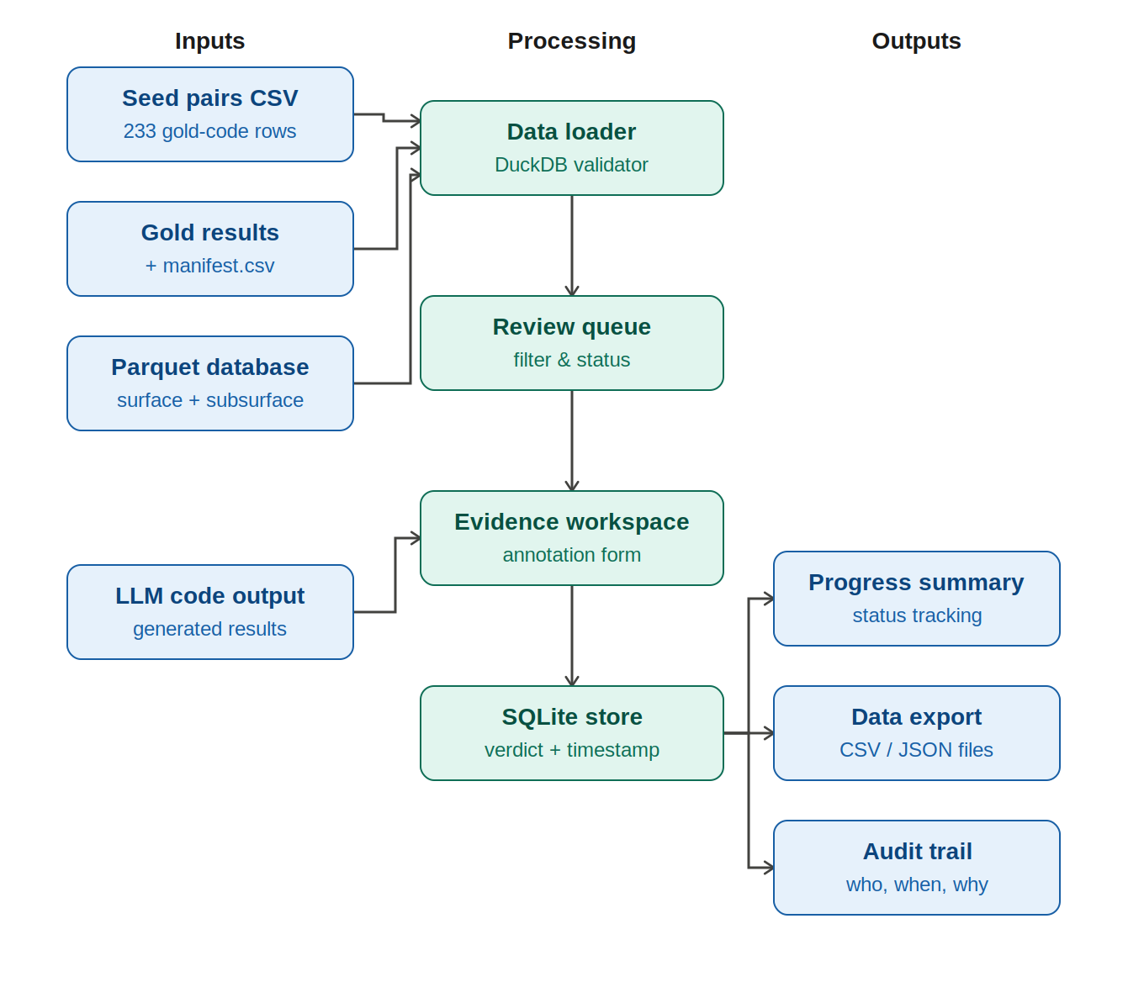
Figure 1. Input, processing and output flow of the annotation platform.

1.4 Project objectives
- Create a usable annotation workflow for NS, CD and RB questions.
- Reduce the time required to locate and compare question, code, result and notes.
- Standardise annotation criteria and make reviewer decisions reproducible.
- Provide progress visibility at question, reviewer, task-type and difficulty levels.
- Export clean data that the client can use for benchmark analysis and publication preparation.

2. Minimum Viable Product (MVP)

2.1 In-scope MVP deliverables
ID | Deliverable | Description | MVP acceptance condition
M1 | Data import and validation | Load the seed-pair CSV, gold manifest and result file references; report missing or duplicate IDs. | A valid project package loads without manual restructuring.
M2 | Question review queue | Filter by scenario, question type, task, difficulty, robustness and annotation status. | A reviewer can locate assigned or unreviewed cases.
M3 | Evidence workspace | Display English/Chinese question, gold code, notes, expected output metadata and model-generated code/output. | All evidence needed for a decision is visible from one screen.
M4 | Structured annotation form | Record executable, schema, logic, numerical/spatial/domain correctness, output compliance, verdict and comments. | Required fields are validated before submission.
M5 | Persistence and traceability | Store reviewer, timestamp, question ID, decision and revision history in a lightweight database. | Annotations remain after restart and can be traced to a benchmark record.
M6 | Progress summary | Show reviewed, pending and disputed counts with filters. | The team and client can monitor completion.
M7 | Export | Export annotations to CSV/JSON for client analysis and backup. | Exported records preserve IDs and annotation fields.

2.2 MVP annotation outcomes
- Correct: the model answer is executable and materially equivalent to a valid gold solution.
- Partially correct: meaningful progress is made, but one or more fixable issues affect completeness or reliability.
- Incorrect: the solution uses invalid schema, faulty logic, incorrect units/CRS, unsupported assumptions or produces the wrong result.
- Correct refusal: the requested information cannot be answered from the available dataset and the model explains why.
- Needs adjudication: reviewers disagree or the gold reference/question itself may be defective.

2.3 Out of scope for the first MVP
- Training or fine-tuning an LLM.
- A complete online IDE or unrestricted execution of arbitrary model-generated code.
- Automatic correction of geological interpretations without human review.
- Public multi-tenant deployment, complex identity management or publication-scale analytics.
- Full SS (subsurface) annotation unless the client expands the agreed first-round scope.

2.4 Post-MVP opportunities
- Containerised code-execution sandbox with time, memory and file-access restrictions.
- Inter-annotator agreement metrics and adjudication workflows.
- Side-by-side visual comparison and spatial-map overlays.
- Model leaderboard and error taxonomy dashboard.
- Publication-ready demonstration mode and expanded question batches.

3. Client Communication and MVP Agreement

3.1 Evidence from the client meeting
Date | Evidence | Agreed outcome
5 Aug 2026 | Client/supervisor meeting | The client described an interactive web app where reviewers can see questions, answers, queries and data traceability, then annotate efficiently.
5 Aug 2026 | Scope clarification | The client confirmed Group 7 should focus on NS, CD and RB rather than SS for the initial work.
5 Aug 2026 | Staged dataset | The client advised the team to begin with roughly 90 checked questions and provide feedback before further questions are supplied.
5 Aug 2026 | UI/technology direction | The team may choose the front-end stack and can use the client website/screenshot as a design reference.
5 Aug 2026 | Review arrangement | The client offered to review the proposal before submission and provide feedback on alignment.
5 Aug 2026 | Communication cadence | Weekly meetings were proposed during the first few weeks to establish an efficient annotation method.

3.2 Stakeholders
Stakeholder | Role/interest | Communication
Client/supervisors | Confirm scientific intent, benchmark scope, annotation policy and MVP acceptance. | Weekly during early development; milestone demonstrations.
Group 7 | Plan, design, implement, test, annotate and document the solution. | Team stand-up twice weekly; continuous project-board updates.
Benchmark annotators | Use the application and provide usability/consistency feedback. | Pilot session and structured feedback form.
Unit facilitator | Assess project specification, process and final outcomes. | Scheduled unit submissions and demonstrations.

3.3 MVP agreement recorded
Agreement evidence: The 5 August 2026 client meeting established the first-round NS/CD/RB scope, an initial batch of approximately 90 checked questions, the need for an interactive annotation interface, freedom for Group 7 to select the implementation stack, and a weekly early-stage review cadence. These recorded outcomes form the MVP baseline for this submission; later changes will be documented in meeting minutes or the project decision log.

3.4 Communication protocol
- Send a short agenda before each client meeting and circulate decisions/action items afterwards.
- Record scope changes as GitHub issues or project-board decisions rather than relying only on chat messages.
- Demonstrate working increments at milestones and request explicit acceptance or changes.
- Escalate ambiguous geological terms, unavailable fields and questionable gold answers to the client instead of guessing.

4. Project Management and Plans

4.1 Delivery approach
The team will use an iterative approach with short build-review cycles. GitHub will provide version control, issues, pull requests and a Kanban-style project board. VS Code will be the standard development environment. Work will be divided into reviewable increments, and no feature will be considered complete until it has acceptance checks, test evidence and documentation.

4.2 Plan for this assessment deliverable
Dates | Activity | Owner | Evidence/output
7-8 Aug | Confirm rubric, meeting decisions and package contents | Project coordinator + whole team | Scope summary and evidence list
9-10 Aug | Agree MVP, architecture, annotation fields and risks | Technical lead + annotation lead | Draft spec, architecture and risk register
11-12 Aug | Create wireframes, repository structure and project board | UI lead + repository owner | Wireframe, backlog and branch rules
13-14 Aug | Internal review and client review request | Quality lead + client liaison | Client-ready draft and decisions log
15-16 Aug | Apply feedback; verify responsibilities and deadlines | Section owners | Revised submission and evidence links
17 Aug | Final rubric audit, proofreading and group approval | Quality lead + whole team | Approved final document
18 Aug | Submit before 11:59 pm AWST | Submission owner | Submission receipt

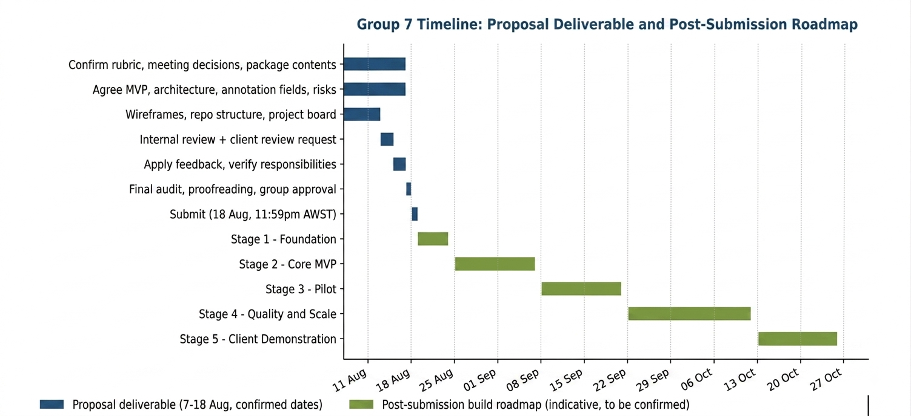
Figure 2. Proposal deliverable timeline (confirmed dates) and post-submission build roadmap.

4.3 Implementation roadmap after specification approval
Stage | Focus | Key work | Exit condition
Stage 1 | Foundation | Repository, environment, data-loader prototype and validated annotation schema. | Package loads; baseline checks pass.
Stage 2 | Core MVP | Question queue, evidence view, annotation form and persistent storage. | End-to-end annotation of one case.
Stage 3 | Pilot | Load the initial NS/CD/RB set and conduct team annotation trials. | Pilot feedback and issue list.
Stage 4 | Quality and scale | Resolve defects, add progress/export and improve performance. | Agreed batch can be annotated reliably.
Stage 5 | Client demonstration | Deployment package, documentation, demo script and final evaluation. | Client acceptance and reproducible handover.

4.4 Responsibility model
The named allocation is recorded in Appendix B and will be copied into GitHub Projects. One person may hold more than one functional responsibility, but every task will have one accountable owner and at least one reviewer.
Functional owner | Responsibilities | Primary outputs
Project coordinator / submission owner | Schedule, project board, deadlines, integration and final submission. | Project plan, status reporting, submission evidence
Client liaison / annotation lead | Meeting agendas/minutes, scope questions, annotation rubric and adjudication. | Decision log, client approvals, annotation guide
Technical lead / data engineer | Architecture, DuckDB/Parquet loading, data validation and performance. | Data service, schema checks, technical review
UI/UX lead | Wireframes, navigation, evidence view, accessibility and usability testing. | Interface implementation and usability evidence
Backend / storage lead | Annotation schema, SQLite persistence, export and audit trail. | API/storage layer and data export
Quality / deployment lead | Tests, security checks, release packaging, demo and user documentation. | Test report, risk checks, deployment and handover

4.5 Project tools and workflow
Tool | Planned use
VS Code | Common development environment, Python debugging and notebook/script execution.
GitHub repository | Source control, protected main branch, feature branches and pull-request review.
GitHub Projects | Backlog, owner, priority, due date, status, acceptance criteria and evidence links.
Microsoft Teams | Client/team meetings and formal communication; decisions transferred to the project log.
Python test tools | Unit and integration checks for loading, filtering, validation, storage and export.
Docker (target) | Reproducible deployment and future isolation of execution-related components.

4.6 Definition of Done
- Acceptance criteria are met and linked to test or demonstration evidence.
- Code has been reviewed through a pull request and no secrets or large raw data files are committed.
- Relevant tests pass and error handling is included.
- User-facing changes are documented and usable at common desktop screen sizes.
- Client-impacting changes have been demonstrated or explicitly approved.

5. Technology Assessment

5.1 Selected MVP architecture
Layer | Choice | Justification
User interface | Streamlit | Fast Python delivery, built-in widgets and strong compatibility with pandas, code display and charts. Suitable for a controlled capstone MVP.
Application language | Python 3.11+ | Matches the supplied benchmark code and team workflow; integrates directly with DuckDB, pandas and GeoPandas.
Benchmark query layer | DuckDB + Parquet | Reads the frozen Parquet database without importing 1.15 GB into a separate database server.
Annotation storage | SQLite | Simple, transactional and portable persistence for a single-team MVP; supports export and backup.
Data processing | pandas / GeoPandas | Required for tabular and spatial outputs already used by GeoQueryBench.
Visualisation | Matplotlib / Plotly | Supports supplied static gold images and optional interactive summary charts.
Version control | GitHub | Enables project planning, traceability, code review and evidence of team workflow.
Deployment | Docker/local controlled host | Provides reproducibility while keeping the large dataset and annotation records under controlled access.

5.2 Alternatives considered
Option | Advantage | Limitation | Decision
React + FastAPI | More flexible interface and stronger long-term separation. | Higher implementation and integration effort for the first deliverable. | Consider after the workflow and annotation schema are stable.
Flask + templates | Lightweight, mature and fully customisable. | More manual UI/state work than Streamlit. | Viable fallback if Streamlit limits the required layout.
Spreadsheet-only annotation | Very quick to begin and familiar to reviewers. | Weak code/result comparison, audit trail, validation and scalability. | Use only as contingency/export format, not the primary solution.
PostgreSQL/PostGIS | Strong concurrency and spatial database features. | Unnecessary operational complexity for the controlled first MVP. | Adopt if concurrent users or server-side spatial querying becomes mandatory.

5.3 Team skills and learning plan
Skill area | Assessment | How the gap will be addressed
Python/SQL | Required | Use supplied gold queries as examples; pair-program data-loading and validation functions.
GeoPandas/CRS | Specialist gap | Complete focused practice on EPSG:7844, metre-based projection and spatial joins before reviewing CD cases.
Streamlit/UI | New or developing | Build a small one-question prototype first; attend the recommended web-coding session and document patterns.
Testing/annotation design | Developing | Create a shared rubric, independently double-annotate a pilot subset and discuss disagreements.
Docker/security | Specialist gap | Assign a security/deployment owner; use a minimal container prototype and secrets checklist.

6. Risk Assessment and Mitigation
ID | Level | Risk | Mitigation/contingency | Owner
R1 | High | Arbitrary model-generated code could read files, consume resources or expose secrets. | Do not execute untrusted code inside the MVP web process. Treat execution as pre-generated evidence or use a separately isolated container with strict limits. | Technical/security lead
R2 | High | Large Parquet files and spatial joins may cause slow loading or memory failure. | Lazy DuckDB queries, column selection, caching, pagination, bounded previews and performance tests using the largest cases. | Data engineer
R3 | High | Incorrect annotations caused by sentinels, mixed units, CRS errors or geological ambiguity. | Embed checklist prompts, require comments for partial/incorrect results, use client adjudication and double-annotation sampling. | Annotation lead
R4 | High | API keys or credentials may be committed or shared accidentally. | No secrets in source/data; use environment variables, .gitignore, pre-commit secret scanning and immediate key rotation if exposed. | Repository owner
R5 | Medium | Scope expands before the core annotation workflow is stable. | Baseline the MVP, place new requests in a prioritised backlog and require client confirmation for scope changes. | Project coordinator
R6 | Medium | Gold reference or question may itself be defective (for example, a successful zero-row gold case). | Add Needs adjudication status; record evidence and obtain client resolution rather than forcing reviewer agreement. | Quality lead
R7 | Medium | Different reviewers apply criteria inconsistently. | Annotation handbook, calibration session, shared examples and inter-annotator agreement checks on a sample. | Annotation lead
R8 | Medium | Team skill gaps or unequal workload delay delivery. | Role ownership, paired tasks, visible board workload, early prototypes and weekly reassignment if blocked. | Project coordinator
R9 | Medium | Deployment environment cannot store or serve the full dataset reliably. | Keep local/Docker deployment as baseline; test storage, permissions and backup before selecting any hosted platform. | Deployment lead
R10 | Low | Licence attribution or government-data provenance is omitted. | Retain CC BY 4.0 attribution and source metadata in documentation and demonstration materials. | Documentation owner

6.1 Cybersecurity controls
- Store secrets only in local environment files excluded from Git and provide a safe example file without values.
- Validate uploaded filenames, file types, sizes and paths; do not permit directory traversal.
- Parameterise database writes and validate annotation inputs.
- Back up the annotation database and exports, and restrict write access to authorised team members.
- Avoid public deployment until authentication, data exposure and code-execution risks have been reviewed.

7. Quality Assurance and Acceptance
Quality area | Acceptance evidence
Data integrity | Duplicate/missing QIDs, manifest mismatches and unavailable outputs are detected and reported.
Functional | A reviewer can filter, open, annotate, save, reopen and export a benchmark case.
Usability | A new reviewer can complete a guided annotation without searching separate folders manually.
Performance | Question lists are paginated/cached and large artefacts are previewed without freezing the interface.
Security | No secrets are committed; untrusted code is not executed in the main application process.
Reproducibility | A clean environment can start the application using documented commands and pinned dependencies.
Client acceptance | The client confirms that mandatory fields, scope and exported records meet the annotation workflow.

8. Project Decisions and MVP Baseline
- The first-round review set will contain approximately 90 NS, CD and RB questions; SS is excluded from the initial scope.
- Annotations will record executability, schema use, logic, numerical/spatial/domain correctness, output compliance, verdict and reviewer comments.
- A pilot sample will be independently reviewed by more than one team member; disagreements and questionable gold answers will be escalated for adjudication.
- Untrusted model-generated code will not execute inside the main web process; the MVP will use supplied outputs or an isolated restricted environment.
- The baseline deployment will be local or Docker-based on a controlled host with restricted access to annotation records.
- Alternative code solutions may be accepted when their schema use, logic and outputs are materially equivalent to a valid reference solution.
- Known zero-row or otherwise questionable gold results will be marked Needs adjudication and retained with supporting evidence.

9. Evidence and References
Evidence source | Use in this plan
Client meeting transcript | CITS5206 Group 7 - Spatial Data Analytics Project Meeting, 5 August 2026.
Assessment rubric | Project Spec and Plans (Group Submission): problem statement; client communication/MVP agreement; project management/plans; risk and technology assessment.
Student package | GeoQueryBench STUDENT_README, seed-pair CSV, gold-results manifest and supporting data documentation supplied by the client.
Dataset licence | CC BY 4.0 derived from WA DMIRS / GSWA / CSIRO open data; attribution required.

Appendix A. Client Communication Record
The following outcomes were recorded from the client/supervisor meeting held on 5 August 2026 and are used as evidence for the submitted MVP baseline.
Agreement area | Recorded outcome | Evidence
Initial project scope | Focus first on NS, CD and RB rather than SS. | Meeting transcript, 5 Aug 2026
Initial question batch | Begin with approximately 90 checked questions and provide feedback before later batches. | Meeting transcript, 5 Aug 2026
MVP product direction | Build an interactive interface that presents questions, answers/queries and data traceability for efficient annotation. | Meeting transcript, 5 Aug 2026
Technology direction | Group 7 may choose the front-end stack and use the client website/screenshot as a design reference. | Meeting transcript, 5 Aug 2026
Review and communication | Use weekly early-stage meetings; the client offered proposal review and feedback. | Meeting transcript, 5 Aug 2026

Appendix B. Team Responsibility Allocation
The allocation below gives each member a clear accountable area while retaining whole-team review of major deliverables.
Accountable area | Named owner | Primary responsibilities
Project coordination, documentation and submission | Chaitanya Neerukattu | Schedule, project board, integration, final document and submission evidence
Client liaison and annotation design | Dilani Gunathilaka Mapitigamage | Agendas/minutes, scope questions, annotation rubric and adjudication log
Technical architecture and data engineering | Sarwesh Kattel | DuckDB/Parquet loading, validation, performance and technical review
UI/UX development and interface testing | Thomas Ouyang | Wireframes, Streamlit interface, accessibility, usability and front-end tests
Backend, storage, security and deployment | Ziyue Xu | SQLite persistence, export/audit trail, security checks and Docker release

