**BANDARA H.G.T.D.**

**2022/E/048**

**SEMESTER 05**

**2025/04/07**

**DESIGN AND COMPUTER SIMULATION OF A CLOSED – LOOP CONTROL SYSTEM OF ATTITUDE CONTROL OF AN AIRCRAFT**

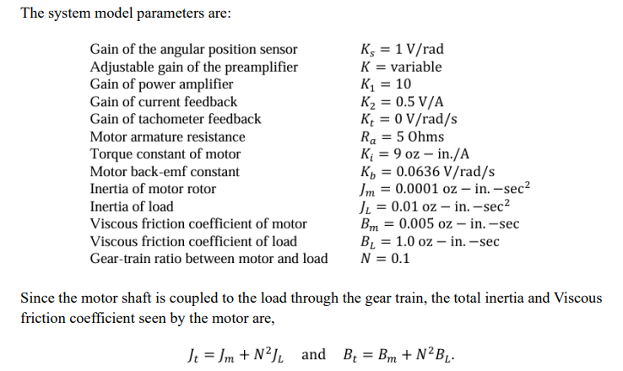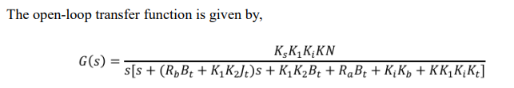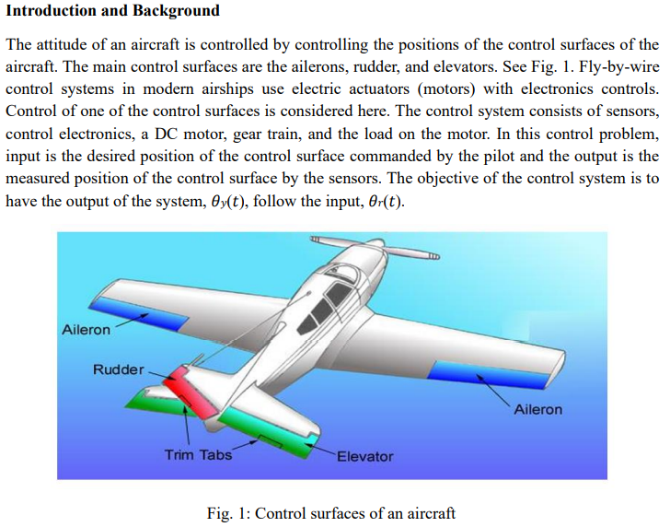

**TASKS**

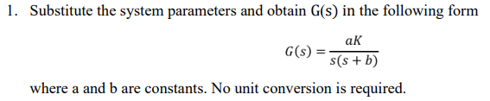

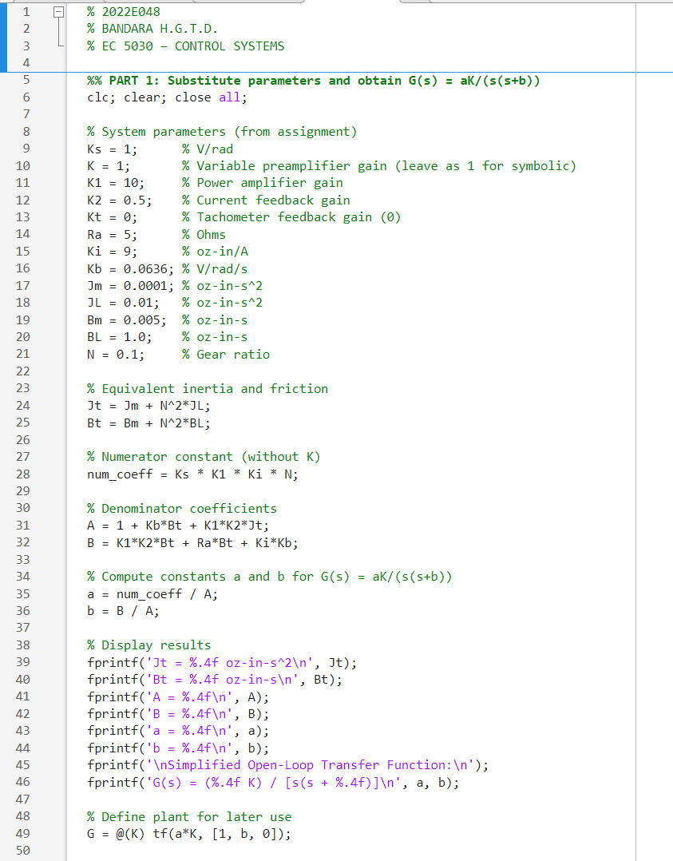

**FIGURE 01: MATLAB CODE FOR OBTAINE G(s)**

**FIGURE 02: OBTAINED MATLAB OUTPUT FOR G(S)**

**Then,**

**G(s) = $\frac{8.9824K}{S(S+0.7210)}$**