Online Exam System

Requirements Specification and Analysis

Version 0.1

19.11.2016

Ayşenur Bayram

Dilara Turanlı

Aslı Tuba Metin

Didar DamlaTuranlı

Prepared for

SE301 Software Engineering



Table of Contents

1. Introduction 1

1.1. Purpose of the System 1

1.2. Scope of the System 1

1.3. Objectives and Success Criteria of the Project 1

1.4. Definitions, Acronyms, and Abbreviations 1

1.5. Overview 1

2. Current System 2

3. Proposed System 2

3.1. Overview 2

3.2. Functional Requirements 3

3.3. Nonfunctional Requirements 5

Usability 5

Reliability 5

Performance 5

Supportability 5

Implementation 5

Interface 5

Packaging 6

Legal 6

3.4. System Models 6

Scenarios 6

Use case model 14

Object model 27

Dynamic model 28

User interface—navigational paths and screen mock-ups 33

4. Glossary 40

5. References 41

6. Project Plan 41

REQUIREMENTS ANALYSIS DOCUMENT

# Introduction

The Online Exam System is provided an overview of the functions which are described by the client. The system is very useful in education areas, training centers etc. which is use safely using time and the student can reach the exam easily. Also the system is using for the checking exam papers and preparing exam papers easily. It will help the educationals areas to testing students and develop their skills. Online exam's scope is many students can do his/her exams and also they can see their marks. To sum up, this system aims to be powerful tool for the evaluate students. Teacher can create exam in anytime.

## Purpose of the System

The purpose of the system is students have to register the site and do their exams. Students can also view the results at the same time. Also exams and courses upload by the instructors into the system. The education areas can enter and edit students, instuctors. Instructors can upload exams,results and correct answers. Students can see their courses, exams and their marks. Exams can be reviewed by the system which is time be inspired from the instructor.

## Scope of the System

Online Exam systems is designed for Educational Institutes like university, college, school. System can be used in every location, user's location does not matter. The system can give exam result when student enter the exam and answered the questions and exam's time is up. Instructors have authority over preparation, time and date of the exam. The system should have records of students and faculty that can be access to the system which can be used only for the authorized person.

## Objectives and Success Criteria of the Project

Online Exam helps the student to make the exam easily. It is not necessary to come university or facility to make the exam. Instructor cannot make an effort to copy a lot of exam's paper. And also student's score will be shown after the exam for the instructor. An Exam may contain multiple choices so student can make the exams very easily.

## Definitions, Acronyms, and Abbreviations

OES: Online Exam System

## Overview

RAD document contains general overview of the system.How the system is modelled by using;

* Use Case Model
* Scenarios
* Object models (Class Diagrams)
* Sequence Diagrams
* Activity Diagram
* Gantt Chart

# Current System

The school is always using OES. The OES is a web system for instructor and student. OES is modeled something on other using online exam systems. OES make it convenient using exam and reading out the result for instructor.

Admin is adding, removing and editing the courses and student’s and instructor’s descriptions, notwithstanding that everything is regular. Instructor prepare and save exams in the OES. Student can pass question, next question and back question following student sends a request to Online Exam System. OES is always controlled by admin, who checks add, edit, delete courses.

# Proposed System

Our system offers an easy,reliable and convenient online test application system for the users.This is our purpose in this system.3 users can be access to our system.These are instructor,student and admin.Enrollment of students and instructors to system will be performed by admin.Users will not be able to do anything without logging into the system.Users will be able to login to the system with their own password and user name after registration.System interface will be a objective-driven system that users can easily use.In this system, we take as an example student takes an online exam in student module.In the instructor module,system offers instructors some easy and helpful functions.For example, prepare exam,review exam ,or update grade in case of need.An other and last module is admin module.In this module admin is responsible for registering users and courses in the system.

## Overview

System makes it easier for instructors to prepare exams.At the same time,students take an exam which is prepared by instructors.Also,exam’s time setting by instructor then students answer the questions into this specified time.These functions occurs as a result of be user-friendly system.

## Functional Requirements

Fuctional requirements indicate the functions the system offers to the user.Therefore,in this part we will specify the functions of our three-actor system

* Instructor Functions
* Student Functions
* Admin Functions

|  |
| --- |
| Login the system |
| Change password |
| Reset password |
| Prepare and publish exam |
| Upload Results |
| Upload Correct Answer |
| Cancel Exam |
| Set Time Limit For Exams |

**Instructor Functions**

|  |
| --- |
| Login the system |
| Change password |
| Reset password |
| Taking exam |
| Pass Question |
| Save Exam |
| View Exam Results |

**Student Functions**

|  |
| --- |
| Login the system |
| Change password |
| Reset password |
| View user |
| View Course And Their Information |
| Add/Delete/Edit Course |
| Add/Delete/Edit User |

**Admin Functions**

## Nonfunctional Requirements

**Usability**

* People who have the average information about using computer and internet he/she can use program easly.
* The student can do the exam with a few click.

**Reliability**

* The system works most of the time .
* The user password must be 8 digits.

**Performance**

* More than one User will be able to use at the same time.
* The database will provide at least 1000 records of student.

**Supportability**

* The developer is responsible for compatibility and testability on OES

**Implementation**

* PHPMYADMİN was used for database.
* The codes of the system were written using the Komodo program

**Interface**

The System can Access on computer which have internet connection and a browser.

In OES’s some interfaces are;

* Admin home Page
* Student home page
* Instructor home page
* See result page
* Doing exam page
* Prepare exam page

**Packaging**

* The System be avaible on GitHub.

**Legal**

* System free to use.
* All content on the OES procted by Copyright law.

## System Models

Describes the scenarios, use cases, object model, and dynamic models for the system. This section contains the complete functional specification, including mock-ups illustrating the user interface of the system and navigational paths representing the sequence of screens.

***Scenarios***

## Scenario 1

|  |
| --- |
| **Scenario name:** Login Admin |
| **Participant actor instances: Didar:**Admin |
| **Flow of events:**   1. Firstly Didar writes [www.OES.com/admin](http://www.OES.com/admin) on browser. 2. Didar sees login pages and she enter user name into user name text field also enter password into Password text field on this pages. 3. If user name, password and status match to information which are in OES Didar can login to the OES. |

## Scenario 2

|  |
| --- |
| **Scenario name:** Login Student |
| **Participant actor instances: Aysenur:**Student |
| **Flow of events:**   1. Firstly Ayşenur writes www.OES.com on browser. 2. Ayşenur sees login pages and she enter user name into user name text field also enter password into Password text field on this pages. 3. Ayşenur choose Student option on Login page. 4. If user name, password match to information and status is Student on OES ,Ayşenur can login to the OES. |

## Scenario 3

|  |
| --- |
| **Scenario name:** Login Instructor |
| **Participant actor instances: Aslı:**Instructor |
| **Flow of events:**   1. Firstly Aslı writes www.OES.com on browser. 2. Aslı sees login pages and she enter user name into user name text field also enter password into Password text field on this pages. 3. Aslı choose Instructor option on Login page. 4. If user name, password match to information and status is Student on OES ,Aslı can login to the OES. |

## Scenario 4

|  |
| --- |
| **Scenario name:** Logout |
| **Participant actors: Dilara:** Admin, OR Instructor, OR Student |
| **Flow of events:**   1. Dilara clicks "Logout" button. 2. OES redirect the Dilara to Login Page. |

## Scenario 5

|  |
| --- |
| **Scenario name:** IncorrectPassword |
| **Participant actors: Aslı:** Admin |
| **Flow of events:**   1. Aslı starts browser and types URL as www.OES.com/admin of the OES. 2. Aslı sees the login page and enter his/her user name into user name text field also enter password into Password text field on this pages. 3. She see a error message that “Incorrect user name or password” on screen. 4. She click Reset Password button. 5. If Aslı recorded on OES,system send e-mail to Aslı about new password. 6. Aslı check her e-mail. 7. Aslı can login on system with new password. |

## Scenario 6

|  |
| --- |
| **Scenario name:** Change Password |
| **Participant actors: Dilara:** Admin, OR Instructor, OR Student |
| **Flow of events:**   1. Dilara login the system. 2. Dilara click “Change Password” button on main page. 3. System show a form which is include old password field and 2 new password fields. 4. System checks the new password and give notification to user if the new password is valid. 5. Aslı informed by the system about his/her password has been changed. |

## Scenario 7

|  |
| --- |
| **Scenario name:** Incorrect Status |
| **Participant actors: Didar:**Student |
| **Flow of events:**   1. Firstly Didar writes www.OES.com on browser. 2. Didar sees login pages and she enter user name into user name text field also enter password into Password text field on this pages. 3. Didar choose Instructor option on Login page. 4. When Didar click ok button. 5. System display a message that “Could not login.Please check user name,password or statu”. 6. Didar realised that she choosed student instead of Student.Therefore she choose Student. 7. If user name, password match to information and status is Student on OES ,Didar can login to the OES. |

## Scenario 8

|  |
| --- |
| ***Scenario Name:*** SeeResults |
| ***Participating actor instance:***  Student:Aysenur |
| 1. All the questions are done, Aysenur can click “Submit Exam” button to finish the exam. 2. Online Exam System takes the request and responds by directing Aysenur to the result page. 3. Aysenur can see his results. |

### **Scenario 9**

|  |
| --- |
| ***Scenario Name:*** SelectExam |
| ***Participating actor instance:***  Student:Aysenur |
| 1. Aysenur logs in to the system and Online Exam System checks her password and id. 2. If Online Exam System affirmed her password and id, directs her to the home page. 3. Aysenur selects his exam to the home page. |

### **Scenario 10**

|  |
| --- |
| ***Scenario Name:*** Do Exam |
| ***Participating actor instance:***  Student: Aysenur  Instructor: Emine |
| 1. Emine logs in to the system and has announced that she has submitted an online exam for her course in Online Exam System . 2. Aysenur logs in to the system and she must take Emine course until a certain date. 3. Online Exam System checks her password and id. 4. If Online Exam System affirmed her password and id, directs her to the Student home page. 5. Aysenur selects the course of Emine and selects the exam. 6. Aysenur then clicks the “Start Exam” button. 7. When “Start Exam” button is clicked, Online Exam System starts the countdown by the instructor. 8. Aysenur starts the exam and answers questions, she can click “Back” button to return to a previous question or pass a question. 9. After all the questions are done, Aysenur can see the passed questions by clicking “Passed questions” button. 10. After all the questions are done, Aysenur can click “Submit Exam” button to finish the exam and return to home page. 11. Aysenur can continue exam until countdown gets to 00:00 or she hits “Submit Exam” button. 12. If Aysenur does not click “Submit Exam” button until countdown is 00:00, the exam is automatically sent for reviewing by the Online Exam System. 13. When “Submit Exam” button is clicked or countdown is 00:00, Aysenur cannot return to the exam. |

### **Scenario 11**

|  |
| --- |
| ***Scenario Name:*** Start Exam |
| ***Participating actor instance:***  Student:Aysenur  Instructor:Emine |
| 1. Aysenur logs in to the Online Exam System and she must take course of Emine until a certain date. 2. Online Exam System checks her password and id, Aysenur is directed to the home page. 3. Aysenur sends a request to Online Exam System to select a course by clicking on it. 4. Online Exam System gets the request and directs Aysenur to the exam page and it starts, after Aysenur clicks the “Start Exam”. |

### 

***Scenario 12***

|  |
| --- |
| ***Scenario Name:*** Select Course |
| ***Participating actor instance:***  Student:Aysenur  Instructor:Emine |
| 1. Emine logs in to the system and has announced that she has submitted an online exam for her course in Online Exam System . 2. Aysenur logs in to the system and she must take Emine course until a certain date. 3. Online Exam System checks her password and id. 4. If Online Exam System affirmed her password and id, directs her to the Student home page. 5. Aysenur selects the course of Emine and selects the exam. |

***Scenario 13***

|  |
| --- |
| ***Scenario Name:*** Submit Exam |
| ***Participating actor instance:***  Student:Aysenur |
| 1. After all the questions are done, Aysenur can click “Submit Exam” button to finish the exam and return to home page. 2. Aysenur can continue exam until countdown gets to 00:00 or she hits “Submit Exam” button. 3. If Aysenur does not click “Submit Exam” button until countdown is 00:00, the exam is automatically sent for reviewing by the Online Exam System. 4. When “Submit Exam” button is clicked or countdown is 00:00, Aysenur cannot return to the exam. |

***Scenario 14***

|  |
| --- |
| ***Scenario Name:*** Pass Question |
| ***Participating actor instance:***  Student:Aysenur |
| 1. Aysenur starts the exam and answers questions, Aysenur can click “Back” button to return to a previous question or pass a question. 2. When all question are done,Aysenur can see the passed questions by clicking “Passed questions” button. 3. Online Exam System gets the request and directs Aysenur to the passed questions. |

***Scenario 15***

|  |
| --- |
| **Scenario name:** Deleting Course |
| **Participant actor instances: Didar:**Admin |
| **Flow of events:**   1. Didar wants to delete course on OES. 2. She logs in OES. 3. She select “Delete Course”. 4. She sees all course list. 5. She select the course that she want to delete. 6. She click “save” button. 7. OES find the course which be deleted on database and delete. 8. Didar see a message that “The course is deleted” 9. Didar logs of. |

***Scenario 16***

|  |
| --- |
| **Scenario name:** Deleting User |
| **Participant actor instances: Didar:**Admin |
| **Flow of events:**   1. Didar wants to delete user on OES. 2. She logs in OES. 3. She select “Delete User”. 4. She sees all User list. 5. She select the user that she want to delete. 6. She click “save” button. 7. OES find the user which be deleted on database and delete. 8. Didar see a message that “The user deleted” 9. Didar logs of. |

***Scenario 17***

|  |
| --- |
| **Scenario name:** Incorrectly Search |
| **Participant actor instances: Didar:**Admin , **Teacher:**Aslı |
| **Flow of events:**   1. Didar Logs in the OES. 2. Didar wants to find a teacher whose name is Aslı. 3. She write Aslı on search box on top of page. 4. She press enter. 5. OES is not found Aslı on database. 6. OES display a message that “Search does not exit.” 7. Didar Logs of. |

***Scenario 18***

|  |
| --- |
| **Scenario name:** AddQuestion |
| **Participant actor instances: Aslı:** Instructor |
| **Flow of events:**   1. Aslı wants to prepare exam and enters the web site. 2. She logins with her id, password and statu which is instructor. 3. She selects “Prepare Exam” button and directs to the course list page. 4. She selects course name and directs to the options which are there add questions, delete questions, see questions, set the limit of time and publish exam. 5. She pushes the “Add Question” button and add questions to the exam. |

***Scenario 19***

|  |
| --- |
| **Scenario name:** CancelTheExam |
| **Participant actor instances: Aslı:** Instructor |
| **Flow of events:**   1. Aslı wants to cancel the exam and enters the web site. 2. She logins with her id, password and statu which is instructor. 3. She selects “Cancel Exam” button and directs to the course list page. 4. She selects course name and directs to the exams list. 5. She selects course name which is she wants to cancel its exam. 6. She pushes the cancel exam button and finishes her duty. |

***Scenario 20***

|  |
| --- |
| **Scenario name:** UploadResult |
| **Participant actor instances:** Aslı: Instructor |
| **Flow of events:**  1) Aslı wants to upload result and enters the web site.  2) She logins with her id, password and statu which is instructor.  3) She selects “Upload Result” button and directs to the course list page.  4) She selects course name and directs to the uploading file page.  5) She pushes the “Upload” button and upload result's file into the system . |

***Scenario 21***

|  |
| --- |
| **Scenario name:** Edit Course |
| **Participant actor instances: Dilara:**Admin |
| **Flow of events:**   1. Dilara wants to edit course on the system. 2. She logs on to OES with her user name and password to edit course. 3. OES checks the password and user name according to the user’s input.If the inputs are valid,system opens new page that include edit course button. 4. She click the edit course button. 5. System display new page if she has already added courses. 6. Dilara selects course from this page. 7. System redirects the user to next page that includes selected course’s information. 8. She edits information about this course. 9. .Dilara clicks save button if the changes are over. 10. System save these or those changes. 11. System display a“edit course succesfully“messages in a box on this page. 12. Dilara logsoff the system if she want. |
| **Entry Condition:** Dilara saw the error in the exam. |
| **Exit Condition:** Dilara complates the edit course operation. |

***Scenario 22***

|  |
| --- |
| **Scenario name:** Exam Time Out |
| **Participant actor instances: Dilara:**Student |
| **Flow of events:**   1. Dilara enters the web-site. 2. System redirects the user to login page. 3. Dilara enters the required username and password fields on the screen. 4. Dilara clicks the StudentLogin button. 5. OES checks the password and user name according to the user’s input.If the inputs are valid,system opens student’s home page. 6. She clicks courses button and selects course which is going to start. 7. System display new page which is include questions if the exam begins. 8. Dilara starts to answer questions. 9. Exam time is over although she can not finish the questions. 10. System saves exam and redirect Dilara student’s home page. |
| **Entry Condition:** Dilara takes an exam.  Dilara starts an exam. |
| **Exit Condition:** System finish exam time. |

,

***Scenario 23***

|  |
| --- |
| **Scenario name:** MisMatched Passwords |
| **Participant actor instances: Dilara:** Instructor |
| **Flow of events:**   1. Dilara enters the web-site. 2. She logs on to OES with her user name and password . 3. OES checks the password and user name according to the user’s input.If the inputs are valid,system opens new page that include change password button. 4. Dilara wants to change her password. 5. .She clicks the changepassword button. 6. System display new page which is include changing password form. 7. .Dilara enter her user name,password,new password and again new password. 8. System checks the entered information. 9. If first new password and second new password not matched,system display a“mismatched password“messages in a box on this page. |
| **Entry Condition:** Dilara log in the system.  Dilara clicks the change password button. |
| **Exit Condition:** Dilara changed password succesfully. |

***Use case model***

### 

**Use case 1:**

|  |
| --- |
| **Use case name:** ChangePassword |
| **Participant actors:** Admin, OR Instructor, OR Student |
| **Flow of events:**   1. User login the system. 2. User selects an option which is name “Change Password” on login page. 3. System show a form which is include old password field and 2 new password fields 4. System checks the new password and give notification to user if the new password is valid. 5. User informed by the system about his/her password has been changed. |
| **Entry Condition**: User wants to change his/her password.  User clicks the button which name is Change Password. |
| **Exit Condition:** User changes his/her password successfully, OR  User informed by the system about his/her password has not been changed. |

**Use case 2:**

|  |
| --- |
| **Use case name:** PublishExam |
| **Participant actors:** Instructor |
| **Flow of events:**   1. User selects the course name. 2. User adds questions about this course. 3. User sets the time for the test. 4. User sends a request about the uploade exam to the system. 5. System displays a notification which is show uploading is done successfully. |
| **Entry Condition**: User wants a create an exam.  User clicks the Publish Exam option. |
| **Exit Condition:** User publishes the exam successfully, OR  User see the notification which is show exam is not upload to the system succesfully. |

**Use case 3:**

|  |
| --- |
| **Use case name:** SelectCourseName |
| **Participant actors:** Insturctor, OR Student |
| **Flow of events:**   1. User selects the course which is user's wants. 2. User gets the request to the enter the course. 3. System response to the user to enter the page of the course. 4. User directs to the course list. |
| **Entry Condition**: User is wanted to begin the Online Exam.  User is enrolled to the course. |
| **Exit Condition:** User is not enrolled to the course.  The course is not avaliable. |

**Use case 4:**

|  |
| --- |
| **Use case name:** UploadResults |
| **Participant Actors:** Instructor |
| **Flow of events:**  1) User selects his/her statu which is Instructor from the login page.  2) User enters his/her id and password into the required fields.  3) System checks the user's request that user registers to the system.  4) System responds to the user to entering the system.  5) User login.  6) User selects Upload Results option.  7) User sends a request to see upload result option.  8) System response to the user to entering upload results option.  9) User selects the course name in the course list and sends request to the system.  10)System response to the user to uploading results. |
| **Entry Conditions:**  User makes a exam before the upload the results. |
| **Exit Conditions:**  User posts the results successfully, OR  System sends a notification why the results are not uploading. |

**Use case 5:**

|  |
| --- |
| **Use case name:** UploadCorrectAnswer |
| **Participant Actors:** Instructor |
| **Flow of events:**  1) User selects his/her statu which is Instructor from the login page.  2) User enters his/her id and password into the required fields.  3) System checks the user's request that user registers to the system.  4) System responds to the user to entering the system.  5) User login.  6) User selects Upload Correct Answers option.  7) User sends a request to see upload correct answers option.  8) System response to the user to entering upload correct answers option.  9) User selects the course name in the course list and sends request to the system.  10)System response to the user to uploading correct answers. |
| **Entry Conditions:**  User selects Upload Correct Answers option.  User knows the exam's time limit is over. |
| **Exit Conditions:**  User uploads result succesfully, OR  User takes a notification why the uploading could not work. |

**Use case 6:**

|  |
| --- |
| **Use case name:** CancelExam |
| **Participant Actors:** Instructor |
| **Flow of events:**  1) User selects the course which is he/she wants to delete its exam.  2) User selects the exam.  3) User clicks the Delete Exam button and sends a request to the system.  4) System gets the request and responds to the user to cancel the exam. |
| **Entry Conditions:**  User has a exam before the cancel.  User selects cancel option. |
| **Exit Conditions:**  User deletes the exam succesfully, OR  User takes a notification about the why is the canceling not working. |

**Use case 7:**

|  |
| --- |
| **Use case name:** PrepareExam |
| **Participant Actors:** Instructor |
| **Flow of events:**  1) User selects the Prepare Exam and sends a request to the system.  2) System takes the request and response to the user to select the course name.  3) User selects the course name and sends a request to the system.  4) System takes the request and response to the user to directly to the prepare exam part. |
| **Entry Conditions:**  User clicks the Prepare Exam button.  User wants to add question to the exam.  User wants to delete question in the exam.  User wants to see questions which is in the exam. |
| **Exit Conditions:**  User prepares and saves the exam succesfully, OR  User takes a notification which is about why the exam is not save succesfully. |

**Use case 8:**

|  |
| --- |
| **Use case name:**AddQuestion |
| **Participant Actors:** Instructor |
| **Flow of events:**  1) User selects the course name to prepare the exam and sends a request to the system.  2) System takes the request and response to the user to select the add question.  3) User adds questions and sends a request to the system  4) System takes the request and response to the user to directly to the add question. |
| **Entry Conditions:**  User starts preparing the exam.  User comes to add question step. |
| **Exit Conditions:**  User adds questions successfully, OR  User takes a notification which is about why questions is not add succesfully. |

**Use case 9**

|  |
| --- |
| **Use case name:** DeleteQuestion |
| **Participant Actors:** Instructor |
| **Flow of events:**  1) User selects the course name to prepare the exam and sends a request to the system.  2) System takes the request and response to the user to select the delete question.  3) User deletes questions which he/she wants and sends a request to the system.  4) System takes the request and response to the user to directly to the delete question. |
| **Entry Conditions:**  User is enrolled to the course. |
| **Exit Conditions:**  The exam is not available. |

**Use case 10**

|  |
| --- |
| ***Use case name:*** SeeResults |
| ***Participant actors:*** Initiated by Student  Connected with Instructor |
| ***Flow of events:***   1. Student sends a request to Online Exam System to see their results. 2. Online Exam System takes the request and responds by directing the student to the results page. 3. Student then can see the results for previously taken exams |
| ***Entry Condition:*** Student is logged in to Online Exam System. Student is registered to the course. |
| ***Exit Condition:*** Student logs off. |

**Use case 11**

|  |
| --- |
| ***Use case name:*** SelectExam |
| ***Participant actors:*** Initiated by Student |
| ***Flow of events:***   1. Student sends a request to Online Exam System to select an exam. 2. Online Exam System takes the request and return by directing the student to the exam |
| ***Entry Condition:*** Student is logged in to Online Exam System.Student is registered to the course. |
| ***Exit Condition:*** Student logs off. The student has taken the exam. |

**Use case 12**

|  |
| --- |
| ***Use case name:*** DoExam |
| ***Participant actors:*** Initiated by Student |
| ***Flow of events:***   1. Student sends a request to Online Exam System to take the online exam by clicking the “Start Exam” button. 2. Online Exam System gets the request and directs the Student to the exam page and it starts. 3. Student answers questions, s/he can click “Back” button to return to a previous question or “Next” button to pass to the next question. 4. Student can see the passed questions by clicking “Passed questions” button. 5. Student clicks “Submit Exam” button to finish the exam and return to home page. 6. Online Exam System takes the request sends the submitted exam to be reviewed. 7. If the student does not click “Submit Exam” button until countdown is finish, the exam is automatically sent for reviewing by the Online Exam System. |
| ***Entry Condition:*** Student is logged in to Online Exam System.Student has not taken the exam.Student clicks the Start Exam button.Student is registered to the course. |
| ***Exit Condition:*** Student clicks the Submit Exam button or the counter ends 00:00. |

**Use case 13**

|  |
| --- |
| ***Use case name:*** SelectCourse |
| ***Participant actors:*** Initiated by Student |
| ***Flow of events:***   1. When Online Exam System checks her password and id, user is directed to the home page. 2. User sends a request to Online Exam System to select a course by clicking on it. 3. Online Exam System gets the request and responds by directing the User to the selected course. |
| ***Entry Condition:*** User is logged in to Online Exam System.User is registered to the course. |
| ***Exit Condition:*** User logs off.The user is not registered to the course. |

**Use case 14**

|  |
| --- |
| ***Use case name:*** Start Exam |
| ***Participant actors:*** Initiated by Student |
| ***Flow of events:***   1. User logs in to the system and user must take instructor course until a certain date. 2. When Online Exam System checks her password and id, user is directed to the home page. 3. User sends a request to Online Exam System to select a course by clicking on it. 4. Online Exam System gets the request and responds by directing the User to the selected course. Student sends a request to Online Exam System to take the online exam by clicking the “Start Exam” button. 5. Online Exam System gets the request and directs the Student to the exam page and it starts. |
| ***Entry Condition:*** Student is logged in to Online Exam System.Student has not taken the exam.Student clicks the Start Exam button.Student is registered to the course. |
| ***Exit Condition :*** Student logs off. The student has taken the exam. |

**Use case 15**

|  |
| --- |
| ***Use case name:*** Submit Exam |
| ***Participant actors:*** Initiated by Student |
| ***Flow of events:***   1. Student clicks “Submit Exam” button to finish the exam and return to home page. 2. Online Exam System takes the request sends the submitted exam to be reviewed. 3. If the student does not click “Submit Exam” button until countdown is finish, the exam is automatically sent for reviewing by the Online Exam System. |
| ***Entry Condition:*** Student is logged in to Online Exam System.Student has not taken the exam.Student clicks the Start Exam button.Student is registered to the course. |
| ***Exit Condition:*** Student clicks the Submit Exam button or the counter ends 00:00. |

**Use case 16**

|  |
| --- |
| **Use case name:** Pass Question |
| **Participant actors:** Initiated by Student |
| **Flow of events:**   1. Student starts the exam and answers questions, student can click “Back” button to return to a previous question or pass a question. 2. All question are done, Student can see the passed questions by clicking “Passed questions” button. 3. Online Exam System gets the request and directs the Student to the passed questions. |
| **Entry Condition:**   * Student is logged in to Online Exam System.Student is registered to the course. |
| **Exit Condition:**   * Student logs off. The student has taken the exam. |

**Use case 17**

|  |
| --- |
| **Use case name:** Delete User |
| **Participant actors:** Admin |
| **Flow of events:**   1. Admin Logs in the OES. 2. OES shows some button such as; add user,add course,delete user,delete course in home page. 3. Admin click “Delete User“ button. 4. OES display a list which have all user on database. 5. Admin selects the user which is going to be deleted. 6. Admin click “save“ button and OES deletes the selected user. 7. OES display a message that “The user is deleted“ 8. Admin logs of. |
| **Entry Condition:**   * Admin logs in to the OES. * Admin click the “delete user“ button on home page. |
| **Exit Condition:**   * OES saves the informations to the database. * Admin sees a message that “The user is deleted“. |

**Use case 18**

|  |
| --- |
| **Use case name:** Delete Course |
| **Participant actors:** Admin |
| **Flow of events:**   1. Admin Logs in the OES. 2. OES shows some button such as; add user,add course,delete user,delete course in home page. 3. Admin click “Delete Course” button. 4. OES display a list which have all course on database. 5. Admin selects the course which is going to be deleted. 6. Admin click “save” button and OES deletes the selected course. 7. OES display a message that “The course is deleted” 8. Admin logs of. |
| **Entry Condition:**   * Admin logs in to the OES. * Admin click the “delete course“ button on home page. |
| **Exit Condition:**   * OES saves the informations to the database. * Admin sees a message that “The course is deleted“. |

**Use case 19**

|  |
| --- |
| **Use case name:** Search |
| **Participant actors:** Admin |
| **Flow of events:**   1. Admin Logs in the OES. 2. When Admin wants to find a user or a course he/she use search part on top of page. 3. Admin enter name or ID on search box. 4. Admin press enter. 5. OES display searched information from database. 6. Admin Logs of. |
| **Entry Condition:**   * Admin logs in to the OES. * Admin enter ID or name on search box and press enter. |
| **Exit Condition:**   * Admin sees a message that Search does not exit. |

**Use case 20**

|  |
| --- |
| **Use case name:** View |
| **Participant actors:** Admin |
| **Flow of events:**   1. Admin Logs in the OES. 2. When Admin wants to see a user or a course he/she uses view button on Admin Main page. 3. He/she clicks View button. 4. Admin choose what she/he wants to view that Users(Teacher/Student), Courses on option box. 5. After admin choose one he/she clicks view button. 6. OES displays list which requested by admin from database. |
| **Entry Condition:**   * Admin logs in to the OES. |
| **Exit Condition:**   * Admin logs of. |

**Use case 21**

|  |
| --- |
| **Use case name:** Add User |
| **Participant actors:** Admin |
| **Flow of events:**   1. Admin starts browser and types URL of the OES. 2. Admin logs in system with his/her password. 3. He/she click “Add User“ button. 4. OES display new page and admin add information about new user on this page. 5. Admin click “save“ button. 6. OES displays “Add User Successfully“ message on box. 7. OES redirects admin tot he user main page. 8. Admin logs of. |
| **Entry Condition:**   * Admin log in the OES. * Admin displays his/her main page. |
| **Exit Condition:**   * Admin saves the user successfully on system |

**Use case 22**

|  |
| --- |
| **Use case name:** Add Course |
| **Participant actors:** Admin |
| **Flow of events:**   1. Admin starts browser and types URL of the OES. 2. Admin logs in system with his/her password. 3. He/she click “Add Course“ button. 4. OES display new page and admin add information about new user on this page. 5. Admin click “save“ button. 6. OES displays “Add Course Successfully“ message on box. 7. OES redirects admin tot he user main page. 8. Admin logs of. |
| **Entry Condition:**   * Admin log in the OES. * Admin displays his/her main page. |
| **Exit Condition:**   * Admin saves the course successfully on system |

**Use case 23**

|  |
| --- |
| **Use case name:** Edit Course |
| **Participant actors:** Admin |
| **Flow of events:**   1. Admin starts browser and types URL of the OES. 2. Admin logs in system with his/her password. 3. He/she click “Edit Course“ button. 4. OES display list of course on new page 5. Admin select course that he/she wants update infotmation about selected course on list. 6. Admin enter necessary information about course 7. Admin click “save“ button. 8. OES displays “Edit Course Successfully“ message on box. 9. OES redirects admin tot he user main page. 10. Admin logs of. |
| **Entry Condition:**   * Admin log in the OES. * Admin displays his/her main page. |
| **Exit Condition:**   * Admin saves new information successfully on system. * Admin click “back“ button. |

**Use case 24**

|  |
| --- |
| **Use case name:** Edit User |
| **Participant actors:** Admin |
| **Flow of events:**   1. Admin starts browser and types URL of the OES. 2. Admin logs in system with his/her password. 3. He/she click “Edit User“ button. 4. OES display list of users on new page 5. Admin select a user that he/she wants update infotmation about selected user on list. 6. Admin enter necessary information about user. 7. Admin click “save“ button. 8. OES displays “Edit User Successfully“ message on box. 9. OES redirects admin tot he user main page. 10. Admin logs of. |
| **Entry Condition:**   * Admin log in the OES. * Admin displays his/her main page. |
| **Exit Condition:**   * Admin saves new information successfully on system. * Admin click “back“ button. |

**Use case 25**

|  |
| --- |
| **Use case name:** Login Admin |
| **Participant actors:** Admin |
| **Flow of events:**   1. Admin starts browser and types URL as www.OES.com/admin of the OES. 2. Admin sees the login page and enter his/her user name into user name text field also enter password into Password text field on this pages. 3. When he/she clicks login button OES checks the user name,password and status. 4. If the admin informations are match OES information admin can login. |
| **Entry Condition**:The admin enter the login screen. |
| **Exit Condition:** The admin logs in successfully. |

**Use case 26**

|  |
| --- |
| **Use case name:** Login User |
| **Participant actors:** Student,OR Instructor |
| **Flow of events:**   1. Users starts browser and types URL as www.OES.com of the OES. 2. He/she enter his/her user name into user name text field also enter password into Password text field on this pages. 3. User choose Instructor if he/she is a instructor or choose student if he/she is a student on login page. 4. When he/she clicks OK button OES checks the user name,password and status. 5. If the user informations are match OES information user can login. |
| **Entry Condition**:User wants to login on OES |
| **Exit Condition:** User logs of. |

***Diagrams***

### Use Case

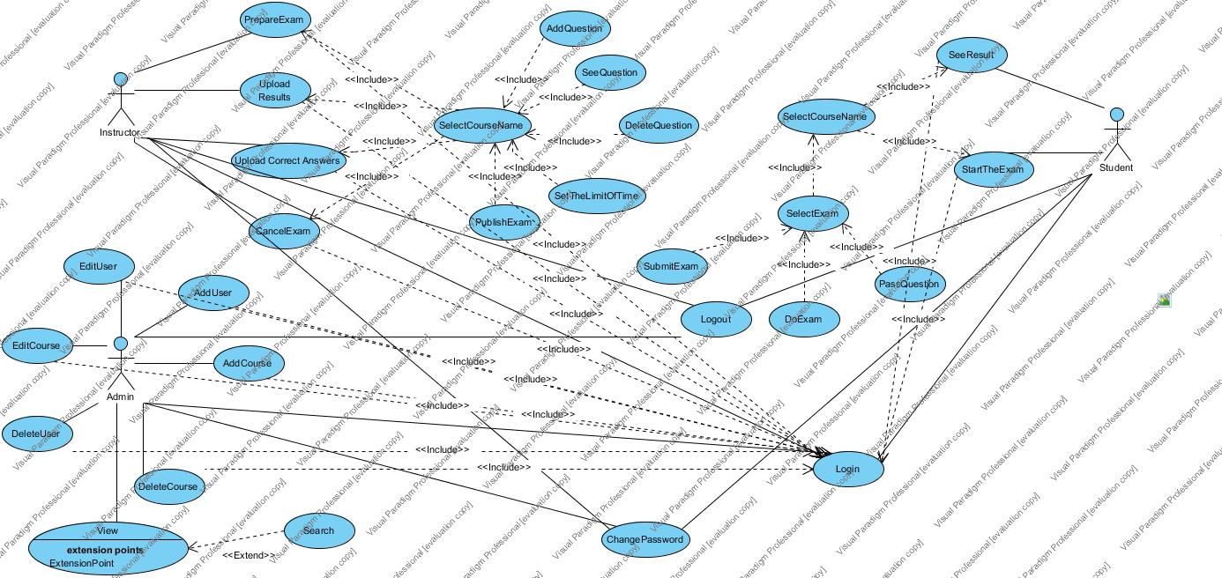

### 

### Object model

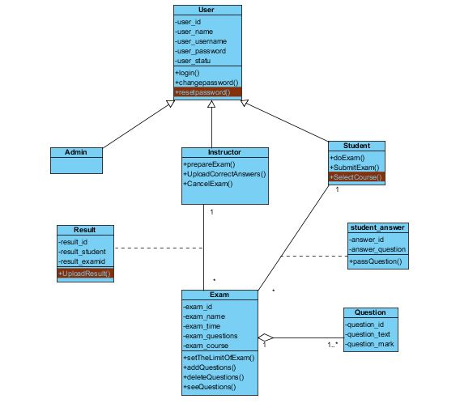

### 

### Dynamic Model

*Sequence Diagram*

Reset Password

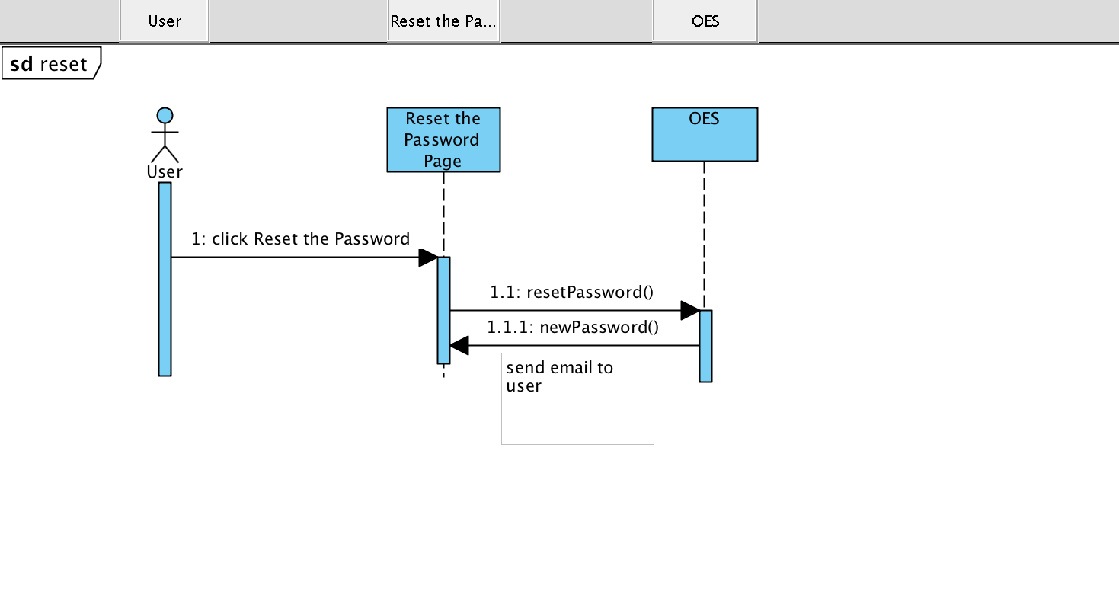

Do Exam

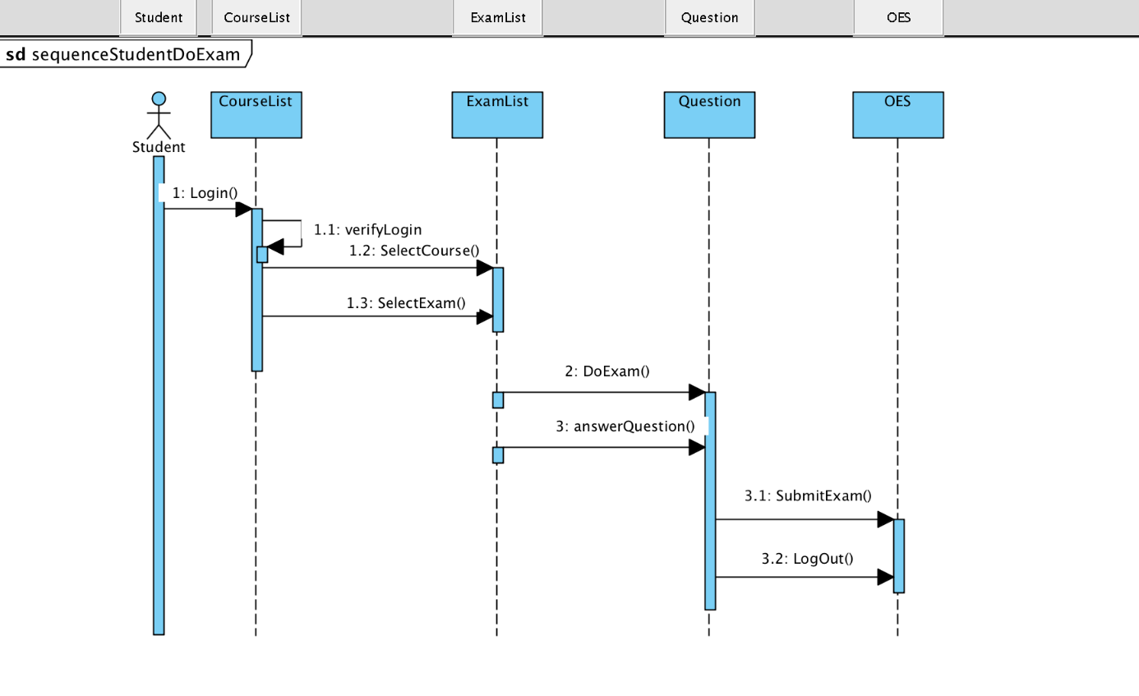

Add User and Course

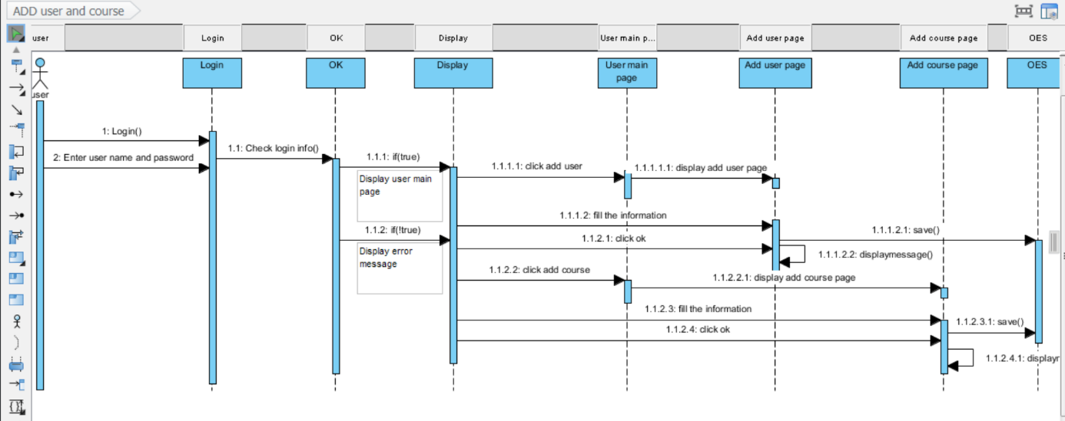

Change Password

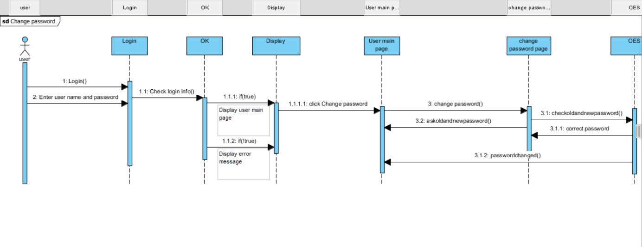

Prepare Exam

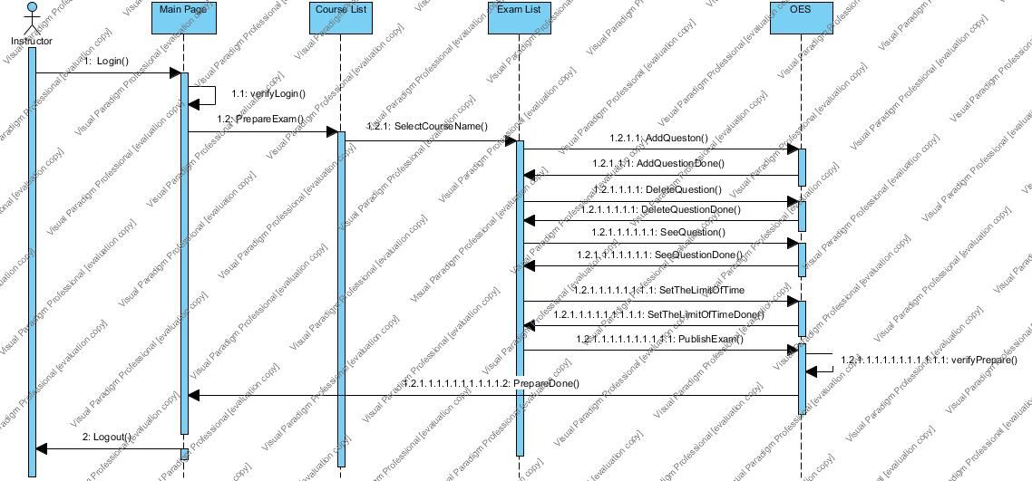

Upload Result

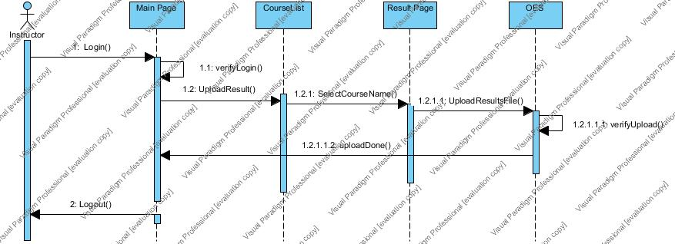

*Activity Diagram*

***Admin***

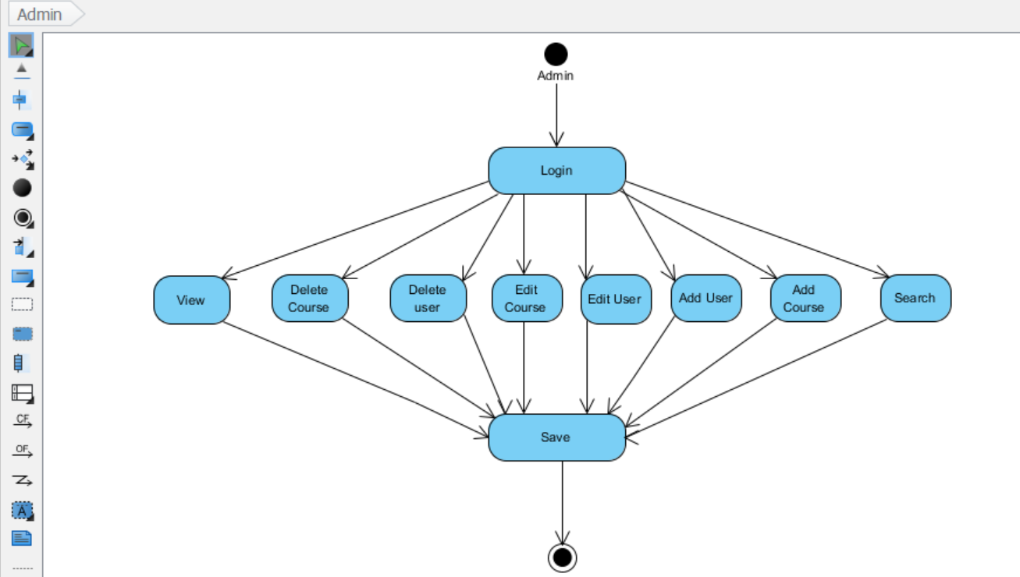

***Student***

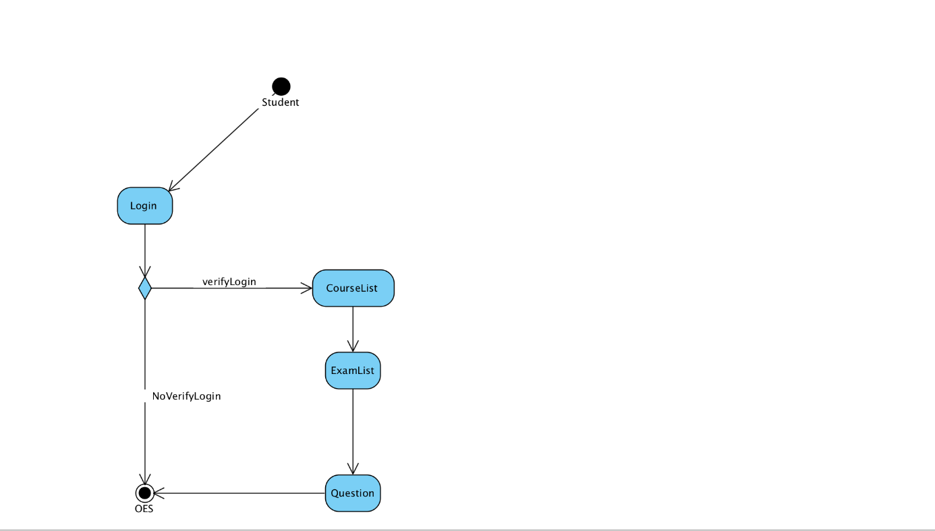

***Instructor Prepare Exam***

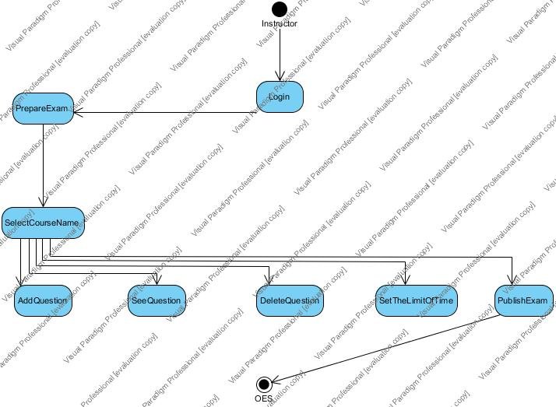

***Interfaces***

*Login Instructor or Student Page*

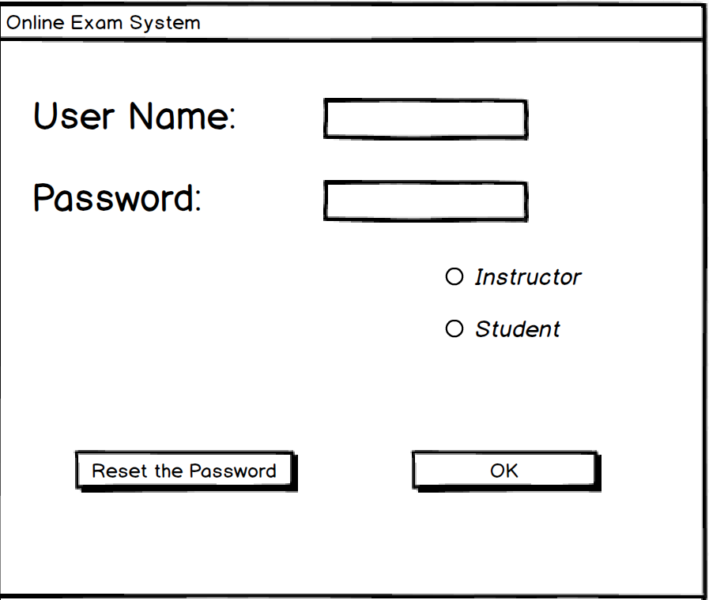

*Login Admin*

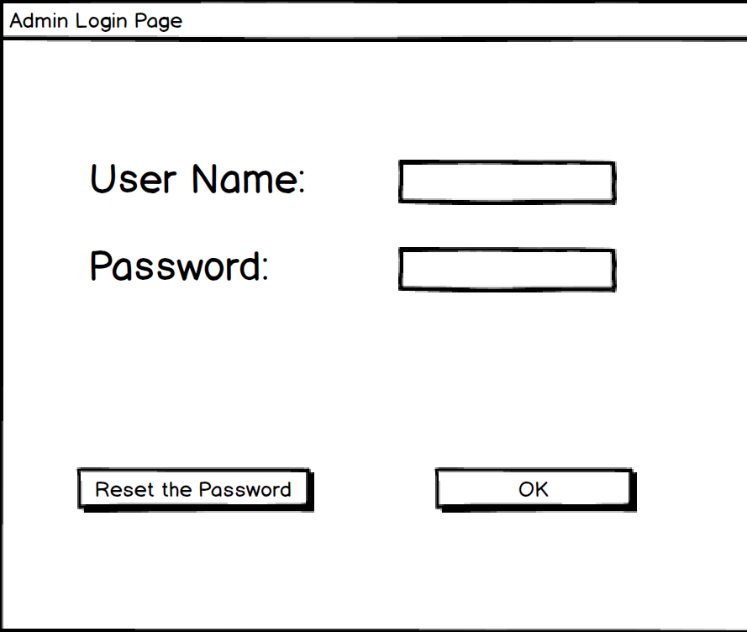

*Prepare Exam Page*

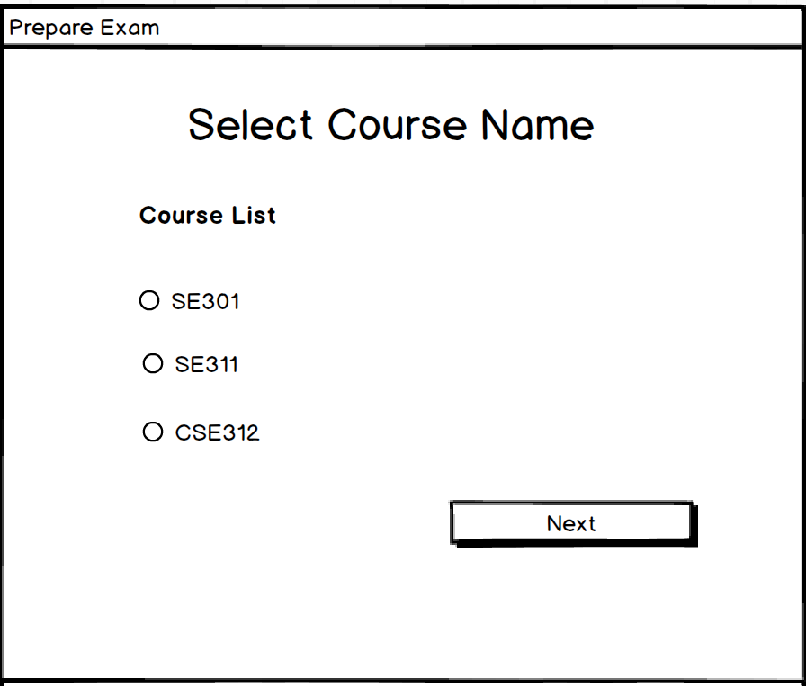

*Do Exam Page 1*

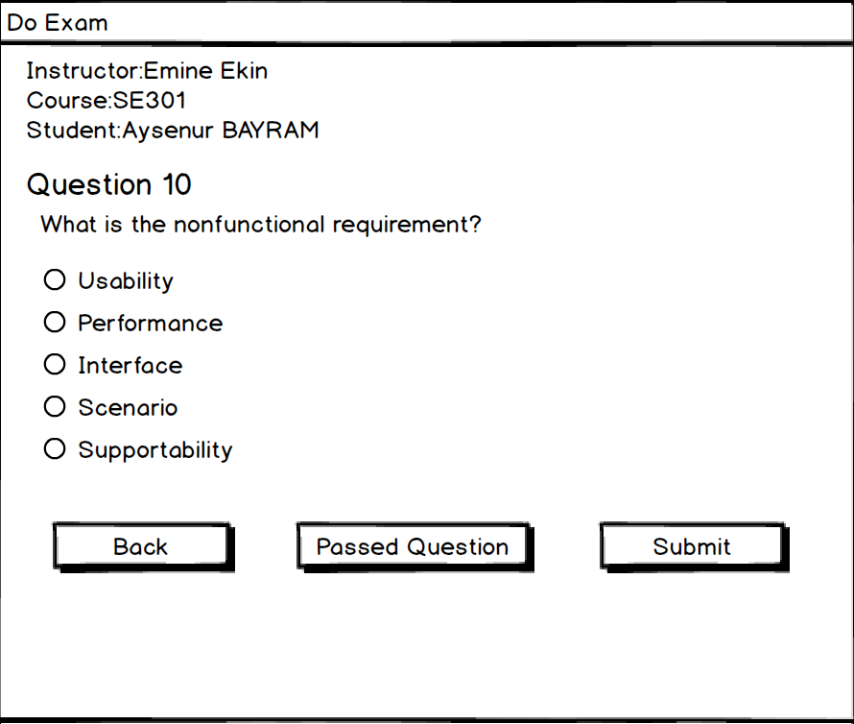

*Instructor Main Page*

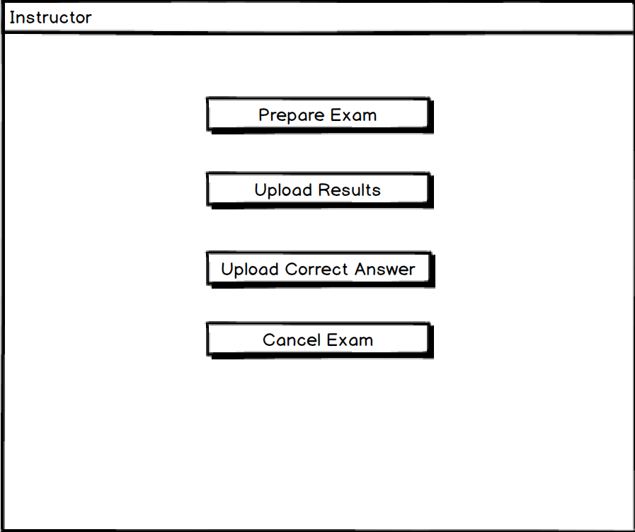

*Instructor Main Page*

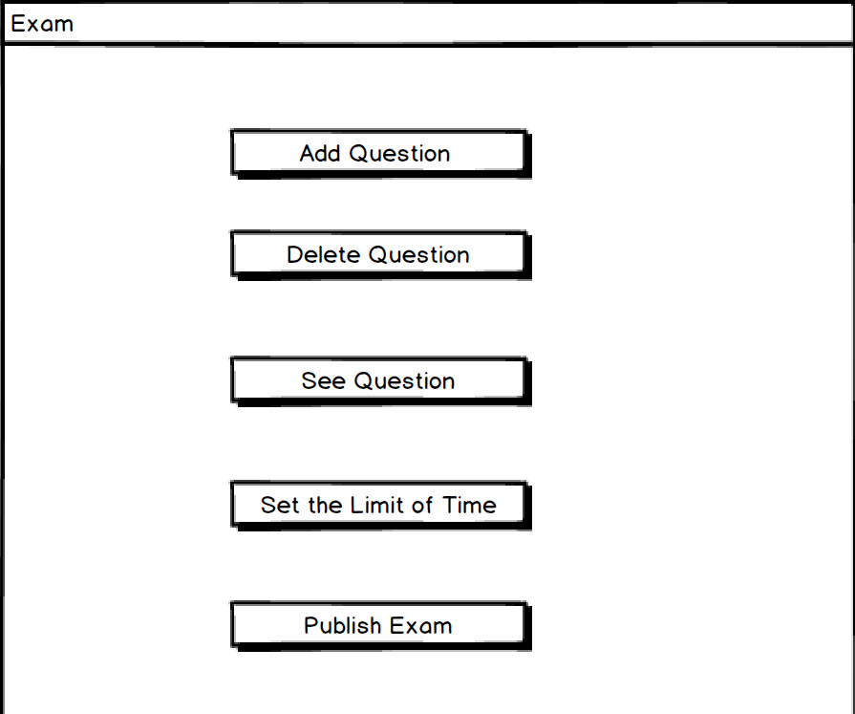

*Do Exam Page 2*

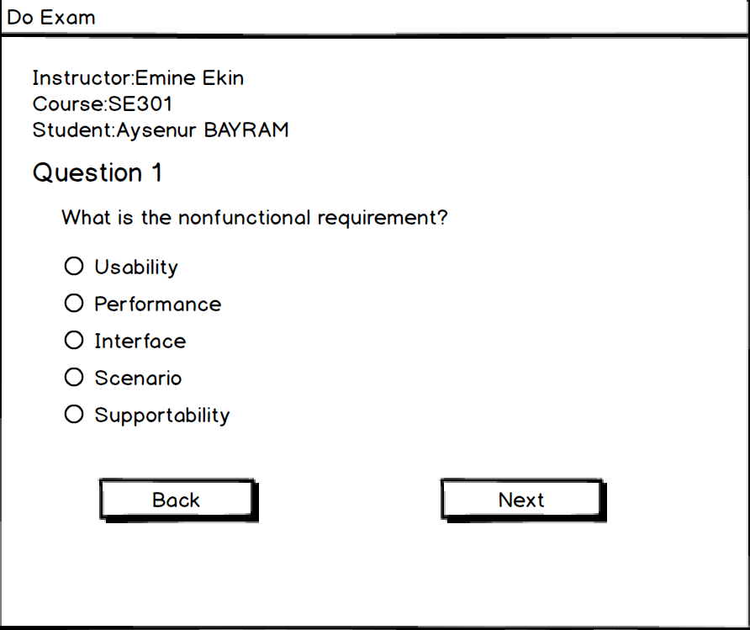

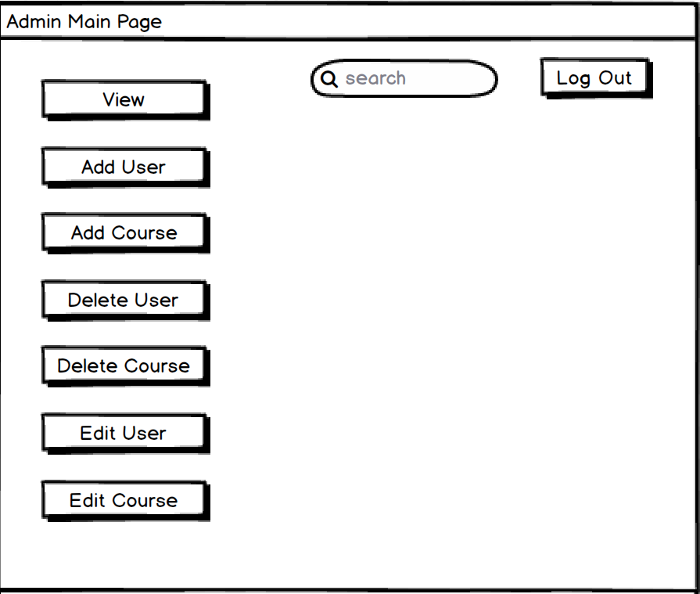

# Glossary

**OES :** Online exam System.

**Online Exam System** : Student use the system to doing exam.

**User :** Student,OR Instructor,OR Admin.

**Admin:** The people who are responsible of add course/user, delete course/user,edit course/user and view course/user.

**Instructor:** The people who are responsible exam operations such as ; prepare exam,upload result,cancel exam on faculty.

**Student:** The people who be an exam on faculty.

**Login:**  Action to access the application.

**Use case:** Definitions user’s steps for reaching a specific goal on a system.

**Use case diagram:**This is a diagram that summarize who uses a system and what they can do with the system.

**Functional Requirement:** A requirement that determines a function or feature of the system.

**Non-FunctionalRequirement:**Definitions system features such as; Usability,Reliability,Performance,Supportability,Implementation,Interface,Packaging,Legal.

**Scenario:** Examples of use of the system, which is usually a story.

**Sequece Diagram:** The behavior of the objects and the messages they communicate with each other on Use case.

# References

* www. balsamiq.com
* SE301 Course Slides
* Bernd Bruegge, Allen H. Dutoit, Object Oriented Software Engineering Using UML, Patterns and Java, 3rd ed., Prentice Hall
* www.ganttproject.biz

# Project Plan

