**3.2. System Decomposition**

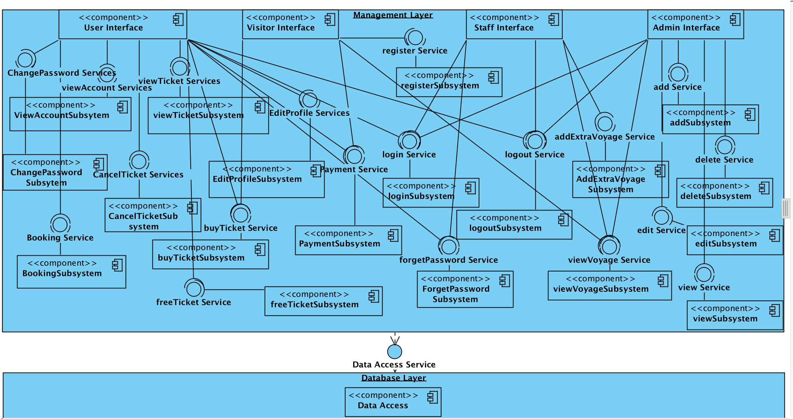

Figure1: Coupling view of Subsystem Decomposition

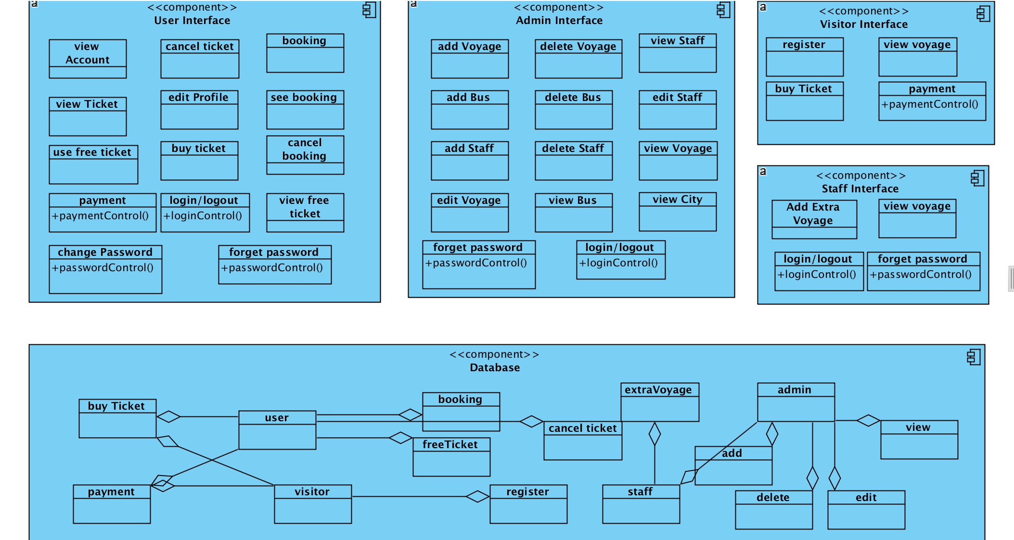

Figure 2: Cohesion view of Subsystem Decomposition

**3.3. Hardware Software Mapping**

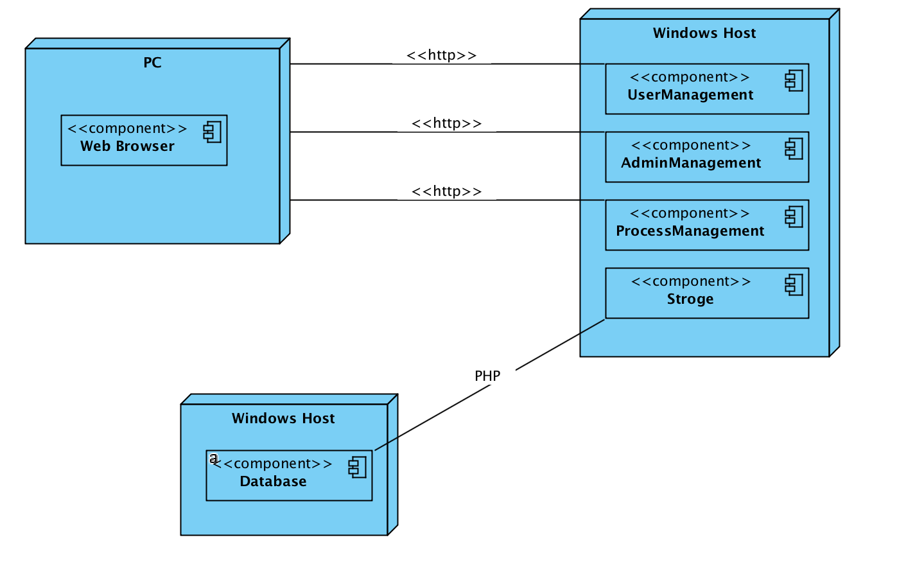

**4. Subsystem Services**

During the subsystem decomposition of *bus ticket reservation / sale* , we divide the system into smaller subsystems with strong coherence. The different subsystems should have a loose coupling.

The subsystem separation shows the entities of the following subsystems:

* + User management subsystems
  + Admin management subsystems
  + Process management subsystems
  + Database subsystems  
      
      
      
    **User management subsystems**

This subsystem responsible for managing different users of the system by taking care of login information of different users. It manages the username and password of all users of the system.

*Operations provided by this subsystem are:*

* + Login()
  + Logout()

**Admin Management Subsystem**

This subsystem responsible for managing user and staff accounts. It provides function for opening an account, updating an account and closing an account. Admin is the actor who communicates with this subsystem. This subsystem uses user management subsystems for authenticating the admin, user ,staff their information and voyages information.

*The operations provided by admin management subsystems are:*

* + Login()
  + Add Staff()
  + Add Voyage()
  + Add Staff()
  + DeleteVoyage()
  + DeleteBus()
  + DeleteStaff()
  + forgetPassword()
  + EditStaff()
  + EditVoyage()
  + viewBus()
  + viewVoyage()
  + viewStaff()
  + viewCity()
  + Logout()

**Process Management Subsystems**

This subsystem is responsible for managing the process. This provides all functions for managing ticket details, booking, free ticket , payment and other things.

*User performed by this subsystem are:*

* + Login()
  + viewAccount()
  + viewTicket()
  + changePassword()
  + cancelTicket()
  + editProfile()
  + booking()
  + seeBooking()
  + cancelBooking()
  + buyTicket()
  + payment()
  + viewFreeTicket()
  + useFreeTicket()
  + forgetPassword()
  + Logout()

*Visitor performed by this subsystem are:*

* + Register()
  + viewVoyage()
  + buyTicket()
  + payment()

*Staff performed by this subsystem are:*

* + Login()
  + AddExtraVoyage()
  + viewVoyage()
  + forgetPassword()

**Database Subsystems**

The database subsystem will be implemented by relational database management system used to store admin’s data, staff’s data ,visitor’s data and user’s data.

**Admin Interface Subsystems**

This subsystem responsible for managing user ,staff and visitor information. It provides function for staff account, ticket information. Admin is the actor who communicates with this subsystem. This subsystem uses user management subsystems for authenticating the admin, staff and user information.

**User Interface Subsystems**

This subsystem in charge of managing the process. This ensure for edit profile, booking, payment, free ticket, ticket, view account, ticket and booking, cancel ticket and booking.

**Visitor Interface Subsystems**

This subsystem in charge of managing the process. This ensure for register , view voyage, buying ticket, payment.

**Staff Interface Subsystems**

This subsystem in charge of managing the process. This ensure for view voyage, adding extra voyage, forget password.

**Database Subsystems**

The database subsystem will be implemented by relational database management system used to store admin’s data, user’s data and visitor’s data and staff’s data.