Online Bus Ticket System

Requirements Specification and Analysis

Version 0.1

17.11.2017

Didar Damla Turanlı

Hatice Dilara Turanlı

Ayşenur Bayram

Anıl Aydıner

Prepared for

SE301 Software Engineering



Table of Contents

1.Introduction 4

1.1.Purpose of the System 4

1.2.Scope of the System 4

1.3.Objectives and Success Criteria of the Project 4

1.4.Definitions, Acronyms, and Abbreviations 4

1.5.Overview 4

2.Current System 4

3.Proposed System 4

3.1.Overview 4

3.2.Functional Requirements 4

3.3.Nonfunctional Requirements 4

Usability 4

Reliability 5

Performance 5

Supportability 5

Implementation 5

Interface 5

3.4.System Models 5

Scenarios 5

Use case model 5

Object model 5

Dynamic model 5

User interface—navigational paths and screen mock-ups 5

4.Glossary 5

5.References 5

REQUIREMENTS ANALYSIS DOCUMENT

# Introduction

## Purpose of the System

Purpose of the system in this project is to offer easy and fast buy ticket to one or more user at a time. Also purpose of the system includes providing some functionalities to bus company owner so that they can manage their own page.

## Scope of the System

The System provides service to user,visitor, bus company , admin . There are some functionalities for both bus company Owner, user, admin . some of them are different too.

Some of the services offered by the user of this system are as follows:.User can login the sytem with his/her username and password then he/she can buy a ticket .Also, this sytem provides some privigiles for registered user.Make a booking,delete ticket and win a gift ticket are most important about this.The other one user in this system is Visitor and he/she do only buying ticket.

OBTS system is provides other services to system’s staff.Those services are add extra voyage and view voyage.Staff login the system his/her information and he/she can do this operations.

The service that the system provides to admin; The admin can login to system to add bus,add staffs,add voyage,delete bus,delete staff,delete voyage,edit staff,edit voyage operations.Also ,admin can do some view operations such as city,bus,staff and voyage

## Objectives and Success Criteria of the Project

The objectives and success criteria of the project is to be provide a reliable and fast service. That means we can buy tickets and view our seat without having to go out.

## Definitions, Acronyms, and Abbreviations

RAD: Requirements Analysis Document

OBTS:Online Bus Ticket System

UI: User Interface

## Overview

Our requirement analysis document contains Current System section, Proposed System section, overview of OBTS system. Functional requirements, Nonfunctional requirement section, system model section, Object model section, Dynamic Model section and Glossary.

In Current system part we explained about system functions and features of new OBTS.

OBTS has a friendly interface and design to be short response time. All functions provide do task quickly and easy payment system.

In Proposed System part, we talked about system advantages and lates developments.

In overview part, we defined generally functions and details of OBTS system.

In Functional requirements part, we explained functions of OBTS and also we defined task of user,visitor,admin and staff.

In Nonfunctional requirements we described usability, performance, reliability or availability of OBTS system.

In System model part, we described scenarios and use cases of OBTS system.

In Object model part, we explained class diagrams of OBTS system and we define relationship with classes of my system.

In dynamic model part, we show sequence diagram that incude step by step interfaces

In Glossary part is like a dictionary which is explained all words that we used in RAD documentation.

# Current System

The OBTS is a web system for passenger and personnel of bus firm. OBTS is a domestic privatized transportation company that runs the vehicle all over the country. They have several branches at different locations of the country, so that they can provide the transportation facilities between the places. Where the details of booking, payment, sale.

Admin is adding ,deleting and editing for city, services, staff and additional services. Admin controlled true of user password and card information. Staff is personal of bus firm who is sending necessary extra voyages to admin. User can does booking, buy ticket, edit profile, free ticket, seeing past ticket, cancel ticket/booking. Visitor is not register who can be register and buy ticket. OBTS is always controlled by admin and staff for voyages and user information.

# Proposed System

Our first goal in this system is to provide fast, convenient and high quality services to more than one user at the same time

Users can get tickets on the system step by step and get tickets quickly. It is an extra advantage for the user to offer the possibility to choose the seats they will take.

## Overview

The OBTS system is buying online bus ticket system.User can buy ticket for many cities.Our operations is very quick and safety.Therefore, it is a targeted project that its use is widespread

## Functional Requirements

Functional requirements indicate the functions the system offers to the user. Therefore,in

this part we will specify the functions of our three-actor system

* User Functions
* Staff Functions
* Admin Function
* Visiter Function

***User Functions***

|  |
| --- |
| Login |
| Logout |
| Forget Password |
| Booking |
| See Booking |
| Cancel Booking |
| View Account |
| Change Password |
| Edit Profile |
| Free Ticket |
| Ticket |
| Cancel / Buy Ticket |
| Payment Transaction |

***Visitor Functions***

|  |
| --- |
| Register on System |
| Buy Ticket |
| View Voyage |

***Admin Functions***

|  |
| --- |
| Login |
| Logout |
| Add Voyage/ Staff/Bus |
| Delete Voyage/Bus/Staff |
| Edit Voyage/Staff |
| View Voyage/Bus/Staff/City |

***Staff Function***

|  |
| --- |
| Login |
| Logout |
| Extra Voyage |
| View Voyage |

## Nonfunctional Requirements

**Usability**

* + User should make 6 clicks to buy a ticket which including login for clicks
  + Visitor should make 5 clicks to buy a ticket.
  + User must register the system to take advantage of privileges
  + The UI must be user-friendly.
  + The system only usable via web.

**Reliability**

* + Our system must available at any time on web browsers.
  + The system must be running 90% of the time.

**Performance**

* System should response less than 2 second.
* All queries must return a response in less than 5 seconds.

**Supportability**

* + The system must be easily to maintenance.
  + The system must be 100% English.

**Implementation**

* There is no need to an install program to use.

**Interface**

* All actors can use our system so easily.

## System Models

### Scenarios

#### Scenario 1

|  |
| --- |
| **Scenario name:** LoginAdmin |
| **Participant actor instances: Didar:**Admin |
| **Flow of events:**   1. Didar starts browser and writes OBTS/admin on browser. 2. Didar sees login page and she enter username into username text field and enter password into password text field on this page. 3. She click login button. 4. When Didar click enter button if she leave any of the text field, OBTS system displays a warning message like “This field can not be empty“ 5. İf username and password match to username and password which are in OBTS database , Didar can login to the OBTS 6. If Didar’s password and username are not match to informations in database OBTS displays message like “your username or password is wrong!“ |

#### Scenario 2

|  |
| --- |
| **Scenario name:** Add Voyages |
| **Participant actor instances: Didar:**Admin |
| **Flow of events:**   1. Didar starts browser and writes OBTS/admin on browser. 2. Didar logs in system with her password. 3. OBTS system directs Didar to home page. 4. She click “Add “ button’s “Voyage“ option on home page. 5. OBTS display new page and she enter a new Voyages information like Voyagesid , busid,startedlocation ,destinationlocation ,date and time on this page. 6. Didar click “save“ button. 7. OBTS displays “Add Voyages Successfully“ message in box on this page.. 8. Didar logs of. |

#### Scenario 3

|  |
| --- |
| **Scenario name:** Delete Voyages |
| **Participant actor instances: Didar:**Admin |
| **Flow of events:**   1. Didar wants to delete a Voyage on OBTS. 2. She logs in OBTS. 3. She select “Delete” button’s “Voyages” option on main page . 4. She sees all Voyages which are registered on OBTS system. 5. She select the Voyage that she want to delete. 6. She click “ save” button. 7. OBTS find the Voyages which be deleted on database and delete all information about this Voyage. 8. Didar sees “The Voyage is deleted” message in box on this page. 9. Didar logs of. |

#### Scenario 4

|  |
| --- |
| **Scenario name:** View Voyages |
| **Participant actor instances: Didar:**Admin |
| **Flow of events:**   1. Firstly Didar logs into the OBTS. 2. Didar clicks the "View" button’s “voyage” option. 3. She sees all voyage which register in the system. 4. If she want to see a spesific voyage like according to date, startlocation or destiationlocation, she choose feature. 5. Didar clicks "Back" button. 6. The system directs didar to her main page. 7. Didar logs of. |

#### Scenario 5

|  |
| --- |
| **Scenario name:** Edit Voyage |
| **Participant actor instances: Didar:**Admin |
| **Flow of events:**   1. Didar starts browser and writes OBTS/admin on browser. 2. Didar logs in system with her password. 3. OBTS system directs Didar to home page. 4. She click “Edit“ button’s “Voyage“ option on home page. 5. System display new page if she has already added Voyages. 6. If there is not any Voyages on system OBTS display a error message “There is not any recorded Voyage on system” 7. System directs the Didar to next page that includes selected Voyage’s information. 8. She edits information about this Voyage. 9. Didar clicks “save” button if the changes are over. 10. System save these or those changes. 11. System display a “edit Voyage succesfully“ messages in a box on this page. 12. Didar logsoff. |

#### Scenario 6

|  |
| --- |
| **Scenario name:** Add Staff |
| **Participant actor instances: Didar:**Admin |
| **Flow of events:**   1. Didar starts browser and types URL of the OBTS. 2. Didar logs in system with her password. 3. She click “Add“ button’s “staff“ option on main page. 4. OBTS display new page and Didar add information about new staff like staffid,personid,name,surname,password,phone,email,gender,age on this page. 5. Didar click “save“ button. 6. OBTS displays “Add Staff Successfully“ message in box on this page. 7. Didar logs of. |

#### Scenario 7

|  |
| --- |
| **Scenario name:** Delete Staff |
| **Participant actor instances: Didar:**Admin |
| **Flow of events:**   1. Didar wants to delete a staff on OBTS. 2. She logs in OBTS. 3. She select “Delete” button’s “staff” option on main page . 4. She sees all staff which are registered on OBTS system. 5. She select the staff that she want to delete. 6. She click “ save” button. 7. OBTS find the staff which be deleted on database and delete all information about this staff. 8. Didar sees “The staff is deleted” message in box on this page. 9. Didar logs of. |

#### Scenario 8

|  |
| --- |
| **Scenario name:** Edit Staff |
| **Participant actor instances: Didar:**Admin |
| **Flow of events:**   1. Didar starts browser and writes OBTS/admin on browser. 2. Didar logs in system with her password. 3. OBTS system directs Didar to home page. 4. She click “Edit“ button’s “staff“ option on home page. 5. System display new page if she has already added Voyages. 6. If there is not any Voyages on system OBTS display a error message “There is not any recorded staff on system” 7. System directs the Didar to next page that includes selected staff’s information. 8. She edits information about this Voyage. 9. Didar clicks “save” button if the changes are over. 10. System save these or those changes. 11. System display a “edit staff succesfully“ messages in a box on this page. 12. Didar logsoff. |

#### Scenario 9

|  |
| --- |
| **Scenario name:** View Staff |
| **Participant actor instances: Didar:**Admin |
| **Flow of events:**   1. Firstly Didar logs into the OBTS. 2. Didar clicks the "View" button’s “staff” option. 3. She sees all staff which register in the system. 4. If she want to see a spesific staff like according to name,id , she can choose feature. 5. Didar clicks "Back" button. 6. The system directs didar to her main page. 7. Didar logs of. |

#### Scenario 10

|  |
| --- |
| **Scenario name:** Add Bus |
| **Participant actor instances: Didar:**Admin |
| **Flow of events:**   1. Didar starts browser and writes OBTS/admin on browser. 2. Didar logs in system with her password. 3. OBTS system directs Didar to home page. 4. She click “Add“ button’s “bus“ option on home page. 5. OBTS display new page and she enter a new bus information like busid , model,sitnumbe on this page. 6. Didar click “save“ button. 7. OBTS displays “Add Bus Successfully“ message in box on this page. 8. Didar logs of. |

#### Scenario 11

|  |
| --- |
| **Scenario name:** Delete Bus |
| **Participant actor instances: Didar:**Admin |
| **Flow of events:**   1. Didar wants to delete a bus on OBTS. 2. She logs in OBTS. 3. She select “Delete” button’s “bus” option on main page . 4. She sees all buses which are registered on OBTS system. 5. She select the bus that she want to delete. 6. She click “ save” button. 7. OBTS find the bus which be deleted on database and delete all information about this bus. 8. Didar sees “The bus is deleted” message in box on this page. 9. Didar logs of. |

#### Scenario 12

|  |
| --- |
| **Scenario name:** View Bus |
| **Participant actor instances: Didar:**Admin |
| **Flow of events:**   1. Firstly Didar logs into the OBTS. 2. Didar clicks the "View" button’s “bus” option. 3. She sees all bus which register in the system. 4. If she want to see a spesific bus like accordin to bus id , she can choose feature. 5. Didar clicks "Back" button. 6. The system directs didar to her main page. 7. Didar logs of. |

#### Scenario 13

|  |
| --- |
| **Scenario name:** View City |
| **Participant actor instances: Didar:**Admin |
| **Flow of events:**   1. Firstly Didar logs into the OBTS. 2. Didar clicks the "View" button’s “city” option. 3. She sees all city which register in the system. 4. Didar clicks "Back" button. 5. The system directs didar to her main page. 6. Didar logs of. |

#### Scenario 14

|  |
| --- |
| **Scenario name:** Add additional Voyages |
| **Participant actor instances: Didar:**Admin **Anıl:**Staff |
| **Flow of events:**   1. Anıl sent notification Didar about must adding an additional Voyages for festive holiday. 2. Didar starts browser and writes OBTS/admin on browser. 3. Didar logs in system with her password. 4. OBTS system directs Didar to home page. 5. She click “Add“ button’s “ Voyages“ option on home page. 6. OBTS display new page and she enter a new Voyages information like Voyagesid , busid,startedlocation ,destinationlocation ,date and time on this page. 7. Didar click “save“ button. 8. OBTS displays “Add Additional Voyages Successfully“ message in box on this page.. 9. Didar logs of. |

#### Scenario 15

|  |
| --- |
| **Scenario name:** Buying Ticket |
| **Participant actor instances: Dilara:**Visitor |
| **Flow of events:**   1. Dilara writes [www.OBTS.com](http://www.OBTS.com) on browser. 2. The system opens the page for buying ticket 3. Dilara clicks “starting location”button to select city and she choses the city for taking a bus. 4. Dilara clicks “destination location” button to select city and she selects one of them.Also Dilara clicks “select date” button and she picks date of journey. 5. OBTS system opens the new page that include voyages’ list. 6. Dilara selects a bus voyage. 7. The system opens the new page that include bus seat. 8. Dilara selects one seat and clicks “continue”button. 9. OBTS system redirect Dilara “payment page” to buy a ticket. 10. Dilara fills in the form with her personnal infos and credit card’s information. 11. Dilara clicks “acknowledge” button when she checked all informations 12. OBTS system checks entered informations.If entered informations correct and complete ,system opens a new page and display a “your transaction has been succesfull”message in a box on this page. |

#### Scenario 16

|  |
| --- |
| **Scenario name:** Paying |
| **Participant actor instances: Dilara:**Visitor |
| **Flow of events:**   1. Dilara writes [www.OBTS.com](http://www.OBTS.com) on browser. 2. The system opens the page for buying ticket 3. Dilara clicks “starting location”button to select city and she choses the city for taking a bus. 4. Dilara clicks “destination location” button to select city and she selects one of them.Also Dilara clicks “select date” button and she picks date of journey. 5. OBTS system opens the new page that include voyages’ list. 6. Dilara selects a bus voyage. 7. The system opens the new page that include bus seat. 8. Dilara selects one seat then she select her gender on same page and clicks “continue”button. 9. OBTS system redirects Dilara “payment page” to buy a ticket and system shows a form that include user’s informations and card’s informations. 10. She enter her id,name,surname ,card’s no,card’s security number and expiration date then clicks “complete payment” button. 11. System check entered informations.If entered informations incorrect or incomplete system displays “your process successfully realized “ message on box. |

#### Scenario 17

|  |
| --- |
| **Scenario name:** View Voyage |
| **Participant actor instances: Dilara:**Visitor |
| **Flow of events:**   1. Dilara writes [www.OBTS.com](http://www.OBTS.com) on browser. 2. The system opens the page for buying ticket 3. Dilara clicks “starting location”button to select city and she choses the city for taking a bus. 4. Dilara clicks “destination location” button to select city and she selects one of them.Also Dilara clicks “select date” button and she picks date of journey. 5. OBTS system opens the new page that include voyages’ list. |

#### Scenario 18

|  |
| --- |
| **Scenario name:** BusIsFull |
| **Participant actor instances: Dilara:**Visitor |
| **Flow of events:**   1. Dilara writes [www.OBTS.com](http://www.OBTS.com) on browser. 2. The system opens the page for buying ticket 3. Dilara clicks “starting location”button to select city and she choses the city for taking a bus. 4. Dilara clicks “destination location” button to select city and she selects one of them.Also Dilara clicks “select date” button and she picks date of journey. 5. OBTS system opens the new page that include voyages’ list. 6. Dilara selects a bus voyage. 7. The system opens the new page that include bus seat. 8. OBTS system displays a “This bus is full ”message in a box on this page. |

#### Scenario 19

|  |
| --- |
| **Scenario name:**InCorrectInformation |
| **Participant actor instances: Dilara:**Visitor |
| **Flow of events:**   1. Dilara writes [www.OBTS.com](http://www.OBTS.com) on browser. 2. The system opens the page for buying ticket 3. Dilara clicks “starting location”button to select city and she choses the city for taking a bus. 4. Dilara clicks “destination location” button to select city and she selects one of them.Also Dilara clicks “select date” button and she picks date of journey. 5. OBTS system opens the new page that include voyages’ list. 6. Dilara selects a bus voyage. 7. The system opens the new page that include bus seat. 8. Dilara selects one seat then she select her gender on same page and clicks “continue”button. 9. OBTS system redirects Dilara “payment page” to buy a ticket and system shows a form that include user’s informations and card’s informations. 10. She enter her id,name,surname ,card’s no,card’s security number and expiration date. 11. Dilara clicks “complete payment” button. 12. System checks entered informations.If entered information incorrect or incomplete system displays “You entered incorrect or incomplete information“ message on box. |

#### Scenario 20

|  |
| --- |
| **Scenario name:** Login User |
| **Participant actor instances:** **Aysenur**: User, **Anıl**: Staff |
| **Flow of events:**   1. Firstly Aysenur writes [www.OBTS.com](http://www.OBTS.com) on browser. 2. Aysenur sees login pages and she enter user name into user name text field also   enter password into Password text field on this pages.   1. If user name, password match to information on OBTS ,Aysenur can login to the OBTS.. |

#### Scenario 21

|  |
| --- |
| **Scenario name:** Change Password |
| **Participant actor instances:** Aysenur: User |
| **Flow of events:**   1. Aysenur login the system. 2. Aysenur click “Change Password” button on Account Page. 3. System show a form which is include old password field and 2 new password fields. 4. System checks the new password and give notification to user if the new password is valid. |

#### Scenario 22

|  |
| --- |
| **Scenario name:** Logout |
| **Participant actor instances:** **Aysenur**: User or Staff or Admin |
| **Flow of events:**   1. Aysenur clicks “Logout” button. 2. OBTS redirect the Aysenur to Login Page. |

#### Scenario 23

|  |
| --- |
| **Scenario name:** See Booking |
| **Participant actor instances:** **Aysenur:** User |
| **Flow of events:**   1. Aysenur logins the system. 2. Aysenur clicks to the See My Booking link on the top of the right side of the account page. 3. OBTS brings the see my booking page to the user. 4. Aysenur checks her booking. |
| **Entry Condition:** Aysenur logins to the website. |
| **Exit Condition:**  Aysenur see her own booking. |
| **Quality Condition:**  Aysenur fills the login details incorrectly. |

#### Scenario 24

|  |
| --- |
| **Scenario name:** Buying Ticket |
| **Participant actor instances:** **Aysenur:** User |
| **Flow of events:**   1. Firstly Aysenur writes [www.OBTS.com](http://www.OBTS.com) on browser. 2. The system opens the page for buying ticket. She clicks “place of departure” button to select city and choses the city for taking a bus. 3. Aysenur clicks “destination” button to select city and choses the city.Also Aysenur clicks “view expedition” button and picks date of departure. 4. OBTS system opens the new page that include expedition informations.Aysenur selects a bus service. 5. The system opens the new page that include bus seat. Aysenur choses one seat and clicks “continue” button. 6. OBTS system redirect Aysenur “payment page” to buy a ticket. 7. Aysenur fills in the form with her personal informations and credit card informations. 8. Aysenur clicks “acknowledge button ” when she checked all informations. 9. OBTS system opens a new page and display a “your transaction has been successful” message in a box on this page |
| **Quality Condition:**   * Aysenur fills the login details incorrectly. Aysenur can not make a choice if *the bus is full.*. |

#### Scenario 25

|  |
| --- |
| **Scenario name:** View Ticket |
| **Participant actor instances:** **Aysenur**: User |
| **Flow of events:**   1. Aysenur logins the system. 2. OBTS takes the request and responds by directing Aysenur to the main page. 3. When OBTS system opens a new page and display a “your transaction has been successful” message in a box on this page.Aysenur clicks account page button. 4. Aysenur clicks see ticket button and she can see ticket’s informations. |
| **Quality Condition:**   * Aysenur can see past ticket when she clicks ticket button on the top of the right side of the account page. |

#### Scenario 26

|  |
| --- |
| **Scenario name:** View Free Ticket |
| **Participant actor instances:** **Aysenur:** User |
| **Flow of events:**   1. Aysenur logins the system. 2. Aysenur clicks to the Free Ticket link on the top of the right side of the account page. 3. OBTS brings the free ticket page to the user. 4. Aysenur checks her free tickets. |
| **Entry Condition:**   * Aysenur logins to the website. |
| **Exit Condition:**   * Aysenur see her own free ticket. |
| **Quality Condition:**   * Aysenur fills the login details incorrectly.Aysenur can not has free ticket. *Previously, Aysenur bought 10 ticket.* |

#### Scenario 27

|  |
| --- |
| **Scenario name:** Use Free Ticket |
| **Participant actor instances:** **Aysenur:** User |
| **Flow of events:**   1. Aysenur logins the system. 2. Aysenur clicks to the Free Ticket link on the top of the right side of the account page. 3. OBTS brings the free ticket page to the user. 4. Aysenur checks her free tickets. If she want to use it, when she buy a ticket , she can clicks use free ticket button. 5. OBTS brings the new buy ticket for free ticket page to the user |
| **Entry Condition:**   * Aysenur logins to the website. |
| **Exit Condition:**   * Aysenur see her own free ticket. |
| **Quality Condition:**   * Aysenur fills the login details incorrectly.Aysenur can not has free ticket. *Previously, Aysenur bought 10 ticket.* |

#### Scenario 28

|  |
| --- |
| **Scenario name:** Cancel Booking |
| **Participant actor instances:** **Aysenur:** User |
| **Flow of events:**   1. Aysenur logins the system. 2. OBTS takes the request and responds by directing Aysenur to the main page. 3. When Aysenur want to cancel booking, she clicks cancel booking button on the top of the right side of the account page of booking page. |
| **Entry Condition:**   * Aysenur logins to the website. |
| **Exit Condition:**   * Aysenur see her own free ticket. |
| **Quality Condition:**   * Aysenur must cancel booking before tree days of voyage date. |

#### Scenario 29

|  |
| --- |
| **Scenario name:** Forget Password |
| **Participant actor instances:** **Aysenur:** User |
| **Flow of events:**   1. Firstly Aysenur writes [www.OBTS.com](http://www.OBTS.com) on browser. 2. Aysenur sees login pages 3. If she forget her password, Aysenur must clicks forget password link on login page. |

#### Scenario 30

|  |
| --- |
| **Scenario name:** Payment Transaction |
| **Participant actor instances:** **Aysenur:** User |
| **Flow of events:**   1. Firstly Aysenur writes [www.OBTS.com](http://www.OBTS.com) on browser. 2. The system opens the page for buying ticket. She clicks “place of departure” button to select city and choses the city for taking a bus. 3. Aysenur clicks “destination” button to select city and choses the city.Also Aysenur clicks “view expedition” button and picks date of departure. 4. OBTS system opens the new page that include expedition informations.Aysenur selects a bus service. 5. The system opens the new page that include bus seat. Aysenur choses one seat and clicks “continue” button. 6. OBTS system redirect Aysenur “payment page” to buy a ticket. 7. Aysenur fills in the form with her personal informations and credit card informations. 8. Aysenur clicks “acknowledge button ” when she checked all informations. 9. OBTS system opens a new page and display a “your transaction has been successful” message in a box on this page.. |
| **Quality Condition:**   * Aysenur fills the login details incorrectly. Aysenur can not make a choice if *the bus is full.* Aysenur fills the credit card information incorrectly.. |

#### Scenario 31

|  |
| --- |
| **Scenario name:** Edit Profile |
| **Participant actor instances:** **Aysenur:** User |
| **Flow of events:**   1. Firstly Aysenur writes [www.OBTS.com](http://www.OBTS.com) on browser and logins the system. 2. Aysenur clicks to the Edit Profile button on the top of the right side of the account page. 3. Aysenur edits an edit profile form which has TC, name, surname, gender, birthday date, E-mail, telephone and she clicks the Edit button. |
| **Entry Condition:**   * Aysenur logins to the website. |

#### Scenario 32

|  |
| --- |
| **Scenario name:** View Account |
| **Participant actor instances:** **Aysenur:** User |
| **Flow of events:**   1. Firstly Aysenur writes [www.OBTS.com](http://www.OBTS.com) on browser and logins the system. 2. Aysenur can see Account Page button on the top of the right side which has free ticket button, booking or ticket buttons, change password button, edit profile button. |
| **Entry Condition:**   * Aysenur logins to the website. |

#### Scenario 33

|  |
| --- |
| **Scenario name:** Cancel Ticket |
| **Participant actor instances:** **Aysenur:** User |
| **Flow of events:**   1. Aysenur logins the system. 2. OBTS takes the request and responds by directing Aysenur to the main page. 3. When Aysenur want to cancel buying ticket, she clicks cancel ticket button on the top of the right side of the account page of ticket page. |
| **Quality Condition:**   * Aysenur must cancel ticket before tree days of voyage date. |

#### Scenario 34

|  |
| --- |
| **Scenario name:** Booking |
| **Participant actor instances:** **Aysenur:** User |
| **Flow of events:**   1. Firstly Aysenur writes [www.OBTS.com](http://www.OBTS.com) on browser. 2. Aysenur clicks “booking” button.She clicks “place of departure” button to select city and choses the city for taking a bus. 3. Aysenur clicks “destination” button to select city and choses the city.Also Aysenur clicks “view expedition” button and picks date of departure. 4. OBTS system opens the new page that include expedition informations.Aysenur selects a bus service 5. The system opens the new page that include bus seat. Aysenur choses one seat and clicks “continue” button. 6. OBTS opens new page that include ticket informations.And she clicks “complate booking” button 7. OBTS system opens a new page and display a “booking has been successful” message in a box on this page. |
| **Quality Condition:**   * Aysenur fills the login details incorrectly. Aysenur can not make a choice if *the bus is full.* |

#### Scenario 35

|  |
| --- |
| **Scenario name:** Register |
| **Participant actor instances:** **Dilara:** User |
| **Flow of events:**   1. Firstly Dilara writes [www.OBTS.com](http://www.OBTS.com) on browser. 2. She click Register Button. 3. System display a new page which contains input box like passengerId,personId,password,name,surname,phone,email,gender. 4. Dilara enter own informations in those text box. 5. Dilara enter save button 6. System display a message “your registarition is succesfully” and directs Dilara to Login page |

#### Scenario 36

|  |
| --- |
| **Scenario name:** Extra Voyage |
| **Participant actor instances:** **Anil:** Staff, **Didar**: Admin **Instances :Mehmet**: User |
| **Flow of events:**   1. Mehmet has been looking for a ticket for his Ankara trip but all the seats are unavailable. He then calls the staff to learn if there could be an extra bus to make his Ankara trip happen. 2. Anil recives the message from Mehmet and activates his "Add Extra Voyage" from his terminal. He enters the informations that are date, time and type of bus of the extra voyage and sends a request to Administrator. 3. . Didar receives the request that has come from Anil and she checks if the request is applicable. Didar activates her "Check Voyages" from her terminal. 4. Didar informs Anil that the request is whether applied or not. |

### Use Cases

#### Use Case 1

|  |
| --- |
| **Use case name:** Add Staff |
| **Participant actors:** Admin |
| **Flow of events:**   1. Admin starts browser and types URL of the OBTS. 2. Admin logs in system with his/her password. 3. He/she click “Add “ button’s “staff“ option. 4. Admin fills the related areas with the personal information of the new staff. 5. Admin click “save“ button. 6. OBTS displays “Add Staff Successfully“ message on box. 7. OBTS redirects admin to the admin main page. 8. Admin logs of. |
| **Entry Condition:**   * Admin log in the OBTS. * Admin displays his/her main page. |
| **Exit Condition:**   * Admin saves the new staff and his/her informations to the database , then system displays a "Add staff successfully!" message and system redirects admin to the admin main page. |
| **Quality Requirements:**   * 5*. If admin closes the page without saving, system does not save the information’s. * 6*. If system fails to save information’s to the database, it displays a "saving is unsuccessful" message. |

#### Use Case 2

|  |
| --- |
| **Use case name:** Add Buss |
| **Participant actors:** Admin |
| **Flow of events:**   1. Admin starts browser and types URL of the OBTS. 2. Admin logs in system with his/her password. 3. He/she click “Add “ button’s “bus“ option. 4. Admin fills the related areas with the bus information of the new bus. 5. Admin click “save“ button. 6. OBTS displays “Add Bus Successfully“ message on box. 7. OBTS redirects admin to the admin main page. 8. Admin logs of. |
| **Entry Condition:**   * Admin log in the OBTS. * Admin displays his/her main page. |
| **Exit Condition:**   * Admin saves the new bus and it ‘s informations to the database , then system displays a "Add bus successfully!" message and system redirects admin to the admin main page. |
| **Quality Requirements:**   * 5*. If admin closes the page without saving, system does not save the information’s. * 6*. If system fails to save information’s to the database, it displays a "saving is unsuccessful" message. |

#### Use Case 3

|  |
| --- |
| **Use case name:** Add Voyage |
| **Participant actors:** Admin |
| **Flow of events:**   1. Admin starts browser and types URL of the OBTS. 2. Admin logs in system with his/her password. 3. He/she click “Add “ button’s “Voyage“ option. 4. Admin fills the related areas with the Voyages’s information of the new Voyage. 5. Admin click “save“ button. 6. OBTS displays “Add Voyage Successfully“ message on box. 7. OBTS redirects admin to the admin main page. 8. Admin logs of. |
| **Entry Condition:**   * Admin log in the OBTS. * Admin displays his/her main page. |
| **Exit Condition:**   * Admin saves the new Voyage and it‘s informations to the database , then system displays a "Add Voyage successfully!" message and system redirects admin to the admin main page. |
| **Quality Requirements:**   * 5*. If admin closes the page without saving, system does not save the information’s. * 6*. If system fails to save information’s to the database, it displays a "saving is unsuccessful" message. |

#### Use Case 4

|  |
| --- |
| **Use case name:** ViewStaff |
| **Participant actors:** Admin |
| **Flow of events:**   1. Admin clicks the "View" button’s “staff” option. 2. System fetches the screen which list of staff’s can be displayed. 3. Admin clicks "Back" button. 4. The system directs admin to his/her main page. |
| **Entry Condition:**   * Admin logs in to the OBTS. * Admini displays his/her main page. |
| **Exit Condition:**   * Admin clicks "Back" button and system directs admin to his/her main page. |

#### Use Case 5

|  |
| --- |
| **Use case name:** Delete Voyage |
| **Participant actors:** Admin |
| **Flow of events:**   1. Admin starts browser and types URL of the OBTS. 2. Admin logs in system with his/her password. 3. He/she click “Delete “ button’s “Voyage“ option. 4. OBTS display a list which have all Voyages on database. 5. Admin selects the Voyage which is going to be deleted. 6. Admin click “save“ button 7. OBTS deletes the selected Voyage. 8. OBTS display a message that “The Voyage is deleted“ 9. Admin logs of. |
| **Entry Condition:**   * Admin logs in to the OBTS. * Admin click the “Delete “ button’s “Voyage“ option on home page. * Admin displays the screen that list of Voyage’s is displayed. |
| **Exit Condition:**   * OBTS saves the informations to the database. * Admin sees a message that “The Voyage is deleted“. |
| **Quality Requirements:**   * 5*. If admin does not select a Voyage from Voyage list, system displays a warning message, like "A selection must be done to delete". * 8*. If system fails to delete information’s from the database, it displays a "deleting is unsuccessful" message. |

#### Use Case 6

|  |
| --- |
| **Use case name:** Delete Bus |
| **Participant actors:** Admin |
| **Flow of events:**   1. Admin starts browser and types URL of the OBTS. 2. Admin logs in system with his/her password. 3. He/she click “Delete “ button’s “bus“ option. 4. OBTS display a list which have all buses on database. 5. Admin selects the bus which is going to be deleted. 6. Admin click “save“ button. 7. OBTS deletes the selected bus. 8. OBTS display a message that “The bus is deleted“ 9. Admin logs of. |
| **Entry Condition:**   * Admin logs in to the OBTS. * Admin click the “Delete “ button’s “bus“ option on home page. * Admin displays the screen that list of bus‘s is displayed. |
| **Exit Condition:**   * OBTS saves the informations to the database. * Admin sees a message that “The bus is deleted“. |
| **Quality Requirements:**   * 5*. If admin does not select a bus from bus list, system displays a warning message, like "A selection must be done to delete". * 8*. If system fails to delete information’s from the database, it displays a "deleting is unsuccessful" message. |

#### Use Case 7

|  |
| --- |
| **Use case name:** DeleteStaff |
| **Participant actors:** Admin |
| **Flow of events:**   1. Admin starts browser and types URL of the OBTS. 2. Admin logs in system with his/her password. 3. He/she click “Delete “ button’s “staff“ option. 4. OBTS display a list which have all sfaffs on database. 5. Admin selects the staff which is going to be deleted. 6. Admin click “save“ button. 7. OBTS deletes the selected staff. 8. OBTS display a message that “The staff is deleted“ 9. Admin logs of. |
| **Entry Condition:**   * Admin logs in to the OBTS. * Admin click the “Delete “ button’s “staff“ option on home page. * Admin displays the screen that list of staf“s is displayed. |
| **Exit Condition:**   * OBTS saves the informations to the database. * Admin sees a message that “The staff is deleted“. |
| **Quality Requirements:**   * 5*. If admin does not select a staff from staff list, system displays a warning message, like "A selection must be done to delete". * 8*. If system fails to delete information’s from the database, it displays a "deleting is unsuccessful" message. |

#### Use Case 8

|  |
| --- |
| **Use case name:** Login |
| **Participant actors:** Admin |
| **Flow of events:**   1. Admin starts browser and types URL of the OBTS. 2. Admin sees the login page and enter his/her user name into user name text field also enter password into Password text field on this pages. 3. Admin clicks "Login" button. 4. System checks the information’s from database. 5. System fetches the main screen of admin. |
| **Entry Condition:**   * Admin displays the login screen of the system. * Admin saves his/her information’s to the database. |
| **Exit Condition:**   * Admin clicks "Login" button and system displays the admin main page. |
| **Quality Requirements**:   * 2*. If admin leaves one or more fields empty, system displays a warning message, like "This area cannot be empty.". * 4*. If the information’s checked from database are not true, system displays a warning message, like "Wrong username or password, please retry.” |

#### Use Case 9

|  |
| --- |
| **Use case name:** Edit Staff |
| **Participant actors:** Admin |
| **Flow of events:**   1. Admin starts browser and types URL of the OBTS. 2. Admin logs in system with his/her password. 3. He/she click “Edit“ button’s “staff“ option . 4. OBTS display a list which have all staff on database. 5. Admin select a staff that he/she wants update infotmation about selected staff on list. 6. Admin changes necessary information about staff. 7. Admin click “save“ button. 8. OBTS displays “Edit Staff Successfully“ message on box. 9. OBTS redirects admin to the admin main page. 10. Admin logs of. |
| **Entry Condition:**   * Admin log in the OBTS. * Admin displays the screen that list of staff’s is displayed. |
| **Exit Condition:**   * System saves the changes to the database and displays a "Saved successfully!" message, then redirects admin to the admin main page |
| **Quality Requirements:**   * 7*. If admin closes the page without saving, system does not save the informations. * 8*. If system fails to save information’s to the database, it displays a "saving is unsuccessful" message. |

#### Use Case 10

|  |
| --- |
| **Use case name:** Edit Voyage |
| **Participant actors:** Admin |
| **Flow of events:**   1. Admin starts browser and types URL of the OBTS. 2. Admin logs in system with his/her password. 3. He/she click “Edit“ button’s “Voyage“ option . 4. OBTS display a list which have all Voyage on database. 5. Admin select a Voyage that he/she wants update infotmation about selected Voyage on list. 6. Admin changes necessary information about Voyage. 7. Admin click “save“ button. 8. OBTS displays “Edit Voyage Successfully“ message on box. 9. OBTS redirects admin to the admin main page. 10. Admin logs of. |
| **Entry Condition:**   * Admin log in the OBTS. * Admin displays the screen that list of Voyage’s is displayed. |
| **Exit Condition:**   * System saves the changes to the database and displays a "Saved successfully!" message, then redirects admin to the admin main page |
| **Quality Requirements:**   * 7*. If admin closes the page without saving, system does not save the informations. * 8*. If system fails to save information’s to the database, it displays a "saving is unsuccessful" message. |

#### Use Case 11

|  |
| --- |
| **Use case name:** Add Staff |
| **Participant actors:** Admin |
| **Flow of events:**   1. Admin starts browser and types URL of the OBTS. 2. Admin logs in system with his/her password. 3. He/she click “Add “ button’s “staff“ option. 4. Admin fills the related areas with the personal information of the new staff. 5. Admin click “save“ button. 6. OBTS displays “Add Staff Successfully“ message on box. 7. OBTS redirects admin to the admin main page. 8. Admin logs of. |
| **Entry Condition:**   * Admin log in the OBTS. * Admin displays his/her main page. |
| **Exit Condition:**   * Admin saves the new staff and his/her informations to the database , then system displays a "Add staff successfully!" message and system redirects admin to the admin main page. |
| **Quality Requirements:**   * 5*. If admin closes the page without saving, system does not save the information’s. * 6*. If system fails to save information’s to the database, it displays a "saving is unsuccessful" message. |

#### Use Case 12

|  |
| --- |
| **Use case name:** ViewVoyage |
| **Participant actors:** Admin or Staff |
| **Flow of events:**   1. Admin clicks the "View" button’s “voyage” option. 2. System fetches the screen which list of voyage’s can be displayed. 3. Admin clicks "Back" button. 4. The system directs admin to his/her main page. |
| **Entry Condition:**   * Admin logs in to the OBTS. * Admini displays his/her main page. |
| **Exit Condition:**   * Admin clicks "Back" button and system directs admin to his/her main page. |

#### Use Case 13

|  |
| --- |
| **Use case name:** ViewCity |
| **Participant actors:** Admin |
| **Flow of events:**   1. Admin clicks the “View” button’s “city” option. 2. System fetches the screen which list of city’s can be displayed. 3. Admin clicks “Back” button. 4. The system directs admin to his/her main page. |
| **Entry Condition:**   * Admin logs in to the OBTS. * Admini displays his/her main page. |
| **Exit Condition:**   * Admin clicks “Back” button and system directs admin to his/her main page. |

#### Use Case 14

|  |
| --- |
| **Use case name:** ViewBus |
| **Participant actors:** Admin |
| **Flow of events:**   1. Admin clicks the “View” button’s “bus” option. 2. System fetches the screen which list of bus’s can be displayed. 3. Admin clicks “Back” button. 4. The system directs admin to his/her main page. |
| **Entry Condition:**   * Admin logs in to the OBTS. * Admini displays his/her main page. |
| **Exit Condition:**   * Admin clicks "Back" button and system directs admin to his/her main page. |

#### Use Case 15

|  |
| --- |
| **Use case name:** View Voyage |
| **Participant actors:** Visitor |
| **Flow of events:**   1. Visitor starts browser and types URL of the OBTS. 2. Visitor enters the system without his/her password. 3. He/she clicks “ Start Location “ button and selects Start city. 4. He/she clicks “ Destination Location “ button and select destination city. 5. He/she clicks “ Select Date “ button and pick one of them then clicks “View Voyage“button. 6. OBTS displays a list which have all Voyage on database. 7. Visitor exist the system. |
| **Entry Condition:**   * Visitor enter the OBTS. * Admin displays his/her main page. |
| **Exit Condition:**   * The user did not find the appropriate time for your bus ride. |
| **Quality Requirements:**   * OBTS system lists by time of voyage. * He/She can not chose full bus to view. |

#### Use Case 16

|  |
| --- |
| **Use case name:** NoSeatAvailable |
| **Participant actors:** Visitor |
| **Flow of events:**   1. Visitor starts browser and types URL of the OBTS. 2. Visitor enters the system without his/her password. 3. He/She clicks “ Start Location “ button and selects Start city. 4. He/she clicks “ Destination Location “ button and select destination city. 5. He/She clicks “ Select Date “ button and pick one oft hem then clicks “View Voyage“ button. 6. OBTS displays a list which have all Voyage on database. 7. Visitor selects the voyage which is going to be bought. 8. OBTS system open new page that include seat of selected bus and visitor picks one of them. 9. OBTS system displays a “This bus is full ”message in a box on this page. 10. Visitor exist the system. |
| **Entry Condition:**   * Visitor writes [www.OBTS.com](http://www.OBTS.com) on browser and click enter button. * Visitor click full seat. |
| **Exit Condition:**   * OBTS checks the informations and visitor clicks “acknowledge” button. * If the bus is full system displays “This bus is full ”message and visitor return   Voyage page which is include list of voyage.\\\\\\ |
| **Quality Requirements:**   * OBTS system lists by time of voyage. * He/She can not chose full bus to buy a ticket. |

#### Use Case 17

|  |
| --- |
| **Use case name:** Buy Ticket |
| **Participant actors:** Visitor |
| **Flow of events:**   1. Visitor starts browser and types URL of the OBTS. 2. Visitor enters the system without his/her password. 3. He/She clicks “ Start Location “ button and selects Start city. 4. He/she clicks “ Destination Location “ button and select destination city. 5. He/She clicks “ Select Date “ button and pick one oft hem then clicks “View Voyage“ button. 6. OBTS displays a list which have all Voyage on database. 7. Visitor selects the voyage which is going to be bought. 8. OBTS system open new page that include seat of selected bus and visitor picks one of them. 9. Visitor click “Continue“ button and OBTS redirects visitor " Payment Page“. 10. Visitor filled all information on related areas and system check all datas. 11. OES display a message that “ your transaction has been succesfull“. 12. Visitor exist the system. |
| **Entry Condition:**   * Visitor writes [www.OBTS.com](http://www.OBTS.com) on browser and click enter button. * Visitor click “Start Location“ ,“Destination Location“ and “Select Date“ buttons step by step. |
| **Exit Condition:**   * OBTS checks the informations and visitor clicks “acknowledge” button. * Visitor sees a message that “ your transaction has been succesfull“. |
| **Quality Requirements:**   * If admin closes the page without click “acknowledge” button, system does not save * If system fails to save information’s to the database, it displays a "saving is unsuccessful" message. |

#### Use Case 18

|  |
| --- |
| **Use Case name:** Login User |
| **Participant actor instances:** User,Staff or Admin |
| **Flow of events:**   1. Firstly User writes [www.OBTS.com](http://www.OBTS.com) on browser. 2. User sees login pages and she enter user name into user name text field also   enter password into Password text field on this pages.   1. If user name, password match to information on OBTS ,User can login to the OBTS. |
| **Entry Condition:**   * User enters the login screen. |
| **Exit Condition:**   * User logs out successfully. |
| **Quality Condition:**   * User forgets her password, she must click forget password button. |

#### Use Case 19

|  |
| --- |
| **Use Case name:** Logout |
| **Participant actor instances:** User,Staff or Admin |
| **Flow of events:**   1. User clicks “Logout” button. 2. OBTS redirect the User to Login Page. |

#### Use Case 20

|  |
| --- |
| **Use Case name:** Change Password |
| **Participant actor instances:** User |
| **Flow of events:**   1. User login the system. 2. User click “Change Password” button on Account Page 3. System show a form which is include old password field and 2 new password fields. 4. System checks the new password and give notification to user if the new password is valid. |
| **Entry Condition:**   * User wants to change his/her password. * User clicks the button which name is Change Password. |
| **Exit Condition:**   * User changes his/her password successfully, OR * User informed by the system about his/her password has not been changed. |

#### Use Case 21

|  |
| --- |
| **Use case name:** See Booking |
| **Participant actor instances:** User |
| **Flow of events:**   1. User logins the system. 2. User clicks to the See My Booking link on the top of the right side of the account page. 3. OBTS brings the see my booking page to the user. 4. User checks her booking. |
| **Entry Condition:**   * User logins to the website. |
| **Exit Condition:**   * User see her own booking. |
| **Quality Condition:**   * User fills the login details incorrectly. |

#### Use Case 22

|  |
| --- |
| **Use Case name:** View Ticket |
| **Participant actor instances:** User |
| **Flow of events:**   1. User logins the system. 2. OBTS takes the request and responds by directing User to the main page. 3. When OBTS system opens a new page and display a “your transaction has been successful” message in a box on this page.User clicks account page button. 4. User clicks see ticket button and she can see ticket’s informations. |
| **Entry Condition:**   * User logins to the website. |
| **Exit Condition:**   * User logs out successfully. |
| **Quality Condition:**   * User can see past ticket when she clicks ticket button on the top of the right side of the account page. |

#### Use Case 23

|  |
| --- |
| **Use Case name:** View Free Ticket |
| **Participant actor instances:** User |
| **Flow of events:**   1. User logins the system. 2. User clicks to the Free Ticket link on the top of the right side of the account page. 3. OBTS brings the free ticket page to the user. 4. User checks her free tickets. |
| **Entry Condition:**   * User logins to the website |
| **Exit Condition:**   * User see her own free ticket |
| **Quality Condition:**   * User fills the login details incorrectly.User can not has free ticket. *Previously, User bought 10 ticket.* |

#### Use Case 24

|  |
| --- |
| **Use Case name:** Cancel Ticket |
| **Participant actor instances:** User |
| **Flow of events:**   1. User logins the system. 2. OBTS takes the request and responds by directing User to the main page. 3. When User want to cancel buying ticket, she clicks cancel ticket button on the top of the right side of the account page of ticket page. |
| **Entry Condition:**   * User logins to the website |
| **Exit Condition:**   * User logs out successfully. |
| **Quality Condition:**   * User must cancel ticket before tree days of voyage date. |

#### Use Case 25

|  |
| --- |
| **Use Case name:** View Account |
| **Participant actor instances:** User |
| **Flow of events:**   1. Firstly User writes [www.OBTS.com](http://www.OBTS.com) on browser and logins the system. 2. User can see Account Page button on the top of the right side which has free ticket button, booking or ticket buttons, change password button, edit profile button. |
| **Entry Condition:**   * User logins to the website. |
| **Exit Condition:**   * User logs out successfully. |

#### Use Case 26

|  |
| --- |
| **Use Case name:** Edit Profile |
| **Participant actor instances:** User |
| **Flow of events:**   1. Firstly User writes [www.OBTS.com](http://www.OBTS.com) on browser and logins the system. 2. User clicks to the Edit Profile button on the top of the right side of the account page. 3. User edits an edit profile form which has TC, name, surname, gender, birthday date, E-mail, telephone and she clicks the Edit button. |
| **Entry Condition:**   * User logins to the website. |
| **Exit Condition:**   * User logs out successfully. |

#### Use Case 27

|  |
| --- |
| **Use Case name:** Forget Password |
| **Participant actor instances:** User |
| **Flow of events:**   1. Firstly User writes [www.OBTS.com](http://www.OBTS.com) on browser. 2. User sees login pages 3. If she forget her password, User must clicks forget password link on login page |

#### Use Case 28

|  |
| --- |
| **Use Case name:** Buying Ticket |
| **Participant actor instances:** User |
| **Flow of events:**   1. Firstly User writes [www.OBTS.com](http://www.OBTS.com) on browser. 2. The system opens the page for buying ticket. She clicks “place of departure” button to select city and choses the city for taking a bus. 3. User clicks “destination” button to select city and choses the city.Also User clicks “view expedition” button and picks date of departure. 4. OBTS system opens the new page that include expedition informations.User selects a bus service. 5. The system opens the new page that include bus seat. User choses one seat and clicks “continue” button. 6. OBTS system redirect User “payment page” to buy a ticket. 7. User fills in the form with her personal informations and credit card informations. 8. User clicks “acknowledge button ” when she checked all informations. 9. OBTS system opens a new page and display a “your transaction has been successful” message in a box on this page. |
| **Entry Condition:**   * User logins to the website. |
| **Exit Condition:**   * User logs out successfully. |
| **Quality Condition:**   * User fills the login details incorrectly. User can not make a choice if *the bus is full.* |

#### Use Case 29

|  |
| --- |
| **Use Case name:** Cancel Booking |
| **Participant actor instances:** User |
| **Flow of events:**   1. User logins the system. 2. OBTS takes the request and responds by directing User to the main page. 3. When User want to cancel booking, she clicks cancel booking button on the top of the right side of the account page of booking page. |
| **Entry Condition:**   * User logins to the website. |
| **Entry Condition:**   * User logs out successfully |
| **Quality Condition:**   * User must cancel booking before tree days of voyage date. |

#### Use Case 30

|  |
| --- |
| **Use case name:** Register |
| **Participant actor instances:** User |
| **Flow of events:**   1. Firstly user writes [www.OBTS.com](http://www.OBTS.com) on browser. 2. She /he click Register Button. 3. System display a new page which contains input box like passengerId,personId,password,name,surname,phone,email,gender. 4. User enter own informations in those text box. 5. He/she enter save button 6. System display a message “your registarition is succesfully” and directs user to Login page |

#### Use Case 31

|  |
| --- |
| **Use Case name:** Extra Voyage |
| **Participant actor instances:** Staff, Admin |
| **Flow of events:**   1. Staff logins the system and clicks on the createForm button from his/her terminal 2. System directs user to the form creation page. 3. User submits the form through his terminal by clicking SubmitForm button. 4. Admin gets notified of the form and activates her CheckAvailable button from his/her terminal 5. Staff gets notified of the outcome. |

**Object Model**

### Object model

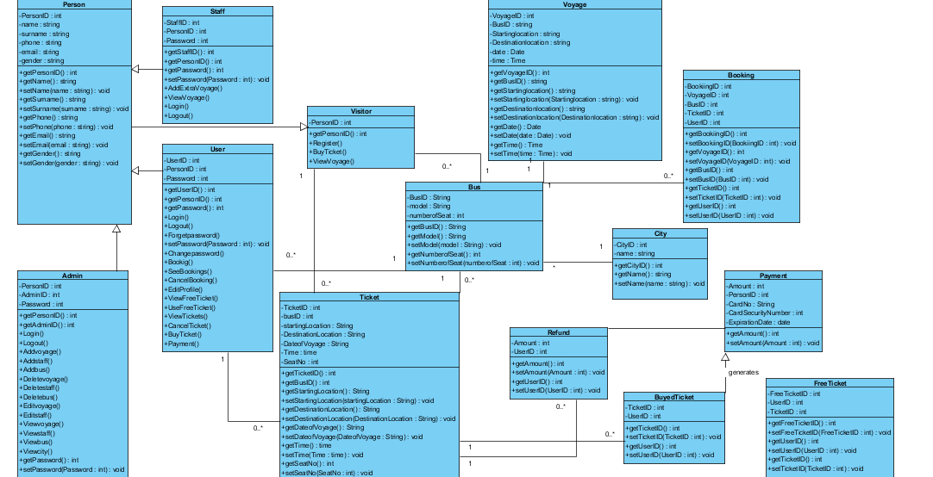

### 

### Use Case Diagram of OBTS

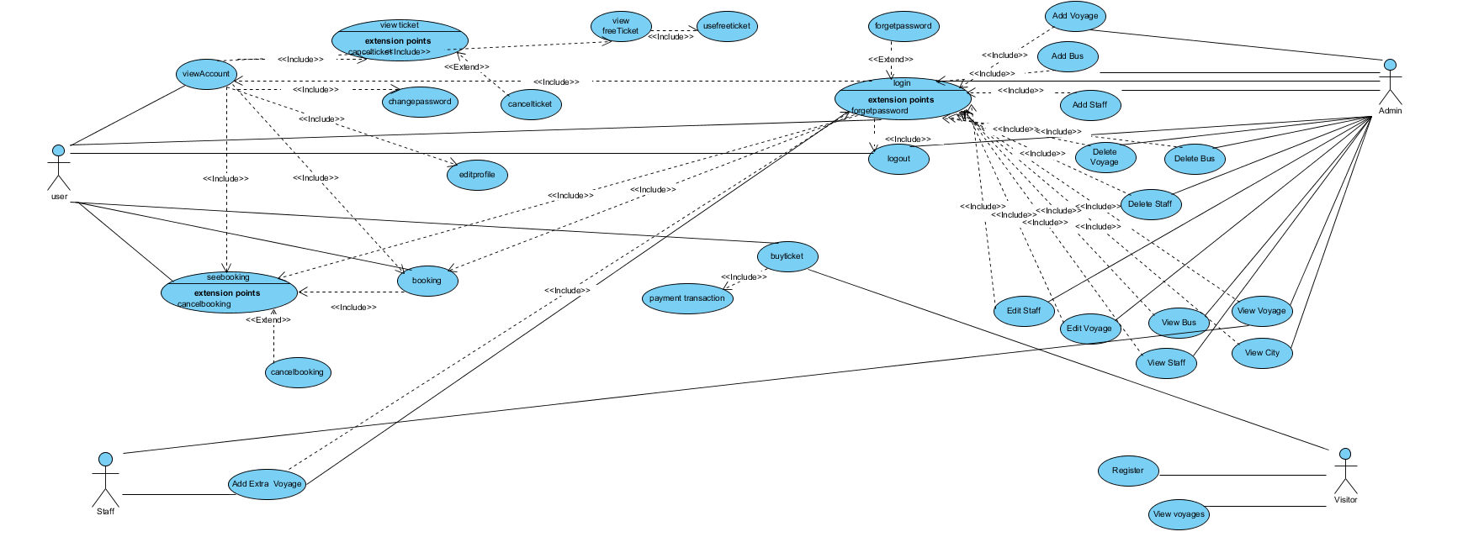

### Dynamic models

**ADMIN DYNAMIC MODEL**

* **LoginAdmin**

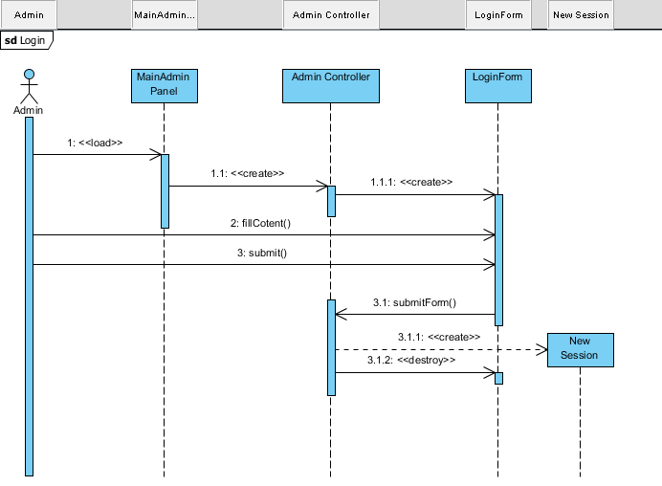

* **Add Voyage**

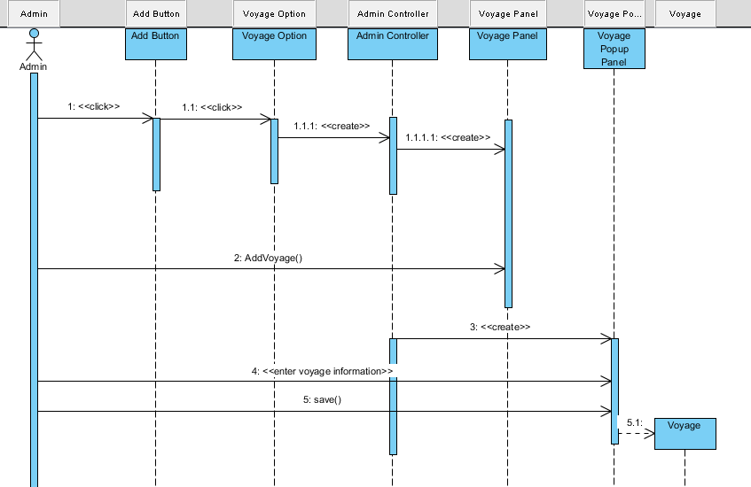

* **Add Staff**

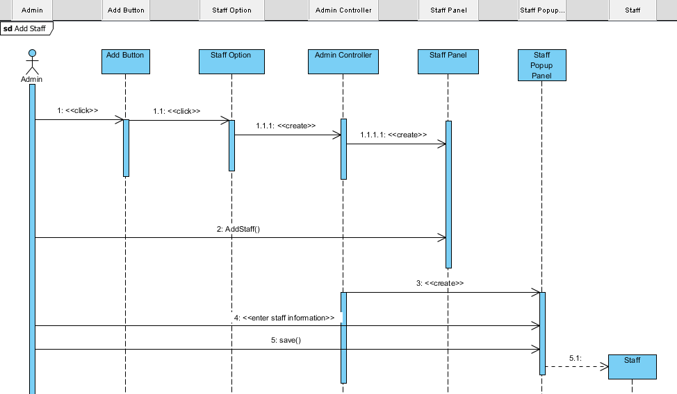

* **Add Bus**

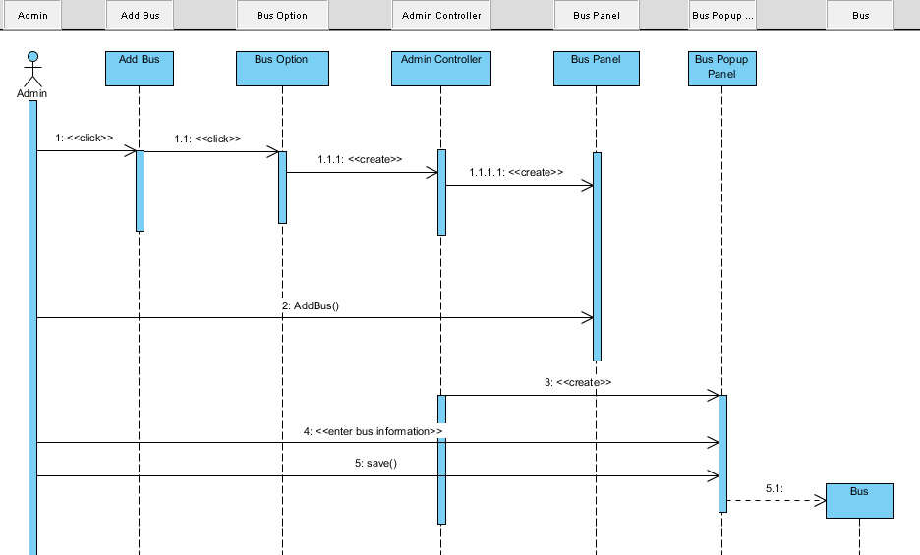

* **Delete Voyage**

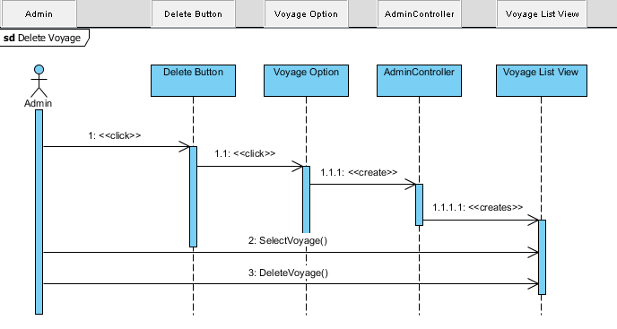

* **Delete Bus**

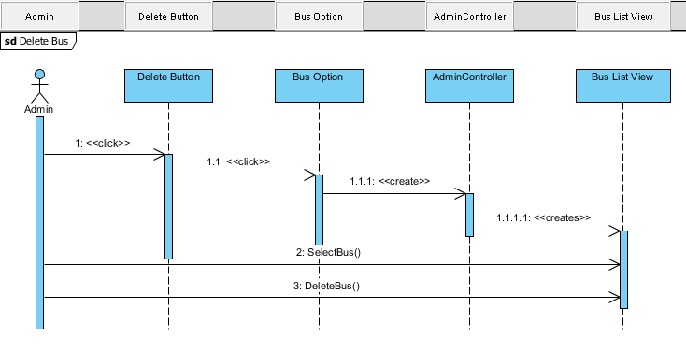

* **Delete Staff**

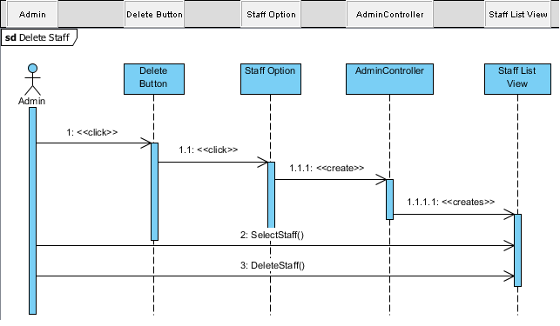

* **Edit Voyage**

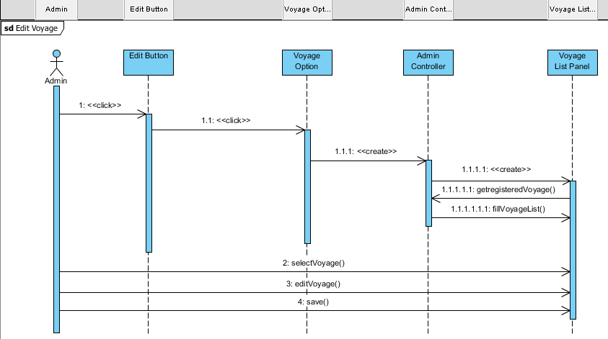

* **Edit Staff**

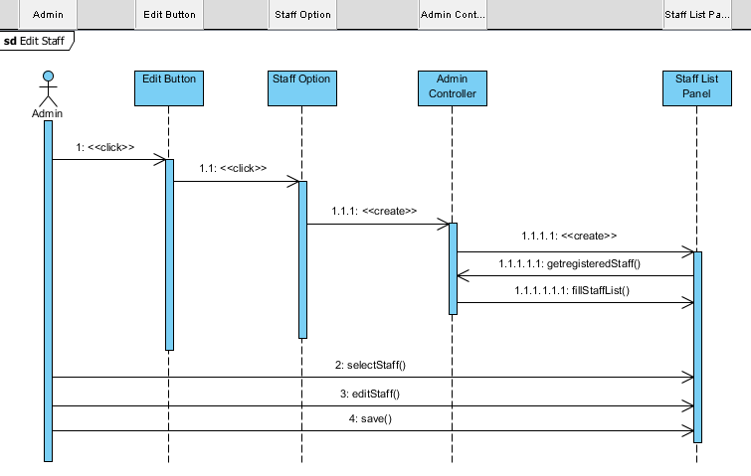

* **View Voyage**

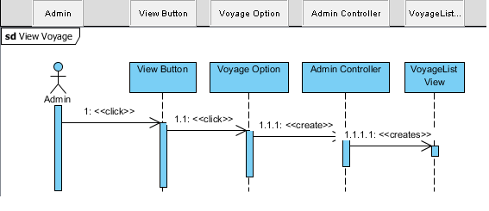

* **View Bus**

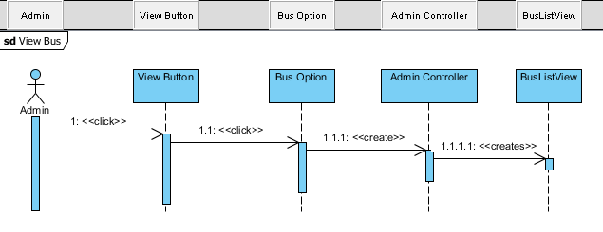

* **View Staff**

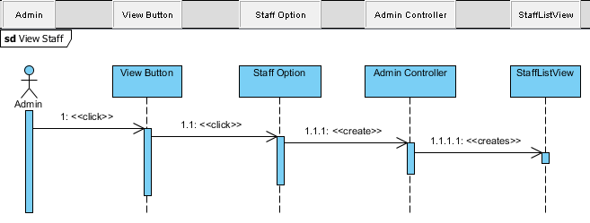

* **View City**

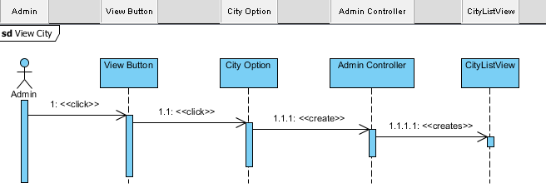

**USER DYNAMIC MODEL**

* **Buying Ticket**

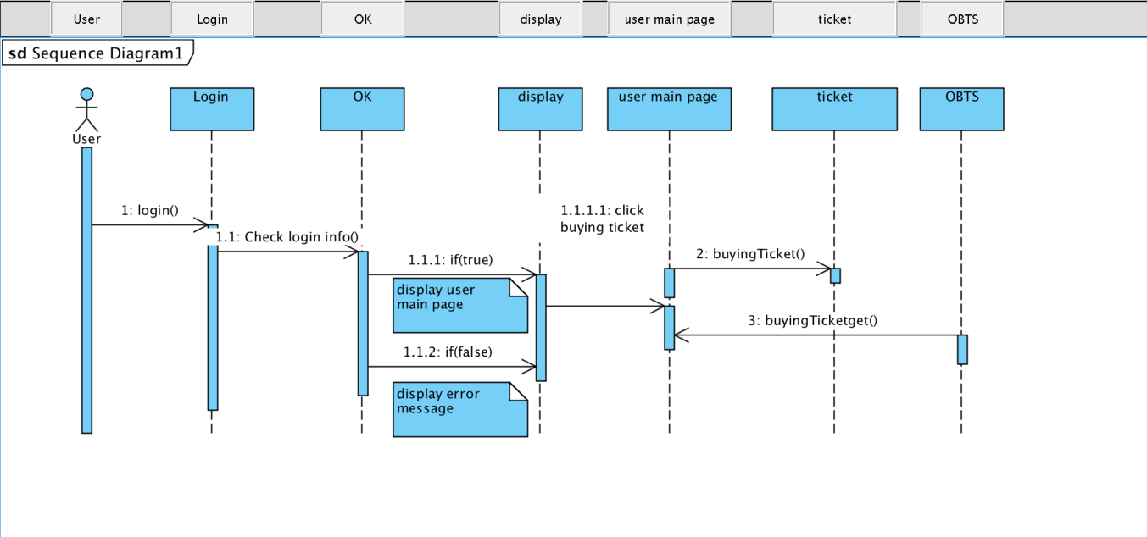

* **Change Password**

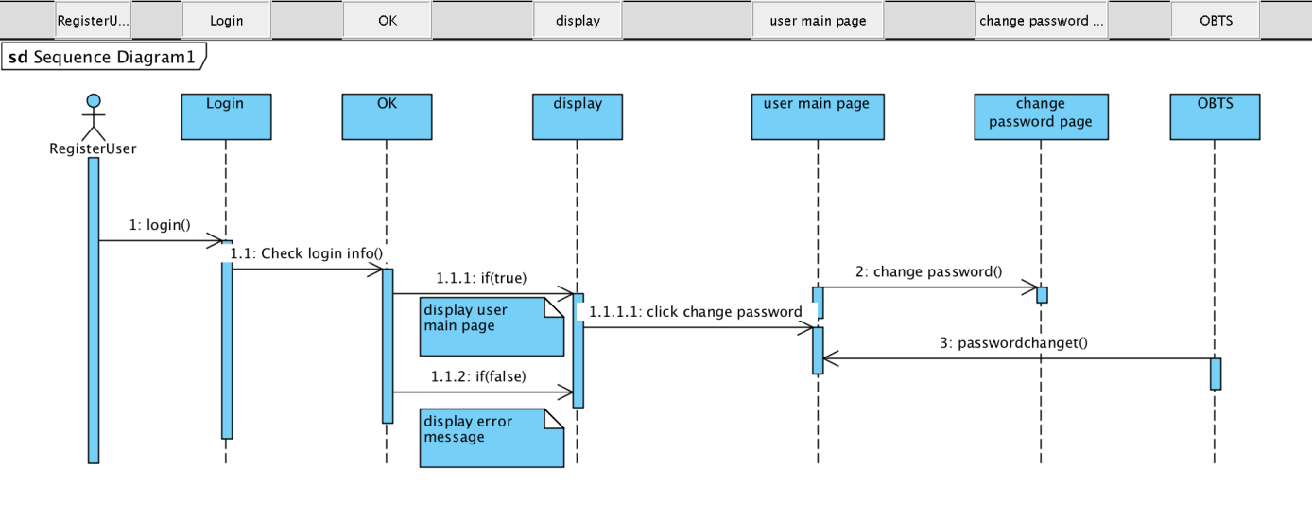

* **Booking**

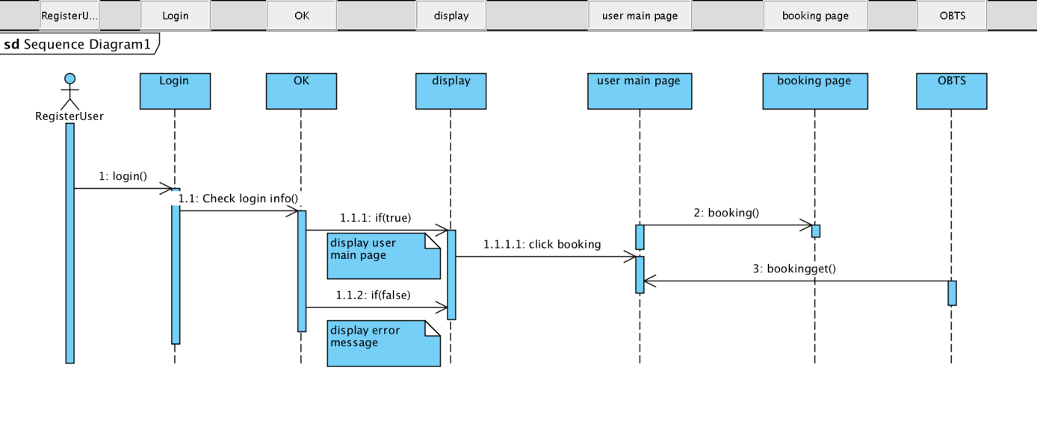

**STAFF DYNAMIC MODEL**

* **Add Extra Voyage**

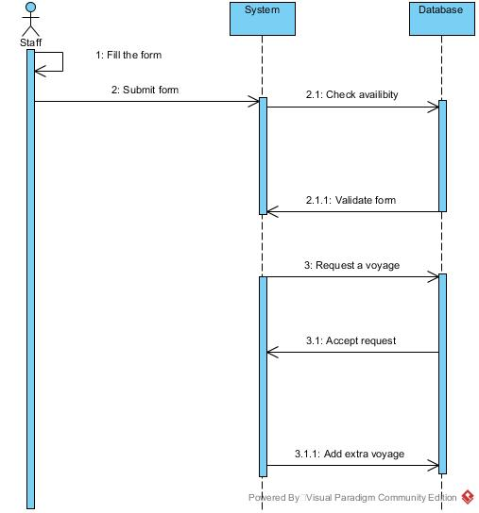

* **View Voyage**

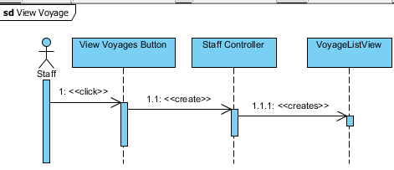

**VISITOR DYNAMIC MODEL**

* **Register**

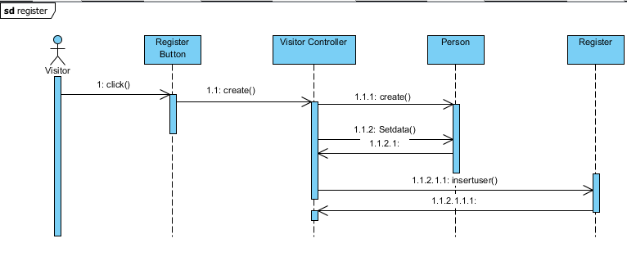

* **Buying Ticket**

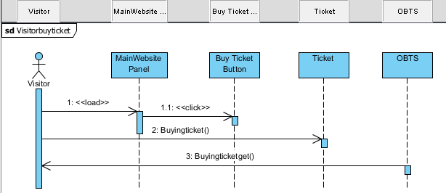

* **View Voyage**

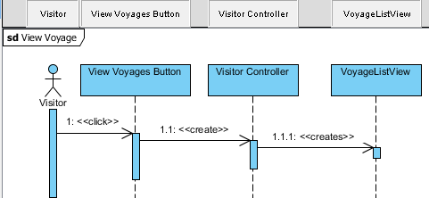

**ACTIVITY DIAGRAMS**

**Activity Diagram for User**

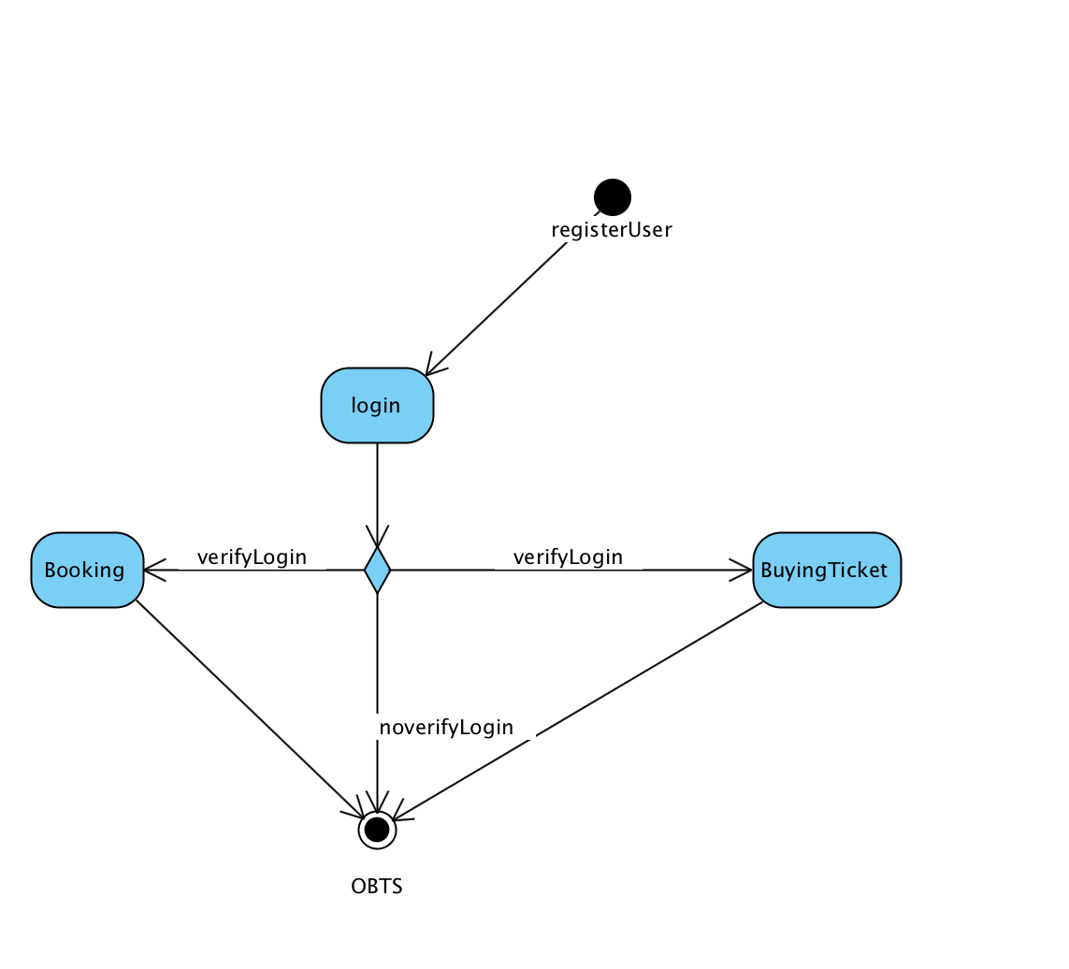

**Activity Diagram for Admin**

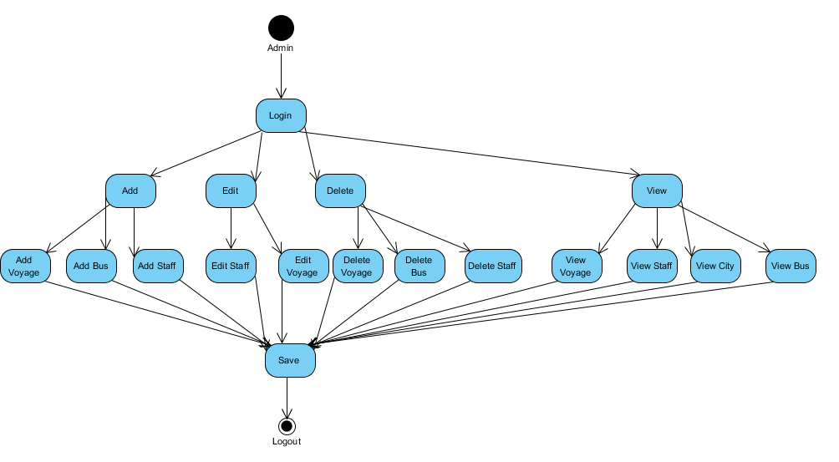

**GANTT CHART OF ONLINE BUS TICKET SYSTEM**

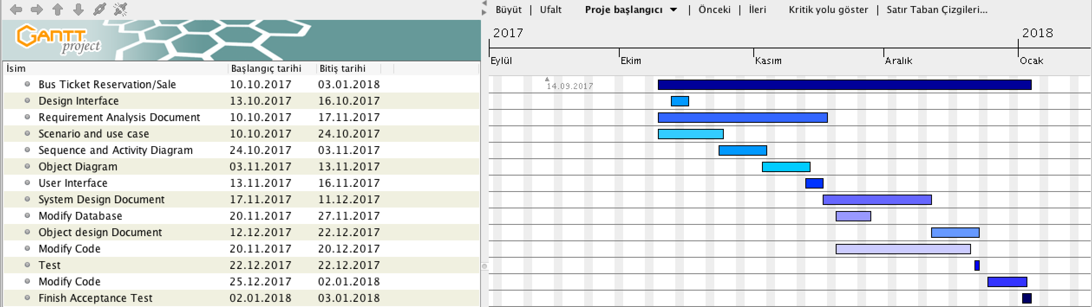

### Interfaces

Adding page

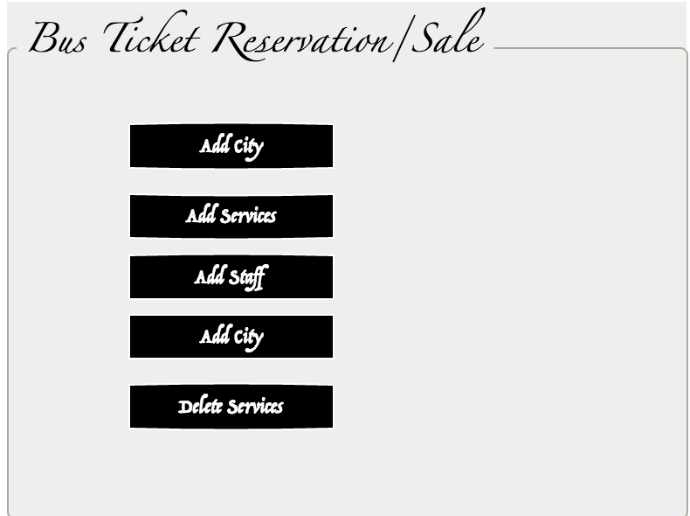

Add Voyage page

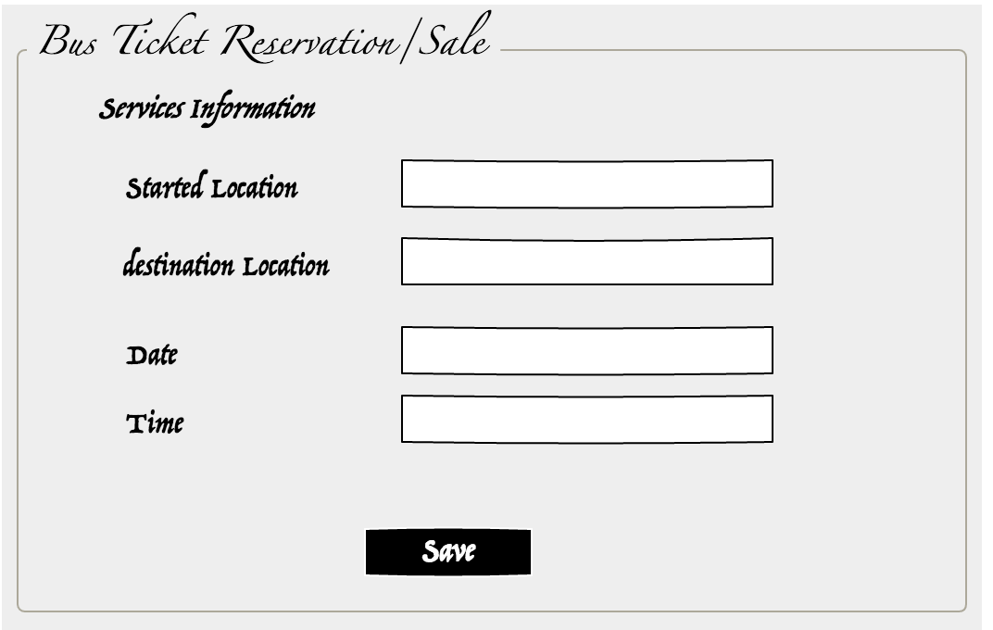

Register page

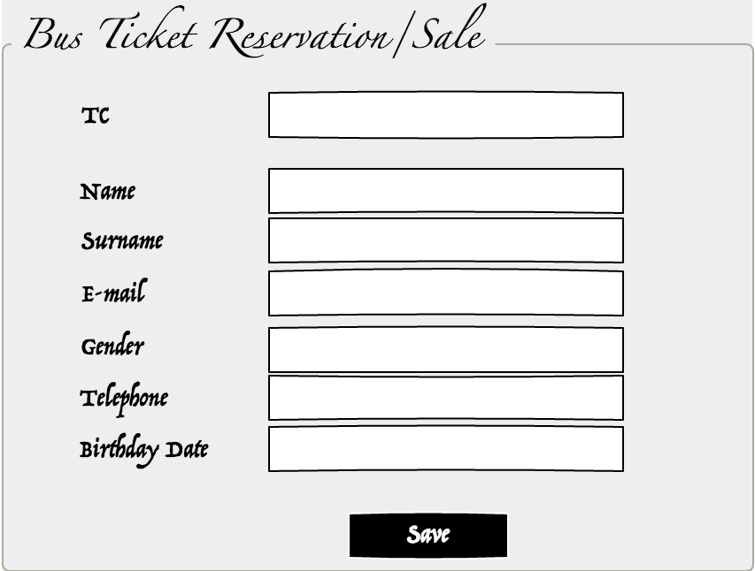

Account page

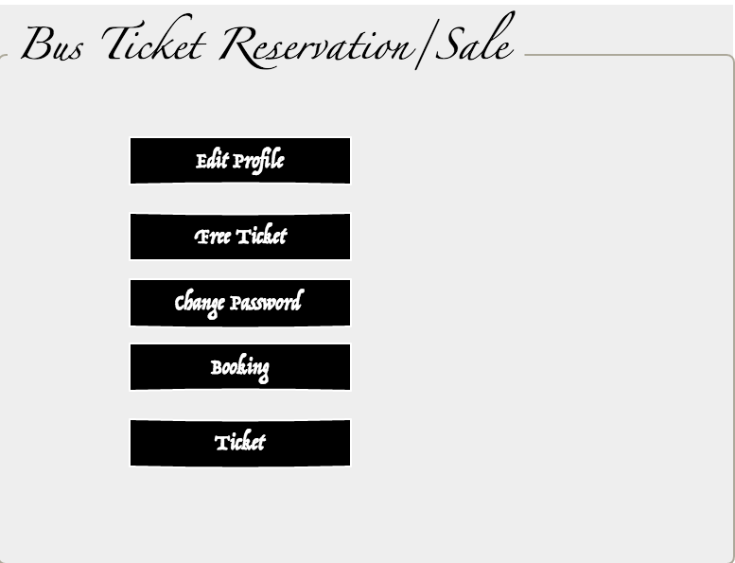

Cancel Booking page

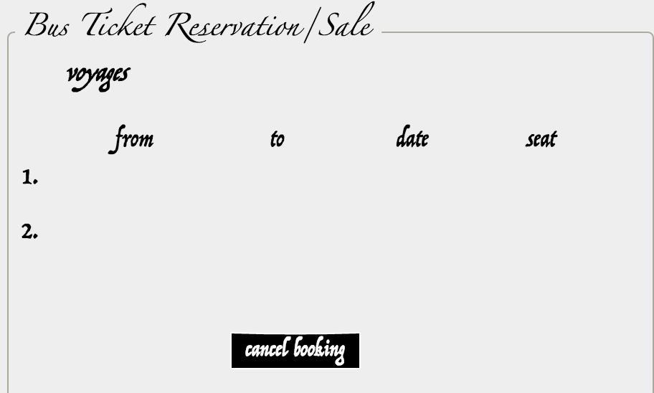

Cancel ticket page

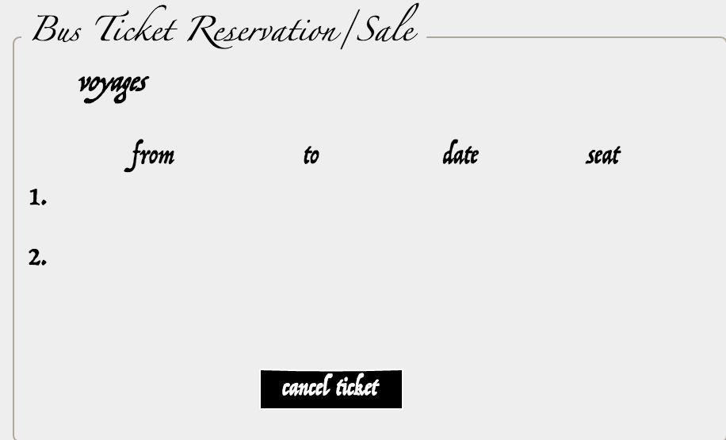

Change password page

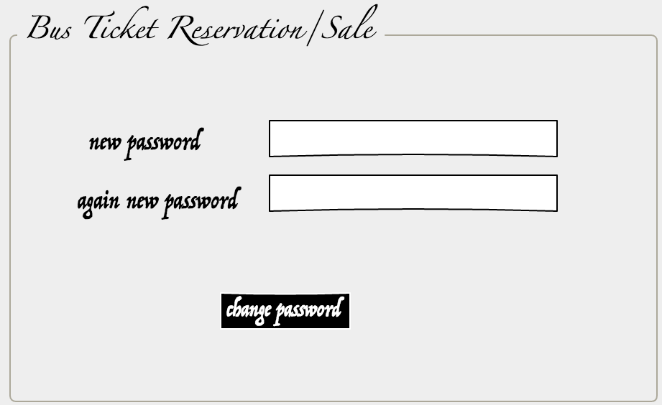

Edit Profil page

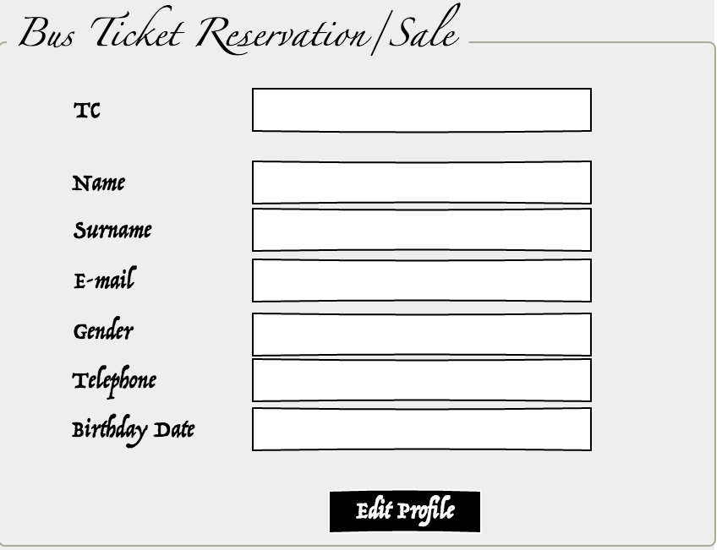

Forgat Password

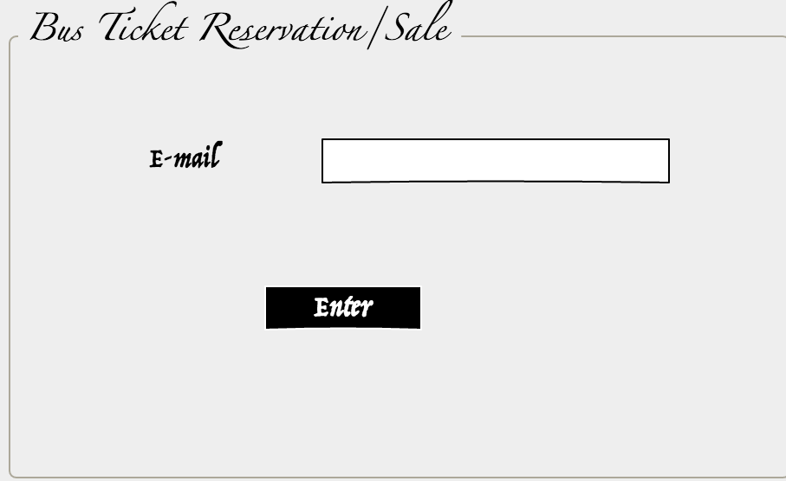

Free Ticket Page

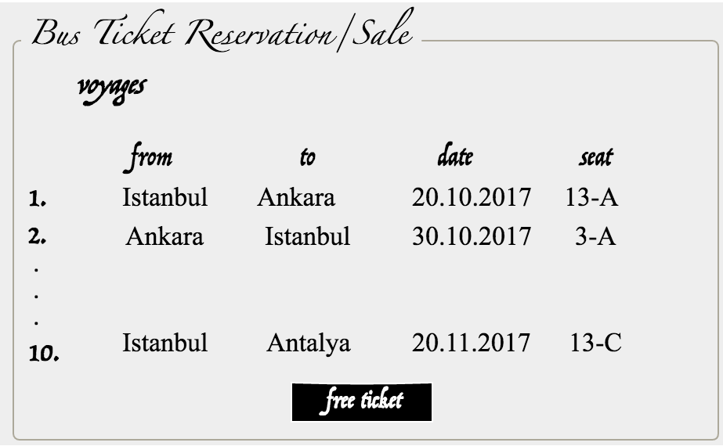

Login user page

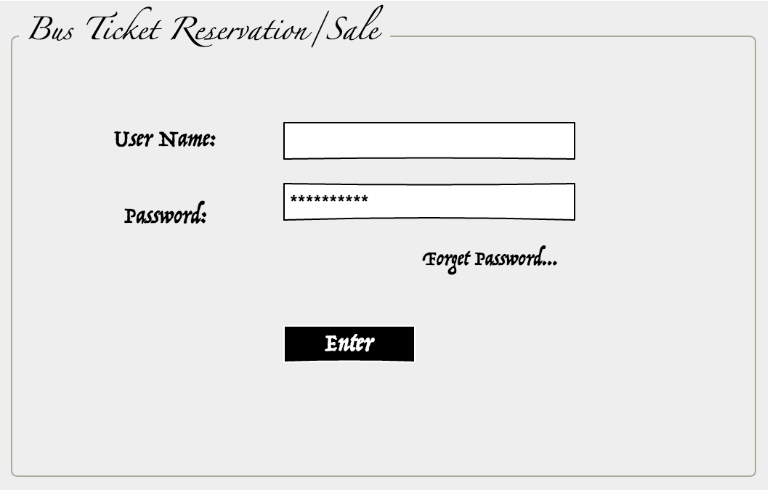

Main page

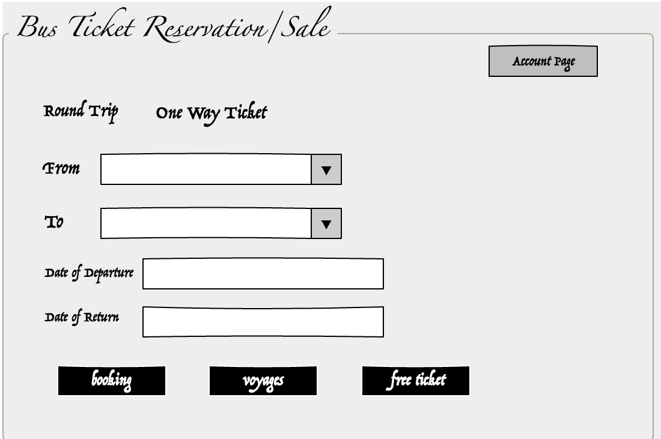

Payment page

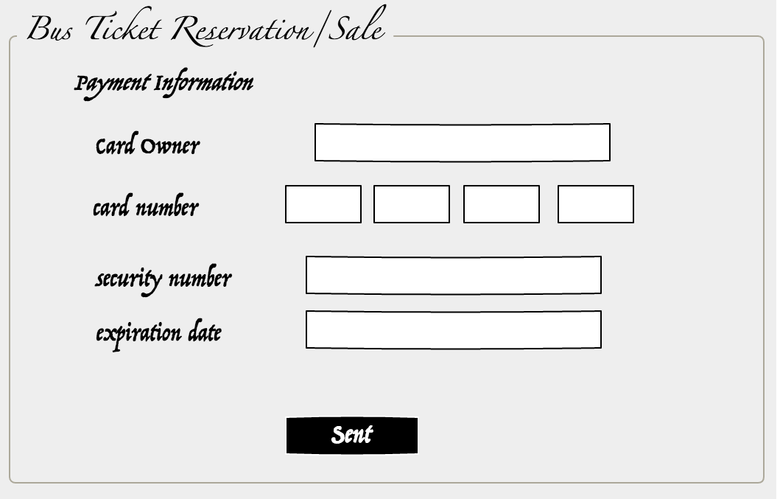

Extra Voyage page

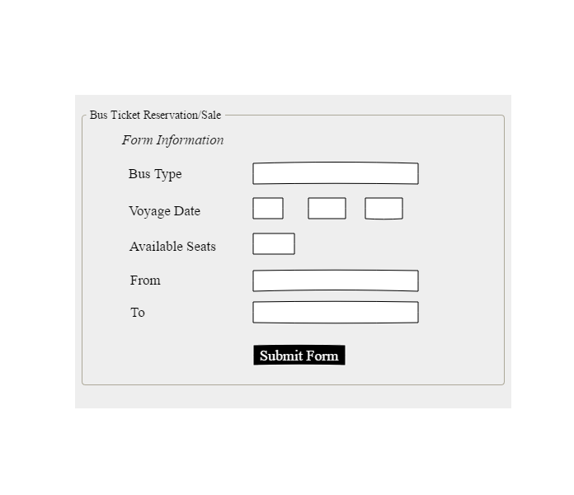

Admin Main page

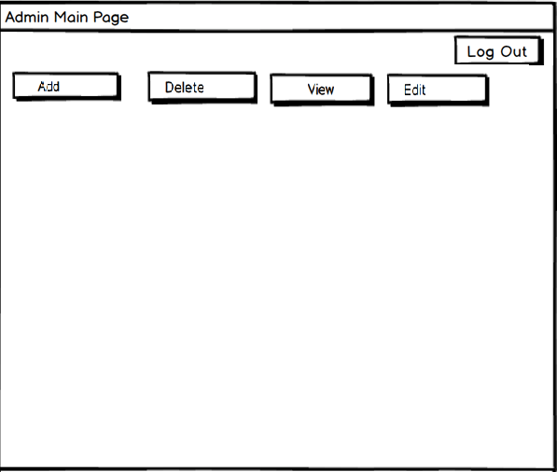

# Glossary

**OBTS :** Online Bus Ticket Reservation/ Sale System.

**Online Bus Ticket Reservation/ Sale System :** User use the system to doing reservation or sale.

**User :** Registered User, OR Visiter, OR Admin ,OR staff

**Admin:** The people who are responsible of add city/services/staff/additional services, delete services edit services/staff and sent forgetting password.

**User:** The people who be a booking or buy a ticket .

**Visiter:** The people who buy a ticket .

**Staff:** The people who be personal of bus firm

**Login:** Action to access the application.

**Use case:** Definitions user’s steps for reaching a specific goal on a system.

**Use case diagram:**This is a diagram that summarize who uses a system and what they can do

with the system.

**Functional Requirement:** A requirement that determines a function or feature of the system.

**Non-FunctionalRequirement:**Definitions system features such as;

Usability,Reliability,Performance,Supportability,Implementation,Interface,Packaging,Legal.

**Scenario:** Examples of use of the system, which is usually a story.

**Sequence Diagram:** The behavior of the objects and the messages they communicate with

each other on Use case.

# References

* SE301 Course Slides
* Bernd Bruegge, Allen H. Dutoit, Object Oriented Software Engineering Using UML, Patterns and Java, 3rd ed., Prentice Hall
* [www.ganttproject.biz](http://www.ganttproject.biz)
* [www.pencil.com](http://www.pencil.com)
* <https://www.kamilkoc.com.tr/>
* https://balsamiq.com/