PROJECT DOCUMENTATION

Job Application & CV Parser
with OCR Automation & n8n Integration

Generated Date: January 31, 2026
Version: 1.0.0
Author: Dilawar Shah
Technology: Python, FastAPI, Streamlit, n8n

Executive Overview
This project is a full-stack automated application tracking system (ATS) starter. It features a user-friendly frontend for submitting job applications and a robust backend that performs Optical
Character Recognition (OCR) on resumes (PDF, Word, or Images) before sending the data to an n8n workflow for downstream processing.

  - Key Features
    - Universal File Support: Accepts PDF, DOCX, PNG, JPG.
    - Intelligent Pre-processing: Converts files to high-contrast grayscale for OCR.
    - Rapid OCR: Uses RapidOCR (ONNX) for fast text extraction.
    - Automation Ready: Instant integration with n8n Webhooks.

System Architecture

Component | Technology | Description
Frontend | Streamlit | User interface for file uploads.
Backend API | FastAPI | Handles routing and file processing.
OCR Engine | RapidOCR | Extracts text from images.
Image Proc | OpenCV / Pillow | Grayscale conversion & resizing.
Automation | n8n | Workflow orchestration (Email, Sheets).

- Installation & Setup
Step 1: Create Environment
conda create --name ocr-env python=3.11 -y conda activate ocr-env
Step 2: Install Dependencies
Ensure you have the following requirements:
pip install streamlit fastapi uvicorn requests pymupdf
pip install rapidocr_onnxruntime opencv-python pillow docx2pdf

Running the Application
The system requires two separate terminals:

Terminal A: Backend API
uvicorn main:app --reload

Terminal B: Frontend UI
streamlit run app.py
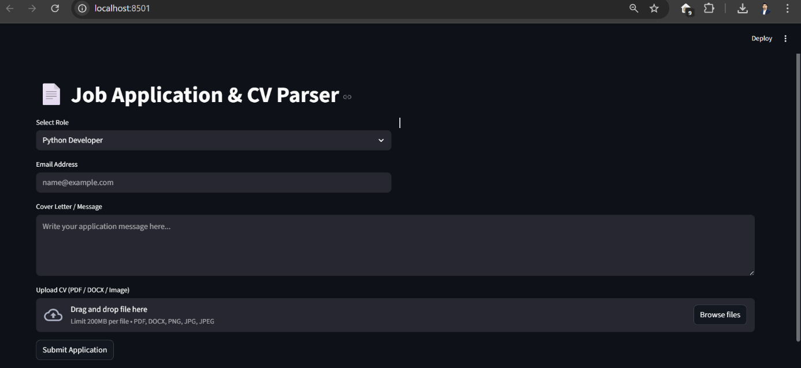
Frontend UI

N8N Workflow
