# **Website Technical Audit**

<https://www.azca.pk/>

**Critical Errors**

**Mixed Content**: The page at 'https://www.azca.pk/#/' was loaded over HTTPS, but requested an insecure stylesheet 'http://fonts.cdnfonts.com/css/optima'. This request has been blocked; the content must be served over HTTPS.  
  


**404 Files not found**: Failed to load some CSS files and the server responded with a status of 404



**Unnecessary data in console:** Multiple Array of objects are logging in the console. Which is writing the data in a continuous loop.

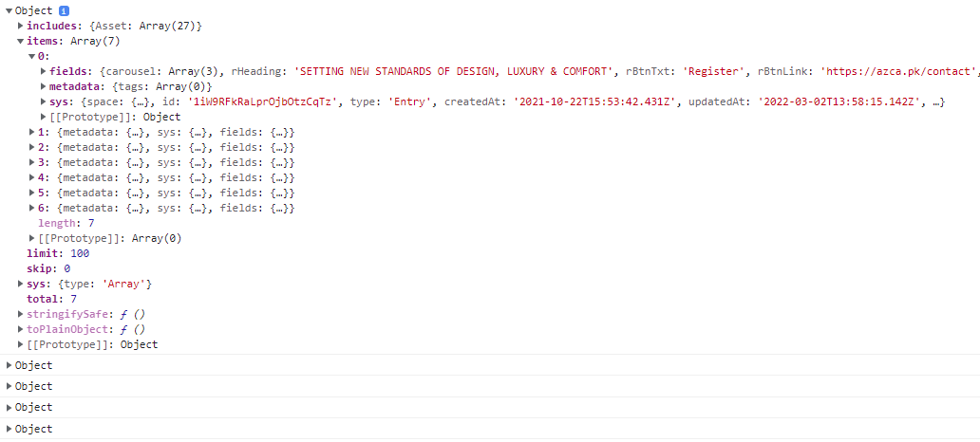

[**Size**](https://gtmetrix.com/reports/www.azca.pk/dFGi9cCM/) **of the files are very big:** Large file size of images and video are causing long load times.

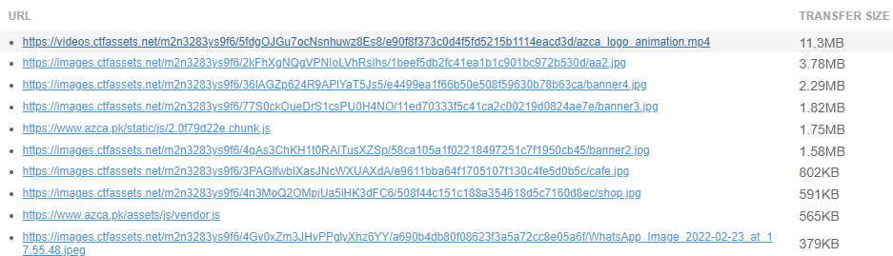

**Text compression is not enabled for the resources:** Text-based resources should be served with compression (gzip, deflate or brotli) to minimize total network bytes.

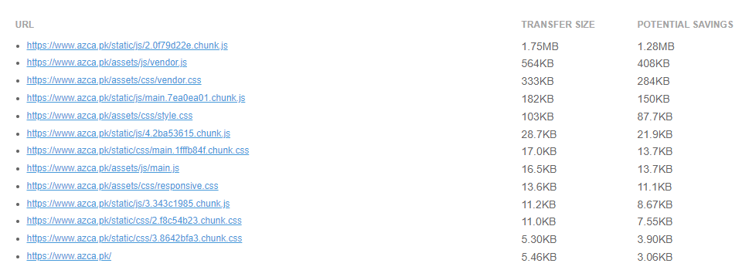

**The size of this page is so big (27.2MB):** Ideal page size of the website should be between 1-2mb and fully loading time should be 3-5s

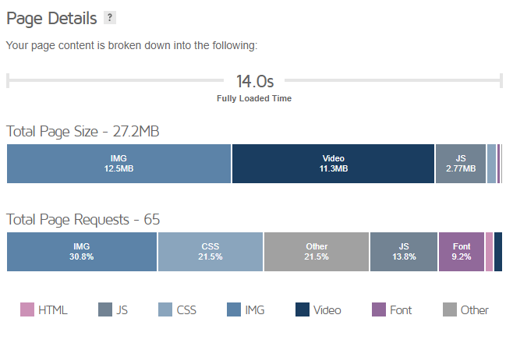

**Unnecessary resources are loading on the website with complex navigation:** Loading that much javascript and css files of a single page is really costing the loading time

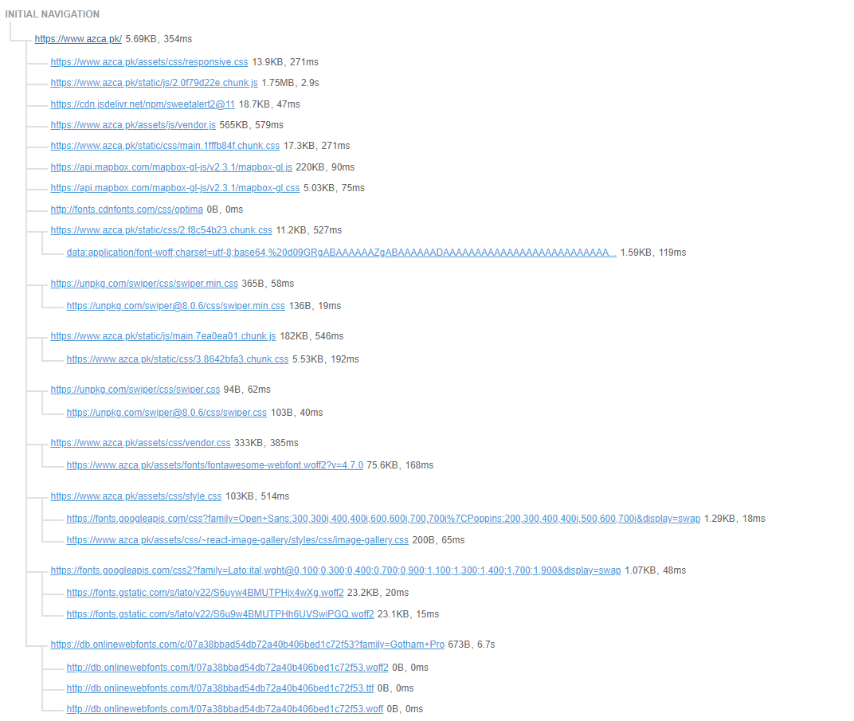

**Images are not sized properly:** Serving images that are appropriately-sized can save cellular data and improve load time.

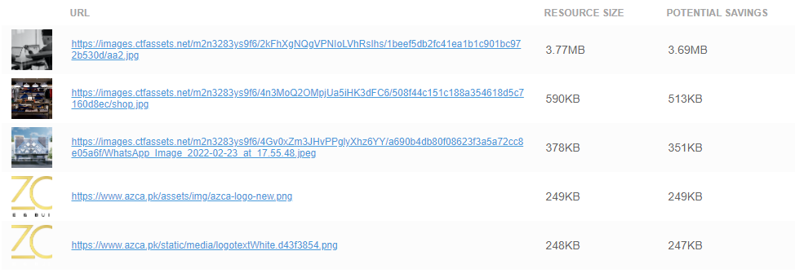

[**Eliminate render-blocking resources**](https://gtmetrix.com/reports/www.azca.pk/dFGi9cCM/)**:** Resources are blocking the first paint of your page. Consider delivering critical JS/CSS inline and deferring all non-critical JS/styles. Resources that **may** be contributing to render-blocking include:

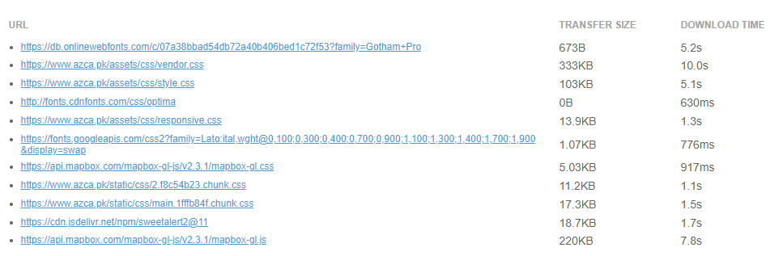

**Other SEO related issues**

|  |  |
| --- | --- |
|  | Issue |
| 1 | Implement a XML sitemaps file |
| 2 | Reduce your total page file size |
| 3 | Remove Duplicate H1 Tags |
| 4 | Optimize your images to reduce their file size |
| 5 | Resolve JavaScript errors |
| 6 | Minify your CSS and JS Files |
| 7 | Review and Increase Font Sizes across devices |

**Here is the final report of the current website.** Which is way too below average

