SecureShield
Project Documentation
Container Security Scanner - Build, Usage, Features, Architecture

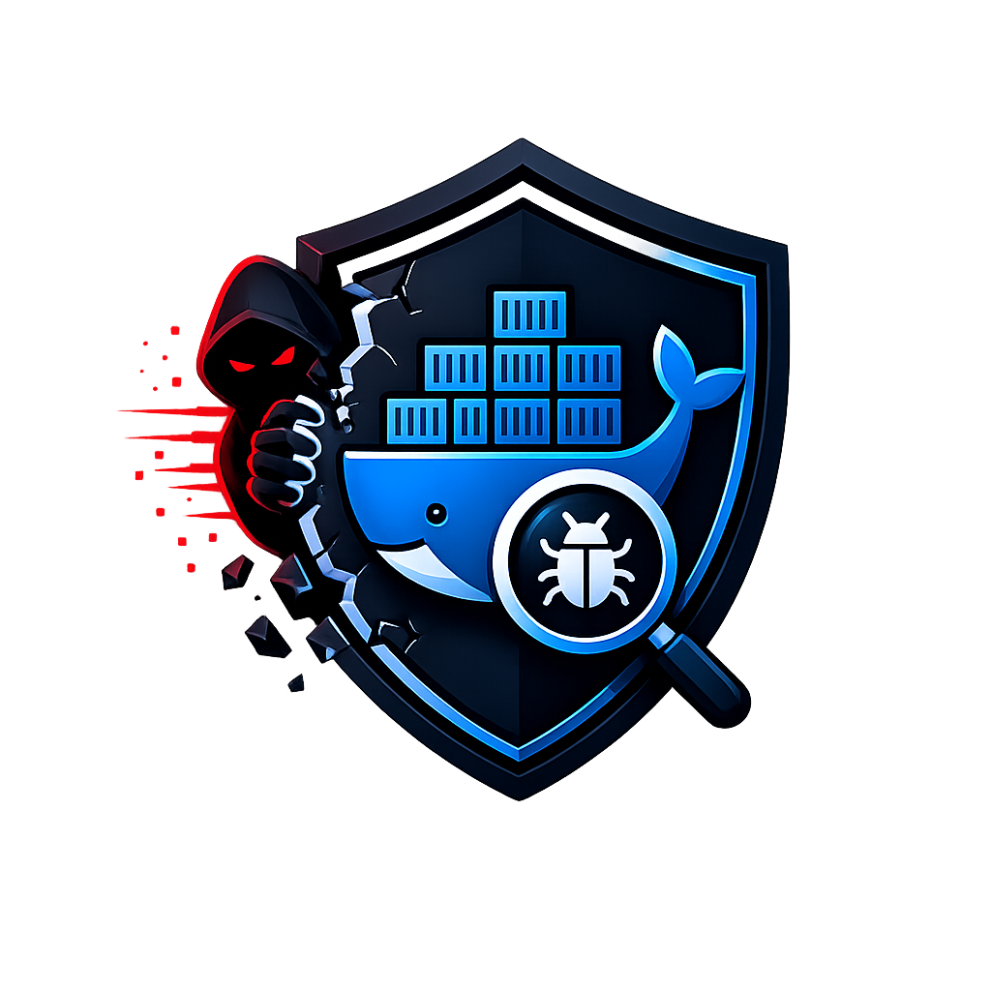
Generated for project folder: /home/dilax/secureshield

1. Project Summary
SecureShield is a local container security platform. It scans Docker images and running containers, stores scan history, shows a React dashboard, exports reports, and can generate AI remediation guidance through Gemini when an API key is configured.
- Main purpose: Docker/container image vulnerability and security posture scanning.
- Backend: Python FastAPI application with CLI support.
- Frontend: React + Vite dashboard served from the FastAPI app.
- Database: SQLite by default, PostgreSQL supported through Docker Compose or env variables.
- External tools needed for real scanning: Docker CLI and Trivy.
- Default local URL: http://localhost:8000

2. What Has Been Built
Area | Implemented Details
Web Dashboard | Dashboard, history, report, admin, settings, scan detail, AI modal, and chat UI.
API | FastAPI routes for scans, history, reports, authentication, users, jobs, AI, and health check.
CLI | secureshield command with scan, module checks, report export, UI build/sync, serve, version, and DB health commands.
Scanning | Trivy CVE scan, CIS-style checks, runtime checks, supply-chain checks, and source secrets scan.
Persistence | Scan records, jobs, users, normalized vulnerabilities, compliance findings, secrets, runtime events, AI outputs, and report artifacts.
Authentication | Local username/password auth, password hashing, signed token, admin/analyst roles, profile and password updates.
Reports | Summary reports and export in JSON, CSV, and Markdown.
Deployment | Local run script, Dockerfile, docker-compose with PostgreSQL, and health check script.

3. Technology Stack
Layer | Technology
Backend language | Python 3.11+ / 3.12 container runtime
Backend framework | FastAPI, Uvicorn
CLI framework | Click
Database ORM | SQLAlchemy 2.x
Database | SQLite default file secureshield.db; PostgreSQL optional
Scanner engine | Trivy for CVE vulnerability scanning
Container metadata | Docker CLI inspect/logs/events
Frontend | React 18, Vite 5, GSAP
AI remediation | Gemini API via GEMINI_API_KEY
Packaging | setuptools, pyproject.toml, setup.py
Containerization | Docker multi-stage build, docker-compose

4. Folder Structure
Path | Purpose
secureshield/ | Main Python package.
secureshield/web/api.py | FastAPI app, API routes, auth, WebSocket scan progress, static frontend serving.
secureshield/scanner/ | CVE, CIS, runtime, supply-chain, secrets scanners and shared helpers.
secureshield/models.py | SQLAlchemy table models.
secureshield/repository.py | Database CRUD and normalized artifact save logic.
secureshield/cli.py | Command line entrypoint.
secureshield/ai/service.py | Gemini remediation and chat service.
frontend/src/App.jsx | Main React application and dashboard workflows.
frontend/dist/ | Built frontend output.
secureshield/web/static/ | Frontend files served by FastAPI.
run_local.sh | One-command local setup/build/run script.
Dockerfile | Production image build file.
docker-compose.yml | App + PostgreSQL deployment.
requirements.txt | Python dependencies.

5. Architecture Flow
- User opens the React dashboard at http://localhost:8000.
- Frontend calls FastAPI endpoints under /api or starts /ws/scan WebSocket for live scan progress.
- FastAPI calls SecureShieldScanner.
- SecureShieldScanner coordinates CVE, CIS, supply-chain, runtime, and optional secrets modules.
- CVE module calls Trivy. CIS/runtime/supply-chain modules call Docker CLI metadata commands.
- Results are normalized into issues, summary counts, and a security score.
- Repository layer saves scan record and normalized findings into SQLite/PostgreSQL.
- Dashboard loads history, reports, jobs, details, exports, and AI guidance from API endpoints.

6. Main Features
- Full image scan: runs CVE + CIS + supply-chain + runtime checks, and secrets scan if source path is given.
- CVE scan: uses Trivy JSON output and extracts CVE ID, package, installed version, fixed version, severity, title, CVSS, and target.
- Critical CVE endpoint: returns only CRITICAL vulnerabilities.
- CIS checks: latest tag, root user, missing HEALTHCHECK, secret-like env variables, SSH/exposed ports, privileged runtime, read-only rootfs, seccomp, AppArmor, capabilities.
- Supply-chain checks: digest pinning, unversioned tags, provenance labels, suspicious entrypoint/CMD, trusted registry, risky bootstrap patterns.
- Runtime checks: privileged mode, read-only rootfs, host PID/IPC/network, sensitive mounts, restart churn, suspicious logs.
- Secrets detection: local source scan using known token patterns and entropy detection, excluding node_modules, venv, dist, build, .git, and __pycache__.
- Security score: calculated from severity count and volume penalty, displayed as 0-100 posture score.
- History: saved scan records with detail pages.
- Reports: aggregate report summary plus JSON/CSV/Markdown export.
- Admin: user create/update/delete, role management, active/deactive status.
- Authentication: login/register, profile update, password update, admin-only routes.
- AI remediation: Gemini-based remediation and finding chat if GEMINI_API_KEY is configured.
- Async jobs: scan job creation, progress tracking, completion/failure status.
- WebSocket scan progress: frontend receives module started/completed events and final result.

7. Database Tables
Table | Stores
secureshield_users | Dashboard user accounts, roles, profile data, active status.
secureshield_scan_jobs | Async scan request status, progress, errors, metadata.
secureshield_scan_records | Completed scan payload, summary, security score, owner.
secureshield_image_assets | Normalized image metadata linked to scan records.
secureshield_vulnerabilities | Normalized CVE findings.
secureshield_compliance_results | CIS and supply-chain findings.
secureshield_secret_findings | Secret scan findings.
secureshield_runtime_events | Runtime security findings/events.
secureshield_ai_recommendations | AI remediation/chat outputs.
secureshield_reports | Generated report snapshots and metadata.

8. Environment Variables
Variable | Default | Use
DB_CONNECTION | sqlite | sqlite/postgres connection mode.
DB_HOST | 127.0.0.1 | PostgreSQL host.
DB_PORT | 5432 | PostgreSQL port.
DB_DATABASE | secureshield.db | SQLite file name or PostgreSQL DB name.
DB_USERNAME | postgres | Database username.
DB_PASSWORD | 2003 | Database password.
DATABASE_URL | auto-built | Full SQLAlchemy database URL override.
APP_SECRET_KEY | secureshield-dev-secret | Token signing secret. Change for production.
DEFAULT_ADMIN_USERNAME | admin | Default admin username created on startup.
DEFAULT_ADMIN_PASSWORD | admin123 | Default admin password. Change for production.
GEMINI_API_KEY | empty | Required for AI remediation/chat.
GEMINI_MODEL | gemini-flash-latest / service fallback gemini-1.5-flash | Gemini model name.
TRIVY_SKIP_DB_UPDATE | false | Skip Trivy DB update if true.
TRIVY_OFFLINE_SCAN | false | Use Trivy offline mode if true.
REDIS_URL | empty | Reserved/cache backend config.

9. Local Setup and Run
Recommended easy method:
cd /home/dilax/secureshield
chmod +x run_local.sh
./run_local.sh
This script creates/uses venv, installs Python dependencies, installs the package in editable mode, installs frontend dependencies, builds React, copies frontend files into secureshield/web/static, and starts Uvicorn on port 8000.
After it starts, open:
http://localhost:8000
Default login created by startup:
username: admin
password: admin123

10. Manual Build From Scratch
- Install prerequisites: Python 3.11+, Node.js/npm, Docker, Trivy.
- Create virtual environment: python3 -m venv venv
- Activate it: source venv/bin/activate
- Install Python dependencies: pip install -r requirements.txt
- Install package: pip install -e .
- Build frontend: cd frontend && npm install && npm run build
- Sync frontend: cd .. && secureshield sync-ui
- Run server: secureshield serve --host 0.0.0.0 --port 8000
- Open http://localhost:8000
cd /home/dilax/secureshield
python3 -m venv venv
source venv/bin/activate
pip install -r requirements.txt
pip install -e .
cd frontend
npm install
npm run build
cd ..
secureshield sync-ui
secureshield serve --host 0.0.0.0 --port 8000

11. Docker Build and Run
Dockerfile uses a multi-stage build: Node builds frontend, docker CLI and Trivy binaries are copied into Python runtime, then FastAPI runs on port 8000.
cd /home/dilax/secureshield
docker build -t secureshield:latest .
docker run --rm -p 8000:8000 -v /var/run/docker.sock:/var/run/docker.sock secureshield:latest
Docker Compose runs the app with PostgreSQL and Trivy cache volume:
docker compose up --build

12. How To Use Web UI
- Start the app and open http://localhost:8000.
- Login with admin/admin123 or register a new analyst user.
- Dashboard page-la image name enter pannunga. Example: nginx:latest, python:3.12-slim, node:20-bookworm-slim.
- Optional source path field-la local project path kudutha secrets scan also run aagum.
- Run scan. Progress panel module-by-module status kaatum.
- Result-la security score, severity summary, module health, top vulnerabilities, CIS card, posture metrics view pannalaam.
- History page-la saved scan records paakalam; record click panna detailed issue table varum.
- Reports page-la aggregate summary, trend, and export JSON/CSV/Markdown use pannalaam.
- Admin page admin role-ku mattum users manage panna use aagum.
- Settings page-la jobs and platform information view pannalaam.
- AI remediation button use panna GEMINI_API_KEY configured irukkanum.

13. CLI Usage
Command | Purpose
secureshield scan IMAGE | Full scan and save result.
secureshield scan IMAGE --format json --output result.json | Export one scan as JSON.
secureshield scan IMAGE --format csv --output result.csv | Export one scan as CSV.
secureshield scan IMAGE --source-path /path/to/source | Run full scan plus secrets scan.
secureshield cis-check IMAGE | Run CIS-style image/runtime checks.
secureshield secrets-scan PATH | Scan local files for secrets.
secureshield supply-chain-check IMAGE | Run supply-chain metadata checks.
secureshield runtime-check TARGET | Inspect running container security posture.
secureshield history --limit 10 | Show saved scan history.
secureshield report-export --format json --output report.json | Export aggregate report.
secureshield build-ui | Build React and sync static files.
secureshield sync-ui | Copy frontend/dist to FastAPI static directory.
secureshield db-health | Check database connection.
secureshield serve --port 8000 | Start API and dashboard.
secureshield version | Print SecureShield version.

14. API Endpoints
Endpoint | Use
GET /api/health | Service/database/cache health.
GET /api/scan/{image} | Run full scan immediately.
GET /api/critical/{image} | Get CRITICAL CVEs only.
GET /api/cis/{image} | Run CIS checks.
GET /api/runtime/{target} | Run runtime checks.
GET /api/supply-chain/{image} | Run supply-chain checks.
GET /api/secrets?path=/path | Run secrets scan.
GET /api/history | List scan records.
GET /api/history/{record_id} | Get scan record detail.
GET /api/reports/summary | Aggregate report payload.
GET /api/reports/export?format=json|csv|md | Download report export.
GET /api/reports/archive | Generated report artifact list.
POST /api/auth/register | Register user.
POST /api/auth/login | Login and receive token.
GET /api/auth/me | Current user.
PUT /api/auth/profile | Update profile.
PUT /api/auth/password | Change password.
GET/POST/PUT/DELETE /api/admin/users | Admin user management.
POST /api/jobs/scan | Create async scan job.
GET /api/jobs | List scan jobs.
GET /api/jobs/{job_id} | Job detail.
POST /api/ai/remediate | AI remediation for a finding.
POST /api/ai/chat | AI chat for a finding.
WS /ws/scan | Live scan progress and final result.

15. Security Score Logic
Security score starts at 100 and subtracts severity and volume penalties. Critical, high, medium, low, and unknown findings reduce the score. The code keeps the score in a useful range with a minimum of 18, so even very risky images still show a comparable score instead of only zero.

16. Reports and Exports
- Report summary aggregates total records, total findings, severity counts, and scan type counts.
- Vulnerability report extracts CVE issues from saved full scan results.
- Exports available in JSON, CSV, and Markdown.
- Each export is saved as a report artifact in the database.

17. AI Remediation
- Gemini service receives only the selected finding context and optional image name.
- Remediation endpoint expects strict JSON fields: summary, risk, remediation_steps, safe_example, priority.
- Chat endpoint answers follow-up questions using supplied finding context and recent chat history.
- If GEMINI_API_KEY is missing, API returns configuration error.
- AI guidance is saved into secureshield_ai_recommendations for audit/history.

18. Important Notes
- Real image scanning requires Trivy installed and available in PATH.
- Docker metadata checks require Docker CLI and Docker daemon access.
- Runtime checks work best when a matching container is already running.
- Default SQLite database file is secureshield.db in project root.
- For production, change APP_SECRET_KEY and DEFAULT_ADMIN_PASSWORD.
- docker-compose mounts /var/run/docker.sock so the app can inspect local Docker resources.
- The backend/ folder appears mostly placeholder; active backend code is in secureshield/.
- Existing documentation folder name is documantation/ and already contains SECURESHIELD.docx and SECURESHIELD.pdf.

19. Troubleshooting
Problem | Fix
Frontend not showing | Run cd frontend && npm run build, then secureshield sync-ui or secureshield build-ui.
trivy not found | Install Trivy or use Docker image build that includes Trivy.
docker not found / permission denied | Install Docker, start daemon, and ensure current user can access Docker socket.
Port 8000 already used | Run secureshield serve --port 8001 and open http://localhost:8001.
AI button error | Set GEMINI_API_KEY in .env or environment.
Database error | Check DATABASE_URL or use default SQLite. For compose, run docker compose up --build.
Scan takes long | First Trivy DB update can take time. Use cache or configure TRIVY_SKIP_DB_UPDATE for offline/demo only.

20. Suggested Future Improvements
- Add automated tests for scanner normalization, API auth, and report exports.
- Add .env.example with production-safe placeholders.
- Add Alembic migrations instead of lightweight manual table alterations.
- Add role-based restrictions to all scan/history/report endpoints if multi-user isolation is required.
- Add Kubernetes scanning if this platform needs cluster-level coverage.
- Add SBOM generation and signing verification for stronger supply-chain assurance.
- Add scheduled scans implementation behind the dashboard item.

