Complete Guide: Offline Text-to-Speech using Piper with Spring Boot

1. Introduction
This document explains how to build an offline Text-to-Speech (TTS) solution using Piper and Spring Boot from scratch. It is written for beginners. After completing this guide, you should understand how Piper works, how to configure it, how Spring Boot communicates with it, and how to expose it as a REST API.

2. What is Text-to-Speech?
Text-to-Speech converts written text into spoken audio. Instead of using cloud APIs, this implementation uses Piper locally. This means there are no internet calls, no API costs, and the text never leaves your machine.

3. Why Piper?
- Open-source
- Runs completely offline
- Uses neural ONNX voice models
- Fast on CPU
- Supports multiple languages and voices
- Easy to integrate using ProcessBuilder

4. Software Prerequisites
Install the following:
• Java 17+ (Java 25 in this project)
• Spring Boot
• Maven
• Piper for Windows
• A Piper voice model (en_US-lessac-medium)
• IDE such as IntelliJ IDEA or Eclipse

5. Download and Setup Piper
Step 1: Download the Piper Windows release.
Step 2: Extract it to a folder, for example C:/SoftwareSetup/piper_windows_amd64/.
Step 3: Download the required voice model from the Piper voice repository.
Step 4: Copy both the .onnx and .onnx.json files into the models folder.
Expected folder structure:
C:\SoftwareSetup\piper_windows_amd64
│
├── piper
│ └── piper.exe
└── models
├── en_US-lessac-medium.onnx
└── en_US-lessac-medium.onnx.json

6. Spring Boot Configuration
tts.piper-path=C:/SoftwareSetup/piper_windows_amd64/piper/piper.exe
tts.model-directory=C:/SoftwareSetup/piper_windows_amd64/models
tts.default-voice=en_US-lessac-medium
Create a @ConfigurationProperties class (TtsProperties) to bind these values. This avoids hardcoding paths in the service.

7. Overall Architecture
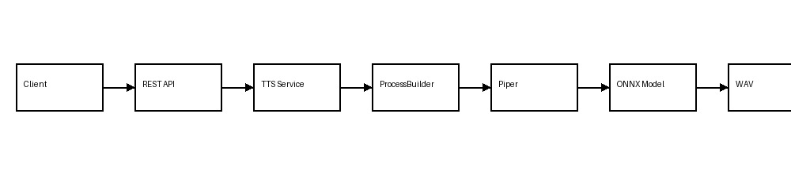
The client sends text to the REST API. The API calls the service. The service starts piper.exe using ProcessBuilder, passes text through standard input, Piper loads the ONNX model, synthesizes speech, creates a WAV file, and the service returns the audio bytes to the client.

8. Understanding the Files
piper.exe: The executable responsible for running the inference engine.
.onnx: The trained neural network model that generates speech.
.onnx.json: Metadata describing sample rate, language, phonemes, and other model settings. Both files must exist together.

9. Coding Walkthrough
Step 1: Inject TtsProperties into PiperTextToSpeechService.
Step 2: Validate that text is not null or blank.
Step 3: Resolve the selected voice model path.
Step 4: Create a temporary WAV output file.
Step 5: Build the ProcessBuilder command.
Step 6: Start the Piper process.
Step 7: Write UTF-8 text to Piper's standard input.
Step 8: Wait for process completion.
Step 9: Read the generated WAV file into a byte array.
Step 10: Delete the temporary file and return the bytes.

10. ProcessBuilder Command
List<String> command = List.of(
properties.piperPath(),
"--model",
modelPath.toString(),
"--output_file",
tempFile.toString()
);
This command is equivalent to running Piper manually from the command line.

11. REST API
Expose an endpoint such as POST /tts. Accept text in the request body and return Content-Type: audio/wav. Browsers can play the returned bytes directly.

12. Error Handling
Validate empty text, invalid model paths, missing executable, non-zero Piper exit codes, and interrupted execution. Return meaningful HTTP error responses.

13. How Piper Internally Works
1. Normalize text.
2. Convert text into phonemes.
3. Load the ONNX neural network.
4. Perform neural inference.
5. Generate waveform samples.
6. Save as WAV audio.

14. Advantages
• Offline
• Secure
• No API cost
• Multiple voices
• Fast
• Easy deployment

15. Production Improvements
• Replace temporary files with streaming.
• Add execution timeout.
• Cache voice models.
• Use SLF4J logging.
• Implement a Piper process pool for better throughput.
• Add monitoring and metrics.

16. Troubleshooting
Problem: 'Voice model not found' -> Check .onnx location.
Problem: Piper executable missing -> Verify tts.piper-path.
Problem: No audio -> Check stderr from Piper.
Problem: Access denied -> Ensure the executable has permission.

17. Summary
The integration is simple: configure Piper, configure Spring Boot properties, execute piper.exe with ProcessBuilder, send text through stdin, read the generated WAV, and return it through a REST API. Understanding this flow enables even a beginner to implement an offline TTS service.

