Task Documentation:

**Technical Requirements:**

**PHP Version:** 8.0.11

**Laravel Version:** 9.5.1

**DataBase:** Mysql

After run the project please click on login link then login with the below credentials.

Email: [admin@admin.com](mailto:admin@admin.com)

Password: password

After login please check dashboard screen here.

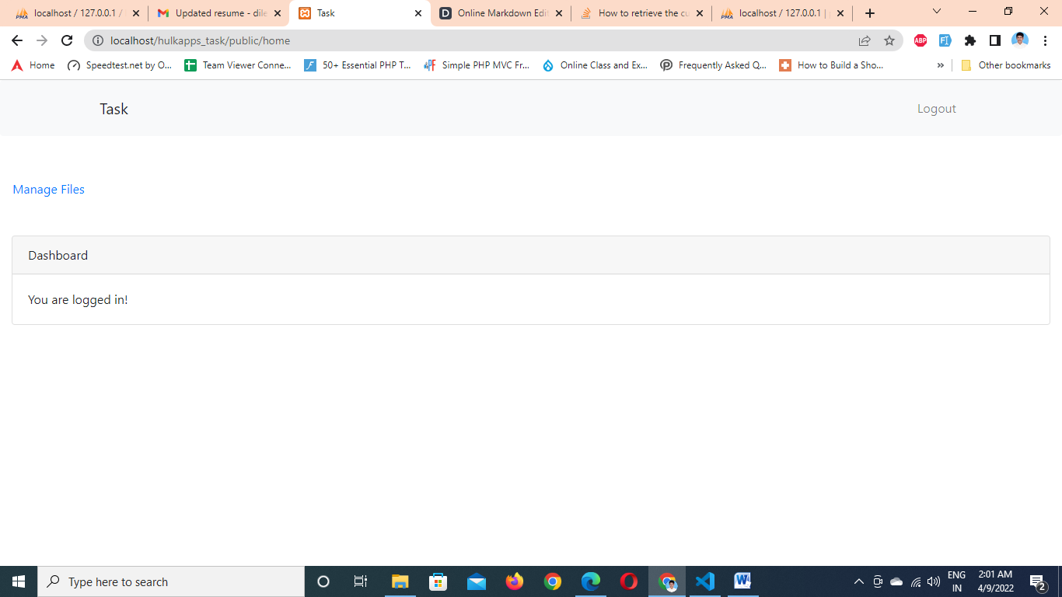

Please click on Manage Files for view the Uploaded pdfs’ list then click on upload button for upload new pdf file.

Please check the below screen for upload new pdf file

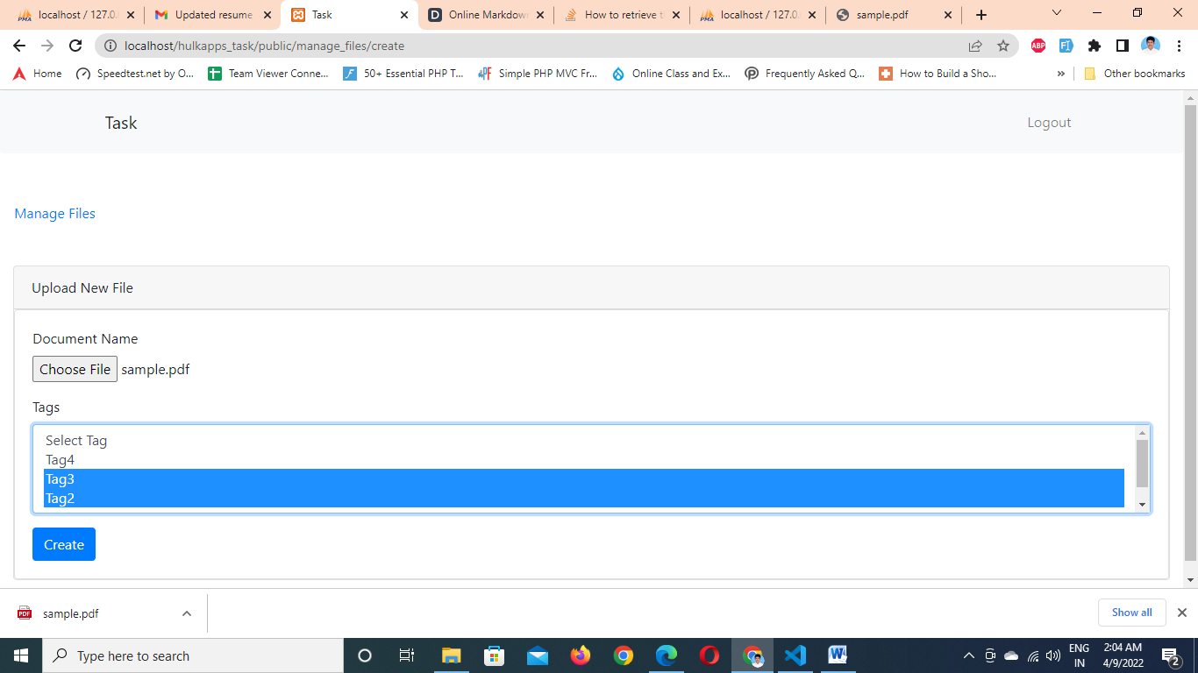

After click on create button it will redirect to Manage files page like below.

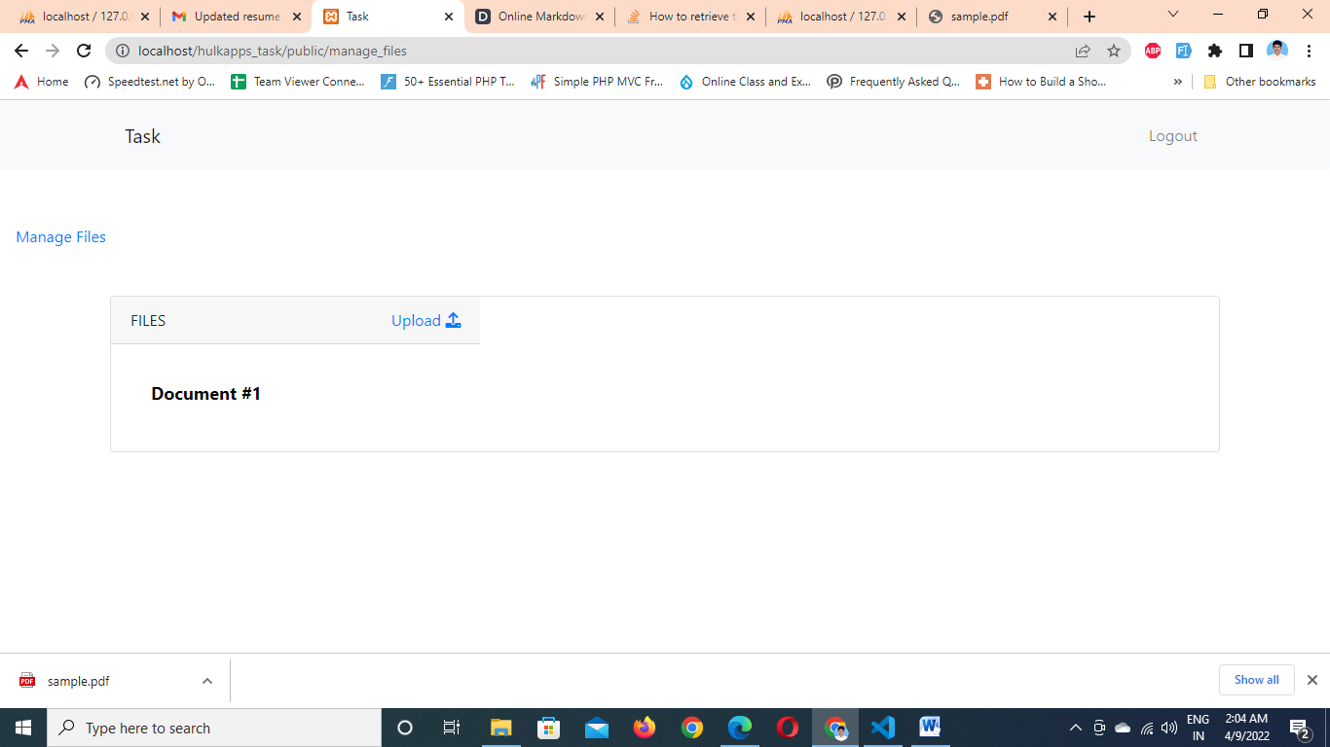

Click on Document one for view the pdf content like below.

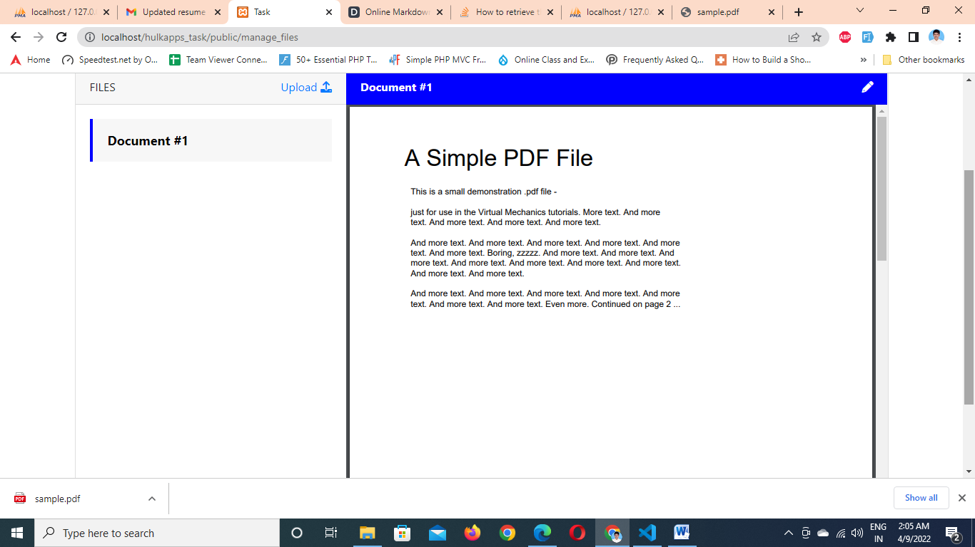

Click on pencil button for update the pdf information like below.

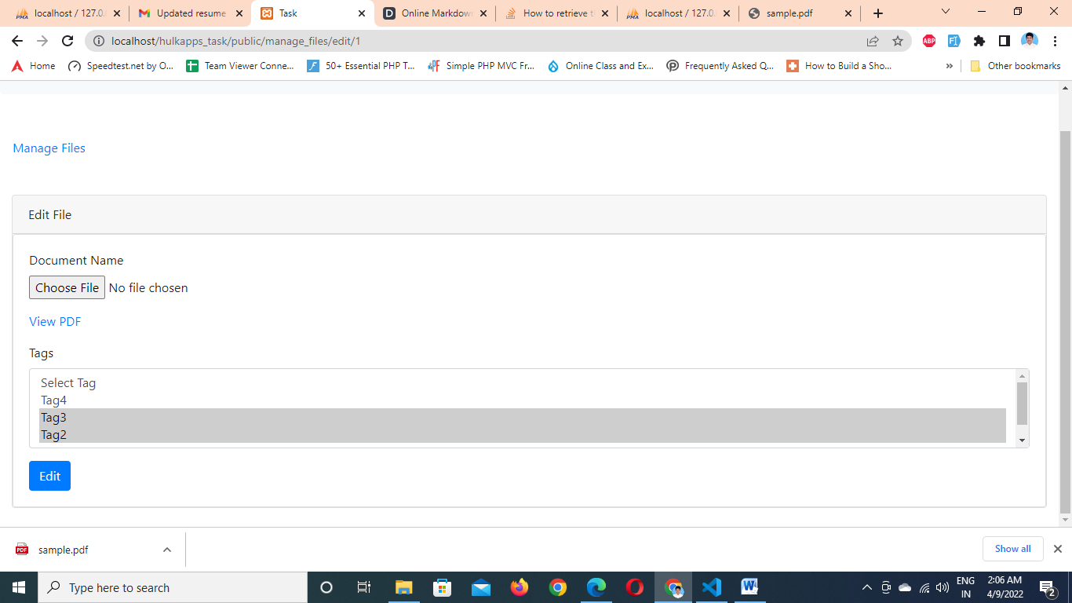

When we click on view pdf button we will view the present pdf. If we want to update pdf click on choose file then upload new file.

After click on edit button it will redirect to manage list page.

Whatever the last selected document file will be there same file will be selected as per below screen.

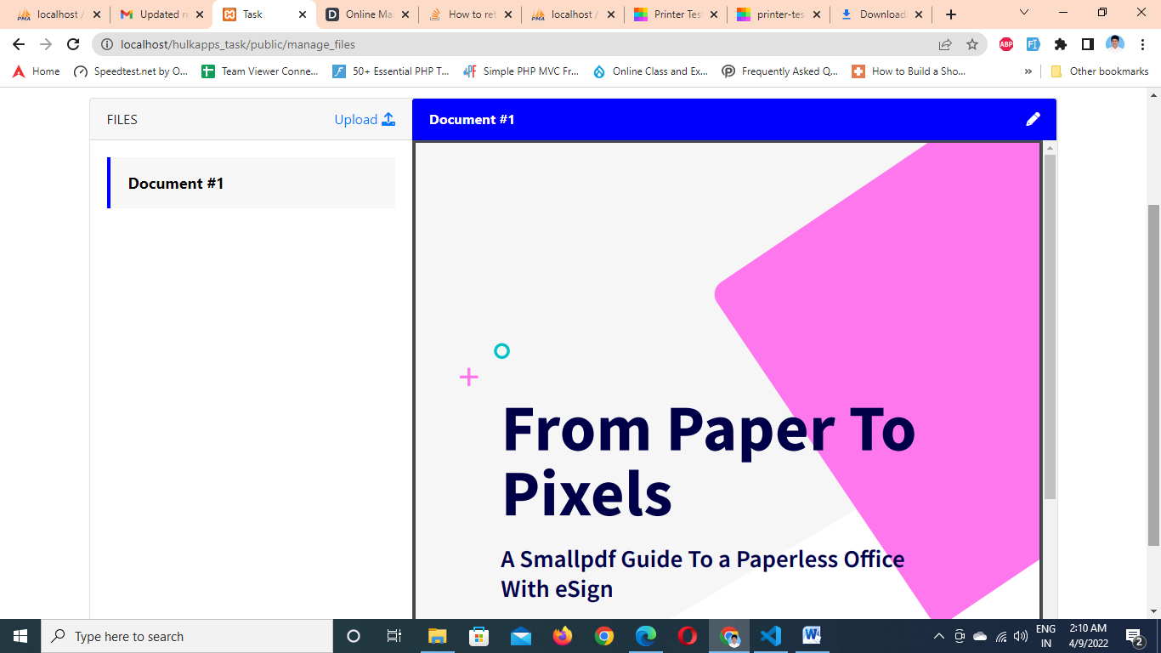

Note: I used ajax communication for new upload, edit upload pages. I used ajax communication for showing the pdf content.