VPC
- Click on ‘create VPC’ -> enter name & create CIDR with 10.0.0.0/16 and click on create
- Now we are going to create 2 public subnets and 2 private subnets for that go to subnet click on create -> select VPC ID then only subnet will be available -> first we will enter a name with public1 and select AZ for 1a AZ in the region and add CIDR number 10.0.0.0/24 create it -> Create 2nd public subnet with public2 and select AZ for 1b in the region and add CIDR number 10.0.1.0/24 and save it.
- Now create private subnet without AZ for that click on create subnet add name private subnet with CIDR 10.0.16.0/20 and create another private subnet with CIDR 10.0.32.0/20 and click on create.
- Now create Internet gateways & route tables.
- Now we already created VPC and subnets for public and private.
- Now we need to create an EC2 instance while creating you need to select your new vpc name and select public subnet. Before doing this go to both public subnets edit subnet settings and enable below one.
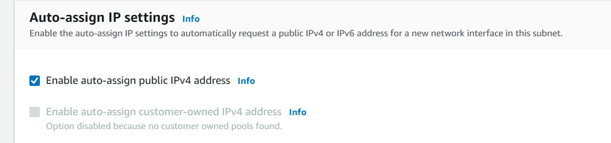
And then save it for both public subnets. now create ec2 instance by selecting created VPC and subnets. We are going to create a new SG with port 22 allow in inbound rules.then create instance.
- Now if you try to login to the instance it will display below.

It’s showing because of the VPC which we selected is not having internet access. For that we need to assign Internet gate way (IGW). Only IGW itself won’t allow traffic we need to assign route table then only the internet traffic will route to ec2 instance.

- Now create an IGW, give name and attach to VPC and create. If you try to access the Ec2 instance it won’t work because connection between our ec2 and IGW hasn’t made.
- For that we need to create 2 route tables one is for public subnet and another is for private subnet.
- First create 2 route tables and allocate VPC to it. Now go to public route table click on edit subnet settings you will see by clicking on actions. Then add the public subnets to public route table and do same for the private route table also. Now select public route table at the bottom you can see routes click on edit add the values as below.
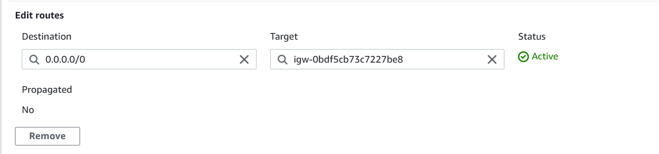
Because earlier we have configured the routes within 10.0.0.0/16 and target is local. So it won’t communicate IGW. If we want get internet it should point to IGW.
- Now ec2 will get internet connection because while creating our ec2 instance we have attached our ec2 instance to one of the public subnet.
How to give internet to Private subnet?
Bastion host:
If we have our ec2 in private subnet we can’t access the internet, because private subnet will not allow the internet traffic.For that we will use Bastion host.
- It’s an ec2 instance which it will be in public subnet with it’s own SG called bastion host SG. For that we will use SSH to connect instance(Bastion host) from public subnet to instance in private subnet & from private subnet to public subnet bastion host.
- Bastion host SG must allow inbound from the internet on port 22 from restricted CIDR, for eg: the public CIDR of your corporation.
- SG of the private ec2 instances must allow the SG of the Bastion Host, or the private IP of the Bastion host.
- Now go to ec2 instance which we already created name it as bastion host. Go to key pairs create a .pem key for private ec2 instance.
- Create a new ec2 instance with by selecting newly created .pem file. Select our VPC and create a new security group by giving ‘privateSG’ name with below permissions.
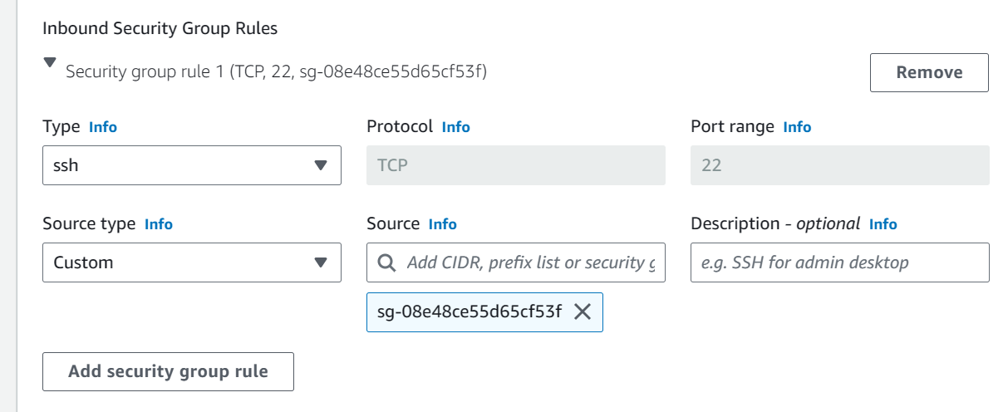
In the Inbound rule as a source type we need to select ‘custom’ and in the source you need to give ‘bastion host SG’ and create the private instance
***You can follow above way or you can add VPC CIDR along with ping security rule that is ‘All ICMP-IPv4’ .
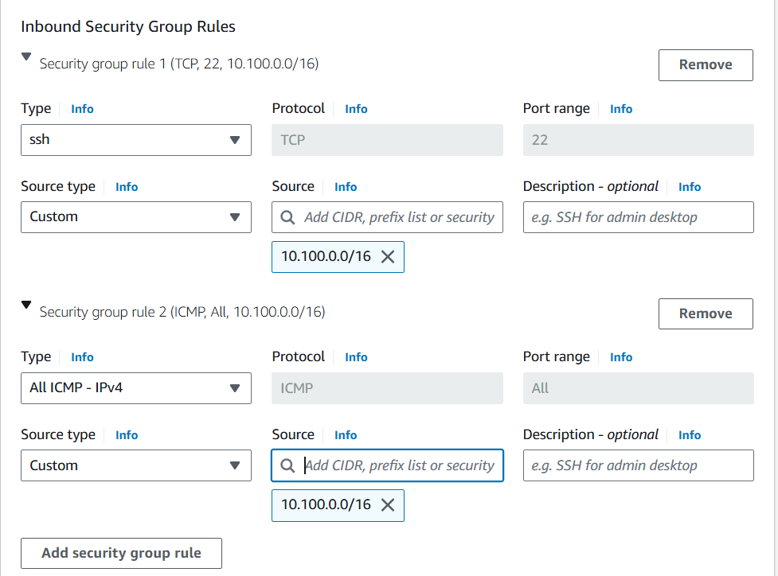
- Now login to bastion host create a file name with ‘demokeypair.pem’ open the file and paste the .pem file content in the ‘demokeypair.pem’ and give ‘chmod 0400 demokeypair.pem’ permissions to the file and collect private ip of private instance and run ‘ssh ec2-user@10.0.22.82 -I demokeypari.pem’ command it will successfully login to the private instance. Now run ‘ping google.com’ it won’t drop packages because private subnet is not still exposed to internet. We will see how to allow internet below.

NAT(Network address translation) Instance (outdated):

- It will allow ec2 instances in private subnet to connect to the internet.
- Must be launched in public subnet.
- Must be disable ec2 setting: Source/destination check
- Must of elastic IP attached to it
- Route table must be configured to route traffic from private subnets to the NAT instance.
Hands on:
- For NAT Ec2 Instance we have a separate AMI in AWS to get that while creation of Ec2 Instance search for ‘nat’ and give check mark on left side to ‘amazon’ so that it will fetch the amazon AMI. Be sure that it should be verified.
- Select the VPC and add the public subnets.
- Now, go to SG add below rules.
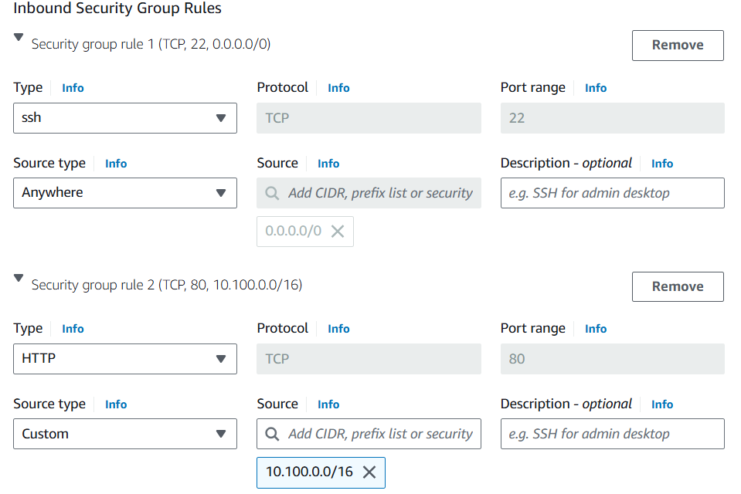
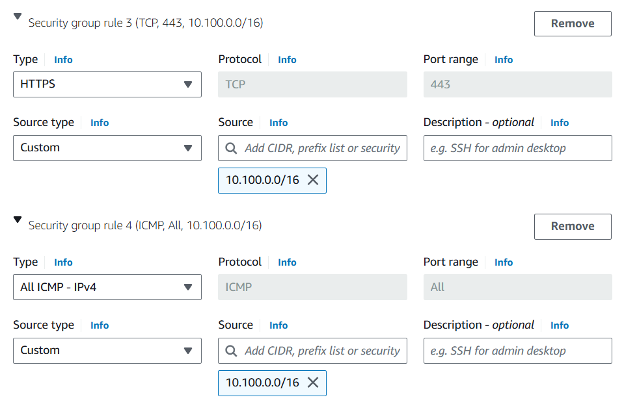
Select the key pair and click on create.
- Once instance gets created go to Actions> Networking > disable “Source and destination check”.
- Now go to private route table and add “NAT-Instance”.
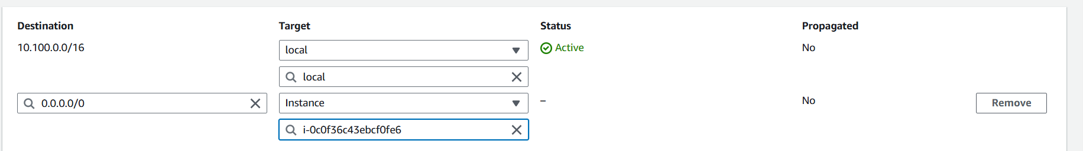
- Now try to ping google.com it will work
NAT Gateway:
- This one is better than NAT instance, It will be managed by AWS.
- Pay per hour
- NAGW is created in a specific AZ, uses an Elastic IP.
- Can’t be used by EC2 instance in the same subnet (only form other subnets)
- Requires IGW (Private subnet => NATGW => IGW)
- 5 Gbps of bandwidth with automatic scaling up to 45 Gbps.
- No SG required
- Must create multiple NAT Gateways in multiple AZs for fault tolerance.
Now we will create a NAT Gateway for that
Go to VPC on left side ‘NAT Gateways’ will be there click on it -> give name to NAT Gateway and select the public subnet1 because there only our bastion host is there and allocate elastic ip and click on create. Click on ‘allocate elastic ip’ it will allocate an elastic ip then click on ‘create’.
Now go to private route table click on actions -> ‘edit routes’ -> add your NAT GW as below.
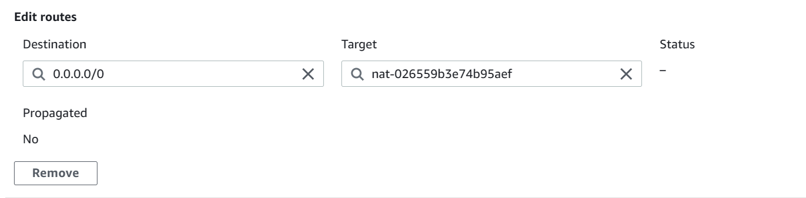
Now go to private subnet instance run ‘ping google.com’ it will drop packages means internet is accessible.
NACL (Network access control list) vs SG:
NACL is extra layer protection for subnet. Normally SG will allow whatever inbound rules you allowed the same rule also will be allowed for outbound rules. But for NACL it won’t allow them. If we want to allow we need to specify them.SG is stateful(return traffic is automatically allowed, regardless of any rules) and NACL is stateless(return traffic must be explicitly allowed by rules(think of ephemeral prots).

