VPC ENDPOINTS
The VPC wants to connect with any service in AWS we use VPC endpoints. There are 2 endpoints 1. Gateway 2. Interface (Private link).
Gateway:
The S3 and DynamoDB will use the Gateway endpoint. To demonstrate this we are going to list the S3 bucket files from private instance in VPC.
Requirements: -
- S3 bucket with objects
- IAM role with read only access
- VPC connection without internet (For practice we are using without NAT device, But in real environment NAT device will be there).
Hands On:-
- Create and S3 bucket and upload any file to it.
- Create and IAM role with read only access.
- Now, go to private ec2 instance and run “aws s3 ls s3://bucketbucket007”.
It won’t list the objects, it will result to timeout. Because the endpoint connection is not established yet.
- Go to VPC > Endpoints > Create endpoint
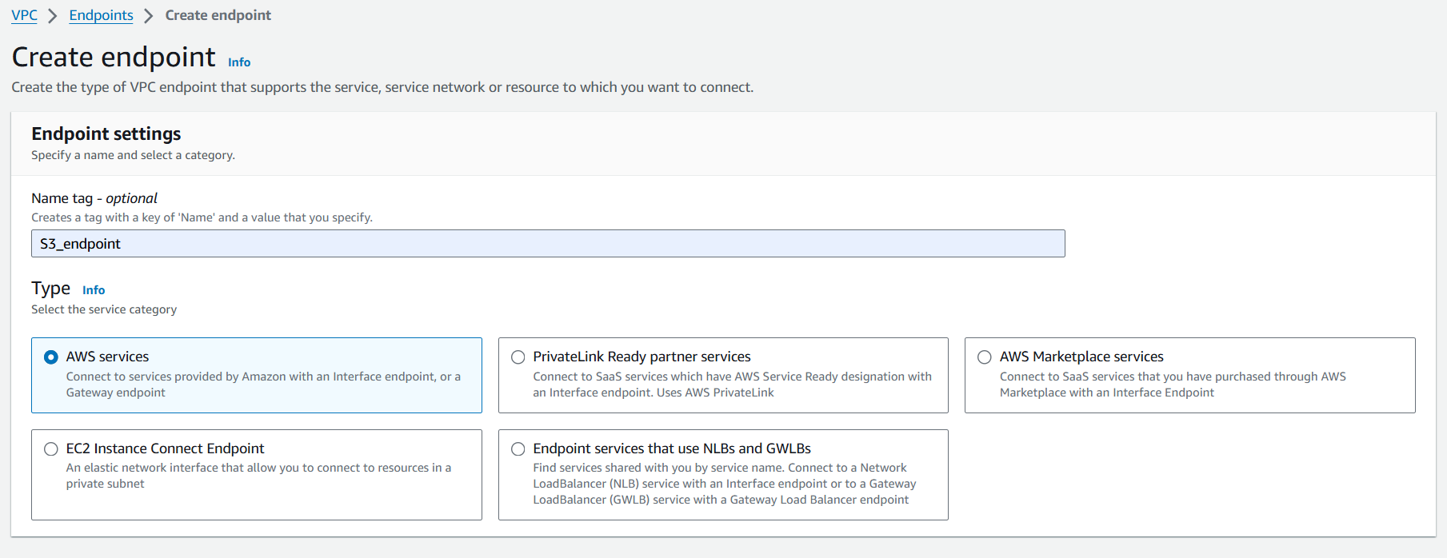
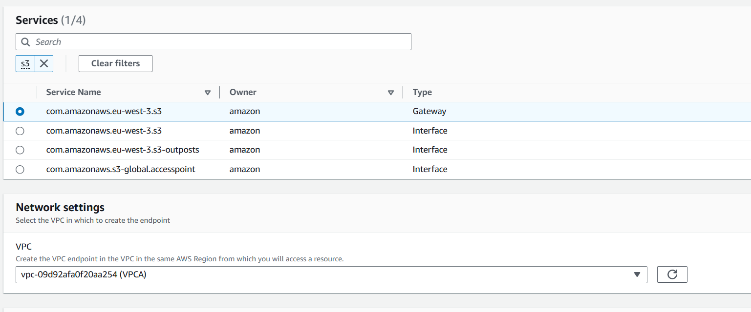
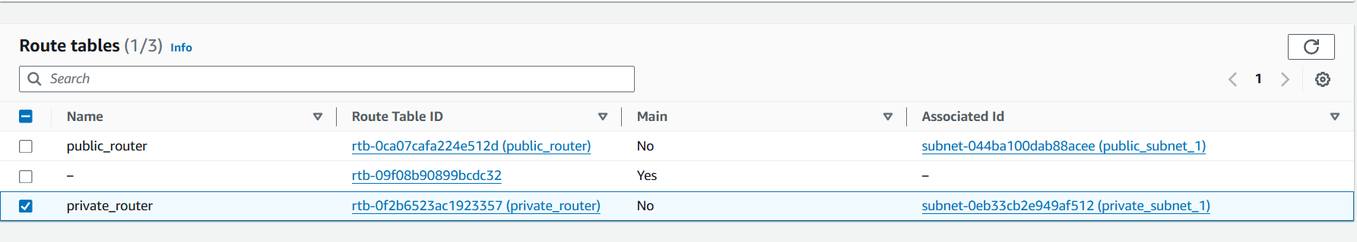
Add name, select ‘AWS Services’ search for ‘s3’ under ‘services’ select the ‘gateway’ one. Now select the VPC and select the private router and click on save.
If you see your private routetable you can see below one.
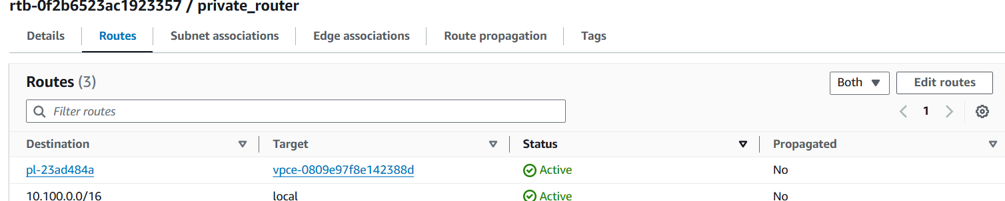
Now if you run “aws s3 ls s3://bucketbucket007” it will list the objects.
VPC Endpoint interface:-
Same like Gateway.
Requirements and steps:
- Make sure to enable Private DNS for the VPC.
- Create a SQS queue in the same region.
- Create an IAM role for private EC2 instance and attach SQS full access IAM policy.
- Create VPC interface endpoint for SQS in the Private subnet. For Security group allow inbound https/443.(Interface endpoint works differently compare to Gateway endpoint.VPC Interface endpoint creates an ENI into your subnet.ENI has a private ip from your subnet when you try to reach to SQS public endpoint. The AWS will automatically resolve the DNS of that public endpoint to the private ip of this ENI then trffic will automatically send to the ENI then it will send to the SQS service that’s why we need to enable private DNS of our VPC).
- Try to send the message to SQS queue.
We need to enable the private DNS:
Go to VPC > select the VPC > Edit VPC settings and give check mark and save
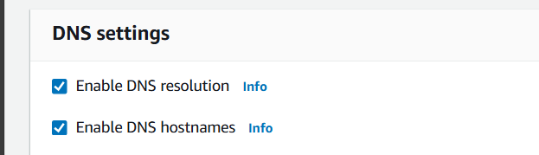
Create SQS:-
Go to SQS > Create queue. Just give the name and create it.
After creating all we need is an url .
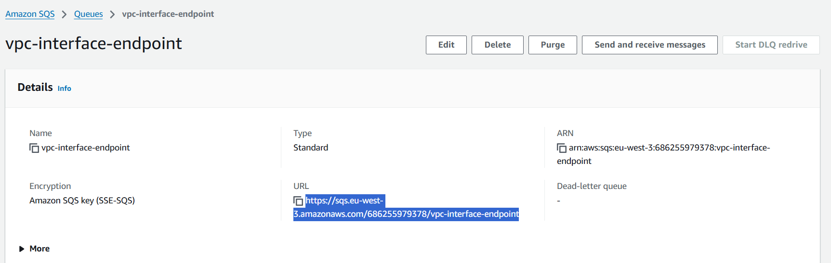
With that url we will send the message.
IAM role for EC2 Instance:-
Create a role with SQS full access and attach to the private ec2 instance.
Now if you run this command “ https://sqs.eu-west-3.amazonaws.com/686255979378/vpc-interface-endpoint ”in CLI it will result to timeout.
Create VPC interface endpoint:-
Before creation of VPC interface endpoint we need to create SG. Because interface has ENI and it has SG. So we need to create SG.Create SG with below inbound rules.
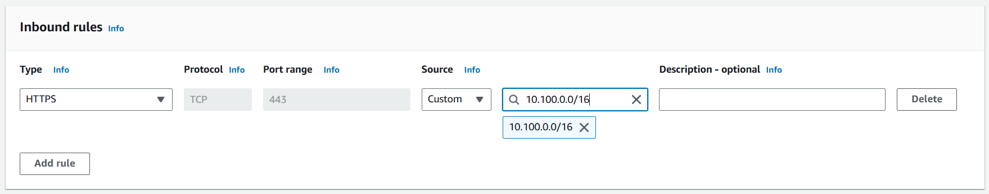
Now we need to create the VPC interface endpoint.
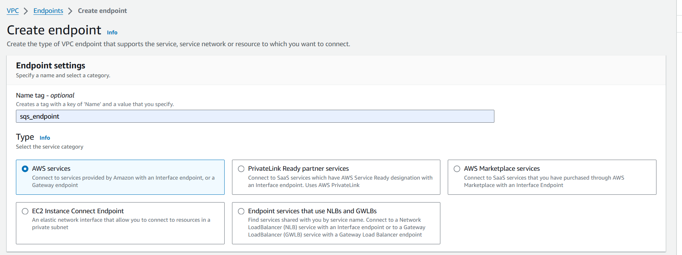
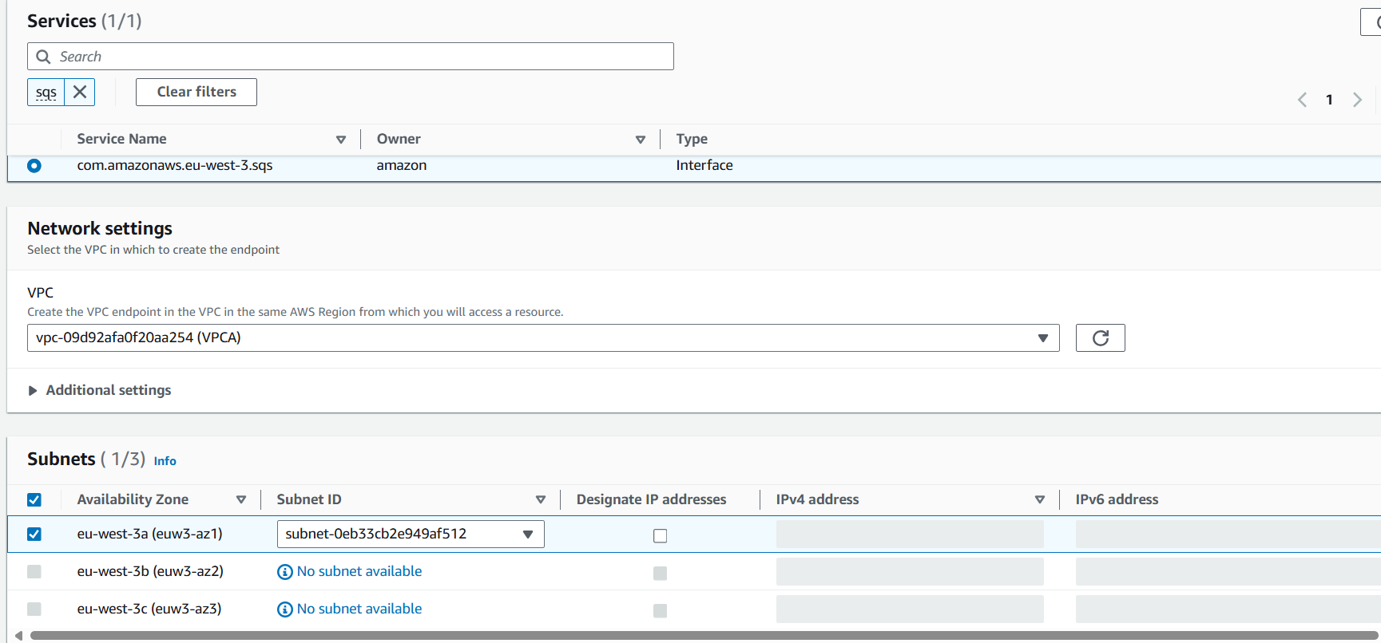
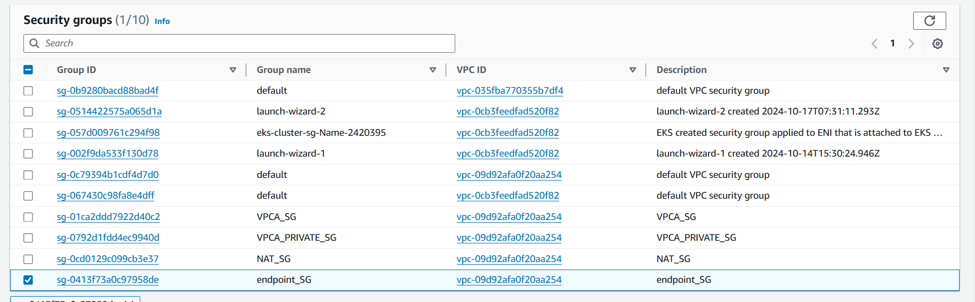
Same like Gateway extra we need to select the SG. We will select the SG which we created earlier and click on create.
If we run the command on cli we will see below response.

