VPC PEERING
VPC Peering:- It’s used to connect from one VPC to another VPC privately whether it will be in the same region or different region or even different AWS account.
We can do it through public ec2-instance but we need a Internet gateway. It is complicated process not a secure way and then it’s not cost efficient.
Note:- As of now(While tutor was teaching) we can have 50 VPC connections it may reach upto 125.
Hands On:-
Let’s assume we are having 2 VPCs in different regions names are VPCA in Paris and VPCB in Mumbai. Now we need to do the VPC peering.
- Remove the NAT Gateway/ NAT Instance now internet connection is not required. We are connecting the 2 VPC’s private instance which are inside the private subnet.
- Now from “VPC_Connection” file our whole set will be there but only internet connection won’t be there for VPCA.
- Now create VPCB in othere region with CIDR 10.200.0.0/16 (Just it should not overlap with the existing one). Create only private subnet because we don’t need internet and create private router and add the private subnet.
- Now we need to create an Private Ec2 instance and attach it to VPCB. For that we while creating private instance we will select the VPCB and private subnet and we will create new pem file.
- Coming to SG we will add our inbound rules like below.
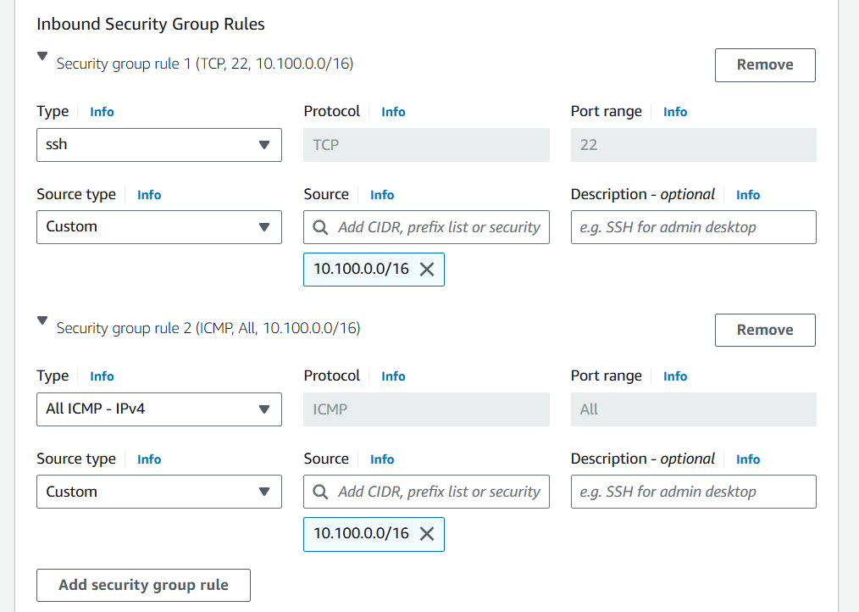
If you observe carefully. We have added VPCA’s CIDR that is 10.100.0.0/16 that means VPCB will allow all the ssh traffic from VPCA. ‘All ICMP’ will allow ping traffic.Click on create.
- Now go to VPCA’s private instance try to ping “ping 10.200.10.113” it won’t drop the packets because still we haven’t created the VPC peering.
- So to create connection the VPCA(Paris) is a requestor and VPCB(Mumbai) is acceptor.
- We need to copy the VPCB’s VPC id. Now go to VPCA’s region go to Peering connections > Create peering connection.
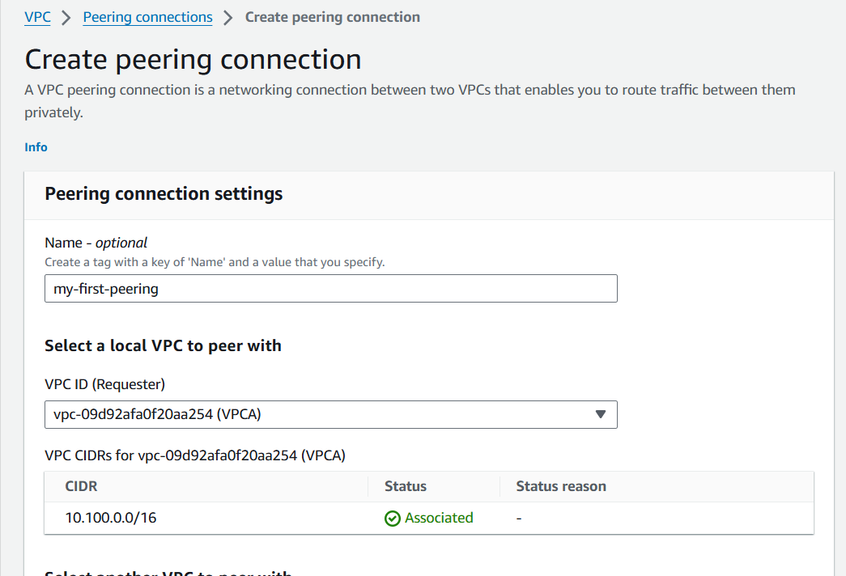
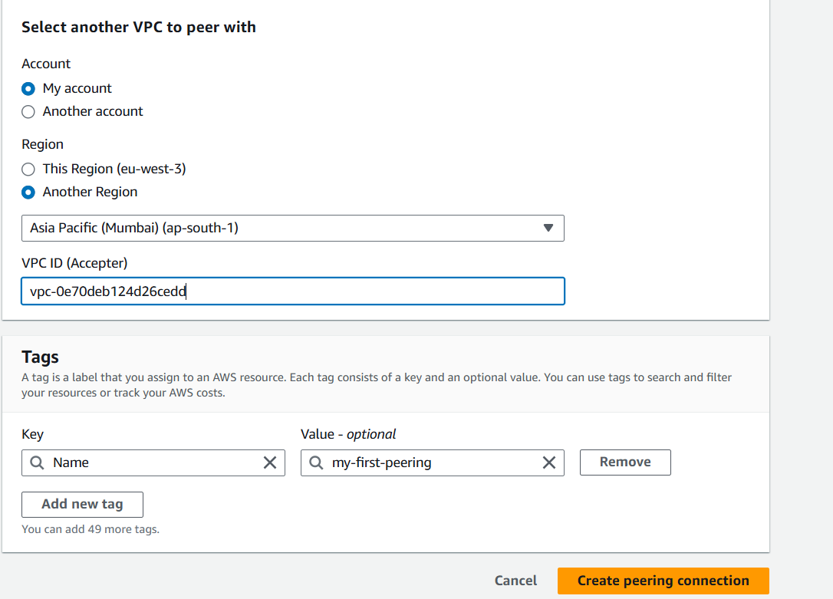
We need to give the name, select the local VPC as requestor that is VPCA and select another region and add the region name and the VPCB’s id and click on ‘create peering connection’.
After creating it, it has sent a request to VPCB’s region there we need to accept the connection. Otherwise it will be in a pending state like below.
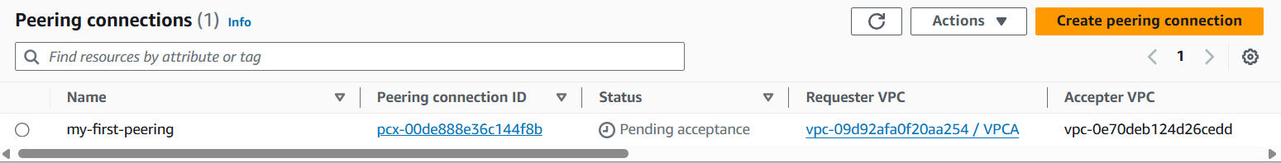
Now go to Mumbai region VPC > peering connections
There we can see the request select the request and click on Actions and aaccept the peering connection.
- Last step is to update the private route tables for both VPCA and VPCB. Now in VPCB region we will update the rule.
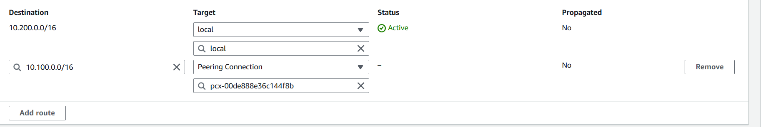
This means if any traffic going to or coming from VPCA the target should be Peering connection.

Same we need to do for VPCA
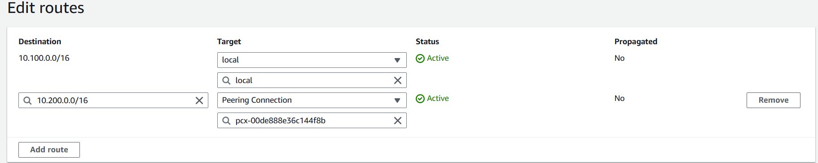
- Now, If you run ping command it will work.

Understanding AWS VPC Peering (Features, Benefits, Scenarios, Limitations and unsupported configurations):-
Features:
- Enables private communication between 2 AWS VPCs.
- Intra region and Inter region.
- Across different AWS accounts.
- Can connect single VPC to multiple VPCs.
- There is no single point of failure for communication or a bandwidth bottleneck.
Benefits:
- No need to have IGW or VPN connection between VPCs.
- Saves VPN connection cost ($0.05/hr). You only pay in/out data transfer charges of $0.01/GB.
Scenarios:
2 VPCs Peered together:
You have different departments Finance, Accounting hosting machines into separate AWS VPCs. You can provide full access to all the resources from one VPC to another VPC and vice-a-versa.
3 VPCs Peered together:
You have different office branches having separate VPCs in same of different AWS accounts and resources in these branches needs to access resources in all other branches.
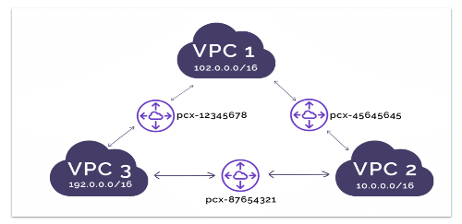

Multiple VPCs Peered to single VPC (Spoke model).
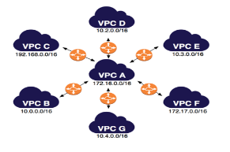
- When you host a centralized services e.g File sharing, AD into one VPC and need to provide access to people or applications hosted into different VPCs.
- You offer SaaS service to customers having their own workloads into their AWS accounts. You can provide SaaS access to all customers making sure individual customers VPCs can not communicate with each other.
- You have centralized Management VPC (e.g Chef server, Jenkins etc) and you have individual customer specific VPCs where you have hosted your single tenant services in each VPC. You can push your configurations as well as monitor health Infra and applications through management VPC.
Limitations:
- VPC CIDR’s should be Non-overlapping.
- Only one peering between given 2 VPCs are allowed.
- Perring connection is not transitive.
Eg: You have mad connection between VPC-A to VPC-B and VPC-B to VPC-C. The VPC-A and VPC-C will not communicate.
Invalid Scenrios:
- A VPN connection or AWS Direct connect connection to a corporate network. It will not communicate with the on premise one.
- If VPC-A has IGW which allows internet traffic to VPC-A, But it won’t allow the internet to VPC-B during peering connection.
- Same like above case through NAT device also it won’t allow.
- A VPC endpoint to an AWS Service (End to Amazon S3 and DyanmoDB) is allowed to VPC-A but VPC-B won’t access the AWS services.
It means it can communicate directly between VPC-A to VPC-B only.

