By default inventory file will be in /etc/ansible/hosts. You can specify different inventory file at the command line using the -i <path> option or in configuration using inventory.
It’s better to keep you own inventory file in your own repo.
Two ways we can write the inventory file 1. INI 2. YAML
For more about inventories read the doc How to build your inventory — Ansible Community Documentation . In this page you can see the variables also.

Now we have created the inventory file like this here I’m using password(not suggestable & less secure). Always use key.
all:
hosts:
web01:
ansible_host: 192.168.29.254
ansible_user: osboxes
# ansible_ssh_private_key_file: targetkey
ansible_ssh_pass: osboxes.org
web02:
ansible_host: 192.168.29.176
ansible_user: ubuntu
# ansible_ssh_private_key_file: targetkey
ansible_ssh_pass: ubuntu

after doing that run -> ansible web01 -m ping -i inventory <- The controller server will SSH to the target server.
While doing this it will ask for to check the host keys. Everytime we need to give yes to avoid that, we have the configuration file under /etc/ansible/ansible.cfg .Open the file uncomment this “host_key_checking = False”
I have added all the servers to an inventory file. Later I have segregated the web servers and db servers into groups. Later I added all the segregated groups should come under one group. The script will look like this:

all:
hosts:
web01:
ansible_host: 192.168.29.254
ansible_user: osboxes
# ansible_ssh_private_key_file: targetkey
ansible_ssh_pass: osboxes.org
web02:
ansible_host: 192.168.29.164
ansible_user: osboxes
# ansible_ssh_private_key_file: targetkey
ansible_ssh_pass: osboxes.org

db01:
ansible_host: 192.168.29.151
ansible_user: ubuntu
# ansible_ssh_private_key_file: targetkey
ansible_ssh_pass: ubuntu
children:
webservers:
hosts:
web01:
web02:
dbservers:
hosts:
db01:
dc_oregon:
children:
webservers:
dbservers:

So according our requirement we can perform the activity on each server or group of servers or on whole servers like this.
ansible web01 -m ping -i inventory #This will run on web01
ansible webservers -m ping -i inventory # this will run on on all the webservers
ansible all -m ping -i inventory # This will run all the servers

Variable:
I have defined the variables under ‘vars’ and I have removed those variables under web01 and web02 like below:
all:
hosts:
web01:
ansible_host: 192.168.29.254
# ansible_ssh_private_key_file: targetkey
web02:
ansible_host: 192.168.29.164
# ansible_ssh_private_key_file: targetkey

db01:
ansible_host: 192.168.29.151
ansible_user: ubuntu
# ansible_ssh_private_key_file: targetkey
ansible_ssh_pass: ubuntu
children:
webservers:
hosts:
web01:
web02:
dbservers:
hosts:
db01:
dc_oregon:
children:
webservers:
dbservers:
vars:
ansible_user: osboxes
ansible_ssh_pass: osboxes.org
If you observe the commented one in the script those are the passwordless (more secure) authentication way.
YAML & JSON:-
The Python dictinary will look like this.
{“DevOps”: [“AWS”, “Jenkins”, “Python”, “Ansible”], “Development”: [“Java”, “NodeJS”, “.net”], “ansible_facts”: {“python”: “/usr/bin/python”}}
JSON will look like this:
{
“DevOps”:
[
“AWS”,
“Jenkins”,
“Python”,
“Ansible”
],
“Development”:
[
“Java”,
“NodeJS”,
“.net”
],
“ansible_facts”:
{
“python”: “/usr/bin/python”
}
}
YAML will look like this:

DevOps:
- AWS
- Jenkins
- Python
- Ansible
Development:
- Java
- NodeJS
- .net
ansible_facts:
python: /usr/bin/python
version: 2.7 #Dictionary will look like this in YAML
Note:- Ansible output will be in JSON format
For mora about YAML documentation for Ansible visit this doc YAML Syntax — Ansible Community Documentation
Ad hoc commands:-
Ansible scripts called as playbooks. Everything should goes through the playbook/code. Very rare case only we have to use ad hoc commands and it’s not suggestable.
More about ad hoc in this doc Introduction to ad hoc commands — Ansible Community Documentation .
Ad hoc commands we generally we pass with the ‘-a’ arguments. Now we are going to install httpd on webservers machines will see how the ad hoc command will be.
Eg:- Now I want to install the httpd on my machines for that we need the module. Here my OS is centos so I’m using “ansible.builtin.yum” and I’ll be passing the arguments also like below.
ansible webservers -m ansible.builtin.yum -a "name=httpd state=present" -i inventory –become
Here we are passing the argumnts like name & state. At name we need to give the package name and the state is present. Present means it should be installed. If it’s absent it will uninstall it. –become is used to run the command with sudo permission.
Since we are using the virtualboxes we have to enter the root password. To pass the password we need to use ‘—ask-become-pass’. The full command is.
ansible webservers -m ansible.builtin.yum -a "name=httpd state=present" -i inventory –become –ask-become-pass
It will prompt for password and we need to enter it.
Note:- Configuration management tools are idempotent. If the target has already that change it will not do anything. Where as scripting it won’t check the target state.
To start and enable the package.
ansible webservers -m ansible.builtin.service -a "name=httpd state=started enabled=yes" -i inventory --become --ask-become-pass
Now we are going to transfer the index.html file to /var/www/html path in webservers.
ansible webservers -m ansible.builtin.copy -a "src=index.html dest=/var/www/html/index.html" -i inventory --become --ask-become-pass
It will transfer the file. After that you can check the index.html content in the browser by running the IP address.
Note:- If you are using AWS account you should allow the port 80 in the inbound rules. If you are using the virtualbox run below commands to add the httpd to your firewall.
sudo firewall-cmd --list-all
sudo firewall-cmd --add-service=http --permanent
sudo firewall-cmd –reload

Playbook:-
Playbook is collection of plays (tasks). Playbook consists of list of plays.
Now, whatever we have implemented with ad hoc we are going to implement through playbook
---
- name: Webserver setup
hosts: webservers
become: yes
tasks:
- name: Install httpd
ansible.builtin.yum:
name: httpd
state: present
- name: Start httpd
ansible.builtin.service:
name: httpd
state: started
enabled: yes

- name: DBserver setup
hosts: dbservers
become: yes
tasks:
- name: Install mariadb-server
ansible.builtin.yum:
name: mariadb-server
state: present
- name: Start mariadb service
ansible.builtin.service:
name: mariadb
state: started
enabled: yes
The above playbook will install httpd service on webservers and maria db will be installed in db servers post installation it will start the services.
After creating it run the play book with “ansible-playbook -i inventory web-db.yaml --ask-become-pass”
If you want to debug the issues add -v at the end we can add upto 4 v like -vvvv
“ansible-playbook -i inventory web-db.yaml --ask-become-pass -vv”.
To check any syntax error add “—syntax-check” at last. If it shows file name then there is no errors.
“ansible-playbook -i inventory web-db.yaml --ask-become-pass - - syntax-check”
To do the dry run “ansible-playbook -i inventory web-db.yaml --ask-become-pass -C”. There is no guarantee that dry-run will match with actual execution. The better suggestable way is first check the ‘syntax’ and the use ‘-C’.
More about playbooks go here Using Ansible playbooks — Ansible Community Documentation .
More about modules go here Index of all Modules — Ansible Community Documentation

Modules:-
Doc for modules Module Index — Ansible Documentation .
Copying a file:
---
- name: Webserver setup
hosts: webservers
become: yes
tasks:
- name: Install httpd
ansible.builtin.yum:
name: httpd
state: present
- name: Start httpd
ansible.builtin.service:
name: httpd
state: started
enabled: yes
- name: Copy file with owner and permissions
copy:
src: index.html
dest: /var/www/html/index.html
backup: yes
The above script will copy the index.html to target servers. If you observe ‘backup: yes ‘ this will first back up the index.html file and then it will add /override the changes.

Creation of user in the database:
For this you can check the modules for database mysql_db – Add or remove MySQL databases from a remote host — Ansible Documentation .
---
- name: DBserver setup
hosts: dbservers
become: yes
tasks:
- name: Install mariadb-server
ansible.builtin.apt:
name: mariadb-server
state: present
- name: Install mysql #To create a user in db we have to install mysql it's a dependecny.
ansible.builtin.apt: # Here .yum or .apt both are working for ubuntu machine
name: python3-pymysql #This one we will get it through apt search python | grep mysql
state: present

- name: Start mariadb service
ansible.builtin.service:
name: mariadb
state: started
enabled: yes
- name: Create a new database with name 'accounts'
mysql_db:
name: accounts #After installing the mysql we are creating the new database
state: present
login_unix_socket: /var/run/mysqld/mysqld.sock # Without this Ansible doesn't know how to communicate with mysql.
- name: Cretae database user with name 'vprofile'
mysql_user:
name: vprofile # Creating new user
password: 12345
priv: '*.*:ALL'
state: present
login_unix_socket: /var/run/mysqld/mysqld.sock

The above script will install the mysql , create the account and it will create the user.
Commonly faced issues:
- Mysql dependency we have defined in the playbook by running apt search python | grep mysql
- Below error was rectified through google search by defining this value login_unix_socket: /var/run/mysqld/mysqld.sock .
We can use community mysql collection for that we need to install it.
ansible-galaxy collection install community.mysql
Refer to this doc for community collection community.mysql.mysql_db module – Add or remove MySQL or MariaDB databases from a remote host — Ansible Community Documentation .

Ansible configuration:-
When we change defaults we change the Ansible configuration.
Eg: We know ssh works on port 22 for some reason we change it to 2020 at that time we need to make the changes Ansible configuration.
Order of Ansible Config:
- ANSIBLE_CONFIG (environment variable if set the ansible will refer to this variable)
- Ansible.cfg (in the current directory- we will use in our project )
- ~/.ansible.cfg (in the home directory)
- /etc/ansible/ansible.cfg
Only ansible.cfg is the repository specific while committing the code we can commit this as well. Remaining are all system specific.
Note:- By default inventory path is /etc/ansible/hosts
Creation of new ansible configuration file (ansible.cfg) under our project folder. Here our project is ext4_playbooks.
I have created ansible file and added below condition inside the file.
[defaults]
host_key_checking=False
inventory = ./inventory
forks = 5
log_path = /var/log/ansible.log

[privilege_escalation]
become=True
become_method=sudo
become_ask_pass=False
If you observe we have defined the inventory file path which it is refering to current inventory file path in our current project folder. So next time onwards we can run our commands without ‘-i inventory’.
Forks will define on how many targets the controller should take action if we give 5 it will take control on 5 servers at a time.
We have defined the log path also. Initially we need to create and give ownership permission to the file.
Note:- Always our ansible.cfg file should be in our current project file.

Variables & Debug:-
We know variables are used to re-use the same value multiple times in a script. Here in Ansible-playbook we define the variables like below.
---
- name: DBserver setup
hosts: dbservers
become: yes
vars:
dbname: electric
dbuser: current
dbpass: tesla
tasks:
- debug:
msg: "The dbname is {{dbname }}" # Used to print the output like echo in bash

- debug:
var: dbuser # Used to print the output like echo in bash

- name: Install mariadb-server
ansible.builtin.apt:
name: mariadb-server
state: present
- name: Install mysql
ansible.builtin.apt:
name: python3-pymysql
state: present

- name: Start mariadb service
ansible.builtin.service:
name: mariadb
state: started
enabled: yes
- name: Create a new database with name 'accounts'
mysql_db:
name: "{{dbname}}"
state: present
login_unix_socket: /var/run/mysqld/mysqld.sock
- name: Cretae database user with name 'vprofile'
mysql_user:
name: "{{dbuser}}"
password: "{{dbpass}}"
priv: '*.*:ALL'
state: present
login_unix_socket: /var/run/mysqld/mysqld.sock
If you observer the script we have defined ‘vars’ under that we have passed the variables in dictionary format.
If you want to print the output we use ‘debug’ module.
How to store the json output?
By using register module we will store the ouput of the logs which are in json format with in the variable. Let’s define it.
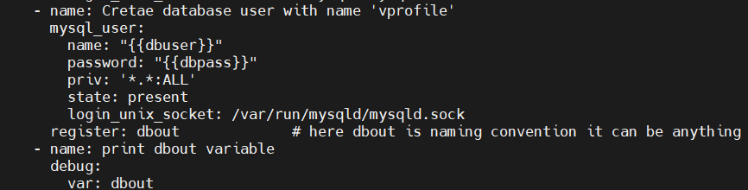
I have took SS of the particular part. If we want particular task’s output we define register at the module level like you can see in SS. Later you can create a task and use the debug module to print the variable. Here the variable is ‘dbout’.
The output will look like this.
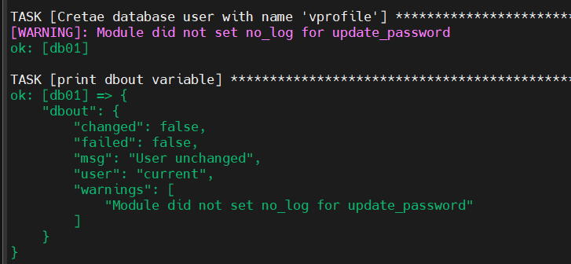

Inventory Based variables:-
Mostly the variables will be defined outside of the playbook. We use the ‘groups_vars’ folder inside that we will create a file ‘all’. We will define the variables like this.
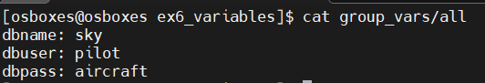
The groups_var folder name should not be changed it’s default one and ‘all’ is the name we given in inventory file. So playbook first it will check inside the playbook file for variable if it’s not defined then this will check in ‘groups_var’ folder. The ‘groups_var’ folder should be in the same path where our playbook will be.
How to print the particular key from the JSON output?
With the help of register we can print like below.
---
- name: Understanding vars
hosts: all
become: yes
vars:
USRNM: playuser
COMM: variable from playbook
tasks:
- name: create user
ansible.builtin.user:
name: "{{USRNM}}"
comment: "{{COMM}}"
register: usrout
- debug:
var: usrout.name # To access the keys inside the dictionary we have to give variable name(usrout) and the key (name & comment).
- debug:
var: usrout.comment
Here, If we use ‘usrout’ only it will print the whole output.
How to provide the variables at group level?
Like we have provided the vars for all the hosts we can provide the vars for group level also. All we need to do is create a file with the “<group name>” inside the group_vars folder and then define the variables. So the playbook will first check inside the playbook if it’s not there it will go and take from ‘groups’ file there also not there it will check in the ‘all’ file
The structure will look like below.
Now I have the ‘webserver’ group file with vars
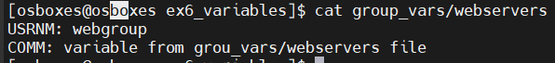
I have ‘all’ all hosts file with vars
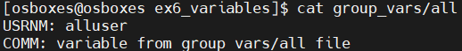
The output will look like below.
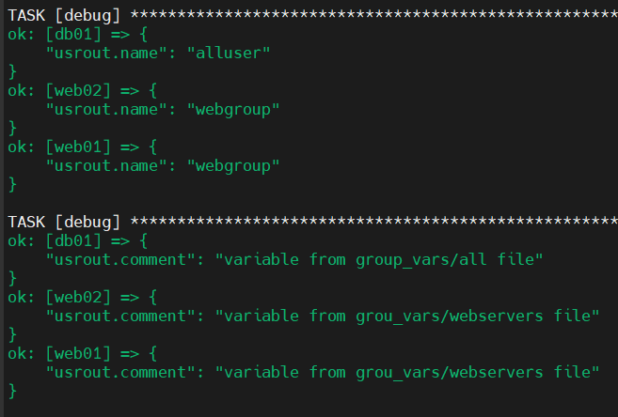
We can define the variable at the host level also for that we don’t use ‘group_vars’ folder. We use ‘host_vars’ inside that folder we will create a file with hostname which we defined in the inventory file that is ‘web02’.
I have defined the variable like below:
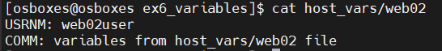
And output is
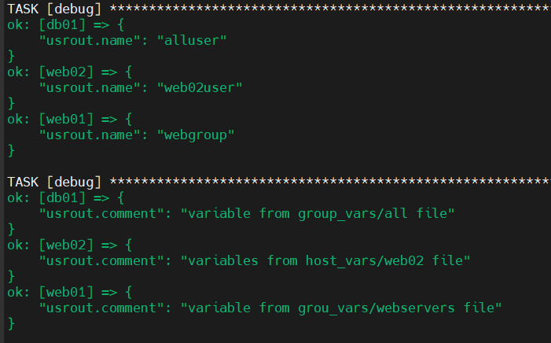

We can pass the vars through command line also like below:
But it’s rarely used.
The precedence of the variables are cli>playbook>host file> group file > all hosts file .
Note:- The commonly used vars file is ‘group_vars/all’ file.
For more read this doc Using Variables — Ansible Community Documentation .
Need to check importing the variable file into the playbook.

Fact Variables:-
Fact Variables(gathering facts tasks) are runtime vars it will generate while setup module gets executed.
The examples of fact variables are:
- Ansible_os_family – It will check the OS name
- Ansible_processor_core- Number of CPUs
- Ansible_kernel – kernel version
- Ansible_devices – Connected device info
- Ansible_default_ipv4 – IP, MAC address, gateway etc.
- Ansible_architecture – 64 bit, 32bit
The above are few examples.
To disable the gathering the facts we need pass the module under the hosts module like this “gather_facts= False”.
Basically the ‘setup’ module is all about the giving the target machine’s info. We can see it through ad-hoc command also.
For that run “ansible -m setup web01”. It will list the all the details about that machine.
Let’s write a playbook to get about OS name.
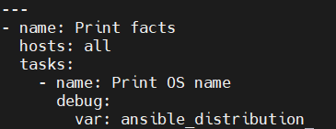
Here ansible_distribution I got it from the above ad-hoc command.
The Ouptut of the above script is
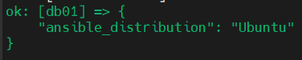
If we disable the gathering facts it won’t print the output.
Let’s execute another variable. I have collected a nested dictionary of JSON which it will look like below.
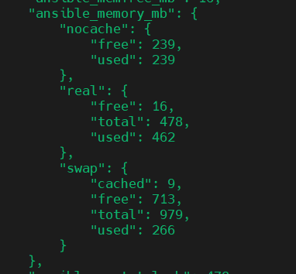
Now I’m going to create a playbook.
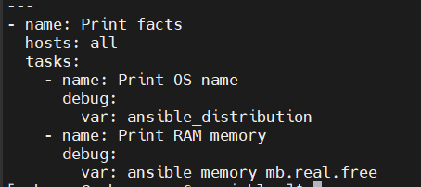

The output will be
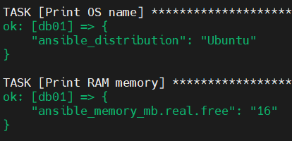
Like that we can do for list format also. But for list we have to use numbers like below.
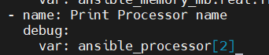
And ouput is
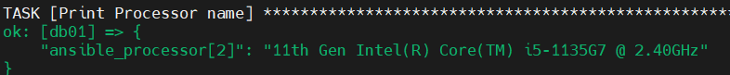
Try to work on to print different type of variables.

Decision Making:-
Provisioning Server:
- NTP service on multi OS
- Users & Groups
- Configuration files
- Decision Making
- Loops
- Templates
- Handlers
- Ansible Roles
Note:- For ubuntu machine If we want to run “apt update”. We need to use ‘update_cache: yes’
Now we are going to install and start a package based on the OS. The play book will look like below:
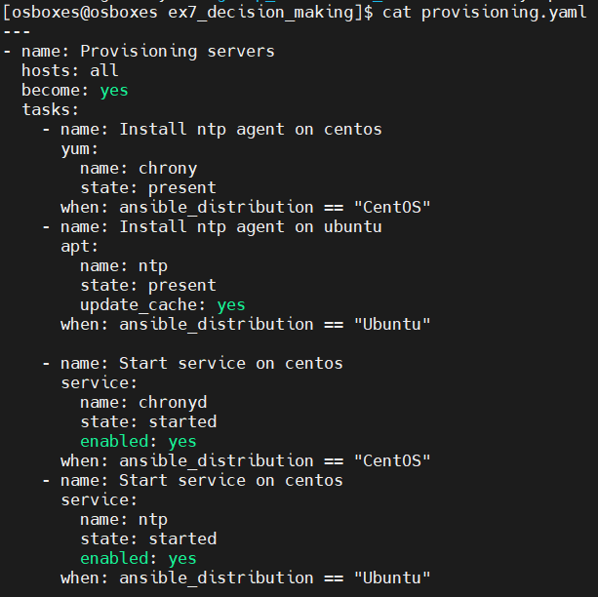
So if it’s centos it will install on centos other than centos it will skip the installation.
As of now we have used simpler conditional/decision making one. For more complicated ones check this doc Conditionals — Ansible Community Documentation .

Loops:-
Loops are used to install the multiple packages/tasks. Let’s assume if we want to install 5 different packages we need to write a big script instead of that we can just define the loops and then we need to add the tasks as list and then we can call it with the variable ‘item’. Item is default we can’t change it.
Let’s write a playbook.
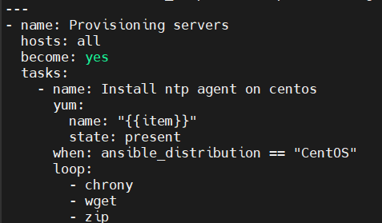
So it will install all the packages.
More on this doc Loops — Ansible Community Documentation .

File, copy & template modules:-
Let’s assume we have a file on target server we need to update it later we need to restart the service. More in this doc Files modules — Ansible Documentation .
If we want to add a line in a file we can do like below.
But it’s better to have a complete configuration file under template folder. By using the template module we will copy the file to destination folder and we will restart the service. The only difference is between copy and template module is template module will read the file whereas copy module will just dump the file.
We will define like below in playbook
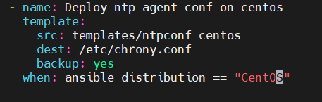
So, the template module will read the each line and then it will push it’s content to the destination file.
Eg: template module’s src file name is content.txt and dest filename is index.html it will copy only the content not the file and it will identify the variables as well in src file and it will replace the vars with values and it will be pushed.
How to create a directory on target machines?


Handlers:-
Let’s see a scenario, there is requirement to make changes in configuration file and after that we will push the changes to target machine and restart it. But when there is no change in the configuration file during that scenario also the ansible playbook will execute the service restart. So to avoid that we will use handlers. The script will look like below:
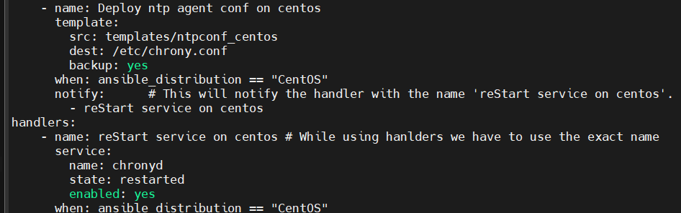
How it work is, Whenever the change is there in ‘/templates/ntpconf_centos’ it will consider the statement as true then it will notify the handler with the specific name otherwise it will consider it as false then it won’t notify.
More about handlers in this doc Handlers: running operations on change — Ansible Community Documentation

Roles:-
Roles are used to simplify our playbook.
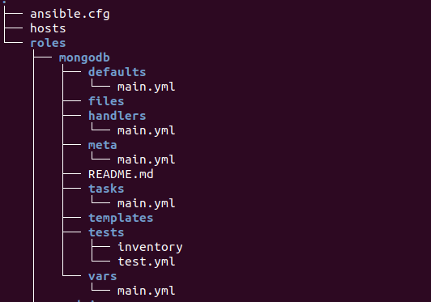
By refering to above image under roles folder we can separate the each play into files//files under the folder with this we can simplify our playbook.
To use the roles we need to initialise Ansible galaxy.
We are going to create a folder with roles there we are going to initiate the roles.
To initiate we use “ansible-galaxy init <any-name>”
After running it, it will create the file and folder structure like below.
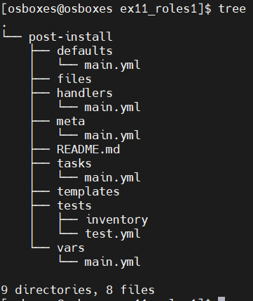
It has simplified our work, all we need to do is to use it.
As a first step of simplifying our playbook I have moved all the vars to vars/main.yaml file.
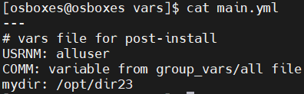
Now we can remove the group_vars, host_vars folders
Now we can move our templates to templates folder and files to files folder and clean it up.
Now move the handlers also to handlers/main.yaml. We have copy it carefully.
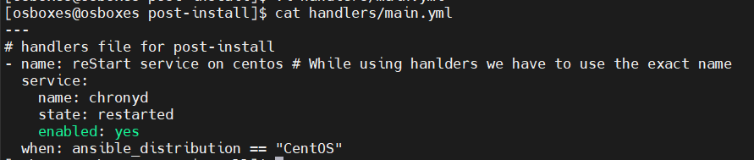
Now, move the tasks.
I have moved all the tasks to tasks/main.yaml file
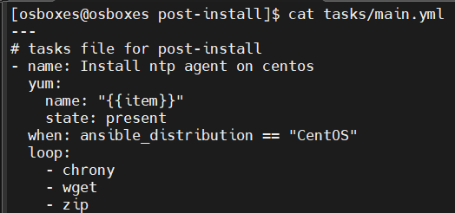
Since unable to capture the whole tasks I was trying to show small snippet for an idea.
Now remove all the tasks from playbook.
Now in tasks clear folder names for files and templates like below.
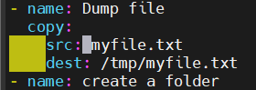
Ansible roles is smart enough to find the files and templates under respective folder structure.

Finally, my playbook will look like below.
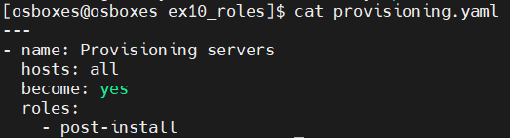
Note:- inventory file, playbook & your roles folder should be under the same folder. Otherwise we can define like below:
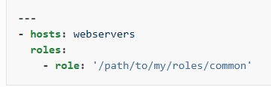
More about roles in this doc Roles — Ansible Community Documentation .
We can exclusively define the vars in the playbook itself like below.
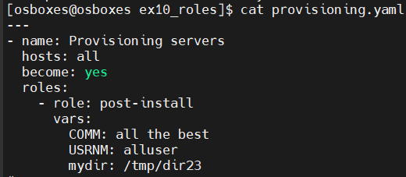
But we need to comment/remove the variables in vars/main.yaml because the playbook’s first priority will be vars/main.yaml.
We have readymade roles in Ansible Galaxy. Instead of writing from scratch we can get the roles from here and then we can make the modification. This was developed by community.
More about it you can see here Ansible Galaxy - Welcome to Galaxy . Since they moved to new page it’s not having the same UI.
Mostly we don’t use it because they have developed for their environment so we need some reverse engineering here. But from here we can get advanced thought how industry experts are using the ansible.

Ansible for AWS:-

