Docker:
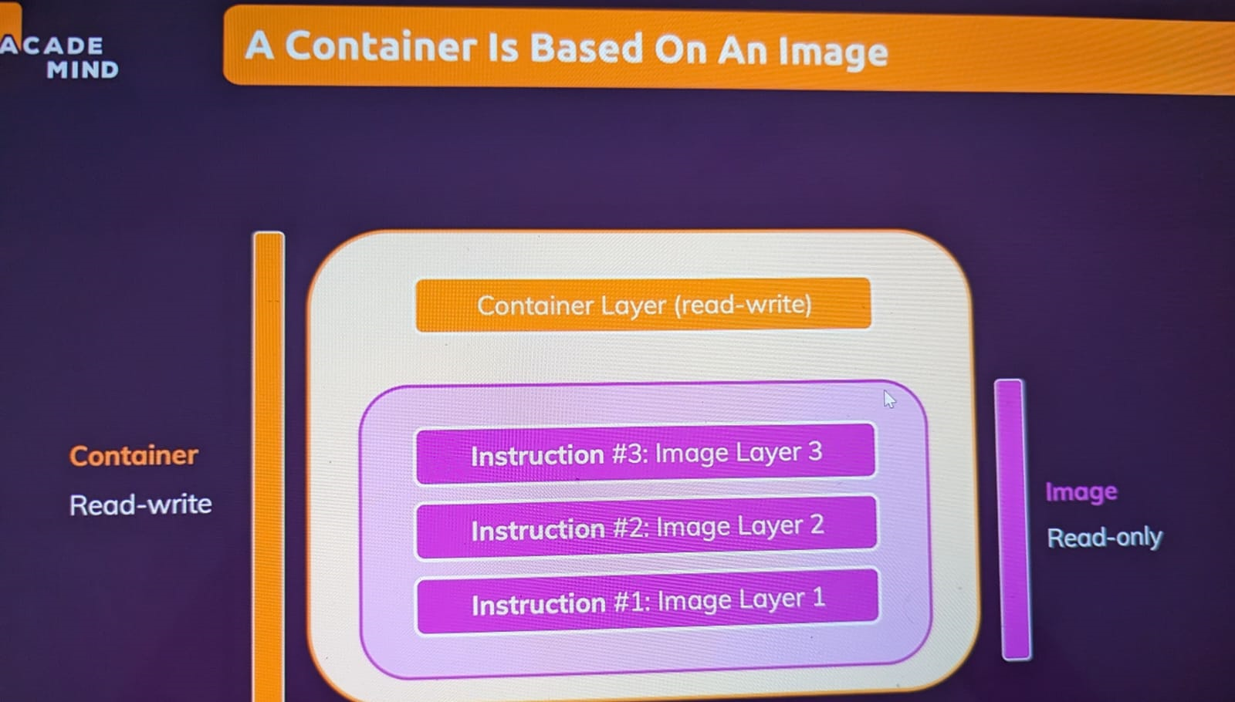
Docker volumes:
Types of data:
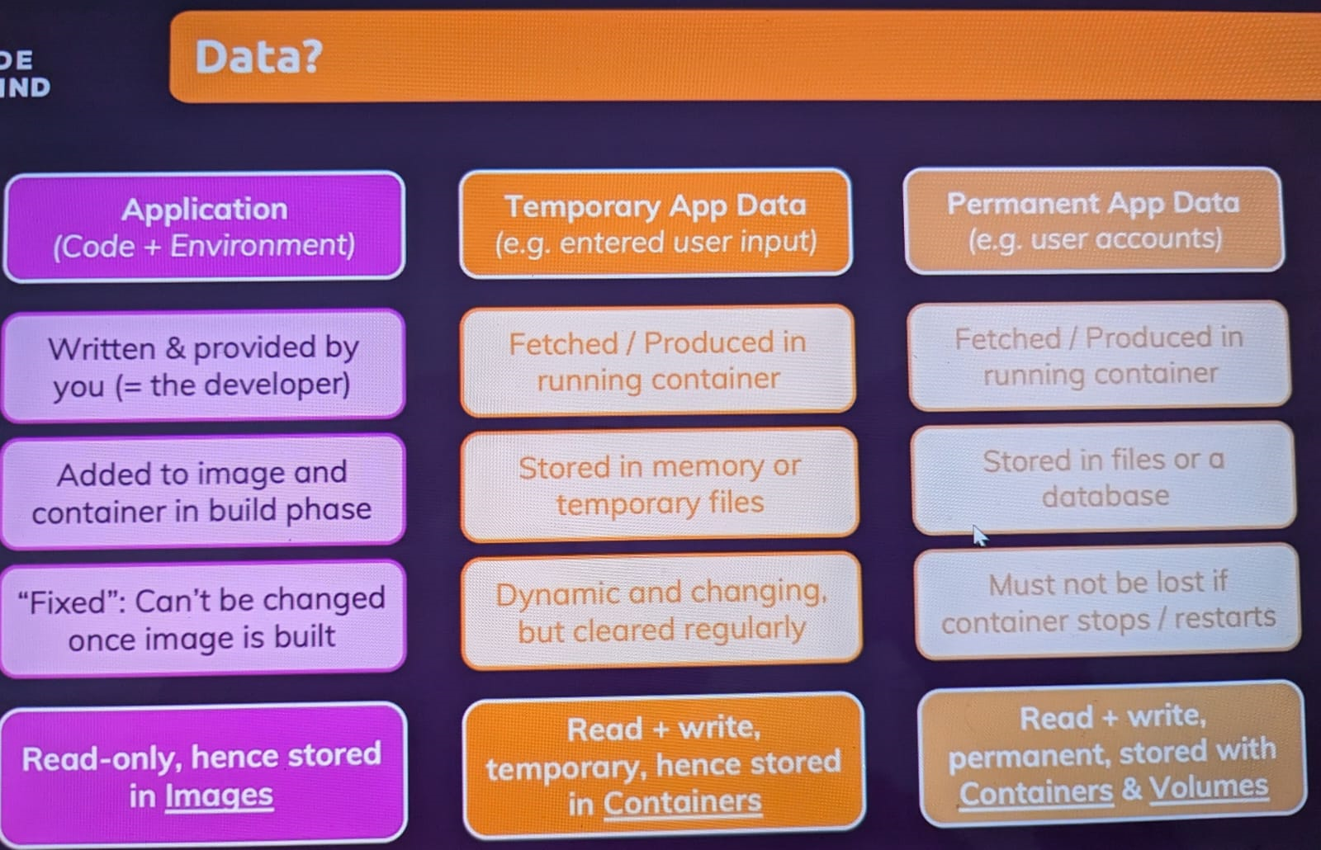
Understanding volumes: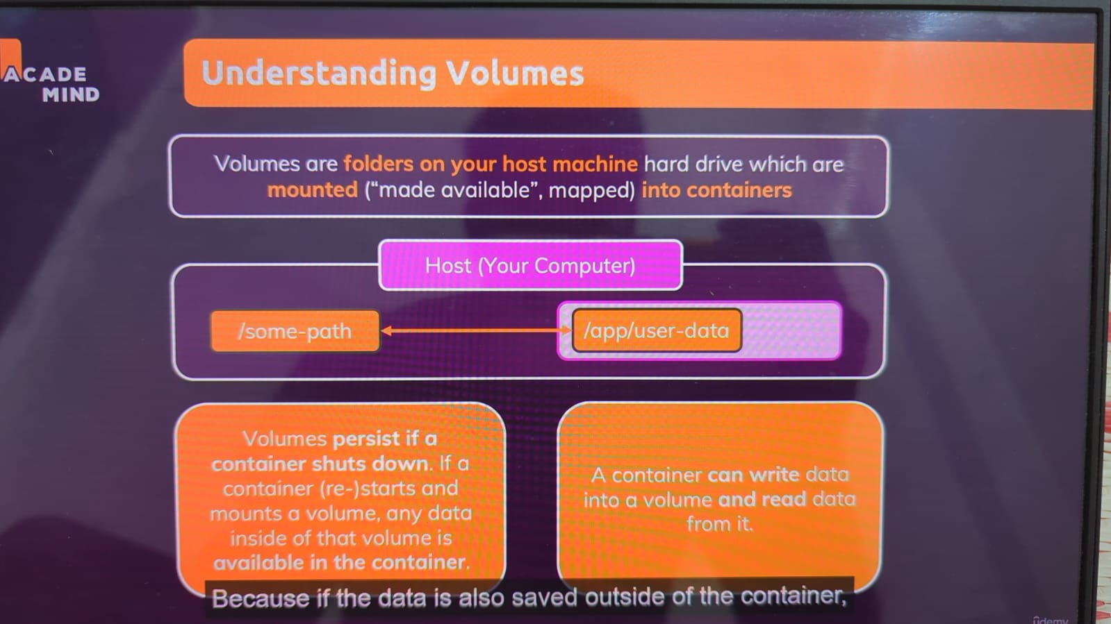
Volume: If we want to persist data during restart or even remove the container still data will servive with the volumes
Types of Volumes: 1. Anonymous volume
2. Named Volume
3. Bind volume
1. Anonymous volume: If we create a volume with just internal path of the container that volume will create as an anonymous volume.
From the above command -v means volume followed by /opt is the internal path of the container.
2. Named volume: If we create a volume with just internal path and attaching that volume with a name is called named volume.
From the above command we use -v flag and followed by volume name here volume name is volume1 and followed by internal file system path of the container which separated with ‘:’
Note: Both Anonymous and Named volumes are both can be listed with docker volume ls command but if you want see the storage path of both volume, we can’t trace it. If we make few changes on server it won’t replicate on container.
3. Bind volume: It is a file system which we attach to inside file system of a container. If we make any changes on attached host file system it will replicate on internal file system.
From the above command after -v /opt is host file system and another /opt is internal file system path of the container which separated by ‘:’.
We use this only on Development environment not on prod.

