What- Observability will provide the internal state of your application, infra & network.
Eg:
- What is the disk utilization for 24 hrs
- What is the CPU utilization for your node.
- Memory utilization
- Out of 1000 http requests how many are failed and succeeded.
Why- Observability will provide why your state of your application,infra & network is like that.
Eg:
- If out of 1000 http requests 5 got failed it will show why it got failed.
- Why the memory leak is happening
How- Observability will provide how to fix the issue.
Eg:
- If 5 http requests are failed it will show how to fix it. We will get the complete traces of the http request like. When did it reach to your Load balancer, Front end app, Backe end and DB.
What-Metrics- Metrics will provide historical data of events
Why-Logging- Developer can instrument/logging the info,debug,trace,error,warn
How-Tracing- Traces will provide extensive information to troubleshoot and debug.

Monitoring VS Observability:-
Observability will cover Metrics(Metrics+Alerts+Dashboard), Logging & Traces. Where as monitoring will cover only Metrics, Alerts & Dashboard.

Note:- Observability is collective approach. If Developers instrument the Metrics, Logging & Traces DevOps will look after the implementation part like Monitoring stack, logging stack and the Distributed tracing.

Day-2
Metrics:-
Eg:- In a hospital a patient need to be monitor for 24 hrs. The nurse will collect the metrics like heartbeat , BP etc., for each 15 mins. The doctor will montior that metrics and will analyze if any abnormality is there. The above scenario is nothing but collecting the historical data of the events.
The data which we collected is raw data. If we implement monitor we can see the date in a graphical way in dashboard. It will happen if someone pushes it or monitoring tool will scrape (pull) it.
We can collect the metrics for the complete system also like if your application inside VPC with EKS cluster. We can collect all the services metrics like CPU of nodes,Memory, POD status.
Here our monitoring tool is Prometheus. Prometheus is going to scrape the data like huge amount using exporter, pushgateway. Prometheus will be having the alert manager it will send the alerts.
Prometheus architecture: -
Whatever data collects via Retrieval it will be stored in TSDB (time series data base). TSDB will store the data with time stamp during what time what happened like that.
Now, If you want to get the info like last 20 minutes status of app we can query the HTTP server of Prometheus. Prometheus supports the query language call PromQL.
Service Discovery:-
If you want to monitor the specific metrics that are sent by our application. Let’s assume if you have 50 apps out of 30 you want to read metrics for that we need to use Service discovery.
The complete doc you can get here in this link observability-zero-to-hero/day-2 at main · iam-veeramalla/observability-zero-to-hero · GitHub.
Hands on:-
While spinning up the EKS cluster you might have noticed the OICD provider it’s used to communicate the Kubernetes service account with IAM roles or policies within your account.
Follow the steps mentioned in this link to install the K8s cluster, helm, helm chart along with Prometheus and Grafana https://github.com/iam-veeramalla/observability-zero-to-hero/tree/main/day-2#%EF%B8%8F--installation--configurations
Note:- If you are using the Jump server to run the port-forward command you need to enable the ports allowed in inbound rule of that jump server after that you can try the links in browser with jump-server-publicIP:port. Note if you are doing port forward then you need mention –address 0.0.0.0 for each port forward command separately and you need to take separate window for Prometheus, Grafana and Alert manager.
Prometheus Architecture:-

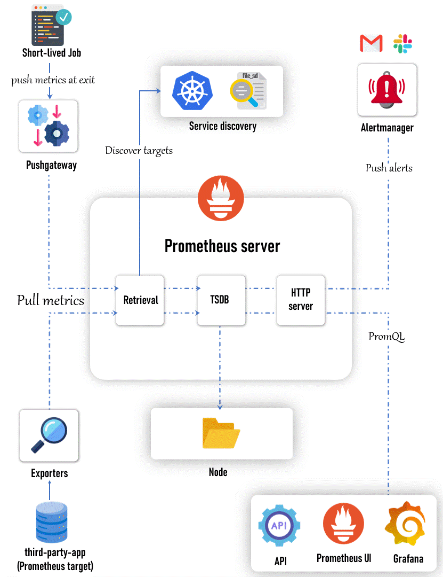
Password for grafan you can get by running “kubectl --namespace monitoring get secrets monitoring-grafana -o jsonpath="{.data.admin-password}" | base64 -d ; echo” or you can directly enter “prom-operator”.
Note:- We will be using ingress as permanent set-up instead of port forwarding.
How Prometheus can scrape the metrics?
AWS K8s
App
The Prometheus need to scrape the data from AWS, K8s & Application. How Prometheus will scrape the data? The answer is exporters. It’s like an add-on or plugin. Each exporter can take care of one thing eg: A node exporter is an plugin or add-on in Prometheus, this node exporter will export the node related metrics. It will go to each node from ‘/proc/’ file it will get the cpu utilization for each minute. The exporters will run as PODs in cluster.
Another metrics is kube-state-metrics, It will get all the info from K8s API server like POD,deployments, how many times the POD get crash, how many K8s events your POD has omitted all kind of status related K8s will get it via kube API server. From this exporter the Prometheus will scrape the metrics.
So for Node exporter will export node level metrics, kube-state-metrcis will fetch K8s metrics. Now, how we will fetch app level metrics?
To get the application level metrics, the developer should right metrics api server ‘/metrics’ endpoint like /login, /logout. Prometheus will use “service discovery mechanism”. We need to tell the Prometheus these are 50 servers with ‘/metrics’ endpoint from where we need to scrape the metrics.
Competitors to prometheus are Nagios, influxdb, Graphite.But Prometheus is the CNCF tool after K8s that’s why we use it.
Day-3: Metrcis and PromQL in Peometheus:-
Note:- In Prometheus stack, the kube-state-metric and node exporter should be there without this Prometheus can’t scrape enough info. If you see kube-state-metrcis exporter will be having one POD because it will directly communicate with kube api. But, where as node exorter will run at daemon set level so each node requires each node-exporter POD.
Now, Collect the ClusterIP IP address of node exporter and kub-state-metrics from kubectl CLI. login to any one of K8s node via session manager run curl <kube-state-metrics-clusterip-ipaddress>:8080/metrics. You can see the metrics which kube-state-metrcis scarped the data from K8s. The generated output for curl command will be in format which Prometheus can understand it.
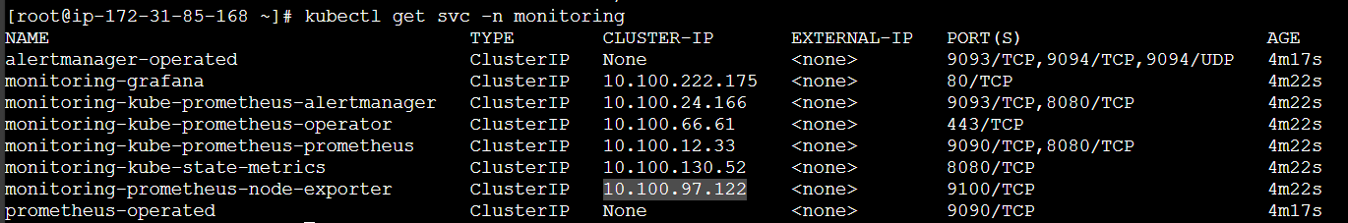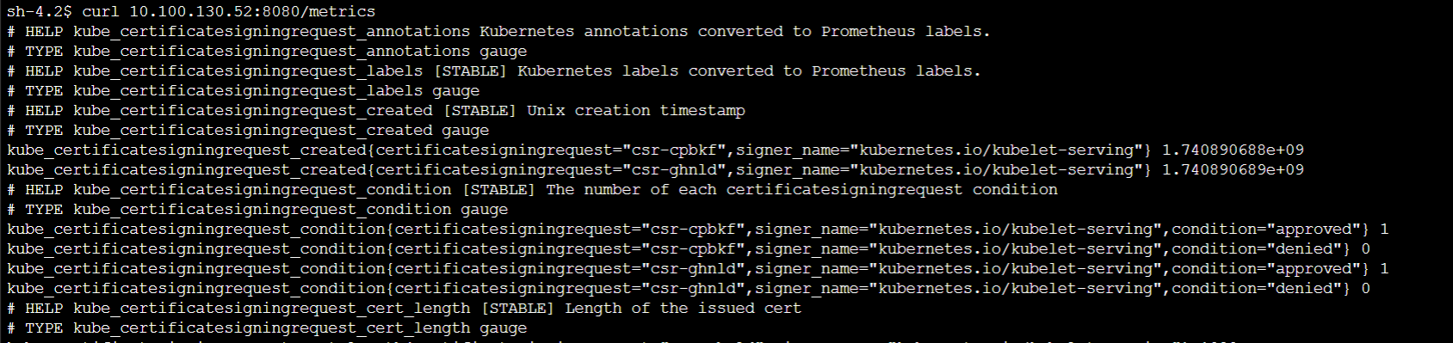
Now, run ‘curl <node-exporter-IPaddress>:9100/metrics’ you can see the metrics of nodes as an output where Prometheus can understand it.
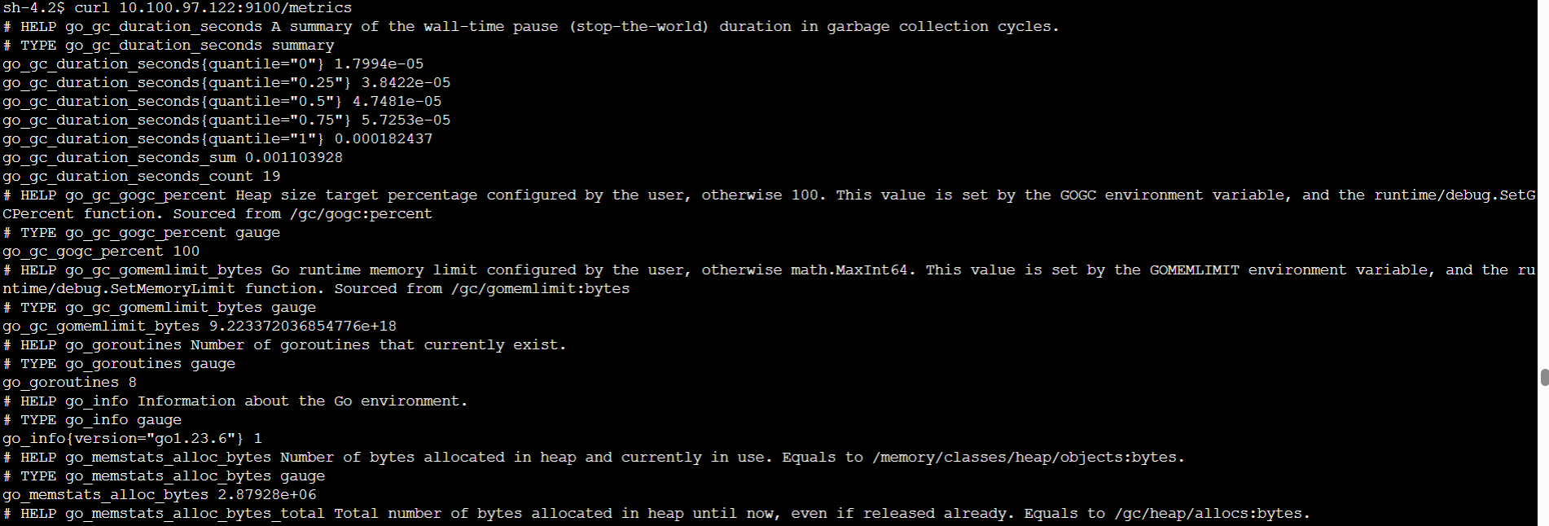
If you observe we have used /metrics for each exporter. The exporter will send the metrics to /metrics endpoint.
Now if you want to see how many times a POD get restarted you can see like below.
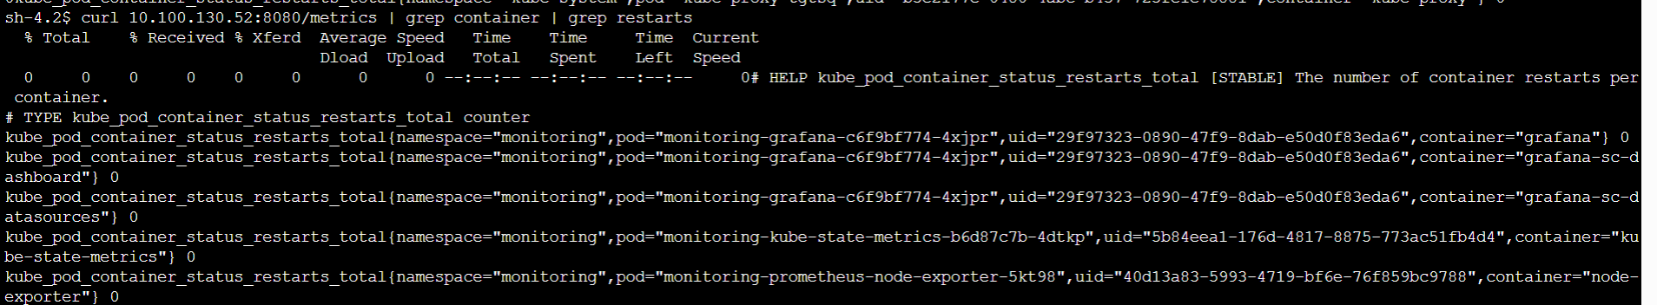
If you see above SS, ‘kube_pod_container_status_restarts_total’ is metric and in the metric we can use particular label like namespace or anything else to filter to that particular metrics. So, Prometheus has stored lot of data via the exporters.
Now, let’s see these data will be storing as per time base in Prometheus tool.
Now, in graph format we are seeing that the K8s doesn’t have any restart.
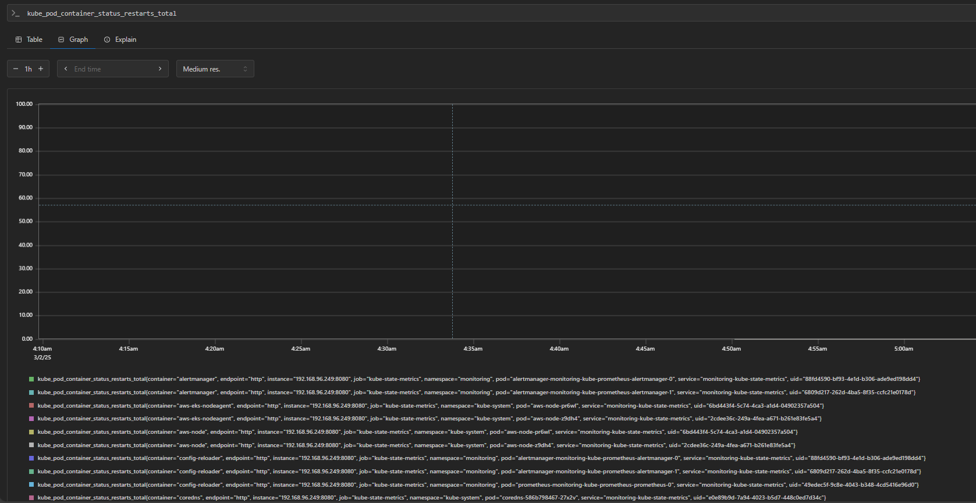
Now, let’s create a POD in default NS. Which it should show the data that how many times the POD get restarted. Please fine the below SS currently we don’t have any PODs running on default NS.
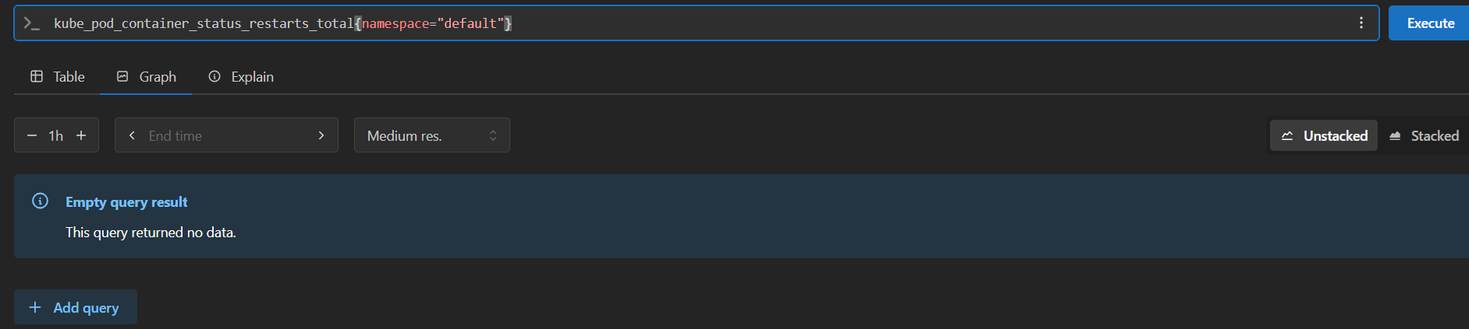
Now we are going to install a command which it will always get crash.
‘kubectl run busybox-crash –image=busybox -- /bin/sh -c “exit 1” ’.
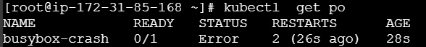
Now our pod is crash loop back off so it will restart continuously.
Now, let’s go and see in Prometheus dashboard for last 15 mins how many restarts were happened for that particular POD.Query we ran ‘kube_pod_container_status_restarts_total{namespace="default"}’
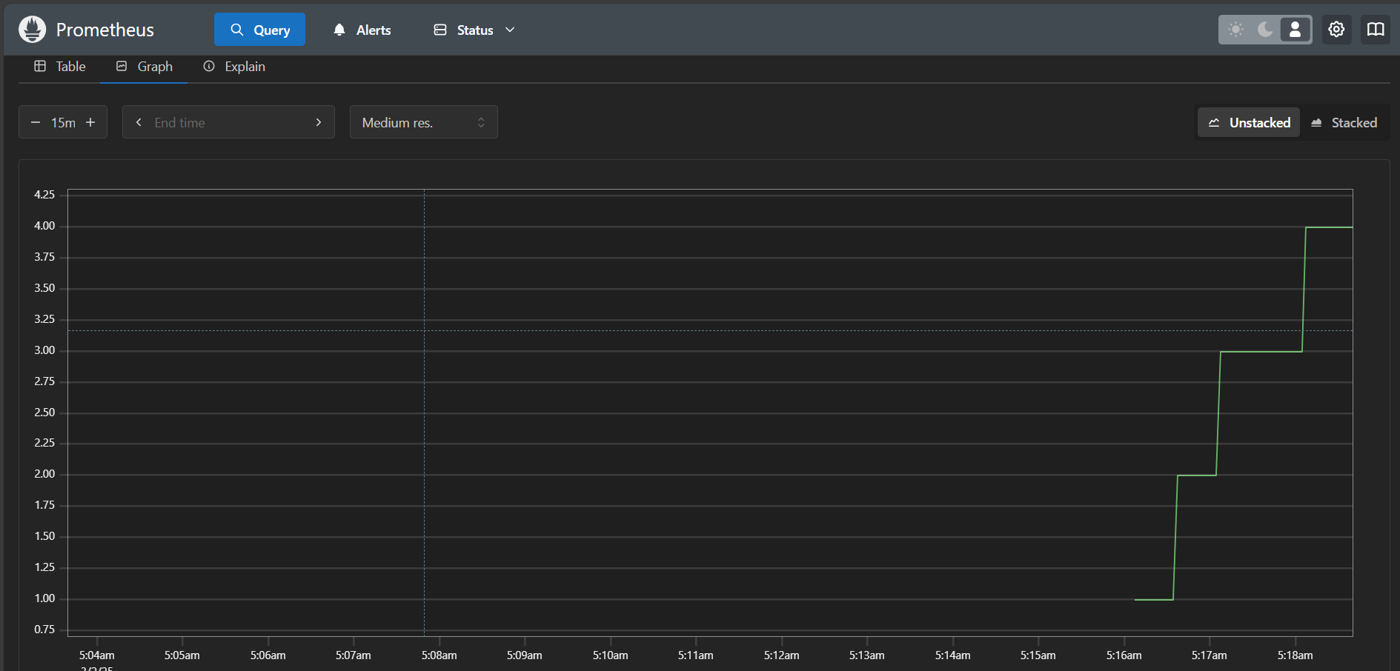
From above SS we can conclude that our POD got restarted 4 times.
Explanation of above received metrics: When create a POD the kube API server will receive the info. By that time the kube-state-metrics exporter always looking for the metrics from kube api server will receive the info from kube api server that you have created a POD or any event. Now the exporter will store the info in /metrics endpoint with Prometheus understandable format. Now, Prometheus will always look at the kube-state-metrics exporter ate the /metrics endpoint and it will parse the data. When we run a PromQL query we will get the info. Like this prometheues will collect the metrics from the exporter.
Let’s see another metric for init container restarts:
While typing itself on the search bar in Prometheus you can see the suggested metrics.
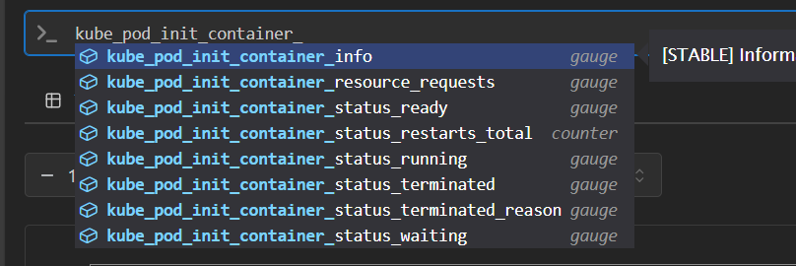
The metric ‘kube_pod_init_container_status_restarts_total’ doesn’t have any metrics it was shown nothing.
Note:-
How we will know that particular metrics are important to my project? The answer is we need to search and find it there is no other option. We can remember important metrics like restarts of POD like above scenarios. Not only for PODs you can see any service in K8s. Please find below SS for more.
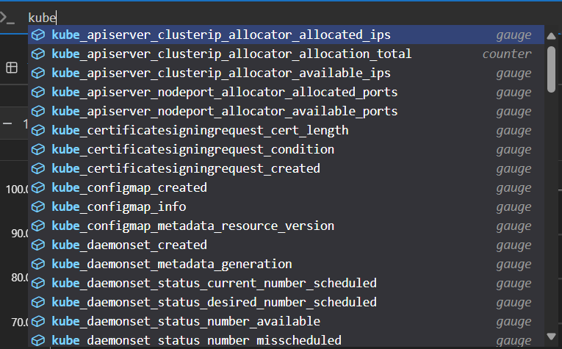
It’s not required to remember all but for interview purpose we can remember crash loop, configmap, secrets, daemonset, http request, user created and few other metrics.
If Prometheus is showing visualization monitoring and alerts then what is the purpose of Grafana.The Grafana has advanced better dashboard, with Grafana we can do authorization. We can add IAM or SSO that particular people can see only particular type of alerts in dashboard. Same way they can create dashboards also with that permissions.
Go to admin -> authentication.
Let’s explore Grafana:-
By default Grafana will be having the dashboard on right side under dashboard section you can see those things.
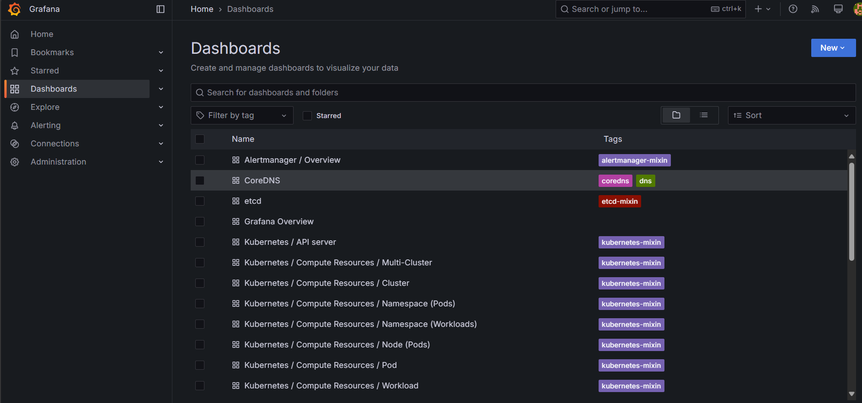
Now let’s select the Kubernetes/Compute Resources/ Namespace (Pods).
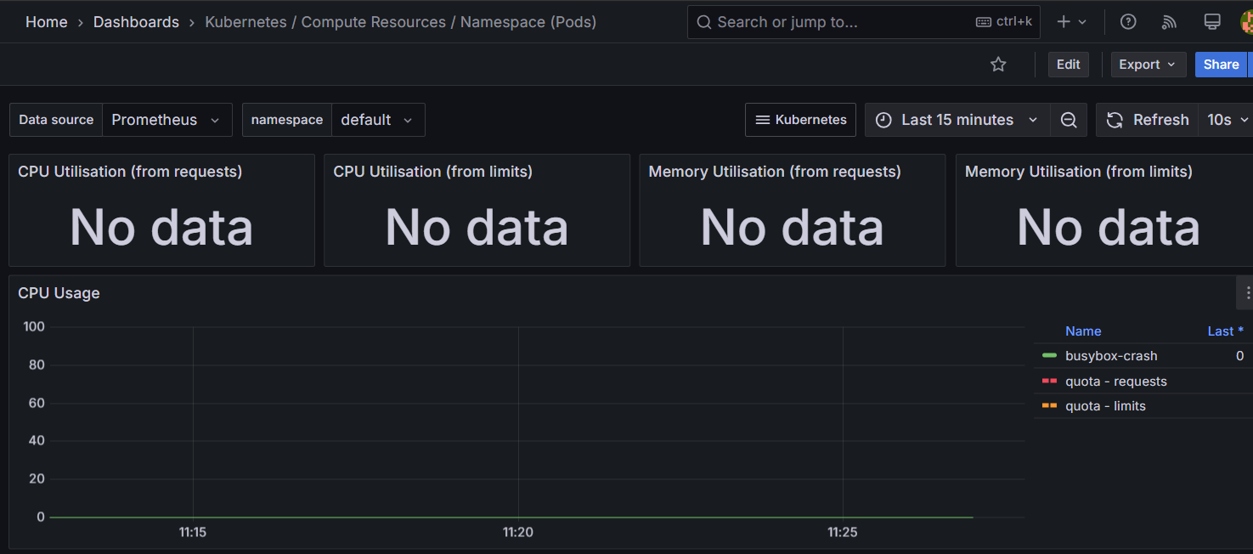
You can see a flat Green line of our busy-box pod. It was not using any CPU so that’s why it was not showing any CPU utilization.
Now, if you compare between Grafana and Prometheus if you want get the same cpu utilization data on Prometheus you would need to write the query where as in Grafana you can select with the options.
Now, let’s select kube-system as Ns and POD as metrics-server. You can see CPU utilization of the POD and memory utilization also you can see if you scroll down. You can see past history like last 15 mins, 1hr, 1 day , 1 week etc.,
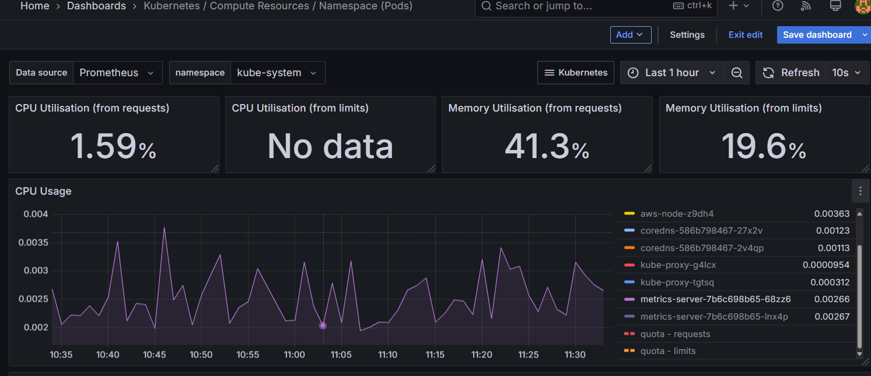
Now, how to create a customized dashboard let’s assume the POD restarts metrics.
On left side > Dashboards > click on ‘New’> select ‘New dashboard’ > Add visualization > select data source as ‘Prometheus’. Enter your query, select the service type like NS and then the default. PFB SS.
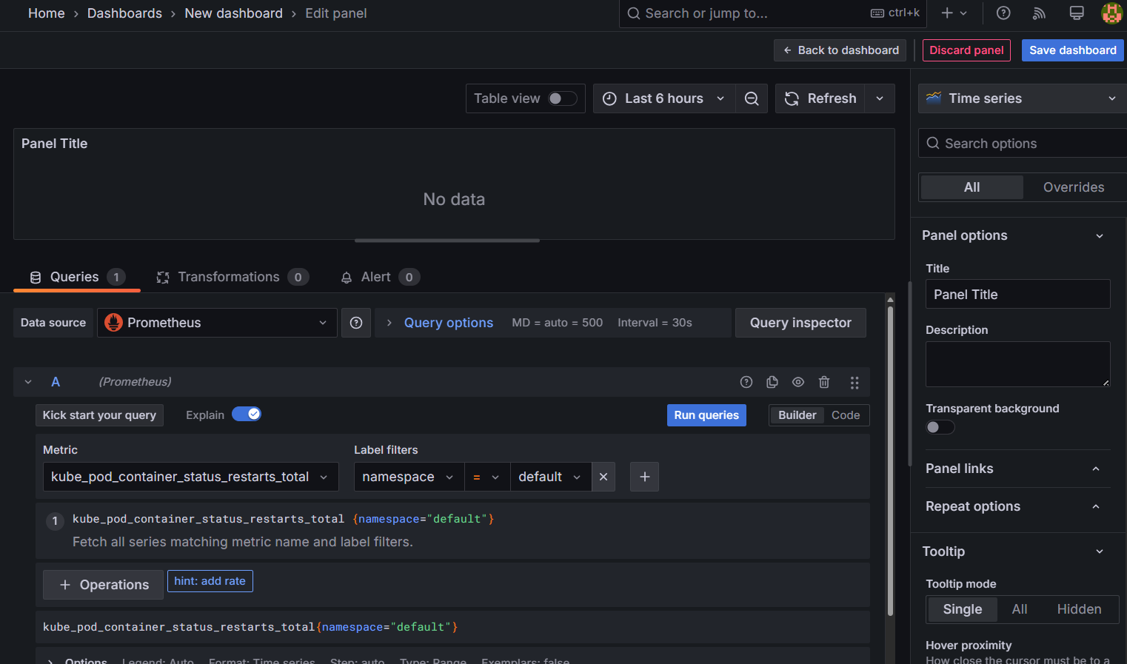
After entering the details click on Run queries. It will show the data on your screen like below and then enter the name off the dashboard and click on save dashboard.
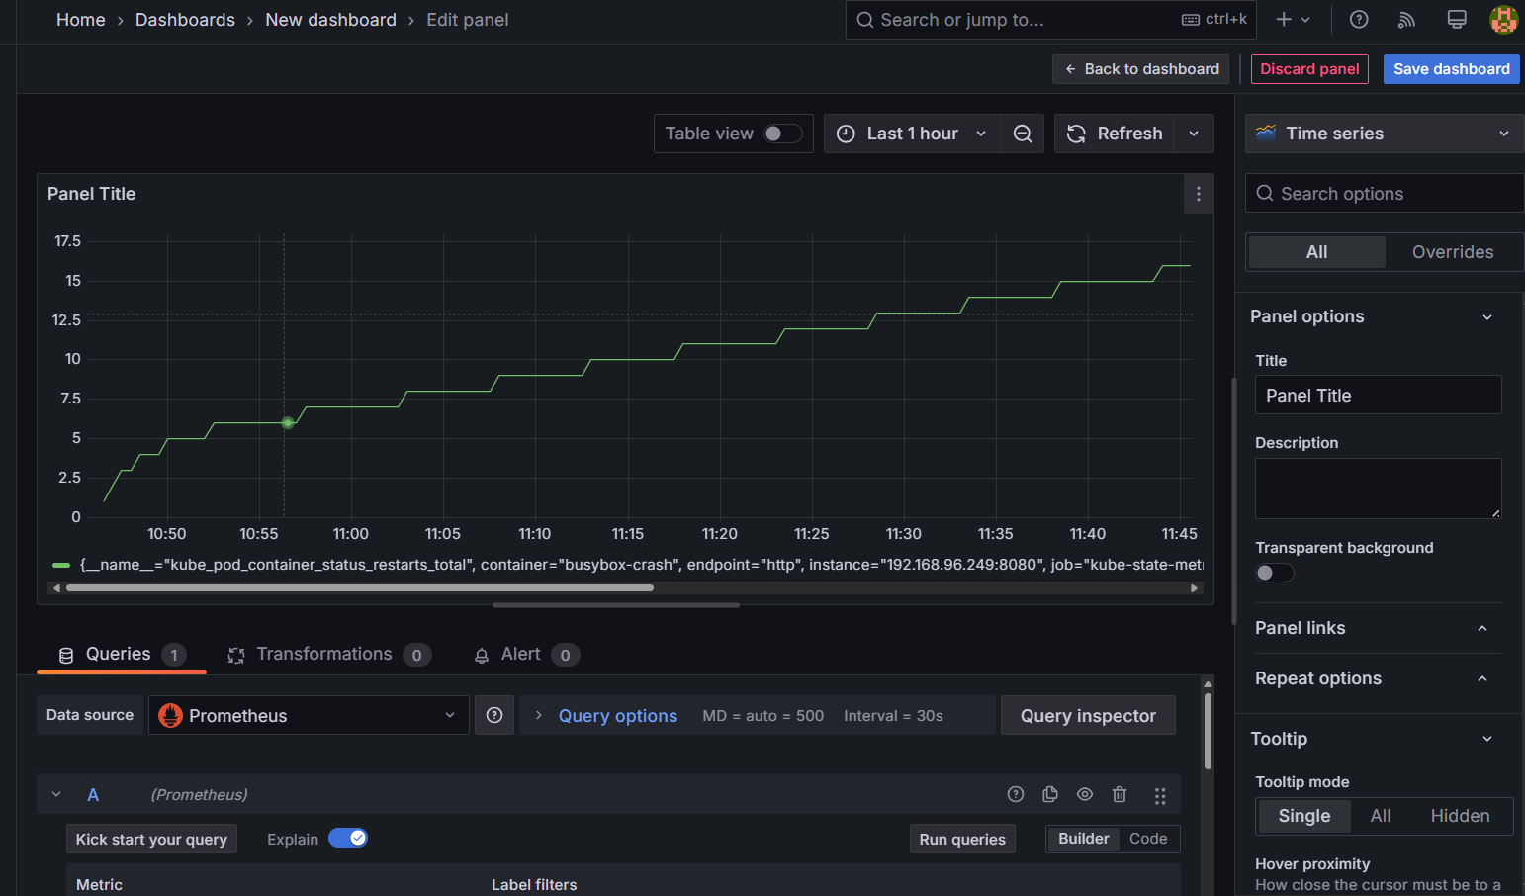
Now, go to Dashboards search with the dashboard name which you have created.
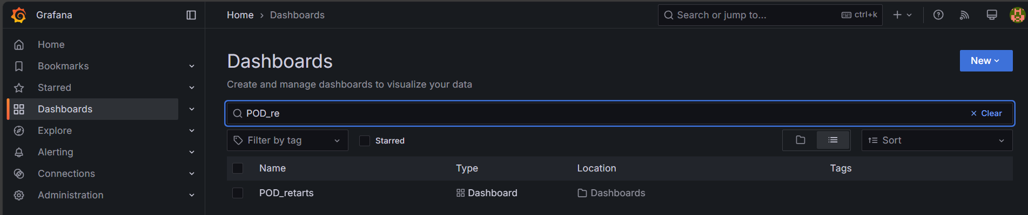
Select the dashboard and start monitoring.
Let’s assume if you want more like nagios, graphite or influxdb. You need to click on Connection on left side > Data sources > Add new data source
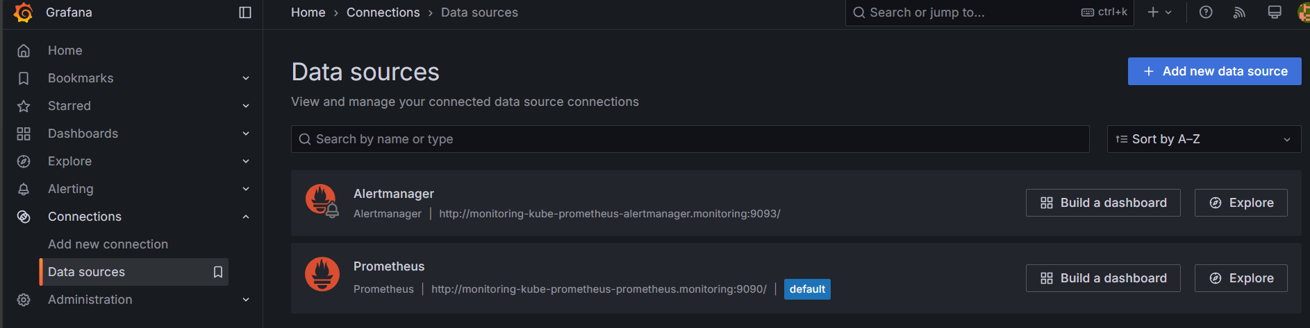
By default we have Alertmanager and Prometheus because they are running on the same cluster.
Let’s select a new data source as influxdb and add requested details.
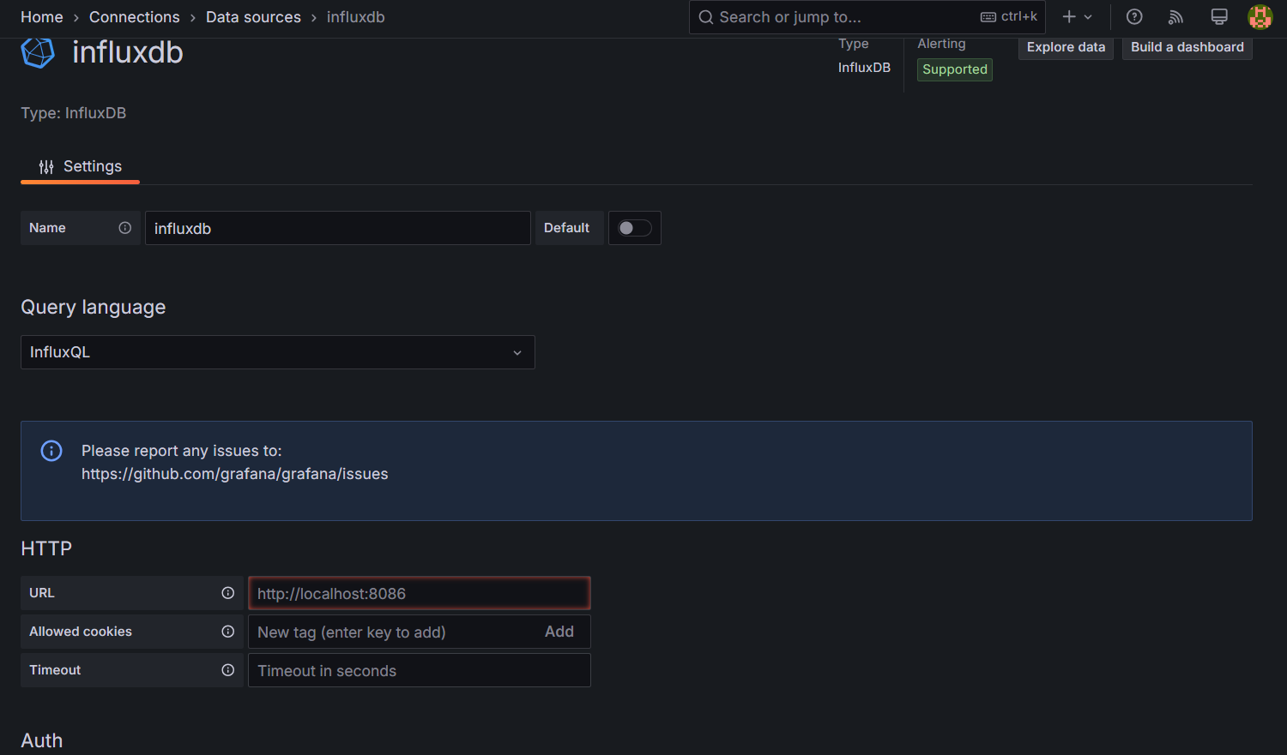
For Prometheus it got auto detected.
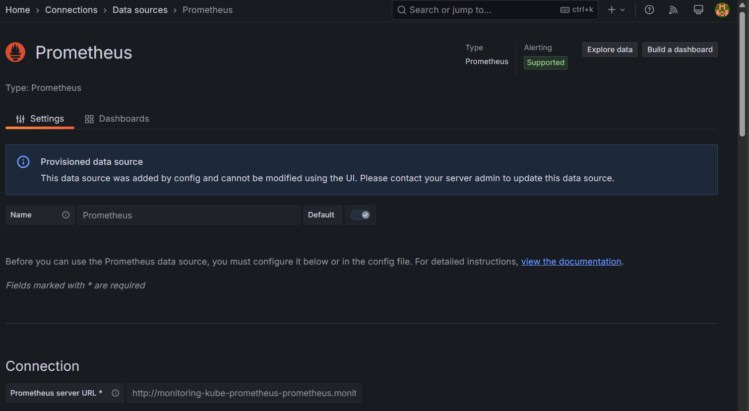
Day 4: Instrument and Custom Metrics:-
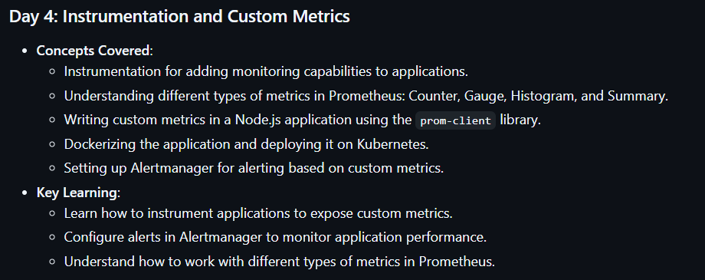
What is instrumentation?
The developer need to define the instrumentation in their application like metrics, logging, traces. If they don’t define in the application then we can’t do anything.
Why metric types are required. Eg. If you want to define data in python we use data types like string, list & dictionary like that we need to define the metrics in different types.
Type of metrics
- Guage
- Counters
- Summary
- Histogram
While developer writing the metrics they need to mention the type.
Counter metric:- The metrics which it always be in increasing Eg: login. If you want to see last 30 days how many members got logged in. For this we use counter metric type.
Gauge metric: The metrics which it will be in decreasing and increasing Eg: CPU.
Histogram metric: If you need bucket of information we use this Eg: What Is the latency of htttp or How many times does the cpu went less than 50 in day. Developer will define the for each latency to which bucket the info should store Eg: for 5ms one bucket for 10ms another bucket like that.
Summary metrics:- Will see later.
Now, go to Day-4 repo in github and go to index.js file there we have defined all the metrics, metric types along with the APIs.
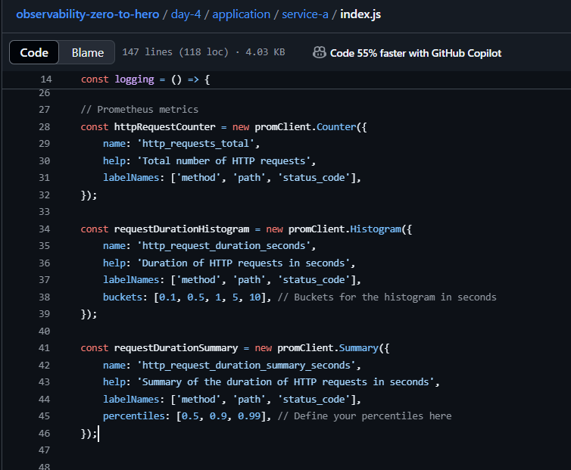
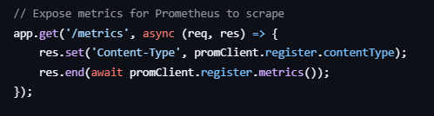
Go through the script it was really informative observability-zero-to-hero/day-4/application/service-a/index.js at main · iam-veeramalla/observability-zero-to-hero .
Now, go to day-4 folder, go through the Kubernetes manifest folder which contains all the scripts including kustomization script.
Now go to cluster create a NS with dev. After creating that run apply command in Kubernetes manifest folder.
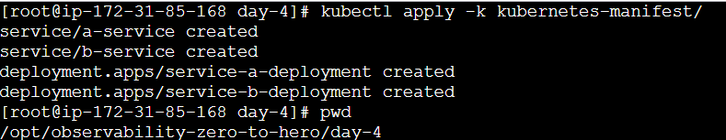
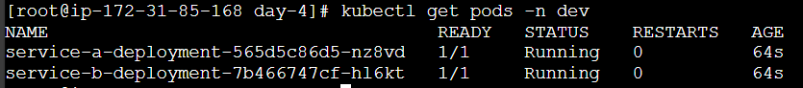
Exposing the service using loadbalancer service in K8s.
Now, collect the LB DNS and run it on browser.
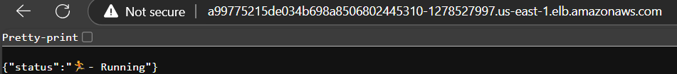
Now, you can run multiple API’s which we have defined in index.js. Eg /logs
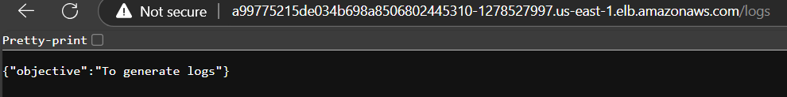
Now, go to Prometheus that our custom metrics are reading directly or not?
Eg: we have instrumented the new metric in index.js as http_requests_total.
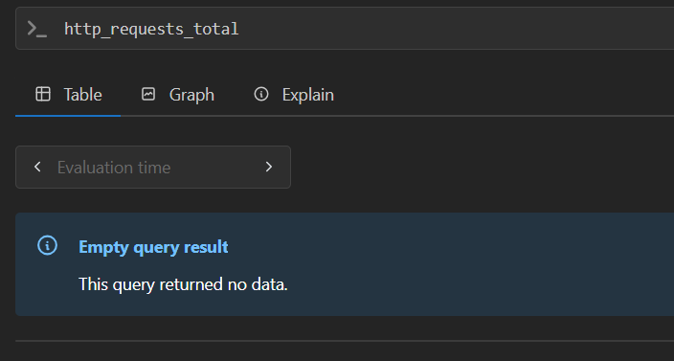
It returned empty, because we haven’t defined the service discovery. Without that how Prometheus will know which metrics need to scrape.
But, if you run <LB-DNS>/metric it will show the customized metric details but in Prometheus we can’t see it. So, we need service discovery you can do through yaml.
Go to day-4 folder run apply command in ‘alerts-alertmanager-servicemonitor-manifest/’ folder.
We have got an error for alert manager we will see it later. Now, go and search the same query ‘http_requests_total’ you can see the data.
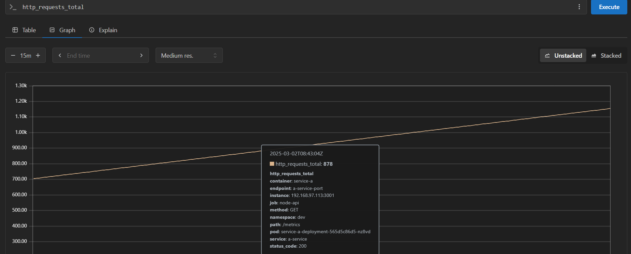
We have used below script.
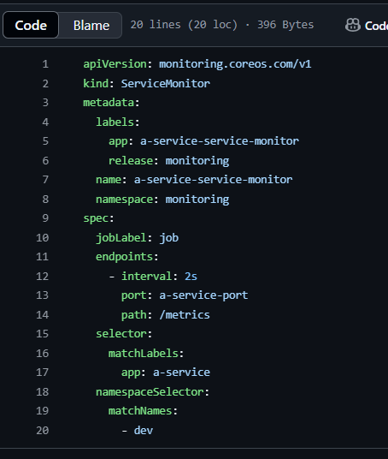
Below you can see the deployment script of app-1.
Task:- tutor has shown only for app-1 in Prometheus. Now you need to show the metrics for app-2 or any other service.
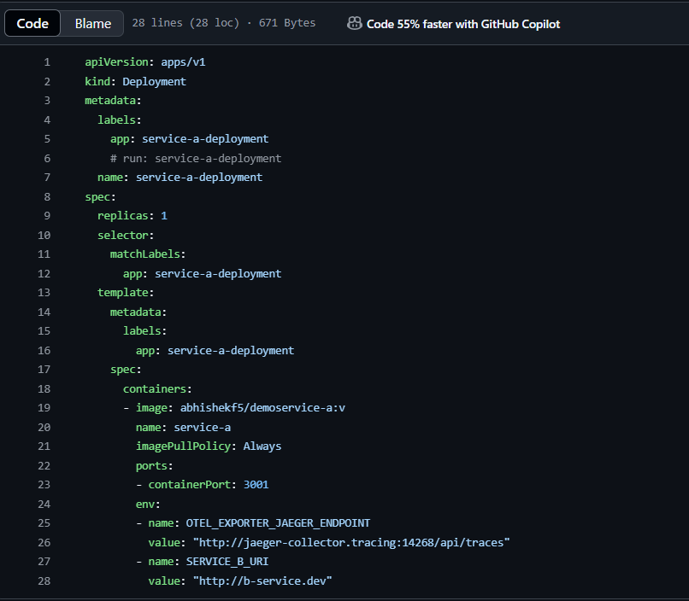
Alerts:-
In alerts manger yaml file we need to define what type of alerts need to trigger.
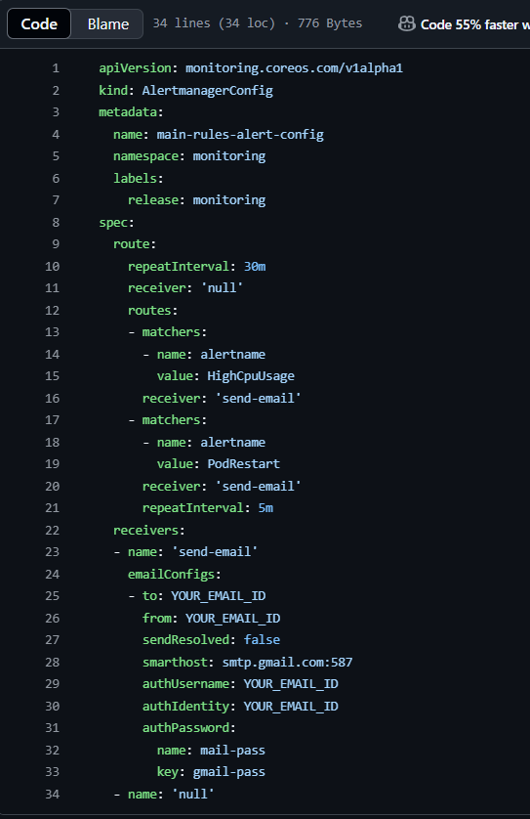
We will modify above script by adding our details and then we will stop the POD and then we will see the alerts are receiving to our mail are not.
Now, first we will go to gmail > manage you gmail account > search for ‘app passwords’ > enter the any name as app name > it will give you the token.
Collect the token and convert it to base64.
Now, go to ‘email-secrets.yml’ file and update the token.
Now, go to alertmanagerconfig.yaml file add below details
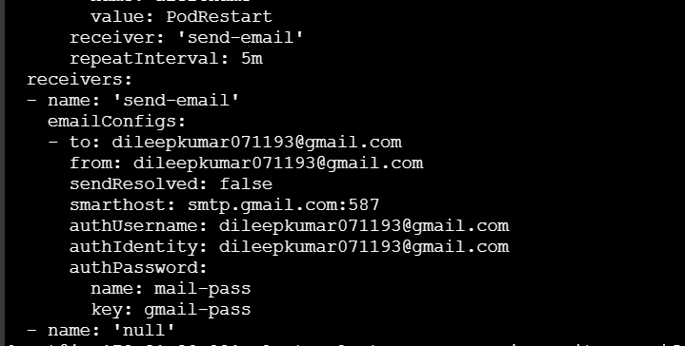
After adding run kubectl apply. Now crash the pod by adding ‘<LB URL>/crash’ at end in LB url. The pod will go to restart mode now you can check the gmail you will receive the mail alert.
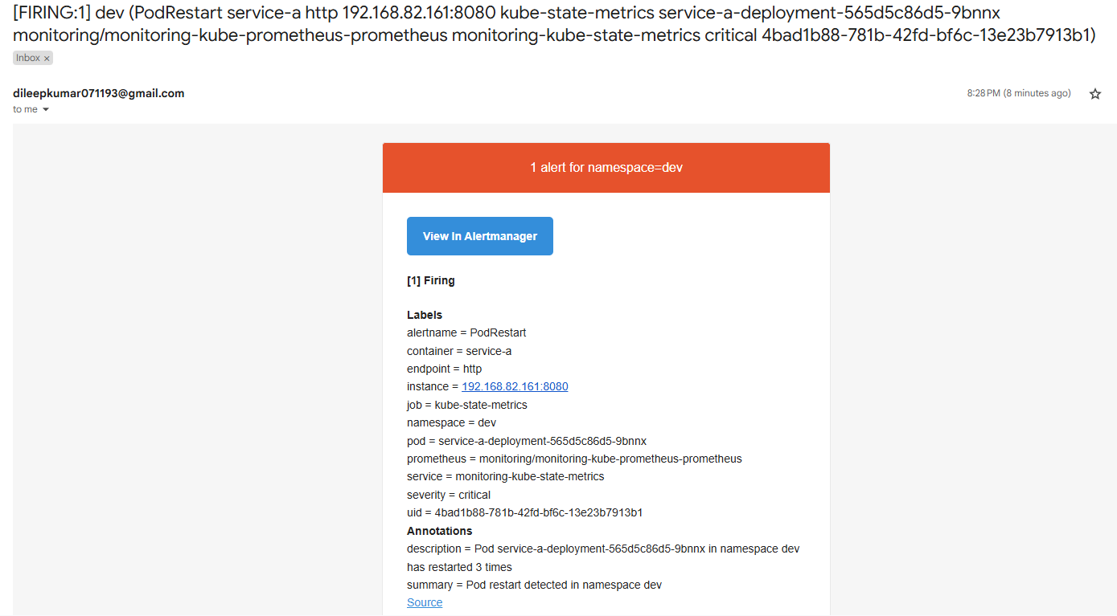
Day-5-logging:-
Prometheus & Grafana: The Prometheus will get the logs via exporter and it will get stored in TSDB and it will displayed in Grafana
Node & POD -> exporter->TSDB -> Grafana
EFK: In EFK, the fluentbit will be running as daemonset on each node it will fetch the data from PODs and nodes and it will be stored in Elasticsearch acts as DB. That data will be displayed in Kibana. Kibana is like Grafana
Node & POD -> Fluentbit -> Elasticsearch -> Kibana
Note: We can attach the elasticsearch to EBS where it can take backup of logs timely.
EFK vs ELK:- fleuntbit vs logstash. Logstash has very rich features. Fluentbit is a just log forwarder where as logstash is log aggregator with this you can filter the logs, adding labels to logs. For most of the organizations fluentbit is more than enough if they take the backup of the logs properly. Fluentbit is very lite weight, issues facing also very less when compare with logstash.
EFK Handson :-
We need to create an IAM role for the service account. Why it’s needed?
Because we have fluentbit which it will forwards the logs to elasticsearch. We will create elasticsearch as statefulset and we will mount the EBS. Here, our elasticsearch is inside the EKS whereas EBS is outside the cluster. To communicate the EKS cluster with EBS volume we are going to attach a IAM role to the elasticsearch’s service account then EKS will communicate with EBS. This cannot be done directly we are going to use CSI driver for EBS. This CSI driver will create the EBS volume, PV & PVC.
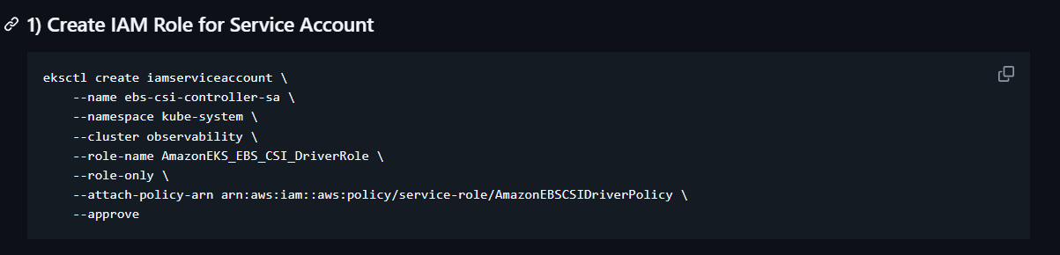
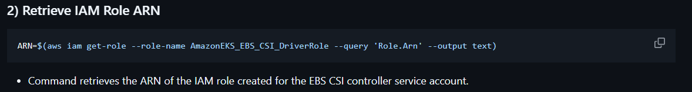
Why we need CSI driver?
When you use PVC and the storage type is EBS volume. You need a driver that can create an EBS volume for you.
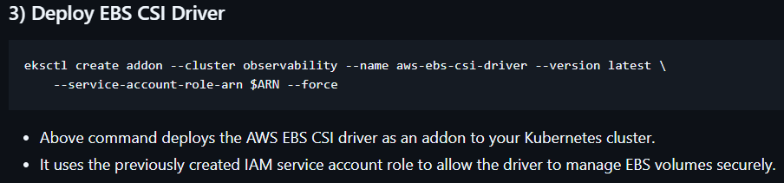
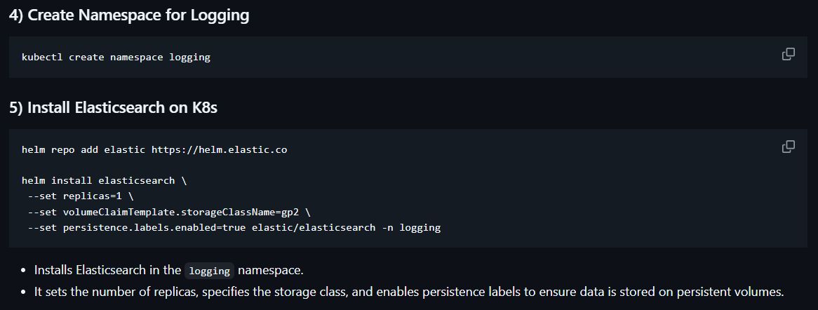
From above helm command you can see that I have added the volume claim type as gp2.
Now, we are going retrieve the elasticsearch username and password. Because when the fluentbit wants to communicate with elasticsearch it requires authentication.
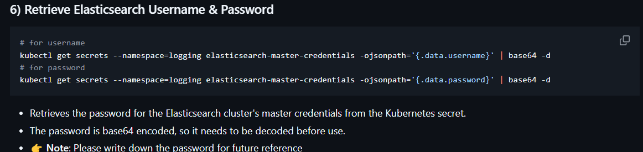
The username is ‘elastic’ and password is ‘YLBxoyTEcsZzfQyk’.
Install Kibana:-
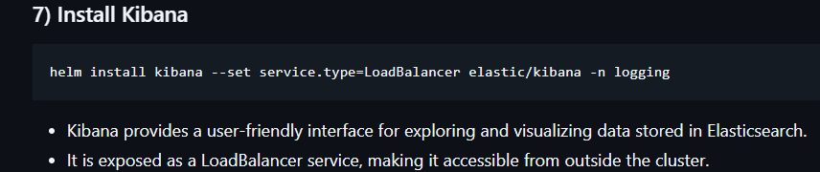
Install Fluentbit:-
Before installing you need to add elasticsearch credentials in ‘fluentbit-values.yml’ file in day-5 folder under ‘output’ session.
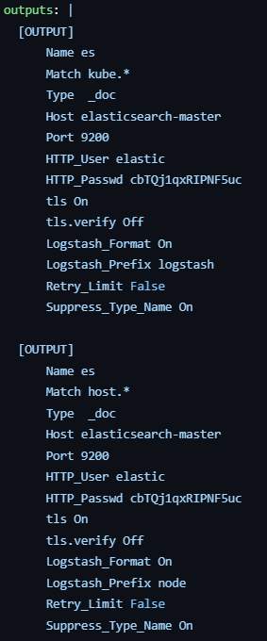
Under ouput session we need to add elasticsearch username and password at HTTP_User and HTTP_Passwd at 2 places and then save and exit. Now, install the fluentbit. 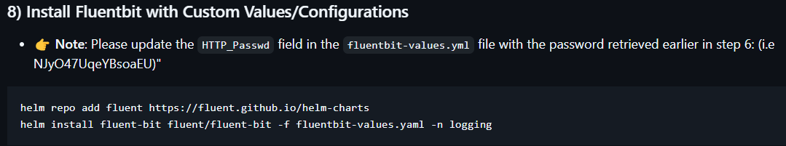
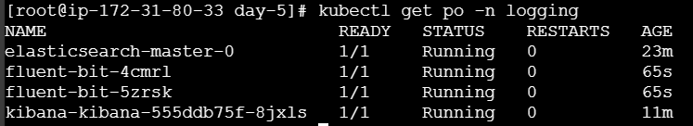
Since we have 2 slave nodes we are having 2 PODs for fluentbit because it will be running as daemonSet.
Collect the loadbalancer DNS go to browser and search ‘a0fff5290e19f4117bd2ba56417e1e40-1828578975.us-east-1.elb.amazonaws.com:5601’ and enter elastic user and password which we got earlier. You will see this. 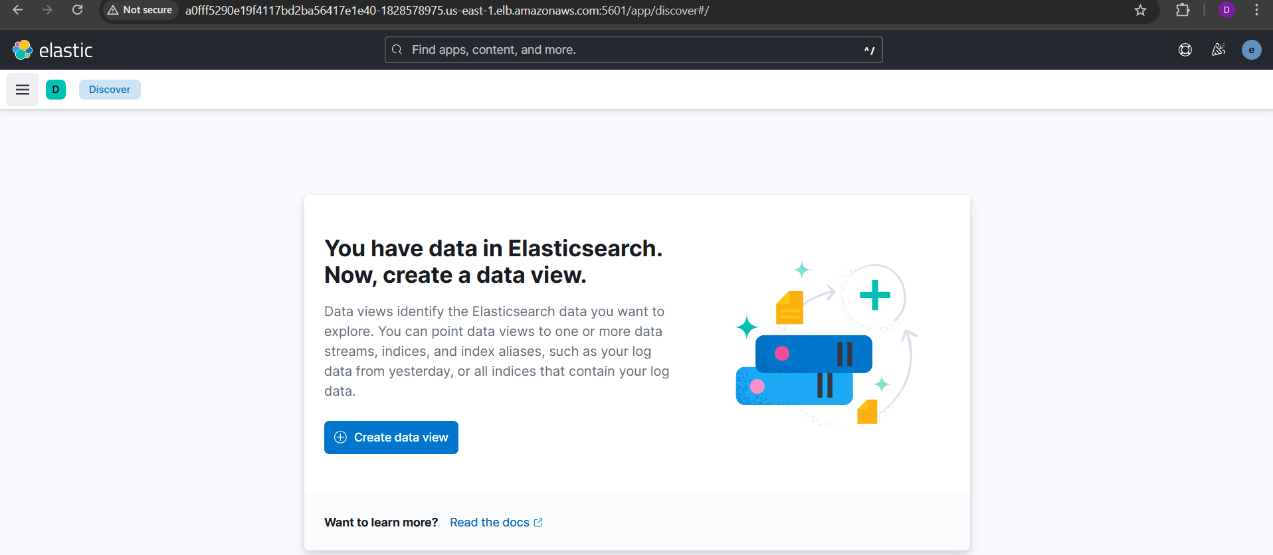
As of now you don’t have any application that it will be running to get the data.
Now, let’s go to day-4 and run the applications which we had run in earlier session.
After running those 2 apps we need to go to fluentbit POD. any one POD will be getting the registered in of 2 apps. You can see below logs.
Now, go to elastic click on data view you can see below window. By default you can see 2 index patterns.
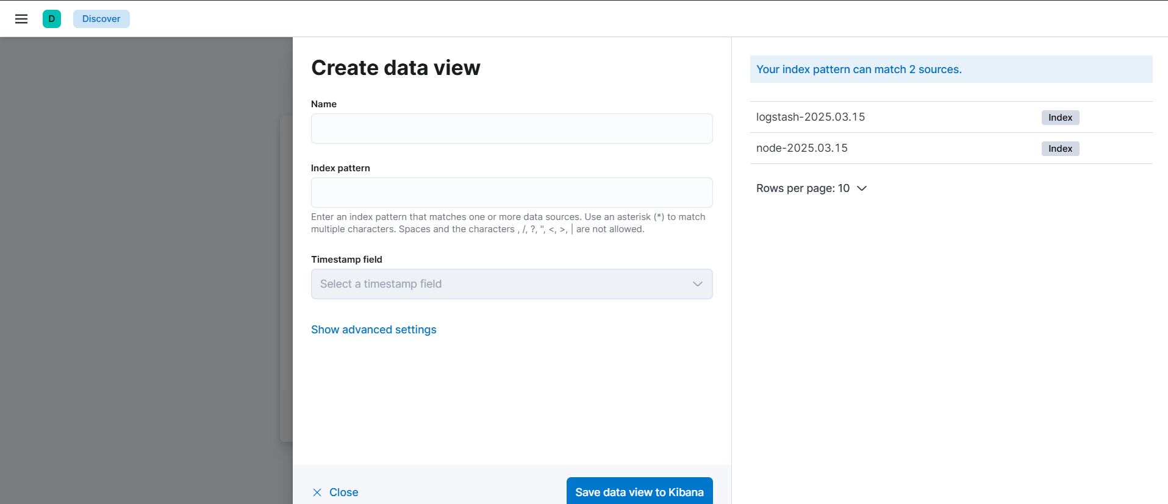
Copy ‘logstash-2025.03.15’ add it in index pattern.
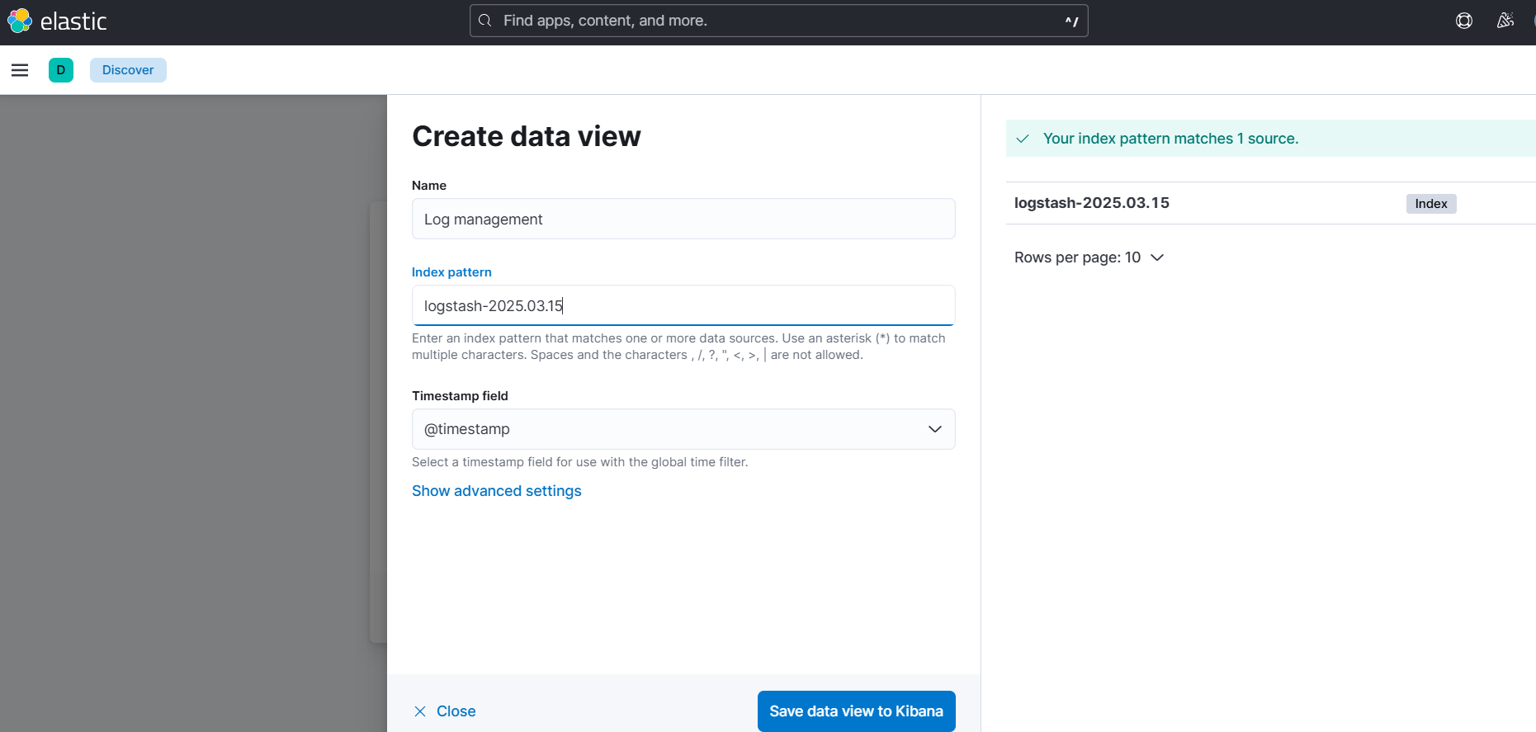
Click on ‘Save data view to Kibana’.Now, you can see the logs with statistics.
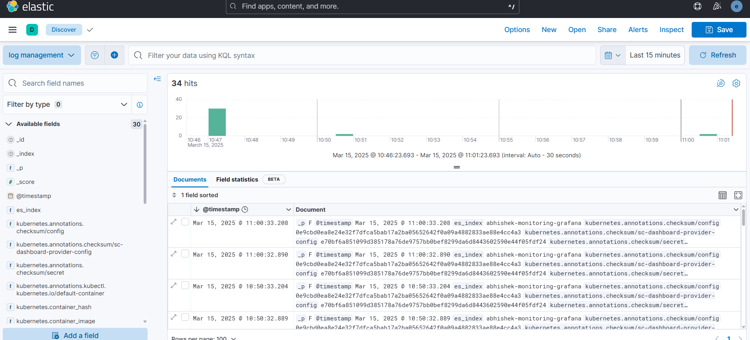
So, Kibana is getting it from elasticsearch, the elasticsearch is getting it from fluentbit.
Note:- Like PromQL we have KQL that is Kibana query language. If you want to fetch any specific value like specific node or namespace you can run KQL in search bar.
Fluentbit is a vendor neutral if you want to move to splunk in future it will work whereas logstash it won’t.
*** Go through the ‘fluentbit-values.yml’ file and try to understand it. There are 4 primary things in flunetbit configuration:
- Service
- Input
- Output
- Filter
Service:- It’s general a service in K8s like if you want export in nodeport, clusterip or loadbalancer mode etc
Input:- It’s where the input is coming from in our case the logs are coming from container.
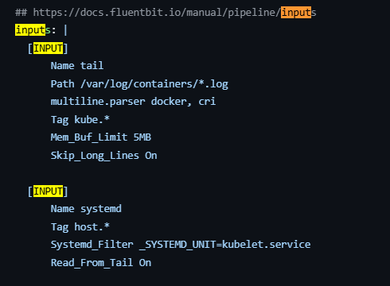
Logs are getting from /var/log/containers/*.log path from all the containers.
Filters:- It’s used to filter out particular namespace. If you see in Kibana you can’t see the logs from logging namespace we have omitted it. You can see it in Lua script in the same file. 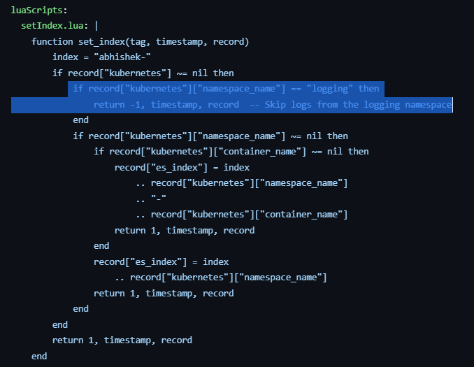
Like that ignore any K8s components.
Output:- Here we will define the where the fluentbit should forward the logs.
If you are using EKS the ‘tls’ should be in on otherwise the connection will not establish.
To know more go through the Fluentbit doc Lua | Fluent Bit: Official Manual.

Day-6 : Distributed tracing with Jaegar
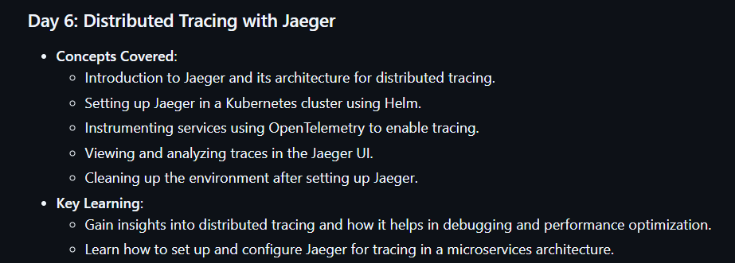
Tracing:-
It will show want went wrong.
Eg:- If you have an ecommerce service a user will login to login service he will select something via service A and service B and then he will checkout to payments service.
Login service -> service A -> service B -> payments service.
Now, usually when we selecting the products the redirection of service A to service B it will take 1 sec but this time it took 4 sec. We need to find why that extra 3 sec delay had happened it will impact the business. For that we need tracing.
If you have implemented the tracing then only you can find out why it got delayed.
Tracing is mainly understanding the root it will analyse the each hop of the request.
The Developers need to instrument the tracing like how they have instrumented for metrics & logs eg: using open telemetry.
Now, DevOps/SRE engineer need to implement the tracing eg: using Jaeger.
How Jaeger works?
Mainly it involves 4 components
- Agent: Collects the traces from you app (If we instrument in Aplication).
- Collector: Receives the traces from the agent and processes them.
- DB: Here it gets stored the collected data Eg: we can used elasticsearch
- UI: If you run the query it will communicate with collector the collector will provide the information about the traces through DB.
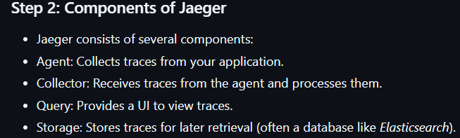
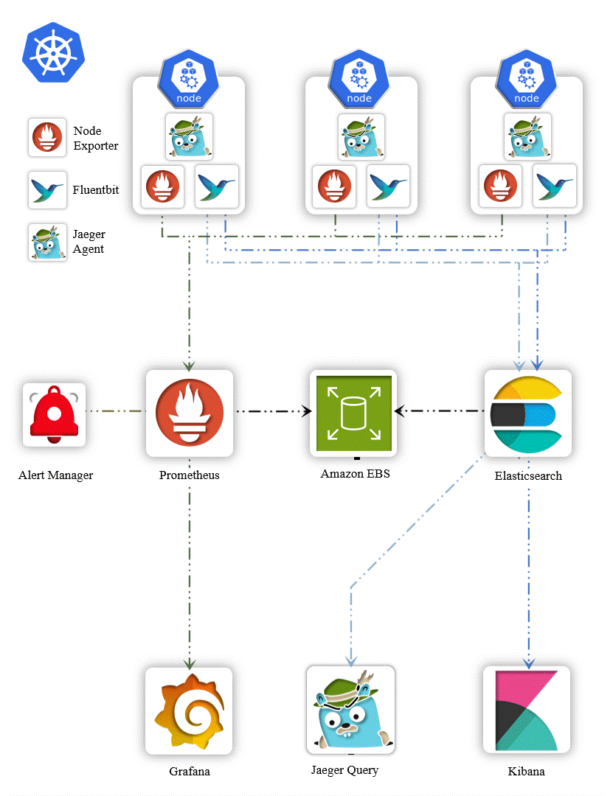
If you see above image
- Metrics will gets collected by exporter (prometheus)
- Logs get collected by fluentbit.
- Traces get collected by Jaeger.
Now, to see those
- For metrics we have Grafana
- For logs we have Kibana
- For traces we have Jaeger.
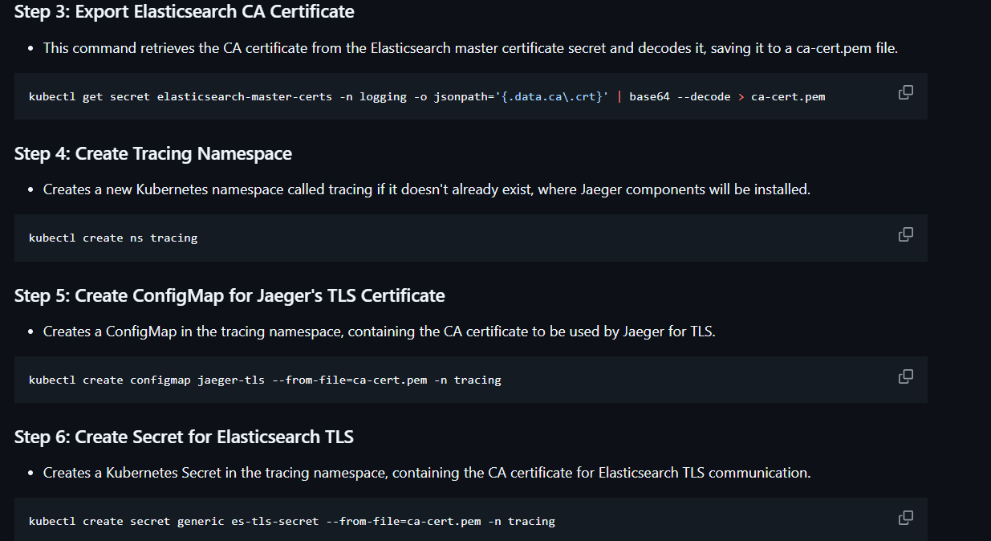
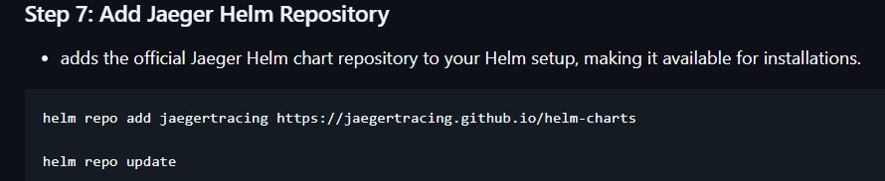
Now, go to day-6 folder and open jaeger-values.yaml file and update the user and secret of elastic serach 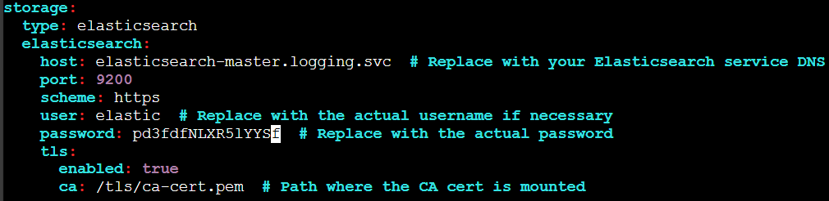
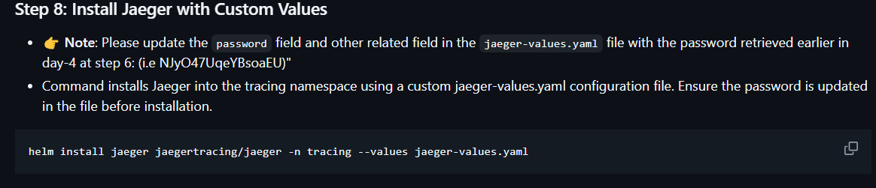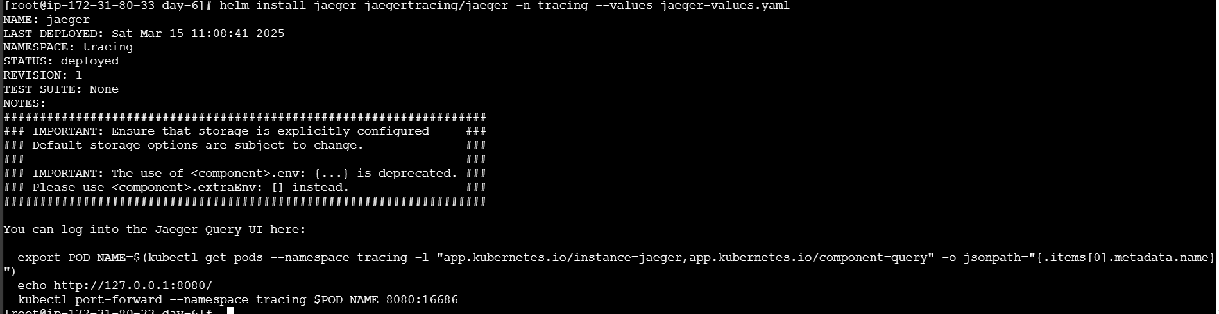
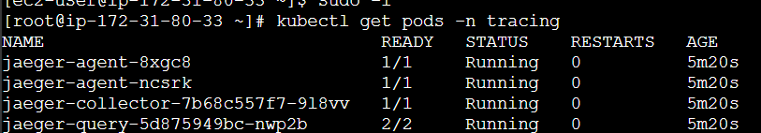
kubectl port-forward svc/jaeger-query 8080:80 -n tracing –address 0.0.0.0
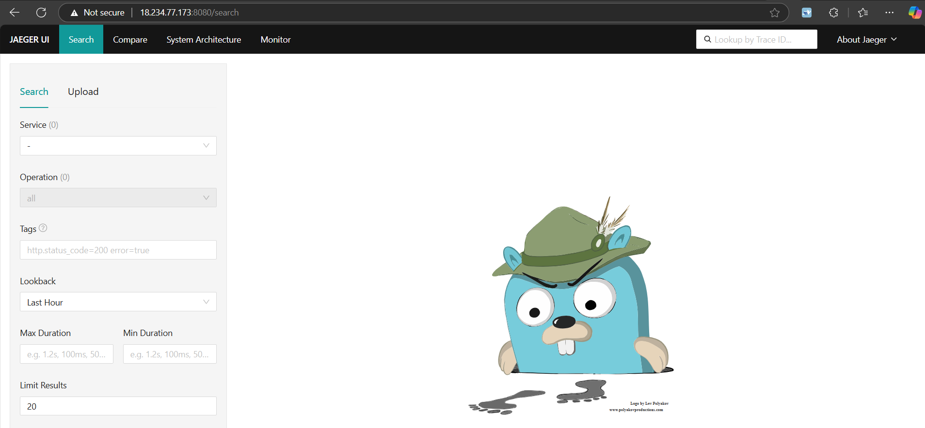
Since our appA and AppB already running we will just run this in browser a7a9c06e0383249769a32155aa8106fd-650122566.us-east-1.elb.amazonaws.com/healthy
Now, if you refresh the Jaeger
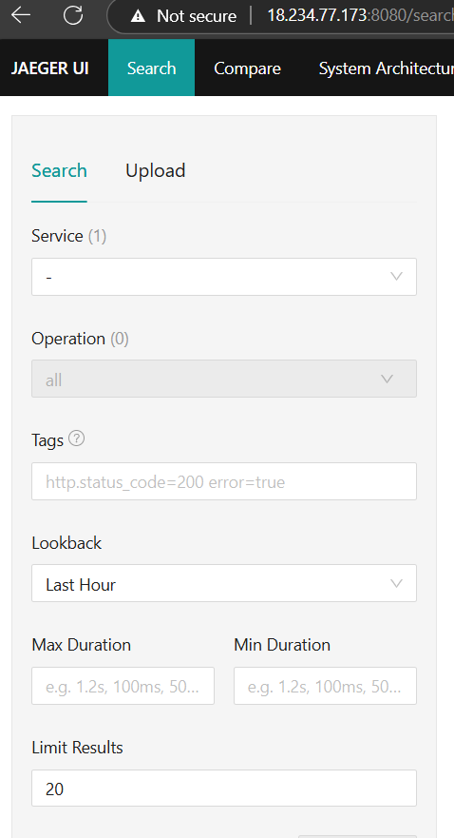
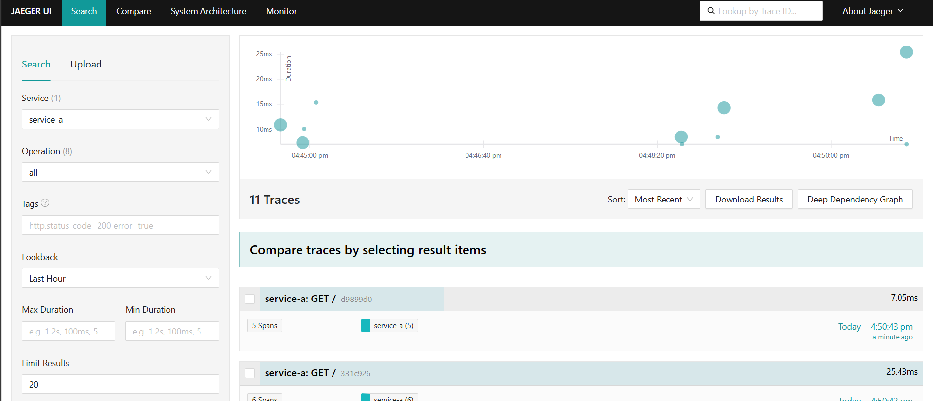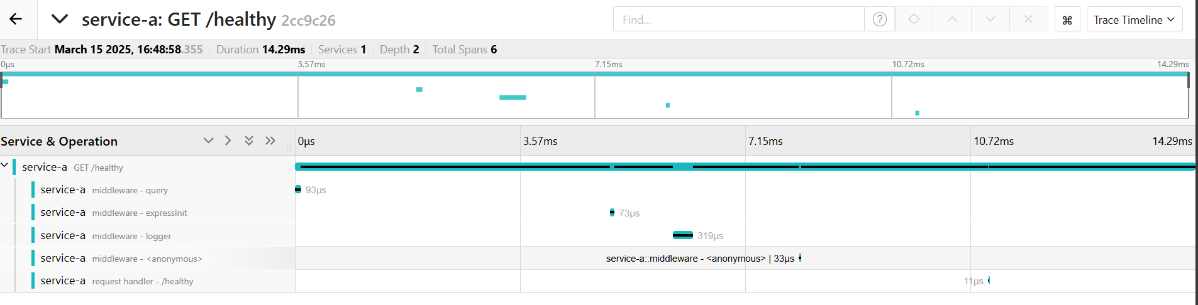
You can see spans. Span is like the stages or we can consider apps from one app to another app how many seconds it took.
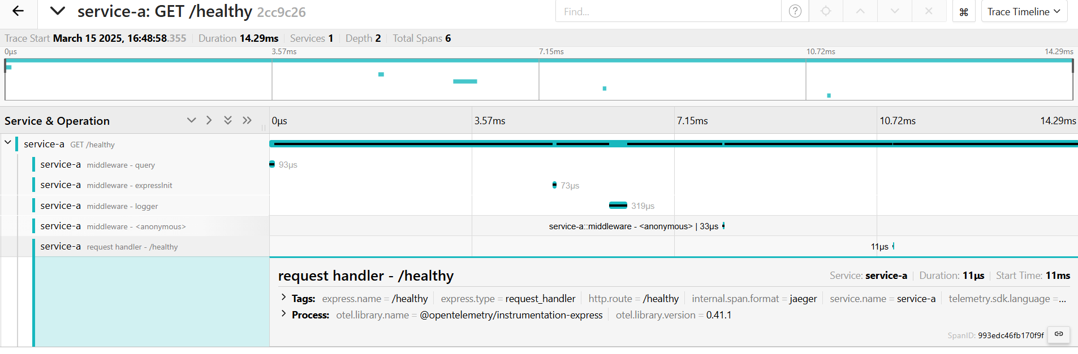
a7a9c06e0383249769a32155aa8106fd-650122566.us-east-1.elb.amazonaws.com/call-service-b
This should call service b same can be viewed in Jaeger as ‘service(2)’. Some how it’s not showing.
Day-7: Observability project ecommerce app:-
Opentelemetry demo application was developed by multiple organizations using multiple code languages like c++,java, python etc,. It has all the services which are running as microservices. 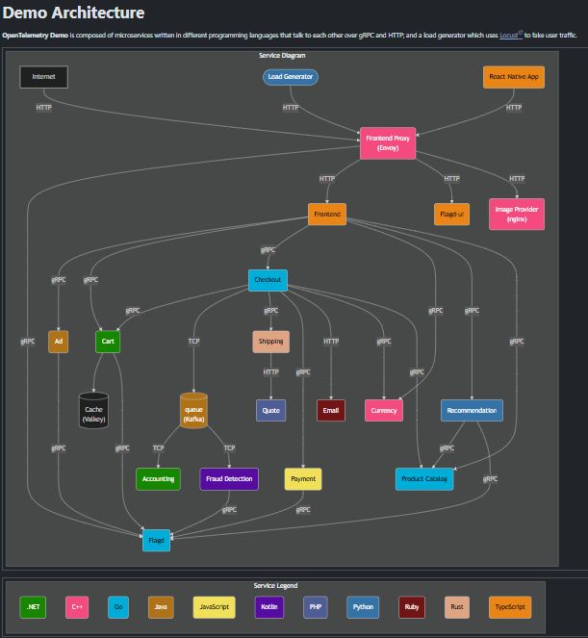
Now if you want view the code of the particular language eg:- python is running with blue color the service name is Recommendation . For that you can see the code in opentelemetry github repo opentelemetry-demo/src/recommendation/recommendation_server.py at main · open-telemetry/opentelemetry-demo.
To deploy this service via K8s follow below steps Kubernetes deployment | OpenTelemetry. Other than K8s there are few other ways to deploy. Read the doc.
Note:- This is the best application on observability which you want to learn as opensource.

Flow of Opentelemetry:-
The developers develop a service which it will be running as microservice->Developer will use the open telemetry API and SDK for omitting the metrics,logs & traces -> These metrics,logs & traces will be received by a receiver component called OTel receiver -> OTel processor will process all the telemetry information -> OTel exporter which it can export the metrics,logs & traces to any backend that you need. This defined it in export config file in OTel. Here the backend will be anything like jaeger,Prometheus etc,.
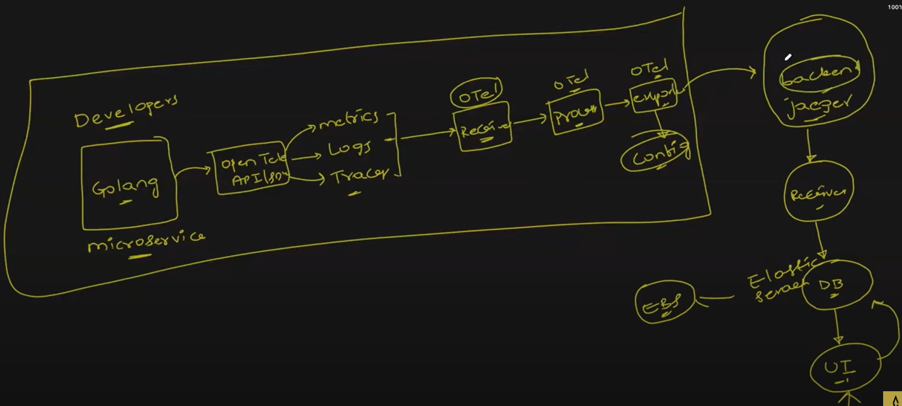
Installation of OTel-demo app:-
Follow the steps mentioned in the doc Kubernetes deployment | OpenTelemetry. I have used helm charts to install. 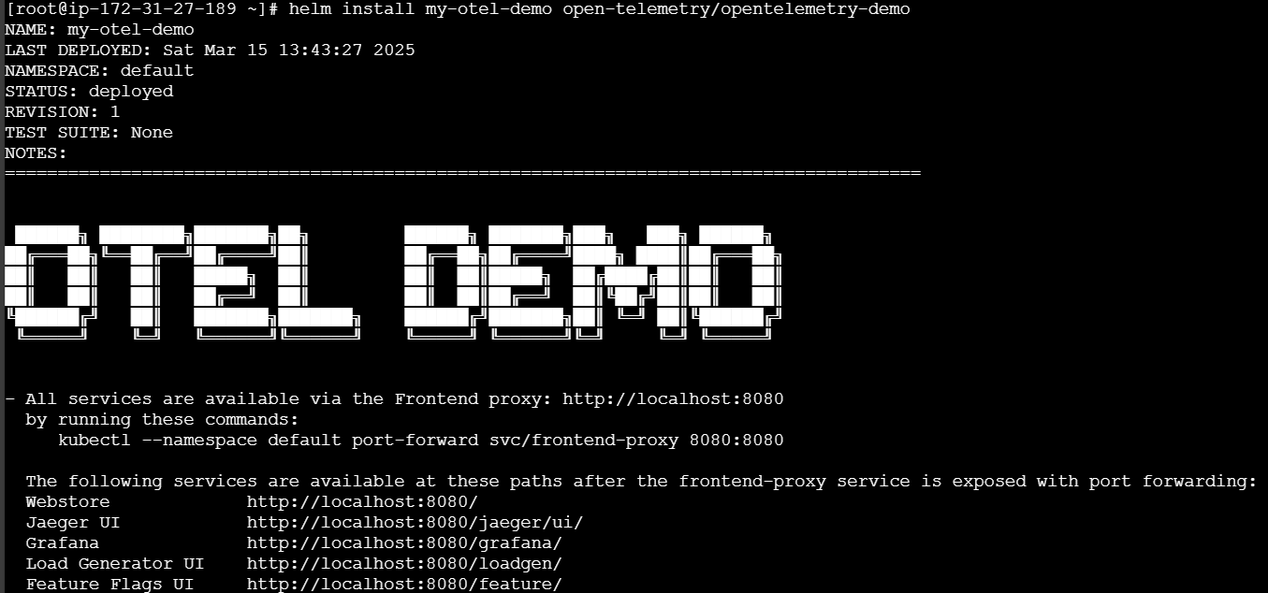
Note:- If your node has less resources the Pod will be in pending status. If required, increase the nodes/resources.
Now do the port forwarding.
You can see the app running
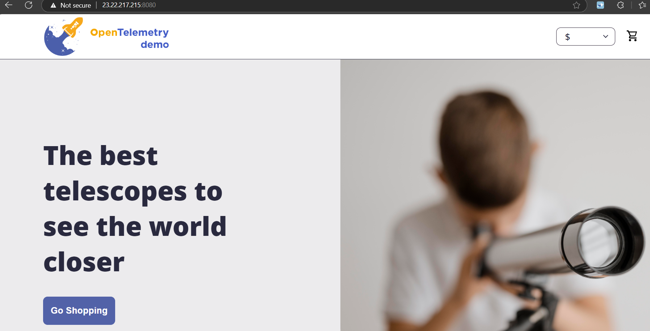
It’s almost like a real application you can select the product and add to cart also.
This app will show the fake load on jaeger, grafana and prometheus. To access it use /grafana,/jaeger, /prometheus. Go and explore the spans in jaeger.
Note:- Go through the code of the service you like and observe how they have instrumented the metrics, logs & traces. Explore the documentation also.

