**VIRUS DISEASE DATABASE**

Submitted in partial fulfillment of the

requirements for the degree of

**Bachelor of Technology**

**In**

**Computer Science Specialization In Bioinformatics**

***by***

**DILEEP KUMAR**

**( 12BIF0044 )**



**DEPARTMENT OF BIOTECHNOLOGY**

**SCHOOL OF BIO SCIENCES AND TECHNOLOGY**

May 2016

**DECLARATION**

I hereby declare that the thesis entitled “**Virus Disease Database**” submitted by me, for the award of the degree **of B.Tech in Computer Science Specialization in Bioinformatics** to VIT University, is a record of bonafide research work carried out by me under the supervision of prof. **Dr. S. Sajitha Lulu.**

I further declare that the work reported in this thesis has not been submitted and will not be submitted, either in part or full, for the award of any other degree or diploma in this institute or of any other institute or university.

**Place: Signature of the Candidate**

**Date:**

**CERTIFICATE**

This is to certify that the dissertation entitled “**VIRUS DISEASE DATABASE** ” submitted by **Dileep Kumar (12BIF0044)** to the VIT University, for the award of the degree of **B.Tech, Computer Science Specialization in Bioinformatics**, is a record of bonafide work carried out by him under my supervision, as per the VIT code of academics and research ethics.

The contents of this report have not been submitted and will not be submitted either in part or in full, for the award of any degree or diploma in this institute or any other institute or university. The thesis fulfills the requirements and regulations of the University and in my opinion meets the necessary standards for submission.

Place:

Date: Signature of the Guide(s)



**Thesis Approval Form**

**This thesis, entitled**

**VIRUS DISEASE DATABASE**

and authored by **“Dileep kumar”(12BIF0044)”**, is hereby accepted and approved

External Examiner(s) Head of Department Dean SBST

**ACKNOWLEDGEMENT**

This project consumed huge amount of work, research and dedication. Still, implementation would not have been possible if we did not have a support of many individuals. Therefore we would like to extend our sincere gratitude to all of them.

We would like to express our deep sense of gratitude towards our beloved chancellor **Dr. G. Viswanathan** for giving us an opportunity to learn and grow in VIT University. We also thank all our respected Vice presidents and lovable Vice Chancellor for all the facilities rendered by them.

I am greatly indebted to our guide **Dr. S. Sajitha Lulu** for her support and encouragement during my project work. I would like to express my gratitude towards her assisting me both technically and morally, giving valuable suggestions. I also like to thank our Respected Dean **Dr. C. Ramalingam** and Head Of Department **Dr. K. Ramanathan** for his encouragement in the project work.

My sincere thanks to **all our lab mates** for their valuable and constant support throughout the course of this project.

Nevertheless, we express our gratitude and love towards both of our Parents and family for their kind co-operation and encouragement which help us in completion of this project.

**ABSTRACT**

Database is a type of collection of the data sets of particular subject .These databases have got the whole information about the subjects. From the database we can get our required information which is useful into the solving of the any kind of problem. But when we talk about the disease related information which are caused by virus, then we are getting difficulties to getting whole information about the virus and disease which is really important for the human being to get fast information about the disease and virus both but now this problem has been solved because now the database of virus disease have been created where will be the whole information of the diseases and their caused virus. For making this database have been searching data like disease name, prevention, spreading method etc. and virus related information, these were the really difficult works.

By adding all the information of the viruses and diseases have been created the database successfully which will be useful in the future as requirement of the information related to diseases and theirs causes. By using this database we will able to get all information about the diseases and pathogenic viruses which will useful in the study, research of any kind of private or public organizations.

**Keywords:** Disease, Treatment, Spreading method, Virus.

TABLE OF CONTENTS

**ACKNOWLEDGEMENT_______________________________________ 5**

**ABSTRACT___________________________________________________6**

**LIST OF TABLES AND FIGURES_______________________________8**

**CHAPTER 1: INTRODUCTION_________________________________**9-22

* 1. VIRUS__________________________________________________9
  2. CLASSIFICATION OF VIRUS______________________________9
     1. DOUBLE STRANDED DNA_________________________9
     2. DOUBLE STRANDED RNA_________________________10
     3. SINGLE STRANDED (+) SENSE DNA_________________11
     4. SINGLE STRANDED (+) SENSE RNA_________________11
     5. SINGLE STRANDED (-) SENSE RNA__________________11
     6. SINGLE STRANDED (+) SENSE RNA WITH DNA INTERMEADIATE LIFE CYCLE______________________11
     7. DOUBLE STRANDED DNA WITH RNA INTERMEADIATE_11
  3. GENERAL CHARECTERISTIC OF VIRUS_____________________12
     1. STRUCTURE______________________________________13
     2. VIRUS LIFE CYCLE________________________________14
     3. MORPHOLOGY____________________________________16

1.4 DISEASE________________________________________________16

1.4.1 INFECTION_______________________________________17

1.4.2 VIRAL INFECTION_________________________________18

1.4.3 VIRAL PATHOGENESIS_____________________________19

1.5 DISEASE SPREADING METHOD____________________________20

1.6 SYMPTOMS OF VIRUS DISEASE____________________________20

1.7 TREATMENT_____________________________________________22

1.8 PREVENTION_____________________________________________22

**CHAPTER 2: MATERIALS AND METHODS______________________**23-46

* 1. DATASET________________________________________________23
  2. DATA SEARCH STRATEGY________________________________23

2.3 TECHNICAL BASIS OF DATABASE_________________________28

2.3.1 SCREENSHOT-CODES________________________________28

2.4 FLOW CHART DIAGRAM FOR TECHENICAL DATABASE______46

**CHAPTER 3: RESULT AND DISCUSSION________________________49-59**

3.1 RESULT_________________________________________________49

3.2 DISCUSSION_____________________________________________59

**CHAPTER 4: CONCLUSION ____________________________________**60-60

**CHAPTER 5: REFERENCES_____________________________________**61

**LIST OF TABLES AND FIGURES**

Figure: 1.2:HERPSVIRUSES___________________________________________11

Figure: 1.2.2: RETROVIRIDAI_________________________________________11

Figure: 1.2.3: HUMAN PARVOVIRUS B19_______________________________12

Figure: 1.2.5: RHABDOVIRUS _________________________________________13

Figure: 1.3.1: VIRUS STRUCTURE _____________________________________14

Figure: 1.3.2: GENERAL REPLICATION OF VIRUSES_____________________15

Figure: 1.3.3A: ISOCOHEDRAL________________________________________16

Figure: 1.3.3B: HELICAL______________________________________________17

Figure: 1.3.3C: RHABDOVIRIDAE AND POXVIRIDAE____________________17

Figure: 2.2A: RAW VIRUS DISEASE DATA 1____________________________25

Figure: 2.2B: RAW VIRUS DISEASE DATA 2____________________________26

Figure: 2.2C: RAW VIRUS DISEASE DATA 3____________________________27

Figure: 2.4A: FLOW CHART DIAGRAM_________________________________46

Figure: 2.4B: VIRUS DISEASE DATABASE AT THE PHPMYADMIN SERVER_46

Figure: 3.1A: HOME PAGE_____________________________________________49

Figure: 3.1B: SIGN UP PAGE____________________________________________50

Figure: 3.1C: LOG IN PAGE FOR USER AND ADMIN BOTH_________________51

Figure: 3.1D: ASK QUESTION PAGE FOR USER___________________________52

Figure: 3.1E: GET ANSWER PAGE FOR USER_____________________________53

Figure: 3.1F: ADMIN CONTACT PAGE___________________________________54

Figure: 3.1G: USER UPLOAD VDISEASE DATA____________________________55

Figure: 3.1H: ADMIN ANSWER PAGE____________________________________56

Figure: 3.1I: ADMIN CHECK USER SEND VIRUS DISEASE DATASET________57

Figure: 3.1A: ADMIN UPLOAD VIRUS DISEASE DATA PAGE_______________58

**CHAPTER 1:**

**INTRODUCTION**

**1.1 VIRUS**

A virus (from the Latin *virus* meaning toxin or poison) is a microscopic organism consisting of genetic material (RNA or DNA) surrounded by a protein, lipid (fat), or glycoprotein coat. Some microbiologists classify viruses as microorganisms, while others don't because they are "nonliving" and describe viruses as microscopic infective agents.

Viruses are unique microorganisms because they cannot reproduce without a host cell. After contacting a host cell, a virus will insert genetic material into the host and take over that host's functions. The cell, now infected, continues to reproduce, but it reproduces more viral protein and genetic material instead of its usual products. It is this process that earns viruses the classification of "parasite".

**1.2 CLASSIFICATION OF VIRUSES**

Viruses are not usually classified into conventional taxonomic groups but are usually grouped according to such properties as size, the type of nucleic acid they contain, the structure of the capsid and the number of protein subunits in it, host species, and immunological characteristics.

**1.2.1 DOUBLE-STRANDED DNA**

Some replicate in the nucleus e.g. adenoviruses using cellular proteins. Poxviruses replicate in the cytoplasm and make their own enzymes for nucleic acid replication.

Eg : Adenoviruses, Herpesviruses , Poxviruses, etc.

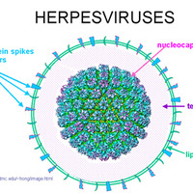

Figure 1.2 : Herpesviruses

**1.2.2 DOUBLE-STRANDED RNA**

These viruses have segmented genomes. Each genome segment is transcribed separately to produce monocistronic mRNAs.

Eg:  Reoviruses, Birnaviruses etc.

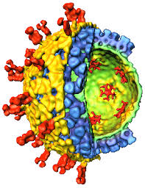

Figure 1.2.2 : Retrovirdai

**1.2.3 SINGLE-STRANDED (+)SENSE DNA**

Replication occurs in the nucleus, involving the formation of a (-)sense strand, which serves as a template for (+)strand RNA and DNA synthesis.

Eg: Parvoviruses etc.

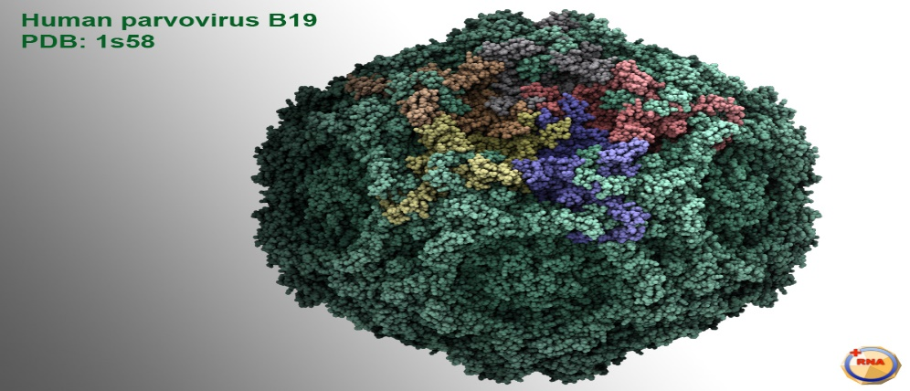

Figure 1.2.3 : Human parvovirus B19

**1.2.4 SINGLE-STRANDED (+) SENSE RNA**

(a) Polycistronic mRNA e.g. Picornaviruses; Hepatitis A. Genome RNA = mRNA. Means naked RNA is infectious, no virion particle associated polymerase. Translation results in the formation of a polyprotein product, which is subsequently cleaved to form the mature proteins.  
(b) Complex Transcription e.g. Togaviruses. Two or more rounds of translation are necessary to produce the genomic RNA.

Eg: Picornaviruses, Togaviruses, etc.

**1.2.5 SINGLE-STRANDED (-) SENSE RNA**

Must have a virion particle RNA directed RNA polymerase.

(a) Segmented e.g. Orthomyxoviruses. First step in replication is transcription of the (-) sense RNA genome by the virion RNA-dependent RNA polymerase to produce monocistronic mRNAs, which also serve as the template for genome replication.

(b) Non-segmented e.g. Rhabdoviruses. Replication occurs as above and monocistronic mRNAs are produced.

eg : Orthomyxoviruse , Rhabdoviruses etc.

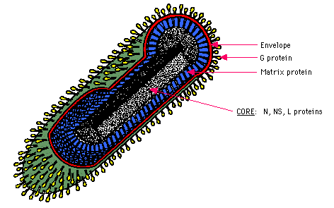

**Figure 1.2.5: Rhabdovirus**

**1.2.6 SINGLE-STRANDED (+) SENSE RNA WITH DNA INTERMEDIATE IN**

**LIFE-CYCLE**

Genome is (+)sense but unique among viruses in that it is DIPLOID, and does not serve as mRNA, but as a template for reverse transcription.

Eg: Retroviruses etc.

**1.2.7 DOUBLE-STRANDED DNA WITH RNA INTERMEDIATE**

This group of viruses also relies on reverse transcription, but unlike the Retroviruses, this occurs inside the virus particle on maturation. On infection of a new cell, the first event to occur is repair of the gapped genome, followed by transcription.

Eg: Hepadnaviruses etc.

* 1. **GENERAL CHARECTERISTIC OF VIRUS**

**1.3.1 STRUCTURE**

Because most viruses are extremely well adapted to their host organism, virus structure varies greatly. However, there are some general structural characteristics that all viruses share. All viruses have a capsid or head region that contains its genetic material. The capsid is made of proteins and glycoproteins. Capsid contruction varies greatly among viruses, with most being specialized for a particular virus's host organism.

Some viruses, mostly of the type infecting animals, have a membranous envelope surrounding their capsid. This allows viruses to penetrate host cells through membrane fusion. The virus's genetical material rests inside the capsid; that material can be either DNA, RNA, or even in some cases a limited number of enzymes. The type of genetic material a virus contains is used in classification

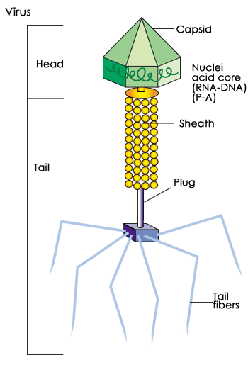

**Figure 1.3.1 : Virus structure**

some viruses, mostly those that infect bacteria, have a tail region. The tail is an often elaborate protein structure. It aids in binding to the surface of the host cell and in the introduction of virus genetic material to the host cell.

**1.3.2 VIRUS LIFE CYCLE**

Though the details of virus infection and replication vary greatly with host type, all viruses share 6 basic steps in their replication cycles. These are:

* Attachment
* Penetration
* Uncoating
* Replication
* Assembly
* Release.

As shown in , the virus must first attach itself to the host cell.

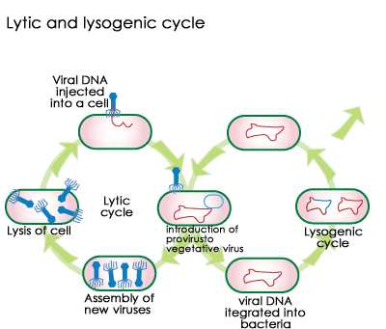

**Figure 1.3.2: General Replication of Viruses**

This is usually accomplished through special glycoprotiens on the exterior of the capsid, envelope or tail. Next, penetration occurs, either of the whole virus or just the contents of the capsid. If the entire capsid enters, the genetic material must be uncoated to make it available to the cell's replication machinery. Replication of genetic material takes place, as well as the production of capsid and tail proteins. Once all of the necessary parts have been replicated, individual virus particles are assembled and released. Release often takes place in a destructive manner, bursting and killing the host cell.

Some viruses have a slightly more complicated replication cycle involving lytic and lysogenic phases. The lytic phase is similar to that described above, with virus particles infecting and being replicated. In the lysogenic phase, however, viral genetic material that has entered the host cell becomes incorportated in the cell and lies dormant. It is passed on to the progeny of the infected cells. Eventually, the lytic phase will start again, and cells that were never infected themselves, but carry the viral genetic material will begin to produce new virus particles.

**1.3.3 MORPHOLOGY**

* **ICOSAHEDRAL**

The protomeres aggregate in groups of five or six to form the capsomere. In electron micrographs, capsomeres are recognized as regularly spaced rings with a central hole. The shape and dimensions of the icosahedron depends on characteristics of its protomeres. All icosahedral capsids have 12 corners each occupied by a penton capsomere and 20 triangular faces, each containing the same number of hexon capsomeres.  Icosahedral symmetry is  identical to cubic symmetry.

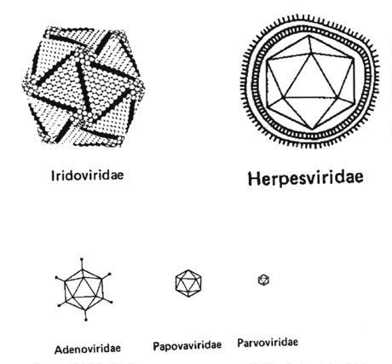

**Figure 1.3.3 A: Icosahedral**

* **HELICAL**

The protomeres are not grouped in capsomeres, but are bound to each other so as to form a ribbon-like structure. This structure folds into a helix because the protomeres are thicker at one end than at the other. The diameter of the helical capsid is determined by characteristics of its protomeres, while its length is determined by the length of the nucleic acid it  encloses.

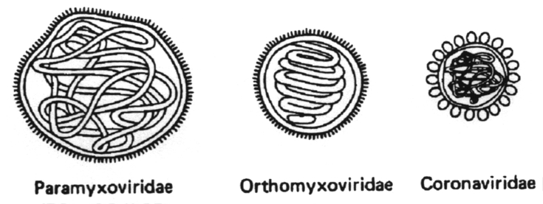

**Figure 1.3.3B:Helical**

* **COMPLEX**

e.g., that exhibited by poxvirus and rhabdovirus. This group  comprises all those viruses which do not fit into either  of  the above two  groups.

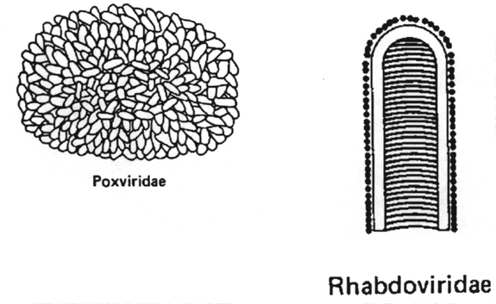

**Figure 1.3.3C: Rhabdoviridae and Poxviridae**

**1.4 DISEASE**

Viruses with RNA as their genetic material can quickly adapt to and exploit these varying conditions because of the high error rates of the virus enzymes (polymerases) that replicate their genomes. It comes as no surprise, then, that several prominent recent examples of emerging or re-emerging diseases are caused by RNA viruses.

The viruses in which have the genetic material like DNA or RNA are maximum do the infection and then that infection convert into the disease which is really dangerous for the human being. Viruses are doing different-different types of diseases, there is have the diversity in the disease of viruses and some of the examples are giving bellow-

* Virus diseases are like Smallpox
* The common cold
* [Measles](http://www.medicalnewstoday.com/articles/37135.php)
* [Chickenpox](http://www.medicalnewstoday.com/articles/239450.php)
* [Hepatitis](http://www.medicalnewstoday.com/articles/145869.php)
* [Influenza](http://www.medicalnewstoday.com/articles/15107.php)
* Human papilloma virus
* [Shingles](http://www.medicalnewstoday.com/articles/154912.php)
* [Herpes](http://www.medicalnewstoday.com/articles/151739.php)
* [Polio](http://www.medicalnewstoday.com/articles/155580.php)
* [Rabies](http://www.medicalnewstoday.com/articles/181980.php)
* [Ebola](http://www.medicalnewstoday.com/articles/280598.php)
* Hanta [fever](http://www.medicalnewstoday.com/articles/168266.php)
* [HIV](http://www.medicalnewstoday.com/articles/17131.php) (the virus that causes [AIDS](http://www.medicalnewstoday.com/articles/17131.php))
* [Cold sores](http://www.medicalnewstoday.com/articles/172389.php)
* [SARS](http://www.medicalnewstoday.com/articles/7543.php) (Severe acute respiratory syndrome)
* Dengue
* Epstein-Barr virus
* Some types of [cancer](http://www.medicalnewstoday.com/info/cancer-oncology/)

**1.4.1 INFECTION**

A human with an infection has another organism inside them which gets its sustenance (nourishment) from that person, it colonizes that person and reproduces inside them. The human with that organism (germ) inside is called the host, while the germ or pathogen is referred to as a parasitic organism. Another name for an organism that causes infection is an infectious agent.

It is only an infection if the colonization harms the host. It uses the host to feed on and multiply at the expense of the host to such an extent that his/her health is affected. The normal growth of the bacterial flora in the intestine is not an infection, because the bacteria are not harming the host.  
An organism which colonizes and harms a host's health is often called a pathogen. Examples include:

* Parasites
* Fungi
* Bacteria
* Prions
* Viroids (plant pathogens, they affect the health of plants)

We all develop a wide range of infections, but fight them off rapidly. Some people, however, develop persistent, long-term (chronic) infections. The majority of chronic infections are caused by viruses, such as [hepatitis](http://www.medicalnewstoday.com/articles/145869.php) or [herpes](http://www.medicalnewstoday.com/articles/151739.php). Chronic bacterial infections are more likely to affected patients with [diabetes](http://www.medicalnewstoday.com/info/diabetes/), as well as those with weakened immune systems.

If two organisms are present in the host together, they fight each other instead of the human body, and the levels of each colony remain balanced - their presence, together does not pose a problem for the host. An example could be some skin bacteria and yeast. [Antibiotics](http://www.medicalnewstoday.com/articles/10278.php) may, in fact, upset the balance by destroying the good bacteria, allowing the other potential pathogen to multiply faster and cause health problems.

**1.4.2 VIRAL INFECTION**

Infections caused by a virus. An individual may become infect by:

* Inhaling the virus (breathing it in)
* Being bitten by infected insects or parasites
* Through sexual contact

Respiratory infections of the upper airways, nose and throat are the most common forms of viral infections.   
  
Some antiviral medications may help, they either undermine the virus' ability to reproduce, or boost the patient's immune system.   
  
Viruses are tiny organisms, much smaller than bacteria or fungi. The virus invades its host and attaches to a cell, entering it and releasing genetic material (DNA or RNA). This genetic material helps the virus multiply; it takes over control of the cell, making it replicate the virus. A cell that has this genetic material inserted into it cannot function properly and soon dies. When it does it releases new viruses, which infect new cells, etc.   
  
Not all the viruses destroy their host cell. Some of them just alter what the cell does. Experts say that some cells become cancerous as a result of a virus interfering with its functions.   
  
Sometimes the genetic material lies dormant in a cell; some time in the future something triggers the cell and the virus starts multiplying again, making the host ill.   
  
Viruses target specific cells in the body, such as those in the genitals or upper respiratory tract. Some target certain age groups, such as babies or young children, such as those that cause [croup](http://www.medicalnewstoday.com/articles/155932.php). The [rabies](http://www.medicalnewstoday.com/articles/181980.php) virus targets the cells in the host's nervous system. Viruses may target skin cells and cause [warts](http://www.medicalnewstoday.com/articles/155039.php).

However, some viral infections can be systemic - they affect many different parts of the body, causing for example runny nose, sinus congestion, cough, and body aches. A viral infection that causes, for example viral [conjunctivitis](http://www.medicalnewstoday.com/articles/157671.php) is local. Viral infections that cause pain, often trigger itching or burning.

**1.4.3 VIRAL PATHOGENESIS**

Viral pathogenesis is the study of how biological [viruses](https://en.wikipedia.org/wiki/Virus) cause diseases in their target [hosts](https://en.wikipedia.org/wiki/Host_(biology)), usually carried out at the cellular or molecular level. It is a specialized field of study in [virology](https://en.wikipedia.org/wiki/Virology). Pathogenesis is a process in which an initial infection becomes a disease. Viral disease is a sum of the effects on the host caused by the replication of the virus and of the host's subsequent immune response

* Pathogenesis is the process by which an infection leads to disease. Pathogenic mechanisms of viral disease include-
* Implantation of virus at the portal of entry,
* Local replication,
* Spread to target organs (disease sites), and
* Spread to sites of shedding of virus into the environment.

Factors that affect pathogenic mechanisms are –

* Accessibility of virus to tissue,
* Cell susceptibility to virus multiplication, and
* Virus susceptibility to host defenses.

Natural selection favors the dominance of low-virulence virus strains.

**1.5 DISEASE SPREADING METHOD**

Germs can spread through:

* The [air as small droplets](http://www.sahealth.sa.gov.au/wps/wcm/connect/public+content/sa+health+internet/health+topics/health+conditions+prevention+and+treatment/infectious+diseases/ways+infectious+diseases+spread#Spread through the air by droplets) (droplet spread) or tiny [aerosol particles](http://www.sahealth.sa.gov.au/wps/wcm/connect/public+content/sa+health+internet/health+topics/health+conditions+prevention+and+treatment/infectious+diseases/ways+infectious+diseases+spread#Spread through the air by aerosol) (airborne spread)
* Contact with [faeces and then with the mouth](http://www.sahealth.sa.gov.au/wps/wcm/connect/public+content/sa+health+internet/health+topics/health+conditions+prevention+and+treatment/infectious+diseases/ways+infectious+diseases+spread#Spread through faeces and then the mouth (faecal-oral spread)) (faeco-oral spread)
* Contact with the [skin or mucus membranes](http://www.sahealth.sa.gov.au/wps/wcm/connect/public+content/sa+health+internet/health+topics/health+conditions+prevention+and+treatment/infectious+diseases/ways+infectious+diseases+spread#Spread by skin or mucous membrane contact)
* [Blood or other body fluids](http://www.sahealth.sa.gov.au/wps/wcm/connect/public+content/sa+health+internet/health+topics/health+conditions+prevention+and+treatment/infectious+diseases/ways+infectious+diseases+spread#Spread through blood or other body fluids) (for example, urine, saliva, breastmilk, semen and vaginal secretions).

Germs can spread:

* Directly from person to person or
* Indirectly from an infected person to the environment (for example toys, door handles, bench tops, bedding and toilets) and then to another person who comes in contact with the contaminated environmental source.

Germs can enter the body through the:

* Mouth
* Respiratory tract
* Eyes
* Genitals
* Broken skin.

Some infections can spread in several different ways-

There are other ways of describing how germs are spread that are commonly used. Germs can be spread through [sexual contact](http://www.sahealth.sa.gov.au/wps/wcm/connect/public+content/sa+health+internet/health+topics/health+conditions+prevention+and+treatment/infectious+diseases/ways+infectious+diseases+spread#Spread through sexual contact (sexually transmitted infections)), which is usually through semen and vaginal secretions (body fluids), but can also occur through contact with mucus membranes. Germs can spread through [food or water](http://www.sahealth.sa.gov.au/wps/wcm/connect/public+content/sa+health+internet/health+topics/health+conditions+prevention+and+treatment/infectious+diseases/ways+infectious+diseases+spread#Spread through food or water). Many but not all the germs spread in this way are through contact with faeces and then with the mouth (faeco-oral). Germs can also spread from a [mother to her unborn child](http://www.sahealth.sa.gov.au/wps/wcm/connect/public+content/sa+health+internet/health+topics/health+conditions+prevention+and+treatment/infectious+diseases/ways+infectious+diseases+spread#Spread from a mother to her unborn child), usually though blood (body fluids) but also through contact with skin or mucous membranes during delivery.

**1.6 SYMPTOMS OF VIRUS DISEASE**

Symptoms of viral diseases vary depending on the specific type of virus causing infection, the area of the body that is infected, the age and health history of the patient, and other factors. The symptoms of viral diseases can affect almost any area of the body or body system. Symptoms of viral diseases can include:

* Flu-like symptoms (fatigue, fever, sore throat, headache, cough, aches and pains)
* Gastrointestinal disturbances, such as diarrhea, nausea and vomiting
* Irritability
* Malaise (general ill feeling)
* Rash
* Sneezing
* Stuffy nose, nasal congestion, runny nose, or postnasal drip
* Swollen lymph nodes
* Swollen tonsils
* Unexplained weight loss

In infants, signs of a viral disease can also include:

* Bulging of the soft spot on the top of the head
* Difficulty with feeding
* Excessive crying or fussiness
* Excessive sleepiness

**1.7 DIAGNOSIS**

* A doctor's evaluation
* For infections that occur in epidemics, the presence of other similar cases
* For some infections, blood tests and cultures

Common viral infections (such as measles, rubella, or chickenpox) may be diagnosed based on symptoms.

For infections that occur in epidemics (such as influenza), the presence of other similar cases may help doctors identify a particular infection.

For other infections, blood tests and cultures (growing microorganisms in the laboratory from samples of blood, body fluid, or other material taken from an infected area) may be done. Blood may be tested for antibodies to viruses or for antigens (proteins on or in viruses that trigger the body’s defenses). Polymerase chain reaction (PCR) techniques may be used to make many copies of the viral genetic material, enabling doctors to rapidly and accurately identify the virus. Tests are sometimes done quickly—for instance, when the infection is a serious threat to public health or when symptoms are severe.

A sample of blood or other tissues is sometimes examined with an electron microscope, which provides high magnification with clear resolution

**1.8 TREATEMENT**

There are no effective antiviral drugs for many viral infections. However, there are several drugs for influenza , many drugs for infection by one or more herpesviruses , and many new antiviral drugs for treatment of HIV and hepatitis C infections.

Antiviral drugs can work by

* Interfering with the replication of viruses
* Strengthening the immune response to the viral infection

Most drugs used to treat human immunodeficiency virus (HIV) infection work this way. Because viruses are tiny and replicate inside cells using the cells' own metabolic functions, there are only a limited number of metabolic functions that antiviral drugs can target. In contrast, bacteria are relatively large organisms, commonly reproduce by themselves outside of cells, and have many metabolic functions that antibacterial drugs (antibiotics) can target. Therefore, antiviral drugs are much more difficult to develop than antibacterial drugs. Also, unlike antibiotics, which are usually effective against many different species of bacteria, most antiviral drugs are usually effective against only one or a very few viruses.

These drugs include several types of interferons, immunoglobulins, and vaccines:

* Interferon drugsare replicas of naturally occurring substances that slow or stop viral replication.
* Immune globulinis a sterilized solution of antibodies (also called immunoglobulins) collected from a group of people.
* Vaccines are materials that help prevent infection by stimulating the body's natural defense mechanisms.

**1.9 PREVENTION OF VIRUS DISEASE**

Vaccinations are generally the cheapest and most effect way to prevent viruses. Currently, vaccinations exist for polio, measles, mumps, rubella, and smallpox among others. In fact, vaccinations have been instrumental in eliminating diseases such as smallpox and reducing other viral diseases to extremely rare status. Virus vaccinations consist of a weakened form of the virus (live-attenuated viruses) or viral proteins called antigens. Live-attenuated vaccines carry the risk causing the original disease in people with weak immune systems. And in addition use bellow methods-

In preventing our self from the disease we should take care our self from the agent or vector which is spreading the disease from source to subject or subject to subject. Those agent can be the mosquito, flee, bee, pig, bird and clean and cover those organs which are the helping in the infection of virus that can be like hand, mouth, saliva etc. So cleaned our body and be safe.

**CHAPTER 2:**

**MATERIALS AND METHODS**

**2.1 DATASET**

The main objective of the database to gather all the possible viruses and their disease used for in the treatment and the study of virus disease. To acquire the desired data for the Virus disease database a number of papers and sites have been studied. Large amount of data has been gathered from research papers and sites.

To extract the specific data keyword searching was done to locate articles reporting treatment and the study of virus disease outcomes in virus.

**2.2 DATA SEARCH STRATEGY**

The following keywords were used: combination of “virus ”,”virus disease” and to search for different types of diseases of different-different types of virus, the key words are used “Virus host”, ”Spreading method”, “Disease”, “Virus name”, “Prevention”, “Treatment”, “Source information”, “Proteins”, “Lengths”, ”Family name”, “Segment”, “Accession id”.

After the collection of all the possible information regarding the virus and disease the data is compiled in an excel sheet and necessary changes are made.

Bellow in the figure shows the raw data that has been collected and arranged in a systematic manner so that when looked upon the query can be searched easily.

Raw data which have been collected from the different-different sources like sites, papers

etc.

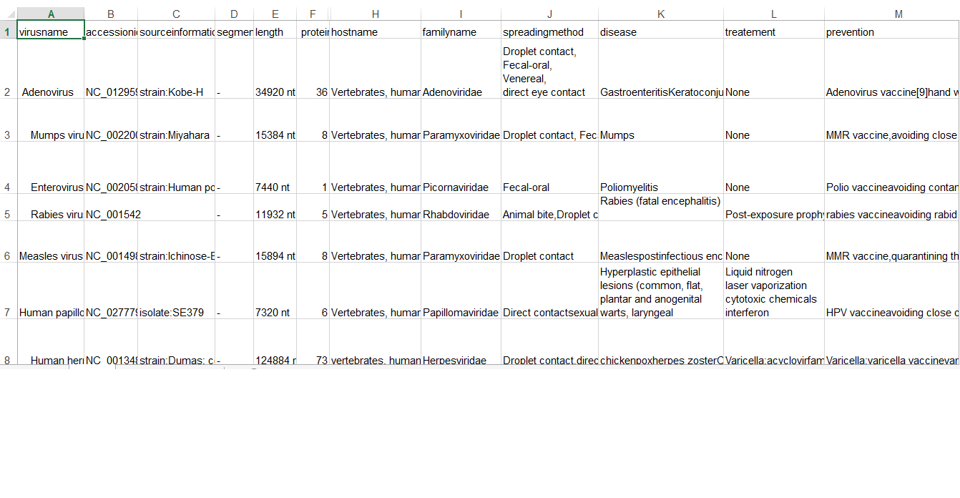

**Figure 2.2A: Raw virus data 1**

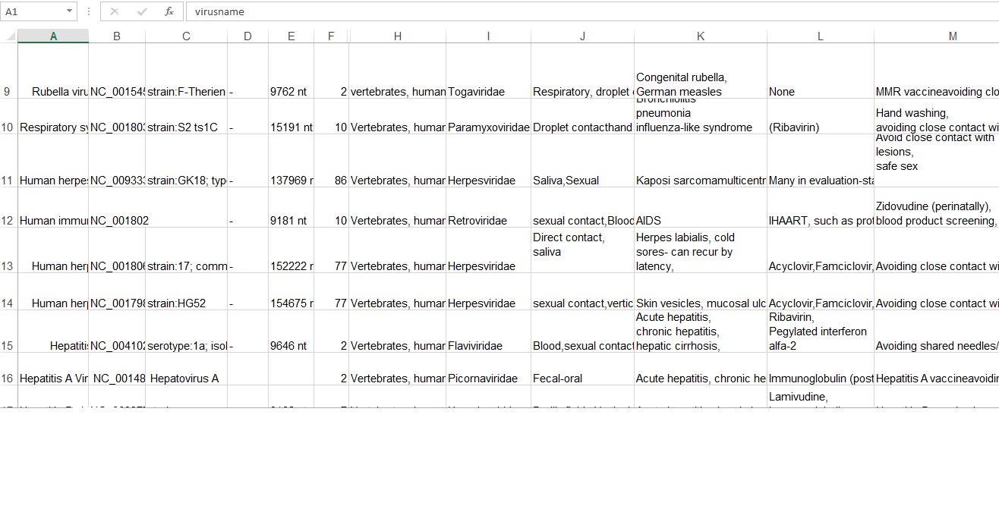

**Figure 2.2B: Raw virus disease data 2**

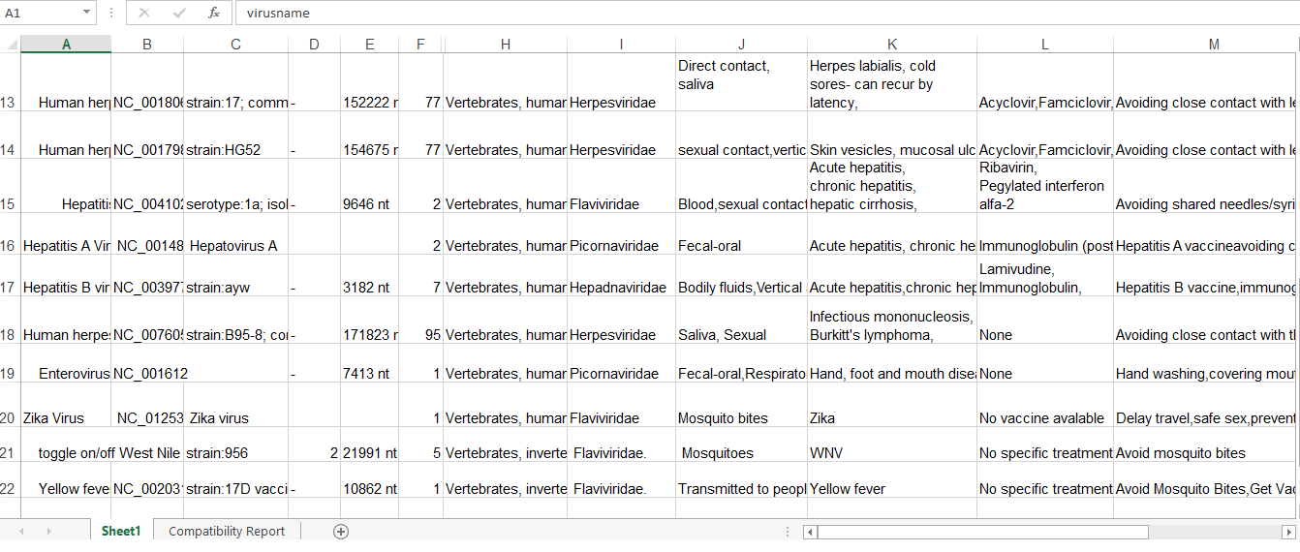

**Figure 2.2C : Raw virus disease data 3**

**2.3 TECHANICAL BASIS DATABASE**

**2.3.1 SOFTWARES USED**:

* XAMPP – local server (Apache)
* PhpMyadmin – database hosting (sequence server)
* Notepad++ – HTML/CSS/Php coding

**2.3.3 SCREENSHOTS-CODES**

* **SCREENSHOT-INDEX PAGE HTML CODE**

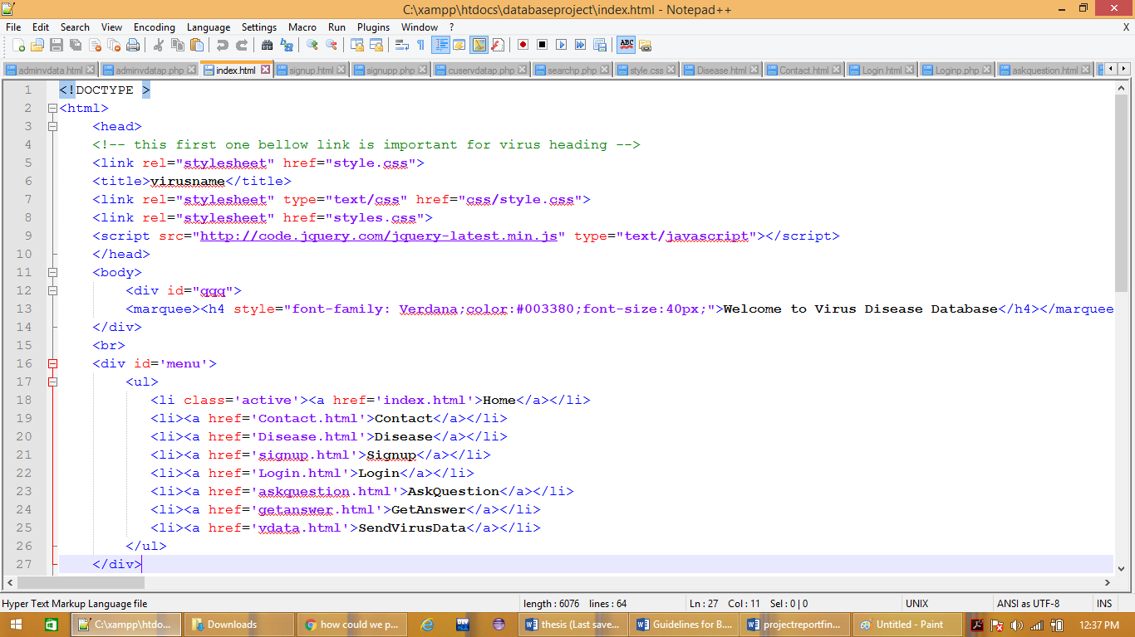

* **SCREENSHOT-SIGNUP PAGE HTML CODE**

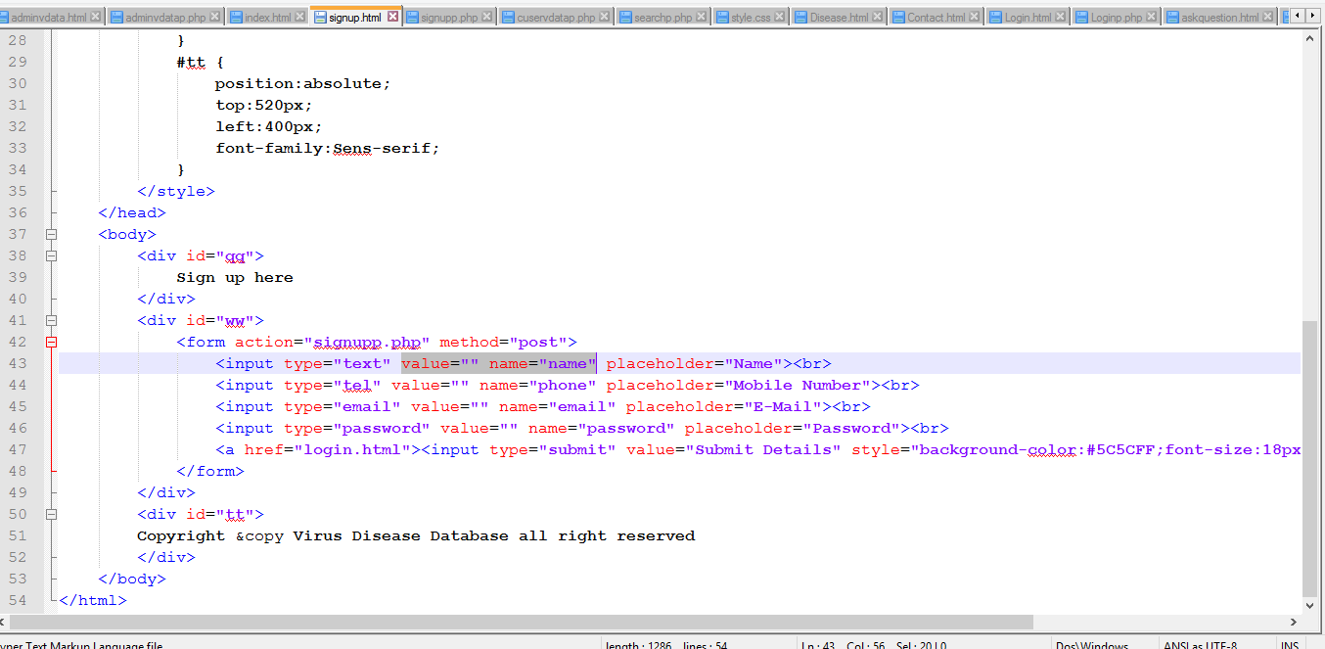

* **SCREENSHOT-SIGN UP PHP CODE**

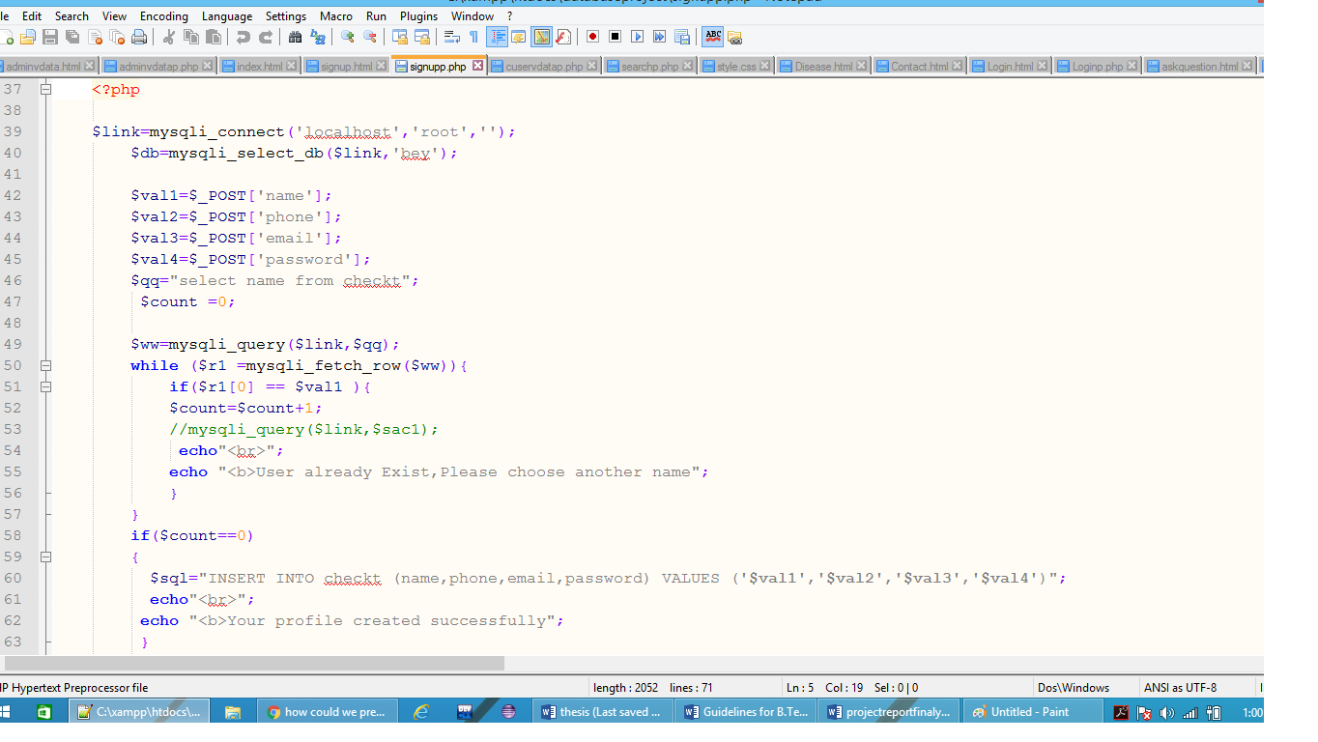

* **SCREENSHOT-LOG IN PAGE HTML CODE**

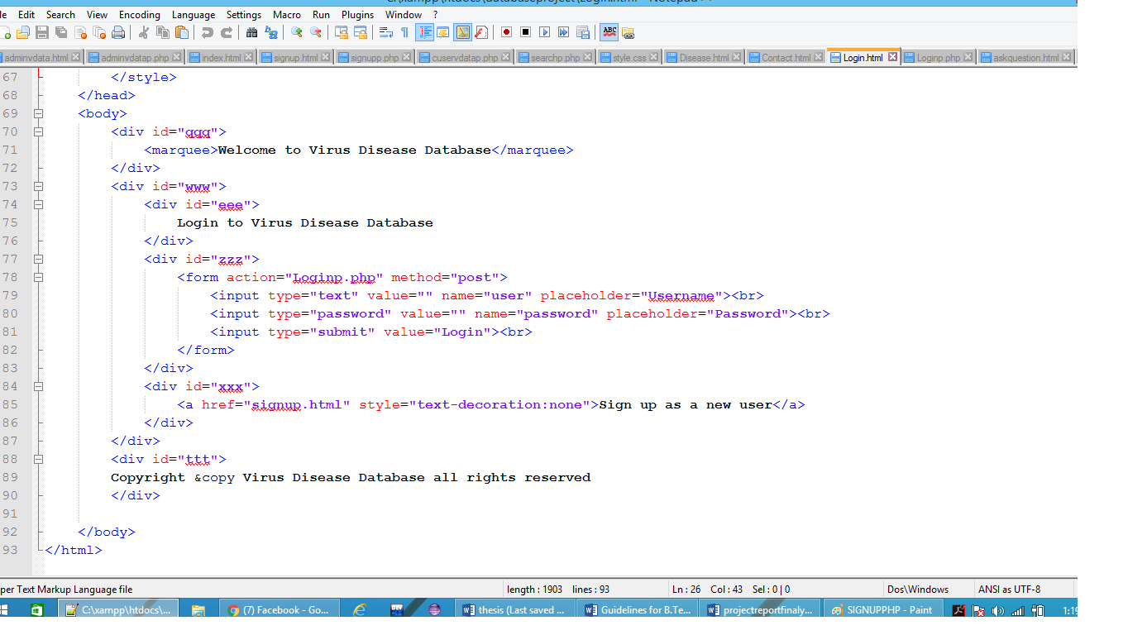

* **SCREENSHOT-LOG IN PAGE PHP CODE**

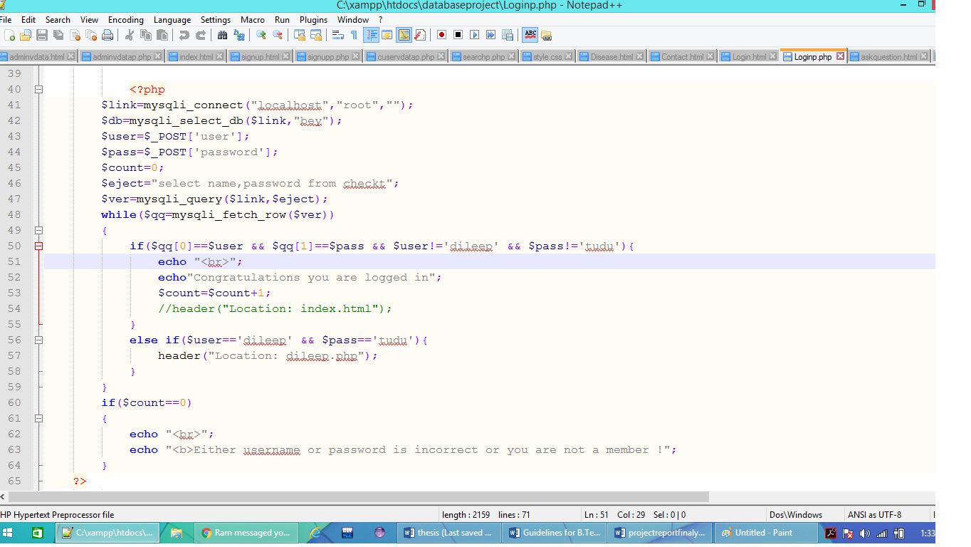

* **SCREENSHOT-ASK QUESTION HTML PAGE CODE**

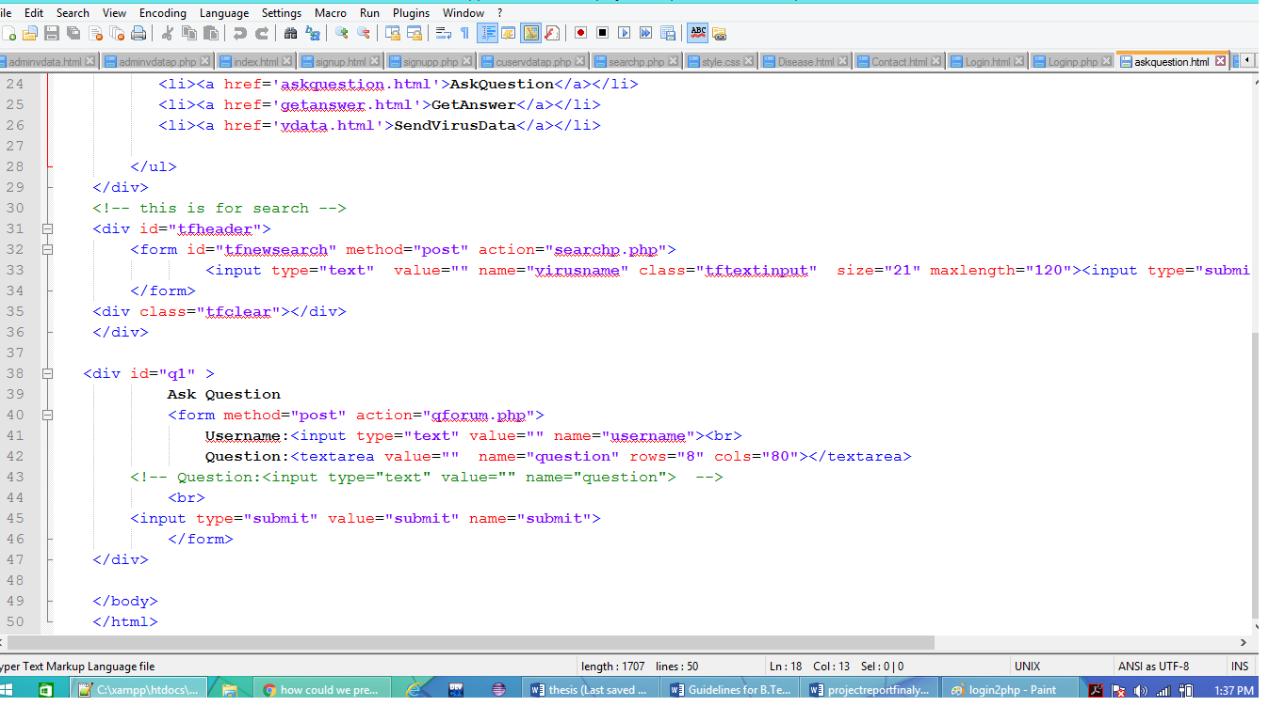

* **SCREENSHOT-ASK QUESTION PHP CODE**

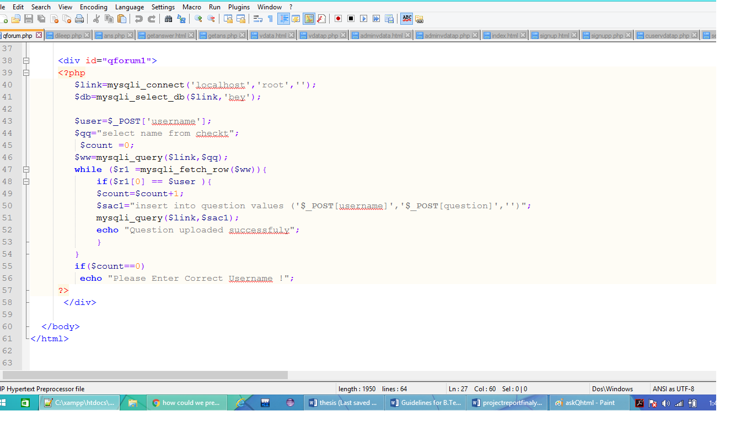

* **SCREENSHOT-GET ANSWER PAGE HTML CODE**

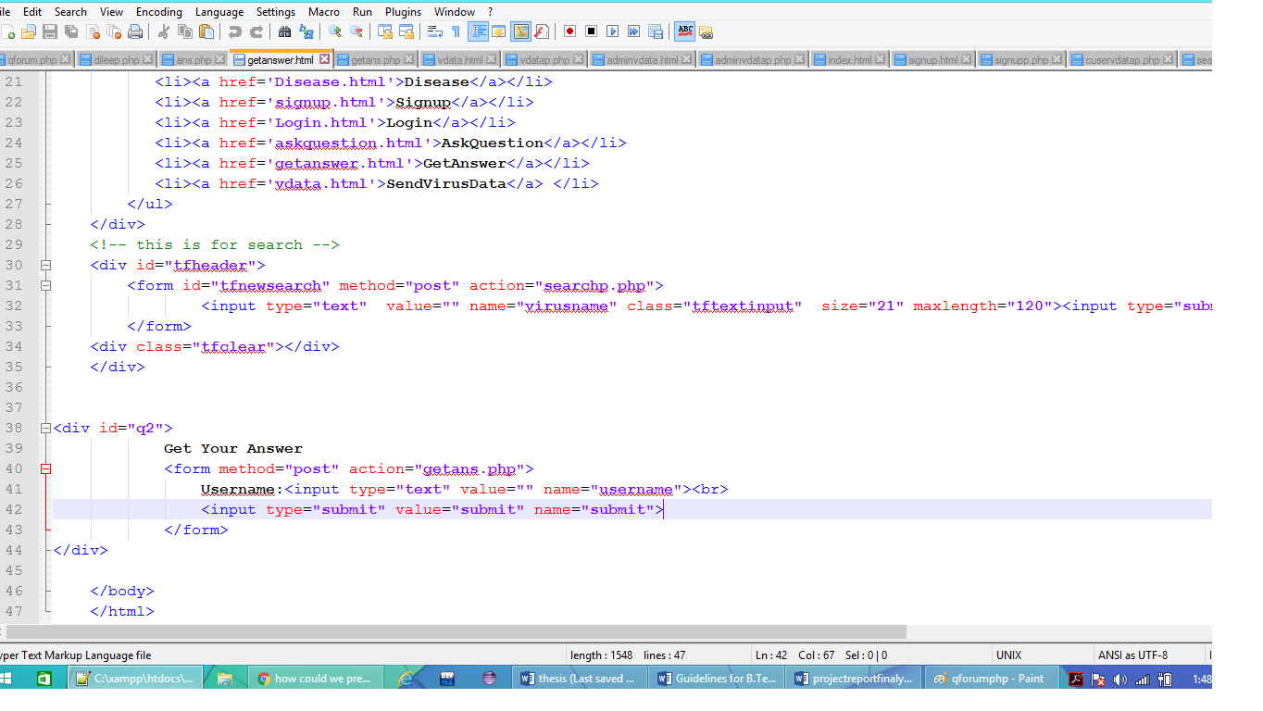

* **SCREENSHOT-ADMIN GIVE ANSWER PAGE HTML CODE**

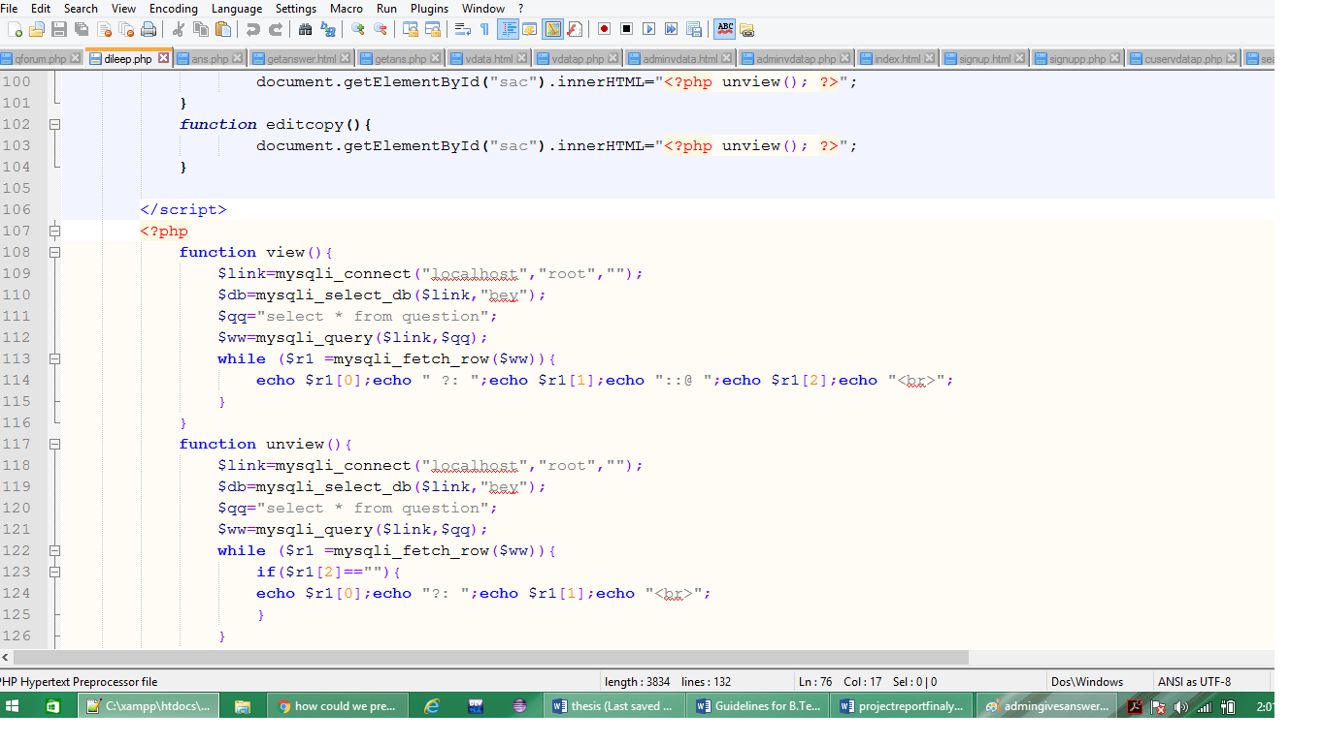

* **SCREENSHOT-ADMIN GIVE ANSWER PAGE PHP CODE**

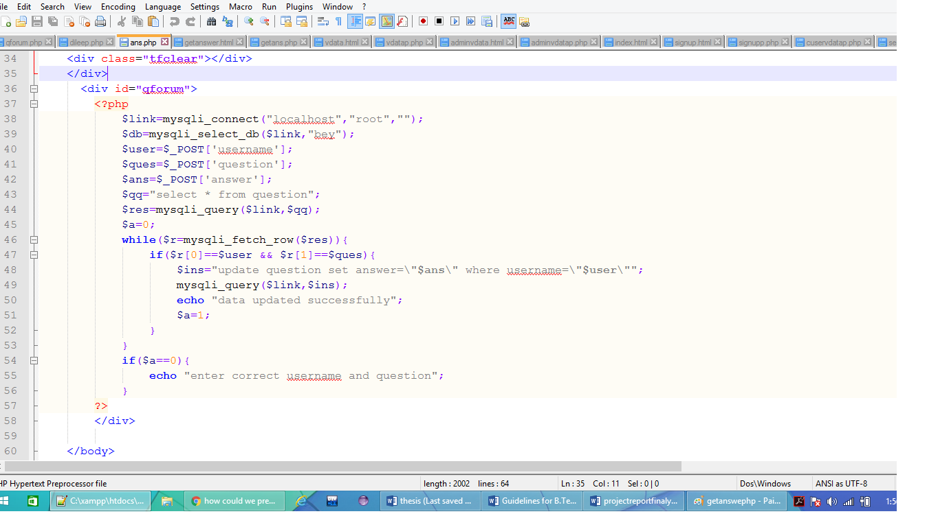

* **SCREENSHOT-GET ANSWER PAGE PHP CODE**

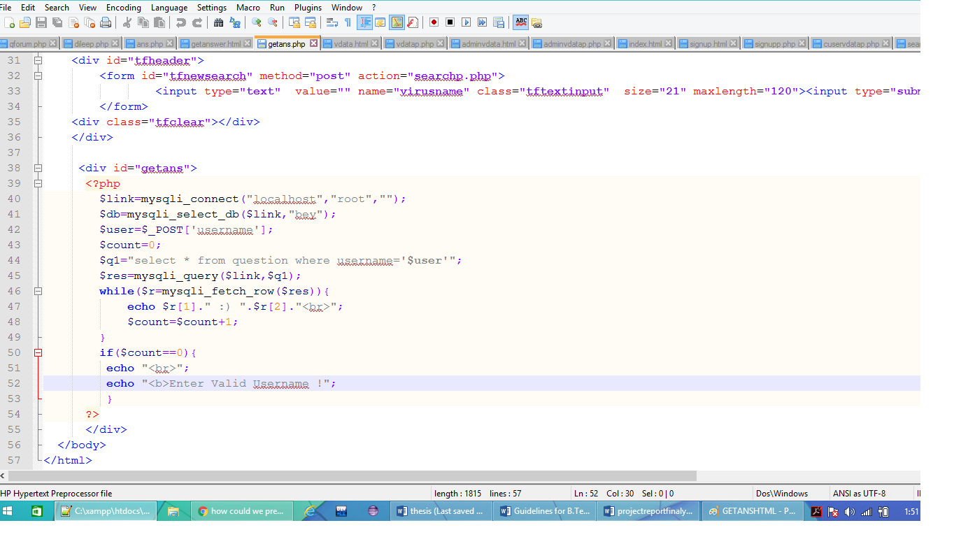

* **SCREENSHOT-USER UPLOAD VDATA PAGE HTML CODE**

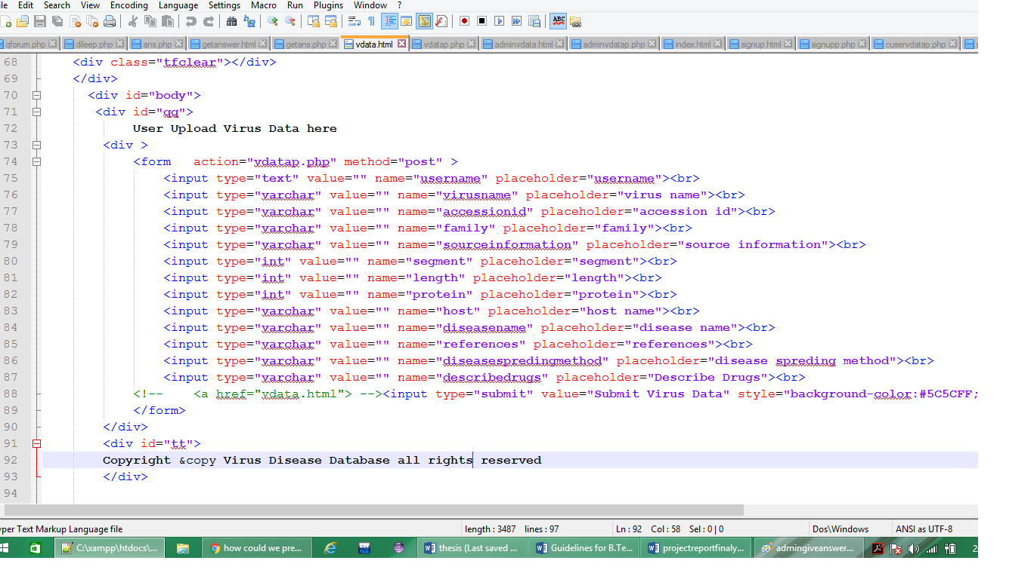

* **SCREENSHOT-USER UPLOAD VDATA PAGE PHP CODE**

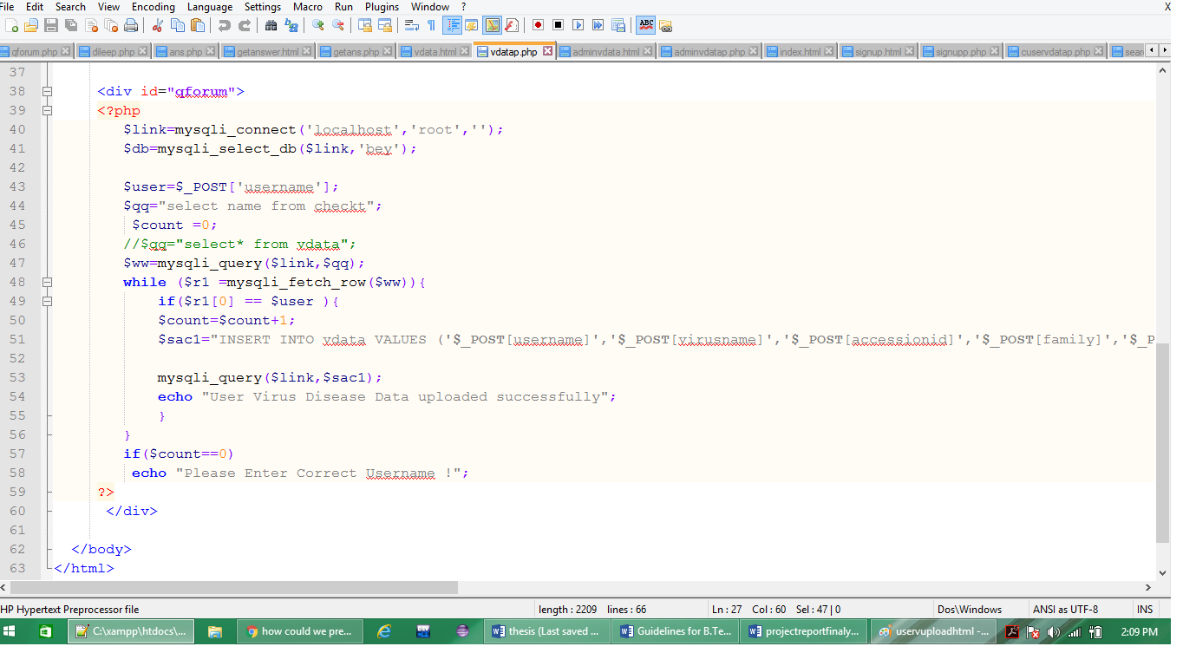

* **SCREENSHOT-ADMIN UPLOAD VDATA PAGE HTML CODE**

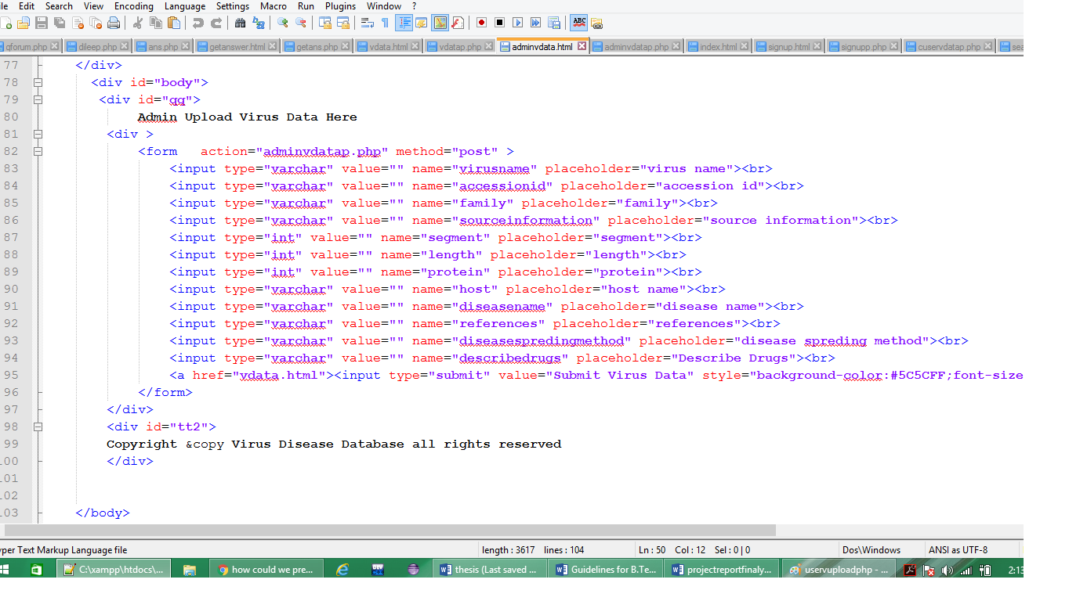

* **SCREENSHOT-ADMIN UPLOAD VDATA PAGE PHP CODE**

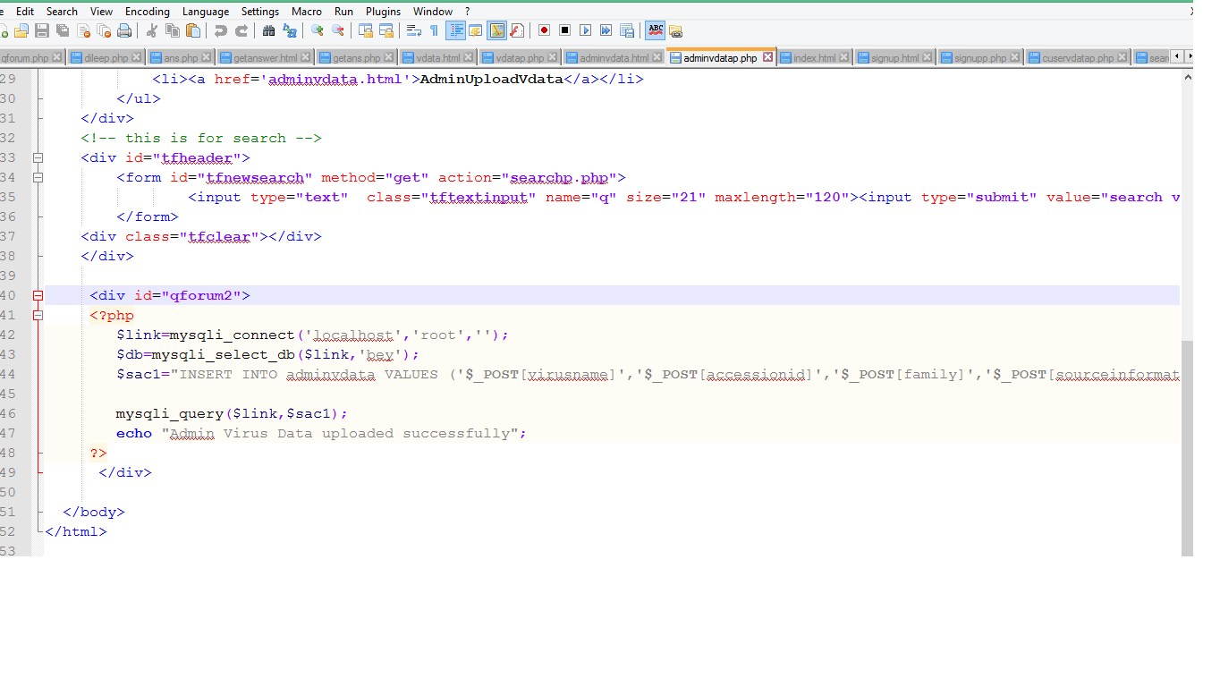

* **SCREENSHOT-CHECK USER SEND VDATA PAGE PHP CODE**

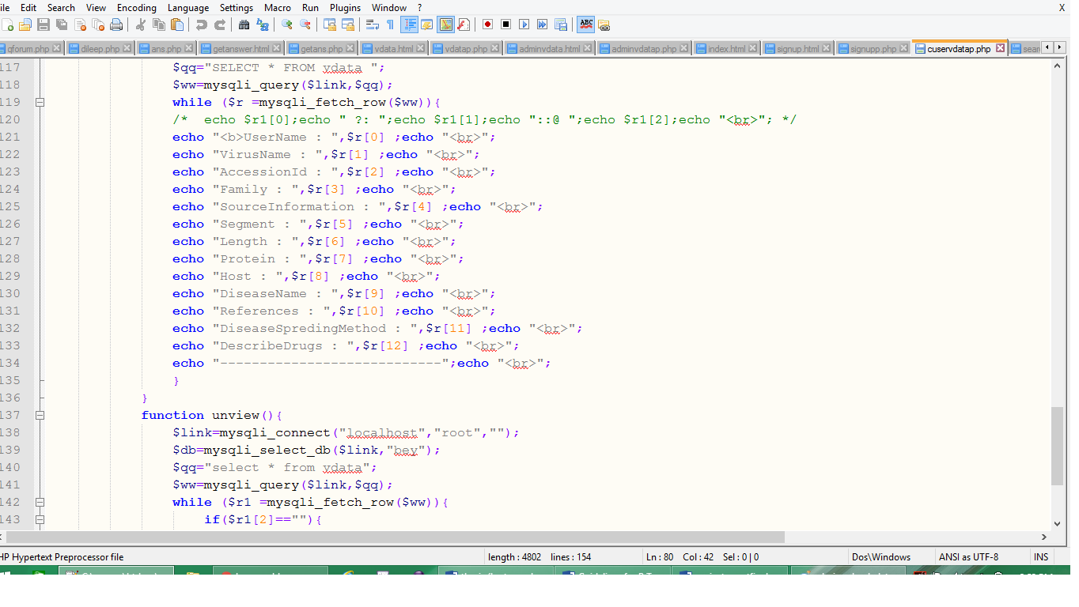

* **SCREENSHOT-CSS CODES FOR ALL HTML PAGES**

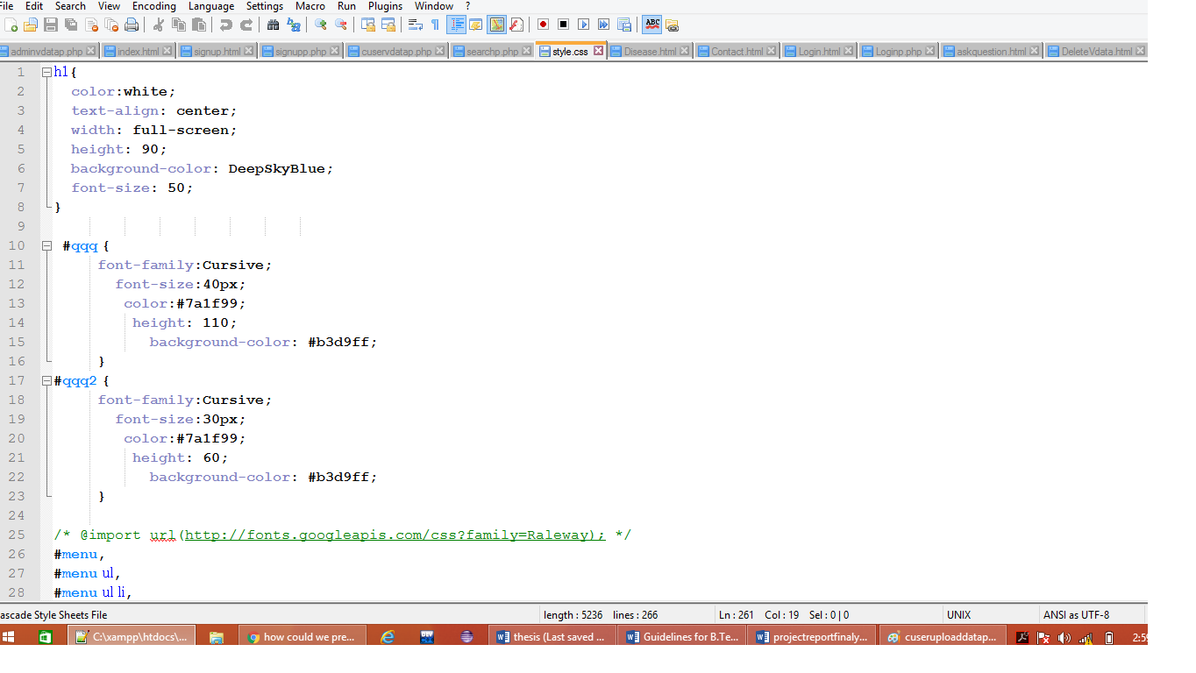

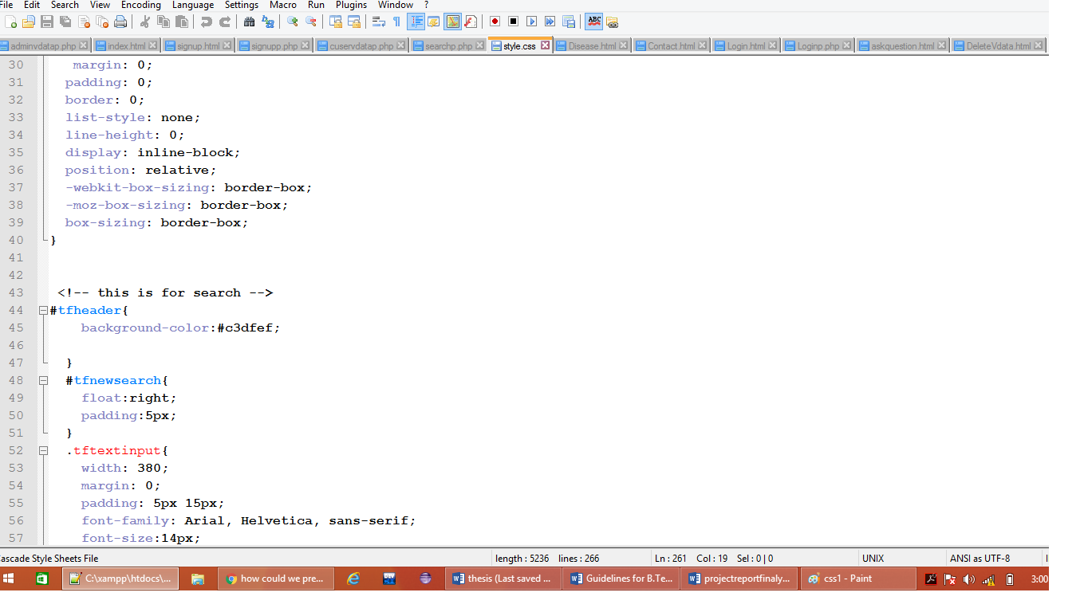

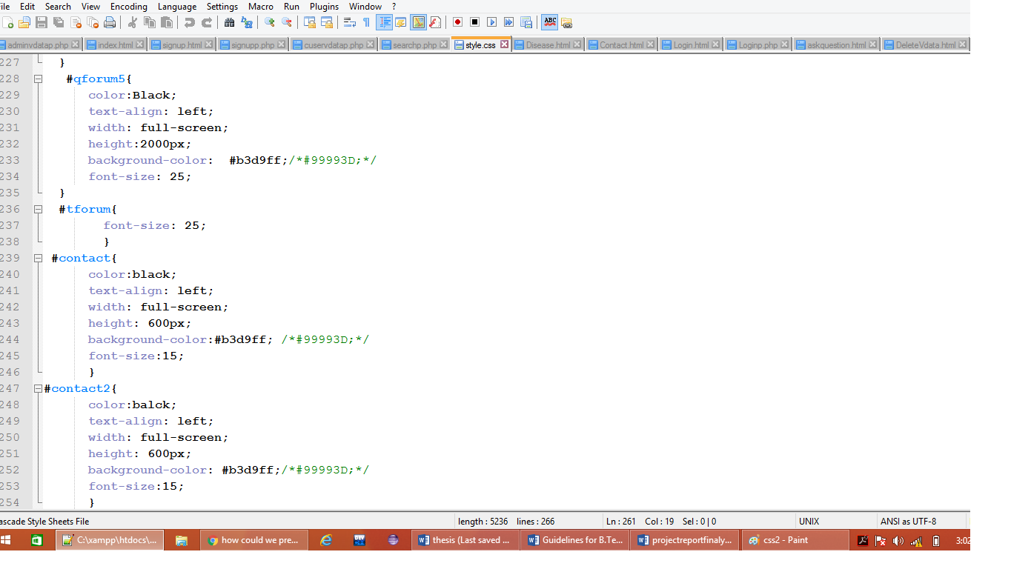

**2.4 FLOW CHART DIAGRAM FOR TECHENICAL DATABASE**

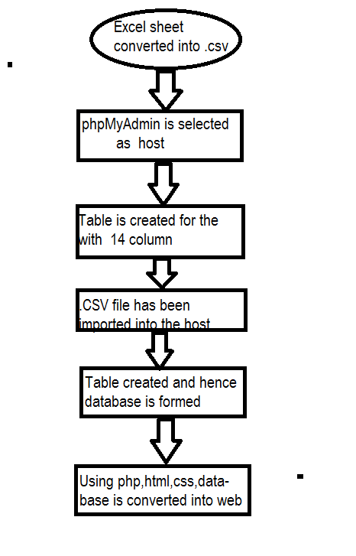

**Figure 2.4 :Flow chart diagram**

In the above showing flow diagram at the initial level excel sheet eill be full filled by the raw data of the virus and disease(and there will be the key structure of raw data like disease, spreading method , prevention, treatement etc.) then it’s file will be converted into the .CSV formate.

PhpMyadmin is a database hosting platform and is used to host the virus disease data. Here all the one excel sheet is converted into one table . Using the import Click Go and the database is created.

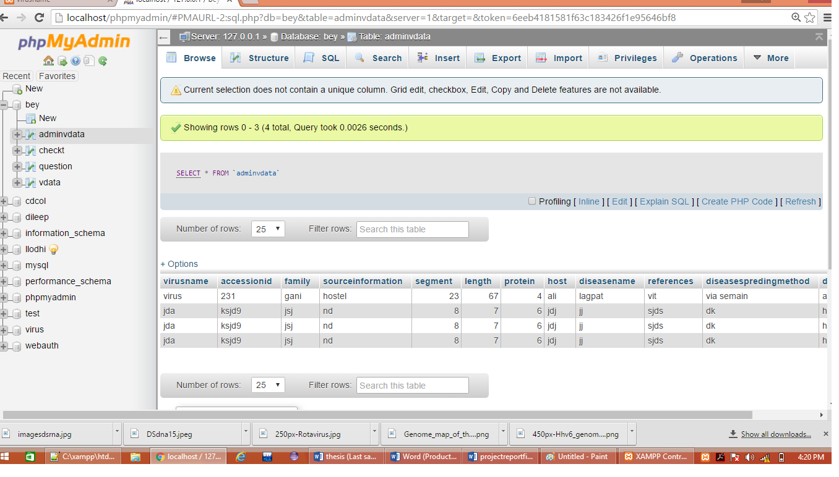

**Figure 2.4: Virus disease database at the phpMyadmin server**

And once the table is created the final step is to upload the data to the website, this is done using php/html/css. The website is ready.

**CHAPTER 3**

**RESULT AND DISCUSSION**

**3.1 RESULT**

The database was successfully created. Below are the images of the Virus disease database. Some are of the user side and some images admin side.

For user-

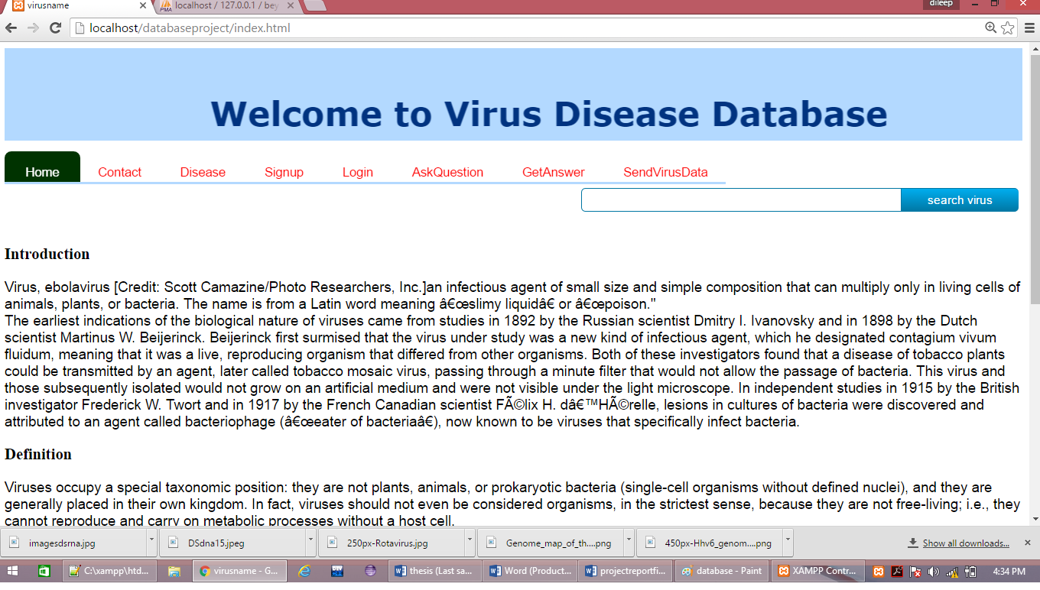

**Figure 3.1 A: Home page**

Any user before goto the log in page he should sign up first because his username and password will not be save in the table so this is the necessary

Part of this website.

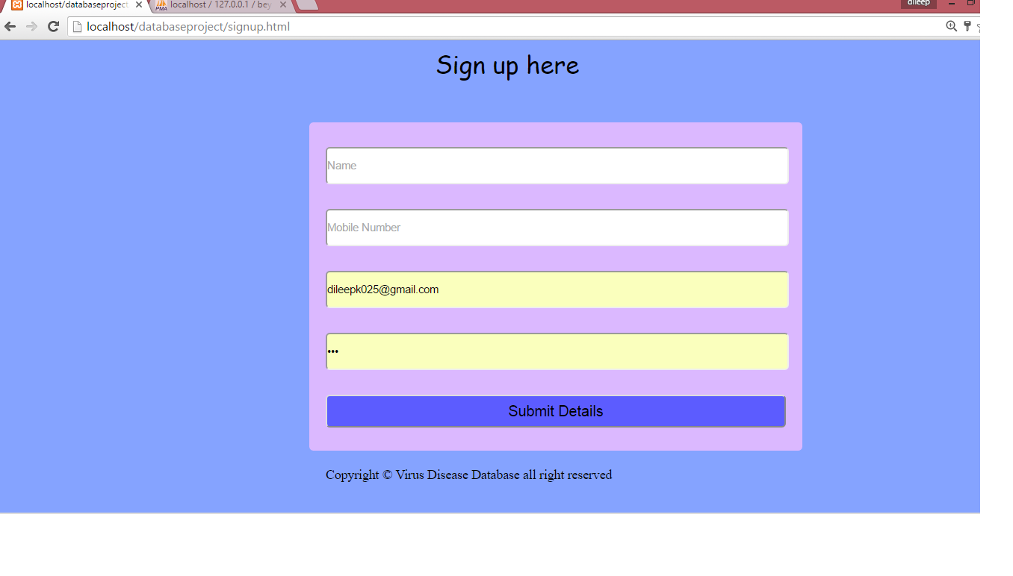

**Figure 3.1B : Sign up page**

From this page user and admin both will able to log in .

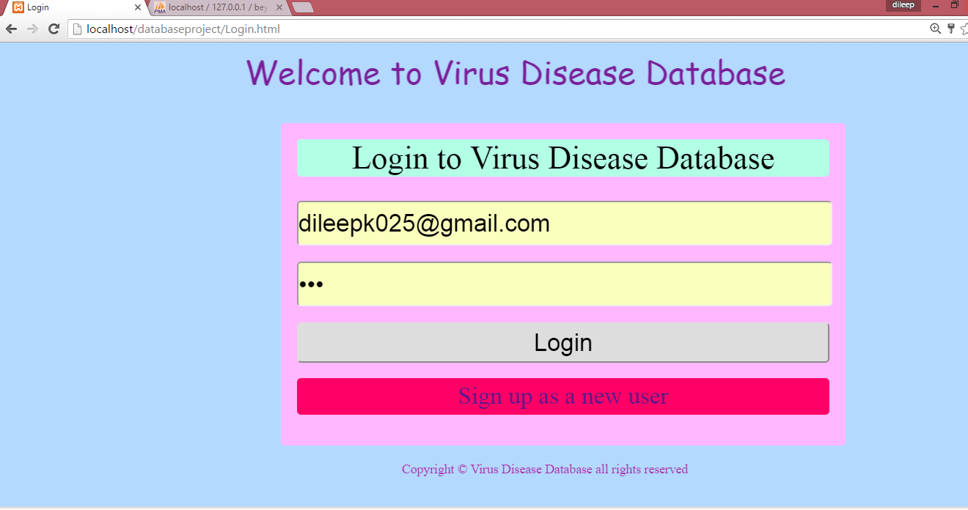

**Figure 3.1C: Log in page for user and admin both**

Using this page user will able to ask the any types of the question from the admin if user have any query .

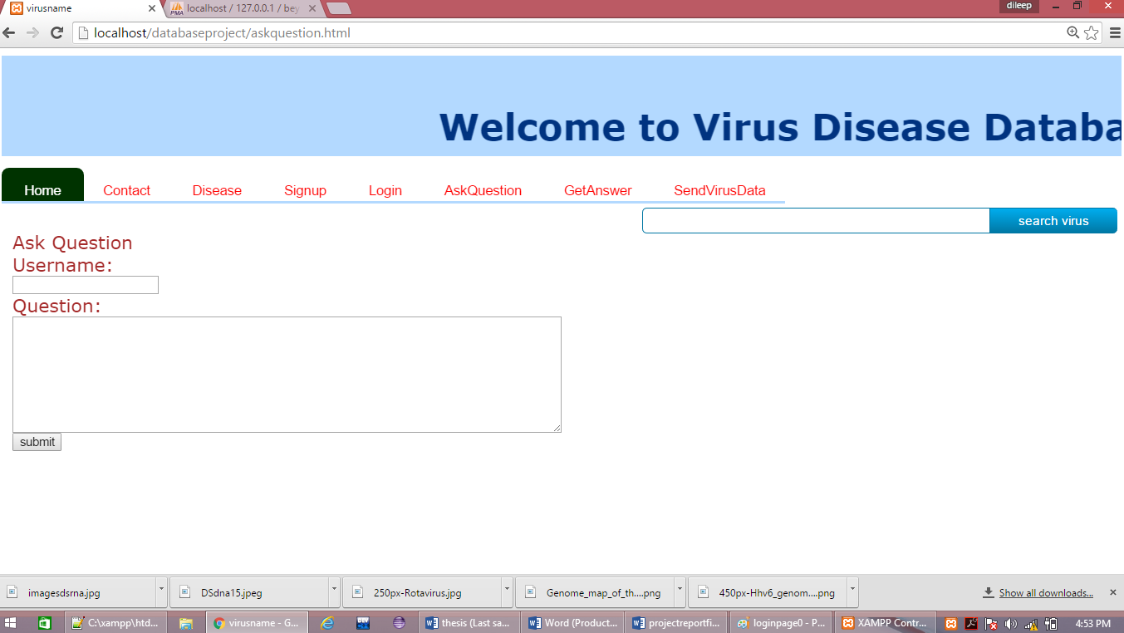

**Figure 3.1D: Ask question page for user**

Here user will get the answer using the the user name and it’s for only register users. This page will make satisfy to the user.

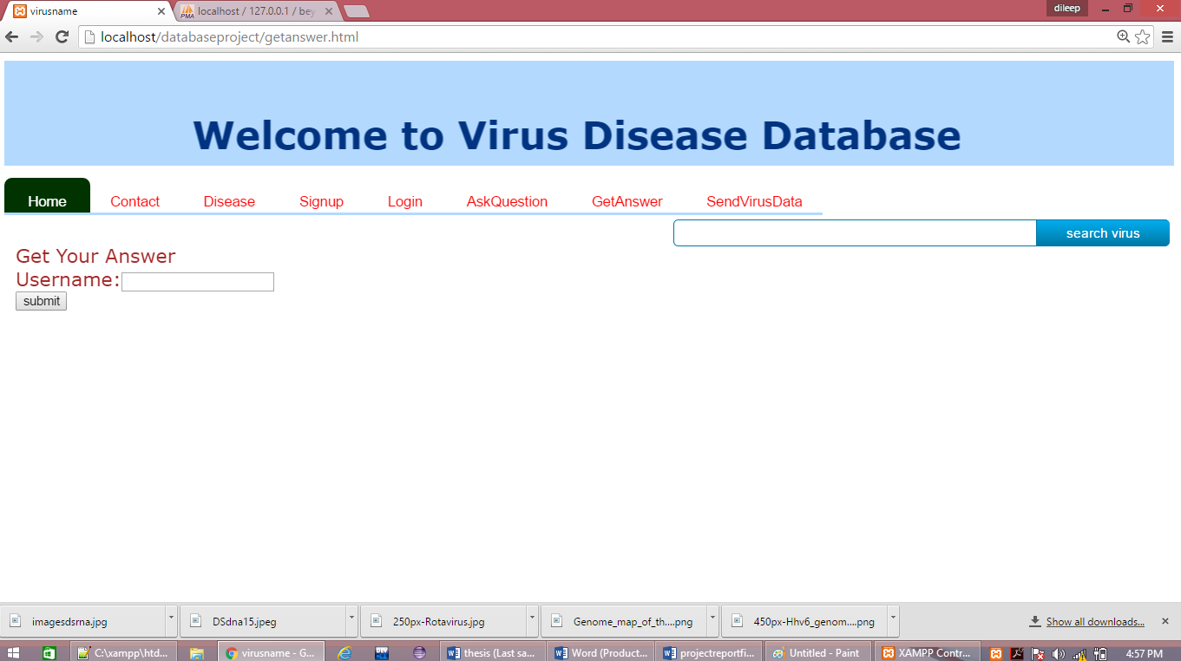

**Figure 3.1E: Get answer page for the user**

Here user using this page will able to direct contact to the admin for important query.

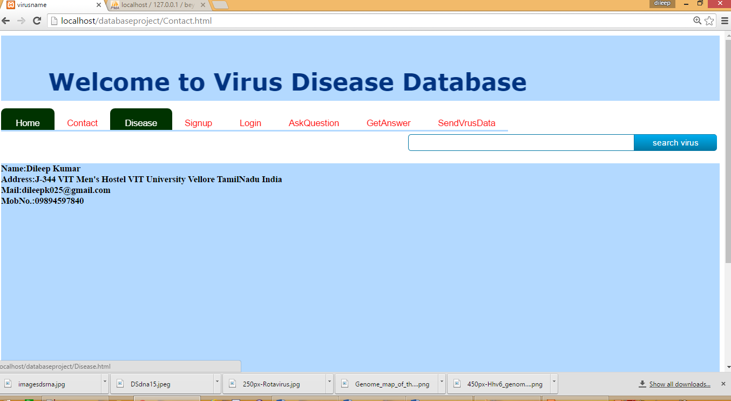

**Figure 3.1F: Admin contact page**

Here using this page user will able send virus disease data to the admin for convenient of gathering the more data about the virus disease it’s a very good and helpful way for admin .Becouse of this feature number of data in the database could be increase more and also user could happy to add these sended virus disease data.

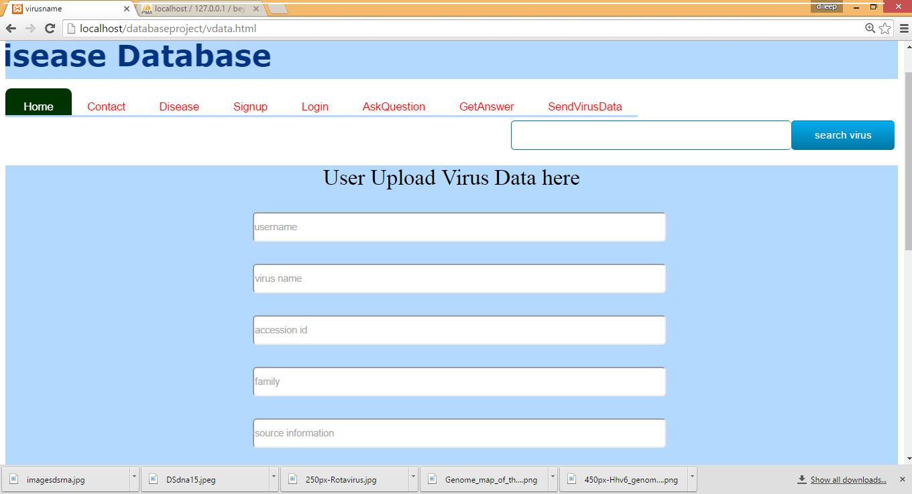

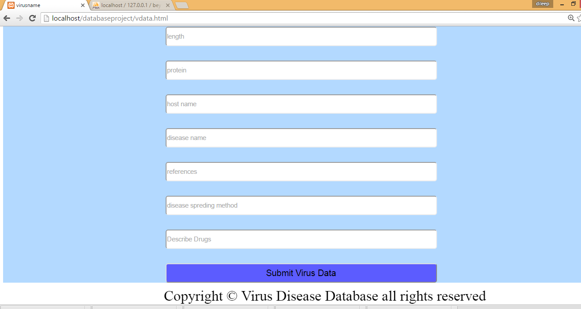

**Figure 3.1G:User uploade vdisease data**

For admin uses-

Admin by using this page will able to give the all answer of the question which have been asked by the users

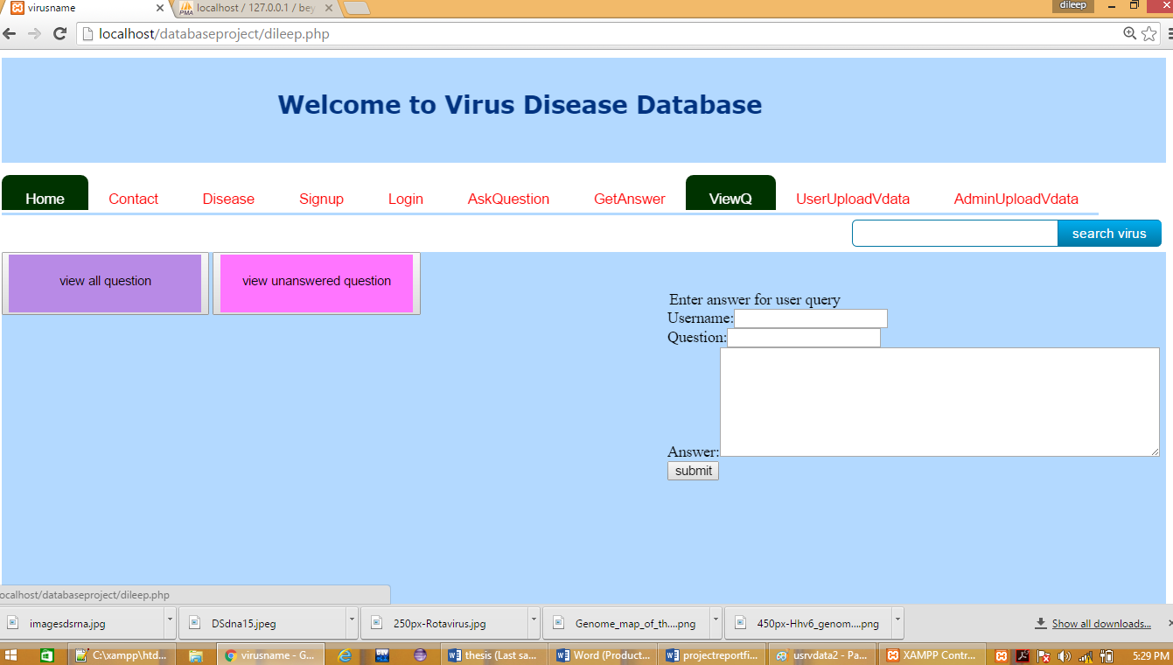

**Figure 3.1H: Admin answer page**

Admin by using this page will able to see and check the virus disease data which have been send by the user.

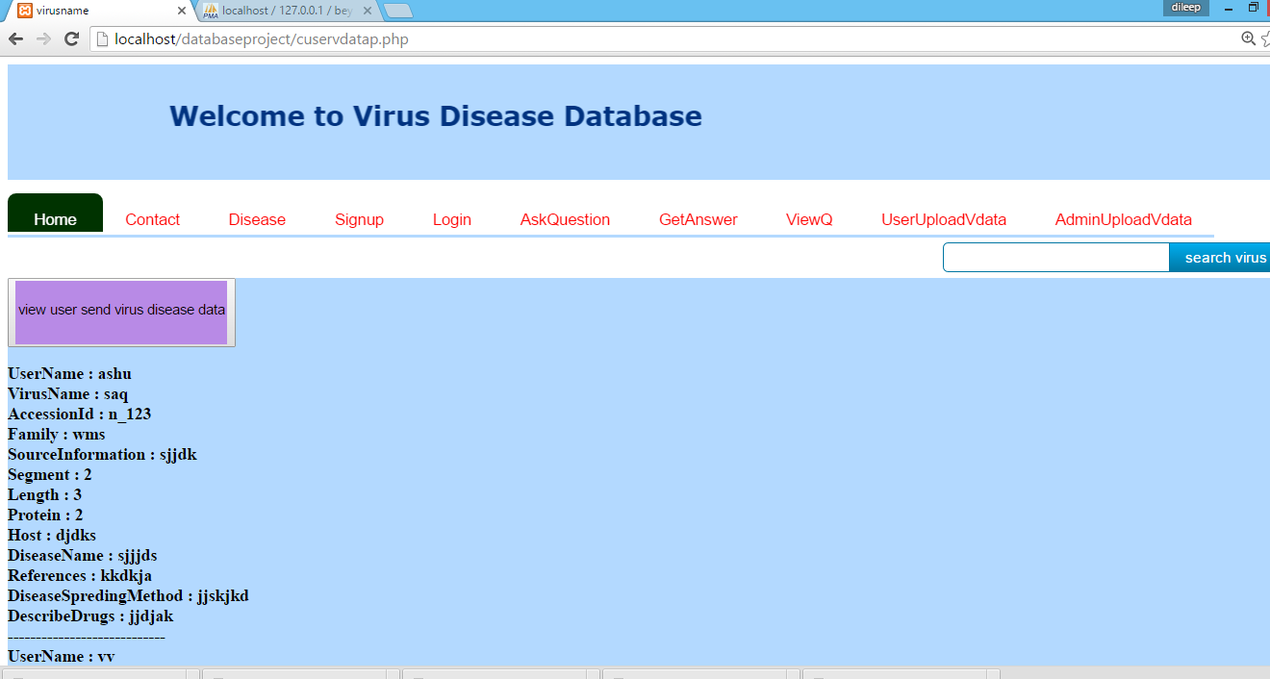

**Figure 3.1I: Admin check user send virus disease data**

Admin by using this page will able to upload the virus disease data and that data too which have been send by the user but after the checking that data because in that may some errors.

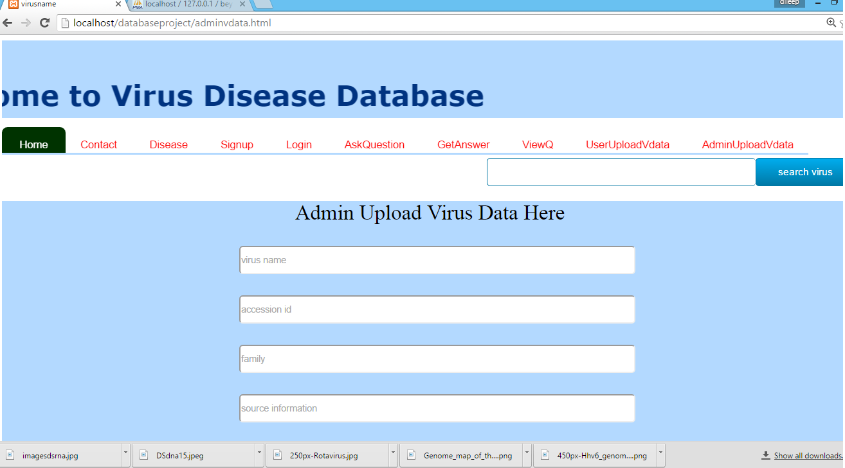

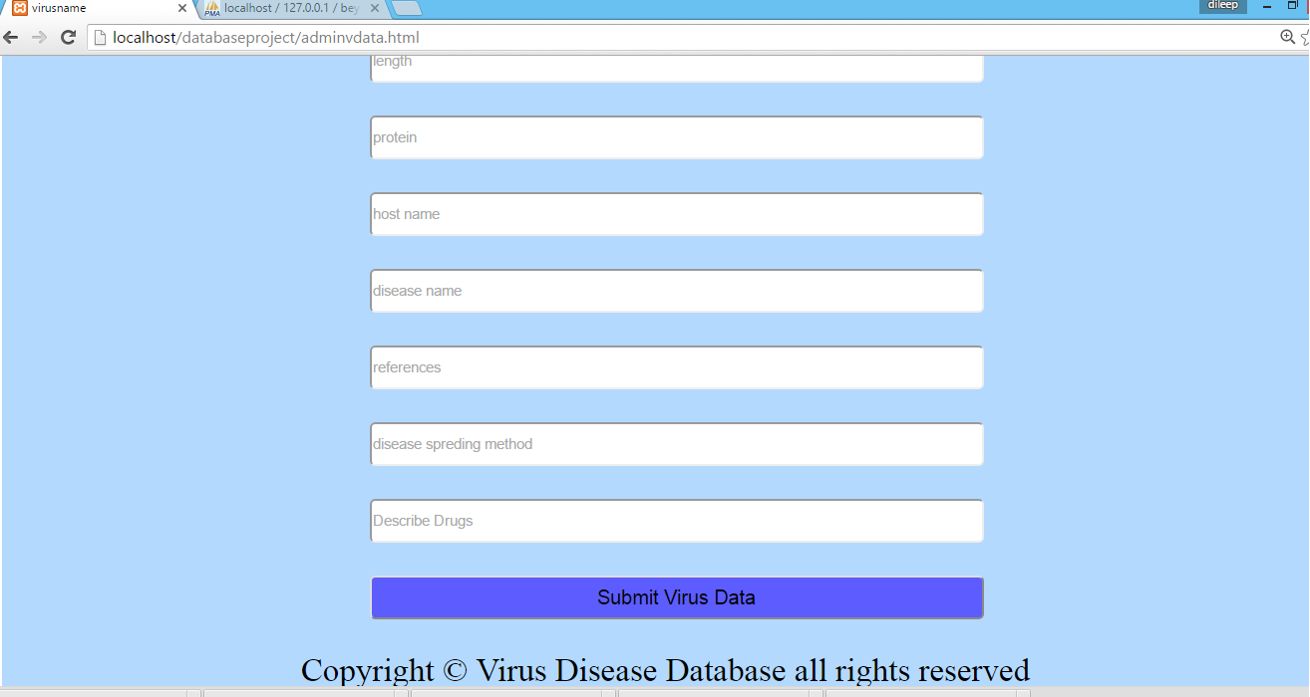

**Figure 3.1J: Admin upload virus disease data page**

**3.2 DISCUSSION**

Virusese have been explored the different - different kinds of disease .So we have been known that one virus could do the one or more than one disease and that disease could be very harmful or may be not . This is depends on the virus that is have pathogenic or not most viruses are pathogenic and they do the infection and that infection converted into the disease after the some time when the mechanism will be completed of the spreading and infection .

But I have made the virus disease database which will be useful into the study of the disease and about the virus too because I have been search for the data of virus disease in the different types of websites which have not been gather the all require of virus disease data which is require for the my virus disease database.

Virus disease database is a effective database which is showing the availability of data both virus and disease. In the virus disease data both have data like name of virus, protein presents in the virus, segments in the virus. family of virus and more about the disease.

**CHAPTER 4:**

**CONCLUSION**

In order to find a more reliable and very fast solution to related to virus and disease, i designed my study towards creating an “virus disease database” by including knowledge and information’s from the different research papers which have been published. The intention of this work is to enable the easy access of researchers, private organization, government organization, Clinical Practitioners and students to focus on identifying novel potent drugs with reduced disease effects.

The database will act as a platform at which all the published information on particular

Virus disease can stored and use in the future. The user can gather various information about a virus and that disease like disease treatment, disease spreading, prevention, segment in the virus, length of virus, proteins in the virus, source information, family of virus etc. and these all information about the virus and disease user will able to send this all information to the admin and admin will able to add all the information at the virus disease database because these all informations are valuable and also admin will able to delete all the virus disease database.

**CHAPTER 5:**

**REFERENCES**

1.Feldmann, H. & Geisbert, T. W. Ebola haemorrhagic fever. *The Lancet* **377**, 849–862

(2011).

2.  ["Viral Fever"](http://www.webhealthcentre.com/DiseaseConditions/vfever.aspx). Web Health Centre. Retrieved August 15, 2013.

3. Cook, S.; Moureau, G.; Harbach, R. E.; Mukwaya, L.; Goodger, K.; Ssenfuka, F.;

Gould, E.; Holmes, E. C.; de Lamballerie, X. (2009). "Isolation of a novel species of

flavivirus and a new strain of Culex flavivirus (Flaviviridae) from a natural mosquito

population in Uganda". Journal of General Virology

4. ["Researchers a step closer to making HIV vaccine"](http://www.medicalnewstoday.com/articles/258647.php).Medical News Today. April 5,

2013. Retrieved April 24,2013.

5.  ["Human hookworm vaccine trial"](http://www.medicalnewstoday.com/articles/240586.php). Medical News Today. January 20, 2012.

Retrieved April 24, 2013.

6. Zapata JC, Carrion R Jr, Patterson JL, Crasta O et al. Transcriptome analysis of human

peripheral blood mononuclear cells exposed to Lassa virus and to the attenuated

Mopeia/Lassa reassortant 29 (ML29), a vaccine candidate. PLoS Negl Trop Dis 2013

7. Tsuge M, Oka T, Yamashita N, Saito Y et al. Gene expression analysis in children

with complex seizures due to influenza A(H1N1)pdm09 or rotavirus gastroenteritis. J

Neurovirol 2014 Feb.

8. Dawany N, Showe LC, Kossenkov AV, Chang C et al. Identification of a 251 gene

expression signature that can accurately detect M. tuberculosis in patients with and

without HIV co-infection. PLoS One 2014