**Abstract**

Online voting system is Android application used to securely conduct votes and elections. As a digital platform, they eliminate the need to cast your votes using paper or having to gather in person.

They also protect the integrity of your vote by preventing voters from being able to vote multiple times.

Our System Make the use of Firebase as backend, for login, registration and for storage purpose which make our system highly secured and reliable.

It also uses Firebase ML kit for face detection which allows us to vote, one person at a time.

This application also verify biometric with the help of finger print sensor.

**Technologies Used**

* Android Studio
* Firebase
* OpenCv
* Biometrics
* Firebase ML Kit

**Table Of Contents**

ABSTRACT 1

LIST OF FIGURES .v

**CHAPTER** **1**

INTRODUCTION…………………………………………………………….5

* 1. Project Plan………………………………………………………………………………5
     1. About the project………………………………………………………………5
     2. Purpose and scope……………………………………………………………..5
  2. Front End……………………………………………………………………………….. 7
     1. Introduction Of Xml…………………………………………………………...7
  3. Back End………………………………………………………………………………...7
     1. Firebase………………………………………………………………………..7
     2. Firebase ML Kit……………………………………………………………….8
     3. Java……………………………………………………………………………9

CHAPETR 2

**PROPOSED AND EXISTING SYSTEM****…………………………………..11**

* 1. Proposed System………………………………………………………………………..12
     1. Feasibility Study……………………………………………………………..12

i) Economic Feasibility……………………………………………………….13

ii) Technical Feasibility………………………………………………………13

iii) Operational Feasibility……………………………………………………14

iv) Behavioural Feasibility……………………………………………………14

* 1. Existing System…………………………………………………………………………15

CHAPETR 3………………………………………………..16

**DIAGRAM** **AND OUTPUT**………………………………………………………………16

1. Data Flow Diagram………………………………………………………………….17
2. E-R Diagram………………………………………………………………………...18
3. Output Snapshots……………………………………………………………………20

CHAPTER 4……………………………………………….25

CONCLUSION / FUTURE ENHANCEMENT……………………………………………26

REFERENCES…………………………………………….27

**CHAPTER 1**

INTRODUCTION

**Introduction**

* 1. **PROJECT PLAN**

## ABOUT THE PROJECT

## Online Voting System is android application which allows user to vote remotely without going to anywhere.

## This Application is user friendly and easy to use for online voting securely and conveniently.

## This Application allows user to create account with their number, which will be used for login purpose and also, account will be create only after authentication by sending OTP on that number.

## This Application also ensure that only those person are allows to vote who are eligible for vote, this task accomplish by allow user to enter their ID, which will check their Date of Birth that are stored in firebase database.

## PURPOSE AND SCOPE

## The main purposes of OVS include:

## Provision of improved voting services to the voters through fast, timely and convenient voting.

## Reduction of the costs incurred by the Electoral Authority during voting time in paying the very many clerks employed for the sake of the success of the manual system.

## Check to ensure that the members who are registered are the only ones to vote.

## Online voting system will require being very precise or cost cutting to produce an effective election management system.

## Increased number of voters as individual will find it easier and more convenient to vote, especially those abroad.

* **Scope of OVS:**

It is focused on studying the existing system of voting and to make sure that STUDY the peoples vote is counts, for fairness in the elective positions.

This is also will produce:

• Less effort and less labor intensive, as the primary cost and focus primary on creating, managing, and running a secure web voting portal.

• Increasing number of voters as individuals will find it easier and more convenient to vote, especially those abroad.

## Front End

## Introduction of XML

Extensible Markup Language (XML) is a markup language that defines a set of rules for encoding documents in a format that is both human-readable and machine-readable .The design goals of XML focus on simplicity, generality, and usability across the Internet.

It is a textual data format with strong support via Unicode for different human languages.

Although the design of XML focuses on documents, the language is widely used for the representation of arbitrary data structures such as those used in web services.

1. XML stands for extensible Markup Language
2. XML is a markup language like [HTML](https://www.geeksforgeeks.org/html-basics/)
3. XML is designed to store and transport data
4. XML is designed to be self-descriptive

## Back End

## Firebase

Firebase is a mobile and web app development platform that provides developers with a plethora of tools and services to help them develop high-quality apps, grow their user base, and earn more profit.

The Firebase Realtime Database is a cloud-hosted NoSQL database that lets you store and sync between your users in realtime.

The Realtime Database is really just one big JSON object that the developers can manage in realtime.

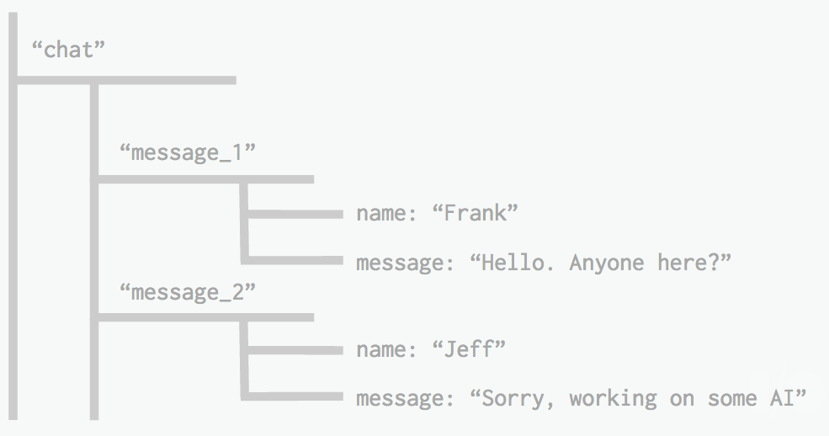

With just a single API, the Firebase database provides your app with both the current value of the data and any updates to that data.

## Firebase ML Kit

[Firebase ML Kit](https://firebase.google.com/products/ml-kit/) was introduced to us at Google I/O ’18. It is a mobile SDK that enables Android and iOS app developers to have advanced machine learning capabilities into their apps with ease.

ML Kit APIs works both on the device and on the cloud. The on-device APIs are designed to work fast with no internet connection.

On the other hand, cloud-based APIs uses Google Cloud Platform’s machine learning technology which gives more accurate results but requires an internet connection.

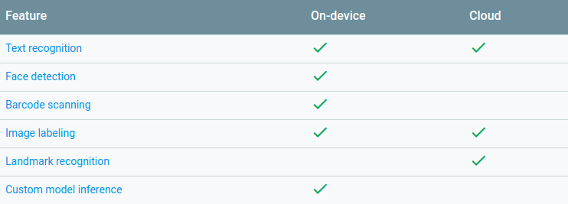

## Java

Java is a popular programming language, created in 1995.

It is owned by Oracle, and more than 3 billion devices run Java.

**It is used for:**

* Mobile applications (specially Android apps)
* Desktop applications
* Web applications
* Web servers and application servers
* Games
* Database connection
* And much, much more!

**CHAPTER 2**

PROPOSED AND EXISTING SYSTEM

**Proposed System**

To overcome the drawbacks of the existing system, the proposed system has been evolved. This project aims to reduce the paper work and saving time to generate accurate results from **Online Voting System (OVS)**.

The system provides with the best user interface. The efficient voting can be done by using this proposed system.

**Advantages of Proposed System**

* It is trouble-free to use.
* It is a relatively fast approach to give vote is highly reliable, approximate result from user Best user Interface and efficient outcomes.

**Feasibility Study:-**

Feasibility analysis begins once the goals are defined. It starts by generating broad possible solutions, which are possible to give an indication of what the new system should look lime.

This is where creativity and imagination are used. Analysts must think up new ways of doing things- generate new ideas. There is no need to go into the detailed system operation yet.

The solution should provide enough information to make reasonable estimates about project cost and give users an indication of how the new system will fit into the organization. It is important not to exert considerable effort at this stage only to find out that the project is not worthwhile or that there is a need significantly change the original goal.

Feasibility of a new system means ensuring that the new system, which we are going to implement, is efficient and affordable. There are various types of feasibility to be determined. They are

* + - 1. **Economically Feasibility**

Development of this application is highly economically feasible. The only thing to be done is making an environment with an effective supervision. It is cost effective in the sense that has eliminated the setup of voting booth and paper work completely. The system is also time effective because the voting is conducted by voter at anywhere in the world.

1. **Technical feasibility**

The technical requirement for the system is internet service and it does not use any other additional Hardware and software.

Technical evaluation must also assess whether the existing systems can be upgraded to use 6 the new technology and whether the organization has the expertise to use it.

This application depends on Google’s Firebase and internet service.

1. **Operational Feasibility**

The system working is quite easy to use and learn due to its simple but attractive interface.

User requires no special training for operating the system. Technical performance include issues such as determining whether the system can provide the right information for the voter personal details, and whether the system can be organized so that it always delivers this information at the right place and on time using internet services.

#### BEHAVIOURAL FEASIBILITY

This includes the following questions

* Is there sufficient support for the users?
* Will the proposed system cause harm?

The project would be beneficial because it satisfies the objectives when developed and installed.

All behavioural aspects are considered carefully and conclude that the project is behaviourally feasible.

## 

Online Voting System(OVS) is behaviourally feasible and there will be no harm for the users.

**Existing System**

* The existing system does not provide combination of face detection and biometric to identify person. Our System Achieve this with the help of **Image Processing** and Use of **finger print recognition**.
* Existing System does not provide high security, as in our system there use of firebase that make OVS more secure and reliable.
* Risk of Vote Redundancy and formatting as with the traditional method it may be possible that there will be redundancy in the votes and formatting.
* High In cost, as traditional system of voting is very high in cost, because there is need to setup voting booth at every place and cost of machines is also increase whole cost.
* Time Consuming, as traditional system of voting takes lot of time to complete whole process of voting, there are lots of plans are prepare to conduct voting which is time consuming process also in setting up voting booth and categories the regions and also rest process after voting that is counting vote is also time consuming.

**CHAPTER 3**

DIAGRAM AND OUTPUT

**Implementation or Architecture Diagrams**

1. **Data Flow Diagram (DFD)**

A data flow diagram is a graphical representation that depicts information flow and the transforms that are applied as data move from input to output. The basic form of a data flow diagram, also known as a data flow graph or a bubble chart, The data flow diagram may be used to represent a system or software at any level of abstraction. As information moves through software, it is modified by a series of transformations.

A data flow diagram is a graphical representation that depicts information flow and the transforms that are applied as data move from input to output. The basic form of a data flow diagram, also known as a data flow graph or a bubble chart. DFD is an abstract description of the system. The data flow diagram may be used to represent a system or software at any level of abstraction. DFDs may be partitioned into levels that represent increasing information flow and functional detail. Therefore, the DFD provides a mechanism for functional modeling as well as information flow modeling.

DFDs are very useful in understanding a system and can be effectively used during analysis. DFDs can be hierarchically organized, which helps in progressively partitioning and analyzing large systems. Such DFDs are called leveled DFDs.

Context diagram is a diagram in which the entire system is treated as a single process and all its inputs, outputs, sinks, and sources are identified and shown.

**Level 0 DFD**

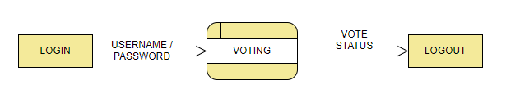

**LEVEL 1 DFD**

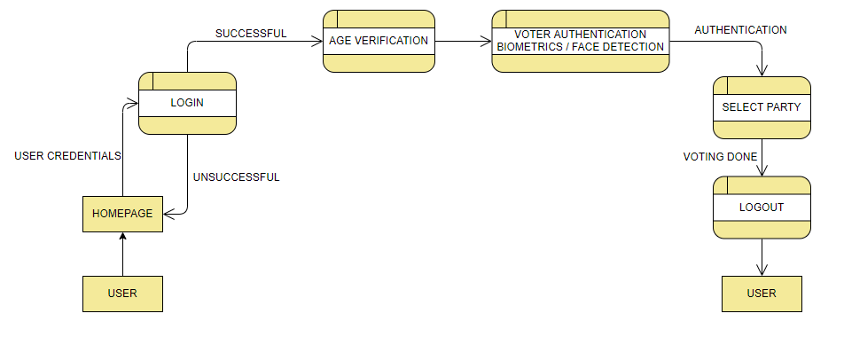

1. **ER DIAGRAM**

An entity–relationship model (ER model) describes interrelated things of interest in a specific domain of knowledge. A basic ER model is composed of entity types (which classify the things of interest) and specifies relationships that can exist between instances of those entity types.

In software engineering, an ER model is commonly formed to represent things that a business needs to remember in order to perform business processes.

Consequently, the ER model becomes an abstract data model, that defines a data or information structure which can be implemented in a database, typically a relational database.

Entity–relationship modeling was developed for database design by Peter Chen and published in a 1976 paper. However, variants of the idea existed previously. Some ER models show super and subtype entities connected by generalization-specialization relationships, and an ER model can be used also in the specification of domain-specific ontologies.

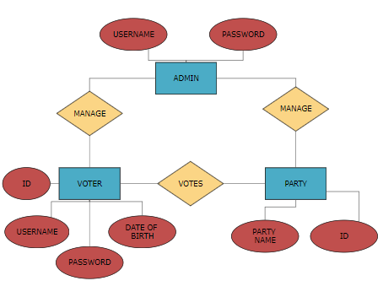

**Output/Screenshot**

* 1. Welcome Page

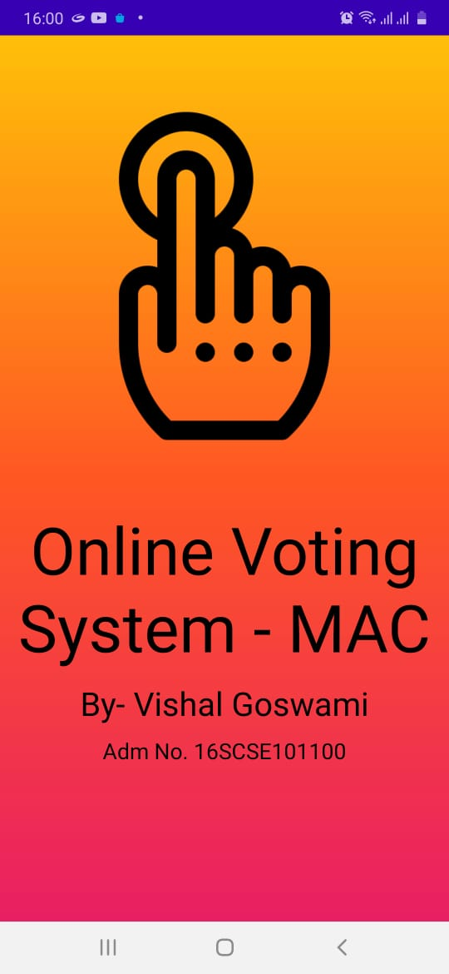

* 1. Home Page

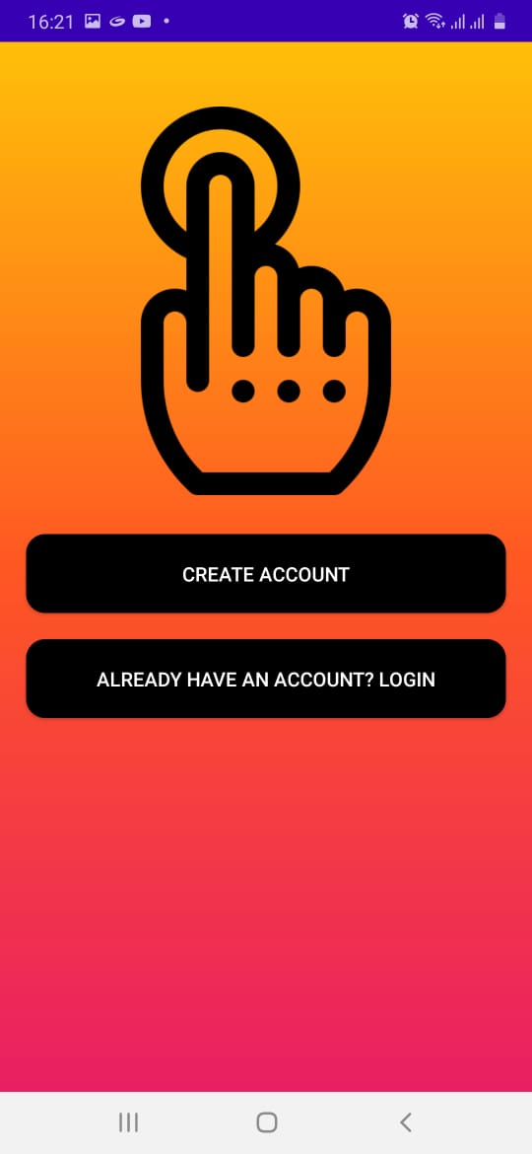

* 1. Registration Page

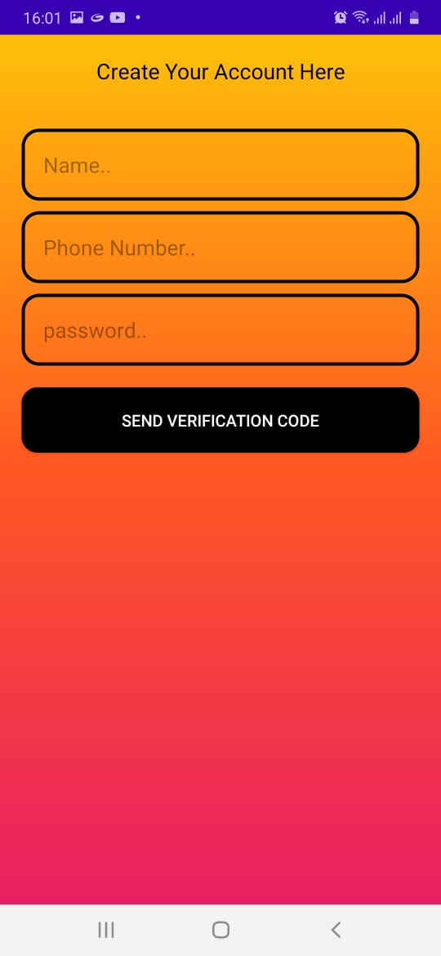

4. Login Page

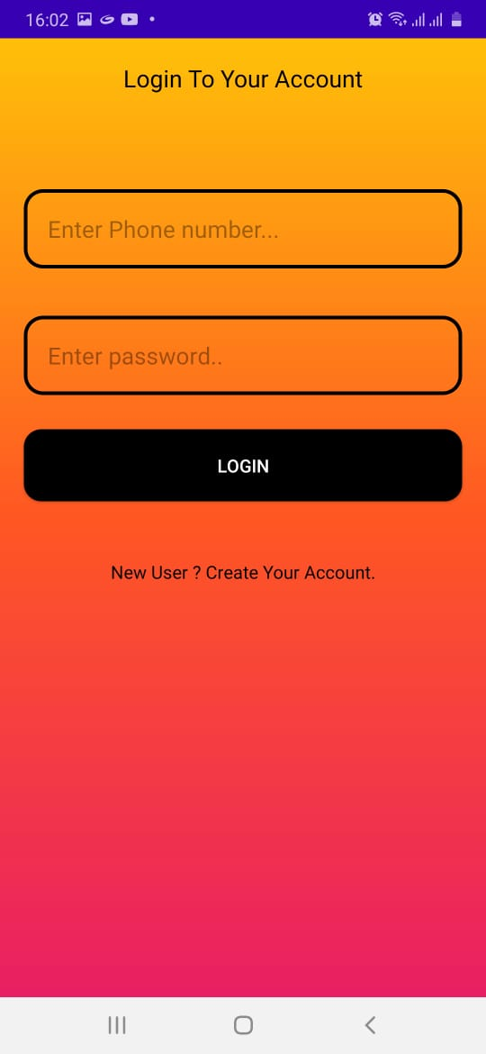

5. Vote Page/Fingerprint Sensor

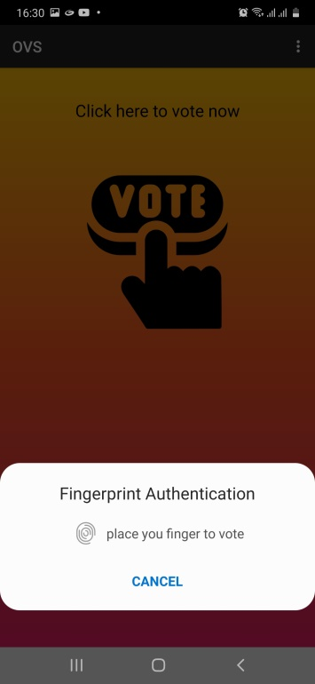

6. ID Verification Page

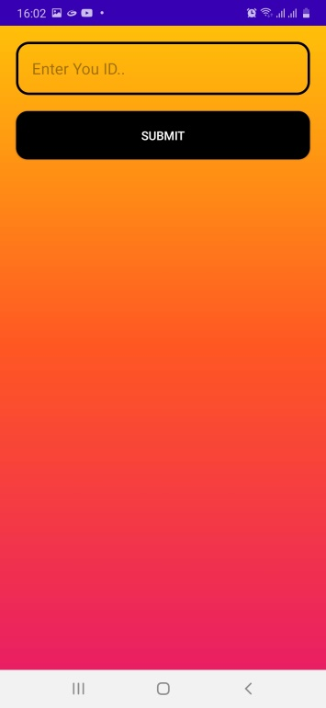

7. Face Detection Page/Image Processing

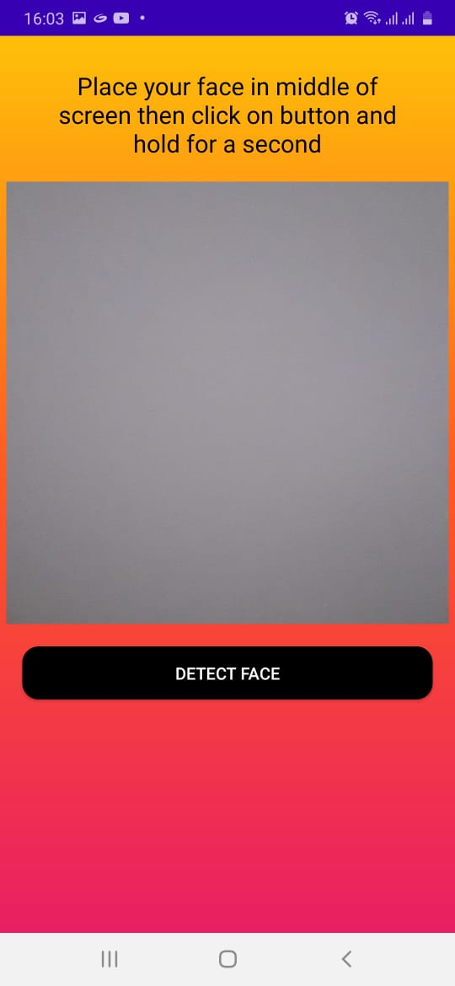

8. Select Party Page

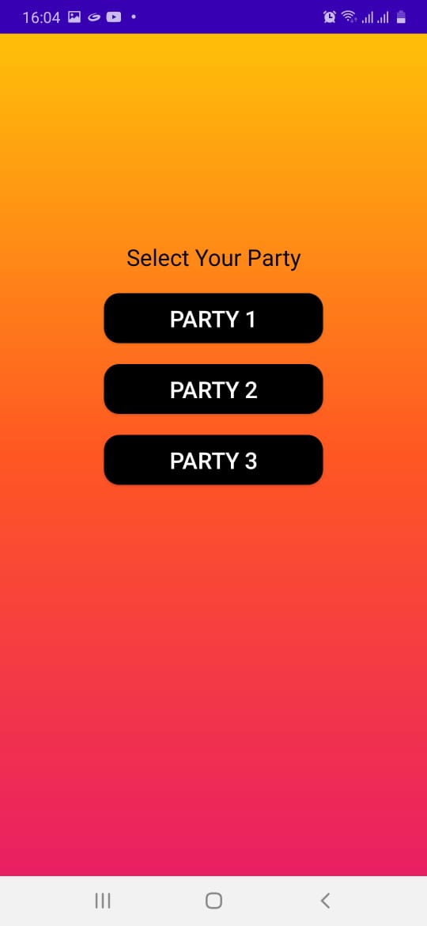

9. Final Status Page

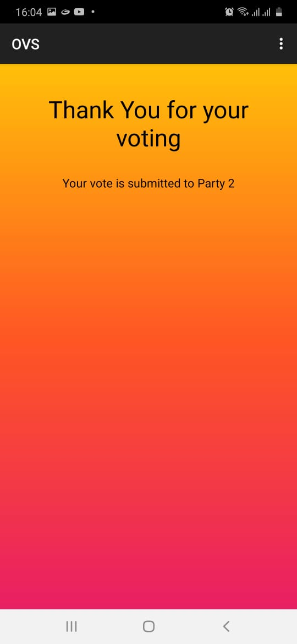

**CHAPTER 4**

CONCLUSION / FUTURE ENHANCEMENT

**Conclusion/Future Enhancement**

* This Online Voting system will manage the Voter’s information by which voter can login and use his voting rights. The system will incorporate all features of voting system. It provides the tools for maintaining voter’s vote to every party. There is a Database which is maintained on platform that is Firebase in which all the names of voter with complete information is stored.
* In this user who is above 18 year’s register his/her information on the database and when he/she want to vote he/she has to login by his id and password and can vote to any party only single time. Voting details store in database. By online voting system percentage of voting is increases. It decreases the cost and time of voting process. It is very easy to use and It is very less time consuming.
* In future we will enhance our system by integrate AADHAAR Card detail API so that, we can match actual Biometrics of user with input biometrics and also, we will add face recognition feature with face detection that will make our system more reliable.

**REFERENCES**

#### BOOKS:

* Ian Somerville ‘Software engineering’
* Rajeev mall ‘Software engineering’

#### ONLINE REFERENCE:

1. [www.google.co.in](http://www.google.co.in)
2. www.stackoverflow.com
3. firebase.google.com/docs
4. W3 school

**Note: creately, visual paradign are online tool for creating diagrams**