TAQA Enterprise Integration

AADC eServices – Drawing –SetLaserFicheDocuments Technical Unit Test Results

Author: Jagadeesh Gutta

Version 1.0 |

© 2022 LTI. All rights reserved.

## Service Details

|  |  |
| --- | --- |
| Feature | Details |
| Package | TAQA_AADC_Drawings |
| Service Name | SetLaserFicheDocuments |
| Dependent Service Names | N/A |
| Consumer | AADC eServices |
| Provider Name | SQL Database |
| Adapter Names | TAQA_AADC_Drawings.adapters:SetLaserFicheDocuments |

## Results

**TLIT-588:** Drawings:Verify"SetLaserFicheDocuments" API, Send a valid Request from AADC Customer (E-services Web site) to LaserFiche Service with Valid Template Type-Positive

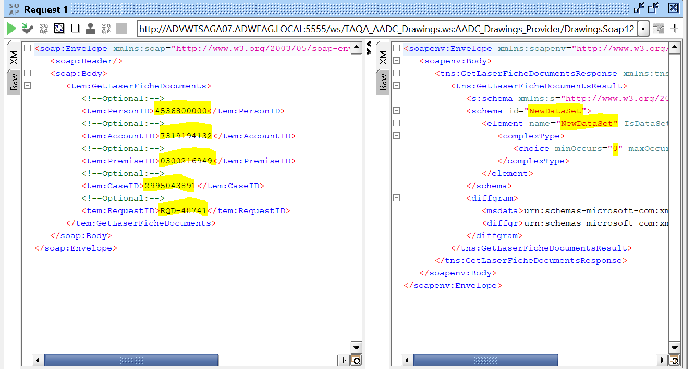

**TLIT-589:** Drawings:Verify"SetLaserFicheDocuments" API, Send a valid Request from AADC Customer (E-services Web site) to LaserFiche Service with Valid Document Type-Positivevalue 

**TLIT-590:** Drawings:Verify"SetLaserFicheDocuments" API, Send a valid Request from AADC Customer (E-services Web site) to LaserFiche Service with Valid Field ID-Positivevalue

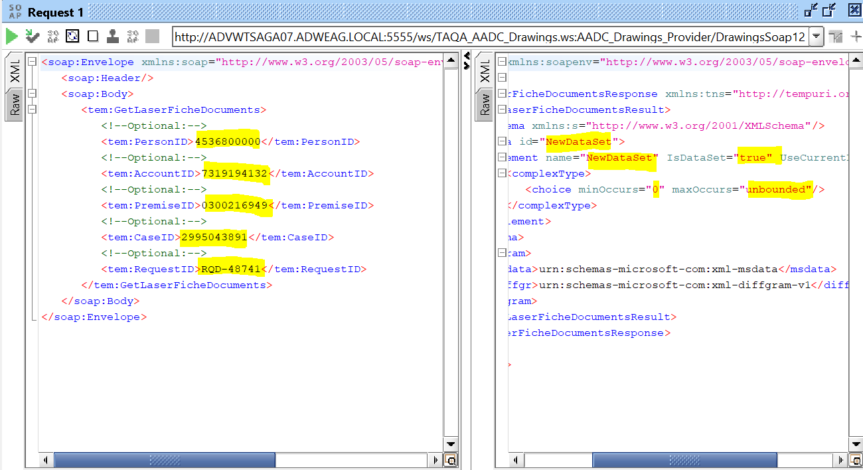

TLIT-591: Drawings:Verify"SetLaserFicheDocuments" API, Send a valid Request from AADC Customer (E-services Web site) to LaserFiche Service with Valid Request ID-Positive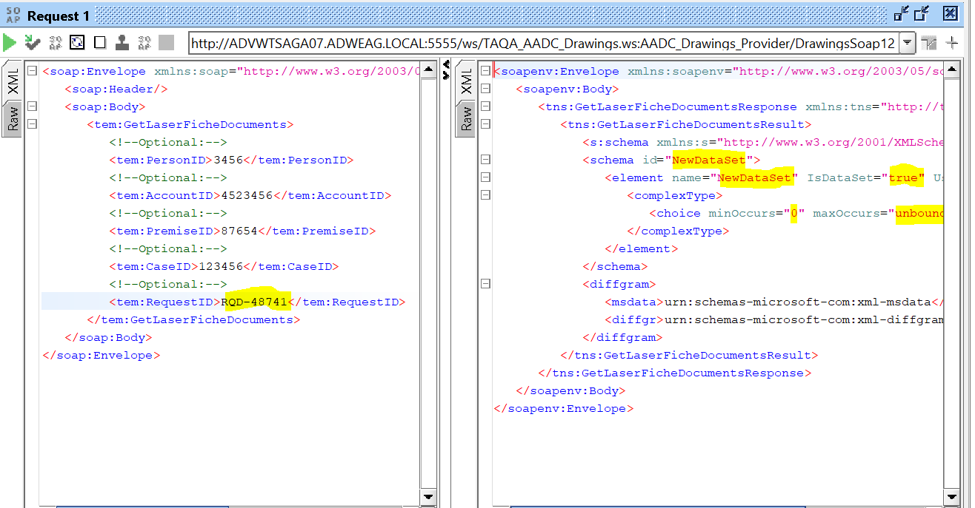

TLIT-592: Drawings:Verify"SetLaserFicheDocuments" API, Send a valid Request from AADC Customer (E-services Web site) to LaserFiche Service with invalid Field ID-Negative

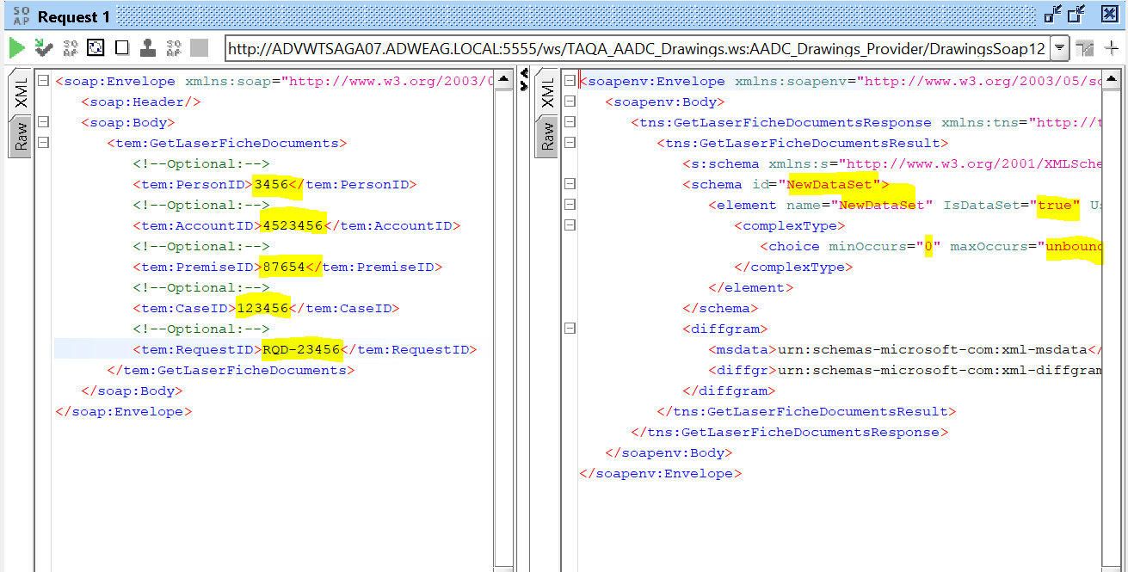

TLIT-593: Drawings:Verify"SetLaserFicheDocuments" API, Send a valid Request from AADC Customer (E-services Web site) to LaserFiche Service with invalid Request ID-Negative

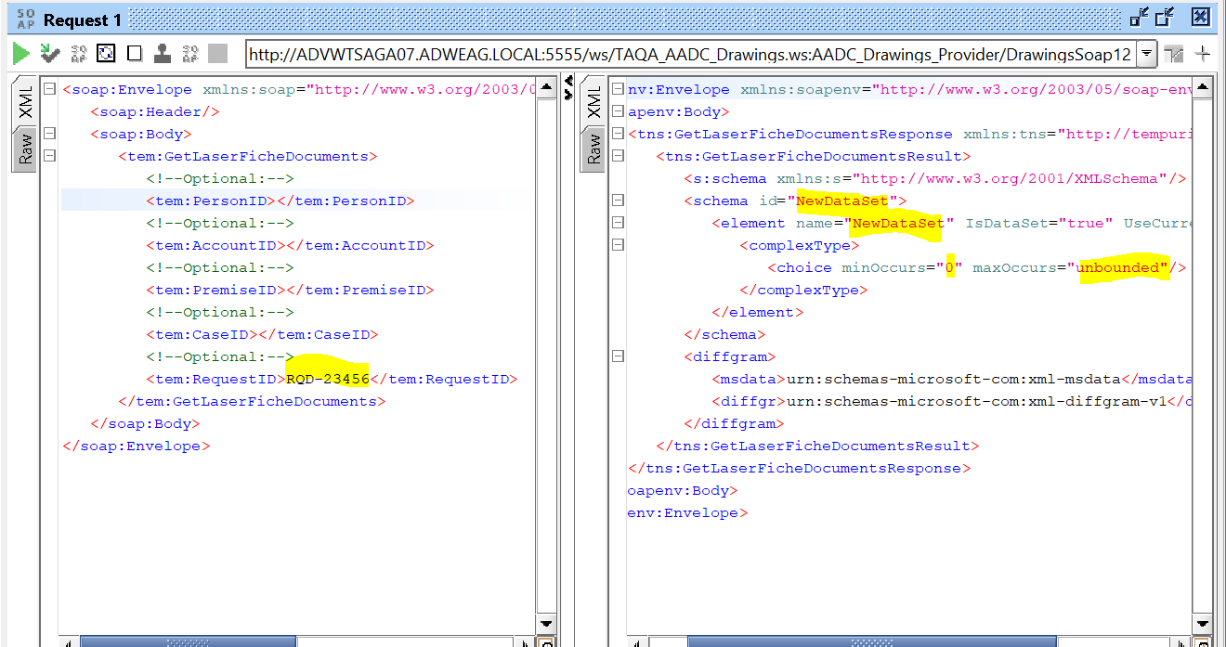

TLIT-594: Drawings:Verify"SetLaserFicheDocuments" API, Send a valid Request from AADC Customer (E-services Web site) to LaserFiche Service with empty or blank payload-Negative

