TAQA Enterprise Integration

AADC eServices – Drawing -GetOutStandingBalance Technical Unit Test Results

Author: Jagadeesh Gutta

Version 1.0 |

© 2022 LTI. All rights reserved.

## Service Details

|  |  |
| --- | --- |
| Feature | Details |
| Package | TAQA_AADC_Drawings |
| Service Name | GetOutstandingBalance |
| Dependent Service Names | N/A |
| Consumer | AADC eServices |
| Provider Name | CCB Oracle Database |
| Adapter Names | TAQA_AADC_Drawings.adapters:getOutStandingBalance |

## Results

**TLIT-298**: Drawing:Verify"GetOutStandingBalanceDetails" API, Send a valid request from AADC Customer (E-services Web site) to Oracle DB CCB with valid account id-Positive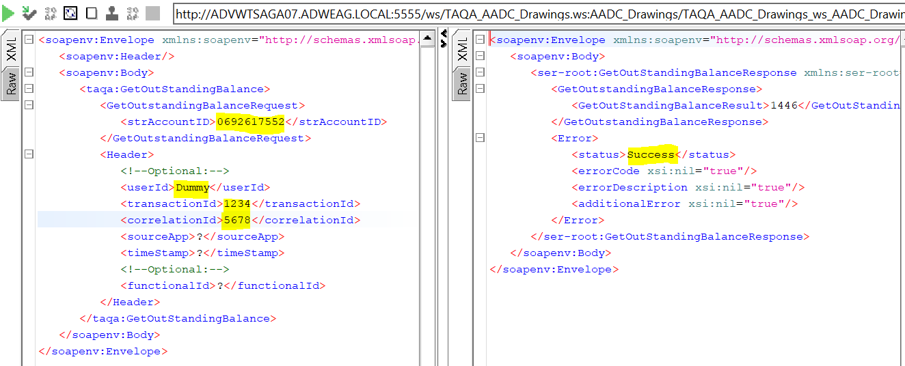

**TLIT-302:** Verify"GetOutStandingBalanceDetails" API, Send a valid request from AADC Customer (E-services Web site) to Oracle DB CCB with invalid account id-Negative

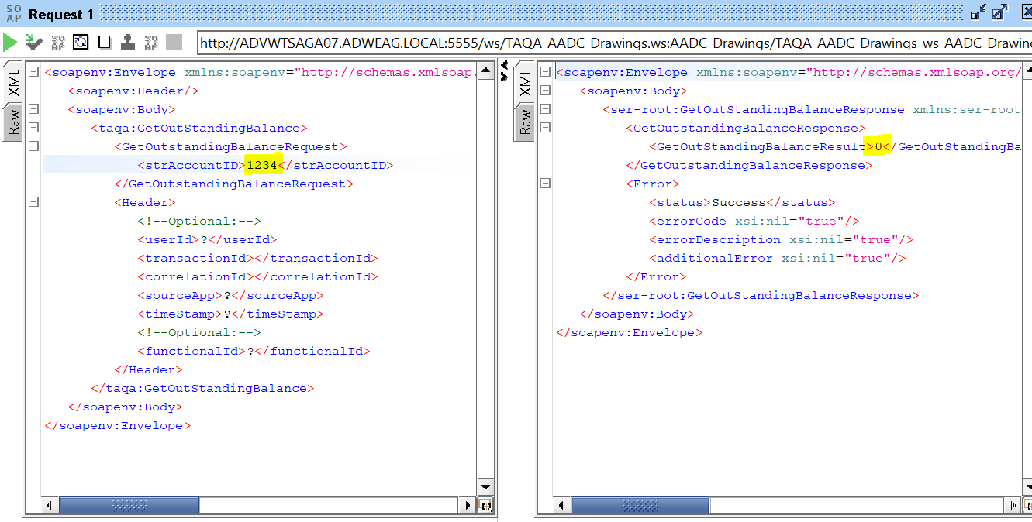

**TLIT-303:** Drawing:Verify"GetOutStandingBalanceDetails" API, Send a valid request from AADC Customer (E-services Web site) to Oracle DB CCB with null account id-Negative

