TAQA Enterprise Integration

AADC eServices – Drawing -GetUserDetails Technical Unit Test Results

Author: Jagadeesh Gutta

Version 1.0 |

© 2022 LTI. All rights reserved.

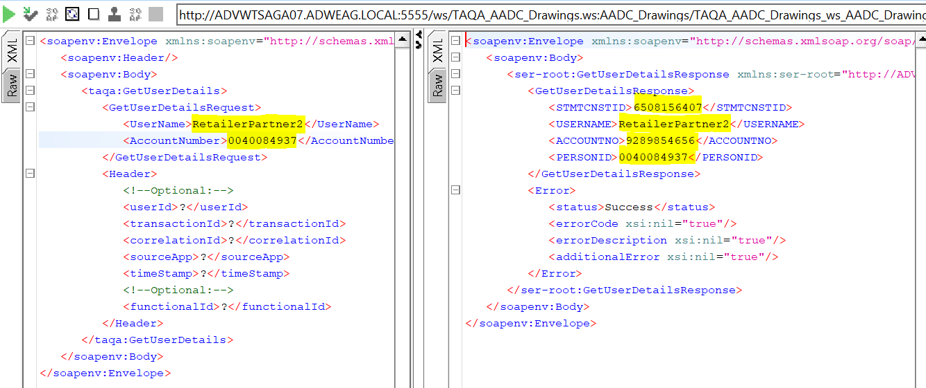

**TLIT-395:** Drawing:Verify"GetUserDetails"API, Send a valid request from AADC Customer (E-services Web site) with correct Username and incorrect Account no.to get user details on SQL DB -Negative

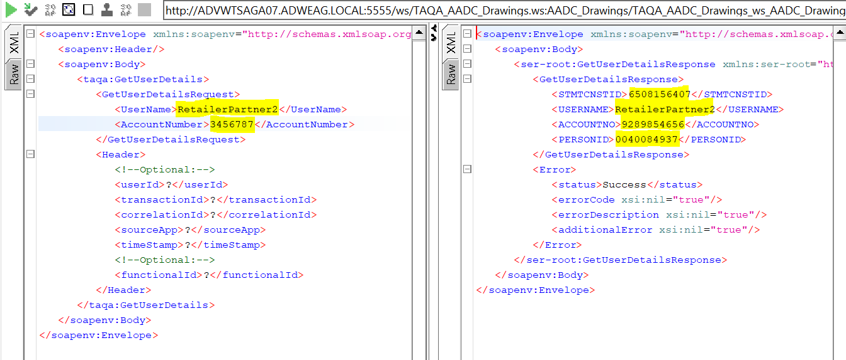

TLIT-398: Drawing:Verify"GetUserDetails"API, Send a valid request from AADC Customer (E-services Web site) with incorrect Username and incorrect Account no.to get user details on SQL DB -Negative

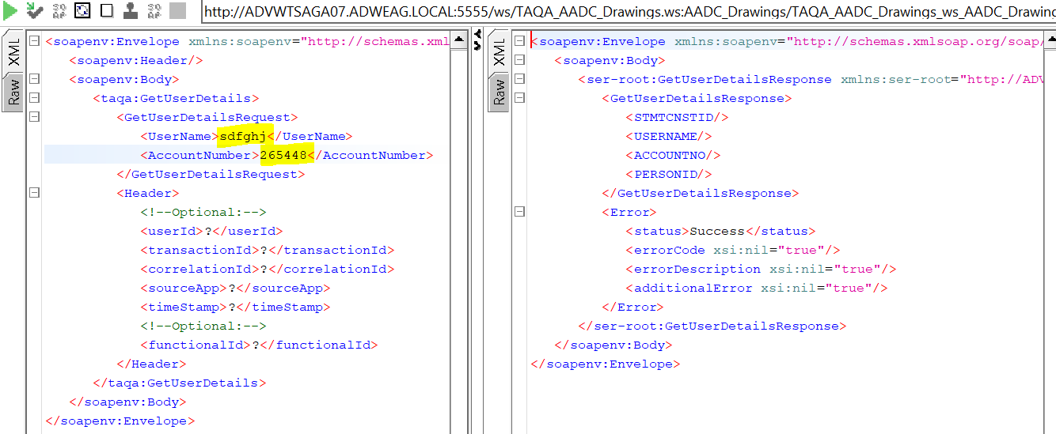

**TLIT-402:** Drawing:Verify"GetUserDetails"API, Send a valid request from AADC Customer (E-services Web site) with null Username and correct Account no.to get user details on SQL DB -Negative

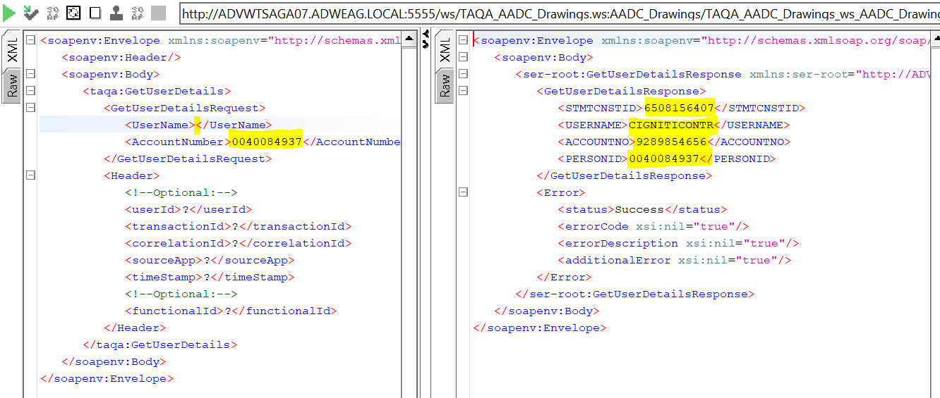

TLIT-404: Drawing:Verify"GetUserDetails"API, Send a valid request from AADC Customer (E-services Web site) with null Username and null Account no.to get user details on SQL DB -Negative

