TAQA Enterprise Integration

AADC eServices – Drawing -GetUserDetails Technical Unit Test Results

Author: Jagadeesh Gutta

Version 1.0 |

© 2022 LTI. All rights reserved.

## Service Details

|  |  |
| --- | --- |
| Feature | Details |
| Package | TAQA_AADC_Drawings |
| Service Name | GetUserDetails |
| Dependent Service Names | N/A |
| Consumer | AADC eServices |
| Provider Name | SQL Database |
| Adapter Names | TAQA_AADC_Drawings.adapters:GetUserDetails |

## Results

**TLIT-411**;Drawings:SqlInsertUpdateContractorSurvey-PositiVerify“SqlInsertUpdateContractorSurvey “ API, Send a valid request from AADC Customer (E-services Web site) to SQL DB with valid Case Details (Request Object) Fields

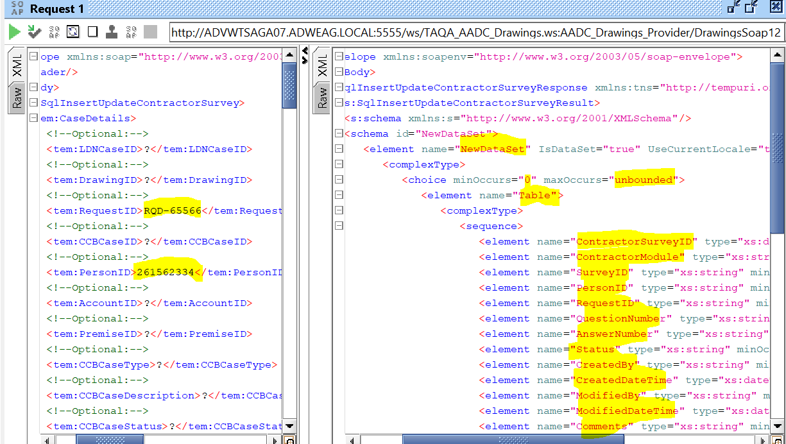

**TLIT-412:**Drawings:SqlInsertUpdateContractorSurvey-NegatVerify“SqlInsertUpdateContractorSurvey “ API, Send a valid request from AADC Customer (E-services Web site) to SQL DB with incorrect Case Details (Request Object) Fields

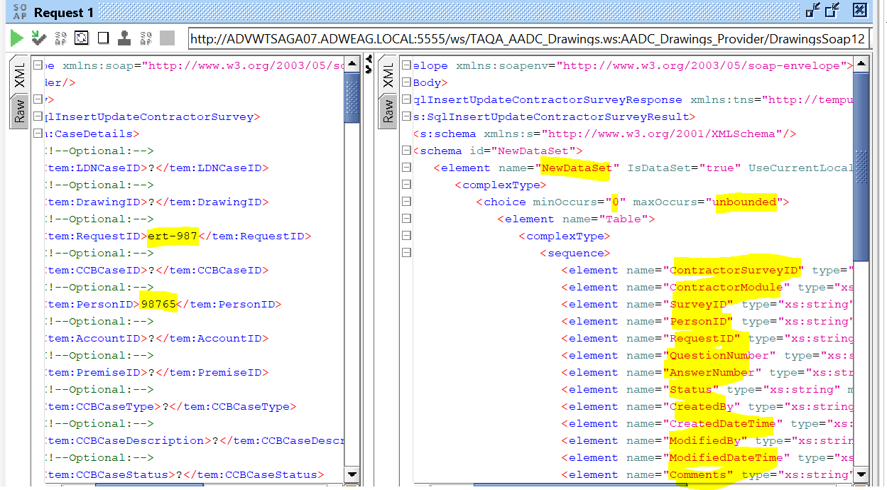

TLIT-413:Drawings:SqlInsertUpdateContractorSurvey-NegatiVerify“SqlInsertUpdateContractorSurvey “ API, Send a valid request from AADC Customer (E-services Web site) to SQL DB with blank Case Details(RequestObject)Fields 