TAQA Enterprise Integration

AADC eServices – Drawing –VerifyOpenCase Technical Unit Test Results

Author: Jagadeesh Gutta

Version 1.0 |

© 2022 LTI. All rights reserved.

## Service Details

|  |  |
| --- | --- |
| Feature | Details |
| Package | TAQA_AADC_Drawings |
| Service Name | VerifyOpenCase |
| Dependent Service Names | N/A |
| Consumer | AADC eServices |
| Provider Name | SQL Database |
| Adapter Names | TAQA_AADC_Drawings.adapters:VerifyOpenCase |

## Results

**TLIT-441:** Drawings:Positive-Verify“VerifyOpenCase “ API, Send a valid request from AADC Customer (E-services Web site) to Oracle DB CCB with valid Premise ID and Case Type value

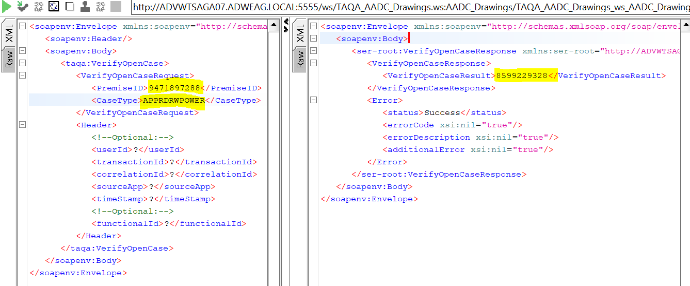

**TLIT-443:** Drawings:Negative-Verify“VerifyOpenCase “ API, Send a valid request from AADC Customer (E-services Web site) to Oracle DB CCB with incorrect Premise ID and valid Case Type value 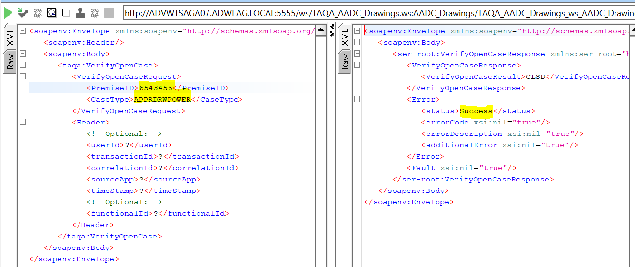

**TLIT-444:** Drawings:Negative-Verify“VerifyOpenCase “ API, Send a valid request from AADC Customer (E-services Web site) to Oracle DB CCB with valid Premise ID and incorrect Case Type value

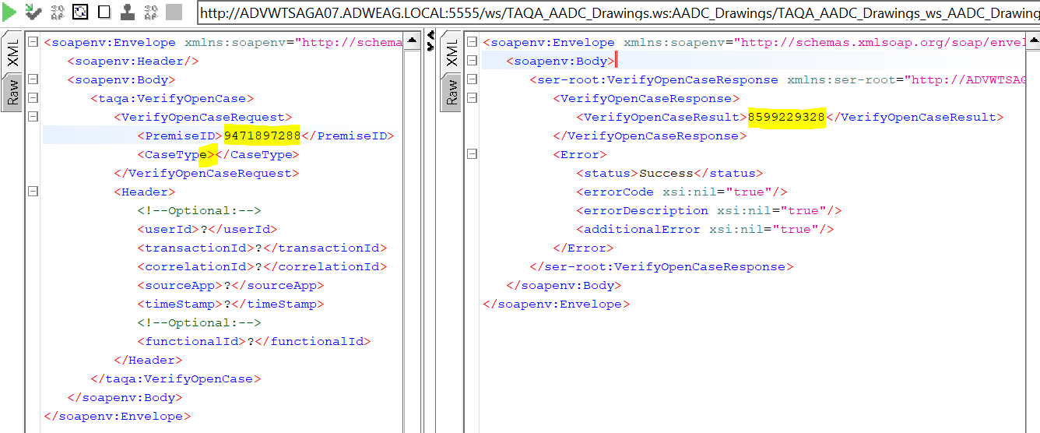

TLIT-445: Drawings:Negative-Verify“VerifyOpenCase “ API, Send a valid request from AADC Customer (E-services Web site) to Oracle DB CCB with incorrect Premise ID and incorrect Case Type value

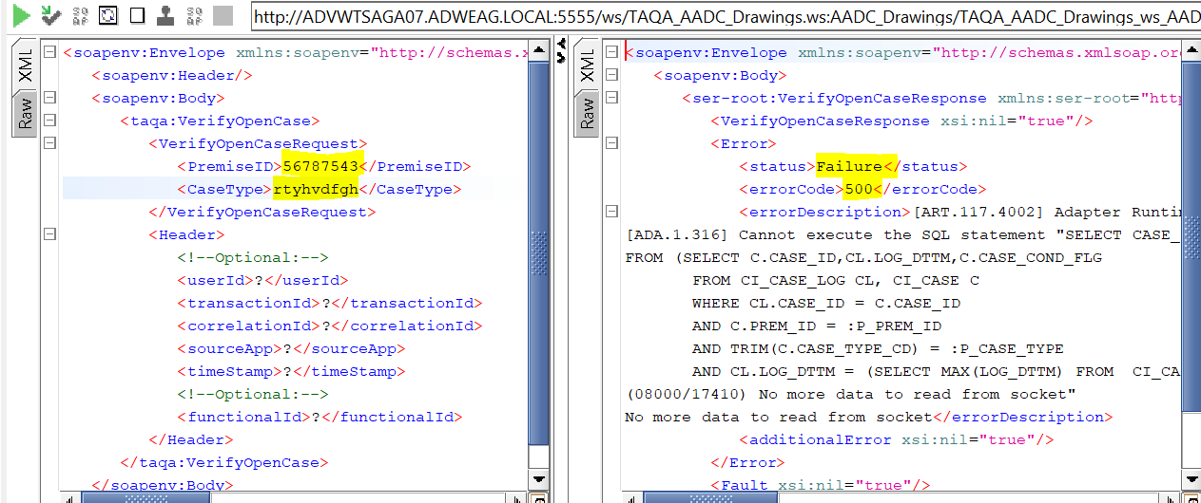

TLIT-447: Drawings:Negative-Verify“VerifyOpenCase “ API, Send a valid request from AADC Customer (E-services Web site) to Oracle DB CCB with blank Premise ID and valid Case Type value

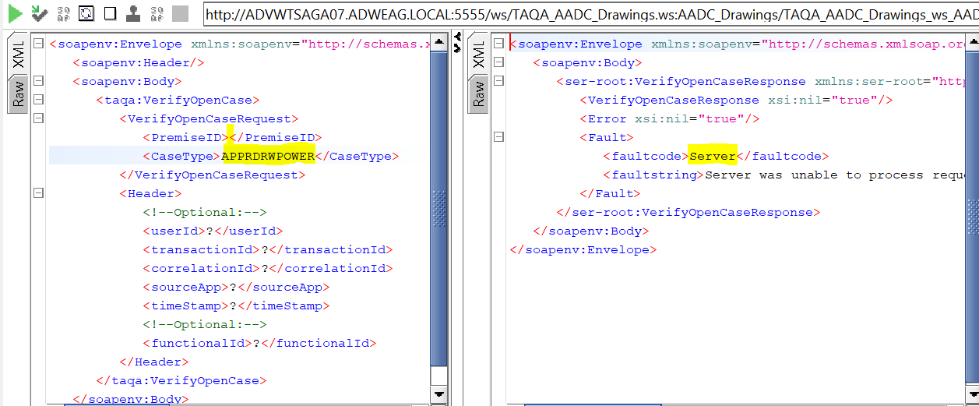

TLIT-449: Drawings:Negative-Verify“VerifyOpenCase “ API, Send a valid request from AADC Customer (E-services Web site) to Oracle DB CCB with blank Premise ID, blank Case Type value