TAQA Enterprise Integration

AADC eServices – Drawing – GetCCBCaseDetails Unit Test Results

Author: Dhindigala Saicharan

Version 1.0 |

© 2022 LTI. All rights reserved.

## Service Details

|  |  |
| --- | --- |
| Feature | Details |
| Package | TAQA_AADC_Drawings |
| Service Name | GetCCBCaseDetails |
| Dependent Service Name | N/A |
| Consumer | AADC Customer (E-services Web site) |
| Provider Name | Oracle CCB XAI Service |

## Results

Success - Screenshot for Success case after implementation.

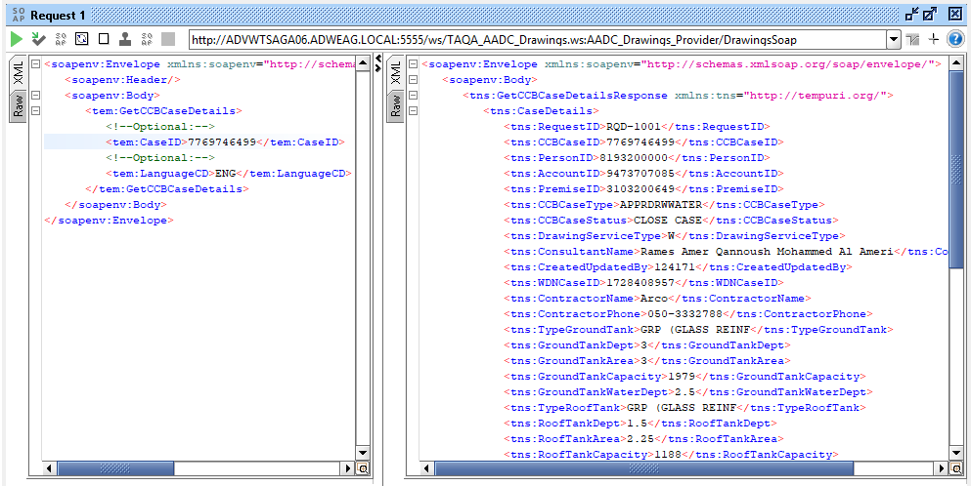

#### Actual Xmls provided in Use case Document

|  |  |  |
| --- | --- | --- |
| Scenario | Request | Response |
| Success |  |  |
| Invalid/Dummy |  |  |
| Blank |  |  |

#### After Implementation in WebMethods

|  |  |  |  |  |
| --- | --- | --- | --- | --- |
| JIRA ID | Scenario | Request | Response | |
| TLIT-307 | Drawing:GetCCBCaseDetails-Positive-Validate Sending a valid request from AADC Customer (E-services Web site) to CCB/Oracle Database with valid Case ID and LanguageCD |  | |  |
| TLIT-308 | Drawing:GetCCBCaseDetails-Negative-Validate Sending a valid request from AADC Customer (E-services Web site) to CCB/Oracle Database with invalid Case ID and LanguageCD |  | |  |
| TLIT-309 | Drawing:GetCCBCaseDetails-Negative-Validate Sending a valid request from AADC Customer (E-services Web site) to CCB/Oracle Database with blank Case ID and LanguageCD |  | |  |
| TLIT-310 | Drawing:GetCCBCaseDetails-Negative-Validate Sending a valid request from AADC Customer (E-services Web site) to CCB/Oracle Database with invalid Case ID and Valid LanguageCD |  | |  |