

API Platform Technology Architecture,
Security & Operational Controls
RBI / Regulatory Technology Audit Document
IDFC FIRST Bank Confidential
Context / Summary
This document describes the current API Platform architecture, deployment model, security and operational controls, data flows, and disaster-recovery arrangement for authorised IDFC FIRST Bank internal and RBI audit use.
Document Control
Document Name | API Platform - Technology Architecture, Security & Operational Controls
Version No. | 1.0
Release No. | 1.0
Release Date | 21-Jul-2026
Previous Release Date | NA
Written By | Dileep Kumar Maurya
Reviewed By | Rashi Bansal
Approved By | Prakash Rangaraj
Classification | IDFC FIRST Bank Confidential
Name of File | IDFC_FIRST_API_Platform_Technology_Controls_v1.0.docx

Document Amendment History
Version | Date | Change Details | Initiated By | Reviewed By | Approved By
1.0 | 21-Jul-2026 | Initial issue | Dileep Kumar Maurya | Rashi Bansal | Prakash Rangaraj

Table of Contents
1. Executive Summary 4
2. Document Purpose and Scope 4
3. Platform Overview and Ownership 5
4. Environment and EKS Deployment Model 6
5. High-Level Architecture and Data Flow 7
6. Application Runtime and Container Architecture 8
7. Authentication and Data Protection 8
8. CI/CD, Source Control and Release Management 9
9. Vulnerability and Container Security 9
10. Secrets and Credential Management 10
11. Logging, Monitoring and Incident Operations 10
12. Data Services and Integrations 11
13. Availability, Backup and Disaster Recovery 11
14. Risk and Control Summary 14
15. Audit Evidence 15
16. Roles and Responsibilities 15
17. Document Approval and Change History 16
Appendix A. EKS Cluster Inventory 16

1. Executive Summary
The API Platform is a high-criticality, reusable technology foundation operated by IDFC FIRST Bank for the development, deployment and operation of API-based services. The platform standardises the application runtime on Java 21 and Spring Boot 3.5, deploys workloads to Amazon EKS, and uses controlled CI/CD promotion through Bitbucket, SonarQube, Amazon ECR, Twistlock/Prisma Cloud and GoCD.
The platform supports integrations with internal bank systems and external partners. Inbound API access is routed through Kong, while authentication and authorisation use Ory Hydra with OAuth 2.0. Approved outbound calls from platform services use the Kong egress path to reach external providers. Detailed Kong controls are intentionally outside the scope of this document. PII and other sensitive data are protected through encryption in transit and classification-based encryption at rest.
Production is hosted in the Mumbai AWS region (ap-south-1) and disaster recovery is hosted in Hyderabad (ap-south-2). PROD and DR use separate VPCs and separate EKS clusters. AWS Global Accelerator provides health-based traffic steering and automatic regional failover through the regional NLB/ALB endpoints. The approved RPO is 30 minutes and the RTO is two hours. DR exercises are performed quarterly.

2. Document Purpose and Scope

2.1 Purpose
This document outlines the current API Platform architecture, deployment model, technology controls and data flows between the platform and the wider IDFC FIRST Bank ecosystem. It provides an audit-oriented view of how platform components are designed, deployed, secured, monitored and recovered.

2.2 In Scope
- Java 21 and Spring Boot 3.5 microservices hosted on Amazon EKS.
- DEV, SIT, UAT, PRE-PROD, PROD and DR environments.
- Bitbucket source control, SonarQube SAST, Amazon ECR, Twistlock/Prisma Cloud and GoCD.
- Ory Hydra with OAuth 2.0 and Kubernetes Secrets.
- Aerospike, Oracle Database (FinnOne), Amazon MSK and Amazon S3 data services.
- ELK/Kibana, Prometheus and Jaeger observability.
- Production operations, backup and disaster recovery.

2.3 Scope Boundary
Kong appears in the architecture as the mandatory API gateway path. Detailed Kong gateway configuration, plugin controls and gateway-team operating procedures are not assessed in this document.

3. Platform Overview and Ownership
Attribute | Confirmed Value
Platform | API Platform
Business purpose | Reusable and governed platform for API projects and data flows across the bank ecosystem
Business criticality | High
Engineering owner | Java Platform Team
24×7 operations | BTO Team - monitoring and first-level incident response
Identity owner | Separate internal IDFC Identity Team
Application runtime | Java 21; Spring Boot 3.5
Core AWS services | Amazon EKS, Amazon ECR, Amazon S3, Amazon MSK
Data stores | Aerospike; Oracle Database (FinnOne - direct integration)
Observability | ELK/Kibana, Prometheus and Jaeger
Source and deployment | Bitbucket and GoCD

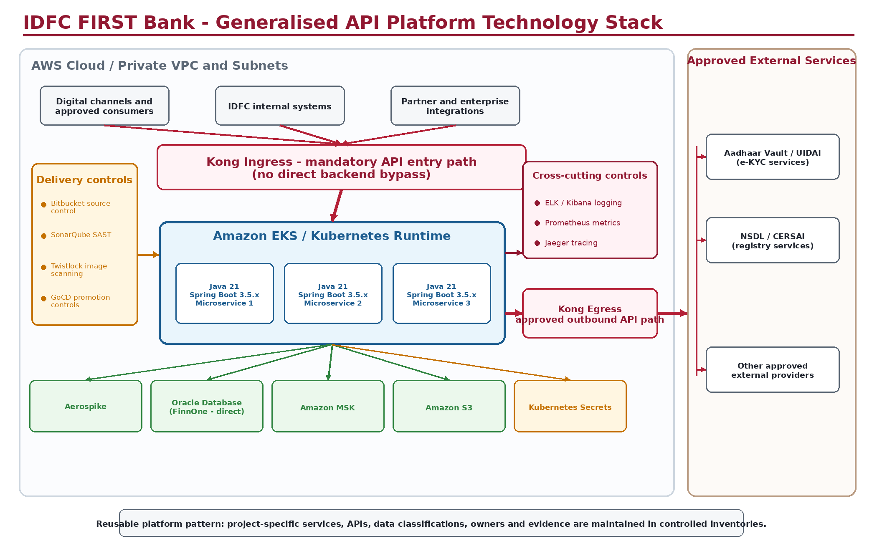
Figure 1 - Generalised API Platform technology stack and reusable project pattern.

4. Environment and EKS Deployment Model
Each environment is hosted on a separate Amazon EKS cluster. Non-production workloads use the non-production AWS account; PROD and DR use the production AWS account. AWS account IDs are intentionally omitted from this document.
Environment | AWS Region | EKS Cluster | Deployment Notes
DEV | ap-south-1 (Mumbai) | dcawsapifactoryjavadev001 | Separate non-production cluster
SIT | ap-south-1 (Mumbai) | dcawsapifactoryjavasit001 | Separate non-production cluster
UAT | ap-south-1 (Mumbai) | dcawsapifactoryjavauat001 | Separate non-production cluster
PRE-PROD | ap-south-1 (Mumbai) | dcawsapifactoryjavapreprod001 | Separate non-production cluster
PROD | ap-south-1 (Mumbai) | dcawsapifactoryjavaprod001 | Separate production VPC; three Availability Zones
DR | ap-south-2 (Hyderabad) | drawsapifactoryjavaprod001 | Separate DR VPC and cluster; three Availability Zones

- Kubernetes version: 1.34 across the confirmed cluster inventory.
- PROD and DR are separate EKS clusters in different regions and different VPCs, within the same production AWS account.
- Readiness and liveness probes are configured for production microservices.
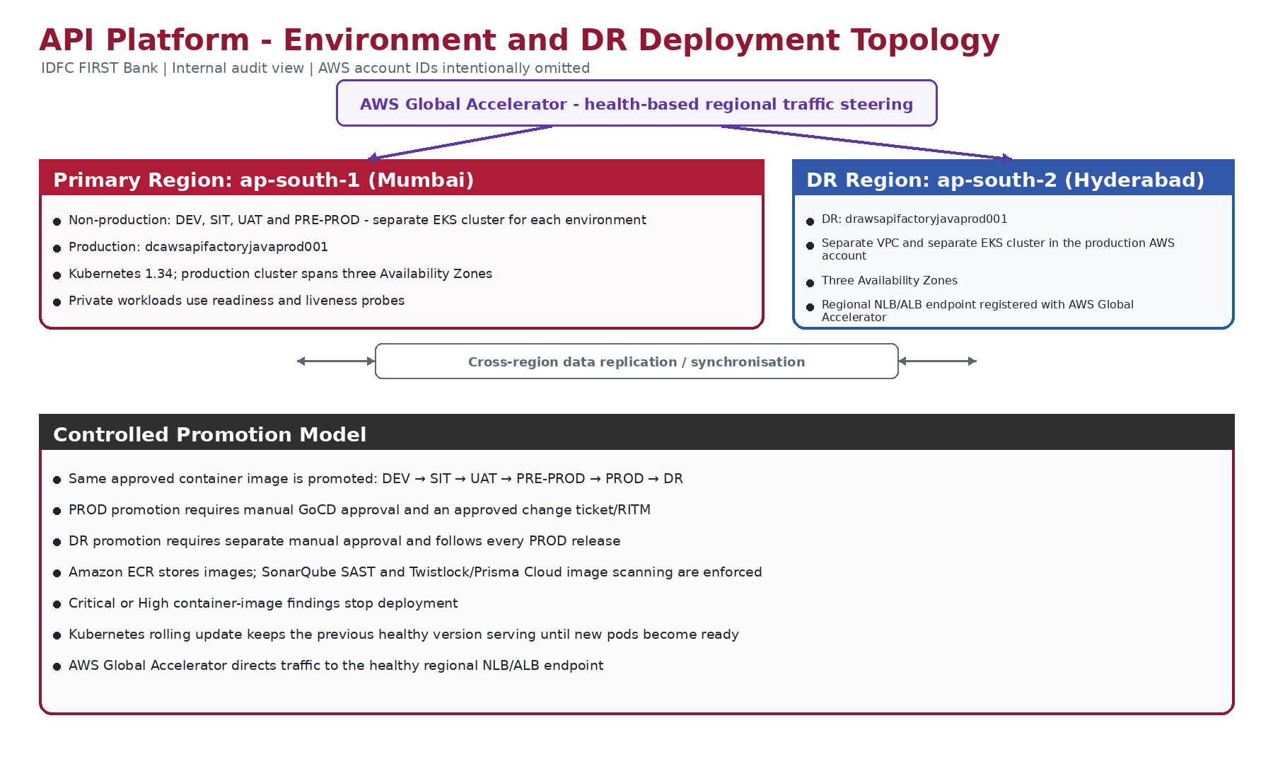
Figure 2 - Confirmed environment, promotion and disaster-recovery deployment topology.

5. High-Level Architecture and Data Flow
Internal bank systems and external partners connect inbound to the API Platform through Kong. Authentication and authorisation are provided through Ory Hydra using OAuth 2.0. API workloads run as Java 21 / Spring Boot 3.5 microservices on Amazon EKS and interact with Aerospike, Oracle Database (FinnOne), Amazon MSK and Amazon S3. Approved outbound API calls from EKS services use the Kong egress path to reach external providers such as Aadhaar Vault/UIDAI, NSDL/CERSAI and other approved services.
HTTPS/TLS is used between consumers, Kong and backend services. The platform processes customer data, transaction data, PII, authentication data and general business data. PII and sensitive data are encrypted in accordance with data classification requirements.
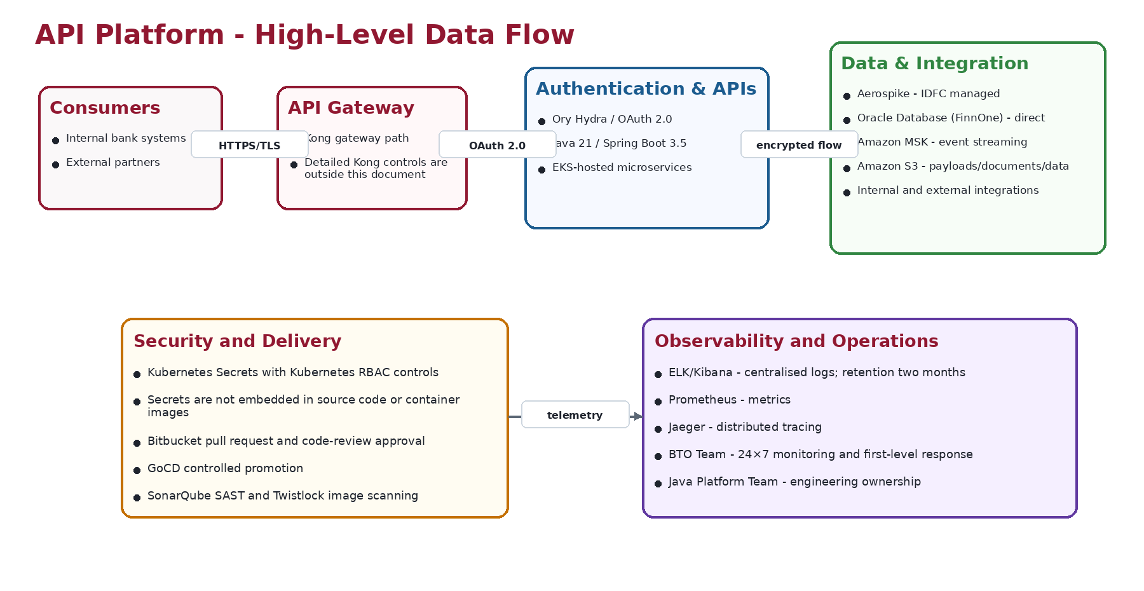
Figure 3 - High-level API request, authentication, data and observability flow.

5.1 Security and Responsibility Boundaries
The API Platform is divided into distinct security and operational responsibility areas. Inbound requests pass from consumers and partner systems through the API gateway and identity layers before reaching Java 21 / Spring Boot 3.5 services hosted in Amazon EKS. Application services access Aerospike, Oracle Database (FinnOne), Amazon MSK and Amazon S3 according to approved access controls. Outbound calls to approved external providers pass through the Kong egress path. Logs, metrics and traces are forwarded to the central monitoring tools used by the BTO Team.

6. Application Runtime and Container Architecture
Control Area | Implementation
Runtime standard | Java 21 and Spring Boot 3.5.
Orchestration | Amazon EKS / Kubernetes 1.34.
Environment separation | Separate EKS cluster for each environment.
Health management | Readiness and liveness probes are configured for production microservices.
Deployment strategy | Kubernetes rolling update. Existing healthy pods continue serving until new pods become ready.
Container registry | Amazon ECR.
Image consistency | The same approved container image is promoted across all environments and is not rebuilt per environment.

During a rolling deployment, the existing healthy application version remains available until the new pods start successfully and satisfy readiness checks. If the new pods do not become ready, the rollout does not complete and the previous healthy pods continue to serve traffic. This statement does not imply an automatic image-version rollback unless separately initiated.

7. Authentication and Data Protection
Control | Implementation | Owner / Boundary
API authentication and authorisation | Ory Hydra using OAuth 2.0 | Internal IDFC Identity Team
Transport encryption | HTTPS/TLS between consumers, Kong and backend services | Shared platform control
Data handled | Customer, transaction, PII, authentication and general business data | Application owners
Encryption at rest | PII and sensitive data are encrypted based on data classification; non-sensitive data uses standard storage controls | Application/data owners

Important: Exact token lifetimes, client configuration and Ory Hydra administration evidence are maintained by the separate internal Identity Team.

8. CI/CD, Source Control and Release Management

8.1 Source Control
- Bitbucket is the source-code repository.
- A pull request is mandatory before code can be merged.
- Code-review approval is required before merge.

8.2 Controlled Promotion
- The same container image is promoted through DEV → SIT → UAT → PRE-PROD → PROD → DR.
- Promotion to PROD requires manual approval in GoCD.
- Every PROD deployment is linked to an approved change ticket/RITM.
- Promotion to DR requires separate manual approval.
- Every approved PROD release is subsequently promoted to DR.
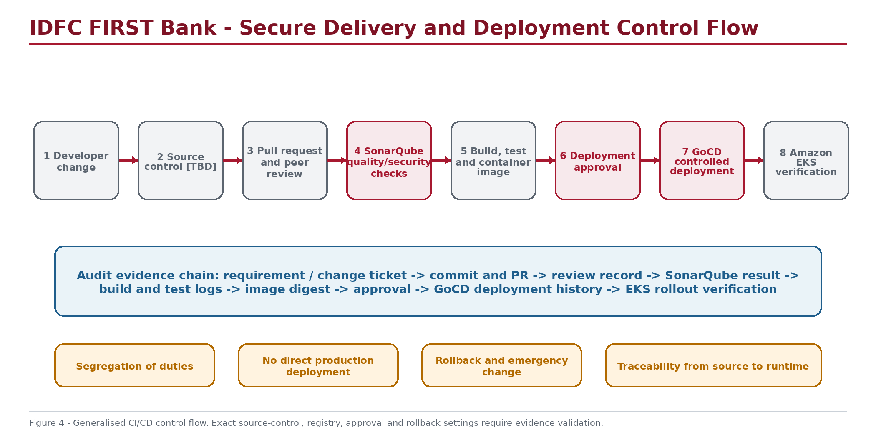
Figure 4 - Controlled CI/CD and deployment control flow.

9. Vulnerability and Container Security
Security Stage | Tool / Control | Enforcement
Source-code analysis | SonarQube SAST and quality gate | A failed quality gate blocks promotion.
Container-image scanning | Twistlock / Prisma Cloud | Critical or High findings stop deployment.
Container registry | Amazon ECR | Stores approved container images.
Independent security testing | VAPT / penetration testing | Performed every six months.

10. Secrets and Credential Management
Application secrets and credentials are managed through Kubernetes Secrets. Access is controlled using Kubernetes RBAC and is restricted to authorised workloads and administrators. Secrets must not be embedded in source code, application configuration committed to Bitbucket, or container images.

11. Logging, Monitoring and Incident Operations
Capability | Implementation | Operational Use
Centralised logging | ELK stack with Kibana | Application and platform log search and dashboards; retention two months
Metrics | Prometheus | Application, EKS and service health metrics
Tracing | Jaeger | Distributed tracing across microservices
Coverage | All environments | DEV, SIT, UAT, PRE-PROD, PROD and DR
24×7 operations | BTO Team | Monitoring and first-level incident response
Escalation | Java Platform Team | Platform/application engineering support

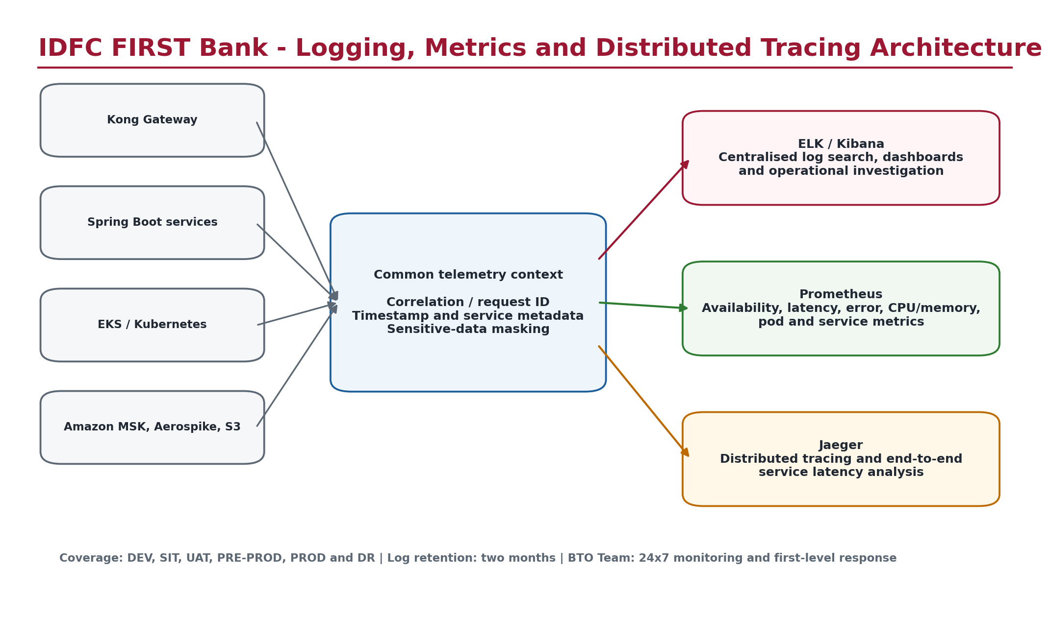
Figure 5 - API Platform observability architecture.

12. Data Services and Integrations
Component | Purpose | Deployment / DR
Aerospike | IDFC-managed operational data store | Deployed in PROD and DR; data is replicated from Mumbai to Hyderabad
Oracle Database (FinnOne) | FinnOne data accessed by applicable API microservices | Direct connectivity from authorised microservices; detailed database-platform controls are outside this document
Amazon MSK | Managed Kafka service for event streaming and asynchronous integration | Deployed in PROD and DR; Kafka data is replicated to DR
Amazon S3 | Large payloads, files/documents and application data | Data is replicated from Mumbai to Hyderabad
External and internal systems | Business integrations | Connectivity occurs through Kong

13. Availability, Backup and Disaster Recovery
Control | Confirmed Implementation
Primary production region | ap-south-1 (Mumbai)
DR region | ap-south-2 (Hyderabad)
Region/VPC model | Separate regions, VPCs and EKS clusters; same production AWS account
Availability Zones | Three for PROD and three for DR
Failover | Automatic health-based failover through AWS Global Accelerator using regional NLB/ALB endpoints
RPO | 30 minutes
RTO | 2 hours
DR drill frequency | Quarterly
Backup frequency | Daily
Backup retention | One year
Backup restoration testing | Every six months

The DR environment is updated after every PROD release using the same approved container image. DR promotion is subject to a separate manual approval. Aerospike, Amazon MSK and Amazon S3 data are replicated from the Mumbai production environment to Hyderabad. AWS Global Accelerator directs traffic to the healthy regional NLB/ALB endpoint and provides automatic regional failover from Mumbai to Hyderabad when the primary endpoint is unhealthy.

13.1 AWS Infrastructure and EKS Architecture
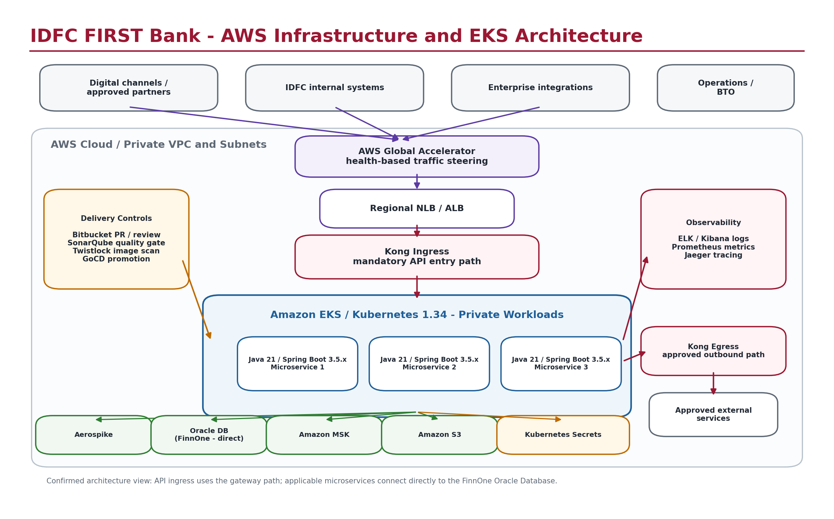

13.2 Production and Disaster Recovery Regional Architecture (AWS Global Accelerator)
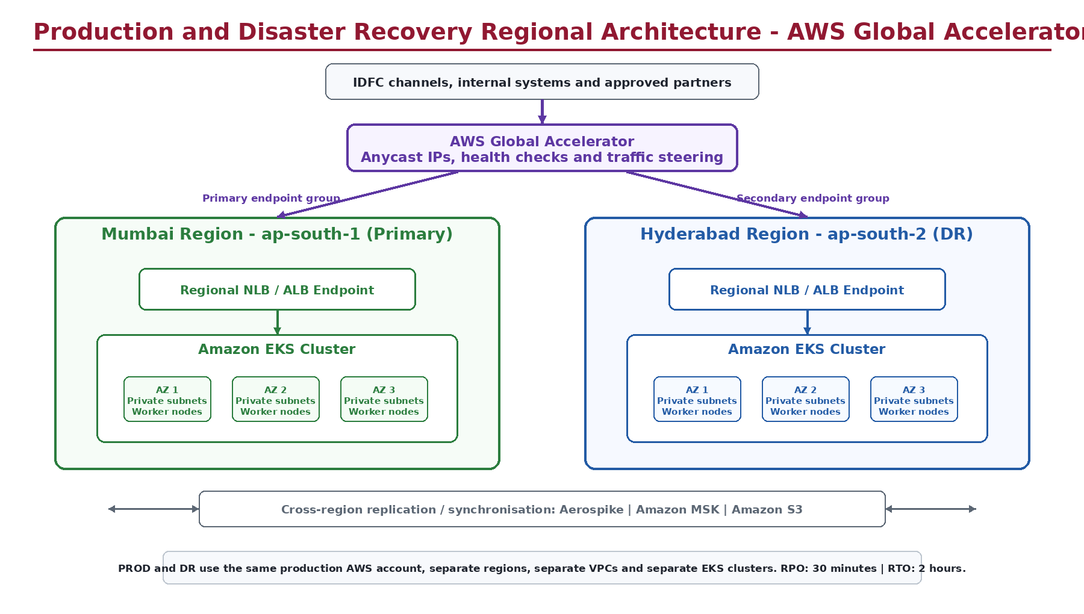

14. Risk and Control Summary
ID | Risk / Objective | Key Control | Owner | Status
CTRL-001 | Unauthorised source change | Mandatory Bitbucket pull request and code-review approval | Java Platform Team | Implemented
CTRL-002 | Unapproved production release | GoCD manual approval and approved change ticket/RITM | Java Platform Team / Change Management | Implemented
CTRL-003 | Vulnerable source code | SonarQube quality gate blocks promotion | Java Platform Team | Implemented
CTRL-004 | Vulnerable container image | Twistlock Critical/High findings block deployment | Platform / Security | Implemented
CTRL-005 | Service interruption during deployment | EKS rolling update with readiness and liveness probes | Java Platform Team | Implemented
CTRL-006 | Regional service outage | Separate DR region, AWS Global Accelerator health-based failover, and quarterly DR drills | Platform / BTO | Implemented

15. Audit Evidence
Evidence supporting the controls described in this document is maintained within the respective IDFC FIRST Bank technology platforms and authorised repositories. This includes GoCD pipeline execution and approval history, Bitbucket pull requests and code reviews, SonarQube quality-gate results, Twistlock container-image scan results, Amazon ECR image records, Amazon EKS deployment and rollout history, monitoring dashboards, VAPT reports and DR-test records. Where the actual process uses a change ticket or RITM, the applicable record forms part of the deployment evidence. Evidence will be made available to authorised auditors upon request. Secret values, credentials, private keys and access tokens must not be included in audit evidence.

16. Roles and Responsibilities
Role / Team | Responsibility
DevOps / Cloud Team | AWS, EKS, VPC, deployment infrastructure and DR platform operations
Information Security | VAPT, security review and vulnerability-governance oversight
Application / Project Owners | Project-specific APIs, data classification, business controls and evidence

17. Document Approval and Change History

17.1 Approval
Role | Name | Approval / Date
Written By | Dileep Kumar Maurya | 21-Jul-2026
Reviewed By | Rashi Bansal | ________________
Approved By | Prakash Rangaraj | ________________

17.2 Change History
Version | Date | Author | Change Description
1.0 | 21-Jul-2026 | Dileep Kumar Maurya | Initial issue

Appendix A - EKS Cluster Inventory
Environment | Region | Cluster Name | Kubernetes | AZs
DEV | ap-south-1 | dcawsapifactoryjavadev001 | 1.34 | Environment-specific
SIT | ap-south-1 | dcawsapifactoryjavasit001 | 1.34 | Environment-specific
UAT | ap-south-1 | dcawsapifactoryjavauat001 | 1.34 | Environment-specific
PRE-PROD | ap-south-1 | dcawsapifactoryjavapreprod001 | 1.34 | Environment-specific
PROD | ap-south-1 | dcawsapifactoryjavaprod001 | 1.34 | 3
DR | ap-south-2 | drawsapifactoryjavaprod001 | 1.34 | 3

Confidentiality: Exact cluster names are included because this document is intended only for authorised IDFC personnel and auditors. AWS account IDs remain omitted.

