End-to-End Loan Approval — Karate Test Flow
A walkthrough of what runs, and what each step proves, when the digital loan origination smoke test executes. Use it to narrate the live demo.

The flow at a glance
When you run the smoke suite, six components hand off to each other. Purple steps are Karate doing its job; teal steps cross the wire to the service; the amber step is where your real business logic runs.
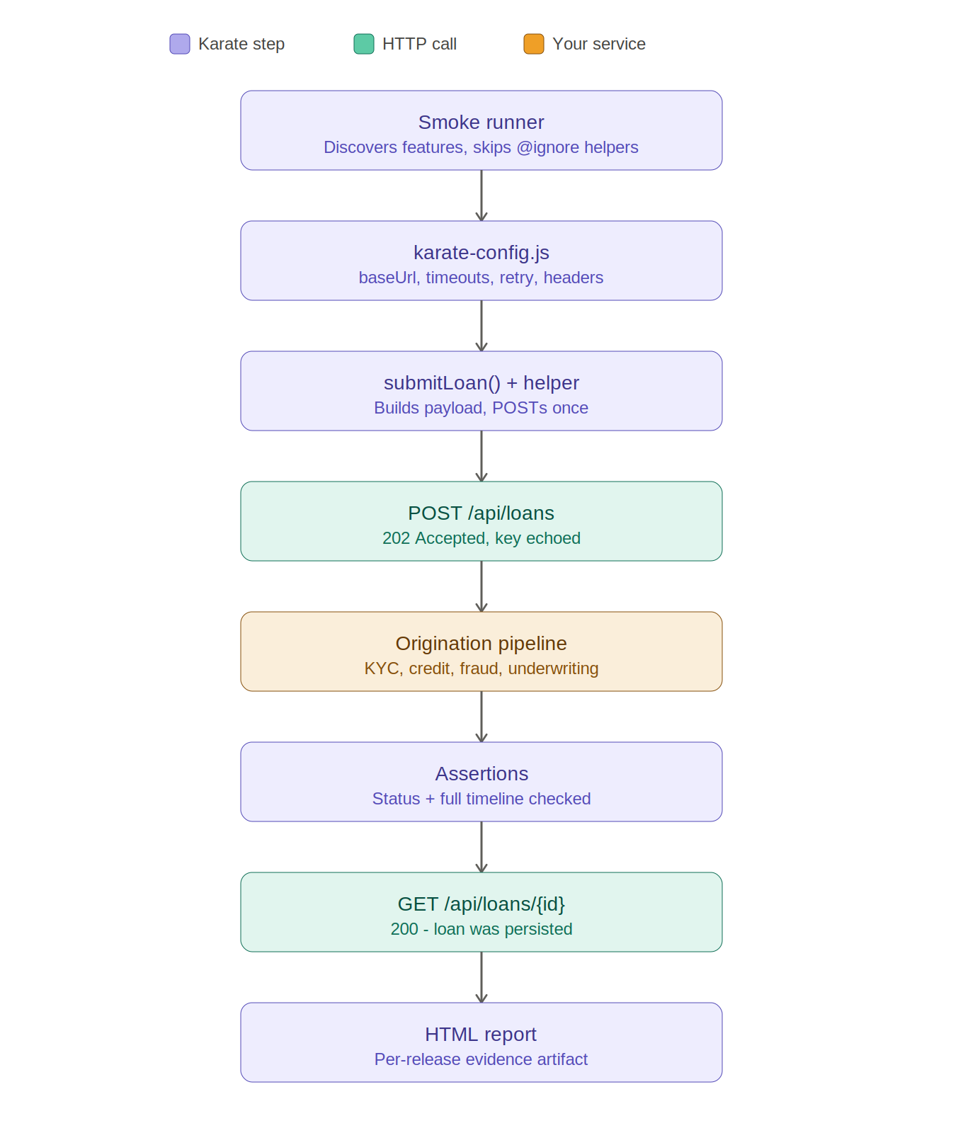
Straight-through approval: one request in, one decision out, one lookup to confirm it stuck.

The moving parts
Component | What it does
Smoke runner (KarateSmokeTestRunner) | The only Java in the test path. Discovers every feature except those tagged @ignore, which is why the submit-loan helper runs only when another scenario calls it.
karate-config.js | Resolves the environment (base URL, auth token), sets connect/read timeouts, and defines the retry policy that powers “retry until”. It also injects a fresh tracing header on every HTTP call.
Background + submitLoan() | Per-scenario setup. Defines reusable helpers (unique IDs, the loan-submission function) so every scenario reads as a single line.
submit-loan.feature (helper) | The single definition of how a loan is submitted. POSTs to /api/loans, asserts 202 Accepted, and confirms the idempotency key is echoed back. Called by five scenarios.
Spring Boot service (system under test) | The real application. Runs the loan through its origination pipeline (KYC, credit, fraud, eligibility, underwriting, decision, offer) and exposes the GET and review endpoints.
HTML report | Full request and response for every step, response times, and scenario names in plain English. This is the artifact shown to management and kept as per-release evidence.

Line by line: straight-through approval
This is the scenario to walk through live, because it exercises the whole pipeline. For each line: what the test does, and what it proves.
submitLoan('STANDARD', 780, 110000, 18000, 900000, ...)
Submits a prime borrower — credit score 780, monthly income ₹1.1L, debt ₹18k, ₹9L requested. Under the hood this POSTs to /api/loans and receives 202 Accepted with the full result.
match application.status == 'APPROVED' / offerId == '#string'
The loan was approved and a real offer was generated. “#string” is a fuzzy match — any non-null string passes, because the exact offer ID is random each run.
match application.timeline[*].name contains only [ … 8 stages … ]
The most important assertion for a bank. “contains only” proves the loan passed through exactly the eight regulated stages — none skipped, none added. One line proves the mandatory KYC, credit, fraud and underwriting checks all ran.
match application.timeline[*].outcome == ['PASS', …, 'APPROVED','PASS']
The result of each stage, in exact order. Every check passed, the final decision was APPROVED, and the offer was generated.
GET /api/loans/{loanId} → 200, same loanId and offerId
A separate read confirms the loan was actually persisted and is retrievable — read-after-write consistency. This is the difference between “the API replied” and “the system recorded it correctly.”

What the six scenarios each prove
Together they cover the six outcomes a real loan system must handle — approve, reject, manual, async, duplicate, and rollback.
- Straight-through approval: The full happy path — all eight stages pass, an offer is generated, and the loan is retrievable.
- Automated rejection: A failing affordability check produces a traceable rejection, with the specific timeline steps marked FAIL rather than a silent decline.
- Manual review: The human-in-the-loop path — submit, then a credit manager POSTs an APPROVE and the status flips to approved with an offer.
- Credit-bureau timeout: Asynchronous recovery using “retry until” — Karate polls the loan until the status becomes APPROVED, driven by the retry policy in karate-config.js.
- Idempotent duplicate: Submitting twice with the same key returns the identical loan, proving no duplicate record is created.
- Offer-failure compensation: A saga rollback — when offer generation fails after approval, a COMPENSATION step runs and the approval is reversed.

How to say it in one line
“The test acts like a real customer — it submits a loan, waits for the decision, then comes back later to look it up — and at every step it checks not just that the API replied, but that it did the right thing.”

