**Real-time/Field-Based Research Project Report**

**On**

**TasteTrove: A Web-Based Application For Finding Everyday Meals With Taste And Nutrition.**

A dissertation submitted to the Jawaharlal Nehru Technological University, Hyderabad in partial fulfillment of the requirement for the award of a degree of

**BACHELOR OF TECHNOLOGY**

**IN**

**COMPUTER SCIENCE AND ENGINEERING**

Submitted by

**M Dileep Krishna (23B81A0576)**

**B Nihan Reddy (23B81A0589)**

**B Prajeeth Reddy (23B81A0592)**



Department of Computer Science and Engineering

**CVR COLLEGE OF ENGINEERING**

(An UGC Autonomous Institution, Affiliated to JNTUH, Accredited by NBA, and NAAC) Vastunagar, Mangalpalli (V), Ibrahimpatnam (M), Ranga Reddy (Dist.) - 501510,

Telangana State.

**2024-25**

**CVR COLLEGE OF ENGINEERING**

*(*An UGC Autonomous Institution, Affiliated to JNTUH, Accredited by NBA, and NAAC)

Vastunagar, Mangalpalli (V), Ibrahimpatnam (M), Ranga Reddy (Dist.) - 501510, Telangana State.

**DEPARTMENT OF COMPUTER SCIENCE AND ENGINEERING**

**CERTIFICATE**

This is to certify that the Project work entitled **TasteTrove-A Web Based Application For Finding Everyday Meals With Taste And Nutrition** is being submitted by M DILEEP KRISHNA (23B81A0576), B NIHAN REDDY (23B81A0589) and B PRAJEETH REDDY (23B81A0592) in partial fulfillment of the requirement for the award of the degree of **Bachelor of Technology** in **Computer Science and Engineering,** during the academic year 2024-2025.

**Signature of the Section Coordinator Signature of the HOD**

**DECLARATION**

We hereby declare that this project report titled **TasteTrove-A Web Based Application For Finding Everyday Meals With Taste And Nutrition** submitted to the Department of Computer Science and Engineering, CVR College of Engineering, is a record of original work done by us. The information and data given in the report is authentic to the best of our knowledge. This Real Time/Field-Based Research Project report is not submitted to any other university or institution for the award of any degree or diploma or published at any time before.

M DILEEP KRISHNA **- 23B81A0576**

B NIHAN REDDY **- 23B81A0589**

B PRAJEETH REDDY **- 23B81A0592**

Date:

Place:

**ABSTRACT**

Taste Trove is an intuitive recipe discovery web based application designed to inspire home cooks and food enthusiasts. With a simple yet powerful interface, it leverages advanced search features and personalized recommendations to help users find recipes based on ingredients, meal types, and dietary preferences. Integrated with popular recipe databases, the website provides recipe details, shopping lists, and interactive cooking timers, making it easier than ever to find, cook, and enjoy delicious meals. Whether you're a beginner or an experienced cook, Taste Trove is your ultimate kitchen companion. Find, cook, and fall in love with every meal Taste Trove makes every kitchen adventure enjoyable!

**TABLE OF CONTENTS**

|  |  |  |  |
| --- | --- | --- | --- |
|  | | | Page No. |
| 1 |  | **INTRODUCTION** | 1 |
|  | 1.1 | Motivation | 1 |
|  | 1.2 | Problem Statement | 2 |
|  | 1.3 | Project Objectives | 2 |
|  | 1.4 | Project Report Organization | 3 |
| 2 |  | **LITERATURE REVIEW** | 4 |
|  | 2.1 | Existing Work | 4 |
|  | 2.2 | Limitations of Existing Work | 5 |
|  | 2.3 | Proposed Work | 5 |
| 3 |  | **REQUIREMENT ANALYSIS** | 7 |
|  | 3.1 | Software requirements | 7 |
|  | 3.2 | Hardware requirements | 8 |
|  | 3.3 | User requirements | 8 |
| 4 |  | **SYSTEM DESIGN** | 10 |
|  | 4.0 | Proposed System architecture | 10 |
|  | 4.1 | Proposed Methods/ Algorithms | 10 |
|  | 4.2 | UML Diagrams | 12 |
|  | 4.3 | Datasets and Technology stack | 15 |
| 5 |  | **IMPLEMENTATION** | 16 |
|  | 5.1 | Front page Screenshot | 16 |
|  | 5.2 | Results and Discussions | 19 |
|  | 5.3 | Testing | 19 |
|  | 5.4 | Validation | 26 |

|  |  |  |  |
| --- | --- | --- | --- |
| 6 |  | **CONCLUSIONS** | 27 |
|  | 6.1 | Conclusion | 27 |
|  | 6.2 | Future scope | 27 |
|  |  | **REFERENCES** | 28 |

**CHAPTER 1**

**INTRODUCTION**

A web-based application is a software solution that operates on web servers and is accessed via web browsers, eliminating the need for local installations. These applications offer cross-platform compatibility, ensuring seamless functionality across various devices and operating systems.

Meals are planned eating occasions that provide essential nutrition and energy. Typically including breakfast, lunch, and dinner, they vary widely across cultures in ingredients and preparation. Beyond nourishment, meals offer opportunities for social interaction and cultural expression, often serving as cherished moments for family and friends to gather and strengthen bonds.

* 1. **MOTIVATION**

In a world where convenience trumps nutritional value, our web-based recipe finder is here to change the face of home cooking. We believe healthy, flavorful meals should be at the heart of every household, and our platform empowers users to make informed , delicious choices in the kitchen. We are here to assist users in managing diets without offending the palates with a user-friendly interface and easy access to comprehensive information on macro-nutrients. Our motto is "Making Home-Made Healthy Food Tasty and Nutritious," a reflection of our purpose in combining wellness with flavor in every-dish.

We understand that meal preparation can be intimidating, whether you’re a seasoned chef or just starting out in the kitchen. That’s why our application is designed with simplicity and ease in mind. Users can quickly search for recipes by name and gain instant access to nutritional information, making it effortless to track and manage macronutrient intake. We hope to create confidence in home cooks by simplifying the process of understanding nutritional content, thus equipping them with the ability to prepare nourishing, enjoyable meals.

Cooking is meant to be a form of creativity, nourishment, and joy and so, our belief in healthy eating forms the core of our platform, committed to making it accessible for all with varied dietary preferences or restrictions. A vast recipe library will include diverse options whether you want to follow a vegan diet, be gluten-free, or want your meal packed with proteins. We would like to make it easy for individuals to adopt healthier lifestyles and provide the tools that they need to cook meals based on personal health objectives.

Our recipe finder is a perfect example of how technology can enhance our daily lives by supporting healthier living. By merging culinary expertise with nutritional science, we’ve created a platform that encourages users to take control of their health while enjoying the process of cooking. The aim here is to bring home cooking back into every single household globally with an approach where flavors are prioritized but not at the cost of nutritional benefits. Using our app, we vision that the celebration of a good meal become synonymous with not only being good tasting but also doing one's body some good.

* 1. **PROBLEM STATEMENT**

This  is  prevalent , as though increased  awareness about the need for  healthy eating exists, many people are still unable to prepare healthy home cooked meals. Mainly, lack of Knowle-dge on nutrition, not having the time, and belief that healthy food does not taste or is hard to prepare will make most people  give in to convenient but nutrient poor alternative. Increased dependence on such unhealthy convenience foods lacking much Nutritional value further perp -etuates the cause of failures in achieving balanced diets.

There is a pressing need for a solution that simplifies the process of discovering and preparing nutritious meals while also educating users about their macronutrient content. Our web-based application directly addresses this gap by providing an easy-to-use platform that helps users find recipes tailored to their dietary needs. By combining convenience with nutritional educa-tion we empower individuals to make healthier choices in the kitchen, fostering a more informed and health-conscious approach to cooking.

**1.3 PROJECT OBJECTIVES**

Our platform encourages healthy eating, providing balanced recipes for use with fresh ingre-dients, along with macronutrient detail, allowing the user to make an Informed decision in terms of preparation. We simplify meal preparation to save precious time for the consumer as they prepare yummy and nutritious meals at home. Our vast reservoir of recipes caters to an incredible variety of tastes, dietary needs, and cultural preferences.

**1.3.1 Promote Healthy and Nutritious Eating:**

Each  recipe on the website must be designed in a way that supports a balanced, nutrient-rich diet, prioritizing natural, fresh ingredients for better overall wellbeing.

**1.3.2 Provide Comprehensive Nutritional Data:**

Provide  macronutrient data  for each recipe to enable users to make informed selections about their personal health goals and dietary requirements.

**1.3.3 Intuitive and Efficient Recipe Search:**

It should have an intuitive, quick search function that allows users to locate recipes by name, ingredients, or dietary preferences for one-click access.

**1.3.4 Save Time during Meal Preparation:**

Optimize the meal planning and cooking process to save time. Their optimized ingredient quantities and resting times will make healthier,  tastier meals easier and quicker to prepare at home without giving in to quality.

**1.3.5 Offer a Diverse Recipe Collection:**

Curate an extensive variety of recipes that cater to different tastes, dietary restrictions, and cultural preferences, providing users with a broad spectrum of options to suit any need.

**1.4 PROJECT REPORT ORGANIZATION**

Chapter 1: introduces the motivation, problem statement, objectives, and organization of the report.

Chapter 2: covers the literature survey, including existing work and the limitations of current Recipe managers.

Chapter 3: describes the software and hardware specifications required for the proposed system.

Chapter 4: outlines the system design and architecture.

Chapter 5: outlines the system’s practical implementation (showcasing front page screenshots, results, testing, and validation)

Chapter 6 : encapsulates the project’s final conclusions and its potential future scope.

**CHAPTER 2**

**LITERATURE REVIEW**

**2.1 EXISTING WORK**

**2.1.1 CookBook**

It is a web app which is also available for android and IOS. It has a user-friendly interface. Allows the users to import recipes from web and they can also scan physical recipes. It is helpful for meal planning and provides smart shopping list for every recipe. It also has multi-device support.

**2.1.2 MealBoard**

Mealboard is an app that simplifies meal planning, grocery shopping, and recipe organization. Users can create meal plans, generate shopping lists, and store their favorite recipes in one convenient place.

**2.1.3 Tandoor**

While not a traditional recipe manager, a tandoor is a versatile used in Indian and Middle Eastern cooking. It provides a unique way to cook various dishes, including tandoori chicken, naan, and kebabs, enhancing the flavors with its high heat and distinctive cooking style.

**2.1.4 BigOven**

BigOven is an app that helps users organize their recipes, plan meals, and generate grocery lists. It also offers a social aspect, allowing users to share their culinary creations and discover new recipes from the community.

**2.1.5 ChefTap**

Chef Tap is a user-friendly app that helps users organize their recipes, create meal plans, and generate shopping lists. It allows users to clip recipes from the web and sync their collection across multiple devices for easy access.

**2.1.6 Paprika Recipe Manager**

Paprika stands out with its ability to save recipes from various websites, create shopping lists, and plan meals. It also offers unique features such as scaling ingredients according to serving size and creating customized grocery lists.

**2.2 LIMITATIONS**

**2.2.1 CookBook**

Some features require a paid subscription. Limited number of free features.

**2.2.2 MealBoard**

Requires a one-time purchase for the app. The interface may take some time to get used to.

**2.2.3 Tandoor**

Require self-hosting, which might be a barrier for non-technical users. Some users find the interface less intuitive compared to other tools.

**2.2.4 BigOven**

Free version has ads that can be intrusive. Some features are only available with a Pro subscription.

**2.2.5 ChefTap**

Requires a subscription for full feature access. Occasional syncing issues reported by users.

**2.2.6 Paprika**

Requires separate purchases for different platforms. Only available as a paid app.

**2.3** **PROPOSED WORK**

Our project stands out by eliminating the need for logins, offering seamless user experience on a website. With a simple and straightforward UI, users can effortlessly navigate through the site. Our user-friendly design ensures that everyone, regardless of tech-savviness, can enjoy the full benefits of “TasteTrove”. The advanced search capabilities provide quick and accurate results, making it easy to find recipes based on ingredients. By providing all details in one place, users no longer need to switch between multiple sources. Whether you’re a novice cook or a seasoned chef, our platform caters to all skill levels. The intuitive interface and personalized recommendations enhance the cooking experience. Healthy eating is now accessible and enjoyable for everyone, thanks to our comprehensive and user-friendly website.

**CHAPTER 3**

**REQUIREMENT ANALYSIS**

**3.1 SOFTWARE REQUIREMENTS**

Software requirements detail the essential functionalities and features that the system must support, along with the technical attributes that ensure smooth operation. These are divided into functional and non-functional requirements:

**3.1.1 Functional Requirements**

**Recipe Search and Discovery**

**Basic Flow:** Users enter search keywords in the search bar. The system filters recipes based on the keywords. The system displays a list of matching recipes.

**Alternate Flow:** If no recipes match the search criteria, the system displays a message: “No matching recipes found.”

**Recipe Details and Instructions**

**Basic Flow:** Users select a recipe from the search results. The system displays detailed recipe information, including ingredients, instructions, cooking time, and nutritional facts. Logged-in users can follow the step-by-step instructions with an interactive timer that allows them to pause, reset, or skip cooking stages.

**Alternate Flow:** If any required recipe information is missing, the system displays a message indicating that the information is incomplete.

**3.1.2 Non-Functional Requirements**

**Uptime and Availability**

The system should aim to be available most of the time (high uptime) so users can access it whenever they need to.

**Compatibility Requirements**

The application should work on standard web browsers like Chrome, Firefox, and Safari.

**Usability Requirements**

The application should be easy to use with a straightforward interface.

**Scalability Requirements**

The system should be able to handle more users and recipes as needed without slowing down. This ensures the project can grow over time.

**Performance Requirements**

The application should ensure that the page’s load quickly and search results are displayed without delay to provide a smooth user experience.

**Reliability**

The system should be reliable, ensuring consistent operation under various conditions.

**3.2 HARDWARE REQUIREMENTS**

The following hardware specifications are recommended for the Taste Trove recipe manager website to function optimally:

**System Requirements**

• Processor: Minimum 2 GHz dual-core processor to support the client-side

application (e.g., web browser) effectively.

• RAM: At least 4 GB to ensure smooth browsing and voting experience.

• Storage: 128 GB storage capacity for basic software and OS requirements.

• Network: Stable internet connection with at least 5 Mbps download/upload speed

for reliable connectivity.

**3.3 USER REQUIREMENTS**

Guest Access: Users can browse and view recipes without registration.

Search & Filters: Users can search by name, ingredients, or dietary preference and apply filters (e.g., veg, non-veg, sweets).

Recipe Details: All users can view full recipe details including ingredients, steps, and nutrition info.

Registered Users: Can add new recipes and use the interactive cooking timer.

Responsive Design: Application must be fast, mobile-friendly, and work on all major browsers.

Usability: Interface should be simple and user-friendly for all types of users.

Accessibility: Must support features like dark mode and readable layouts for better experience.

**CHAPTER 4**

**SYSTEM DESIGN**

**4.0 PROPOSED SYSTEM ARCHITECTURE** 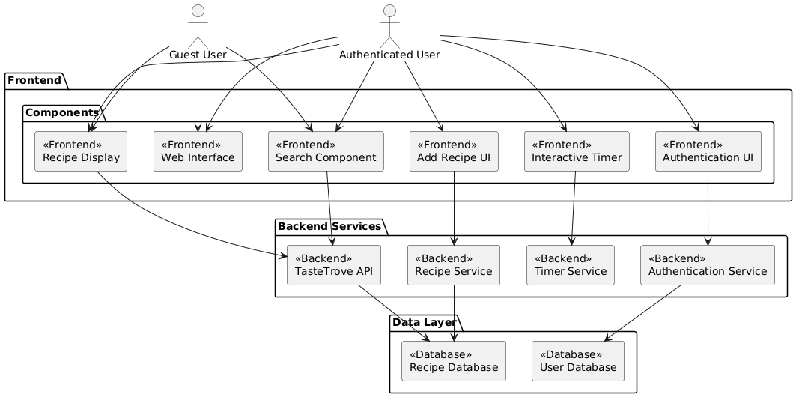

**Fig 4.0.1 Proposed System Architecture Overview**

Fig 4.0.1: This image illustrates the architecture of a recipe application, showing interactions between guest/authenticated users, frontend components, backend services, and the data layer. It outlines the flow of user actions through UI components to backend APIs and databases.

**4.1 PROPOSED METHODS / ALGORITHMS**

**4.1.1. User Interaction (Landing Page):**

* Users first land on the homepage of the website. The landing page displays options for both log-in and guest users.

**4.1.2. User Authentication:**

* If the user is logged in, the website will show additional features such as interactive timer.
* If the user is not logged in, they can browse the site as a guest with limited features. They can view recipes but will not be able interact with certain advanced features like the interactive timer.

**4.1.3. Recipe Browsing and Searching:**

* Allow users to browse through a collection of recipes.
* Provide a search bar where users can search for specific recipes based on name or ingredients.
* Allow users to filter recipes by dietary preferences (e.g., vegetarian or non-vegetarian). This could be a dropdown or checkbox filter.
* Once the user finds a recipe they are interested in, they can select it to view its details.
* Display detailed information about the recipe including:
  + Ingredients required
  + Cooking steps
  + Nutritional information (if available)

**4.1.4. Interactive Timer (For Logged-in Users):**

* If the user is logged in, they can start an interactive timer that will guide them through the recipe, helping them keep track of cooking time for different stages. The timer should be interactive with the ability to pause, reset, or skip time.

**4.1.5. End the Process:**

* Once the user is done browsing, viewing recipes, or using the interactive timer, the process ends.

**4.1.6. Add Recipe (For Logged-in Users):**

**•** User-Friendly Form: Provide logged-in users with an intuitive form to add new recipes.

Fields could include:

* Recipe Name
* Ingredients (with quantity specification)
* Step-by-step Cooking Instructions
* Optional: Upload photos of the recipe.
* Tags for easy categorization (e.g., Veg, Non-Veg, Sweets).

**4.2 UML DIAGRAMS**

**4.2.1 CLASS DIAGRAM**

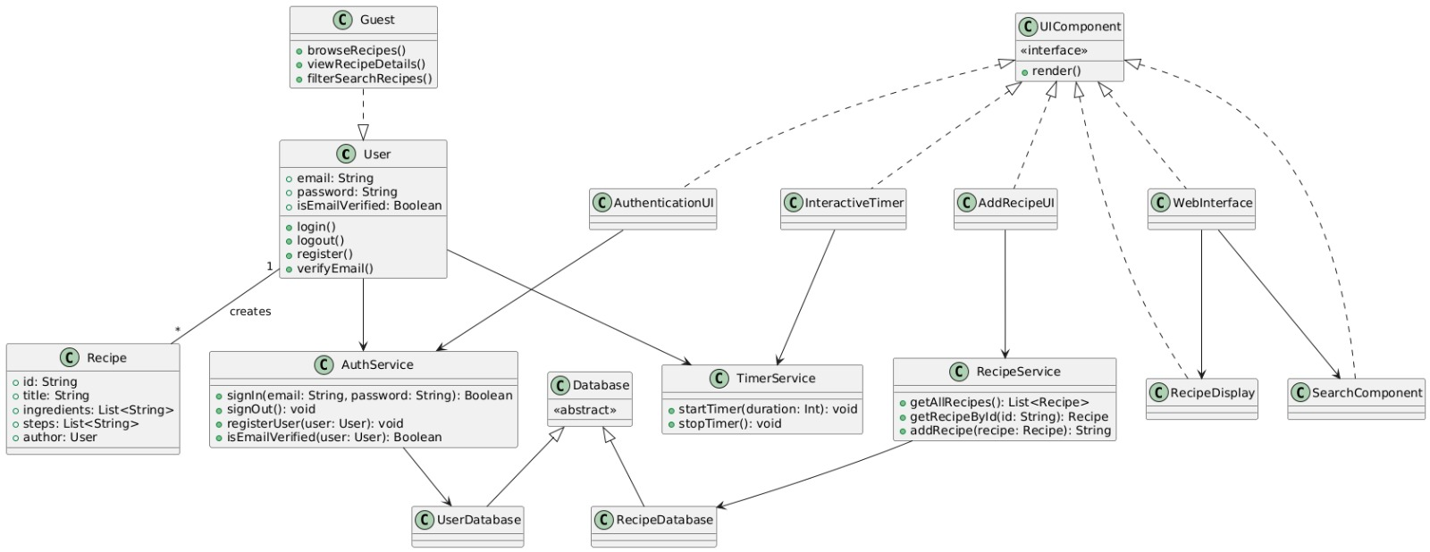

**Fig 4.2.1: Class Diagram of the Proposed System**

Fig 4.2.1: This diagram represents the class-level design of the recipe application, detailing user roles, UI components, services, and database interactions. It shows how classes interact through methods and attributes to support key functionalities.

**4.2.2 USE CASE DIAGRAM**

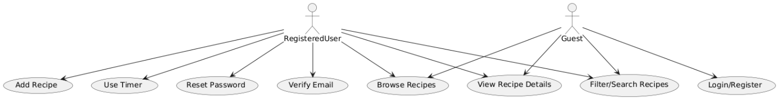

**• Fig 4.2.2: UML Use Case Diagram Illustrating User Interactions**

Fig 4.2.2: This use case diagram outlines the actions available to guest and registered users in the recipe application. It distinguishes user capabilities like browsing, searching, adding recipes, and using timers based on authentication status.

**4.2.3 ACTIVITY DIAGRAM**

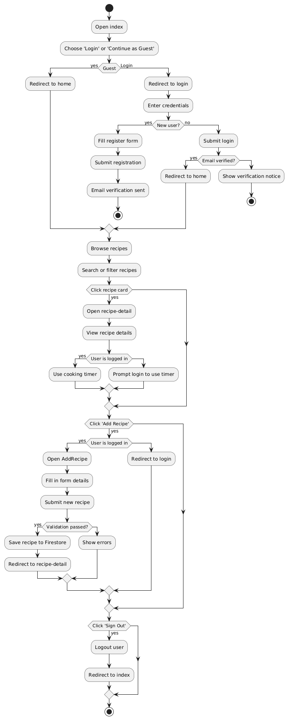

**Fig 4.2.3: UML Activity Diagram Representing System Workflow**

Fig 4.2.3: This flowchart illustrates the user journey within the recipe application, covering both guest and registered user actions—from login/registration and recipe browsing to adding new recipes and using the cooking timer. It highlights decision points and redirects based on user status and input validation.

**4.2.4 SEQUENCE DIAGRAM**

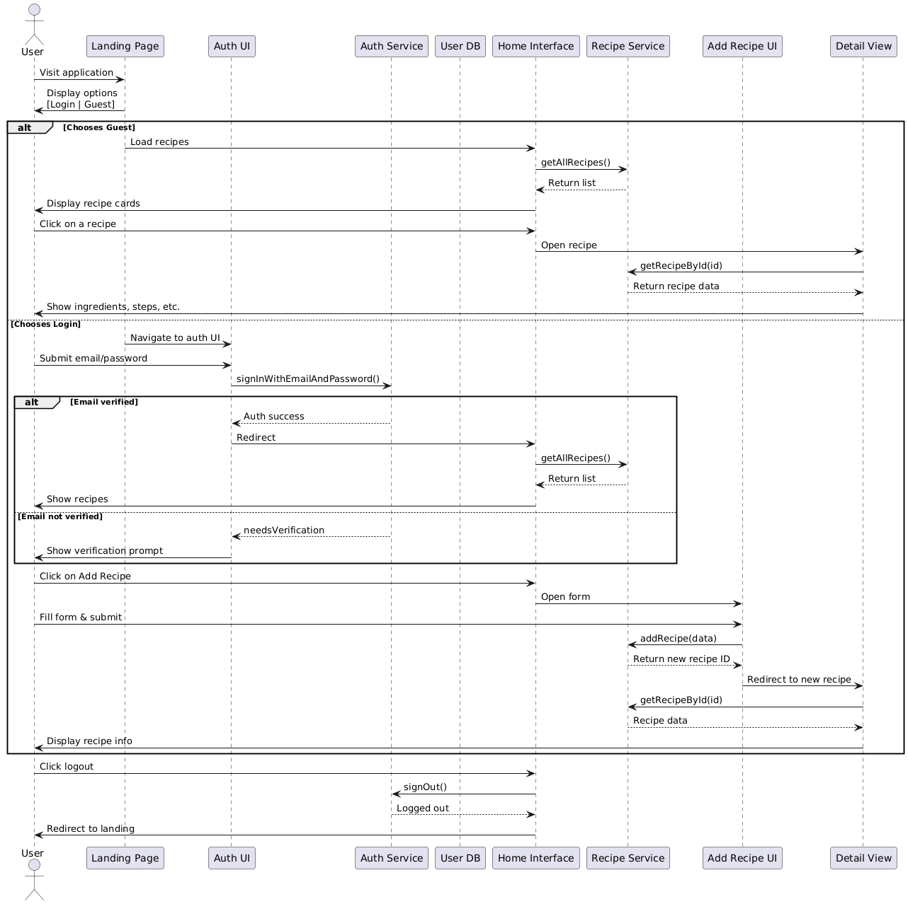

**Figure 4.4: Sequence Diagram of the Proposed System**

Fig 4.4: This sequence diagram outlines the interaction flow between the user and system components, covering both guest and authenticated user scenarios. It captures the step-by-step communication for viewing, adding recipes, authentication, and logout processes.

**4.3 DATASETS AND TECHNOLOGY STACK**

1. **HTML** - The structural markup language that defines the content and organization of web pages using tags.
2. **CSS** - The styling language that controls how HTML elements look and are presented on screen.
3. **JavaScript**: Facilitates interactivity and dynamic behavior, enabling functionalities like filtering recipes, managing user inputs, and implementing the interactive timer.
4. **Firebase**: Acts as a backend-as-a-service (BaaS), offering solutions like:

Real-time database for storing and retrieving recipes.

Authentication services for managing logged-in users.

1. **VS Code** - A free, feature-rich code editor that provides tools for writing, debugging and managing code efficiently**.**
2. **Git:** version control sytem.
3. **Netlify:** application for website deployment.

**CHAPTER 5**

**IMPLEMENTATION**

The implementation chapter details the transformation of system designs into a fully functional application. It encompasses the development of key modules such as the frontend interface, backend services, and database integration. Each component is developed in alignment with the architectural, class, and interaction diagrams to ensure consistency and maintainability. This section also elaborates on the practical realization of features such as user authentication, recipe browsing, recipe management, and the cooking timer. Both guest and registered user flows are handled effectively, ensuring a seamless and secure user experience.

**5.1 Front Page Screenshot**.

Landing Page:

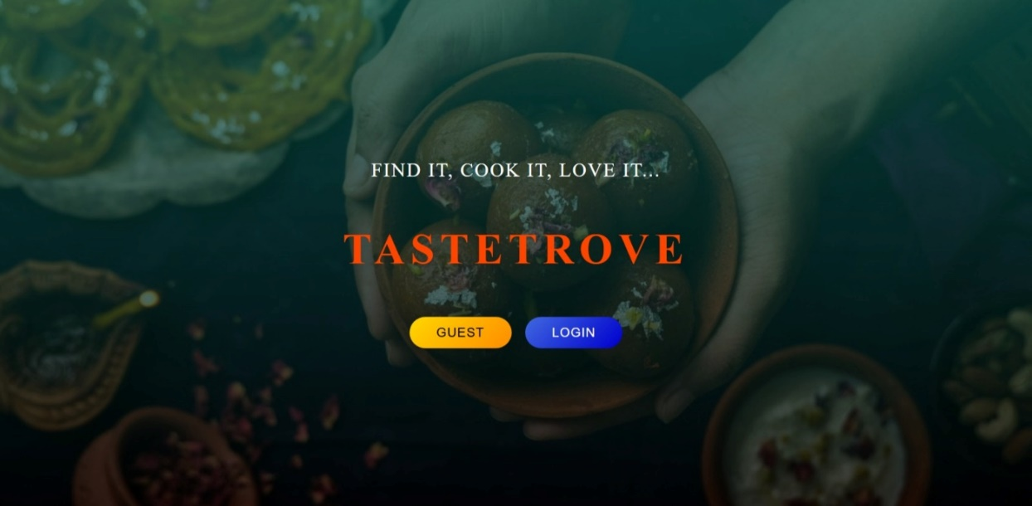

**Figure 5.1: Landing Page of the Application**

Fig 5.1: This is the landing page of the TasteTrove application, offering users a choice to either continue as a guest or log in to access personalized features. The design emphasizes the theme of cooking and discovery, aligning with the application's motto: *"Find it, cook it, love it..."*.

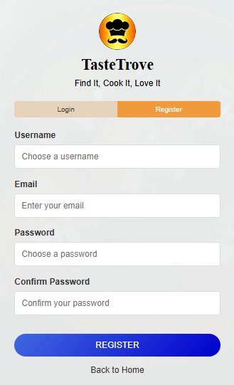Login/Register page:

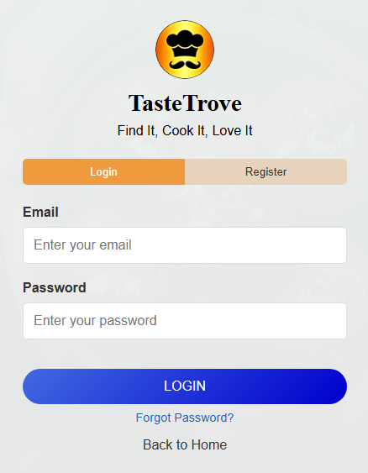

**Figure 5.2: Login Interface**  **Fig 5.3:** **Registration Interface**

Fig 5.2: This is the login interface of the TasteTrove application, where users can enter their credentials to access personalized features. The screen also provides navigation options for registration, password recovery, and returning to the home page.

Fig 5.3: This is the registration interface of the TasteTrove application, allowing new users to create an account by entering a username, email, and password. The screen ensures user input validation and offers navigation back to the home page.

Home Page :

Fig 5.4: This figure displays the home screen of the TasteTrove application after login. It showcases a search bar, a filter section for categories like Vegetarian, Non-Vegetarian, and Sweets, and a grid view of available recipes. The “Add Recipe” button allows users to contribute new recipes, and the user profile is visible at the top right.

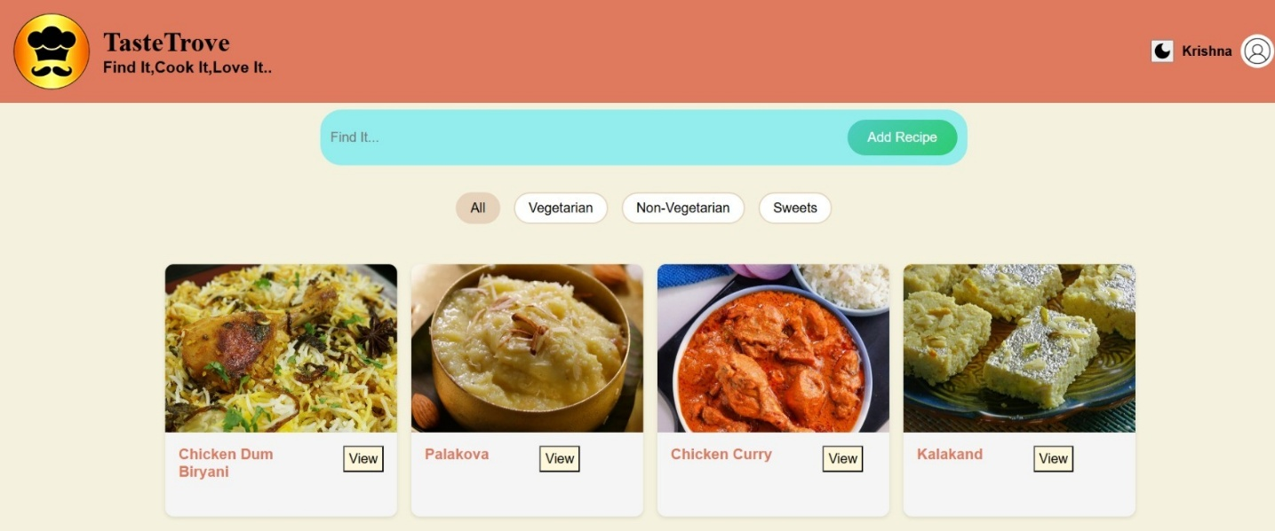

**Fig 5.4: Home Page After Successful Login**

Dark Mode of Home Page :

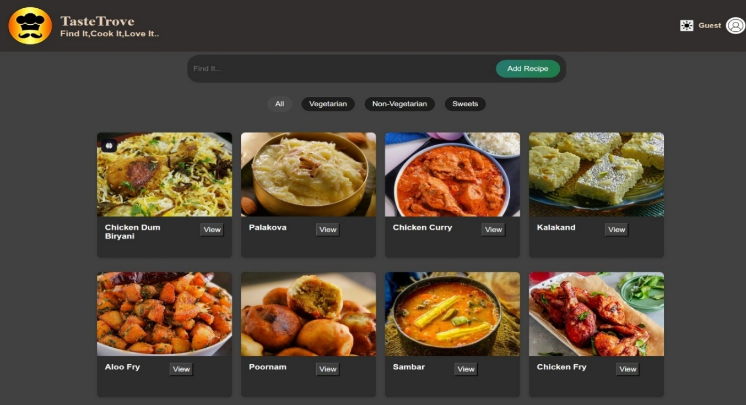

**Fig 5.5: Home Page in Dark Mode**

Fig 5.5: This figure shows the TasteTrove home screen in **dark mode**. Users can still browse recipes, use the search and filter functions, and view detailed cards for each dish. The interface adapts visually while maintaining the same functionality, and the profile section reflects the current "Guest" mode.

**5.2 RESULTS AND DISCUSSION**

The developed recipe web application was tested for its core functionalities including user authentication, recipe browsing, detailed viewing, and recipe submission. The results demonstrate a smooth user experience for both guest and registered users.  
For guest users, the system successfully allows access to browse and filter recipes without login, aligning with the designed flow. However, when attempting to use restricted features such as the cooking timer or recipe submission, the system correctly redirects them to the login page. This shows that the access control mechanism works as intended.  
   
For authenticated users, the entire flow from login, email verification, and interaction with the application was thoroughly tested. The cooking timer, recipe addition, and logout functionalities were validated to work without errors. Additionally, edge cases such as submitting incomplete forms or attempting actions without email verification were handled with proper feedback messages or redirection, enhancing the robustness and usability of the system.  
   
The system architecture promotes modularity, and each component from frontend UIs to backend services and databases effectively communicates through structured APIs. The use of Firebase for real-time database functionality provided a seamless backend experience. In summary, the system behavior during testing confirmed the effectiveness of the architectural and functional design decisions depicted in the sequence, use case, activity, and component-diagrams.

**5.3 TESTING**

**Testcase1: Guest Mode browsing**

* The user selects Guest in landing page.
* Opens a recipe of his/her choice.

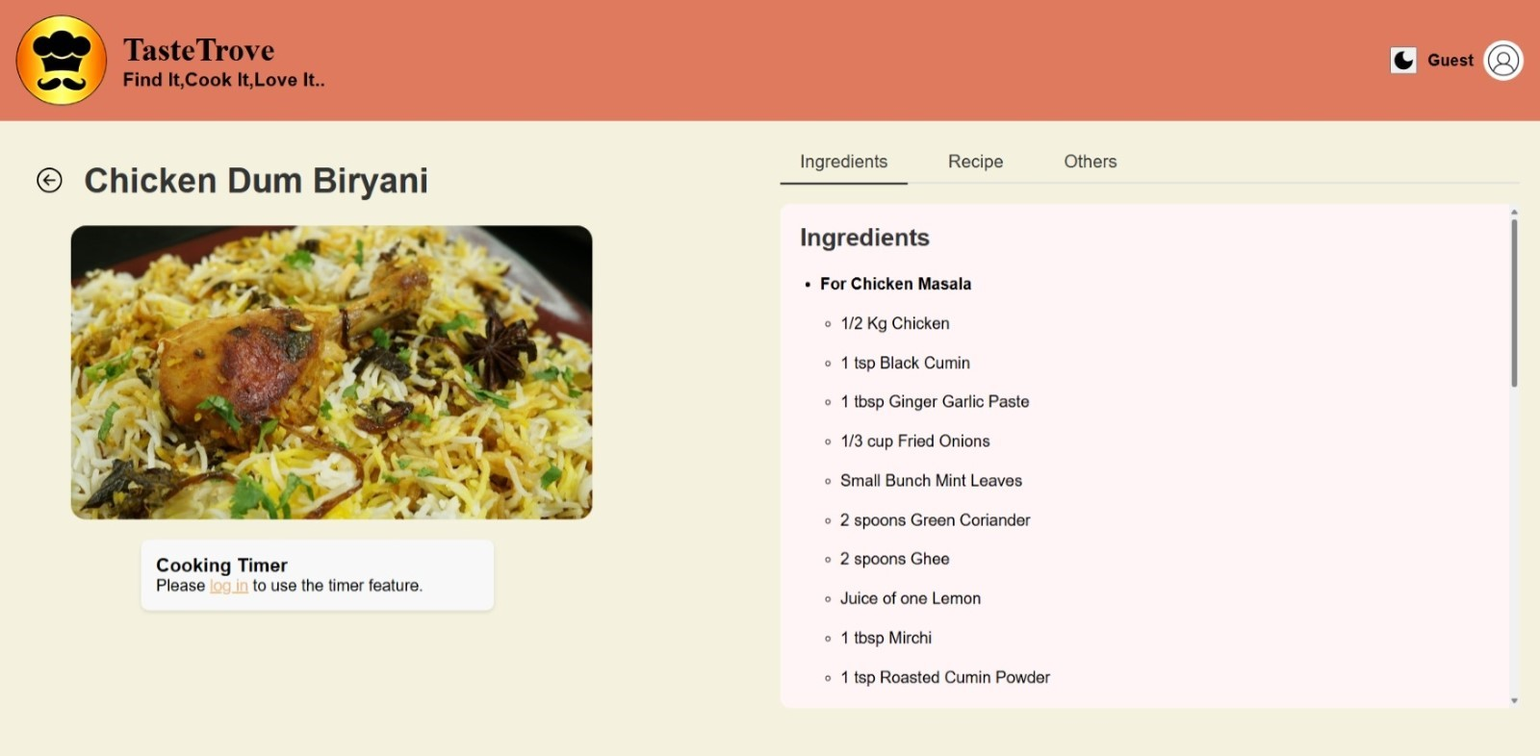**Fig 5.6: Guest Mode – Recipe Browsing**

**Fig 5.6: Guest Mode- Recipe Browsing**  
This screenshot showcases the detailed view of a selected recipe as seen by a guest user. It verifies that the UI correctly fetches and displays the ingredient list, and conditionally hides features like the cooking timer which require login. This ensures proper access control and content visibility based on user roles.

**Testcase2:Login of registered user**

* The registered user login is verified.
* Prompt is given for incorrect credentials.

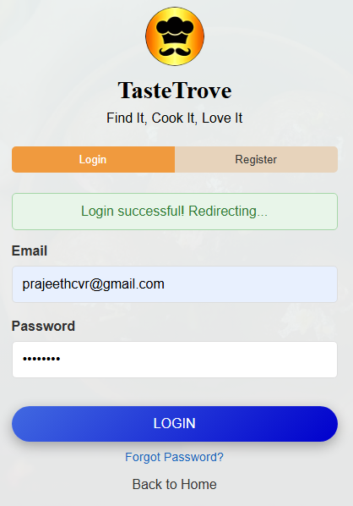  
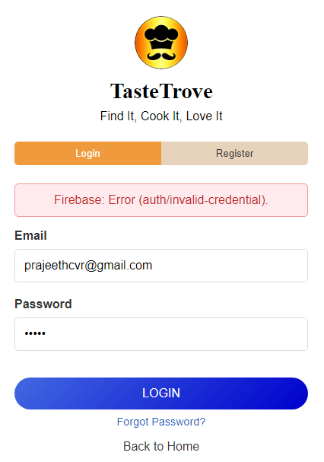**Fig 5.7: Successful Login of** **Fig 5.8: Error Prompt for Incorrect Registered User** **Login Credentials**

Fig 5.7: Login Success State  
This figure demonstrates a successful login attempt by a registered user. Upon entering valid credentials, a success message ("Login successful! Redirecting...") is displayed, confirming backend authentication. This serves as validation of the login workflow, redirect logic, and user feedback mechanism.

Fig 5.8: Login Error – Invalid Credentials

This figure illustrates an error scenario that occurs during the login process when a user provides incorrect credentials. The interface displays a clear error message: *"*Firebase: Error (auth/invalid-credential*)"*, ensuring the user is informed about the failed authentication attempt. This test case verifies the system’s ability to handle login errors gracefully, improving user experience by delivering immediate feedback and preserving input data for correction.

**Tastcase3:Registration of user**

* New user registers before Login
* Email will be verified

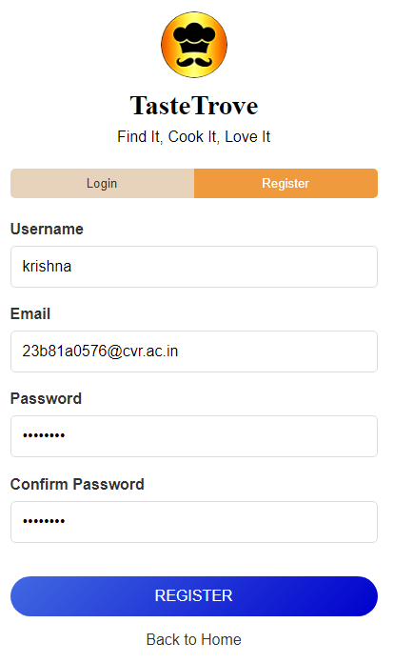 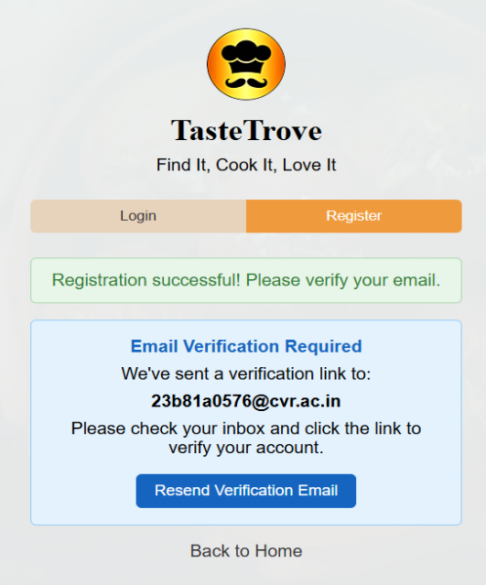**Fig. 5.9: New User Registration**  **Fig. 5.10: Email Verification Prompt**  **After Registration**

Fig 5.9: User Registration Screen  
This figure illustrates the user registration interface, where users input credentials to create a new TasteTrove account.

Fig 5.10: Email Verification Prompt  
This screen confirms successful registration and prompts the user to verify their email to activate the TasteTrove account.

**Tastcase4: Add Recipe by user**

* The registered user can add recipes.  
  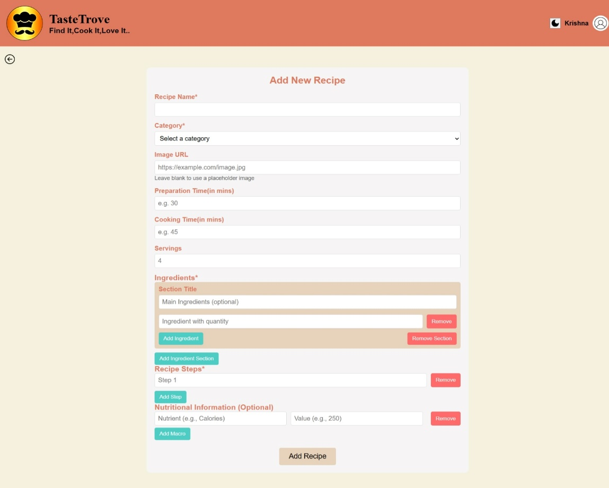

**Fig. 5.11: Add Recipe Interface for Logged-In Users**

Fig 5.11: Add New Recipe Interface  
This form allows users to input and submit a new recipe by specifying details like name, category, preparation time, ingredients, steps, and optional nutritional info.

**Tastcase5: Timer for user**

* The registered user gets additional feature of timer for cooking.

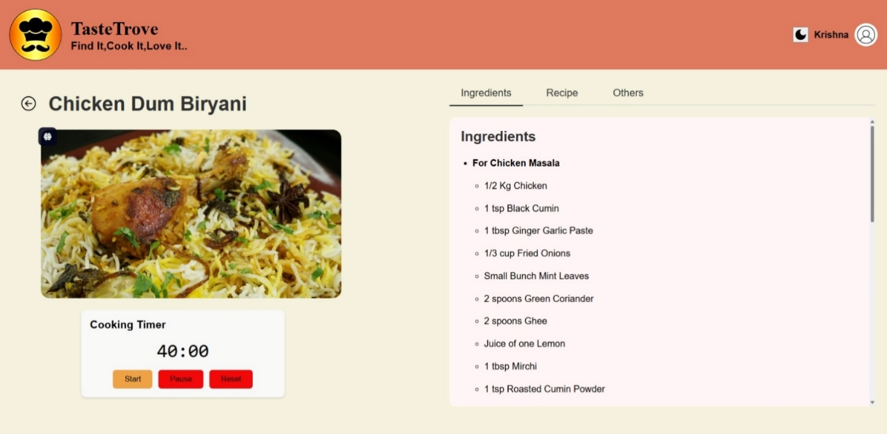

**Fig. 5.12: Cooking Timer Accessible to Registered Users**

Fig 5.12: Cooking Timer Interface  
The recipe view now includes a built-in timer feature, allowing users to start, pause, and reset the cooking countdown while following the recipe.

**Tastcase6: Alert for guest user accessing add recipe**

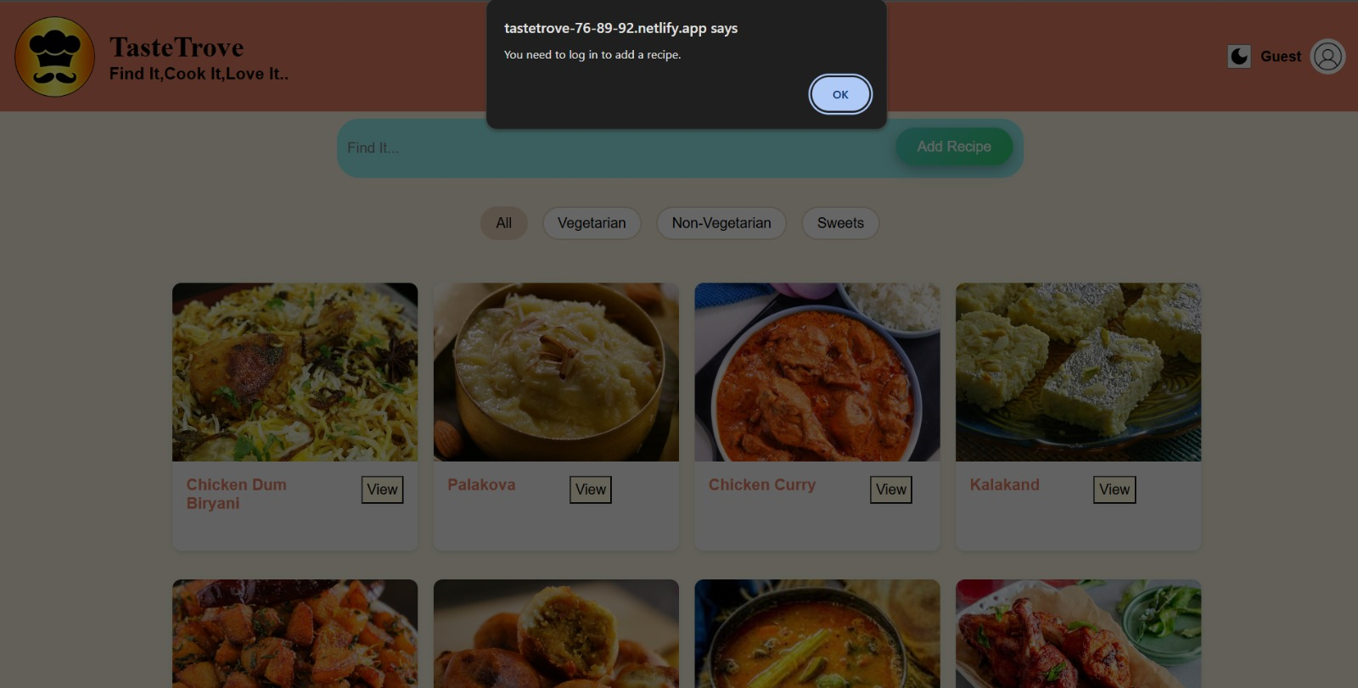

**Fig. 5.13: Access Denied Alert for Guest Attempting to Add Recipe**

Fig 5.13: Add Recipe Access Restriction Alert  
A modal alert appears when a guest user attempts to add a recipe, indicating that login is required to perform this action.

**Tastcase7: View of a particular recipe for User /Guest**

* The view of any particular recipe for User and Guest are the same except that the User gets an additional feature of cooking timer.

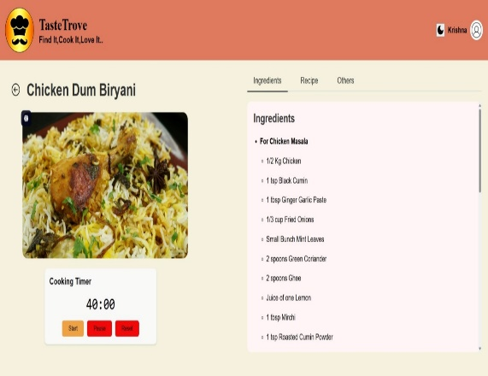 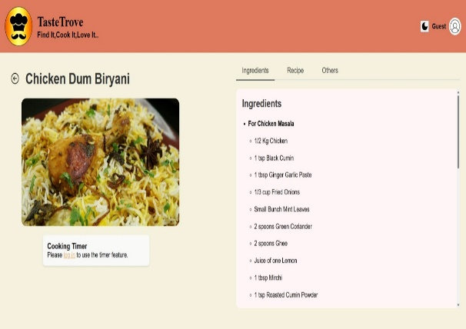

**Fig. 5.14: Recipe View for Registered Fig. 5.15: Recipe View for Guest User**

**User with Cooking Timer Feature**

Fig 5.14: Cooking Timer Feature for Logged-in Users  
Displays the cooking timer integrated into the recipe view for a logged-in user. The timer can be started, paused, or reset while cooking.

Fig 5.15: Cooking Timer Access for Guest Users  
Guest users are prompted to log in to access the cooking timer feature, ensuring that only registered users can utilize this functionality.

**Tastcase8: Use of search bar**

* Any particular recipe of choice can be searched by using this feature
* When the particular recipe is not found we will get an alert.

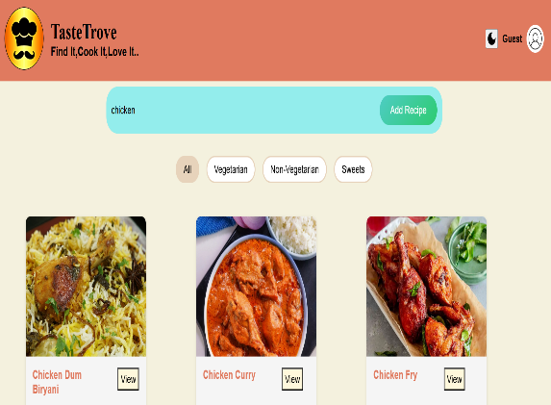 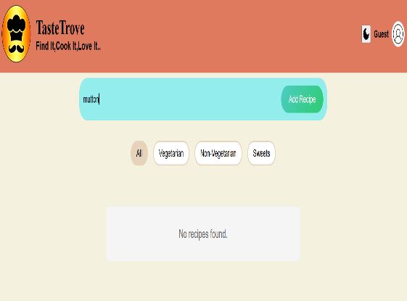

**Fig. 5.16: Search Bar – Finding a Fig. 5.17: Alert Message When No**

**Specific Recipe** **Matching Recipe is Found**

Figure 5.16: Search Functionality in Use  
The search bar is used to filter recipes based on the keyword "chicken," displaying relevant results such as Chicken Dum Biryani, Chicken Curry, and Chicken Fry.

Fig 5.17: Search Yields No Results  
When a user searches for "mutton," the application displays a "No recipes found" message, indicating the absence of matching entries in the current recipe database.

**Tastcase9:Use Filters**

* We can use the filters to browse in a particular category .(eg veg,nonveg,sweets).

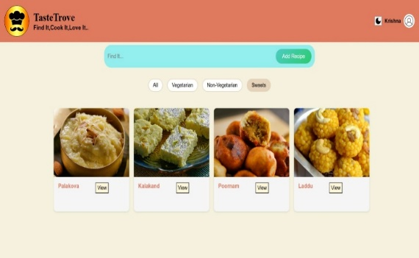 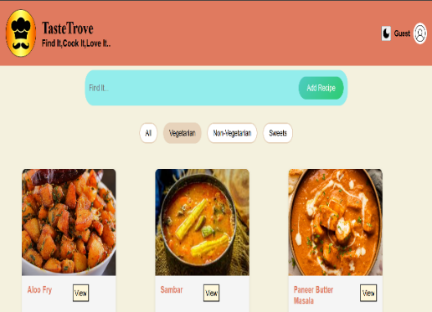

**Fig. 5.18: Recipe Filtering by Category (e.g., Veg, Non-Veg, Sweets)**

Fig 5.18: The interface allows users to filter recipes using tags like All, Vegetarian, Non-Vegetarian, and Sweets. Selecting a tag updates the view to display only the relevant recipes, making browsing easier and more efficient.

**5.4 VALIDATION**

Validation was conducted to ensure the application fulfills all specified functional requirements and use case scenarios. The system was verified against the following key points:

**User Authentication and Verification:** The login, registration, and email verification flows were validated. Unverified users were correctly restricted from accessing secure features.

**Guest Access:** Guest users could browse, search, and view recipes, but were restricted from adding new recipes or using the cooking timer as expected from the use case definitions.

**Recipe Management:** Authenticated users were able to add new recipes, which were then validated and saved to Firestore. Any errors in form submission triggered appropriate feedback.  
   
**Timer Feature:** The cooking timer was successfully tested for logged-in users.

**Logout Flow:** Upon logout, users were redirected to the landing page. All components worked cohesively across the architecturewith frontend components interacting reliably with backend services and the database layer. This confirms that the system meets both functional and architectural requirements set at the beginning of the development-cycle.

**CHAPTER 6**

**CONCLUSIONS**

### **6.1 CONCLUSION**

**Empowering Healthier Lifestyles through "TasteTrove"**

TasteTrove revolutionizes home cooking by offering a user-centric, web-based platform that balances convenience with health. By providing a rich library of recipes, intuitive search features, and nutritional transparency, the platform enables users to take control of their dietary habits with confidence. Prioritizing diversity and accessibility, TasteTrove aligns with modern lifestyles, making healthy eating more achievable and enjoyable. Its innovative approach to combining culinary creativity with nutritional science ensures users can Savor each meal while promoting their overall wellbeing.

### **6.2 FUTURE SCOPE**

**1. Enhanced Personalization:** Integrating advanced AI capabilities to deliver highly personalized recipe recommendations based on user preferences, dietary requirements, and health objectives.

**2. Community Engagement Features:** Introducing interactive forums and recipe-sharing platforms where users can connect, exchange tips, and inspire each other, fostering a vibrant culinary community.

**3. Dietary Analytics and Insights:**  Providing users with advanced analytics that track and analyse dietary patterns, enabling them to make informed decisions about their eating habits.

**4. Interactive Learning Tools:** Incorporating step-by-step tutorials, video guides, and cooking tips to support novice users in developing confidence and expertise in the kitchen.

**5. Expanding Global Recipe Database:** Enhancing the recipe collection by including diverse cuisines from around the world to cater to a wider range of cultural preferences and tastes.

**REFERENCES**

Articles:

[1] Mozilla Developer Network (MDN), "HTML: HyperText Markup Language." [Online]. Available: <https://developer.mozilla.org/en-US/docs/Web/HTML>

[2] Mozilla Developer Network (MDN), "CSS: Cascading Style Sheets." [Online]. Available: <https://developer.mozilla.org/en-US/docs/Web/CSS>

[3] Mozilla Developer Network (MDN), "JavaScript." [Online]. Available: <https://developer.mozilla.org/en-US/docs/Web/JavaScript>

[4] Google Developers, "Firebase Realtime Database - Firebase Documentation." [Online]. Available: <https://firebase.google.com/docs/database>

[5] Google, "Cloud Firestore – NoSQL Database." [Online]. Available: <https://firebase.google.com/products/firestore>

[6] W3Schools, "Responsive Web Design." [Online]. Available: <https://www.w3schools.com/html/html_responsive.asp>

[7] USDA FoodData Central, "Comprehensive Food and Nutrient Data." [Online]. Available: <https://fdc.nal.usda.gov/>

[8] Nielsen Norman Group, "Usability Heuristics for User Interface Design." [Online]. Available: <https://www.nngroup.com/articles/ten-usability-heuristics/>

[9] Vismai Food, "Authentic Telugu Recipes." [Online]. Available: <https://vismaifood.com/te>

[10] D. Jakubowicz and J. Wainstein, "The Impact of Nutritional Education on Home Cooking Practices: A Web-Based Approach," *Nutrition & Dietetics*, vol. 75, no. 4, pp. 423–430, 2018.

[11] M. Fowler, *UML Distilled: A Brief Guide to the Standard Object Modeling Language*, 3rd ed. Boston, MA: Addison-Wesley, 2003.

[12] R. S. Pressman and B. R. Maxim, *Software Engineering: A Practitioner's Approach*, 8th ed. New York, NY: McGraw-Hill Education, 2014.