CHAPTER 4
PROPOSED SYSTEM DESIGN
4.1Proposed Website Workflow for Recipe Manager:
4.1.1. User Interaction (Landing Page):
- Users first land on the homepage of the website. The landing page displays options for both log-in and guest users.
4.1.2. User Authentication:
- If the user is logged in, the website will show additional features such as interactive timer.
- If the user is not logged in, they can browse the site as a guest with limited features. They can view recipes but will not be able interact with certain advanced features like the interactive timer.
4.1.3. Recipe Browsing and Searching:
- Allow users to browse through a collection of recipes.
- Provide a search bar where users can search for specific recipes based on name or ingredients.
- Allow users to filter recipes by dietary preferences (e.g., vegetarian or non-vegetarian). This could be a dropdown or checkbox filter.
- Once the user finds a recipe they are interested in, they can select it to view its details.
- Display detailed information about the recipe including:
  - Ingredients required
  - Cooking steps
  - Nutritional information (if available)
4.1.4. Interactive Timer (For Logged-in Users):
- If the user is logged in, they can start an interactive timer that will guide them through the recipe, helping them keep track of cooking time for different stages. The timer should be interactive with the ability to pause, reset, or skip time.

4.1.5. End the Process:
- Once the user is done browsing, viewing recipes, or using the interactive timer, the process ends.
4.2 CLASS DIAGRAM
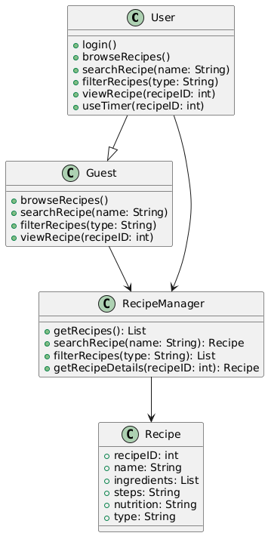

4.3 USE CASE DIAGRAM
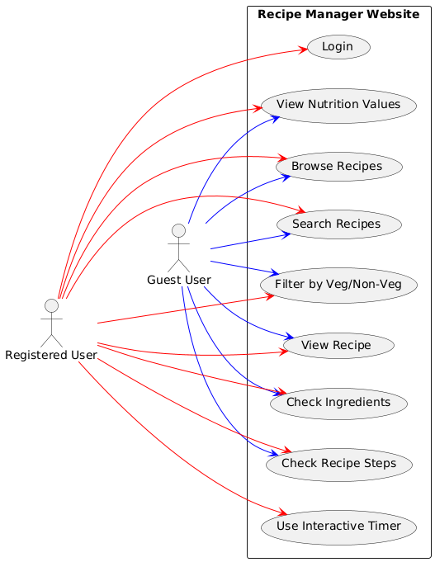

4.4 ACTIVITY DIAGRAM
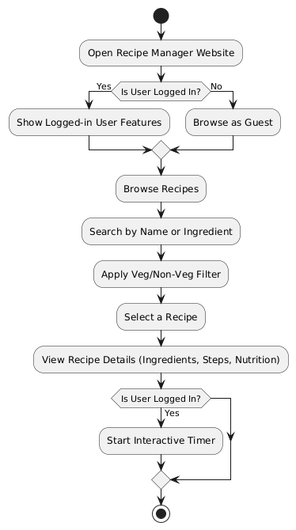
4.5 SEQUENCE DIAGRAM
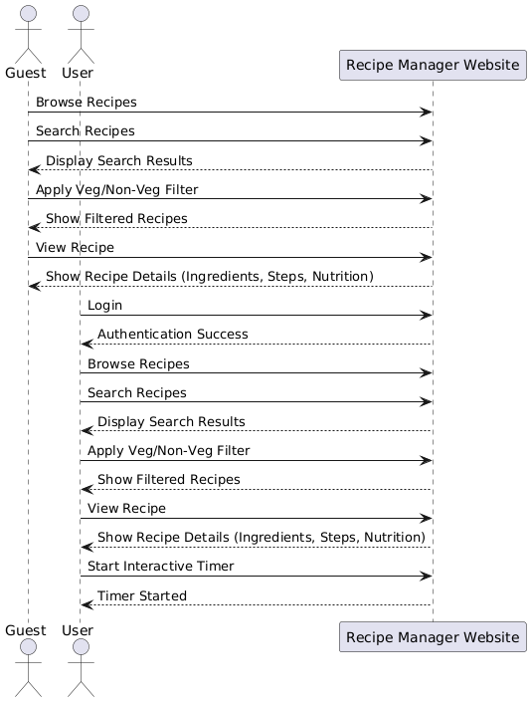

4.6 Features Based on the Workflow:
- Guest Browsing: Users who aren't logged in can still browse recipes but will lack the advanced features such as the interactive timer.
- Personalized Experience for Logged-in Users: Users who are logged in can Start interactive timers
- Recipe Searching: A powerful search system that lets users find recipes by name or ingredient.
- Dietary Preferences Filter: Easy filtering for vegetarian and non-vegetarian users.
- Interactive Timer: A feature that helps logged-in users keep track of cooking times while preparing a recipe.

