Industry Grade project

**Pushing the Source code to the Git Repository:-**

Step 1:-

$ git init

Initialized empty Git repository in C:/Users/DAnuga/OneDrive - Micro Focus/Documents/EDUREKA_PROJECT/ABC Technologies/.git/

Step 2:-

$ git add .

Step 3:-

$ git status

On branch master

No commits yet

Changes to be committed:

(use "git rm --cached <file>..." to unstage)

new file: .classpath

new file: .project

new file: .settings/org.eclipse.jdt.core.prefs

new file: .settings/org.eclipse.m2e.core.prefs

new file: README.md

new file: pom.xml

new file: pom.xml.bak

new file: src/main/java/com/abc/RetailModule.java

new file: src/main/java/com/abc/dataAccessObject/RetailAccessObject.java

new file: src/main/java/com/abc/dataAccessObject/RetailDataImp.java

new file: src/main/webapp/WEB-INF/web.xml

new file: src/main/webapp/index.jsp

new file: src/test/java/com/abc/dataAccessObject/ProductImpTest.java

Step 4:-

$ git commit -m "First edureka project"

[master (root-commit) b954b07] First edureka project

Committer: Dileep Kumar Anuga <dileepkumar.anuga@microfocus.com>

Your name and email address were configured automatically based

on your username and hostname. Please check that they are accurate.

You can suppress this message by setting them explicitly. Run the

following command and follow the instructions in your editor to edit

your configuration file:

git config --global --edit

After doing this, you may fix the identity used for this commit with:

git commit --amend --reset-author

13 files changed, 313 insertions(+)

create mode 100644 .classpath

create mode 100644 .project

create mode 100644 .settings/org.eclipse.jdt.core.prefs

create mode 100644 .settings/org.eclipse.m2e.core.prefs

create mode 100644 README.md

create mode 100644 pom.xml

create mode 100644 pom.xml.bak

create mode 100644 src/main/java/com/abc/RetailModule.java

create mode 100644 src/main/java/com/abc/dataAccessObject/RetailAccessObject.java

create mode 100644 src/main/java/com/abc/dataAccessObject/RetailDataImp.java

create mode 100644 src/main/webapp/WEB-INF/web.xml

create mode 100644 src/main/webapp/index.jsp

create mode 100644 src/test/java/com/abc/dataAccessObject/ProductImpTest.java

Step 5:-

$ git remote add origin https://github.com/DileepKumargit-account/Edureka_project1.git

Step 6:-

$ git push -u origin master

Enumerating objects: 29, done.

Counting objects: 100% (29/29), done.

Delta compression using up to 8 threads

Compressing objects: 100% (20/20), done.

Writing objects: 100% (29/29), 4.45 KiB | 198.00 KiB/s, done.

Total 29 (delta 0), reused 0 (delta 0), pack-reused 0

To https://github.com/DileepKumargit-account/Edureka_project1.git

* [new branch] master -> master

branch 'master' set up to track 'origin/master'.

**Screenshot of the Git repository**

Jenkins:-

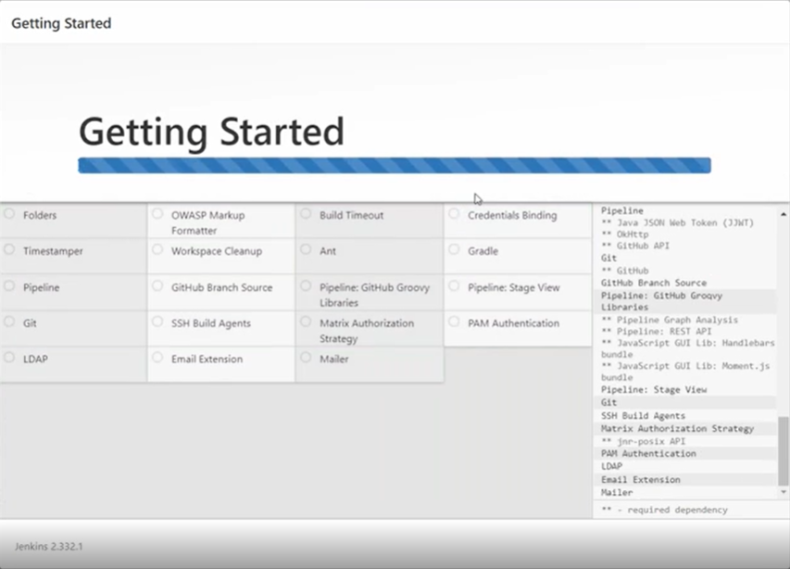

Jenkins Script File:-

**Creation of Dockerfile and integration with Ansible**



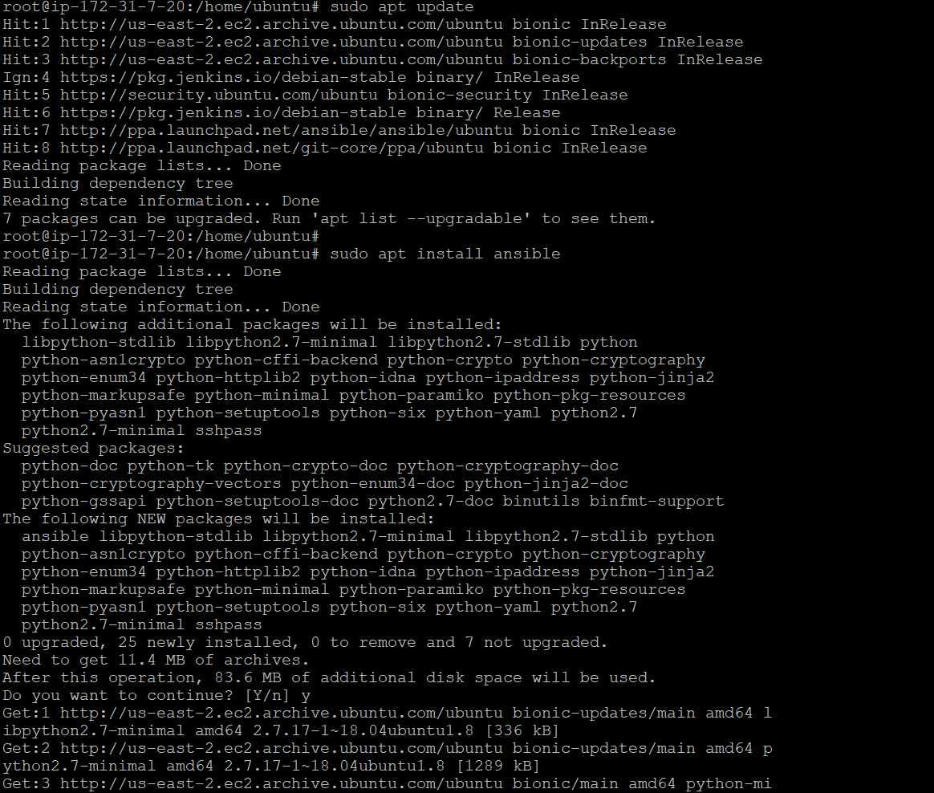

**Host file in ansible to mention the IP Address under Webserver field:-**

**Enabling password authentication to YES in ansible configuration file.**

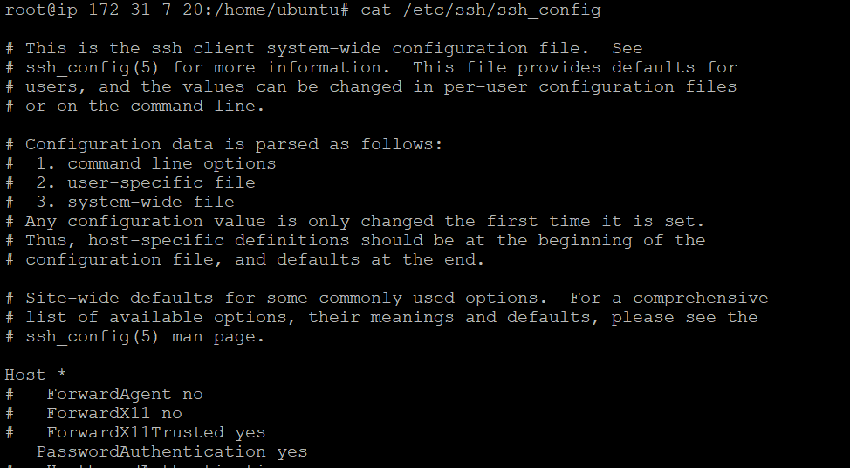

**docker_image_creation_in_asnisblenode.yml**

**Dockercontainer-run.yml**

**Dockerinstallation_in_hosts.yml**

**Prometheus installation:-**



Creating a Prometheus user, required directories, and make Prometheus the user as the owner of those directories.

Copying prometheus and promtool binary from prometheus-files folder to /usr/local/bin and change the ownership to prometheus user.

**Setting up Prometheus configuration**

Create the prometheus.yml file:-



Create a prometheus service file:-



Reloading the systemd service to register the prometheus service and start the prometheus service.

To record the time series resulting from this expression into a new metric called **job_instance_mode:node_cpu_seconds:avg_rate5m**

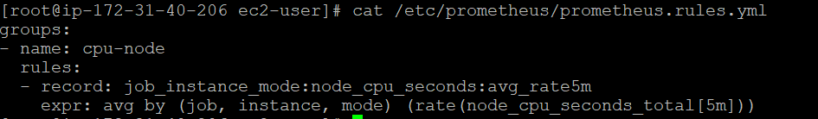

To make Prometheus pick up this new rule, add a rule_files statement in your Prometheus.yml The config should now looks like below.

