

CO1 DESIGN ASSIGNMENT

Student Name: Mollala Dileep Reddy Course Code: ECA1803
Reg.N0: 19231572 Course Faculty: Dr Princy Magdaline

Programme: B.E ECE Date of Submission: 14/10/2026

Standards-Compliant Optical Fiber Link Design: From Communication Requirement to Deployment Decision

Executive Summary
This report follows the sequence REQUIREMENT → ALTERNATIVES → ANALYSIS → SELECTION → LINK DESIGN → VERIFICATION → DEPLOYMENT DECISION. The two candidate fibers, the loss budget, chromatic dispersion, PMD and OSNR were each analysed numerically, and the results were combined into one integrated link. The main conclusions are given below.
Design decision | Adopted configuration | Governing numbers
1. Fiber / propagation | Single-mode, step-index fiber (Fiber A type). ITU-T G.652.D trunk, G.657.A tail at the building entry | V = 1.951 < 2.405; λc = 1.257 µm; NA = 0.120; one mode (LP01)
2. Power budget | Passive link with G.657.A building entry; fiber loss 0.18 dB/km | Total loss 13.3 dB; Pr = −10.3 dBm; margin 9.7 dB (≥ 6 dB)
3. Dispersion / PMD | 10.2 km DCF (−100 ps/(nm·km)) at the receive end; standard low-PMD fiber, no PM fiber | Δτ = 408 ps → 0 net; DCF loss 5.1 dB; PMD = 0.77 ps
4. OSNR / amplification | EDFA pre-amplifier, 14 dB gain, with optical band-pass filter | OSNR 23 dB → 21 dB (≥ 17 dB); margin 4 dB
5. Deployment | YES – deploy | Final Pr = −1.4 dBm; margin 18.6 dB over sensitivity

Stage 1 – Interpret the Communication Requirement
The service must deliver 10 Gb/s (T_b = 100 ps) over 60 km at 1550 nm to a business building and must be upgradable to 100 Gb/s (T_b ≈ 10 ps). Before calculating anything, the physical quantities that decide whether such a link works are identified below.

1.1 Why 1550 nm, and the nature of light that governs propagation
- Operating window. The attenuation of silica is lowest near 1550 nm. Rayleigh scattering falls as λ⁻⁴ and infrared (multiphonon) absorption only starts to rise beyond about 1600 nm, so 1550 nm gives the minimum total loss. It is also the gain band (C-band) of the erbium-doped fiber amplifier (EDFA), which makes amplification and a later upgrade possible. The price paid is a large chromatic dispersion in standard fiber (17 ps/(nm·km)), which is addressed in Stage 4.
- Ray versus wave behaviour. When the core is much larger than the wavelength (a/λ ≫ 1) light can be treated as rays undergoing total internal reflection. When the core is only a few wavelengths wide, diffraction matters and the field must be found from Maxwell’s wave equation (∇²E + (n²k₀² − β²)E = 0), giving discrete LP/HE/EH modes.
- Coherence. A source of spectral width Δλ = 0.4 nm has a coherence length L_c = λ²/Δλ = (1550 nm)²/0.4 nm ≈ 6.0 mm (coherence time ≈ 20 ps). The finite spectral width is exactly what produces chromatic-dispersion broadening, and in multimode fiber coherent light also produces modal noise (speckle).
- Polarization. The fundamental mode of a single-mode fiber consists of two orthogonal polarization states. If the fiber is slightly birefringent they travel at different speeds, giving polarization-mode dispersion (PMD).

1.2 Light acceptance and guided-mode characteristics
The numerical aperture NA = √(n₁² − n₂²) = n₀ sin θ_max measures how much light the fiber accepts. The normalized frequency V = (2πa/λ)·NA combines wavelength, core size and index difference. A step-index fiber supports only the fundamental LP₀₁ (HE₁₁) mode when V < 2.405 (the first zero of the Bessel function J₀), which defines the cut-off condition; the corresponding cut-off wavelength is λc = 2πa·NA/2.405. For large V the number of guided modes is approximately V²/2 (step-index) and V²/4 (parabolic graded-index).

1.3 Propagation characteristics and ITU-T fiber categories
- G.652.D – standard single-mode fiber with a low-water-peak, cable cut-off wavelength ≤ 1260 nm, D ≈ 17 ps/(nm·km) at 1550 nm and a low PMD link-design value. It is the most widely deployed, lowest-cost fiber for a 60 km link.
- G.655 – non-zero dispersion-shifted fiber. Dispersion at 1550 nm is small but not zero (4.5 ps/(nm·km) here), which reduces chromatic broadening and suppresses four-wave mixing in WDM systems.
- G.657 – bend-insensitive single-mode fiber. The A-category (A1/A2) is fully compatible with G.652.D, so it can be spliced directly to a G.652.D trunk, and it tolerates the tight bends at a building entry (bend radius of a few millimetres to about 10 mm).

1.4 Loss and power-budget quantities
The total fiber attenuation coefficient is α = α_abs + α_Rayleigh + α_bend. In addition the link contains connector, splice and building-entry bend losses. The power budget requires P_r = P_t − (αL + connectors + splices + entry bend) ≥ S_rx + M, where S_rx = −20 dBm is the receiver sensitivity and M = 6 dB the required system margin.

1.5 Dispersion quantities and compensation
- Modal dispersion exists only in multimode fiber (different modes travel at different group velocities). It is reduced by a graded-index profile and eliminated by single-mode operation.
- Chromatic dispersion gives a broadening Δτ = D·Δλ·L (material + waveguide dispersion acting on a finite source spectrum). It is compensated with a dispersion-compensating fiber (DCF), fiber Bragg gratings, or electronic/coherent DSP.
- PMD gives a mean differential group delay Δτ_PMD = D_PMD·√L, to be kept below 0.1 T_b.

1.6 Signal-quality quantity: OSNR and its relation to BER
An amplifier adds amplified spontaneous emission (ASE) noise. The optical signal-to-noise ratio, OSNR = P_signal/P_ASE measured in a 0.1 nm (≈ 12.5 GHz) reference bandwidth, is the quantity that judges signal quality. Because Q² is proportional to OSNR, and BER = ½·erfc(Q/√2), a lower OSNR directly means a lower Q-factor and a higher BER.

1.7 Practical constraints
Tight bends at the building entry (bend radius), the 100 Gb/s upgrade path (smaller bit period, so much tighter dispersion and PMD tolerance) and the 6 dB system margin (to cover ageing, repairs, temperature and connector re-mating) all influence the final configuration.

1.8 Characteristics of an acceptable solution
- Single-mode operation at 1550 nm (V < 2.405) using standard ITU-T fiber, with a bend-insensitive section where the bends are tight.
- Received power P_r ≥ −20 dBm + 6 dB = −14 dBm, i.e. a total loss no greater than +3 − (−14) = 17 dB.
- Output pulse width after compensation well below the 100 ps bit period (no inter-symbol interference).
- PMD below 0.1 T_b: 10 ps for 10 Gb/s, and ideally 1 ps for 100 Gb/s.
- OSNR ≥ 17 dB (0.1 nm reference bandwidth) at the receiver.

STAGE 1 DELIVERABLE – DESIGN REQUIREMENT STATEMENT
The proposed 60 km optical link shall carry 10 Gb/s traffic at 1550 nm over single-mode ITU-T fiber (V < 2.405), using bend-insensitive G.657.A fiber at the building entry, such that: (i) the received power is at least −14 dBm (receiver sensitivity −20 dBm plus a 6 dB system margin), meaning the total loss must not exceed 17 dB from a +3 dBm launch; (ii) the chromatic-dispersion broadening is compensated so that the output pulse is well within the 100 ps bit period; (iii) the PMD stays below 0.1 T_b (10 ps at 10 Gb/s, with a path to 1 ps at 100 Gb/s); (iv) the OSNR is at least 17 dB in a 0.1 nm bandwidth; and (v) all of these choices remain valid for a later 100 Gb/s upgrade without re-cabling.

Stage 2 – Fiber / Propagation Configuration

2.1 Numerical aperture (light-acceptance parameter)
NA = √(n₁² − n₂²) = √((n₁ − n₂)(n₁ + n₂)). Relative index difference Δ = (n₁ − n₂)/n₁.
Fiber A: NA = √(1.4500² − 1.4450²) = √(0.005 × 2.895) = √0.014475 = 0.1203, θ_max = sin⁻¹(0.1203) = 6.91°
Fiber B: NA = √(1.480² − 1.465²) = √(0.015 × 2.945) = √0.044175 = 0.2102, θ_max = sin⁻¹(0.2102) = 12.13°
Fiber B accepts light from a cone almost twice as wide, so it couples more power from a poor-quality source, but, as shown below, this advantage is paid for with many modes.

2.2 Normalized frequency (V-number) at 1550 nm
V = (2π a / λ) · NA
Fiber A: V = (2π × 4.0 µm / 1.55 µm) × 0.1203 = 16.215 × 0.1203 = 1.951
Fiber B: V = (2π × 25 µm / 1.55 µm) × 0.2102 = 101.34 × 0.2102 = 21.30

2.3 Mode count and cut-off
- Step-index approximation: M ≈ V²/2. For Fiber B: M ≈ 21.30²/2 = 453.7/2 ≈ 227 modes.
- Graded-index (parabolic) approximation: M ≈ V²/4 ≈ 113 modes if Fiber B had a graded profile.
- Cut-off condition: only the LP₀₁ mode propagates when V < 2.405. For Fiber A, V = 1.951 < 2.405, so it is single-mode at 1550 nm.
- Cut-off wavelength of Fiber A: λc = 2π a NA / 2.405 = (2π × 4.0 × 0.1203)/2.405 = 1.257 µm. The fiber is single-mode for all λ > 1257 nm, so 1550 nm is well inside the single-mode region (λc is also just below the 1260 nm limit used for G.652.D cable cut-off).
- Mode-field diameter of Fiber A (Marcuse approximation): w = a(0.65 + 1.619V^−1.5 + 2.879V^−6) = 5.19 µm, so MFD ≈ 10.4 µm, which matches the roughly 10 µm field of standard fiber at 1550 nm and splices with low loss.

2.4 When is ray theory adequate and when is wave optics required?
Quantity | Fiber A | Fiber B
a/λ (core radius / wavelength) | 2.6 | 16.1
V-number | 1.951 (small) | 21.30 (large)
Critical angle sin⁻¹(n₂/n₁) | 85.2° | 81.8°
Modes | 1 (LP₀₁ only) | ≈ 227
Appropriate theory | Wave optics (Maxwell/LP modes). The core is comparable to λ, the field spreads into the cladding and a ray picture has no meaning | Ray optics is an adequate approximation: many modes form a quasi-continuum, so rays with total internal reflection describe delay spreads well

2.5 Comparison of propagation types and ITU-T categories
Modal dispersion of Fiber B was evaluated for the full 60 km. For step-index: Δτ ≈ L·n₁Δ/c = (60 000 × 1.48 × 0.010135)/(3 × 10⁸) = 3.0 µs (≈ 50 ns/km). For an ideal parabolic graded-index profile: Δτ ≈ L·n₁Δ²/(8c) = (60 000 × 1.48 × 1.027 × 10⁻⁴)/(8 × 3 × 10⁸) = 3.8 ns. The usable bit rate is approximately 1/(2Δτ).
Parameter (60 km) | Single-mode (Fiber A) | Step-index multimode (Fiber B) | Graded-index multimode (B with parabolic profile)
Guided modes | 1 | ≈ 227 | ≈ 113
Modal dispersion | None (one mode) | 3.0 µs (≈ 30 000 bit periods) | 3.8 ns (≈ 38 bit periods)
Max. bit rate ≈ 1/(2Δτ) | Limited only by chromatic dispersion and PMD (Stage 4) | ≈ 0.17 Mb/s | ≈ 0.13 Gb/s
Bandwidth × distance | Hundreds of Gb/s·km (needed: 10 Gb/s × 60 km = 600 Gb/s·km) | ≈ 10 Mb/s·km | ≈ 8 Gb/s·km
Verdict for 10 Gb/s, 60 km | Suitable | Unsuitable (about 6 × 10⁴ times too slow) | Unsuitable (about 76 times short)

ITU-T category | Relevant characteristic | Role in this link
G.652.D | D = 17 ps/(nm·km), low loss, low water peak, cut-off ≤ 1260 nm, widely available | Trunk fiber for 60 km
G.655 | D = 4.5 ps/(nm·km); less broadening; useful in dense WDM | Considered alternative (see Stage 4)
G.657.A | Bend-insensitive, compatible with G.652.D, bend loss 0.1 dB vs 0.8 dB | Building-entry tail

DESIGN DECISION 1 – FIBER / PROPAGATION CONFIGURATION
I recommend single-mode, step-index propagation (Fiber A type, V = 1.951, λc = 1.257 µm) using ITU-T G.652.D fiber for the 60 km trunk and a G.657.A bend-insensitive tail at the building entry because only one guided mode (LP₀₁) exists at 1550 nm, so modal dispersion is completely absent; Fiber B would produce 3.0 µs (step-index) or 3.8 ns (graded-index) of modal spreading, against a 100 ps bit period, and cannot reach 600 Gb/s·km. G.652.D has the lowest cost and widest availability, its 17 ps/(nm·km) dispersion can be compensated (Stage 4), and G.657.A is fully compatible with it while removing the 0.8 dB building-entry bend loss.

Stage 3 – Optical Power Budget

3.1 Fiber attenuation coefficient
The single attenuation coefficient that represents the combined effect of absorption, Rayleigh scattering and bending is:
α = α_abs + α_Rayleigh + α_bend = 0.04 + 0.11 + 0.03 = 0.18 dB/km
Fiber loss = α·L = 0.18 × 60 = 10.8 dB

3.2 Link budget for G.652.D-type and G.657.A-type building entry
Loss element | Calculation | G.652.D entry (dB) | G.657.A entry (dB)
Absorption | 0.04 × 60 | 2.4 | 2.4
Rayleigh scattering | 0.11 × 60 | 6.6 | 6.6
Bending (distributed) | 0.03 × 60 | 1.8 | 1.8
Fiber subtotal | 0.18 × 60 | 10.8 | 10.8
Connectors | 4 × 0.4 | 1.6 | 1.6
Splices | 10 × 0.08 | 0.8 | 0.8
Building-entry bend | given | 0.8 | 0.1
Total link loss |  | 14.0 | 13.3
Transmitter power |  | +3.0 dBm | +3.0 dBm
Received power P_r | 3 − loss | −11.0 dBm | −10.3 dBm
Margin over sensitivity (−20 dBm) | P_r − (−20) | 9.0 dB | 9.7 dB
Required system margin |  | 6 dB | 6 dB
Surplus after required margin |  | 3.0 dB (satisfied) | 3.7 dB (satisfied)

Both configurations meet the receiver requirement without any amplifier or compensation, but the G.657.A version gives 0.7 dB more margin. This budget will be revisited in Stage 4 because the DCF adds loss.

3.3 Dominant loss mechanism
Mechanism | Loss over 60 km | % of fiber loss (10.8 dB) | % of total passive loss (13.3 dB)
Rayleigh scattering | 6.6 dB | 61.1 % | 49.6 %
Absorption | 2.4 dB | 22.2 % | 18.0 %
Distributed bending | 1.8 dB | 16.7 % | 13.5 %
Connectors (4) | 1.6 dB | – | 12.0 %
Splices (10) | 0.8 dB | – | 6.0 %
Building-entry bend (G.657.A) | 0.1 dB | – | 0.8 %

Rayleigh scattering (0.11 dB/km, 6.6 dB) is the dominant specified fiber-loss mechanism. It is intrinsic to silica and varies as λ⁻⁴, so it is already minimised by operating at 1550 nm; it cannot be reduced further by installation practice. The mechanism that can actually be optimised is bending (distributed 1.8 dB plus the entry bend of up to 0.8 dB), followed by connectors (1.6 dB, the largest single passive item).

3.4 Two practical actions to reduce avoidable loss
- Use G.657.A bend-insensitive fiber at the building entry and enforce bend-radius control in cable trays and splice closures. This cuts the entry bend from 0.8 dB to 0.1 dB (saves 0.7 dB) and reduces the risk of future microbend and macrobend loss.
- Minimise connectors and use fusion splices: replacing two connectors by fusion splices reduces the loss by 2 × (0.4 − 0.08) = 0.64 dB; the remaining connectors should be cleaned and inspected (with low-loss, UPC/APC polished types) to avoid dirt-induced excess loss.

DESIGN DECISION 2 – POWER-BUDGET CONFIGURATION
I recommend the G.657.A building-entry power-budget configuration (total passive loss 13.3 dB, received power −10.3 dBm) because the calculated attenuation of 0.18 dB/km gives 10.8 dB over 60 km, the total link loss is 13.3 dB, the received power is −10.3 dBm, and the margin over the −20 dBm sensitivity is 9.7 dB, which exceeds the required 6 dB by 3.7 dB. The G.652.D version (14.0 dB, −11.0 dBm, 9.0 dB margin) is also acceptable but wastes 0.7 dB. Rayleigh scattering is the dominant specified loss (49.6 % of the total) but is intrinsic; the greatest optimisation effort should go to bending loss (G.657.A and bend-radius control) and then to connector count.

Stage 4 – Dispersion and Polarization Management

4.1 Modal dispersion: absent in Fiber A, dominant in Fiber B
In Fiber A (V = 1.95 < 2.405) only the LP₀₁ mode exists, so all optical energy travels with one group velocity and there is no mode-to-mode delay difference. In Fiber B about 227 modes propagate; steep-angle rays (high-order modes) travel a longer geometric path than the axial ray, giving a delay spread of about 3.0 µs over 60 km. A graded-index profile makes the refractive index decrease smoothly from the axis to the cladding, so rays that travel farther also travel faster in the lower-index outer region, and the transit times of the different modes are almost equalised. The residual spread drops from 3.0 µs to about 3.8 ns (a reduction of the order of Δ/8 ≈ 0.13 %), which is still far too large for 10 Gb/s over 60 km.

4.2 Chromatic-dispersion broadening
Δτ = D · Δλ · L
G.652.D: Δτ = 17 × 0.4 × 60 = 408 ps
G.655: Δτ = 4.5 × 0.4 × 60 = 108 ps

4.3 RSS combination with the 30 ps input pulse and comparison with T_b = 100 ps
τ_out = √(τ_in² + Δτ²)
G.652.D: τ_out = √(30² + 408²) = √167 364 = 409.1 ps (4.09 T_b)
G.655: τ_out = √(30² + 108²) = √12 564 = 112.1 ps (1.12 T_b)
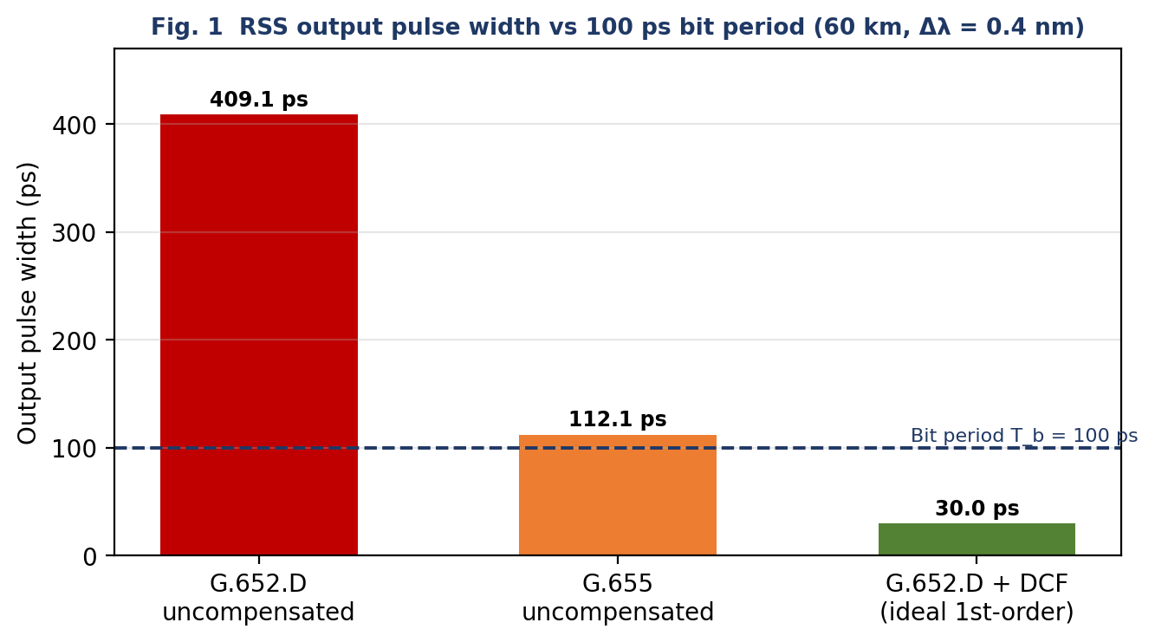
Fig. 1 – Output pulse width after 60 km compared with the 100 ps bit period
With G.652.D the pulse spreads over more than four bit slots, so each bit overlaps the next three or four neighbours; the eye is completely closed and inter-symbol interference (ISI) makes the BER unacceptable. Even G.655 (112 ps) is still wider than one bit period, so ISI persists, only less severely. Uncompensated chromatic dispersion is therefore not acceptable for either fiber at 10 Gb/s with this 0.4 nm source, and at 100 Gb/s (T_b ≈ 10 ps) the 408 ps broadening would span about 41 bit periods.

4.4 Dispersion compensation and DCF length
Complete first-order compensation requires the accumulated dispersion of the transmission fiber and of the DCF to cancel:
D₁L₁ + D_DCF·L_DCF = 0 ⇒ L_DCF = D₁L₁ / |D_DCF|
G.652.D: L_DCF = (17 × 60)/100 = 1020/100 = 10.2 km
DCF loss = 0.5 dB/km × 10.2 km = 5.1 dB
(For comparison, a G.655 link would need only (4.5 × 60)/100 = 2.7 km of DCF with a loss of 1.35 dB.) Because the DCF loss is added to the passive loss, the budget must be recomputed:
Quantity | G.652.D entry bend | G.657.A entry bend
Passive loss before DCF | 14.0 dB | 13.3 dB
DCF loss | 5.1 dB | 5.1 dB
Total loss with DCF | 19.1 dB | 18.4 dB
Received power (3 dBm − loss) | −16.1 dBm | −15.4 dBm
Margin over −20 dBm sensitivity | 3.9 dB | 4.6 dB
Required margin | 6 dB | 6 dB
Result | Short by 2.1 dB | Short by 1.4 dB

Compensating the dispersion therefore pushes the passive link below the required 6 dB margin. A gain of at least 2.1 dB (G.652.D) or 1.4 dB (G.657.A) is needed, which the amplifier in Stage 5 provides with a large reserve. Placing the DCF at the receive end, where the optical power is already low (about −10 dBm), also keeps nonlinear effects in the small-core DCF negligible, and the +3 dBm launch into the G.652.D trunk is safely below the nonlinear thresholds.

4.5 Polarization-mode dispersion
PMD = 0.1 · √L = 0.1 × √60 = 0.775 ps
Case | Bit period T_b | Limit 0.1 T_b | PMD = 0.775 ps
10 Gb/s | 100 ps | 10 ps | 7.7 % of limit – acceptable
100 Gb/s upgrade | ≈ 10 ps | 1 ps | 77.5 % of limit – acceptable but marginal

If the DCF has a PMD coefficient similar to the trunk (an assumption, since no value is given), its contribution is 0.1 × √10.2 = 0.32 ps and the total adds in quadrature to √(0.775² + 0.32²) = 0.84 ps, still below 1 ps. PMD mitigation technique: specify low-PMD fiber (≤ 0.1 ps/√km) and, for the 100 Gb/s upgrade, use coherent detection with DSP equalisation (alternatively an optical PMD compensator).

4.6 Birefringence, beat length and the role of PM fiber
Birefringence B = |n_x − n_y| is the refractive-index difference between the two orthogonal polarization states. The beat length L_B = λ/B is the distance over which the two states accumulate a 2π phase difference. The exponents of B were not legible in the supplied PDF; the standard values B = 1 × 10⁻⁷ (standard fiber) and B = 4 × 10⁻⁴ (PM fiber) are used.
Standard fiber: L_B = 1.55 × 10⁻⁶ / 1 × 10⁻⁷ = 15.5 m
PM fiber: L_B = 1.55 × 10⁻⁶ / 4 × 10⁻⁴ = 3.875 mm
In PM (polarization-maintaining) fiber the strong built-in birefringence makes the beat length only a few millimetres, so coupling between the two polarization states is negligible and linear polarization launched along a principal axis is preserved. PM fiber is not needed for this link: the system uses intensity modulation with direct detection, which is insensitive to the state of polarization, the PMD of ordinary G.652.D fiber is already far below the limit, and PM fiber is more expensive, lossier and difficult to splice. PM fiber is justified only in short pigtails to polarization-sensitive devices (such as an external modulator).

DESIGN DECISION 3 – DISPERSION / PMD MANAGEMENT CONFIGURATION
I recommend the G.652.D trunk (with G.657.A entry) plus a 10.2 km DCF module (−100 ps/(nm·km), 5.1 dB loss) at the receive end, with standard low-PMD fiber and no PM fiber because uncompensated G.652.D broadens the 30 ps pulse to 409 ps (4.09 T_b) and even G.655 gives 112 ps (1.12 T_b), both causing ISI at 100 ps/bit; the 10.2 km DCF cancels the +1020 ps/nm accumulated dispersion to zero. The DCF loss lowers the received power to −15.4 dBm (4.6 dB margin, 1.4 dB short), which is recovered by the amplifier of Stage 5. PMD is 0.775 ps, only 7.7 % of the 10 ps limit at 10 Gb/s and 77.5 % of the 1 ps limit at 100 Gb/s. G.652.D is preferred over G.655 because it is cheaper and universally compatible with G.657.A, the extra 7.5 km of DCF (3.75 dB) is recovered by the amplifier that the OSNR study requires anyway, and at 100 Gb/s coherent DSP can remove the DCF altogether.

Stage 5 – OSNR and Amplification Strategy

5.1 Performance metric and initial OSNR
The metric that judges signal quality relative to ASE noise is the optical signal-to-noise ratio (OSNR). It is measured as the ratio of signal power to ASE noise power in a 0.1 nm reference bandwidth, which at 1550 nm corresponds to about 12.5 GHz (Δν = cΔλ/λ²).
OSNR = P_signal(dBm) − P_ASE(dBm) = −16 − (−39) = 23 dB

5.2 Effect of the amplifier
Item | Signal power (dBm) | ASE noise (dBm, 0.1 nm) | OSNR (dB)
Before amplifier | −16 | −39 | 23.0
Amplifier effect | +14 dB gain | +16 dB increase | −2.0 (= 14 − 16)
After amplifier | −2 | −23 | 21.0
Required OSNR |  |  | 17.0
Remaining margin |  |  | 4.0 dB

The amplifier raises the signal by 14 dB but the noise by 16 dB, so the OSNR falls by 2 dB (23 → 21 dB). This is the unavoidable noise penalty of amplification; the amplifier improves signal power, not signal quality. The final OSNR of 21 dB is still 4 dB above the required 17 dB, so the strategy is acceptable. The input of −16 dBm used in the OSNR study is almost identical to the −15.4 dBm available after the DCF, which shows that the amplifier belongs at the receive end, behind the DCF. The given −16 dBm figure is used (conservative by about 0.6 dB).

5.3 Effect of inadequate OSNR on Q-factor, BER and system margin
Q = (I₁ − I₀)/(σ₁ + σ₀) measures the separation of the ‘1’ and ‘0’ levels relative to the noise, and BER = ½·erfc(Q/√2). Since Q² is proportional to OSNR, a 1 dB loss of OSNR reduces Q by 1 dB (20 log Q). The 4 dB OSNR margin corresponds to a factor 10^(4/20) = 1.58 in Q. If the OSNR fell by 4 dB, Q would drop from 7 to about 4.4 and the BER would rise from 1.3 × 10⁻¹² to about 5 × 10⁻⁶. Because ASE-limited noise grows with the signal, extra received power does not recover the BER, so the system margin is effectively lost.
Q-factor | 3 | 4 | 5 | 6 | 7
BER | 1.3 × 10⁻³ | 3.2 × 10⁻⁵ | 2.9 × 10⁻⁷ | 9.9 × 10⁻¹⁰ | 1.3 × 10⁻¹²

5.4 Two practical measures to maintain or improve OSNR
- Use a low-noise-figure EDFA and place it where the signal is strong. Position the amplifier early (a pre-amplifier ahead of further loss) and, where the module allows, put the DCF in the interstage (mid-stage) position of a two-stage EDFA. This hides the 5.1 dB DCF loss from the first-stage input, and a higher amplifier input power gives a higher OSNR.
- Filter the ASE and add FEC. An optical band-pass filter after the amplifier removes out-of-band ASE noise, and forward error correction at the receiver tolerates a lower Q/OSNR for the same post-FEC BER.

DESIGN DECISION 4 – OSNR / AMPLIFICATION STRATEGY
I recommend accepting the proposed amplification strategy (14 dB EDFA gain, 16 dB ASE increase, with a band-pass filter) because the OSNR falls only from 23 dB to 21 dB, which is 4 dB above the required 17 dB, while the signal level rises from −16 dBm to −2 dBm. The amplifier recovers the 1.4–2.1 dB budget shortfall created by the DCF with a large reserve, and the expected communication performance is an error-free (BER ≤ 10⁻¹²-class) 10 Gb/s link.

Stage 6 – Verification and Critical Evaluation
The results of Stages 2–5 are compared with the original requirement below.
Requirement | Specified / Target | Achieved | Satisfactory?
Modal condition / fiber category | Single-mode at 1550 nm, standard ITU-T fiber | V = 1.951 < 2.405; λc = 1.257 µm; G.652.D trunk + G.657.A entry | Yes
Fiber loss / link loss | Total ≤ 17 dB (3 dBm − (−14 dBm)) | Fiber 10.8 dB; passive link 13.3 dB; with DCF 18.4 dB | Yes for passive link; DCF case needs amplifier
Received power and margin | P_r ≥ −14 dBm (sensitivity −20 dBm + 6 dB) | Passive: −10.3 dBm (9.7 dB). With DCF: −15.4 dBm (4.6 dB). With EDFA: −1.4 dBm (18.6 dB) | Yes (with EDFA)
Pulse broadening / DCF requirement | Output pulse ≪ T_b = 100 ps | Uncompensated 409 ps; 10.2 km DCF cancels +1020 ps/nm → net 0 (pulse ≈ 30 ps) | Yes (with DCF)
PMD / polarization performance | ≤ 10 ps (10G); ≤ 1 ps (100G) | 0.775 ps (≈ 0.84 ps incl. assumed DCF PMD); no PM fiber needed | Yes (10G); marginal-pass (100G)
OSNR | ≥ 17 dB (0.1 nm) | 21.0 dB after amplifier (23 dB before); margin 4.0 dB | Yes

Consistency with the requirement. Every row is satisfied by the integrated design, but the verification also shows that the individual choices depend on each other: the DCF is needed for pulse integrity but costs 5.1 dB; that cost makes the power margin insufficient; the amplifier restores it but costs 2 dB of OSNR; and the remaining OSNR margin of 4 dB confirms that this chain of trade-offs closes with margin. The weakest items are the 4 dB OSNR margin and the 77.5 % PMD utilisation at 100 Gb/s, and these are the points to monitor during commissioning and upgrade.

Final System Design (K6 – Create / Design)

F.1 Design philosophy: how the choices work together
The configuration was built stage by stage, with each decision constraining the next: a single-mode fiber removes modal dispersion, leaving only chromatic dispersion and PMD to manage; G.652.D with a G.657.A entry gives the cheapest low-loss trunk while removing the 0.7 dB entry bend penalty; the 10.2 km DCF cancels chromatic dispersion; the resulting loss is covered by the EDFA, whose ASE penalty is checked against the OSNR budget. The final link was then verified as a whole rather than stage by stage.

F.2 Final parameter / design table
Parameter | Adopted value
Operating wavelength / bit rate | 1550 nm; 10 Gb/s NRZ (upgrade path to 100 Gb/s)
Trunk fiber | ITU-T G.652.D single-mode, 60 km, 0.18 dB/km (10.8 dB), D = 17 ps/(nm·km), low PMD (≤ 0.1 ps/√km)
Building-entry fiber | ITU-T G.657.A (A1/A2) bend-insensitive tail, spliced to G.652.D; entry bend loss 0.1 dB
Launch power | +3 dBm
Connectors / splices | 4 connectors × 0.4 dB = 1.6 dB; 10 fusion splices × 0.08 dB = 0.8 dB
DCF | 10.2 km, D = −100 ps/(nm·km), 0.5 dB/km = 5.1 dB; at the receive end, ahead of (or in the interstage of) the EDFA
Amplifier setting | EDFA pre-amplifier, signal gain 14 dB, ASE increase 16 dB, followed by a band-pass optical filter
Receiver | Sensitivity −20 dBm; required margin 6 dB
PMD management | Standard low-PMD fiber; no PM fiber; coherent DSP / PMD compensation reserved for 100G

F.3 Block diagram of the proposed 60 km link
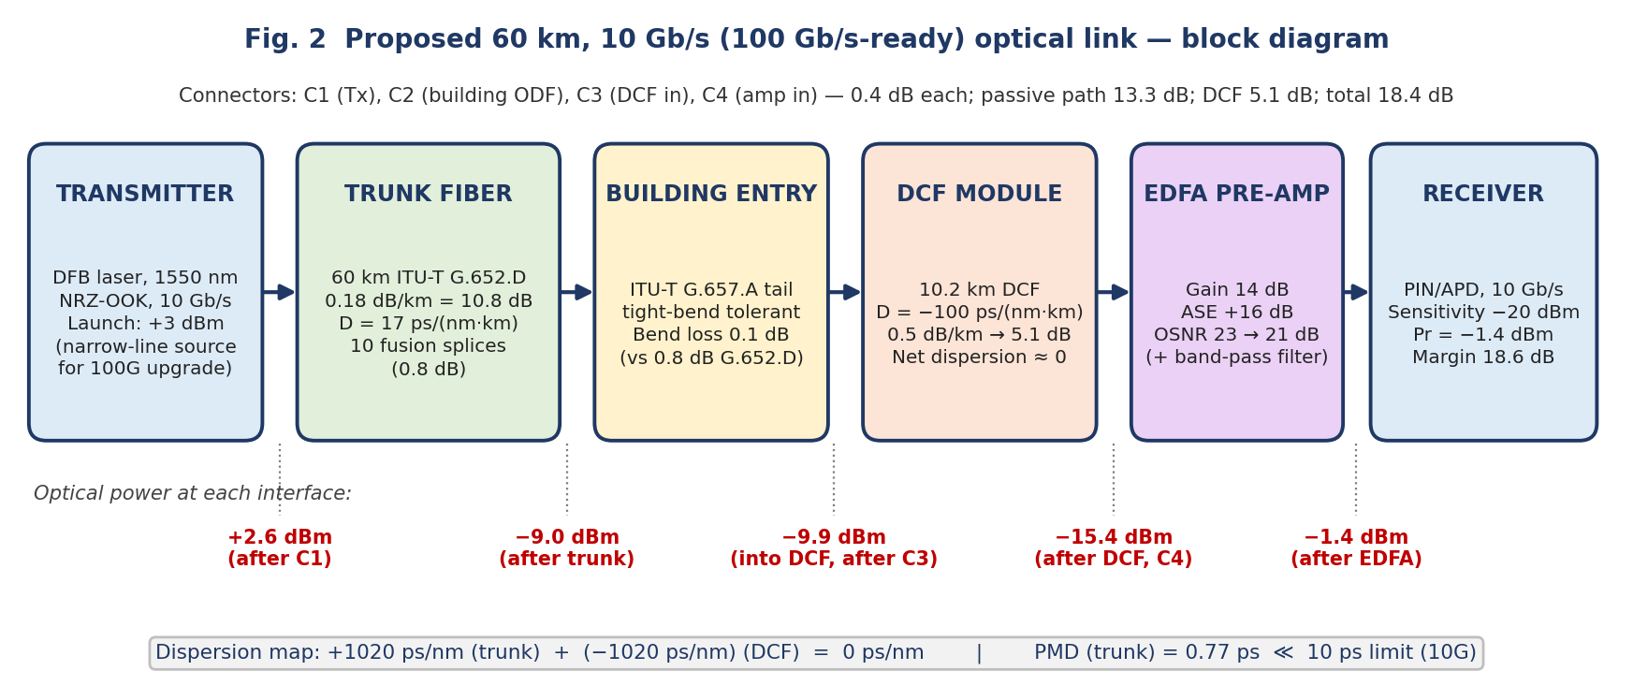
Fig. 2 – Block diagram of the proposed 60 km optical link with power levels

F.4 Calculated optical power budget and received power
Element | Loss / gain (dB) | Power after element (dBm)
Transmitter output | – | +3.0
Connector C1 | −0.4 | +2.6
Trunk fiber 60 km (0.18 dB/km) | −10.8 | −8.2
10 fusion splices | −0.8 | −9.0
Connector C2 | −0.4 | −9.4
Building-entry bend (G.657.A) | −0.1 | −9.5
Connector C3 | −0.4 | −9.9
DCF, 10.2 km | −5.1 | −15.0
Connector C4 | −0.4 | −15.4
EDFA gain | +14.0 | −1.4
Receiver sensitivity |  | −20.0
Margin over sensitivity (required 6 dB) |  | 18.6 dB (12.6 dB spare)

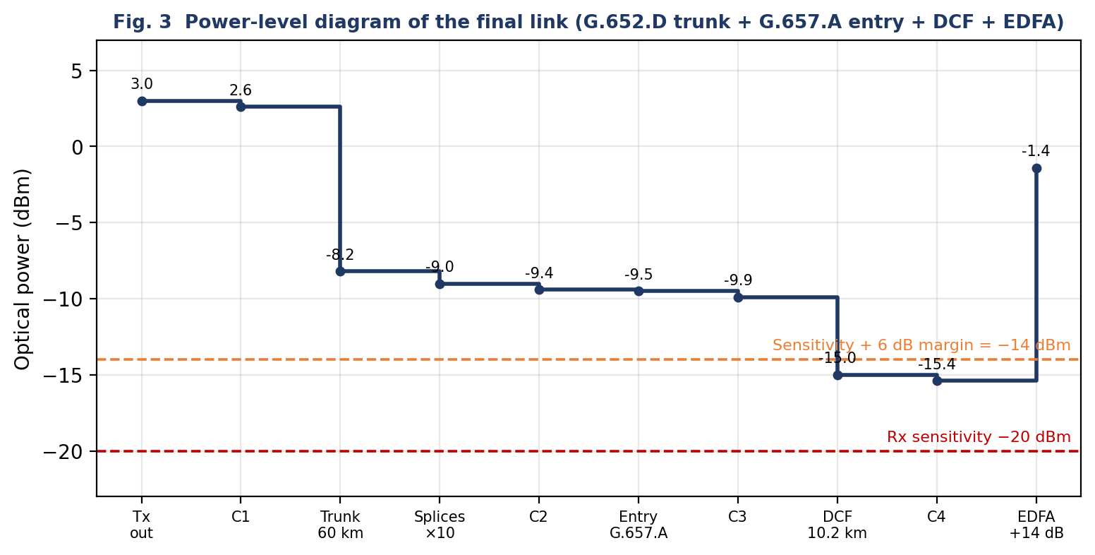
Fig. 3 – Power-level diagram of the final link

F.5 Dispersion, PMD and OSNR arrangement
- Dispersion map: trunk +1020 ps/nm and DCF −1020 ps/nm cancel to 0 ps/nm at 1550 nm, so the pulse is not broadened to first order (an ideal output width ≈ 30 ps).
- PMD: 0.775 ps (≈ 0.84 ps with an assumed DCF contribution), 7.7 % of the 10 ps limit at 10 Gb/s.
- OSNR: 23 dB at the amplifier input and 21 dB after it, 4 dB above the 17 dB requirement.

F.6 Upgrade path to 100 Gb/s
Single-mode G.652.D/G.657.A fiber needs no re-cabling. At 100 Gb/s the bit period is about 10 ps, so the source must be replaced by a narrow-linewidth laser and the terminals by coherent transceivers (DP-QPSK) with DSP, which corrects residual chromatic dispersion and PMD electronically. The DCF can then be removed, which recovers 5.1 dB of loss and, to first order, improves the amplifier input power and OSNR by a similar amount. The PMD (0.775 ps against a 1 ps limit) is the item to re-measure before the upgrade.

F.7 Assumptions and limitations
- The exponents of the birefringence values were not legible in the PDF; B = 1 × 10⁻⁷ and 4 × 10⁻⁴ were assumed. Speed of light c = 3 × 10⁸ m/s.
- Compensation is first-order only (no dispersion-slope data given); residual dispersion due to the finite 0.4 nm source spectrum is not modelled.
- The DCF module is assumed to use the four connectors already counted; any additional connectors (0.4 dB each) are absorbed by the 12.6 dB of spare margin. The DCF PMD and the receiver overload level were not given; if the overload level is below −1.4 dBm a variable optical attenuator should be added after the EDFA.
- The OSNR study uses the given −16 dBm / −39 dBm values rather than recomputing the noise from the amplifier noise figure.

Final Engineering Decision
WOULD YOU DEPLOY THE DESIGN YOU CREATED? ➜ YES
I would deploy the designed link: a 60 km single-mode link (G.652.D trunk, G.657.A building entry) with a 10.2 km DCF and a 14 dB EDFA pre-amplifier, because all verified quantities meet the requirement with margin and the identified weak points are measurable and manageable.

Technical justification
Consideration | Evidence from the design
Fiber / modal suitability, ITU-T category | V = 1.951 < 2.405 and λc = 1.257 µm give a single LP₀₁ mode at 1550 nm; G.652.D trunk with G.657.A entry is standards-compliant and low-cost.
Propagation and bandwidth–distance | No modal dispersion. Multimode Fiber B would give 3.0 µs (step-index) or 3.8 ns (graded) of spreading, far above 100 ps.
Total loss and received power | 13.3 dB passive; 18.4 dB with DCF; P_r = −10.3 dBm passive, −15.4 dBm with DCF and −1.4 dBm after the EDFA.
Dominant loss mechanism and optimisation | Rayleigh scattering (6.6 dB) dominates but is intrinsic; bending (G.657.A saves 0.7 dB) and connector count (fusion splices save 0.64 dB per two connectors) are optimised.
Chromatic dispersion, PMD, compensation | Uncompensated: 408 ps broadening gives a 409 ps output pulse (4.09 T_b); the 10.2 km DCF gives zero net dispersion; PMD 0.775 ps ≪ 10 ps.
OSNR and amplification | 23 dB → 21 dB, 4 dB above 17 dB; margin over sensitivity 18.6 dB.
Reliability and 100 Gb/s upgrade | 6 dB system margin is preserved with 12.6 dB to spare; upgrade needs only new transceivers (coherent DSP) and possibly removal of the DCF; PMD (77.5 % of the 1 ps limit) must be verified before the upgrade.

Residual risks and contingency (redesign options if a risk materialises)
Since the answer is YES, no redesign is required. The following contingency actions are nevertheless identified, with their predicted effects:
- If measured PMD exceeds 1 ps at the 100 Gb/s upgrade: use coherent detection with DSP or install PMD-compensated or lower-PMD fiber; this restores the PMD within the limit at the cost of terminal equipment only.
- If the OSNR margin proves insufficient at 100 Gb/s: move the DCF to the interstage of a low-noise-figure two-stage EDFA, or remove it and use coherent DSP for chromatic dispersion; to first order this raises the amplifier input by up to 5.1 dB and the OSNR by a similar amount.
- If the receiver overload level is below −1.4 dBm: insert a variable optical attenuator after the amplifier; the 12.6 dB of spare margin allows several dB of attenuation without leaving the budget.
- If G.655 is preferred for WDM growth: the DCF shortens to 2.7 km (1.35 dB) and the received power rises by 3.75 dB; the cost is a non-standard fiber type, so G.652.D was retained as the primary choice.

Conclusion
The requirement → alternatives → analysis → selection → design → verification chain closes. The designed 60 km link delivers 10 Gb/s with a −1.4 dBm received power (18.6 dB above sensitivity), zero net chromatic dispersion, 0.775 ps PMD and 21 dB OSNR, and keeps a defined upgrade path to 100 Gb/s. Decision: deploy.

