SIMATS ENGINEERING
SAVEETHA INSTITUTE OF MEDICAL AND TECHNICAL SCIENCES
CHENNAI – 602105

ECA18 – OPTOELECTRONICS AND OPTICAL COMMUNICATION
CO3 SCENARIO-BASED ASSIGNMENT

Design and Performance Evaluation of an Integrated Photodetection, Imaging, Biomedical Sensing and Display System

Submitted by
Mollala Dileep Reddy
Register Number: 192312572
Course Faculty: Dr Princy Magdaline
Date: 14 October 2026

ABSTRACT
This report develops an integrated optoelectronic platform for wearable biomedical monitoring, automotive LiDAR, low-light detection, imaging, ultraviolet sensing, photovoltaic energy harvesting and compact displays. The design is based on the parameters supplied in the assignment and on explicitly stated assumptions where data are unavailable. The PPG photocurrent variation is 15 µA, the LiDAR photocurrent is 2.4 µA, the low-light SNR is 15 dB, the transit-time bandwidth estimate is 22 GHz, and the photovoltaic maximum-power estimate is 2.25 W. PIN photodiodes are recommended for low-noise linear PPG, while APDs are considered for weak-return LiDAR when their multiplication noise and bias requirements are controlled. A CMOS sensor and MicroLED display are selected for the integrated automotive/consumer platform, with flexible PV as an auxiliary wearable energy source. MATLAB/SCILAB-style models are provided for responsivity, SNR and detector bandwidth. The platform is recommended for prototype deployment only after component-level validation, full noise budgeting, optical safety review and application-specific testing.

CONTENTS
- 1. Introduction and Objectives
- 2. Design Basis and Assumptions
- 3. Stage 1 – Application Requirements
- 4. Stage 2 – Photodetector Selection and Calculations
- 5. Stage 3 – Noise and SNR Strategy
- 6. Stage 4 – Response Time and Bandwidth
- 7. Stage 5 – PV, Image Sensors and Displays
- 8. Stage 6 – Biomedical and Industrial Applications
- 9. Stage 7 – MATLAB/SCILAB Simulation
- 10. Final System Verification
- 11. Integrated System Design and Final Decision
- 12. Conclusion
- References
- Appendix A – MATLAB/SCILAB Code

1. INTRODUCTION AND OBJECTIVES
Optoelectronic systems convert optical signals into electrical signals and combine light sources, photodetectors, image sensors, signal-processing electronics and displays. Their performance depends on responsivity, quantum efficiency, noise-equivalent power (NEP), detectivity, linearity, response time, bandwidth, optical coupling and power consumption.
The scenario combines several application classes: PPG and NIR spectroscopy for biomedical sensing; LiDAR and vehicle sensing for automotive use; CMOS/CCD imaging for face recognition; UV detection; PV energy harvesting; and OLED, MicroLED and quantum-dot display technologies.

Objectives
- Calculate the PPG and LiDAR photocurrent values from the given responsivities and optical powers.
- Compare PIN and APD detectors, including gain, noise, speed, bias and complexity.
- Calculate the low-light SNR, detector bandwidth and PV maximum power.
- Select practical image-sensor and display technologies for the intended use cases.
- Develop application-specific configurations for PPG, NIR, LiDAR, face recognition and UV sensing.
- Provide simulation code, plots, verification results and a defensible deployment decision.

2. DESIGN BASIS AND ASSUMPTIONS
Parameter | Given value / design assumption
PPG responsivity | 0.60 A/W
PPG received optical-power variation | 25 µW
LiDAR received optical power | 3 µW
LiDAR responsivity | 0.80 A/W
Low-light signal power | −22 dBm
Low-light noise power | −37 dBm
Detector transit time | 20 ps
Bandwidth approximation | f ≈ 0.44 / tr
PV open-circuit voltage | 0.60 V
PV short-circuit current | 5 A
PV fill factor | 0.75
Display options | OLED, MicroLED, quantum dot
Image sensor options | CMOS and CCD
Simulation platform | MATLAB or SCILAB

Assumptions and limits: no detector area, wavelength, dark current, APD multiplication factor, excess-noise factor, bandwidth integration limits, PV irradiance, or image/display performance measurements were supplied. Consequently, NEP and detectivity cannot be calculated numerically without additional specifications; these are discussed using their definitions. The PV power calculation uses the supplied Voc, Isc and fill factor. The simulation plots are idealized model results, not measurements from physical hardware.

3. STAGE 1 – APPLICATION REQUIREMENTS
Application | Key requirements | Design implication
Wearable PPG | Detect small reflected-light variations; low power; stable baseline | Low-noise, linear PIN photodiode, optical shielding and low-noise transimpedance amplifier
NIR spectroscopy | Wavelength-appropriate responsivity; repeatable optical path; filtering | Select detector material to match the NIR wavelength and calibrate source/detector pair
Automotive LiDAR | Weak returns, fast response, accurate timing and sunlight rejection | APD or suitable high-speed PIN receiver, narrow optical filter and high-bandwidth front end
Low-light sensing | High sensitivity and low equivalent input noise | Reduce dark current and bandwidth; optimize gain and cooling where practical
Face recognition | Resolution, low-light performance, fast readout and integration | CMOS sensor with suitable visible/NIR illumination and image processing
UV detection | UV responsivity and visible-light rejection | UV-enhanced silicon or a dedicated UV photodiode with optical filter
Wearable energy | Low mass, flexibility and safe charging/power management | Flexible PV as auxiliary supply, not assumed to power the full system continuously
AR/VR/MR and foldable display | Brightness, contrast, response, efficiency and compact integration | MicroLED for high brightness; OLED for flexibility and contrast; QD for colour conversion/colour gamut

Application Requirement Statement
The platform must reliably convert small and weak optical signals into electrical measurements, preserve sufficient bandwidth for fast ranging, suppress detector and circuit noise, provide suitable imaging and UV sensing, harvest auxiliary energy where feasible, and present information on a compact high-quality display. Each subsystem must be selected against its own wavelength, speed, noise, power, thermal and integration constraints rather than forcing one detector or display technology to serve every application.

4. STAGE 2 – PHOTODETECTOR SELECTION AND CALCULATIONS

4.1 Responsivity and PPG photocurrent
Responsivity R is the ratio of photocurrent to incident optical power. It describes how much current is generated for each watt of received optical power.
R = Iph / P ⇒ ΔIph = R × ΔP
ΔIph = 0.60 A/W × 25 × 10⁻⁶ W = 15 × 10⁻⁶ A = 15 µA
Therefore, the specified PPG optical-power variation produces a theoretical photocurrent variation of 15 µA before analogue gain, filtering and digitization. PPG measures changes in reflected or transmitted light associated with pulsatile blood-volume changes. The signal also contains a larger non-pulsatile component and motion artefacts, so baseline removal and filtering are required.

4.2 LiDAR photocurrent
Iph = R × P = 0.80 A/W × 3 × 10⁻⁶ W = 2.4 µA
The received 3 µW LiDAR optical signal produces a theoretical 2.4 µA photocurrent at the stated responsivity. Actual ranging performance depends on pulse width, return loss, background light, detector noise, receiver bandwidth and timing electronics.

4.3 PIN versus APD
Feature | PIN photodiode | Avalanche photodiode (APD)
Internal gain | Approximately unity | Avalanche multiplication, M > 1
Sensitivity | Good when optical power and front-end noise permit | Often better for weak returns due to internal gain
Noise | No avalanche excess-noise contribution; shot and dark noise remain | Multiplication increases signal and also introduces excess avalanche noise
Bandwidth | Can be very high with low capacitance | High-speed devices exist, but gain/bandwidth trade-off applies
Bias | Usually lower reverse bias | Higher reverse bias, near avalanche region
Linearity | Generally strong over specified operating range | Gain and linearity depend on bias and optical level
Complexity | Simpler, lower power and easier bias control | More demanding bias, temperature and gain stabilization
Best fit here | Wearable PPG and general linear sensing | LiDAR/low-light receiver when measured sensitivity justifies added complexity

4.4 Quantum efficiency, NEP and detectivity
Quantum efficiency η is the fraction of incident photons that contribute to collected charge. For a unity-gain photodiode, responsivity and quantum efficiency are related by:
R = ηqλ/(hc) ⇒ η = Rhc/(qλ)
The wavelength λ is not provided, so a numeric quantum efficiency cannot be justified from the assignment data alone. At wavelength λ in micrometres, the common form is R(A/W) ≈ ηλ(µm)/1.24. Therefore η ≈ 1.24R/λ(µm), subject to the unity-gain assumption.
NEP is the incident optical power that produces a signal equal to the detector noise in a 1 Hz noise bandwidth, commonly expressed in W/√Hz. Lower NEP means better weak-signal capability. Specific detectivity D* normalizes sensitivity by detector area and noise bandwidth; it is commonly expressed in Jones (cm·√Hz/W). Numeric NEP and D* require measured or specified noise current, area and bandwidth, none of which are supplied.
Dark current generates shot noise even when no useful optical signal is present. APD multiplication can improve the signal current, but it also amplifies primary shot noise and adds avalanche excess noise. Detector selection must therefore use measured NEP or receiver sensitivity at the actual wavelength and bandwidth, not gain alone.

Design Decision 1 – Detector Configuration
I recommend a low-noise PIN photodiode for wearable PPG and linear imaging measurements, with an APD-based LiDAR receiver as the preferred candidate for weak returns if its excess noise, bias stability and bandwidth are validated. A high-speed PIN receiver remains a valid alternative when the return power is sufficient and lower complexity is more valuable than internal gain.

5. STAGE 3 – NOISE AND SNR STRATEGY

5.1 SNR calculation
For signal and noise powers expressed in dBm, the power SNR in decibels is the difference between the two dBm values, provided both refer to the same measurement bandwidth and reference point.
SNR(dB) = Ps(dBm) − Pn(dBm)
SNR = (−22) − (−37) = 15 dB
Linear SNR = 10^(15/10) ≈ 31.62
The signal power is approximately 31.6 times the noise power. The result is acceptable as an initial design point, but final acceptability depends on the required ranging accuracy, detection probability, false-alarm rate and system bandwidth.

5.2 Noise mechanisms
Noise source | Cause / behaviour | Mitigation
Shot noise | Discrete charge-carrier arrivals; variance grows with total current and bandwidth | Use suitable optical power, reduce unnecessary bandwidth and choose low-dark-current detector
Dark-current noise | Thermal generation and leakage current produce current noise even without light | Choose low-dark-current device; reduce temperature if practical; prevent leakage and contamination
Avalanche excess noise | Statistical variation in APD multiplication adds noise | Use only the gain needed; select low-excess-noise APD and stabilize bias/temperature
Thermal/electronic noise | Resistors and amplifier electronics contribute input-referred noise | Use low-noise front end, suitable feedback resistance and careful grounding/shielding
Background-light noise | Sunlight or ambient light raises photocurrent and shot noise | Narrow optical bandpass filter, field-of-view control and synchronous/pulsed detection

When received optical power falls while dark current stays constant, signal current falls but dark-current noise does not fall proportionally. The SNR therefore deteriorates and eventually becomes limited by dark/electronic noise. Increasing APD gain is not a universal fix because avalanche excess noise and bandwidth limitations may offset the gain.

Design Decision 2 – Noise/SNR Configuration
I recommend a noise-controlled receiver using an application-matched optical bandpass filter, low-dark-current detector, low-noise transimpedance amplifier, minimum necessary bandwidth and carefully optimized APD gain for LiDAR. The given low-light point has 15 dB SNR. Cooling is reserved for cases where the measured dark-current contribution warrants its power and packaging cost; optical coupling and shielding should be optimized first.

6. STAGE 4 – RESPONSE TIME AND BANDWIDTH

6.1 Transit-time bandwidth
f ≈ 0.44 / tr
tr = 20 ps = 20 × 10⁻¹² s
f ≈ 0.44 / (20 × 10⁻¹²) = 22 × 10⁹ Hz = 22 GHz
The approximate transit-time-limited bandwidth is 22 GHz. This is a theoretical estimate for the carrier transit-time contribution only, not a guarantee of 22 GHz end-to-end receiver bandwidth.

6.2 RC limitation and trade-off
fRC ≈ 1 / (2πRload Ctotal)
The actual detector bandwidth is limited by both carrier transit time and the RC response. A larger active area can collect more light and ease optical alignment, but usually increases junction capacitance. Higher capacitance with load resistance reduces RC bandwidth. A smaller detector can be faster but may demand tighter optical alignment or a more sophisticated optical coupling design. Package parasitics and amplifier bandwidth also reduce total system bandwidth.

Design Decision 3 – High-Speed Configuration
I recommend a small-area, low-capacitance high-speed photodiode or APD matched to the LiDAR wavelength, mounted close to a wideband receiver front end. The 22 GHz transit-time estimate provides headroom, but the complete detector, package, amplifier and sampling chain must be characterized together. The final usable bandwidth is the lowest relevant bandwidth among the detector, RC network, amplifier and digitizer.
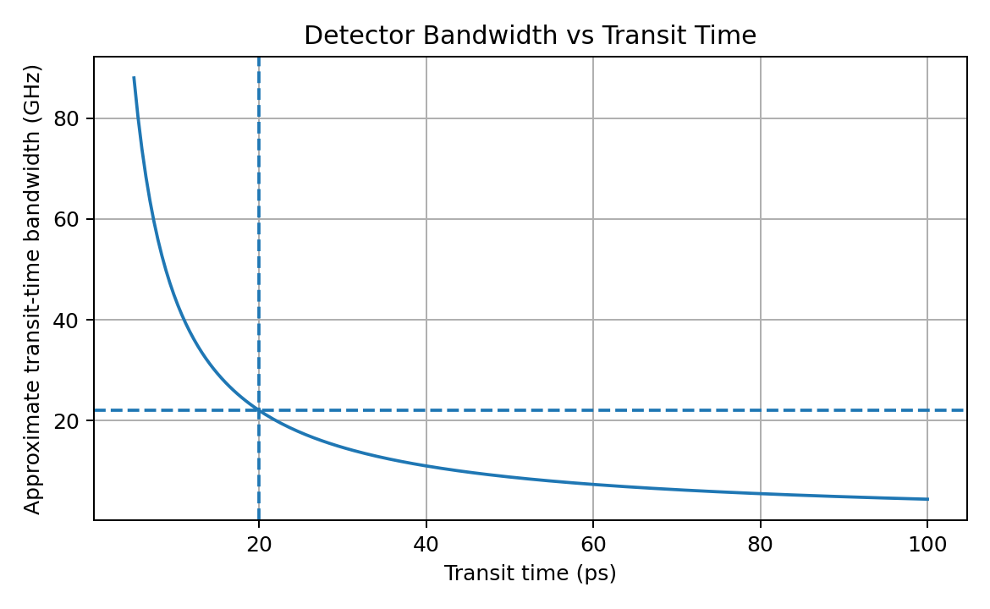

7. STAGE 5 – PV, IMAGE SENSOR AND DISPLAY TECHNOLOGIES

7.1 Photovoltaic maximum power
The maximum power at the maximum-power point is estimated from the fill factor:
FF = Pmax / (Voc × Isc)
Pmax = FF × Voc × Isc
Pmax = 0.75 × 0.60 V × 5 A = 2.25 W
The idealized maximum-power estimate is 2.25 W. Voc is the terminal voltage at zero output current; Isc is the current at zero terminal voltage. The fill factor indicates how square the I–V curve is and captures losses relative to Voc×Isc. It is not the same as conversion efficiency: efficiency additionally requires incident irradiance and cell area.
Flexible PV can conform to wearable surfaces and reduce rigid packaging, but commonly trades some efficiency, durability and thermal management against flexibility. The stated 2.25 W cannot be assumed available continuously in a wearable system because irradiance, area, orientation, temperature and power-conditioning losses are not given. Treat it as an arithmetic estimate from the supplied values.

7.2 CMOS versus CCD image sensors
Criterion | CMOS | CCD
Architecture | Photodiode and readout circuitry integrated at pixel/column level | Charge transferred across pixels to a common output register
Readout | Often parallel/column readout; flexible addressing | Charge-transfer based, often sequential
Power | Generally lower system power | Can require higher clocking and support power
Speed | Typically high frame rates and fast readout | Can provide excellent image quality but may have slower readout
Noise | Modern CMOS can offer low read noise; varies by process | Historically known for uniformity/low noise; implementation-dependent
Pixel scaling | Well suited to dense arrays and small pixels, with trade-offs in full-well capacity and crosstalk | Scaling and charge-transfer complexity can be less convenient
SoC integration | Strong integration with ADC, timing, logic and image processing | Less naturally integrated with complex logic
Face/automotive use | Preferred for compact, low-power, high-frame-rate embedded systems | Useful in specialized imaging where CCD characteristics justify complexity

Shrinking pixels increases resolution per unit area but reduces photon collection area per pixel and may reduce full-well capacity. Low-light signal-to-noise can decline unless microlenses, backside illumination, improved quantum efficiency, pixel binning or computational processing compensate. Pixel size should therefore be selected from the actual resolution and low-light requirements, not minimized in isolation.

7.3 OLED, MicroLED and quantum-dot displays
Criterion | OLED | MicroLED | Quantum-dot (QD) display
Light generation | Organic emissive pixels | Inorganic micro-scale emissive LEDs | Usually quantum-dot colour conversion or QD enhancement; implementation varies
Contrast | Excellent; pixels can turn off individually | Excellent; emissive pixels can turn off individually | Depends on backlight/emissive architecture; QD can improve colour gamut
Brightness | Good to high, but sustained brightness and ageing matter | Potentially very high brightness | High brightness possible with suitable backlight or emissive architecture
Response | Fast | Very fast | Depends on LCD/OLED/QD implementation
Efficiency | Good, but content and brightness dependent | Potentially high; micro-display yield and drive matter | Colour conversion can be efficient; full system depends on light source
Lifetime | Organic materials may age or burn in | Inorganic emitters can offer long lifetime; manufacturing/yield is challenging | QD material and stack stability depend on architecture
Flexibility | Strong candidate for foldable displays | Transfer and packaging challenge for flexible panels | Depends on the display stack; QD film can be flexible, but full display may not be
AR/VR/MR | Good contrast and compact panels | Promising for high brightness and compact microdisplays | Useful for colour performance, but architecture-specific
Main limitation | Ageing/burn-in and high-brightness efficiency trade-off | Cost, transfer yield, repair and manufacturing complexity | Not one single architecture; performance depends on backlight/emitter and QD stack

Design Decision 4 – PV, Image Sensor and Display
I recommend flexible PV as auxiliary wearable energy harvesting, CMOS image sensors for face recognition and automotive imaging, and MicroLED as the preferred high-brightness compact display candidate where cost and manufacturing maturity permit. OLED is a strong alternative for foldable consumer devices because of its flexible emissive stack and contrast. Quantum-dot technology is attractive when wide colour gamut is the priority, but the exact QD architecture must be specified before claiming system-level superiority.

8. STAGE 6 – BIOMEDICAL AND INDUSTRIAL APPLICATIONS

8.1 Wearable PPG
A red/green/infrared LED illuminates tissue and a photodiode measures transmitted or reflected light. Pulsatile arterial blood changes absorption over each cardiac cycle. A PIN photodiode with responsivity near the supplied 0.60 A/W is a suitable starting point for PPG because it provides linear response and avoids APD multiplication noise. The calculated 15 µA change should be conditioned by a transimpedance amplifier, ambient-light cancellation, band-pass filtering and ADC. Mechanical contact, skin tone, movement, LED duty cycle and optical shielding must be evaluated in testing.

8.2 NIR spectroscopy
NIR spectroscopy measures wavelength-dependent absorption and scattering from biological material. The source wavelength must match the absorption features of the target analyte and the detector must retain sufficient responsivity at that wavelength. Use source modulation or reference channels, optical filtering and calibration to reduce ambient light and path-length variation. A single responsivity value is not enough to guarantee performance across the NIR band.

8.3 Automotive LiDAR
A pulsed or modulated laser illuminates a target and the receiver measures the return timing. Low received power requires high sensitivity; accurate ranging requires stable timing and sufficient bandwidth. The stated 3 µW return yields 2.4 µA at 0.80 A/W. An APD is a candidate where the link budget needs gain, while a PIN can be selected if the receiver noise budget is already adequate. Narrow optical filtering, sunlight rejection, high-speed transimpedance amplification and calibration are essential.

8.4 Face recognition and vehicle sensing
CMOS sensors are recommended for embedded face recognition because they combine fast readout, low power and straightforward SoC integration. Visible-light imaging can be supplemented with NIR illumination and an NIR-sensitive sensor for low-light or depth/anti-spoofing functions. Resolution, exposure, lens quality, illumination safety and algorithmic performance must be tested together.

8.5 UV sensing
UV detection should use a UV-enhanced silicon photodiode or a dedicated UV detector whose spectral response covers the required UV band. An optical filter can reject visible and NIR light. The system should specify wavelength range, responsivity, linearity, temperature dependence and calibration. UV photodetection does not by itself establish a safe exposure level; any UV source must be separately assessed for exposure hazards.

Design Decision 5 – Application-Specific Configuration
I recommend a PIN-based low-noise PPG/NIR sensing path, a high-speed APD candidate for low-return LiDAR, a CMOS visible/NIR imaging module for face and vehicle sensing, and a UV-selective photodiode with a suitable filter. Separate signal-conditioning and calibration paths are required because the applications operate at different wavelengths, signal levels and bandwidths.

9. STAGE 7 – MATLAB/SCILAB SIMULATION AND VERIFICATION
The following idealized models verify the linear responsivity relation, SNR arithmetic and transit-time bandwidth. They are theoretical simulations based on the assignment values. The assignment does not provide detector dark current, APD multiplication/noise factor, detector area, wavelength, or receiver equivalent noise bandwidth; therefore a quantitative shot/dark/avalanche-noise simulation would require those extra inputs. The code includes a simple placeholder noise model that must not be treated as measured hardware performance.

9.1 Responsivity model
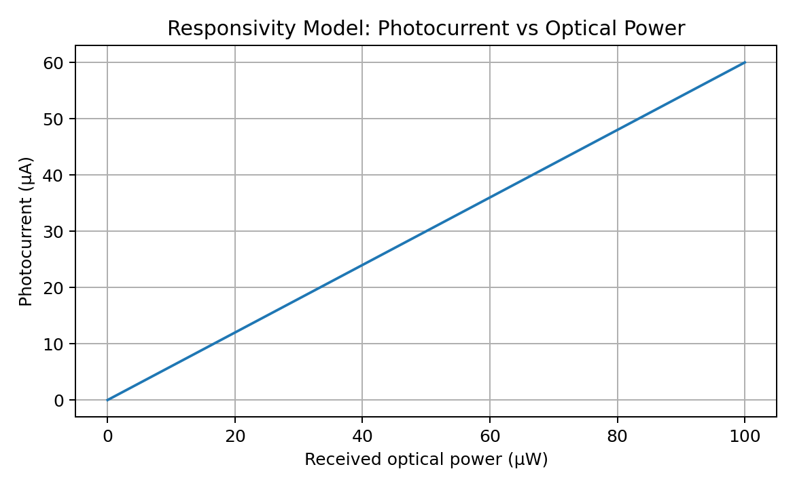
Interpretation: for a fixed responsivity of 0.60 A/W, photocurrent rises linearly with received optical power. At 25 µW, the model gives 15 µA, matching the hand calculation.

9.2 SNR model
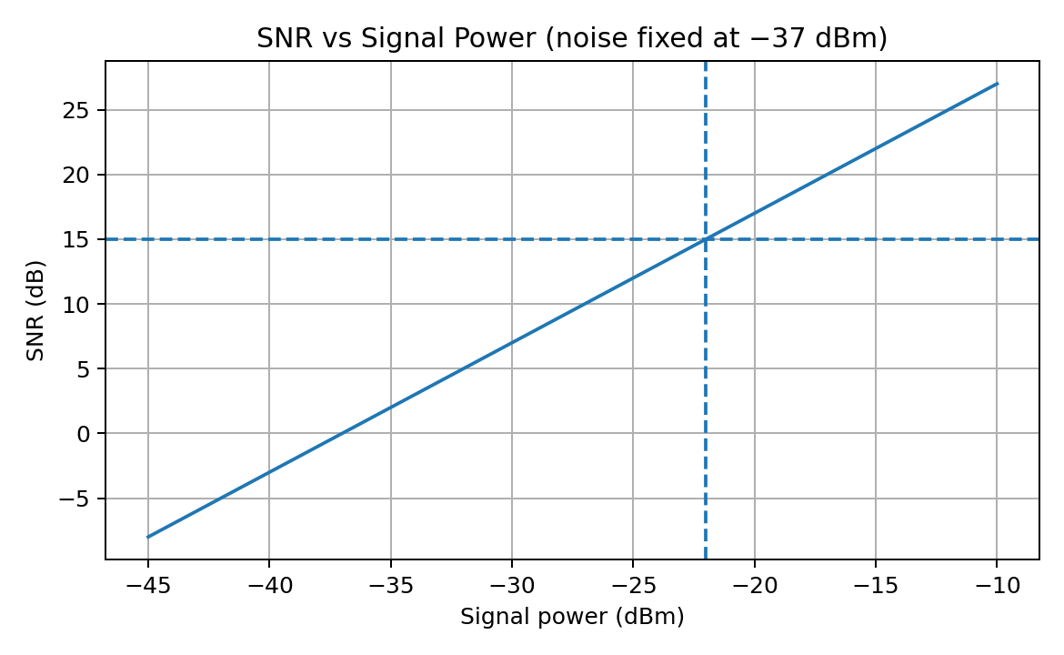
Interpretation: with noise fixed at −37 dBm, SNR rises one decibel for each one-decibel increase in signal power. At −22 dBm, the model gives 15 dB, matching the specified operating point.

9.3 Bandwidth model
The plot shows the inverse relation between transit time and the approximate bandwidth. At 20 ps, the curve gives 22 GHz. It does not include RC, package, amplifier or digitizer limits.

9.4 Noise model equations
For a physical detector, shot-noise current density can be approximated by in = √(2qI) A/√Hz, where I includes relevant photocurrent and dark current. For a bandwidth B, the RMS shot-noise current is √(2qIB). An APD model must include multiplication M and excess-noise factor F(M), and amplifier thermal/electronic noise must be added consistently as mean-square contributions. The numerical parameters needed to compute these terms are absent from the assignment, so no unsupported noise number is asserted.

9.5 MATLAB code
% ECA18 CO3: ideal responsivity, SNR and bandwidth models
clear; clc; close all;
% A. Photocurrent versus optical power
R_ppg = 0.60; % A/W
P_uW = linspace(0,100,201); % optical power in micro-watts
I_uA = R_ppg .* P_uW; % (A/W)*(uW) gives uA numerically
figure; plot(P_uW,I_uA,'LineWidth',1.5); grid on;
xlabel('Optical power (uW)'); ylabel('Photocurrent (uA)');
title('Photocurrent versus Optical Power');
% Verify PPG variation
deltaP = 25e-6; % W
deltaI = R_ppg * deltaP; % A
fprintf('PPG photocurrent variation = %.2f uA\n',deltaI*1e6);
% B. SNR versus signal power, with noise fixed
noise_dBm = -37;
signal_dBm = linspace(-45,-10,200);
SNR_dB = signal_dBm - noise_dBm;
figure; plot(signal_dBm,SNR_dB,'LineWidth',1.5); grid on;
xlabel('Signal power (dBm)'); ylabel('SNR (dB)');
title('SNR versus Signal Power');
SNR_given = -22 - (-37);
fprintf('Specified low-light SNR = %.2f dB\n',SNR_given);
% C. Transit-time bandwidth
tr_ps = linspace(5,100,200);
BW_GHz = 0.44 ./ (tr_ps*1e-12) / 1e9;
figure; plot(tr_ps,BW_GHz,'LineWidth',1.5); grid on;
xlabel('Transit time (ps)'); ylabel('Bandwidth (GHz)');
title('Approximate Bandwidth versus Transit Time');
tr = 20e-12;
BW = 0.44/tr;
fprintf('Transit-time bandwidth = %.2f GHz\n',BW/1e9);
% D. Optional shot-noise illustration (insert real measured values)
% q = 1.602e-19; I_total = ...; B = ...;
% shot_noise_rms = sqrt(2*q*I_total*B);
% For an APD, include multiplication gain and excess-noise factor.

9.6 Theoretical versus simulation results
Metric | Theoretical calculation | Ideal simulation result | Verification
PPG photocurrent variation | 0.60 × 25 µW = 15 µA | 15.00 µA | Matches
Low-light SNR | −22 − (−37) = 15 dB | 15.00 dB at specified point | Matches
Transit-time bandwidth | 0.44 / 20 ps = 22 GHz | 22.00 GHz at 20 ps | Matches
PV maximum power | 0.75 × 0.60 × 5 = 2.25 W | Not time-domain simulated; equation verified directly | Matches arithmetic
Noise/NEP/D* | Missing detector noise, area and bandwidth data | Not numerically claimed | Requires component specifications

Deviation: the ideal model agrees with the analytical equations because it implements the same assumptions. Real measurements will differ due to detector spectral response, temperature, dark current, parasitic capacitance, amplifier noise, optical coupling and component tolerances. The next verification step is to enter measured detector and circuit parameters and compare hardware results against these baselines.

10. FINAL SYSTEM VERIFICATION
Requirement | Specified / calculated target | Status | Verification note
PPG photocurrent response | 15 µA variation | Pass – theoretical | Calculated from supplied R and ΔP
LiDAR photocurrent | 2.4 µA | Pass – theoretical | Calculated from supplied R and P
Responsivity | 0.60 A/W PPG; 0.80 A/W LiDAR | Pass – input-based | Use measured spectral responsivity for hardware
Quantum efficiency | η = Rhc/(qλ) | Pending | Wavelength not specified
NEP / detectivity | Requires noise, area and bandwidth | Pending | Cannot be calculated from supplied values alone
Low-light SNR | 15 dB | Pass – arithmetic | Requires same reference bandwidth for meaningful comparison
Noise performance | Low dark/electronic noise; controlled APD gain | Design proposed | Needs detector and amplifier noise specifications
High-speed bandwidth | 22 GHz transit-time estimate | Pass – partial | RC and receiver bandwidth not supplied
PV maximum power | 2.25 W arithmetic estimate | Pass – conditional | Area, irradiance and efficiency not supplied
Image sensor | CMOS | Selected | Validate pixel size, low-light and frame-rate needs
Display | MicroLED candidate; OLED foldable alternative | Selected conditionally | Cost, yield and panel availability must be assessed
PPG / NIR | PIN path and filtered/calibrated optical source | Design proposed | Validate wavelength and physiological measurement quality
LiDAR / automotive | APD candidate plus high-speed receiver | Design proposed | Validate eye safety, range, timing and sunlight rejection
Face recognition | CMOS visible/NIR sensor | Design proposed | Validate resolution, illumination and algorithms
UV sensing | UV-selective photodiode plus filter | Design proposed | Specify UV band and calibrate
MATLAB/SCILAB | Responsivity, SNR and bandwidth models | Pass – ideal simulation | Noise simulation awaits missing physical parameters
Overall platform | Integrated, application-specific architecture | Conditional | Prototype before deployment

11. INTEGRATED SYSTEM DESIGN AND FINAL DECISION

11.1 Block diagram
PPG LED / NIR source → Tissue / sample → PIN photodiode → Low-noise TIA + filtering → ADC / DSP
LiDAR laser → Target → Optical bandpass filter → APD or high-speed PIN → Wideband TIA / timing
Visible / NIR illumination → Scene / face → CMOS image sensor → ISP / SoC → Recognition / vehicle logic
UV radiation → UV filter + UV photodiode → Amplifier / ADC → Calibration / UV output
Flexible PV → MPPT / power management → Battery / regulated rails → Sensors, SoC and display
Sensor / SoC outputs → Display driver → MicroLED display (OLED alternative for foldable use)
The architecture uses separate sensing branches because PPG, LiDAR, visible/NIR imaging and UV sensing have different wavelength, bandwidth, dynamic-range and safety requirements. The SoC combines digitized measurements and controls the display. Power management isolates noisy display/laser rails from sensitive analogue detector paths.

11.2 Final design parameter table
Subsystem | Selected configuration | Key calculated/specification point | Open verification item
PPG | PIN photodiode + low-noise TIA | ΔI = 15 µA | Motion artefact, LED wavelength, ambient rejection
NIR spectroscopy | Wavelength-matched PIN/photodiode array | Responsivity depends on λ | Target analyte, wavelength, calibration
LiDAR | APD candidate; high-speed TIA | Iph = 2.4 µA at 3 µW; 22 GHz transit estimate | APD gain/noise, link budget, eye safety
Low-light receiver | Low-dark-current detector, optical filter, optimized bandwidth | SNR = 15 dB at given powers | Reference bandwidth and noise spectrum
PV | Flexible PV with power management | Pmax = 2.25 W arithmetic estimate | Irradiance, area, conversion efficiency, load profile
Imaging | CMOS visible/NIR image sensor | Fast readout and SoC integration | Pixel pitch, resolution, dynamic range
Display | MicroLED candidate; OLED foldable alternative | Architecture-specific performance | Brightness, cost, yield, power, thermal limits
UV | UV-selective photodiode + optical filter | Wavelength band must be defined | Spectral response and calibration
Simulation | MATLAB/SCILAB ideal models | 15 µA; 15 dB; 22 GHz | Insert measured noise and RC parameters

11.3 Final engineering decision
DECISION: YES – WITH CONDITIONS, for a controlled prototype and validation phase; NO for immediate production deployment without further verification. The calculated PPG and LiDAR photocurrents, 15 dB SNR, 22 GHz transit-time estimate and 2.25 W PV arithmetic result are internally consistent with the supplied inputs. However, these values do not prove end-to-end performance. Quantum efficiency requires wavelength; NEP and detectivity require detector noise, active area and bandwidth; RC bandwidth requires capacitance and load; PV feasibility requires irradiance and area; and APD suitability requires gain/noise data.
Before deployment, the engineering team must: (1) obtain detector datasheets and measure responsivity, dark current and noise; (2) determine APD multiplication gain and excess-noise factor at operating temperature; (3) measure the complete receiver bandwidth; (4) establish a full optical and electrical SNR budget; (5) validate PPG and NIR against reference instruments; (6) test LiDAR range and sunlight rejection; (7) calibrate UV response; (8) verify display thermal/power constraints; (9) test PV under realistic illumination; and (10) conduct electrical, optical and product-safety reviews.

12. CONCLUSION
The integrated optoelectronic platform is feasible as a modular engineering prototype. A PIN detector is appropriate for low-noise linear PPG, while APD gain can be valuable for weak LiDAR returns when avalanche noise and bias stability are managed. The supplied data produce a 15 µA PPG current variation, a 2.4 µA LiDAR current, 15 dB low-light SNR, 22 GHz transit-time bandwidth estimate and 2.25 W PV maximum-power estimate. CMOS offers a practical embedded imaging path; MicroLED is a high-brightness display candidate, with OLED advantageous for foldable applications. The ideal MATLAB models reproduce the theoretical calculations, but physical noise, quantum efficiency and system bandwidth remain unverified because necessary component parameters were not supplied. Therefore, deployment is recommended only after component characterization, system-level simulation with real data and application-specific safety/performance testing.

REFERENCES
- Saleh, B. E. A., and Teich, M. C., Fundamentals of Photonics, 3rd ed., Wiley.
- Keiser, G., Optical Fiber Communications, 5th ed., McGraw-Hill.
- Sze, S. M., and Ng, K. K., Physics of Semiconductor Devices, 3rd ed., Wiley.
- IEC 60825-1, Safety of laser products – Equipment classification and requirements. Consult the current applicable edition and local regulations for the intended LiDAR product.
- MATLAB documentation, MathWorks, for plotting, numerical modelling and signal processing.
- Scilab documentation, Scilab Enterprises, for numerical computation and plotting.
Note: References are general technical sources. Confirm the current editions and applicable standards before formal submission. No unsupported manufacturer-specific specifications have been assumed.

