ECA18 – OPTOELECTRONICS AND OPTICAL COMMUNICATION
CO4 – INVESTIGATIVE ASSIGNMENT REPORT
Ultra-High-Speed Photonic Transport Link: Technology Evaluation, Impairment Mitigation, and Integrated System Design

32-Channel DWDM | 200 Gb/s per channel | 6.4 Tb/s aggregate gross rate

Submitted by :
Mollala Dileep Reddy
Register Number: 192312572
Course Faculty: Dr Princy Magdaline
Date: 14 October 2026

Investigative engineering report
Prepared from the supplied CO4 assignment brief

Contents
- Abstract
- 1. Communication Requirement and Baseline
- Investigation Requirement Statement
- 2. Modulation and Modulator Selection
- Modulation mechanism trade-off
- MZI versus micro-ring and platform choice
- Design Decision 1
- 3. Optical Amplification Configuration
- Gain flatness and ASE management
- Design Decision 2
- 4. Impairments and Coherent DSP
- Recommended coherent DSP order
- Design Decision 3
- 5. Integrated WDM Architecture and Trade-offs
- Proposed parameter baseline
- 6. Verification and Critical Evaluation
- Simulation and validation plan
- Final Engineering Decision
- References and Standards for Verification

Abstract
This report investigates an end-to-end 32-channel dense wavelength-division multiplexing (DWDM) transport system with a target gross line rate of 200 Gb/s per channel. The required aggregate line rate is 6.4 Tb/s. The proposed baseline uses dual-polarization 16-QAM (DP-16QAM) coherent transmission, silicon-photonic Mach–Zehnder I/Q modulators, an AWG/MMI multiplexer, hybrid distributed Raman plus EDFA amplification with gain flattening, and coherent-receiver digital signal processing (DSP).
The assignment omits numerical per-channel input/output power, fiber length, span count, grid spacing value, and required OSNR/BER threshold. To demonstrate the method, this report explicitly adopts illustrative engineering assumptions where necessary. These values are design targets for simulation, not measured or guaranteed results. A final deployment decision is conditional on OptiSystem/OptSim/MATLAB simulation, component datasheets, and a standards-conformance review.

1. Communication Requirement and Baseline
The network must transport 32 wavelength channels at 200 Gb/s each with high spectral efficiency, acceptable pre-FEC BER, adequate OSNR margin, manageable nonlinear penalties, and a scalable photonic integrated circuit (PIC) implementation. A 50-GHz grid is selected as an illustrative baseline; the exact frequency slots must be checked against the applicable ITU-T G.694.1 grid and the chosen interface specification. ITU-T G.698.x application codes and IEEE/OIF electrical-interface standards address different parts of the system and must not be treated as interchangeable end-to-end certifications.
Aggregate line rate: C = N × Rch = 32 × 200 Gb/s = 6,400 Gb/s = 6.4 Tb/s. This is gross line rate before framing/FEC overhead and does not equal user payload throughput.
At 50-GHz spacing, the nominal channel-slot allocation is 32 × 50 GHz = 1.6 THz. The actual edge-to-edge occupied spectrum depends on slot definition and channel placement; roll-off and filtering must be checked to avoid adjacent-channel interference.
Key metrics are aggregate and net throughput, symbol rate, occupied bandwidth, spectral efficiency, OSNR at a defined reference bandwidth, pre-FEC BER, Q-factor, launch power per channel, insertion loss, amplifier noise figure, gain ripple, CD/PMD tolerance, nonlinear penalty, electrical/optical bandwidth, thermal control, power per bit, and PIC footprint.
- CD: compensate with frequency-domain or FIR equalization in coherent DSP.
- PMD and polarization rotation: adaptive 2×2 MIMO equalizer and polarization tracking.
- SPM/XPM/FWM: control launch power and channel loading; use optional DBP where complexity is justified.
- ASE: low-noise amplification, OSNR monitoring, gain planning, and adequate FEC margin.
- AWG/MMI crosstalk and insertion loss: characterize passband, isolation, loss, and wavelength alignment.

Investigation Requirement Statement
Design a 32-channel DWDM link delivering 6.4 Tb/s gross capacity, based on 200 Gb/s per channel, with a nominal 50-GHz grid and coherent DP-16QAM. The design must maintain sufficient OSNR for the selected pre-FEC BER/FEC threshold, flatten amplifier gain across the occupied band, compensate CD and PMD digitally, manage Kerr nonlinearities through launch-power optimization and optional DBP, and demonstrate acceptable crosstalk, insertion loss, thermal stability, power consumption, and manufacturability. Numerical performance claims remain provisional until verified in simulation and with real component specifications.

2. Modulation and Modulator Selection
For an M-ary modulation format, the ideal gross symbol rate is R_s = R_b / log2(M), with adjustments for polarization, coding and framing overhead. DP-16QAM carries 4 bits/symbol in each polarization, or 8 bits per dual-polarization symbol interval. Thus R_s = 200/8 = 25 GBd ideal. With an illustrative 12% overhead, the line symbol rate becomes approximately 28 GBd (200 × 1.12 / 8).
PAM4 carries 2 bits/symbol, so 200 Gb/s requires 100 GBd before overhead. With 12% overhead, approximately 112 GBd would be required unless the specified 200 Gb/s is a gross rate. This creates substantially higher electrical bandwidth demands and makes PAM4 more suitable for shorter-reach direct-detect links than for a high-capacity long-haul transport design.
With a raised-cosine roll-off factor α = 0.1, approximate one-sided baseband bandwidth is B ≈ (1+α)R_s/2. At 25 GBd, B ≈ 13.75 GHz per I/Q tributary; the complex optical channel occupies approximately (1+α)R_s ≈ 27.5 GHz. This fits within a nominal 50-GHz slot in an idealized design, although practical filtering, laser drift and implementation penalties require guard margin.

Format comparison
Format | Ideal baud at 200 Gb/s | Strength | Main limitation
NRZ-OOK | 200 GBd (1 bit/symbol) | Simple, low DSP burden | Very high bandwidth; poor spectral efficiency
PAM4 | 100 GBd (2 bits/symbol) | Two bits/symbol; simple detection | Higher baud and tighter linearity/noise margin
DPSK/DQPSK | ~100 / 50 GBd (illustrative bit mapping) | Differential detection options | Less flexible than coherent high-order QAM for this target
Single-pol 16-QAM | 50 GBd (4 bits/symbol) | Good spectral efficiency | Single polarization requires twice the baud of DP-16QAM
DP-16QAM | 25 GBd (8 bits/symbol) | Strong balance of capacity and spectral efficiency | Higher OSNR and coherent DSP complexity
DP-64QAM | ~16.7 GBd (12 bits/symbol) | Higher spectral efficiency | Higher OSNR sensitivity and reduced reach margin

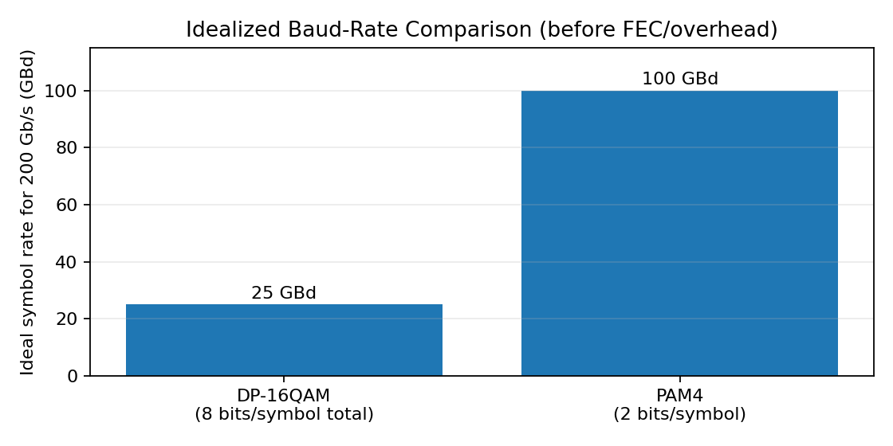

Modulation mechanism trade-off
Electro-optic (EO) modulation is selected because it supports high-speed electrical control of optical phase/amplitude. Acousto-optic devices are generally limited by acoustic transit time and are not the preferred primary modulator at this per-channel rate. Thermo-optic tuning is useful for slow resonance/phase trimming but is too slow for symbol-by-symbol data modulation. Magneto-optic effects are mainly used for polarization control/isolation rather than high-speed data modulation. Kerr-effect devices provide fast nonlinear phase response but generally require careful optical-power and integration management.
Vπ is not a universal material constant: it depends on electrode geometry, interaction length, wavelength, device structure and drive definition. Therefore the final design must use the selected vendor/device datasheet or an explicit device model. For a first-pass simulation only, use an assumed modulator electrical bandwidth of at least 35 GHz for a ~28-GBd DP-16QAM signal, then sweep bandwidth and Vπ to assess penalty; do not report the assumed value as measured hardware performance.

MZI versus micro-ring and platform choice
A silicon-photonic MZI is selected for the primary high-speed modulator because it offers broadband operation and comparatively relaxed wavelength alignment. It generally occupies more area and may have higher drive voltage than a compact resonant micro-ring, but it is less sensitive to resonance drift. Micro-ring resonators are very compact and can be energy-efficient, but their narrow resonance and thermal sensitivity require active tuning and can complicate a 32-channel deployment. EO polymers can offer high EO response and potentially low drive voltage, but packaging, long-term stability and manufacturing qualification must be checked. Silicon photonics is chosen as the integration baseline, with external narrow-linewidth lasers and temperature control.

Design Decision 1
I recommend coherent DP-16QAM with an EO silicon-photonic MZI I/Q modulator because the ideal baud rate is 25 GBd for 200 Gb/s gross rate, compared with 100 GBd for PAM4. With α = 0.1, the approximate complex-channel bandwidth is 27.5 GHz, allowing a 50-GHz slot with implementation margin. The selection trades increased OSNR and DSP requirements for lower baud rate, high spectral efficiency and a practical PIC architecture. DP-16QAM is preferred over DP-64QAM where reach and robust margin matter more than maximum bits/s/Hz.

3. Optical Amplification Configuration
EDFA provides mature C-band gain, high output power and convenient multi-channel amplification, but its ASE noise accumulates across spans and gain tilt must be managed. SOAs are compact and integrate readily, but can have higher noise, saturation and pattern/crosstalk penalties in high-power multi-channel line amplification. Lumped Raman amplification offers flexible gain but needs a pump and careful safety/monitoring. Distributed Raman amplification reduces effective span noise and can improve OSNR, at the cost of pump complexity and operational safeguards. A hybrid distributed-Raman + EDFA span is selected to improve noise performance while retaining EDFA output power and operational maturity.
The assignment does not specify the input and target per-channel powers. For a transparent worked example, assume input power = −10 dBm/channel and target output = 0 dBm/channel. The required per-channel gain is G = 0 − (−10) = 10 dB. At 0 dBm/channel, each channel is 1 mW. Total output power = 32 × 1 mW = 32 mW = 0.032 W. In dBm, Ptotal = 10 log10(32 mW / 1 mW) = 15.05 dBm. The total input at −10 dBm/channel is 0.1 mW × 32 = 3.2 mW; a 10-dB gain raises this to 32 mW, consistent with the calculation.
These are illustrative power levels, not values provided in the assignment. Real design must include mux/demux, connector, splice, fiber and margin losses. The amplifier must be sized for aggregate output, per-channel saturation, transient behavior and total launch-power nonlinear limits.

Amplifier comparison
Type | Advantages | Risks / limitations | Role in proposal
EDFA | Mature C-band, high output, multi-channel gain | ASE, gain tilt, noise accumulates span-to-span | Booster/inline power stage
SOA | Small, integrable | Saturation, ASE, nonlinear distortion/crosstalk | PIC or short-link option; not primary long-haul stage
Lumped Raman | Flexible wavelength-dependent gain | Pump complexity and safety; design sensitivity | Alternative / supplementary gain
Distributed Raman | Can improve effective noise figure/OSNR | Pump power, monitoring and reliability burden | Pre-amplification along fiber span
Hybrid Raman + EDFA | OSNR/reach benefit plus high output power | Higher complexity and cost | Selected for long-reach baseline

Gain flatness and ASE management
Across 32 channels, amplifier gain must be equalized using a gain-flattening filter (GFF), dynamic gain equalization or per-channel power control. Gain ripple causes channel-to-channel OSNR differences and may cause some wavelengths to fail FEC before others. The gain plan should be checked at the band edges as well as the center, including filter loss and temperature drift.
ASE grows as amplifiers are cascaded. For a first-order planning model, OSNR is assessed at a stated reference bandwidth (commonly 0.1 nm in optical-link reporting), using amplifier noise figure, gain, signal power and number of spans. Exact OSNR cannot be calculated from the assignment because span count, gain, noise figure, reference bandwidth and fiber losses are unspecified. A simulator or link budget must calculate the final value.

Design Decision 2
I recommend distributed Raman pre-amplification followed by an EDFA with gain flattening and per-channel power monitoring. It is selected for a long-reach C-band DWDM system because Raman gain can improve effective span noise performance while EDFA supplies stable output power. The worked example requires 10 dB span gain for −10 to 0 dBm/channel and 15.05 dBm aggregate output. Deployment is acceptable only if the full loss budget, saturated output, gain ripple and OSNR at the receiver are verified.

4. Impairments and Coherent DSP
Chromatic dispersion (CD) broadens pulses because group delay varies with wavelength. PMD arises from birefringence and creates differential group delay between polarization states. SPM is phase modulation from a channel’s own intensity; XPM is cross-phase modulation from neighboring channels; FWM mixes channel frequencies and can create in-band crosstalk. PDL causes different attenuation for different polarization states. ASE from optical amplifiers adds broadband noise, while AWG/MMI imperfections introduce insertion loss and channel crosstalk.
Optical DCF can compensate CD before detection but adds loss, footprint and nonlinear interaction; optical phase conjugation can reverse some propagation distortions but requires specialized hardware and symmetry. Coherent DSP is selected as the main compensation approach because it is tunable and avoids dedicated DCF for every link, although it consumes receiver power and cannot perfectly reverse all noise and nonlinear effects.

Impairment-to-mitigation mapping
Impairment | Primary response | Limitation
CD | Static FIR or frequency-domain equalizer | Needs accurate dispersion estimate; finite precision
PMD / polarization rotation | Adaptive 2×2 MIMO equalizer; CMA then decision-directed adaptation | Tracking must follow time-varying channel
Carrier phase noise | Frequency offset estimation and carrier phase estimation (CPE) | Higher-order QAM is more phase-sensitive
SPM/XPM/FWM | Launch-power optimization; optional DBP | DBP complexity grows with bandwidth, steps and channels
ASE noise | Low-NF amplification, OSNR monitoring, FEC | DSP cannot remove random noise completely
PDL / crosstalk | Polarization tracking; component isolation/passband optimization | Residual penalty depends on hardware quality

Recommended coherent DSP order
1. Coherent optical front end and balanced photodetection; 2. ADC sampling and timing recovery; 3. front-end IQ imbalance/DC correction; 4. chromatic-dispersion compensation; 5. frequency-offset estimation/correction; 6. adaptive 2×2 MIMO polarization demultiplexing and PMD equalization (CMA for acquisition, then decision-directed/LMS adaptation); 7. carrier-phase estimation; 8. symbol decisions and soft demapping; 9. FEC decoding and BER/Q monitoring. Optional DBP is inserted as a propagation-compensation stage where the link budget shows a material nonlinear penalty.
The exact ordering of timing recovery, CD compensation and frequency correction can vary with implementation and sampling architecture; the chain above is a practical conceptual pipeline, not a vendor-specific DSP specification. DBP can improve nonlinear tolerance, but multi-channel DBP has high computational and power cost. A practical deployment should begin with single-channel or reduced-complexity DBP and compare its benefit against simpler launch-power optimization.

Design Decision 3
I recommend coherent DSP with frequency-domain CD compensation, adaptive 2×2 MIMO polarization equalization, carrier-frequency/phase recovery and FEC. Launch-power optimization is the first nonlinear mitigation step; reduced-complexity DBP is optional if simulation demonstrates meaningful improvement. This balances CD/PMD robustness with implementable power consumption. No numeric Q-factor improvement or reach extension is claimed without simulation data.

5. Integrated WDM Architecture and Trade-offs
The integrated architecture uses 32 narrow-linewidth lasers, DP-16QAM I/Q modulators, a silicon-photonic transmitter PIC, AWG/MMI WDM multiplexer, isolators and polarization management, SMF-28 spans with hybrid Raman–EDFA amplification and gain flattening, an AWG demultiplexer, coherent integrated receiver (ICR), ADCs and DSP/FEC.
The 32 × 200-Gb/s channels provide 6.4 Tb/s gross line rate. At a 50-GHz nominal grid the total slot allocation is 1.6 THz. If the full 1.6-THz grid is used, average gross spectral efficiency across allocated slots is 6.4 Tb/s ÷ 1.6 THz = 4 bit/s/Hz. This is a grid-based aggregate figure; net spectral efficiency is lower after FEC/framing overhead and actual occupied bandwidth depends on pulse shaping.
Higher-order modulation reduces baud rate and increases spectral efficiency, but DP-16QAM requires better OSNR and more accurate phase recovery than OOK/PAM4. MMI/AWG insertion loss lowers received power and may force higher launch power; raising launch power increases Kerr nonlinearity. The correct design optimizes launch power per channel rather than maximizing it. Thermal control, laser wavelength stability, gain equalization, pump safety, and DSP power are major system-level constraints.
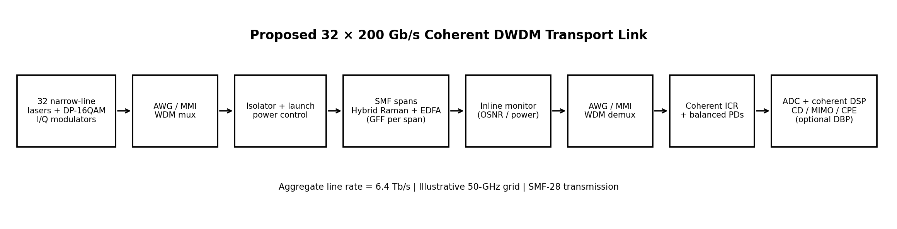
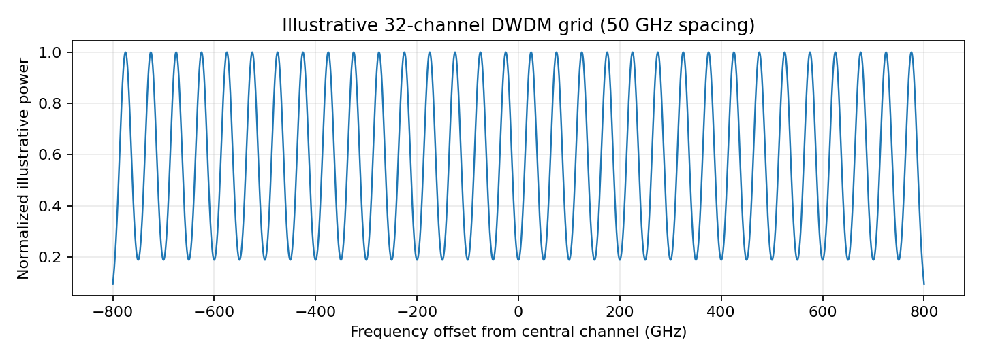

Proposed parameter baseline

Illustrative design parameter table
Parameter | Baseline / assumption | Status
Channel count | 32 | Given
Gross rate per channel | 200 Gb/s | Given
Aggregate gross rate | 6.4 Tb/s | Calculated
Grid spacing | 50 GHz | Design assumption; confirm applicable grid/interface
Modulation | DP-16QAM | Selected
Ideal symbol rate | 25 GBd | Calculated, no overhead
Symbol rate with 12% overhead | 28 GBd approximately | Illustrative overhead assumption
Pulse-shaping roll-off | 0.1 | Simulation assumption
Complex-channel occupied bandwidth | 27.5 GHz at 25 GBd | Approximate, idealized
Modulator | EO silicon-photonic MZI I/Q | Selected platform
Modulator bandwidth target | ≥35 GHz for ~28-GBd case | Engineering target; validate device response
Power example | −10 dBm/ch input, 0 dBm/ch output | Assumed because prompt omits values
Span gain in example | 10 dB | Calculated from assumed powers
Aggregate amplifier output | 32 mW = 15.05 dBm | Calculated from assumed output power
Amplification | Distributed Raman + EDFA + GFF | Selected
Fiber | SMF-28; span length and count TBD | Need route specification
DSP | CD FDE + 2×2 MIMO + CPE + FEC; optional DBP | Selected conceptual chain
Laser linewidth / Vπ / NF / CD / PMD | Must be populated from chosen device datasheets | Not specified in assignment

6. Verification and Critical Evaluation

Verification matrix
Requirement | Target / design value | Evidence status
Aggregate capacity | 6.4 Tb/s gross (32 × 200 Gb/s) | PASS by arithmetic
Grid and spectral efficiency | 50-GHz illustrative grid; 4 bit/s/Hz gross across 1.6 THz | Conditional; grid/interface compliance must be checked
DP-16QAM baud rate | 25 GBd ideal; ~28 GBd with assumed 12% overhead | Calculated under stated assumptions
Modulator bandwidth/footprint | MZI PIC; ≥35 GHz target for assumed rate | To verify with vendor datasheet / simulation
Amplifier gain/output | 10 dB gain; 32 mW / 15.05 dBm aggregate in example | Calculated only for assumed powers
Gain flatness | GFF/dynamic equalization | To verify over all 32 channels
OSNR / pre-FEC BER / Q | Must exceed selected transceiver/FEC threshold with margin | Not numerically verifiable from supplied prompt
CD/PMD mitigation | FDE + adaptive 2×2 MIMO | Architecturally addressed; simulation required
Nonlinear tolerance | Power optimization; optional DBP | Requires launch-power sweep and Q/BER curves
Standards | ITU-T G.698.x / grid and interface-specific IEEE/OIF clauses | Formal compliance not established by this conceptual report
Power per bit / footprint / cost | Measure from chosen components and PIC layout | Insufficient source data

Simulation and validation plan
The assignment requests OptiSystem/OptSim/MATLAB schematics, optical spectra, eye diagrams, constellations and Q-factor versus launch power. The figures included here are conceptual illustrations, not simulation outputs. To complete validation, build a 32-channel source array at selected ITU grid frequencies; generate DP-16QAM at 25–28 GBd; apply pulse shaping and MZI transfer functions; combine with an AWG; propagate through specified SMF-28 spans with CD, PMD and Kerr effects; add hybrid Raman/EDFA gain and ASE; then demultiplex, coherently detect and run the DSP/FEC chain.
Run sweeps over per-channel launch power, amplifier noise figure/gain ripple, fiber length, linewidth, PMD coefficient, modulator bandwidth and OSNR. Save optical spectrum and channel power, constellation plots before/after DSP, BER versus OSNR, Q-factor versus launch power, and per-channel performance. Report simulation version, component models, random seeds, FEC threshold, OSNR reference bandwidth and parameter assumptions. Do not label illustrative plots as simulated results.

Final Engineering Decision
DECISION: NO — not for immediate field deployment; YES for a controlled simulation and laboratory prototype. The architecture is technically credible: DP-16QAM provides 25-GBd ideal operation at 200 Gb/s gross per channel, a 50-GHz grid gives 4 bit/s/Hz gross across the allocated 1.6 THz, and hybrid Raman–EDFA amplification with GFF plus coherent DSP addresses the main noise and dispersion challenges.
Immediate deployment is not justified because the assignment does not specify span length/count, actual per-channel power levels, amplifier noise figure/gain ripple, modulator Vπ/bandwidth, laser linewidth, receiver OSNR/FEC thresholds, or measured simulation results. Before field use, complete the loss/OSNR budget, verify all 32 channels at band edges, run launch-power and BER/Q sweeps, validate component thermal stability and pump safety, confirm applicable standards/interface clauses, and conduct a laboratory test with real hardware. If OSNR margin is inadequate, reduce modulation order to DP-QPSK or lower baud/channel rate; if nonlinear penalty dominates, reduce launch power and evaluate DBP or shorter spans; if gain ripple is excessive, retune/upgrade GFF and per-channel equalization.

References and Standards for Verification
1. ITU-T Recommendation G.698 series, multichannel optical transport systems with single-channel optical interfaces; consult the exact application code and edition applicable to the link.
2. ITU-T Recommendation G.694.1, Spectral grids for WDM applications: DWDM frequency grid.
3. IEEE Std 802.3ct, Ethernet operation over 100 Gb/s per wavelength optical links; confirm applicability to the specific interface under study.
4. IEEE Std 802.3ck, electrical interfaces and related high-speed Ethernet PHY specifications; note that it is not a blanket certification for an optical DWDM line system.
5. OIF Common Electrical I/O (CEI) Implementation Agreements, applicable electrical interface rate and channel-loss class.
6. G. P. Agrawal, Fiber-Optic Communication Systems, Wiley. Use the edition available through the institution for equations and nonlinear-propagation background.
7. S. J. Savory, “Digital coherent optical receivers: algorithms and subsystems,” IEEE Journal of Selected Topics in Quantum Electronics, 2008.
8. E. Ip and J. M. Kahn, “Digital equalization of chromatic dispersion and polarization mode dispersion,” Journal of Lightwave Technology, 2007.
Note: Verify exact edition numbers, clause applicability and current standard status through the official standards bodies before claiming compliance. This report is a design investigation, not a certification statement.

