ECA18 – OPTOELECTRONICS AND OPTICAL COMMUNICATION
CO5 CASE-STUDY ASSIGNMENT REPORT
DWDM Metro Link Commissioning: From Field Measurements to a Standards-Based Upgrade Decision

Submitted by: Mollala Dileep Reddy
Course: Optoelectronics and Optical Communication

Date: 30 October 2026

Abstract and final answer in brief
The as-built link loss is 22.52 dB, which is 1.27 dB above the 21.25 dB design allowance. The dominant abnormal events are event 3 (1.20 dB, −22 dB reflectance) at 59.900 km and event 2 (0.62 dB mechanical splice) at 31.500 km. Calculated receiver power is -21.52 dBm before penalties. After the stated dispersion and ER penalties, Channel 3 has 0.37 dB effective margin and Channel 5 has -1.75 dB; neither meets the 3 dB design-margin requirement. Estimated OSNR is 47.0 dB, so OSNR is adequate for the legacy 20 dB target and all three upgrade OSNR requirements, but power margin and Channel 5 transmitter quality require correction.
Final decision: NO immediate deployment. Repair event 3 connector and event 2 mechanical splice, re-test the link, correct Channel 5 so ER ≥ 8.2 dB and Q ≥ 7.03, then validate the selected upgrade under launch-power, OSNR, BER and nonlinear checks. Option Q is the provisional balanced choice for 1.6 Tb/s; Option R uses less module power but has the tightest OSNR margin.

Stage 1 – Interpret the measurement / performance requirement (10 marks)

1.1 Instruments and what each validates
Instrument | Quantity validated | Use in this case
Optical power meter | Absolute launch/receive power; insertion loss | Measure per-channel power and confirm total loss before/after repair.
Optical spectrum analyzer (OSA) | Wavelength/frequency, channel power, OSNR, spectral shape | Check 100 GHz legacy grid and verify new flex-grid channel plan.
OTDR | Distance to events, event loss/reflectance, fibre attenuation | Locate event 2, event 3 and close event 4; verify repairs.
Eye/BER tester | Eye opening, Q, BER, extinction ratio, jitter | Diagnose Channel 5 and verify BER ≤ 10⁻¹².
Dispersion/PMD analyzer | Chromatic dispersion and PMD | Check dispersion penalty and PMD against tolerance.

1.2 Budget items and symptom interpretation
The practical link budget includes fibre attenuation, connector insertion loss, splice loss, demultiplexer loss, dispersion penalty, extinction-ratio penalty, receiver sensitivity and required margin. The OSNR budget includes EDFA noise figure, amplifier input power, ASE noise and the receiver's required OSNR. Nonlinear effects should be checked if launch power is raised.
A partially closed eye indicates reduced vertical noise margin and/or horizontal timing margin. High deterministic/random jitter closes the eye horizontally; low extinction ratio reduces the separation between logical 1 and 0 levels and reduces effective receiver sensitivity. A low Q-factor implies higher BER. The target is BER ≤ 10⁻¹², corresponding to Q ≥ 7.03.
OTDR dynamic range determines whether the far end remains visible above the noise floor. Event dead zone (EDZ) limits separation of reflective events; attenuation dead zone (ADZ) limits accurate loss measurement after a reflective event. The 9 m connector spacing therefore requires a short pulse for local characterization.

1.3 Standards, repair choices and constraints
ITU-T G.652.D describes the single-mode fibre characteristics; ITU-T G.694.1 defines the DWDM frequency grid. Fusion splices generally provide lower loss and reflectance than mechanical splices and are preferred for permanent backbone repairs. LC is compact and suitable for dense patch panels; SC is larger; MPO is a multi-fibre connector; CS is a compact high-density connector. UPC is appropriate for clean low-reflection standard links; APC is preferred where low back-reflection is important, but APC and UPC must not be mated together.
The design must retain the existing fibre pair, meet at least 3 dB effective margin, satisfy BER/OSNR requirements, fit the allocated spectrum and minimize energy per bit.

Stage 1 deliverable – Performance Requirement Statement
The repaired 60 km G.652.D link shall have total loss ≤ 21.25 dB, at least 3 dB effective system margin, OSNR above the selected transceiver requirement, Q ≥ 7.03 and BER ≤ 10⁻¹² on every channel, ER ≥ 8.2 dB, and verified OTDR events. The upgraded system shall carry 1.6 Tb/s on the existing fibre pair using a valid G.694.1-compatible channel plan with acceptable OSNR and energy per bit.

Stage 2 – Link budget, dispersion and OSNR (20 marks)

2.1 Step-by-step total loss
Fibre attenuation = αL = 0.21 dB/km × 60 km = 12.60 dB
Measured connector loss = event 3 (1.20) + 3 other connectors × 0.50 = 2.70 dB
Measured splice loss = 12 fusion splices × 0.05 + event 2 (0.62) = 1.22 dB
As-built total loss = 12.60 + 6.00 demux + 2.70 + 1.22 = 22.52 dB
Design loss = 12.60 + 6.00 + 4×0.50 + 13×0.05 = 21.25 dB
Excess loss = 22.52 − 21.25 = 1.27 dB
Loss component | Design (dB) | Measured/as-built (dB) | Comment
60 km fibre | 12.60 | 12.60 | 0.21 dB/km
Demultiplexer | 6.00 | 6.00 | Fixed insertion loss
Connectors | 2.00 | 2.70 | Event 3 is abnormally high
Splices | 0.65 | 1.22 | Event 2 mechanical splice is high loss
TOTAL | 21.25 | 22.52 | Excess = 1.27 dB

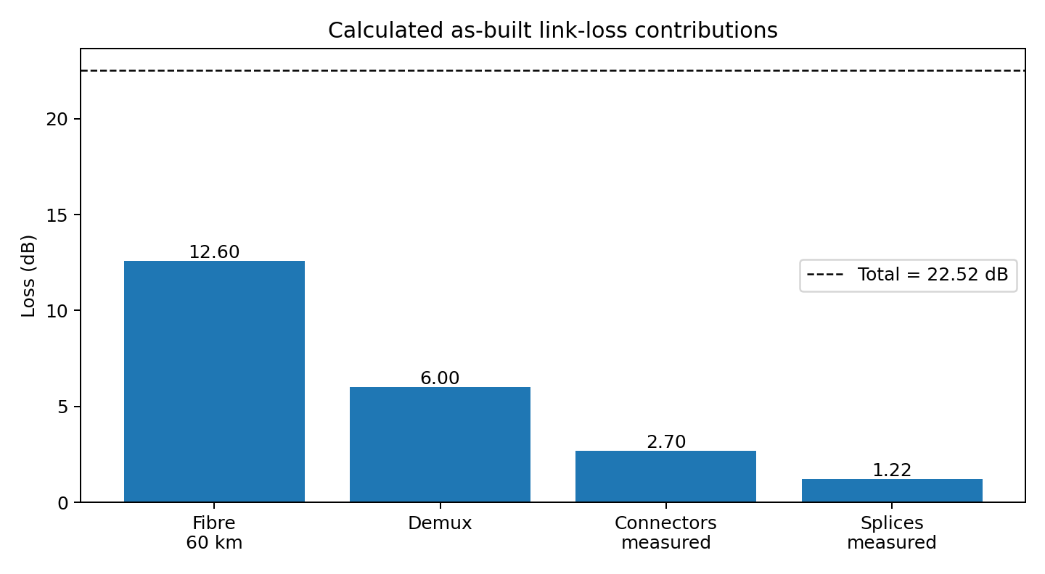
Figure 1. Calculated loss contributions. The demultiplexer is included in the end-to-end power budget; OTDR trace loss itself may not include this terminal component depending on test setup.

2.2 Received power and penalties
Received power before penalties = +1 dBm − 22.52 dB = -21.52 dBm
Dispersion penalty δ = 5 log₁₀[1 + (2π B D L σλ)²] = 1.01 dB
For the supplied ER-penalty relation, P_ER = 10 log₁₀[(r+1)/(r−1)], where r = 10^(ER/10).
Channel 3 ER penalty (ER = 9.0 dB) = 1.10 dB
Channel 5 ER penalty (ER = 4.5 dB) = 3.22 dB
Effective margin = P_rx − P_sensitivity − dispersion penalty − ER penalty
Channel 3 margin = -21.52 − (−24) − 1.01 − 1.10 = 0.37 dB
Channel 5 margin = -21.52 − (−24) − 1.01 − 3.22 = -1.75 dB
Parameter | Channel 3 | Channel 5 | Requirement / result
Raw received power | -21.52 dBm | -21.52 dBm | Same common path
Dispersion penalty | 1.01 dB | 1.01 dB | Common link penalty
ER penalty | 1.10 dB | 3.22 dB | Channel 5 penalty is much larger
Effective margin | 0.37 dB | -1.75 dB | Must be ≥ 3 dB: both fail

2.3 OSNR and PMD
OSNR = 58 + P_in − NF = 58 + (−6) − 5 = 47.0 dB (0.1 nm)
Legacy OSNR margin = 47.0 − 20 = 27 dB. The estimate is also above Options P/Q/R requirements, but this must be confirmed by OSA measurement at the receiver.
Bit period at 10 Gb/s = 1/(10¹⁰) = 100 ps
PMD DGD estimate = 0.1 ps/√km × √60 = 0.775 ps
10% bit-period tolerance = 0.10 × 100 ps = 10 ps
PMD passes the stated tolerance: 0.775 ps < 10 ps. PMD is not the dominant impairment.

Stage 2 design decision
The as-built link fails the margin requirement. Correct the abnormal connector and splice losses first, then verify the channel-specific ER impairment. Increasing launch power is not the first action because it can increase nonlinear penalties and does not fix Channel 5's poor ER. The OSNR estimate is adequate; the immediate limits are excess insertion loss and penalties.

Stage 3 – OTDR, splice and connector configuration (20 marks)

3.1 Pulse-width selection
Pulse width | Dynamic range | EDZ | ADZ | Spatial pulse length cτ/n | Use
10 ns | 20 dB | 1 m | 4 m | 2.04 m | Local close-event measurement; limited range
100 ns | 27 dB | 5 m | 15 m | 20.42 m | End-to-end trace and adequate far-end range
1 μs | 33 dB | 40 m | 100 m | 204.20 m | Long reach only; close events merge

Required dynamic range is one-way OTDR trace loss + 6 dB. Using the fibre/connector/splice trace estimate of approximately 16.52 dB gives a target of about 22.52 dB. A 10 ns pulse has only 20 dB and is insufficient for the full trace; 100 ns has 27 dB and is suitable for the end-to-end trace. Use 10 ns locally around the far-end connector pair.
Events 3 and 4 are separated by only 9 m. A 10 ns pulse has EDZ 1 m and ADZ 4 m, so the events can be resolved and the second connector loss can be measured with suitable launch/receive leads. With 100 ns, the EDZ is 5 m so two reflections may be visually separable, but 9 m is less than the 15 m ADZ; accurate event-4 loss is not assured. With 1 μs, the 40 m EDZ exceeds 9 m, so the events cannot be resolved separately.

3.2 Event interpretation and repair order
Event | Distance | Loss / reflectance | Interpretation | Priority/action
1 | 12.000 km | 0.05 dB, non-reflective | Normal fusion splice within allowance | Low; record baseline
2 | 31.500 km | 0.62 dB, −34 dB | High-loss mechanical splice; reflectance moderate | Priority 2: replace with fusion splice
3 | 59.900 km | 1.20 dB, −22 dB | Poor LC/UPC patch-panel connector; high reflection and loss | Priority 1: clean/inspect/replace connector pair/adapter
4 | 59.909 km | Loss unresolved, −40 dB | Second connector 9 m from event 3; hidden by ADZ on long pulse | Inspect patch cord and test with 10 ns pulse

Event 3 is the first priority because it contributes 1.20 dB and has the strongest reflection (−22 dB). Event 2 is second because 0.62 dB is far above the 0.05 dB fusion-splice allowance. Replace the mechanical splice with a fusion splice; clean/inspect connector end faces and replace damaged LC/UPC components. Do not mate UPC with APC. If low back-reflection is required by the system, use an APC interface consistently at both mating ends.

3.3 Round-trip delay and distance uncertainty
Round-trip time t = 2nL/c; location uncertainty from group-index error: ΔL ≈ L(Δn/n)
Event distance | Round-trip delay | Distance uncertainty for ±0.002 group-index error
12.000 km | 117.534 μs | ±16.3 m
31.500 km | 308.528 μs | ±42.9 m
59.900 km | 586.692 μs | ±81.6 m
59.909 km | 586.780 μs | ±81.6 m

At 59.900 km, the ±0.002 group-index error alone corresponds to about ±81.6 m. This is larger than the 9 m separation of events 3 and 4; accurate close-event separation depends on pulse/dead-zone performance and calibration, not merely the displayed absolute distance. Use a known fibre group index, launch/receive leads and bidirectional traces.

3.4 Repair verification procedure
1) Save baseline OTDR traces and power-meter readings. 2) Clean and inspect the LC connector; replace damaged connector/patch cord. 3) Replace event 2 with a fusion splice. 4) Run a 100 ns end-to-end OTDR trace in both directions. 5) Run a 10 ns local trace at 59.90–59.91 km. 6) Confirm no event exceeds its allowance and measure insertion loss with a calibrated power meter. 7) Recalculate total loss and margin; accept only if total loss ≤ 21.25 dB and effective margin ≥ 3 dB.

Stage 3 design decision
Use a 100 ns pulse for the full span and 10 ns for the closely spaced far-end connectors. Repair event 3 first and event 2 second. Event 4 must be re-measured with the short pulse because the 100 ns ADZ is 15 m, longer than the 9 m separation.

Stage 4 – Eye diagram, BER and quantum limit (20 marks)

4.1 BER from Q-factor
BER = ½ erfc(Q/√2)
Channel | Q | Calculated BER | Target 10⁻¹² | Decision
Channel 3 | 7.6 | 1.481e-14 | Pass | Passes BER target
Channel 5 | 4.7 | 1.301e-06 | Fail | Fails; transmitter/channel path needs correction

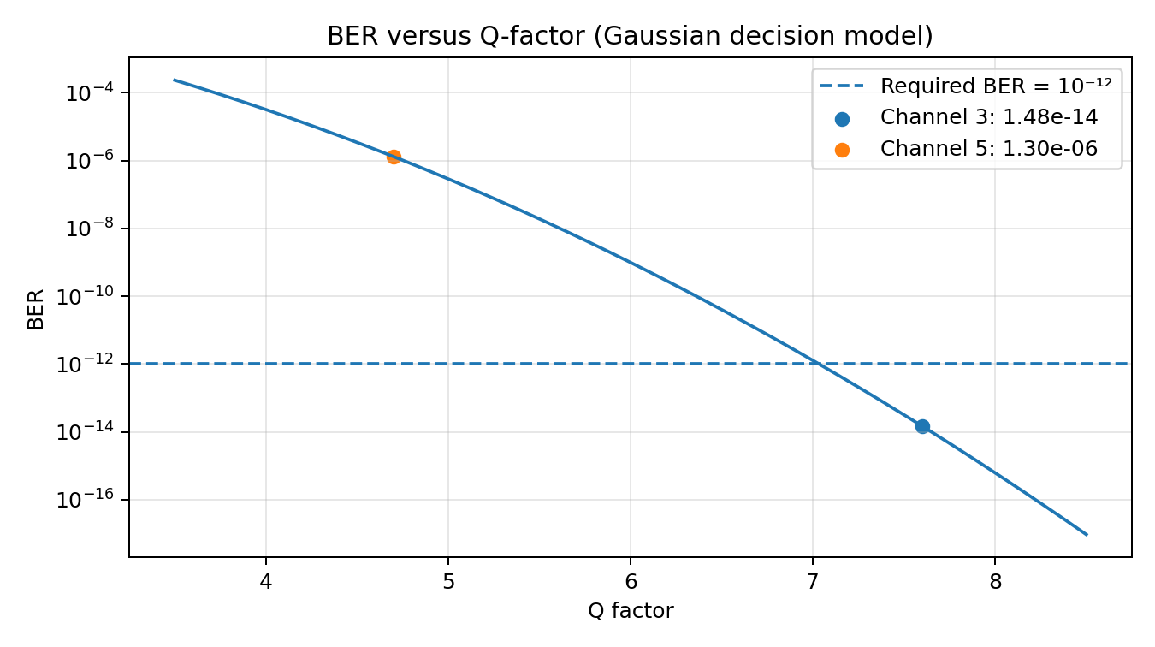
Figure 2. Gaussian decision-model BER versus Q. Channel 3's BER is below 10⁻¹²; Channel 5 is approximately 1.30 × 10⁻⁶, far above target.

4.2 Total jitter and eye width
TJ at BER 10⁻¹² = DJ + 14.07 × RJ; eye width = 1 − TJ (UI)
Parameter | Channel 3 | Channel 5
Deterministic jitter DJ | 0.18 UI p-p | 0.30 UI p-p
Random jitter RJ | 0.012 UI rms | 0.022 UI rms
TJ | 0.349 UI | 0.610 UI
Eye width | 0.651 UI | 0.390 UI
Eye / ER status | Open; ER 9.0 dB | Partially closed; ER 4.5 dB

Channel 5 has higher deterministic and random jitter, leaving only 0.390 UI horizontal opening versus 0.651 UI for Channel 3. Vertical margin is reduced by noise and poor ER; horizontal margin is reduced by jitter. The healthy Channel 3 on the same fibre is evidence against a purely shared-fibre cause.

4.3 Extinction-ratio root cause
The finite-ER penalty estimate is 1.10 dB for Channel 3 (ER 9 dB) and 3.22 dB for Channel 5 (ER 4.5 dB), a difference of 2.12 dB. This explains a significant part of the channel performance difference, although the measured Q/jitter also indicates channel-specific transmitter, drive or receiver impairment. Repair the fibre faults for shared margin, but separately repair/replace Channel 5 transmitter/modulator or its electrical drive/receiver path.

4.4 Quantum-limit calculation at BER 10⁻¹²
Direct detection: BER = ½ exp(−N₁) ⇒ N₁ = −ln(2 BER) = 26.94 photons/bit
Photon energy at 1550 nm: Eγ = hc/λ = 1.282 × 10⁻¹⁹ J
Direct-detection ideal power at 10 Gb/s = N₁EγR = -44.62 dBm
Homodyne PSK: N = ½[erfc⁻¹(2 BER)]² = 12.37 photons/bit; sensitivity ≈ -48.00 dBm
Heterodyne PSK: N = [erfc⁻¹(2 BER)]² = 24.74 photons/bit; sensitivity ≈ -44.99 dBm
Detection model | Photons/bit | Ideal sensitivity at 10 Gb/s | Gap to −24 dBm receiver sensitivity
Direct detection | 26.94 | -44.62 dBm | 20.62 dB
Homodyne PSK | 12.37 | -48.00 dBm | 24.00 dB
Heterodyne PSK | 24.74 | -44.99 dBm | 20.99 dB

These are ideal theoretical limits based on the relations supplied in the assignment, not practical receiver sensitivities. The practical −24 dBm receiver is roughly 20.6 dB above the direct-detection ideal sensitivity. Real systems require additional photons because of quantum efficiency, thermal/electronic noise, implementation penalties and required margin. Coherent detection enables advanced modulation and DSP but does not eliminate OSNR, nonlinear or implementation constraints.

Stage 4 design decision
Channel 5 is unacceptable: Q = 4.7 < 7.03, BER ≈ 1.30 × 10⁻⁶, ER = 4.5 dB < 8.2 dB, TJ = 0.610 UI and eye width = 0.390 UI. Replace or re-bias the transmitter/modulator/drive path and verify ER ≥ 8.2 dB, Q ≥ 7.03, BER ≤ 10⁻¹² and acceptable jitter. Fibre repairs alone cannot fix this channel-specific fault.

Stage 5 – Integrated WDM upgrade and energy strategy (20 marks)

5.1 G.694.1 frequency and wavelength
f(n) = 193.1 THz + n × 0.05 THz
For n = +3: f = 193.1 + 0.15 = 193.25 THz
λ = c/f = 1551.36 nm
The 193.1 THz anchor and 50 GHz spacing are used for this channel-frequency calculation. Option Q uses a flex-grid with 12.5 GHz slot granularity.

5.2 Occupied spectrum and spectral efficiency
Option Q nominal channel bandwidth = baud rate × (1 + roll-off) = 32 GBd × 1.1 = 35.2 GHz
Slots required = ceil(35.2 / 12.5) = 3 slots per channel; allocated width = 37.5 GHz
Total Option Q allocated spectrum = 8 × 37.5 = 300 GHz
Option | Channel plan | Gross capacity | Spectrum calculation | Allocated spectrum | Gross spectral efficiency
P | 16 × 100G DP-QPSK | 1.6 Tb/s | 16 × 50 GHz | 800 GHz | 2.00 bit/s/Hz
Q | 8 × 200G DP-16QAM | 1.6 Tb/s | 8 × 3 × 12.5 GHz | 300 GHz | 5.33 bit/s/Hz
R | 4 × 400G Si-photonic | 1.6 Tb/s | 4 × 75 GHz | 300 GHz | 5.33 bit/s/Hz

The above is gross spectral efficiency (1.6 Tb/s divided by allocated spectrum); payload spectral efficiency will be lower after FEC/framing overhead. Option Q's 35.2 GHz estimated occupied bandwidth fits within a 37.5 GHz allocation.

5.3 OSNR margin and energy per bit
Option | Required OSNR | Estimated OSNR | OSNR margin | Module count × power | Total module power | Energy per bit
P | 12.5 dB | 47.0 dB | 34.5 dB | 16 × 22 W | 352 W | 220.0 pJ/bit
Q | 19.5 dB | 47.0 dB | 27.5 dB | 8 × 20 W | 160 W | 100.0 pJ/bit
R | 26.0 dB | 47.0 dB | 21.0 dB | 4 × 15 W | 60 W | 37.5 pJ/bit
Legacy 10G SFP+ | 20 dB (legacy target) | 47.0 dB | 27 dB | 1 × 3.5 W per 10G | 3.5 W per 10G | 350 pJ/bit

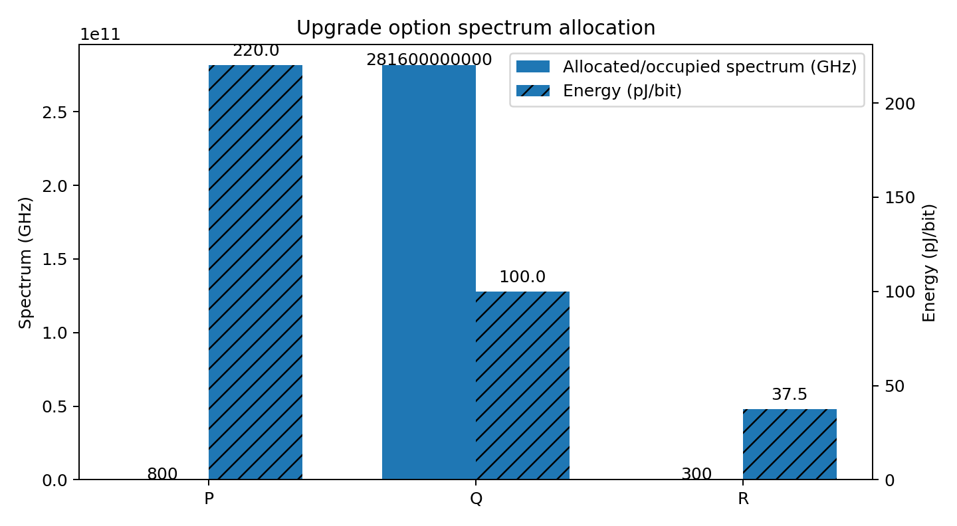
Figure 3. Spectrum allocation and module energy per bit. Option P is spectrally widest; Q and R have the smallest allocation. R has the lowest module-only energy, while Q has substantially more OSNR margin than R.

5.4 Ranking and selected option
Criterion | Best → worst | Reason
Spectrum use | Q ≈ R → P | Q and R each allocate about 300 GHz; P allocates 800 GHz.
OSNR margin | P (34.5 dB) → Q (27.5 dB) → R (21 dB) | All positive using estimated 47 dB, but R has least margin.
Module energy per bit | R (37.5 pJ) → Q (100 pJ) → P (220 pJ) → legacy (350 pJ) | Module-only power divided by gross bit rate.
Balanced provisional choice | Q | High spectral efficiency and 27.5 dB estimated OSNR margin with 100 pJ/bit.

Option Q is selected provisionally because it reaches 1.6 Tb/s using 300 GHz, has a 27.5 dB estimated OSNR margin and consumes 100 pJ/bit in modules. Option R has better module energy (37.5 pJ/bit), but its required OSNR is 26 dB, leaving only 21 dB estimated margin before implementation allowances. R may be preferred if energy dominates and its real transceiver/FEC performance is verified.

5.5 Si-photonic integration and deployment sequence
Silicon-photonic integration can reduce component count, footprint, alignment complexity and potentially power, while enabling compact high-density pluggables. Actual wall-plug power, thermal control, laser efficiency and DSP/FEC power must be measured; module-only figures are not total system energy.
1. Record baseline power, OSA and OTDR readings.
2. Repair event 3 connector, then event 2 mechanical splice.
3. Verify ≤21.25 dB total loss, ≥3 dB effective margin, and no out-of-limit OTDR event.
4. Repair Channel 5 transmitter/drive path; verify ER ≥8.2 dB, Q ≥7.03, BER ≤10⁻¹² and jitter.
5. Measure receiver OSNR and perform a launch-power sweep; confirm no unacceptable SPM/XPM/FWM or EDFA saturation.
6. Configure the selected G.694.1-compatible Option Q channel plan; verify channel powers, spectrum, OSNR and pre-/post-FEC BER.
7. Deploy only after acceptance tests pass across every channel.

Stage 5 design decision
A repair-and-upgrade workflow can deliver 1.6 Tb/s without re-laying the fibre in principle, but not with immediate activation. Option Q is the balanced provisional choice; the final choice is conditional on measured OSNR, BER/FEC, spectral occupancy and launch-power validation.

Stage 6 – Final verification and critical evaluation (10 marks)
Requirement | Target | Calculated / observed evidence | Status before repair | Acceptance evidence required
Total optical loss | ≤21.25 dB | 22.52 dB as-built; expected 21.25 dB after correcting excess loss | FAIL | Post-repair power-meter and OTDR loss ≤21.25 dB
Received power / margin | ≥−24 dBm and ≥3 dB effective margin | Raw -21.52 dBm; C3 margin 0.37 dB; C5 -1.75 dB | FAIL | Recalculate with measured loss and penalties
OTDR events | No event above allowance | Event 2 = 0.62 dB; event 3 = 1.20 dB; event 4 needs 10 ns test | FAIL | 100 ns bidirectional + 10 ns local trace
Eye / Q / ER / jitter | Q ≥7.03; ER ≥8.2 dB; acceptable jitter | C3 Q 7.6; C5 Q 4.7, ER 4.5 dB; C5 TJ 0.610 UI | C3 BER pass; C5 fail | All channels pass after transmitter correction
BER | ≤10⁻¹² | C3 1.48e-14; C5 1.30e-06 | C3 PASS; C5 FAIL | Measured BER and FEC status per channel
OSNR | Above selected requirement | Estimate 47.0 dB; Q margin 27.5 dB | Provisional pass | OSA at receiver; check reference bandwidth and channel-by-channel OSNR
Upgrade capacity | 1.6 Tb/s | P/Q/R each calculate to 1.6 Tb/s gross | Design arithmetic pass | Demonstrate all channels and required post-FEC BER
Energy per bit | Minimize while meeting link limits | P 220.0; Q 100.0; R 37.5 pJ/bit | Calculated module-only | Measure actual transceiver/system wall-plug power

Final parameter / diagnostic table
Parameter | Adopted value / decision
Fibre | 60 km G.652.D; 0.21 dB/km at 1550 nm; group index 1.4682
Legacy system | 8 × 10 Gb/s NRZ; +1 dBm/channel; 100 GHz grid
Design / as-built loss | 21.25 dB / 22.52 dB; excess 1.27 dB
Dispersion penalty | 1.01 dB using supplied formula
OSNR estimate | 47.0 dB at 0.1 nm; verify by OSA
PMD estimate | 0.775 ps vs 10 ps tolerance; passes
Priority repairs | 1) event 3 LC/UPC connector; 2) event 2 mechanical splice; inspect event 4
Channel 5 | Replace/re-bias transmitter/drive; ER ≥8.2 dB, Q ≥7.03, BER ≤10⁻¹²
OTDR strategy | 100 ns end-to-end/bidirectional; 10 ns local close-event test
Upgrade | Option Q provisional: 8 × 200G DP-16QAM, 300 GHz allocation, 160 W modules, 100 pJ/bit
Deployment | NO immediate deployment; conditional YES after repair and all-channel acceptance

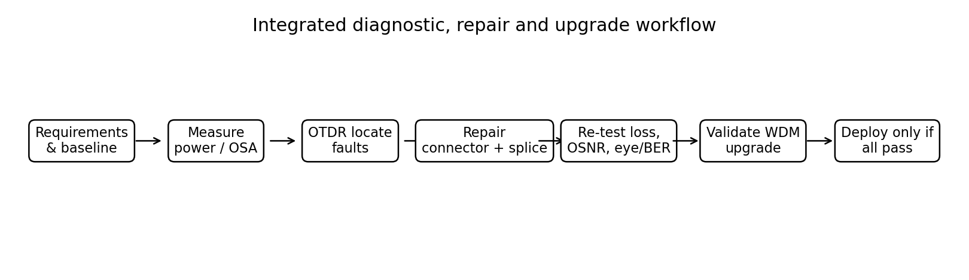
Figure 4. Required workflow. The deployment gate occurs only after physical repairs, channel-specific recovery and full upgrade acceptance.

Final engineering decision – Would I deploy?
DECISION: NO — not in the present as-built condition. CONDITIONAL YES after corrective work and measured acceptance.
The current link has 22.52 dB loss, 1.27 dB excess above design and fails the required margin: Channel 3 effective margin is 0.37 dB and Channel 5 is -1.75 dB. Event 3 contributes 1.20 dB at 59.900 km and event 2 contributes 0.62 dB at 31.500 km. Channel 5 has BER ≈ 1.30e-06, Q = 4.7, ER = 4.5 dB and only 0.390 UI eye width. These are measurable failure conditions, so immediate deployment would be unjustified.
Redesign and acceptance plan: (i) replace/clean the event 3 connector and replace event 2 with a fusion splice; (ii) repeat OTDR with 100 ns end-to-end and 10 ns local pulses and confirm total loss ≤21.25 dB; (iii) repair Channel 5 transmitter/modulator/drive and demonstrate ER ≥8.2 dB, Q ≥7.03 and BER ≤10⁻¹²; (iv) sweep launch power, initially considering +2.6 dBm/channel only if nonlinear and safety checks pass; (v) choose Option Q provisionally and verify receiver OSNR, channel spectrum and BER/FEC before service. If Option Q fails OSNR or FEC acceptance, reduce modulation order or reconsider Option R/P according to measured margins.

References and calculation notes
Standards to consult for the exact applicable edition and interface: ITU-T G.652 (single-mode fibre characteristics), ITU-T G.694.1 (DWDM frequency grid), and the relevant ITU-T G.698 application code where applicable. The numerical values in this report are calculated from the assignment's supplied data and formulas. Figures are calculated illustrations, not OptiSystem simulation outputs. Final field measurements and standards applicability must be verified before claiming compliance.

