ALIGNER CASE MANAGEMENT
SOFTWARE PRD
Product Requirements Document
Based on supplied handwritten workflow • Version 1.0 • 03 November 2026
Document field | Value
Product | Aligner Case Management & Manufacturing Workflow System
Purpose | Digitize case intake, planning, clinician approval, manufacturing, QC and dispatch
Primary users | Marketing, planners, clinicians, lab/manufacturing, QC, admin/dispatch
Status | Draft for stakeholder validation
Source | User-provided workflow chart; assumptions marked for validation

1. Executive Summary
The proposed system provides one case record and traceable workflow for clear-aligner cases, replacing fragmented WhatsApp updates, email attachments, desktop folders and manual dispatch coordination. It coordinates marketing, planning, clinicians, lab/manufacturing and administration. The workflow follows the source sequence: case intake; collection of scans and clinical images; treatment planning; clinician review and revisions; approval and payment confirmation; STL handoff and printing; finishing and QC; packaging and dispatch.

2. Problem Statement
- Case information is distributed across WhatsApp groups, email, clinician communication and desktop folders.
- The workflow relies on staff remembering to post updates, send files and communicate changes.
- There is no described single authoritative status, approval record, payment gate or manufacturing history.
- Plan revisions and file versions may be difficult to distinguish from approved versions.
- Dispatch readiness and local/non-local delivery updates require manual coordination.

3. Goals and Success Measures
Goal | Suggested measure (validate)
Single source of truth | ≥95% of active cases have complete records and required files
Faster handoffs | Reduce intake-to-plan and approval-to-print turnaround
Traceability | 100% of approvals, revisions, payment gates and QC outcomes timestamped
Fewer missing requirements | Required files and instructions captured before planning
Dispatch visibility | All finished cases have QC status, delivery type and dispatch update

4. Scope

4.1 In scope
- Clinic/clinician and case registration; marketing-owned intake.
- Upload and version management for scan/STL files, intraoral/extraoral photos, X-rays, plan PDFs and videos.
- Case requirements, issue notes and revision management.
- Treatment plan creation, assignment, review, clinician approval/rejection and revision loops.
- Payment status tracking as a manufacturing prerequisite.
- Lab queue, STL handoff, print status, finishing, QC and packaging.
- Local/non-local dispatch preparation and daily delivery status updates.
- Role-based access, audit log, notifications, dashboards and reports.

4.2 Out of scope for MVP
- Automated diagnosis or clinical decision-making.
- Automatic treatment-plan generation or autonomous approval.
- Payment gateway processing (initially record confirmation only).
- Courier booking/API integrations unless selected during discovery.
- WhatsApp/email sending until integration, consent and security are confirmed.

5. Users and Roles
Role | Responsibilities | Permissions (proposed)
Marketing / coordinator | Register clinic/case; collect scans, photos, requirements; coordinate clinician communication | Create case; upload intake; view status; communicate; request files
V Clear planner | Review intake; plan treatment; produce plan details, PDF/video; manage revisions | Access assigned cases; create plan versions; submit; respond to changes
Clinician | Review plan; approve, reject or request changes; resolve clinical queries | View clinical files; comment; approve/reject; request revision
Lab / manufacturing | Receive approved STL package; print, trim, polish and finish | View manufacturing-ready cases; update production; upload records
QC reviewer | Inspect finished aligners and record pass/fail | Complete checklist; pass/fail/hold; initiate rework
Admin / dispatch | Record payment confirmation; package; local/non-local dispatch | Payment gate; packaging; dispatch batch and delivery status
System admin | Configure users, workflow, templates, access and audit | Manage users and configuration

6. End-to-End Workflow
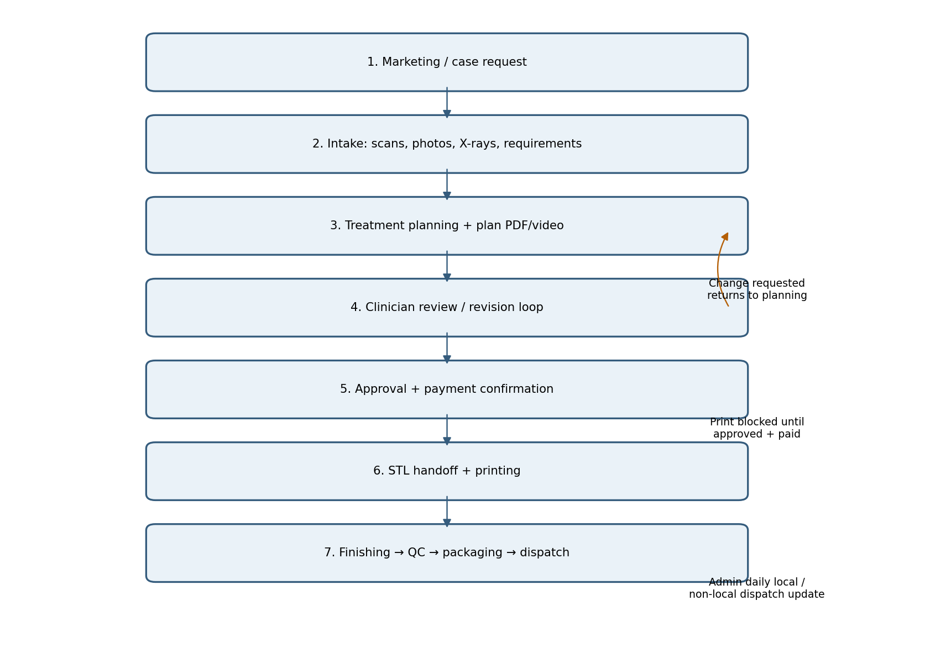
A case advances through the stages below. Any change request returns it to planning/review. Production cannot start until clinician approval and payment confirmation are recorded.
Stage | Owner | Activity | Exit condition
Lead / request | Marketing | Clinic contacts marketing; case opened and assigned ID | Case created
Intake | Marketing / coordinator | Collect scans, intraoral/extraoral photos, X-rays and requirements; check completeness | Complete or missing items requested
Planning | Planner | Review files; prepare treatment plan; attach details, PDF/video | Plan version submitted
Clinician review | Clinician | Approve, reject or request changes; clarify as needed | Approval or revision request
Approval + payment | Marketing / admin | Communicate approved plan; record payment | Approved + payment confirmed
Manufacturing handoff | Lab | Retrieve approved STL package; queue print | Print started
Production + finishing | Lab | Print, trim, polish and finish | Ready for QC
Quality control | QC / V Clear doctor | Check finished product against approved case and checklist | QC pass or rework
Packaging + dispatch | Admin | Package; classify local/non-local; record delivery details | Dispatched / delivered

7. Functional Requirements
ID | Feature | Requirement
FR-01 | Case creation | Create unique case ID; capture clinic, clinician, marketing owner, received date and case type.
FR-02 | Intake checklist | Configurable required scans, intraoral/extraoral photos, X-rays and case instructions.
FR-03 | Missing information | Mark missing items, assign follow-up owner and notify relevant contact.
FR-04 | File repository | Store files with type, uploader, date, version and status; preserve previous versions.
FR-05 | Plan versioning | Create numbered plan versions; attach details, PDF/video; previous versions read-only.
FR-06 | Clinician review | Approve, reject or request changes with comments, reviewer and timestamp.
FR-07 | Revision loop | Reopen planning, preserve prior version and require re-review of revised plan.
FR-08 | Communication log | Log internal notes and external communications; integrations optional.
FR-09 | Payment gate | Block manufacturing-ready status until authorized payment confirmation.
FR-10 | Manufacturing handoff | Expose approved STL package and production checklist to authorized lab users.
FR-11 | Production tracking | Record queued/started/completed, finishing, hold and rework with timestamps.
FR-12 | QC | Checklist, pass/fail/hold, notes, reviewer and evidence.
FR-13 | Packaging | Allow packaging only after QC pass; record packer and timestamp.
FR-14 | Dispatch | Record local/non-local, dispatch date, carrier/reference and delivery status.
FR-15 | Daily dispatch report | Generate daily local/non-local dispatch view; source workflow indicates 1 PM update.
FR-16 | File import | Support secure upload/import from planning workstation; no automatic desktop access assumed.
FR-17 | Dashboard | Show cases by stage, aging, owner, blockers, revisions and dispatch readiness.
FR-18 | Audit trail | Record status changes, uploads, approvals, payment, QC and dispatch events.

8. Business Rules
- Every case has a unique ID and linked clinic/clinician.
- Planning requires complete intake unless an authorized exception is recorded.
- Approval applies to one exact plan version; only the latest submitted version can be approved.
- Any change after approval invalidates approval and requires new clinician review.
- Printing is blocked until clinician approval and payment confirmation.
- Only QC-passed cases may be packaged.
- QC failure sends the case to rework; reworked items require another QC pass.
- Dispatch updates retain actor and timestamp.
- Clinical records and files are restricted to users with a legitimate case role.

9. Case Status Model
Status | Meaning
New | Case created; intake not complete
Awaiting Intake | Required files or requirements missing
Intake Complete | Required checklist passed
Planning | Planner working
Plan Submitted | Awaiting clinician review
Changes Requested | Clinician requested changes
Approved | Current plan version approved
Awaiting Payment | Approval recorded; payment pending
Manufacturing Ready | Approval and payment gates satisfied
Print Queued / Printing | Lab queue or print in progress
Finishing | Trim, polish and finish
QC Hold / Rework | QC failed or correction required
QC Passed | Finished aligners passed QC
Packaging | Packaging in progress
Ready for Dispatch | Packaged; dispatch details prepared
Dispatched / Delivered | Delivery status recorded
Cancelled / On Hold | Paused/cancelled with reason

10. Workflow and Role Handoffs
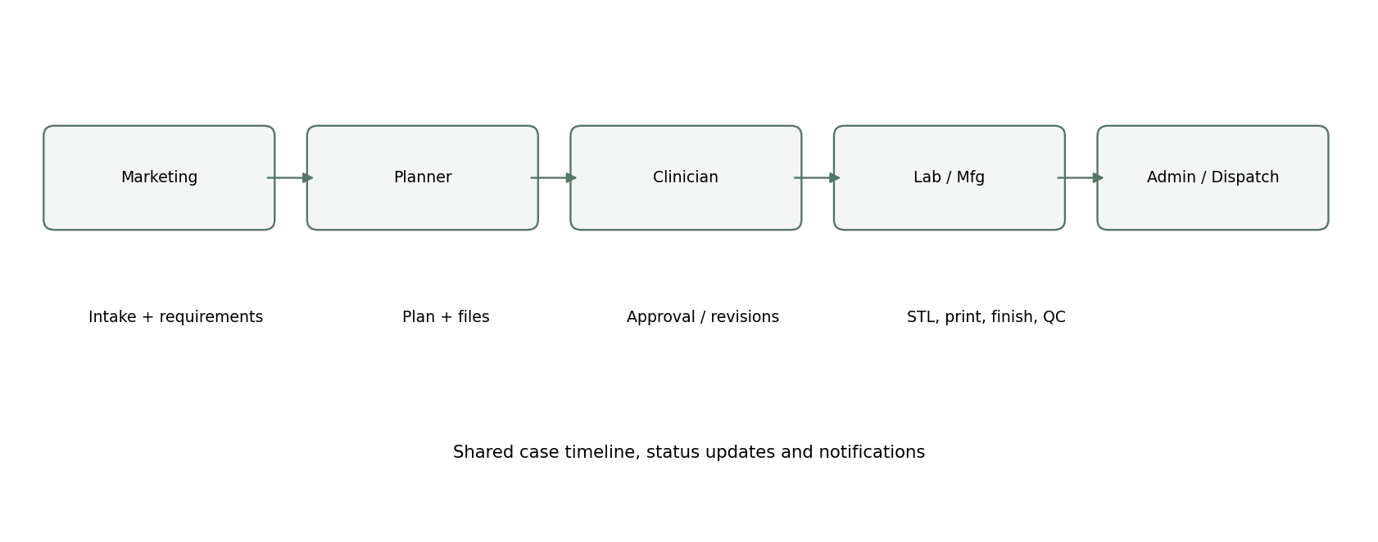
The source chart uses WhatsApp for status updates and email for scan/plan transfers. The product should become the authoritative record while optionally sending familiar notifications. External channels should not be treated as the system of record.

11. Data Requirements
Entity | Key fields
Case | Case ID, clinic, clinician, marketing owner, received date, priority, type, status
Patient / subject | Clinic-provided identifier; minimize direct identifiers; demographics only if needed
Intake checklist | Required item, received flag, file reference, comments, completeness reviewer
File / asset | File ID, case ID, category, version, filename, uploader, timestamp, access class
Plan version | Version, planner, details, PDF/video links, submitted date, current/obsolete flag
Review / approval | Clinician, decision, comment, timestamp, approved version
Payment | Status, reference, confirmed by and date; amount only if needed
Manufacturing job | STL refs, queue, batch, start/end, operator, notes
QC record | Checklist, outcome, reviewer, timestamp, defects/rework, evidence
Dispatch | Local/non-local, package, carrier/tracking, dispatch/delivery timestamps
Audit event | Actor, action, entity, before/after, timestamp, reason

12. Notifications and Communication
Trigger | Recipient | Notification
Case created / intake incomplete | Marketing owner / coordinator | Case ID, missing items and follow-up
Intake complete | Planner | Case ready for planning
Plan submitted | Clinician / coordinator | Review requested; plan version link
Changes requested | Planner / coordinator | Comment, action and due date
Plan approved | Marketing / admin | Approved version and payment state
Payment confirmed | Lab | Manufacturing may proceed
Production / QC update | Admin / owner | Progress or blocker
QC failed | Lab / QC lead / owner | Defect and rework action
QC passed | Admin / dispatch | Package and dispatch
Daily 1 PM summary | Internal operations | Local/non-local dispatch list

13. Reports and Dashboards
- Active cases by status, clinic, planner and owner.
- Intake completeness and cases waiting on scans/photos/requirements.
- Planning and clinician-review turnaround; pending approvals.
- Revision counts and reasons.
- Approved cases blocked by payment.
- Manufacturing queue, print duration, finishing and rework.
- QC pass rate, defects and rework trends.
- Daily local/non-local dispatch and delivery exceptions.
- Case audit timeline and downloadable case packet.

14. Non-Functional Requirements
Category | Requirement
Security | Role-based access, least privilege, secure authentication, encryption in transit/at rest where supported.
Privacy | Minimize patient identifiers; configurable retention; access logging; consent/legal review.
Availability | Uptime and recovery objectives to be agreed; communicate planned maintenance.
Performance | Search/status views meet agreed SLA at expected load.
Reliability | Verify file upload integrity; retry failed uploads without duplicates.
Auditability | Critical events immutable to ordinary users; admin correction requires reason.
Usability | Responsive web UI; case timeline; visible blockers and next action.
Backup/recovery | Regular backups, tested restore and defined RPO/RTO.
Interoperability | Export case packet; support approved file types and APIs where available.

15. Exception Handling
Exception | Expected behavior
Unreadable/incomplete scan | Mark intake incomplete; request replacement; preserve prior file and reason.
Wrong file uploaded | Authorized correction with audit; prevent silent overwrite.
Plan revised after approval | Invalidate old approval; return to planning/review.
Clinician unavailable | Escalate review after configured SLA; never auto-approve.
Payment pending | Remain Awaiting Payment; block manufacturing.
Printer failure/delay | Place hold with reason, owner and ETA; notify; retain history.
QC failure | Record defect; create rework; require retest.
Dispatch details missing | Prevent dispatch completion; flag required fields.
Case cancelled | Require reason; stop downstream work; preserve record.

16. MVP Prioritization
Priority | Features
Must have | Case ID; intake checklist; repository/versioning; planning; clinician decision; revision loop; payment gate; production statuses; QC; dispatch; role access; audit timeline.
Should have | Dashboards, 1 PM dispatch report, reminders/SLA escalation, case packet export, rework analytics.
Could have | WhatsApp/email, courier, payment gateway, barcode/QR package tracking, file validation.
Later | Capacity planning, machine integration, predictive turnaround and analytics.

17. Acceptance Criteria (MVP)
- Marketing creates a case and uploads intake assets; case searchable by ID and clinic.
- Missing intake items are visible and progression is blocked unless completed or exception-authorized.
- Planner submits plan version 1 with PDF/video and relevant files.
- Clinician approves or requests changes; decision/comment/reviewer/time retained.
- Revision creates new version and preserves previous plan and review history.
- Manufacturing release blocked unless current plan approved and payment confirmed.
- Lab records print, finishing and hold/rework events.
- QC pass required before packaging; QC fail creates rework.
- Admin records local/non-local dispatch and generates daily dispatch list.
- Access restrictions enforced; critical actions appear in audit history.

18. Open Questions / Assumptions to Validate
- Does one case represent one patient, one arch or a treatment package? Are refinements linked cases?
- Which intake files are mandatory vs optional?
- Who is the formal clinical approver: treating clinician, V Clear doctor or both?
- When is payment required, and who confirms it?
- How are STL files transferred today; can secure shared storage replace workstation copying?
- Is 1 PM dispatch reporting fixed, and which timezone/working days apply?
- What are QC criteria, tolerances and evidence requirements?
- How are local/non-local defined; what delivery fields are required?
- Which WhatsApp groups/email channels exist and should integrations be MVP?
- What privacy, consent, retention and regulatory rules apply?
- What turnaround SLAs, escalation paths and capacity constraints should be configured?

19. Recommended Product Screens
Screen | Core contents
Operations dashboard | Stage totals, aging, blockers, due reviews, production queue, dispatch today
Case workspace | Summary, owner, status, next action, timeline, files, checklist, comments
Intake | Clinic/clinician, upload slots, required-file checklist, requirements
Planning | Plan version metadata, attachments, submit-for-review
Clinician review | Plan viewer, version comparison, approve/request changes/reject
Manufacturing board | Approved/paid queue, STL package, print/finishing status, batch/operator
QC | Checklist, defect categories, evidence, pass/fail/rework
Dispatch | Package, local/non-local, carrier/tracking, daily summary
Admin | Users/roles, workflow, templates, SLA rules, audit search

20. Implementation Recommendation
Build the MVP around a case-centric workflow engine, secure file repository, role-based permissions and append-only activity timeline. Start with responsive web application and manual payment/dispatch updates. Add WhatsApp, email, payment and courier integrations only after stakeholders confirm channels, ownership and compliance constraints.

Appendix A — Source Workflow Summary
- Marketing promotes service to clinics; clinic contacts marketing for a case.
- Marketing posts case update in WhatsApp group; scan person sends scan files.
- After scanning, intraoral/extraoral pictures and requirements are updated in group.
- Scan files are sent to V Clear by email; X-rays may be included; OPG requirement communicated to marketing.
- Treatment planning completed; plan details, PDF and video emailed to marketing.
- If change is required, marketing informs planner; clinician may call for query resolution.
- Marketing communicates with clinician; approved case PDF/details posted in group; payment before printing.
- Lab/manufacturing head retrieves required STL files from V Clear computers and places them for print.
- After print, status updated; lab trims, polishes and finishes aligners.
- Quality check by V Clear doctor; then packaging and ready for delivery.
- Admin updates local/non-local deliveries in WhatsApp group every day at 1 PM.
- Case files saved on desktop: scanned STL, planned treatment PDF/video, clinical photos and X-rays.
Note: This PRD translates the source workflow into proposed software behavior. Roles, file transfer, approval ownership, payment timing and operational SLAs should be validated before development.

